Purpose of the Project
The aim of this project is to analyse a bank marketing dataset containing demographic and financial information of clients. The main business question is: Which clients are most likely to subscribe to a term deposit during a marketing campaign?
This question refers to the bank’s marketing department. It will help the marketing department understand customer response patterns, allow the bank to target its target groups more effectively, reduce unnecessary calling costs, and increase overall campaign success. Improvement in such a way ensures that marketing resources are used efficiently by concentrating on clients with the highest probability of success.

Business Strategy
This project supports a marketing efficiency and customer acquisition strategy. Concentrating on high-potential clients and ignoring low-likelihood segments, the bank can avoid costly and ineffective outreach. This strategy fits the problem because the bank’s resources, such as call centre time and marketing budget, are limited. Such actions can greatly reduce campaign waste and increase overall return on marketing investment.

Data description
In each row of the used data, there is information about each client, with variables such as age, job, marital status, education, account balance at the time of call, housing, loan, personal loan and the outcome of the term deposit campaign. The target variable is deposit, which indicates if the client subscribed to a term deposit(yes/no). There are a little over 11,000 observations. The data is balanced as we have 5395 non-subscribers and 5079 subscribers.

KPIs.
The main KPIs used to measure performance are:
- Deposit conversion rate (percentage of clients with deposit = "yes"),
- Deposit rate by job group and age group,
- Average account balance by deposit outcome,
- Distribution of clients across age groups.

Cleaning and new variables
Before analysis, some data processing was done. Job, marital status, education, housing loan, personal loan, and contact type were converted from categorical data to factors. A new column “deposit_num” was created, which is a binary variable representing whether the client took a deposit and an age_group variable was split into 3 groups (“<30”, “30–45”, “45+”) for simplifying the insights.

Descriptive analysis
Looking at descriptive statistics, 53% of clients do not subscribe to a term deposit and just 43% do, hence the overall conversion rate is low. When considering the deposit rate by job and age group, we notice that some groups respond better than the rest. For instance, some occupations and older age groups have higher rates compared to other professions and younger age groups. Additionally, account balances matter too, as those who subscribe, in general, have higher balances than the average.

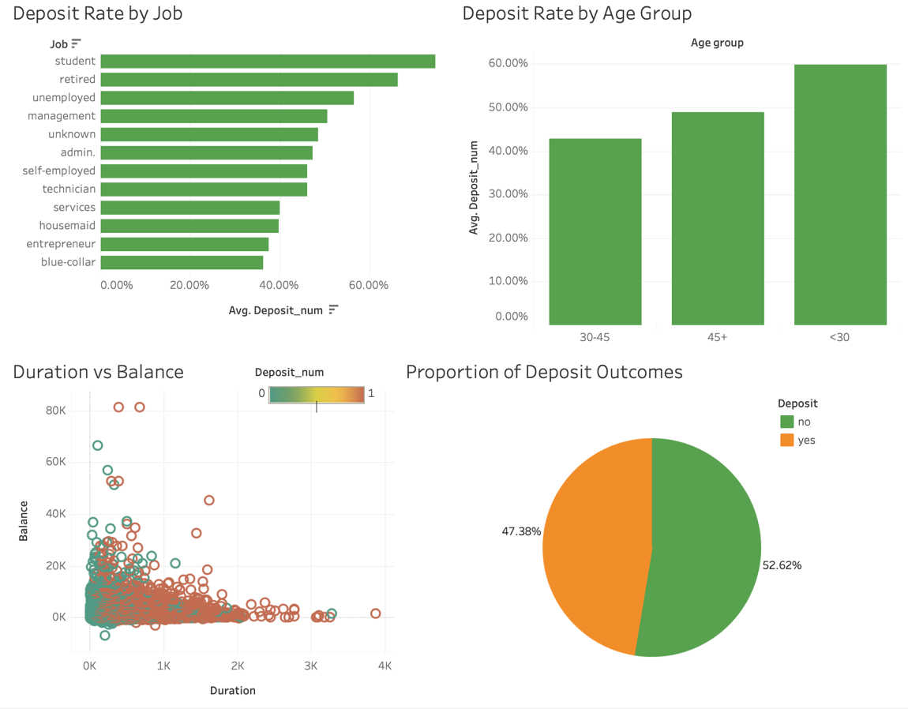

Looking at our Tableau Dashboard, we can see the following trends:

- Deposit Arte by Job
Students and retired clients are more likely to subscribe to a deposit than others

- Deposit Rate by Age Group
From the second graph, we can conclude that the second age group(30-45) is the one the falls behind the other two.

- Duration vs Balance
One of the key findings is shown in this graph. The longer the calls, the more the probability of subscription, however, we can see that the balance alone is not a strong indicator, though it matters too.

- Proportion of deposit outcomes
The pie chart shows that the data is balanced and has relatively similar proportion of deposit outcomes

One of the key findings is shown in this graph. The longer the calls, the more the probability of subscription, however, we can see that the balance alone is not a strong indicator, though it matters too.

Logistic Regression Model
We used linear regression to identify which factors most strongly influence the decision to subscribe to a deposit. Here are the results
duration (0.004652, p < 2e-16) - longer calls conclude in a much higher chance of saying “yes”
balance (0.000033, p ≈ 2.19e-05) - with a higher account balance, more likely to say “yes”
previous (0.222357, p < 2e-16) - clients contacted before are more likely to take the deposit
housingyes (-1.206635, p < 2e-16) - clients with a housing loan are less likely to subscribe
loanyes (-0.784238, p < 2e-16) - clients with a personal loan are less likely to subscribe
age (-0.002269, p = 0.244) - not statistically significant, hence age doesn’t matter much here

Our model has an accuracy of 76% and balanced precision and recall. Our model predicts deposit subscription with 78% precision. This shows that much effort could be saved if banks followed the strategy of this model. Recall is 0.71, which means 71% of all actual subscribers are identified. The balance between precision and recall is represented by the F1 score, which is 75%. It is a good balance between those two metrics. Overall, these scores indicate that the model is effective and can help us identify potential customers.
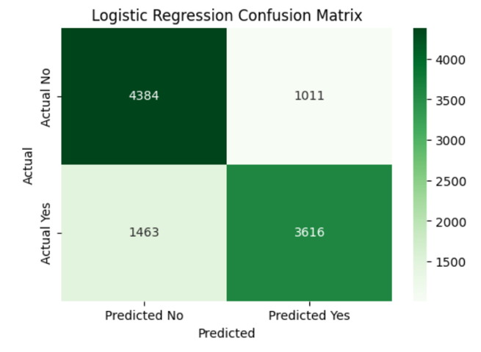
The model predicts correctly 4382 failures and 1013 successes. In addition, there are 1462 false negatives and 3617 false positives. Overall, the model is good for marketing decision-making, as it provides sufficiently accurate approximations to improve campaign efficiency.
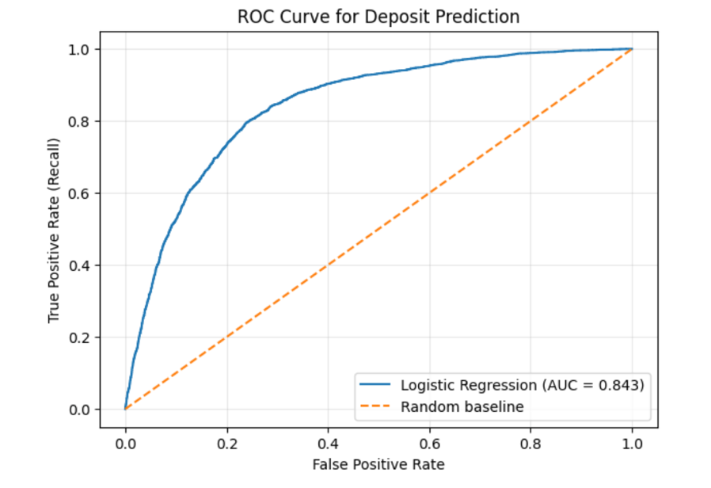
Based on the ROC curve, we can conclude that the model performs much better than random guessing, as the curve is located much above the diagonal baseline. AUC is 0.843 indicates that the model greatly distinguishes between clients who will and will not subscribe to a deposit. Hence model is reliable for marketing decisions.

KNN segmentation

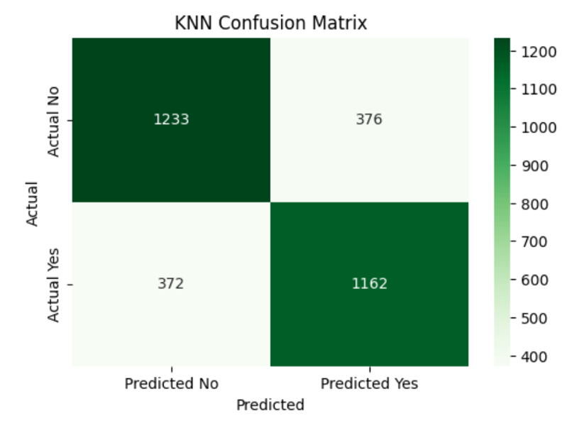

To complement the Regression model, we implemented the K-nearest neighbour method. The results were 1233 True negatives, 1162 True positives, 376 False positives and 372 False negatives. It had 76.2% accuracy.

KNN and Regression models comparison

KNN has 76.2% accuracy, while the Regression model has 76.4%. The difference is small, however Regression model gives more details, including p-values and significances of each factor. This allows the bank to understand which sectors need to be focused on and what decisions should be made in order to get the maximum financial return. Although KNN is helpful for comparison, the Linear Regression model has more advantages for decision-making.

Elbow Method and Silhouette score

The elbow method helps us to understand the optimal value for k. We can see that the within-cluster sum of squares (WCSS) decreases as the number of clusters increases. At about 4 or 5, the curve starts to flatten; therefore, 4 or 5 is the optimal value for k.

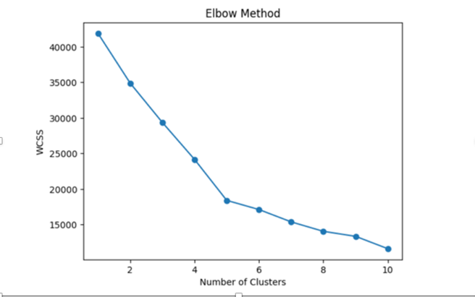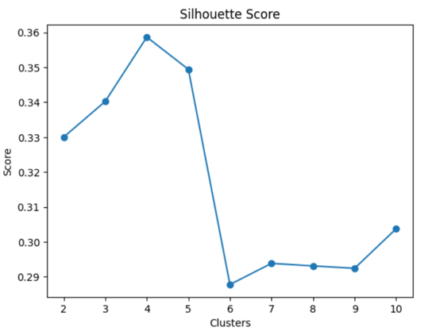

Looking at the Silhouette score, we notice that at k = 4 score peaks at 0.36 and slightly decreases to 0.35. Hence, both are acceptable, but we are going to proceed with k = 4 based on the Silhouette score and the elbow method.

Customer Segmentation (K-Means)
We separated customer segments into 4 groups based on age, account balance, call duration and previous contacts. Cluster 2 has the strongest indicator, it stands on top with long call durations and the highest deposit rate (84%), hence it is the most valuable segment. The segment with the highest balance is cluster 3, they have a 56% deposit rate, which tells us that they have potential for cross-selling. Cluster 0 has a high deposit rate (70%), and it contains clients with previous contacts. Finally, cluster 1 is the least valuable one as they have the lowest balances, the shortest calls and the lowest deposit rate (38%)
Overall, the most valuable segments are clusters 2 and 3. Although cluster 0 has a higher conversion rate than cluster 3, it takes more effort to keep it high, as clients need to be contacted over eight times, also, it has a lower balance, which means the deposit amount will be lower than cluster 3. The bank should prioritise clusters 2 and 3 and continue following up with cluster 0, reducing effort for cluster 1 for better financial returns.
A/B testing

The A/B testing was used for the comparison of two marketing strategies. Strategy A is the approach of calling every client. Strategy B contacts those clients whose probability of success is greater than 0.5.

The results indicate that strategy B is more efficient. Strategy A requires 11,162 calls to reach 5,289 deposits (a conversion rate of 47.4%), Strategy B requires only 4,760 calls to achieve 3,731 deposits (a conversion rate of 78.4%). This means Strategy B gives almost the same results as Strategy A, with 57% fewer calls, which is a huge improvement.

Null Hypothesis (H₀):
The deposit conversion rate is the same for both strategies (Strategy A = Strategy B).

Alternative Hypothesis (H₁):
The deposit conversion rates are different for the two strategies (Strategy A ≠ and Strategy B). We get Z-statistic: -33.99614020725025, p-value: 2.5 × 10⁻²⁵³ and Chi-square statistic: 1155.74. P-value is far below 5% significance level, hence we reject the null hypothesis and say that the difference is significant. Hence, strategy B performs better than strategy A in terms of conversion rate. Because Strategy B relies on model predictions, the results reflect improved targeting efficiency rather than the effect of a fully randomised A/B experiment.

SWOT Analysis

Strengths
- The model finds factors that have a statistically significant effect on the deposit rate
- The dataset has various kinds of demographic and financial information, which allows to get meaningful segmentation.
- K-Means segmentation is informative and gives information on which segments are more valuable

Weaknesses
- The dataset lacks detailed financial variables such as income, credit score, or spending patterns, which limits full customer profiling.
- No marketing campaign cost, which makes it harder to evaluate the expected financial return

Opportunities
- The marketing team can concentrate on high-probability clients, therefore reducing operational costs and unnecessary labour.
- The data shows that the longer the calls, the more effective. Hence, call agents can be trained to keep clients engaged in conversation.
- Clients who have been contacted before and have higher-than-average balances are not only more likely to take a deposit, but also may buy other products too

Threats
- If clients are over-targeted, it may cause customer fatigue or reduce satisfaction.
- Some competitors could focus on the same valuable customer segments.
- Even though highly valuable segments are found, due to law restrictions, they cannot be contacted too often

Decision
Since Bank resources are limited, a decision can be made to call the clients who have a high probability of subscribing based on our regression model. Not to lose potential customers, the bar can be set at 0.5, meaning clients with a higher probability than that will be contacted. After K-means segmentation, it turned out that clusters 2 and 3 should be prioritised, with follow-ups to cluster 0. However, it is also important to take into consideration that over-targeting may cause issues. Therefore, the bank should maintain a balanced strategy by focusing on high probability customers without overtargeting them.

Data: Bachmann, J. (2020). Bank Marketing Dataset. Kaggle.
https://www.kaggle.com/datasets/janiobachmann/bank-marketing-dataset

