**ASSIGNMENT # 01**

**COMPUTER NETWORKING**

**Submitted by Tahla Shah**

**(2121-323065)**

**BSCS 3rd**

**Submitted to Sir Bakhtawar**

**Lecturer**

**DEPARTMENT OF EDUCATION**

**PRESTON UNIVERSITY KOHAT**

**31 JANUARY 202**

**Table of Contents**

QUESTION NO 01 3

UNICAST PROTOCOLS 3

ANSWER 3

UNICAST PROTOCOLS 3

1.1 Definition and Explanation of Unicast Communication 3

### 1.1.1 **How Unicast Works**………………………………………...…………………………….…3

## **1.2 Three Types of Unicast Protocols………………………………………..……………………3**

### 1.2.1 Transmission Control Protocol (TCP)………………………………………………………3

* + 1. User datagram protocol (UDP)……………………………………………………………4
    2. **Internet Protocol (IP)……………………………………………………………………...4**

**1.3 Advantages and Disadvantages of Unicast Communication………………………………….5**

**1.3.1 Advantages………………………………………………………………………………..5**

1.3.2 **Disadvantages…………………………………………………………………………….5**

QUESTION NO 02 6

MULTICAST PROTOCOLS 6

Answer 6

2.1 Multicast Communication in Networking 6

2.2 Three Multicast Protocols 6

2.3 How Multicast Routing Works and Its Benefits 8

2.3.1 Multicast Routing 8

2.3.2 Source-based Trees 8

2.3.3 Shared Trees (like PIM Sparse Mode) 8

2.4 Benefits of Multicast Routing 8

QUESTION NO 3 10

CONFIGURING RIP OR OSPF WITH LOOPBACK ADDRESSES 10

Answer 10

Successful ping results 10

3.2 Network topology in Packet Tracer 11

# **QUESTION NO 01**

# **UNICAST PROTOCOLS**

* Define **unicast communication** and explain how it works in networking.
* List and describe at least **three unicast protocols**.
* Explain the **advantages and disadvantages** of unicast communication.
* Provide real-world examples of unicast protocol usage.

**ANSWER:**

### **UNICAST PROTOCOLS**

## **1.1 Definition and Explanation of Unicast Communication**

Data is transmitted from a single sender to a single recipient using unicast communication, a one-to-one networking transmission technique. Every data packet is specifically addressed to a particular IP address. Traditional client-server models, in which a user asks a server for information and the server answers immediately, frequently employ this kind of communication.

### **1.1.1** **How Unicast Works**

* The sender transmits data packets addressed to a specific recipient.
* Network routers and switches direct the packet through the best possible path.
* The receiver accepts and processes the packet.
* The process continues for every request-response interaction.

## **1.2 Three Types of Unicast Protocols**

Several protocols support unicast communication. Here are three major ones:

### **1.2.1** **Transmission** **Control** **Protocol** **(TCP)**

**Description:** TCP is a connection-oriented protocol that creates a session between the sender and the recipient to guarantee dependable data transfer. It makes use of retransmission methods, error-checking, and acknowledgements (ACKs).

**Use Cases**: File transfers (FTP), email (SMTP, IMAP, POP3), and web surfing (HTTP/HTTPS).

* + 1. **User datagram protocol** **(UDP)**

**Description**: The User Datagram Protocol (UDP) is a connectionless protocol that transmits data without creating a session. Compared to TCP, UDP is quicker but less dependable. It doesn't offer retransmission or error correction.

**Use Case**: VoIP (Voice over IP), live streaming, and gaming applications where dependability is less crucial than speed.

* + 1. **Internet Protocol (IP)**

**Description**: IP is in charge of addressing and directing data packets throughout networks. IPv4 and IPv6 are mostly utilized for unicast addressing in point-to-point communication, however they may also handle broadcast, multicast, and unicast communication.

**Use Case:** Data transfer in TCP/IP networks as well as general internet communication.

#### **Advantages and Disadvantages of Unicast Communication**

**1.3.1 Advantages**

* **Effective for Individual Communications:** Ideal for direct, tailored client-server communication.
* **Reliable:** Assures error checking and retransmission for assured delivery, particularly when using TCP.
* **Secure and Private:** Compared to broadcast, data is less likely to be intercepted because it is sent straight to a designated recipient.

**1.3.2 Disadvantages**

* **Not Scalable for Large Audiences:** The sender must send distinct unicast packets in response to many users requesting the same material, which uses server resources and bandwidth.
* **Increased Network Load:** Sending several unicast streams can cause congestion in applications like video streaming.
* **Latency in Real-Time Communication:** Compared to broadcast or multicast techniques, the TCP connection setup procedure may introduce delays.

#### **1.4 Real-World Examples of Unicast Protocol Usage**

**1.4.1 Web browsing (HTTP/HTTPS)**

Your browser sends a server an HTTP request when you visit a website, and the server uses TCP to deliver the requested webpage.

**1.4.2 Email Communication (SMTP, IMAP, POP3)**

Unicast communication is used by email clients and servers to safely send and receive emails.

**1.4.3 Video Conferencing (Zoom, Microsoft Teams)**

Direct audio and video connections between participants are made via Unicast.

**1.4.4 Online Banking Transactions**

HTTPS, which uses TCP/IP, allows for secure data transfer between a user's device and the bank's server.

**1.4.5 Remote Desktop Access (RDP, SSH)**

To enable safe access to another computer, a remote desktop or terminal connection makes use of unicast protocols like TCP.

**QUESTION NO 02**

### **MULTICAST PROTOCOLS**

* Define **multicast communication** and how it differs from unicast.
* List and describe at least **three multicast protocols** (e.g., **IGMP, PIM, RTP**).
* Explain how **multicast routing** works and its benefits.

Provide real-world examples where multicast protocols are used (e.g., video streaming, IPTV).

**Answer**

### **2.1 Multicast Communication in Networking**

### Data transfer from a single sender to a designated set of recipients inside a network is referred to as multicast communication. Multicast enables the sender to deliver data to numerous recipients at once without overloading the network, as contrast to unicast, which sends data to a single destination. A multicast group, denoted by a unique multicast IP address, must be joined by each recipient who wishes to receive the multicast stream. The Differences between Unicast and Multicast.

* + 1. **How Multicast Differs from Unicast**
* **Unicast:** Information is transmitted from a single sender to a single recipient. Each packet is delivered to a specific recipient after being individually addressed. Since the sender must transmit a different copy of the data to each recipient, this method is inefficient when distributing the identical data to several recipients.
* **Multicast**: Data is sent from one sender to many receivers. The sender only sends one copy of the data to a multicast group address, and network routers manage the delivery of this data to multiple recipients. This is more bandwidth-efficient when distributing the same content to multiple devices.

### **Three Multicast Protocols**

**2.2.1 Internet Group Management Protocol (IGMP)**

**Description:** In IPv4 networks, multicast group membership is managed by IGMP, which functions at the network layer. A device sends an IGMP join request to a multicast group in order to receive multicast traffic. In order to determine which devices wish to receive particular multicast streams, routers employ IGMP.

**Use Case:** In situations where users must subscribe to particular multicast channels or groups, such as IPTV or video conferencing, IGMP is essential.

* + 1. **PIM, or Protocol Independent Multicast**

**Description:** In large-scale networks, multicast traffic is routed using the PIM family of multicast routing protocols. PIM is "protocol independent" since it can function with any routing protocol, such as RIP, OSPF, or any other unicast routing protocol.

* + 1. **Real-Time Protocol (RTP)**

**Description**: RTP is an application-layer protocol that is often used in conjunction with multicast for delivering real-time audio and video data, such as in video conferencing or streaming. RTP provides mechanisms for end-to-end delivery services, including payload type identification, sequence numbering, and time-stamping to manage the real-time nature of the data.

**Use Case**: RTP is frequently used for streaming multimedia content, including VoIP, video conferencing, and live video streaming.

### **How Multicast Routing Works and Its Benefits**

### **2.3.1** **Multicast Routing**

### Routing multicast packets over a network to several recipients who have indicated interest in receiving the multicast traffic is known as multicast routing. Multicast routers create distribution trees that provide the optimal route from the sender to every group member using a multicast routing protocol such as PIM.

### Multicast routing trees come in two main varieties

### **2.3.2 Source-based Trees**

### Every source has a multicast distribution tree that covers the whole network, such as PIM Dense Mode.

### **2.3.3 Shared Trees (like PIM Sparse Mode)**

### This technique lowers the amount of trees required for multicast routing by sharing a single tree across several sources.

### **2.4** **Benefits of Multicast Routing**

**2.4.1 Bandwidth Efficiency**

When numerous recipients are involved, multicast is significantly more efficient than unicast because it reduces the requirement for duplicate traffic transmission.

**2.4.2** **Scalability**

It works well for big receiver groups, particularly in situations where the group size is dynamic and sizable, like in IPTV or live streaming events.

* + 1. **Less Network Load**

Multicast makes sure that the sender delivers just one copy of the data, with routers handling distribution to all recipients, as opposed to sending numerous copies to various devices.

**2.4.4 Examples of Multicast Protocol Use in the Real World**

* **Video Streaming:**

**Example** For instance, live video streaming applications that require a single video stream to be sent to numerous viewers simultaneously employ multicast. For instance, multicast enables effective video data delivery during live sporting events or sizable online conferences.

* **IPTV**

**Example** As an illustration, IPTV (Internet Protocol Television) distributes television programming to numerous viewers via multicast. A single multicast stream is transmitted to a multicast group, and only channel subscribers receive it, as opposed to delivering several unicast streams to every user.

* **Video conferencing**

**Example** Video Conferencing o For instance, multicast is used by video conferencing systems to provide participants with real-time voice and video. A conference host can use multicast to

* **Software Distribution**

**Example** Large software updates or patches can be distributed using multicast in a corporate environment. Rather than sending separate unicast downloads to each machine, a multicast stream is sent once, and all devices that wish to receive the update can join the multicast group.

* **Stock Market Data**

**Example** Multicast is used by financial businesses that provide real-time stock market data to send updates to several trading platforms. This guarantees that all recipients receive the information at the same time and lessens the strain on data servers.

**QUESTION NO 3**

**CONFIGURING RIP OR OSPF WITH LOOPBACK ADDRESSES**

Students will configure Routing Information Protocol (RIP) or Open Shortest Path First (OSPF) routing in Packet Tracer, including loopback addresses, to understand how routers manage multiple networks.

**Answer**

**3.1 Routing**

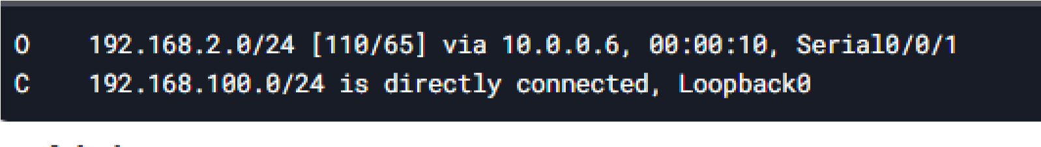

## Successful ping results

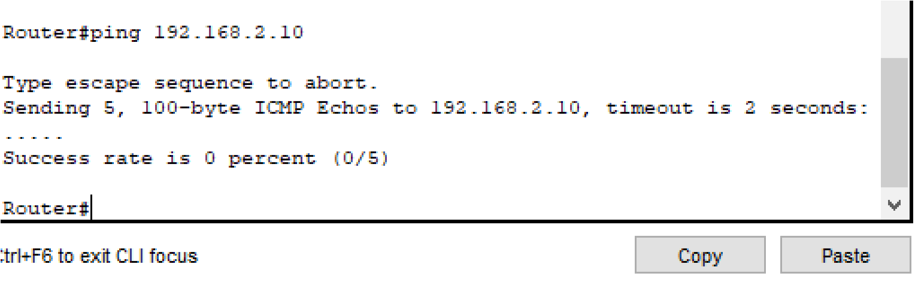

## **3.2 Network topology in Packet Tracer**

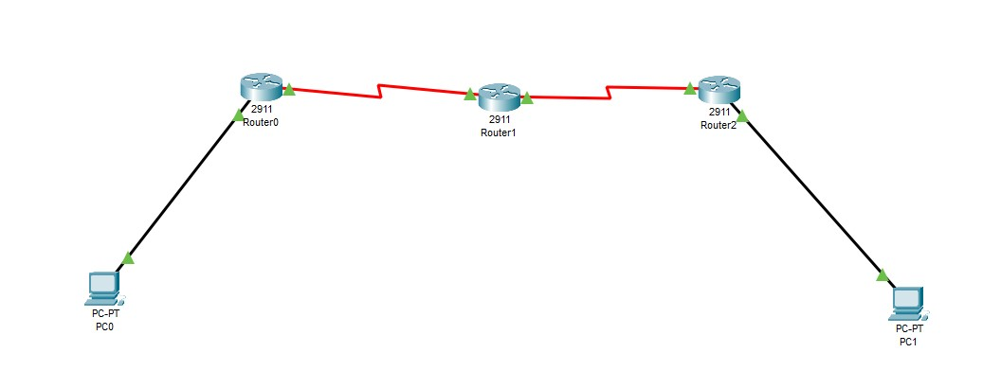

**Assign IP Address to routers**

#### **Step = 2 for router 1**

Router> activate Router# setup term   
Gigabit Ethernet0/0 Router(config)# interface

192.168.1.1 255.255.255.0

Router(config-if)# ipaddress#no shutdown   
# exit Router(config)

Router(config-if)Interface number: Serial0/2/0   
IP address of the router (config-if)# 10.0.0.1 255.255.255.252   
config-if# no shutdown for the router   
Routing 2 Router(config-if)# exit   
Router> activate

**Step No 2**

Router# configure terminal

Router(config)# interface Serial0/2/0

Router(config-if)# ip address 10.0.0.2

255.255.255.252

#### Router(config-if)# no shutdown

#### Router(config-if)# exit

#### Router(config)# interface Serial0/2/1

#### Router(config-if)# ip address 10.0.0.5

#### 255.255.255.252

#### Router(config-if)# no shutdown

#### Router(config-if)# exit

#### Router 3

#### Router> enable

#### Router# configure terminal

#### Router(config)# interface

#### GigabitEthernet0/0

#### Router(config-if)# ip address

#### 192.168.2.1 255.255.255.0

#### Router(config-if)# no shutdown

#### Router(config-if)# exit

#### Router(config)# interface Serial0/2/1

#### Router(config-if)# ip address 10.0.0.6

#### 255.255.255.252

#### Router(config-if)# no shutdown