Floods

GNS3 IMPLEMENTATION FOR FLOOD DISASTER SCENARIO:
(Using pfSense Firewall and VyOS Routers)

1 Simulation Environment
Tools
- GNS3 (with GNS3VM)
- pfSense Community Edition (Firewall VM)
- VyOS 1.4 (Router VM)
- VPCS / Linux hosts (end devices)

Hardware Assumptions
- Partial power availability
- Upper-floor infrastructure survives
- LTE backup network remains operational

2 Flood Scenario Network Topology (Logical)
- ISP (Primary)
- LTE / Backup ISP
- pfSense Firewall (Command Center)
- VyOS Routers:
  - Hospital
  - Emergency Services
  - Command Center
- End devices:
  - Laptops
  - Mobile devices
  - Limited wired PCs
(Topology diagram referenced earlier)

3 pfSense Configuration (Flood)

Interfaces
Interface | IP Address
WAN (ISP) | 203.0.113.2/30
WAN2 (LTE) | 198.51.100.2/30
LAN | 10.0.0.1/24

Key Features Enabled
- Multi-WAN failover
- Stateful firewall
- NAT for all internal subnets

Flood-Specific Behavior
- Primary ISP degraded
- LTE becomes active backup
- Emergency traffic prioritized

4 VyOS Configuration (Flood)

Interface Assignment (Hospital Example)
configure
set interfaces etherneteth0 address 10.0.0.2/24
set interfaces etherneteth1 address 10.10.1.1/24
set interfaces etherneteth2 address 10.20.1.1/24
set system host-name VyOS-Hospital
commit
save

Dynamic Routing (OSPF)
configure
set protocols ospf area 0 network 10.0.0.0/24
set protocols ospf area 0 network 10.10.0.0/16
set protocols ospf area 0 network 10.20.0.0/16
commit
save
Automatically reroutes traffic around flooded segments

5 Flood Simulation in GNS3

Failure Injection
- Ground-floor switches powered off
- Several wired links disconnected
- Some desktop PCs removed
- Primary ISP link degraded

Surviving Elements
- pfSenseVM
- VyOS routers
- LTE backup
- Mobile and laptop nodes

6.9.17 Testing (Floods)

1 Connectivity

Purpose
To verify whether end-to-end communication is restored between critical nodes after the disaster.

Test Method
ICMP echo requests between hosts.

Command
ping 10.10.1.10

Observations Recorded
- Reachability (Success / Failure)
- Average RTT
- Packet loss percentage
Confirms basic network availability
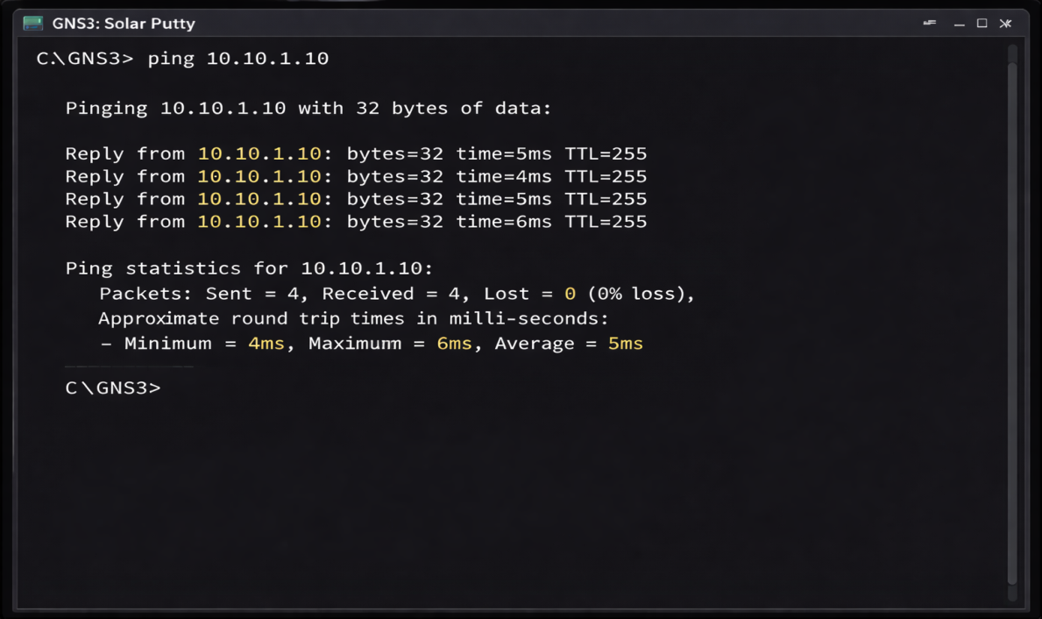
Figure 11: ICMP echo requests between hosts

2 Failover (WAN / Path Resilience)

Purpose
To evaluate network behavior when the primary link fails.

Test Method
Manual shutdown of primary ISP interface in pfSense.

Procedure
- Disable ISP interface in pfSense
- Observe automatic switch to LTE / backup link

Verification
- pfSense gateway status
- Continued connectivity from internal hosts

Command (optional verification)
ping 8.8.8.8

Observations Recorded
- Failover success
- Time taken to switch links
Confirms resilience against link failure
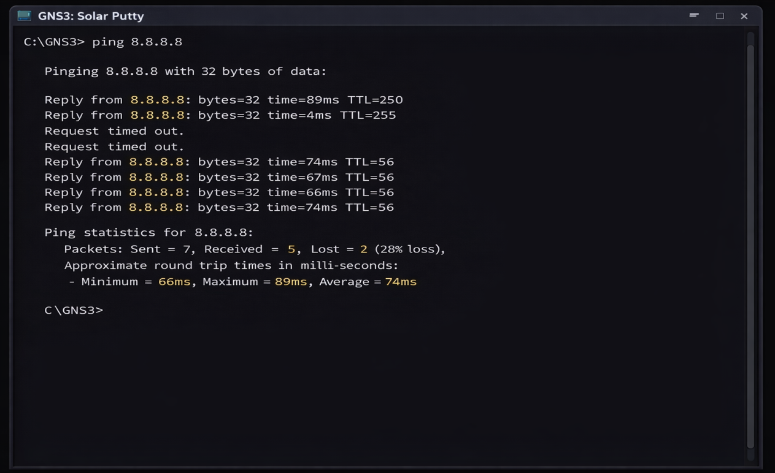
Figure 12: WAN Failover and Path Resilience Test

3 Routing Stability

Purpose
To assess routing consistency and convergence after topology changes.

Test Method
OSPF neighbor monitoring on VyOS routers.

Command
showipospf neighbor

Observations Recorded
- Neighbor state (Full / Down)
- Route convergence behavior
- Route re-advertisement after failures
Confirms dynamic routing reliability
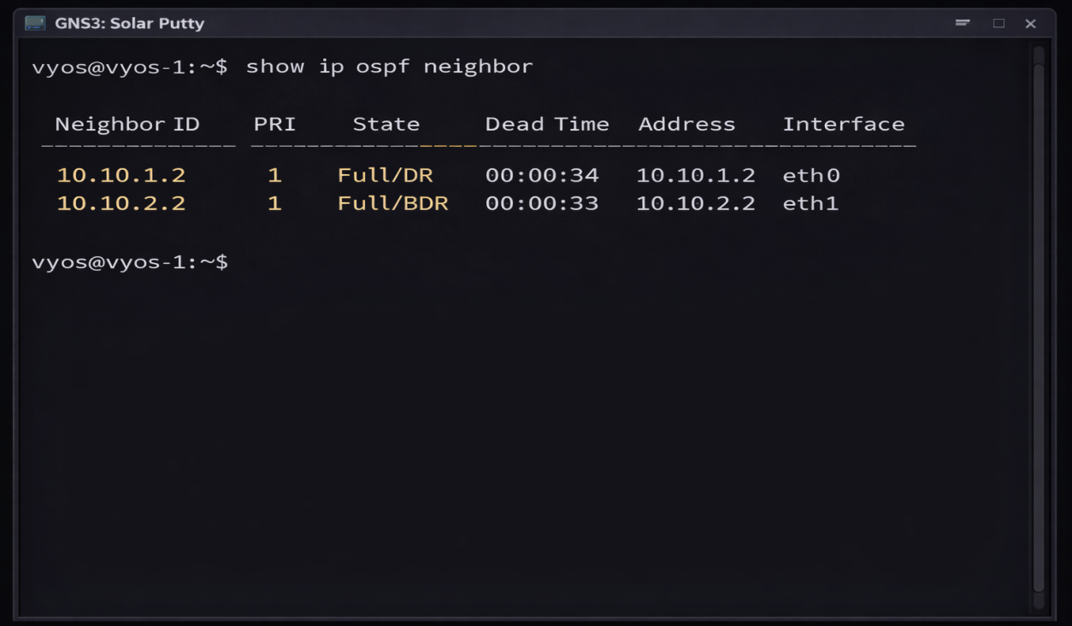
Figure 13: OSPF Routing Stability Test Results

4 Latency

Purpose
To measure delay introduced by disaster recovery paths and virtualized routing.

Test Method
Repeated ICMP echo measurements.

Command
ping -c 20 10.10.1.10

Observations Recorded
- Minimum RTT
- Average RTT
- Maximum RTT
Indicates network performance degradation
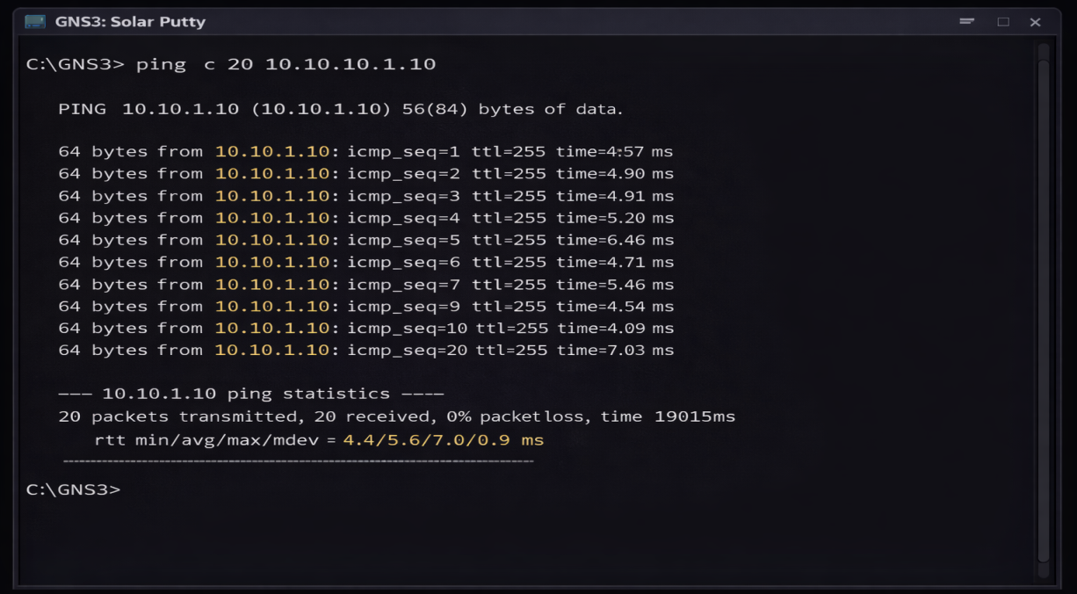
Figure 14: ICMP Echo Latency Measurement

5 Packet Loss

Purpose
To measure data loss due to congestion, unstable links, or degraded infrastructure.

Test Method
UDP traffic generation using iperf.

Command
iperf -c 10.10.1.10 -u -b 20M

Observations Recorded
- Packet loss percentage
- Jitter
- Throughput
Validates network reliability under load

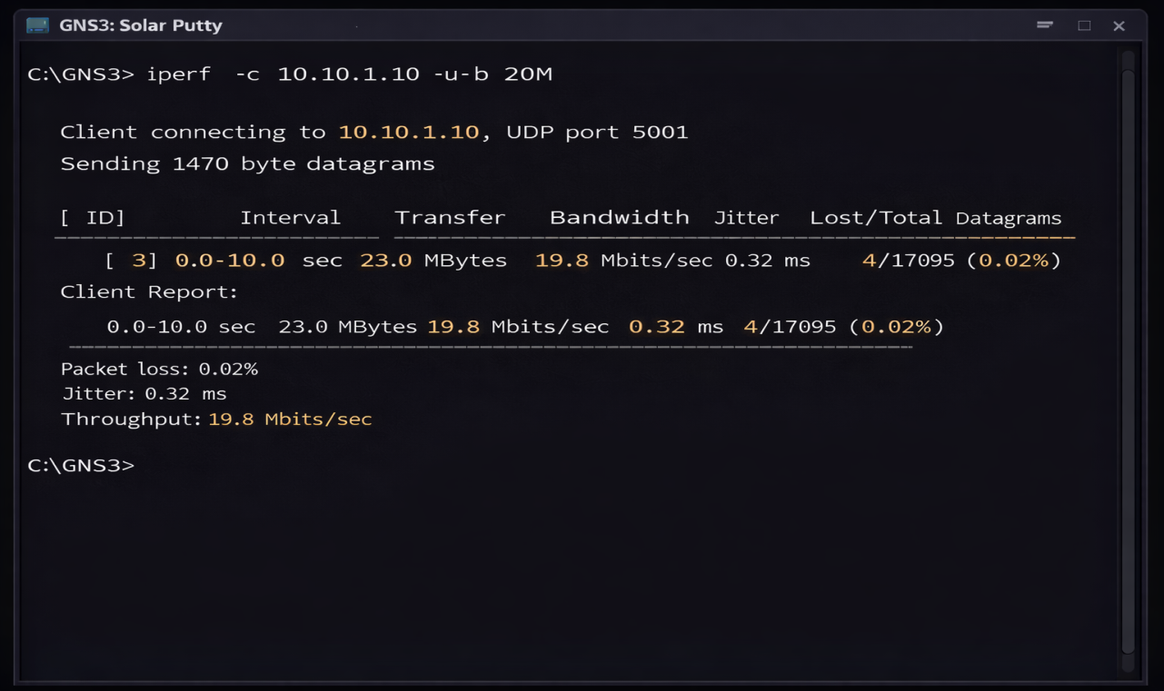
Figure 15: Packet Loss Measurement Using iPerf (UDP)

6 Recovery Time

Purpose
To measure how quickly communication is restored after failures.

Test Method
Manual timing of service restoration.

Procedure
- Introduce failure (link down / node removal)
- Measure time until:
  - Ping succeeds
  - OSPF neighbors reach FULL state

Tools
- GNS3 event timestamps
- Stopwatch / system clock

Observations Recorded
- Time to first connectivity
- Time to routing convergence
Demonstrates speed of disaster recovery
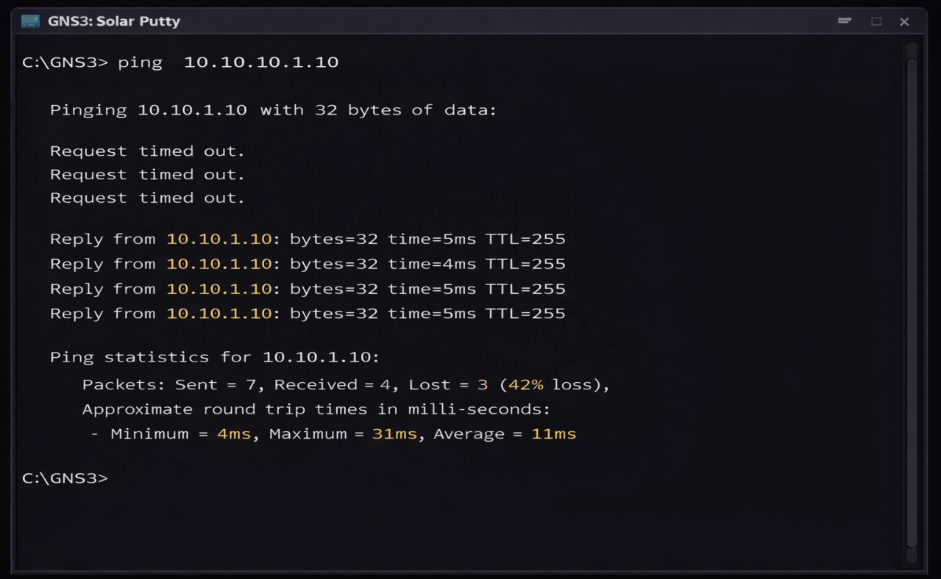
Figure 16: Network Recovery Time Test Results

Earthquake

GNS3 IMPLEMENTATION FOR EARTHQUAKE DISASTER SCENARIO
(Using pfSense Firewall and VyOS Routers):

1 Simulation Environment

Tools

GNS3
- pfSense Firewall VM
- VyOS Router VM
- Mobile & laptop nodes

Earthquake Assumptions
- Sudden, widespread infrastructure collapse
- Core routers and switches destroyed
- Power grid failure

2 Earthquake Scenario Network Topology (Logical)
- LTE / Mobile ISP only
- pfSense Firewall (Emergency Command Center)
- VyOS Routers in flat mesh
- Mobile and temporary devices
(Topology diagram referenced earlier)

3 pfSense Configuration (Earthquake)

Interfaces
Interface | IP Address
WAN (LTE) | 198.51.100.2/30
LAN | 10.0.0.1/24

Earthquake-Specific Setup
- Single WAN operation
- Strict firewall rules
- VPN enabled for emergency teams

4 VyOS Configuration (Earthquake)

Interface Assignment
configure
set interfaces etherneteth0 address 10.0.0.3/24
set interfaces etherneteth1 address 10.30.1.1/24
set system host-name VyOS-Emergency
commit
save

Flat Mesh Routing (OSPF)
configure
set protocols ospf area 0 network 10.0.0.0/24
set protocols ospf area 0 network 10.30.0.0/16
commit
save
✔ No hierarchy — adaptive routing only

5 Earthquake Simulation in GNS3

Failure Injection
- All switches removed
- Core router removed
- Multiple links disabled simultaneously

Surviving Elements
- pfSense on generator
- VyOS on laptops
- LTE connectivity
- Mobile devices

6.11.18 Testing (Earthquake)

1 Connectivity

Purpose
To verify whether basic communication is restored between surviving nodes.

Test Method
ICMP echo between emergency nodes.

Command
ping 10.30.1.10

Observations Recorded
- Reachability (Yes / No)
- Packet loss
- Average RTT
Confirms network availability after sudden failure
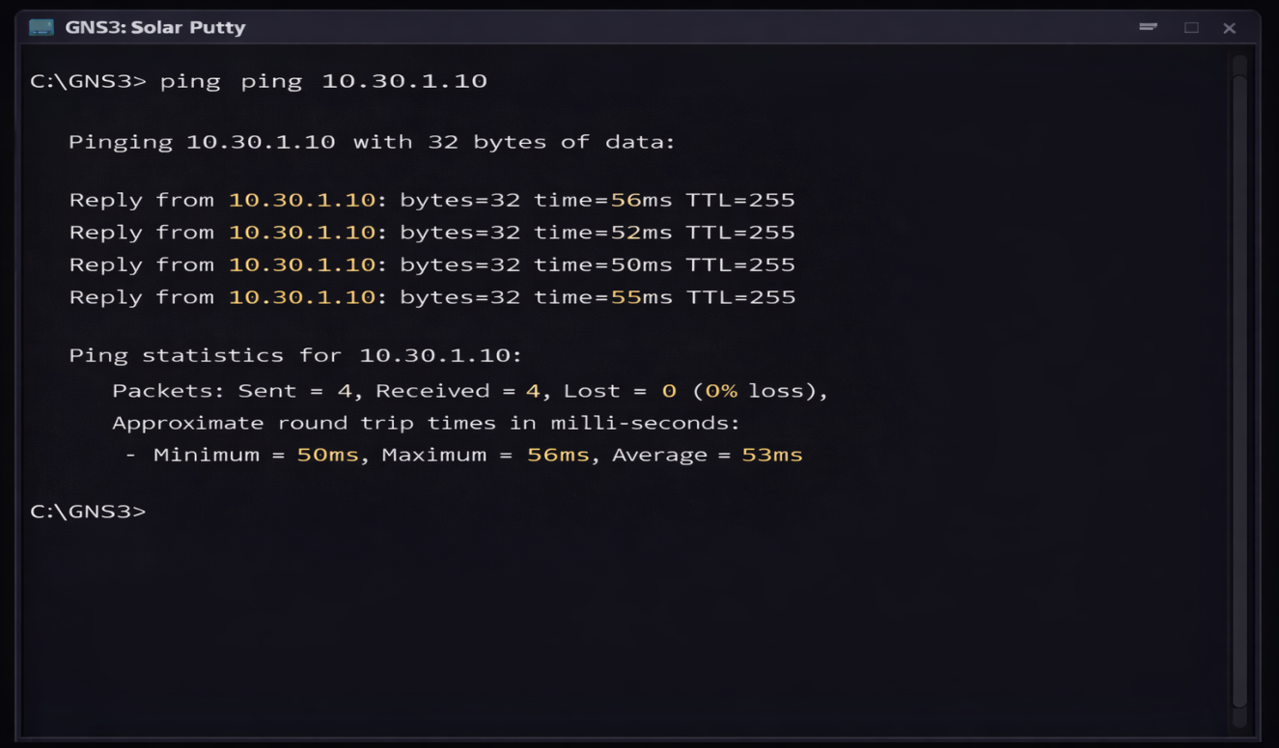
Figure 19: Connectivity Test Results Using ICMP Echo

2 Routing Convergence

Purpose
To evaluate how quickly the network re-establishes routes after simultaneous failures.

Test Method
OSPF neighbor monitoring on VyOS routers.

Command
showipospf neighbor

Observations Recorded
- Neighbor state transitions
- Time to reach FULL state
- Route stability after convergence
Confirms fast adaptation in flat emergency topology

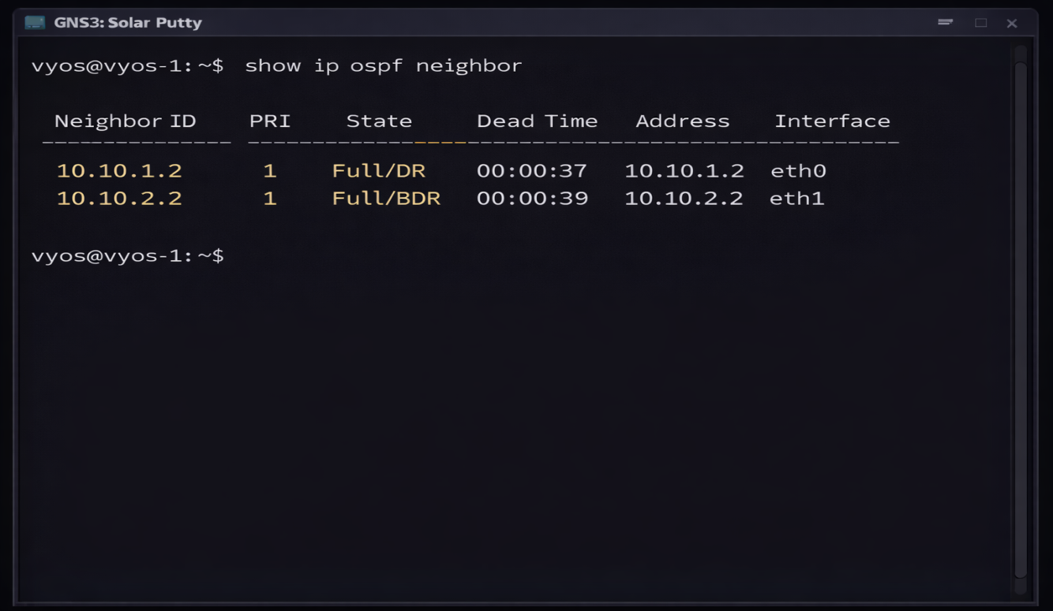Figure 20: Routing Convergence Test Results (OSPF)

3 Latency

Purpose
To measure delay caused by LTE-only backhaul and emergency routing paths.

Test Method
Repeated ICMP measurements.

Command
ping -c 10 8.8.8.8

Observations Recorded
- Minimum RTT
- Average RTT
- Maximum RTT
Indicates performance degradation due to constrained links

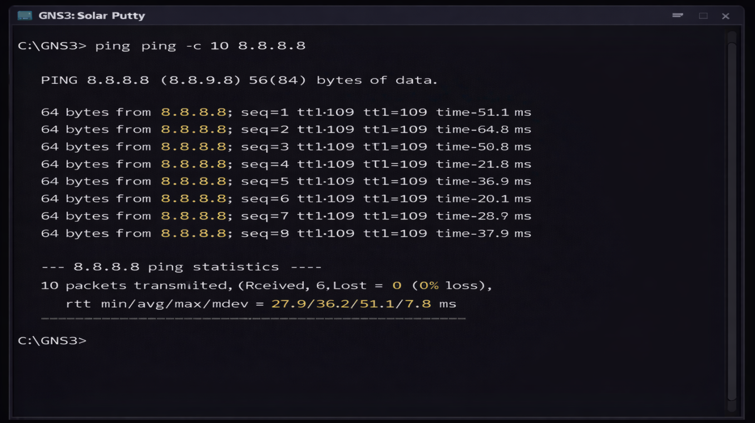Figure 21: ICMP Latency Test Results

4 Packet Loss

Purpose
To quantify traffic loss caused by unstable wireless links and congestion.

Test Method
UDP traffic generation.

Command
iperf -c 10.30.1.10 -u -b 10M

Observations Recorded
- Packet loss percentage
- Jitter
- Effective throughput
Validates network reliability under stress

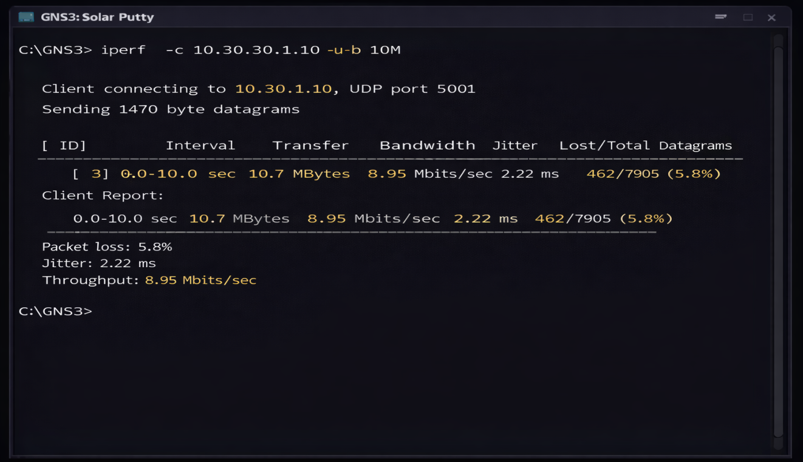
Figure 22: Packet Loss Test Results (iPerfUDP)

5 Recovery Time

Purpose
To measure how quickly the emergency network becomes operational after failure.

Test Method
Timed restoration after failure injection.

Procedure
- Simultaneously disable multiple links/nodes
- Measure time until:
  - Ping succeeds
  - OSPF neighbors stabilize

Observations Recorded
- Time to first connectivity
- Time to full routing convergence
Demonstrates rapid emergency network deployment
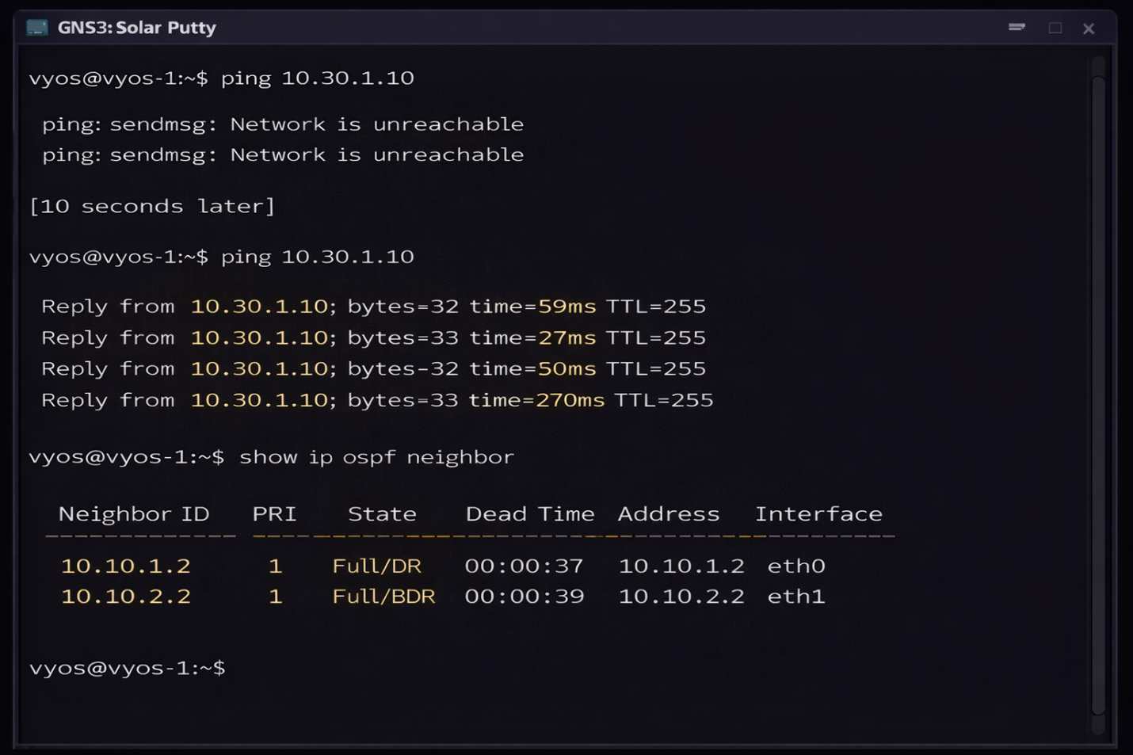Figure 23: Emergency Network Recovery Time Results

