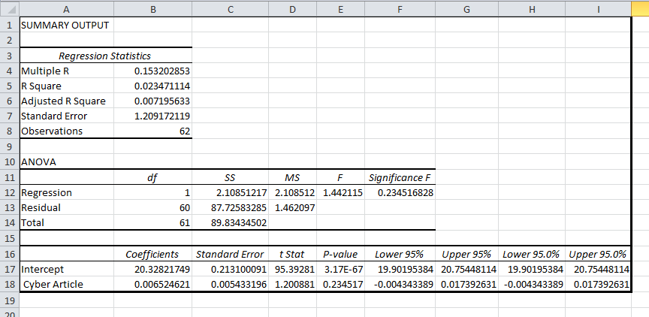

**Multiple R:** Square root of R-squared. It represents the correlation between the closing-price for each day within the selected time-frame. The value of 1 represents perfect linear relationship and 0 represents no correlation between the variables being tested.   
As we can see above, the multiple R value is 0.1532 which is very low and it is evident that the number of articles related to cyber security about Sony Pictures had no significant impact on the stock price of the company.  
**R Square:** This is the coefficient of determination, which essentially tells us how many points fall on the regression line. i.e. What percentage of data fits the model. As we can see, only 2.3% of the values fit the model. This makes it clear that number of cyber security related articles do not determine the stock price of a company.