

PrOJECT management

[Document subtitle]



November 20, 2019

Contents

1) Home Screen 2

2) Add Project 2

3) Project Validation 3

4) Add New Project 4

5) Sort Project 6

6) Update existing project 8

7) Add Task 9

8) Add Task Validation 10

9) Add new Task as Parent task 12

10) Add New task as Task 14

11) View Task Screen 15

12) Sort Task 16

13) Add User screen 18

14) Add New User 19

15) Sort User 21

16) Code Checked in to Github 22

# Home Screen

Description: This screen has following tabs

Add Project

Add Task

Add User

View Task

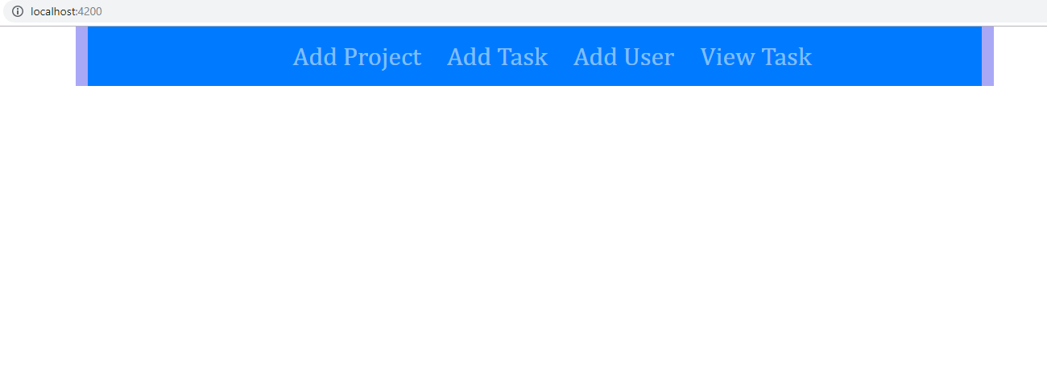

# Add Project

* After clicking on Add project tag, application will give options to add new Project as well as it will show existing projects

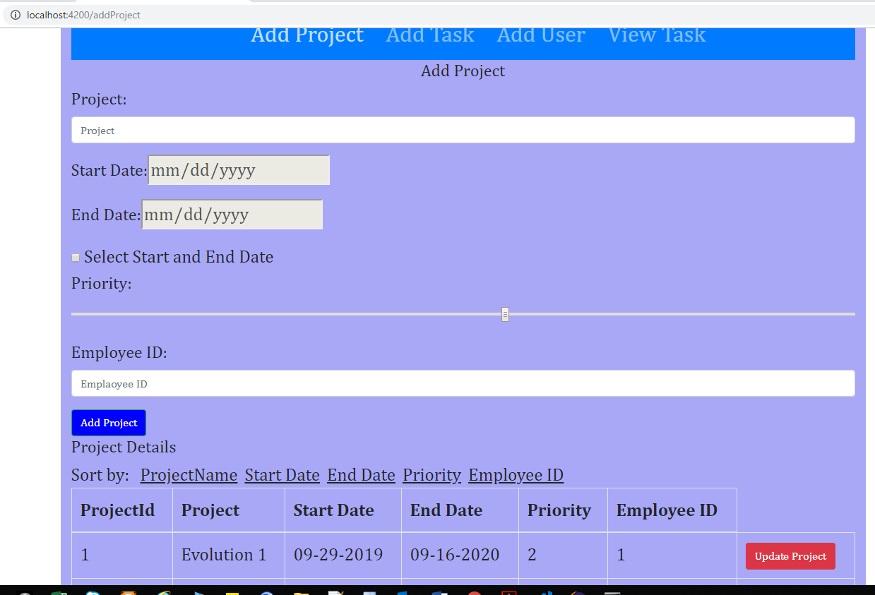

# Project Validation

* Provided Project Name
* Disabled Select start and End date option this makes Start Date and End date Disable
* Not provided Priority and Employee Id input
* Clicked on Add Project button

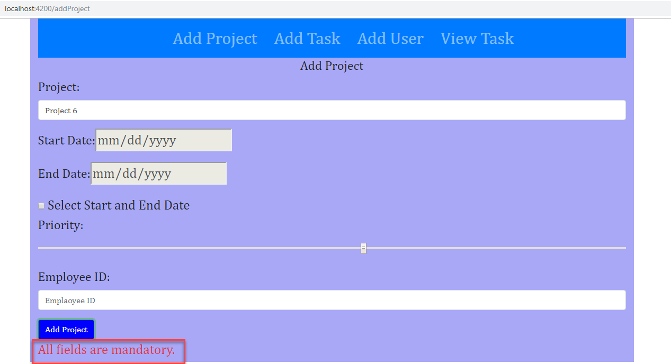

# Add New Project

* Provided all input
* Clicked on Add project button
* New project added successfully and displayed into existing project list

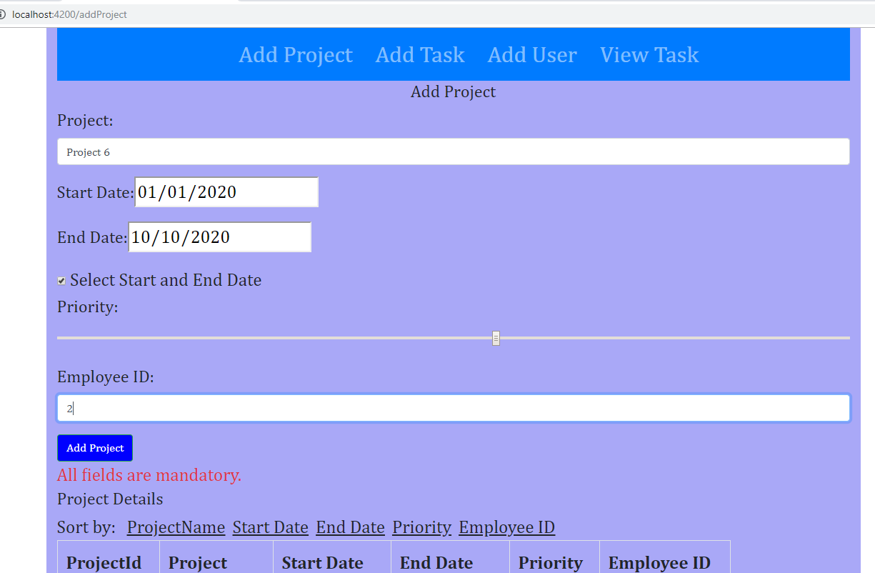

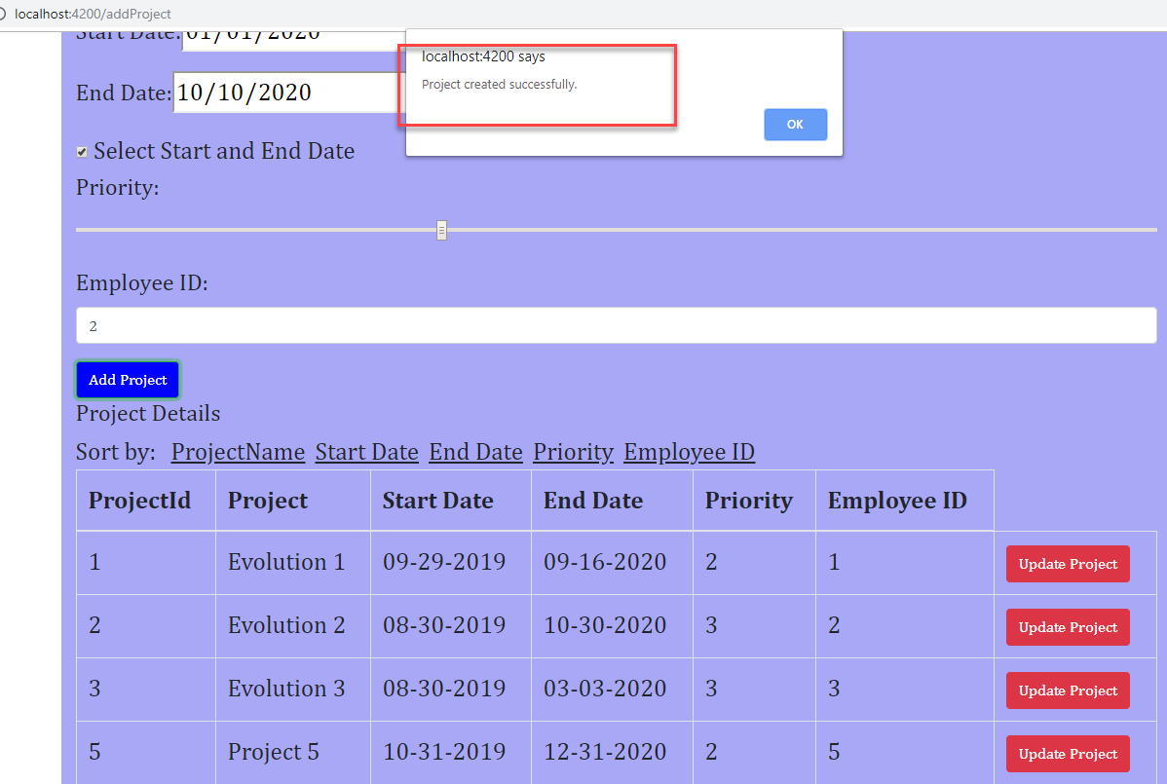

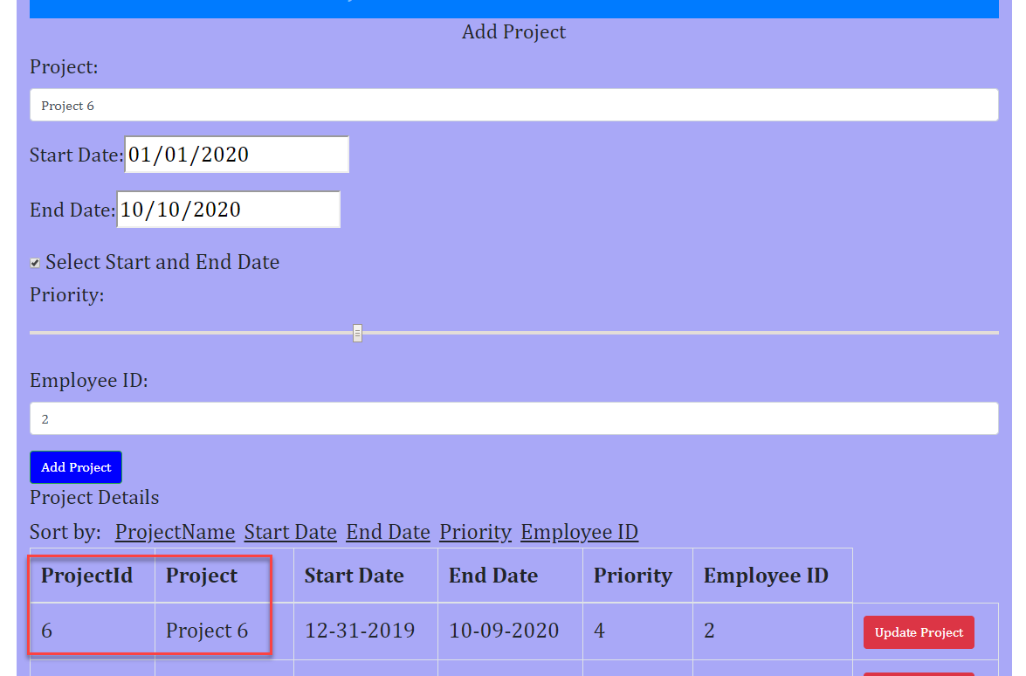

# Sort Project

* Sort by Project Name

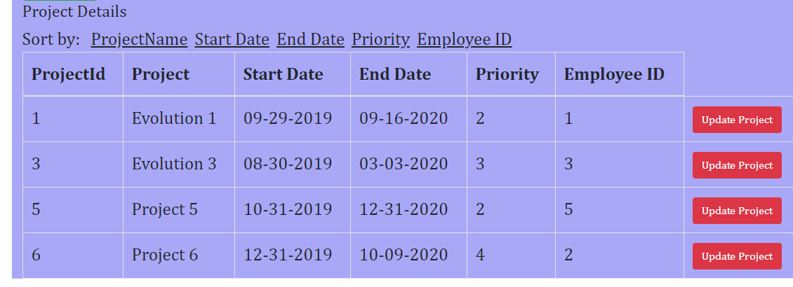

* Sort by Start date

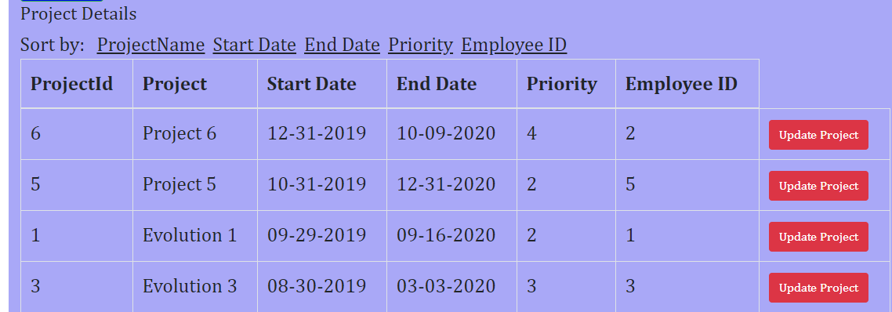

* Sot by End Date

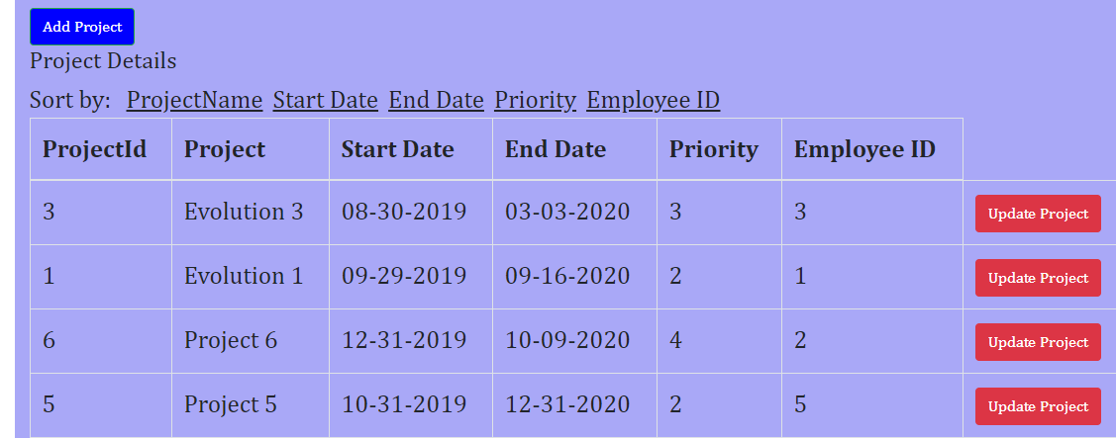

* Sort by Priority

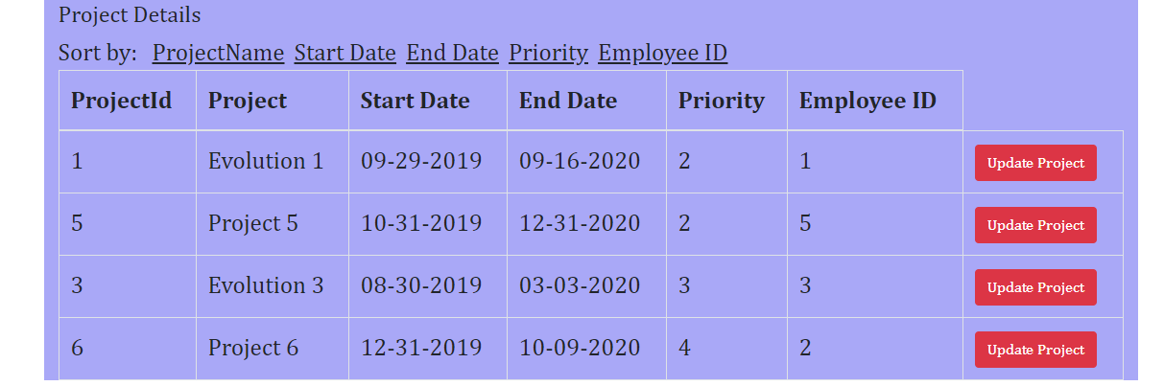

* Sort by Employee ID

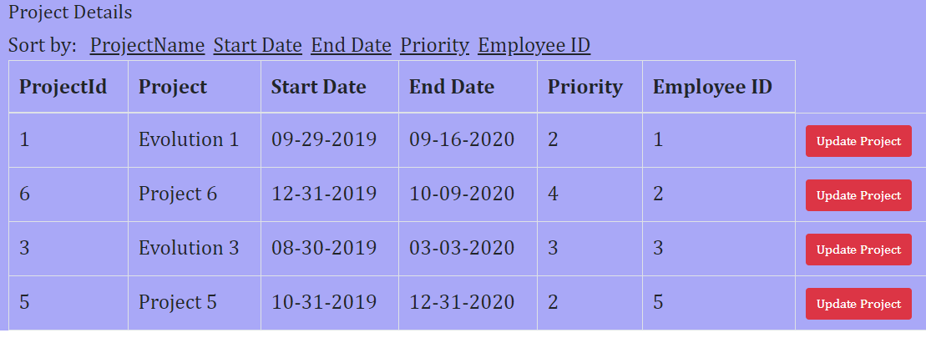

# Update existing project

* Select Evolution 1 project
* Click on Update Project
* Update details and click on Update project button
* Details will update in Project Details section

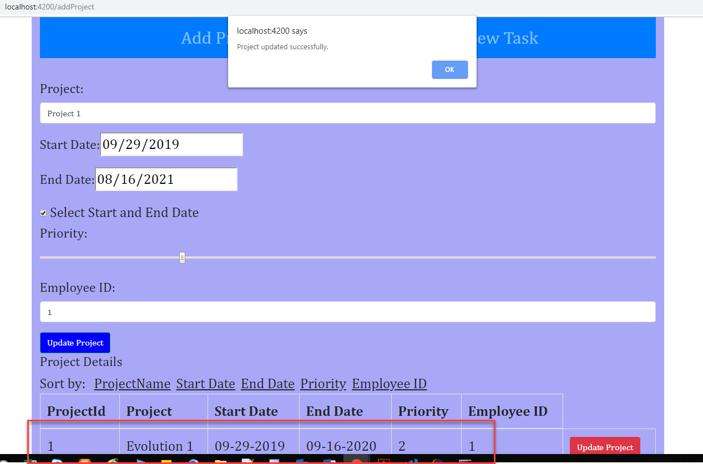

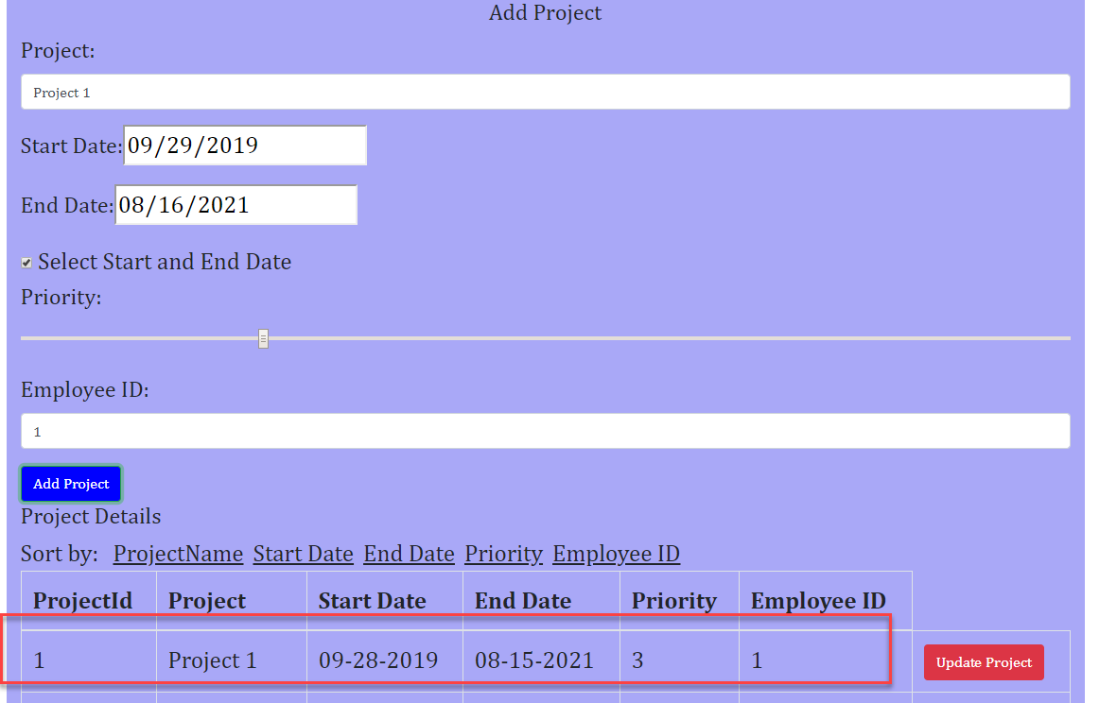

# Add Task

* Click on Add Task tab
* Application will show Add Task screen

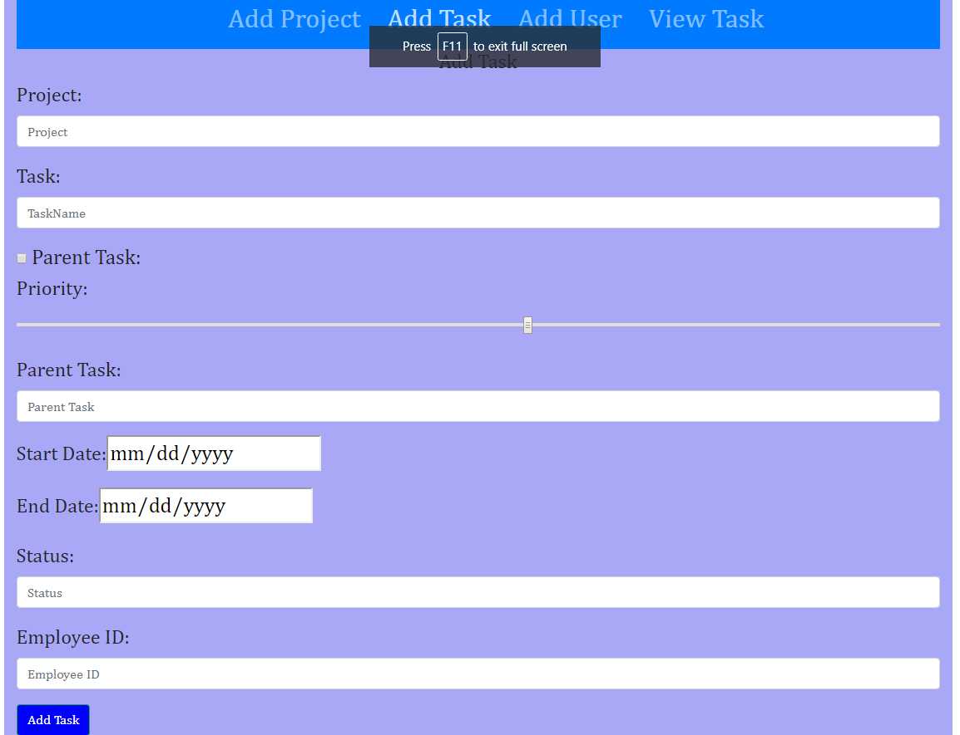

# Add Task Validation

* Click on “Parent Task” check box will disable all other fields

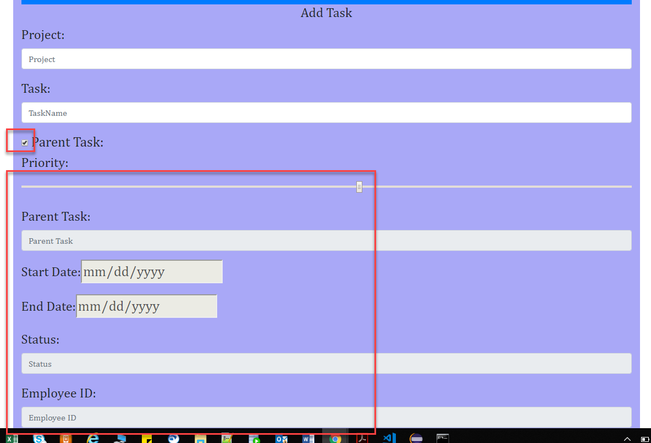

* Provided task details but other fields not provided. Application is providing validation error

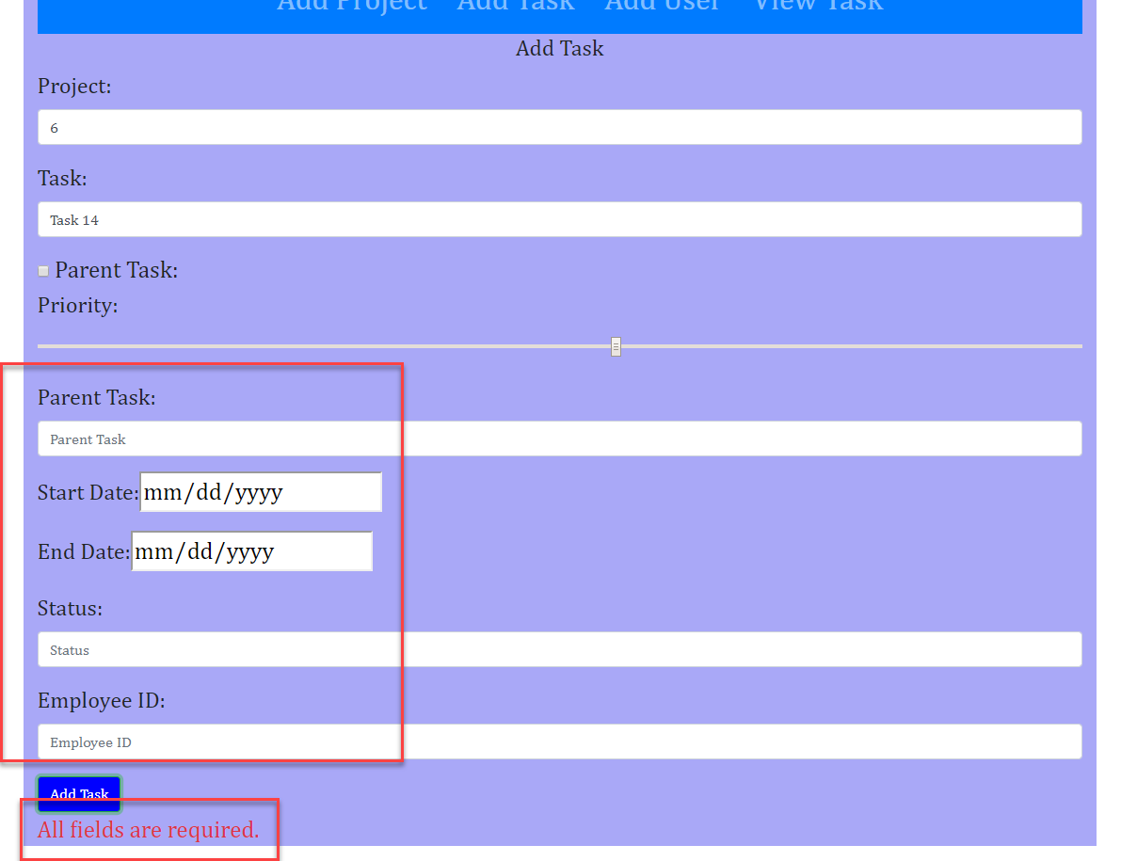

# Add new Task as Parent task

* Provided Parent task details

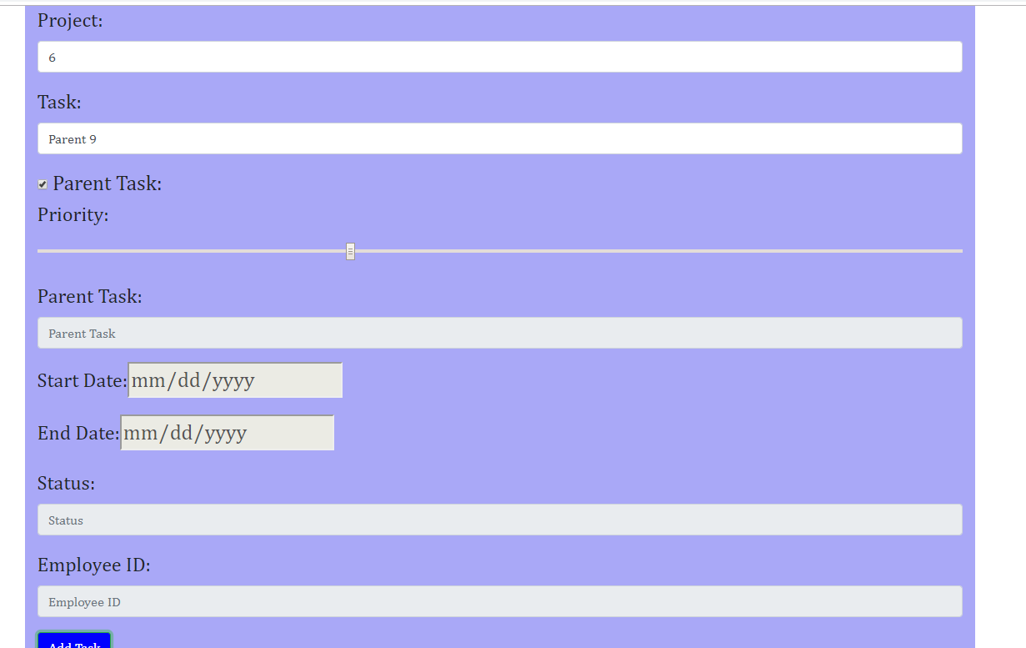

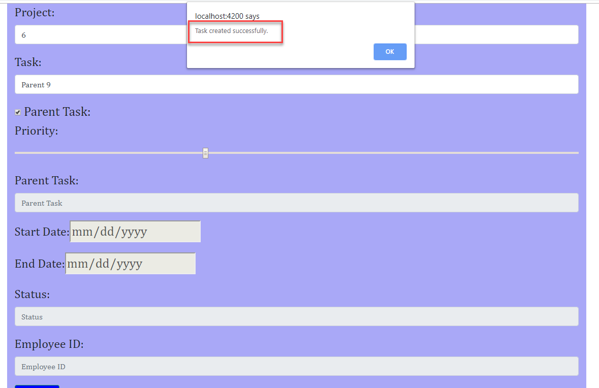

# Add New task as Task

* Provided new task details
* Provided Parent task 9 (previously added task)
* Click on Add Task button

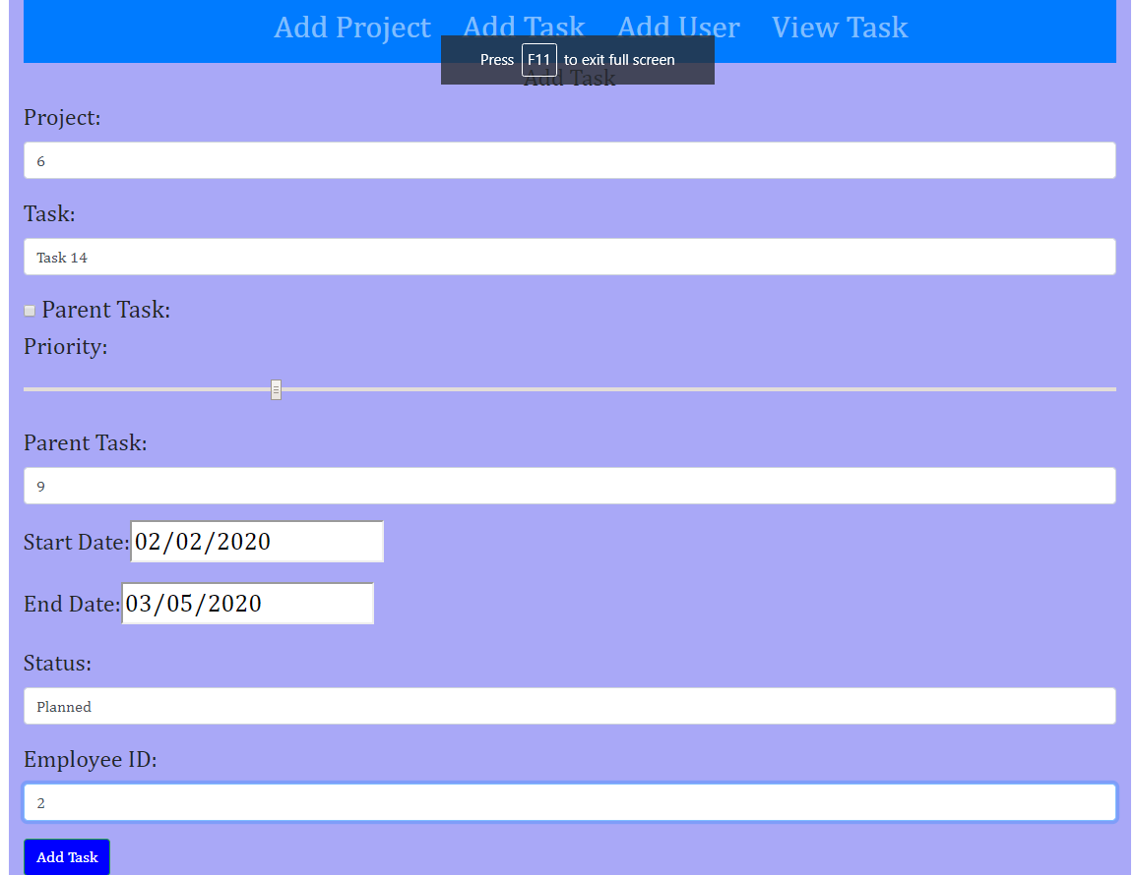

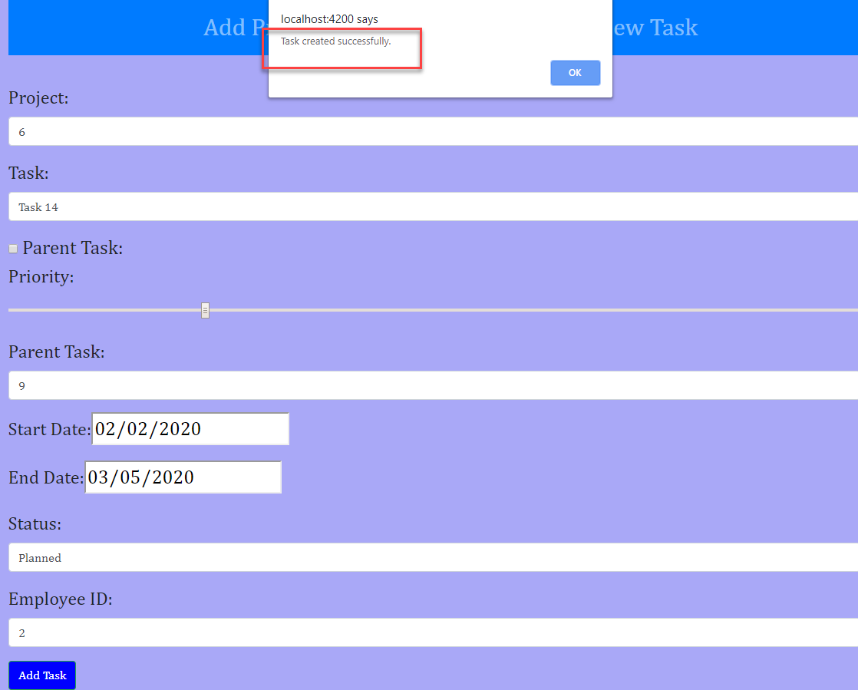

# View Task Screen

* Click on View Task Tab
* Application will display search option for Project Id
* Provide Project id as 6 (added in previous step 10) and click on Search
* Application will display task 14 added in step 10

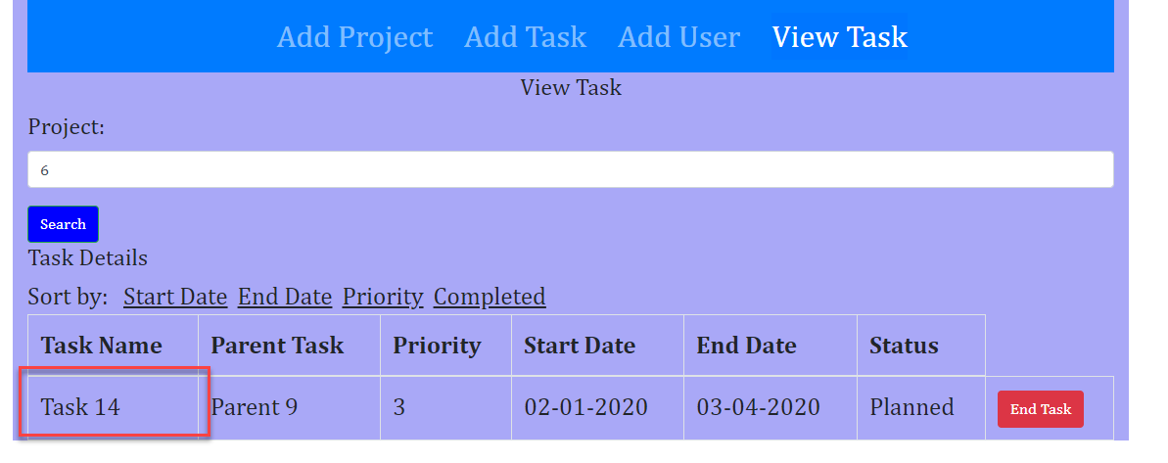

# Sort Task

* View all task related to project 2

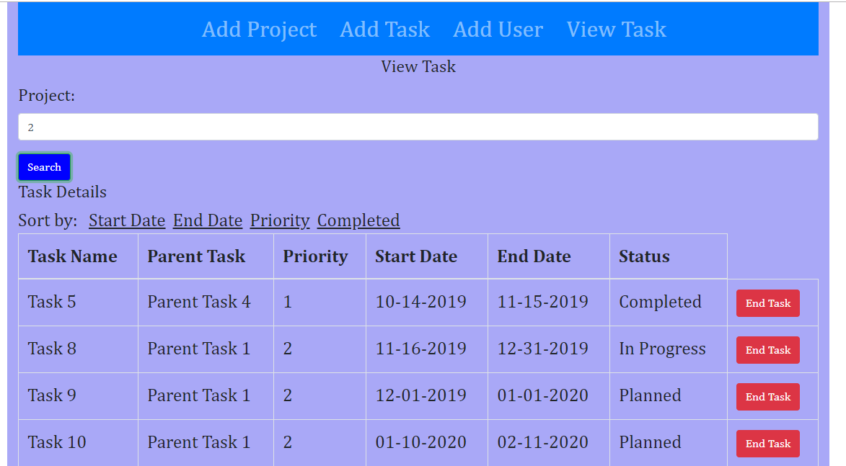

* Sort by Start date

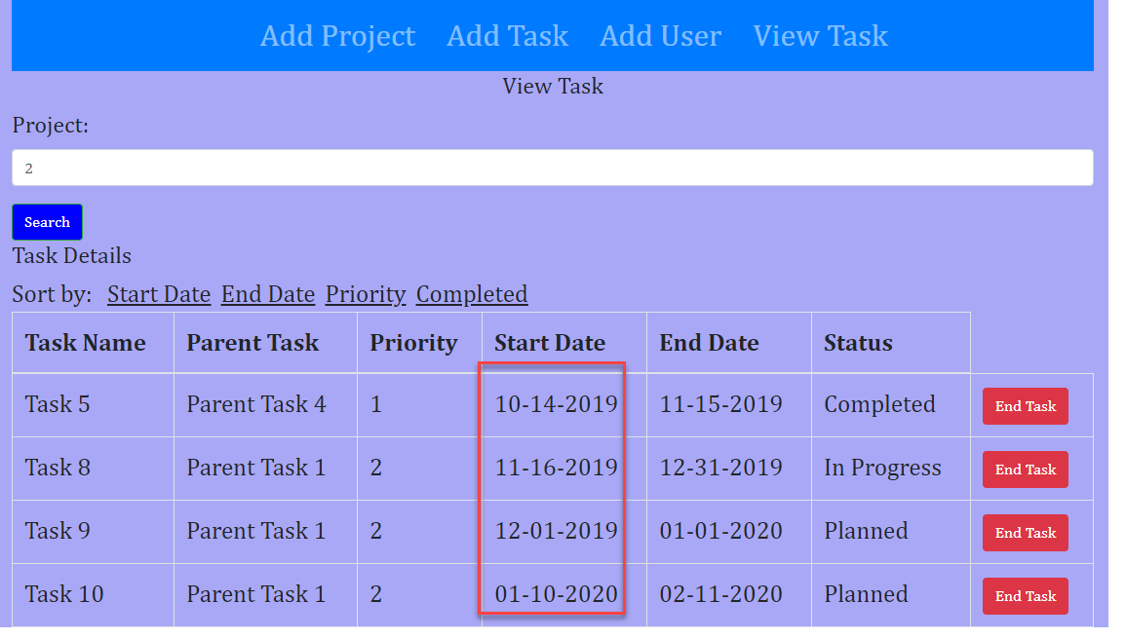

* Sort by End Date

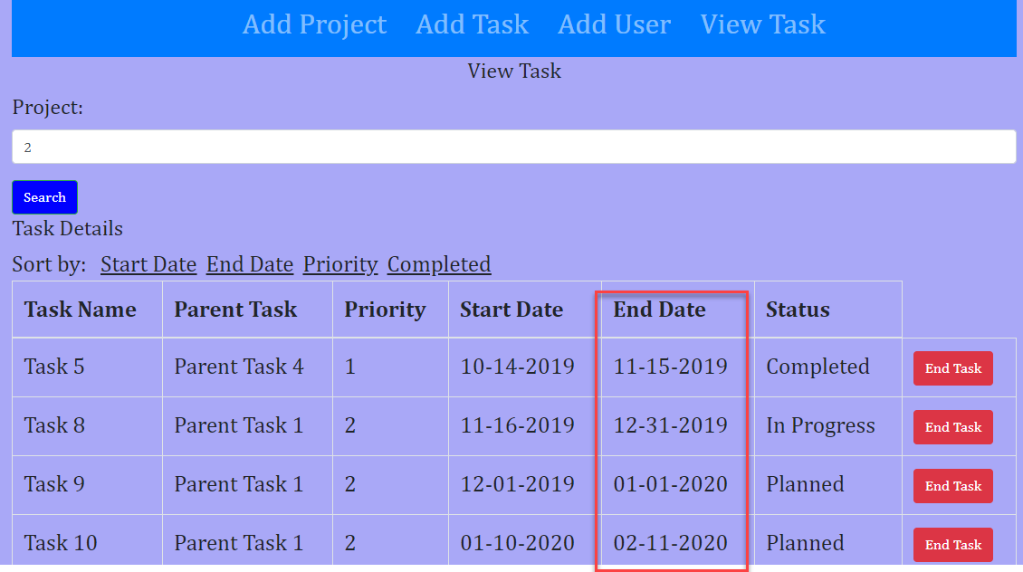

* Sort by priority

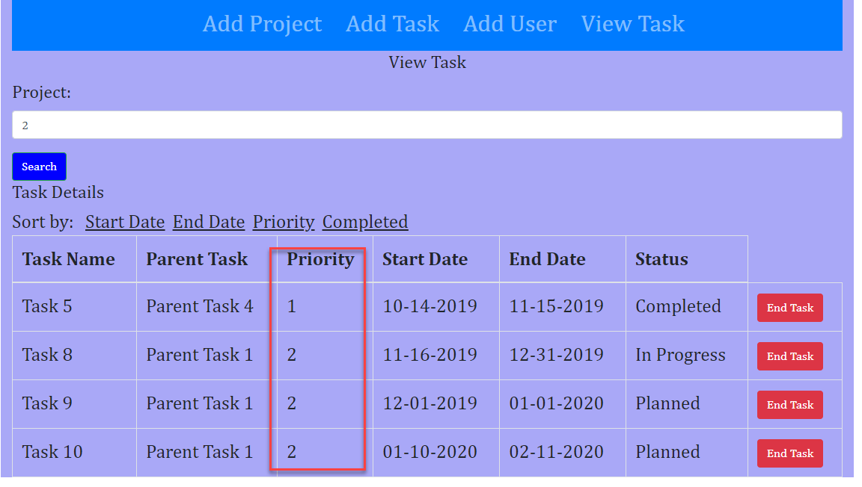

* Sort by Completed Status

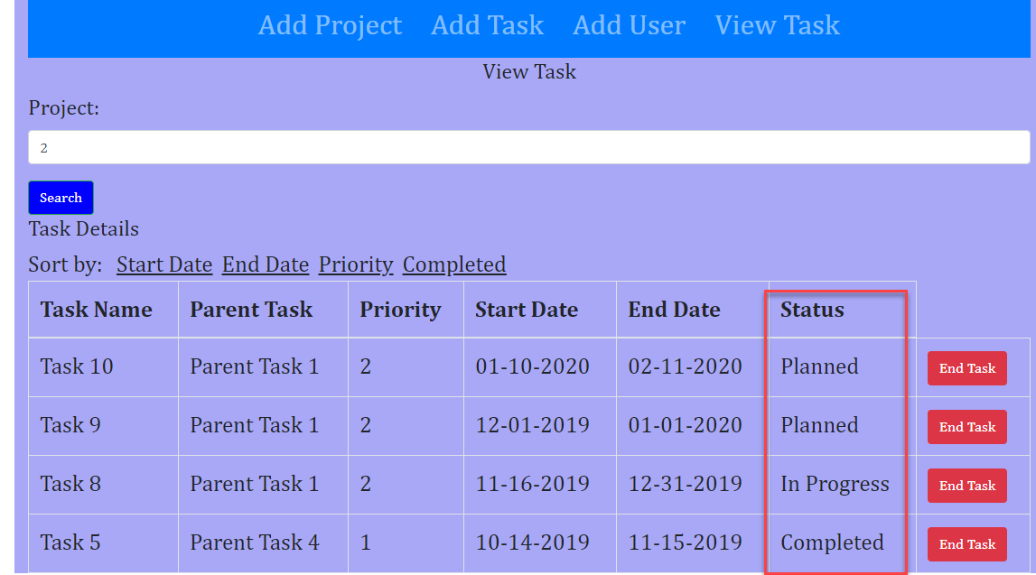

# Add User screen

* Click on “Add User” screen
* Application will open Add User screen
* Application will display all existing Users in User Details section

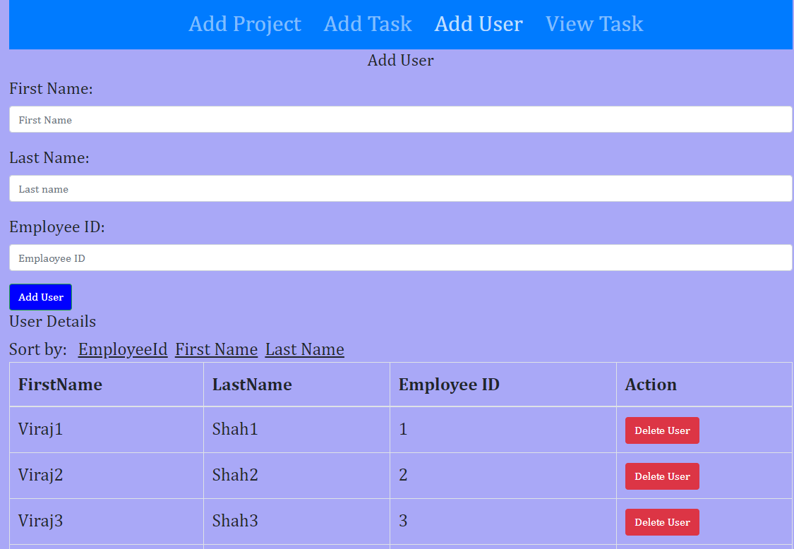

# Add New User

* Provide user details and click on “Add User” button
* Application will add new user successfully

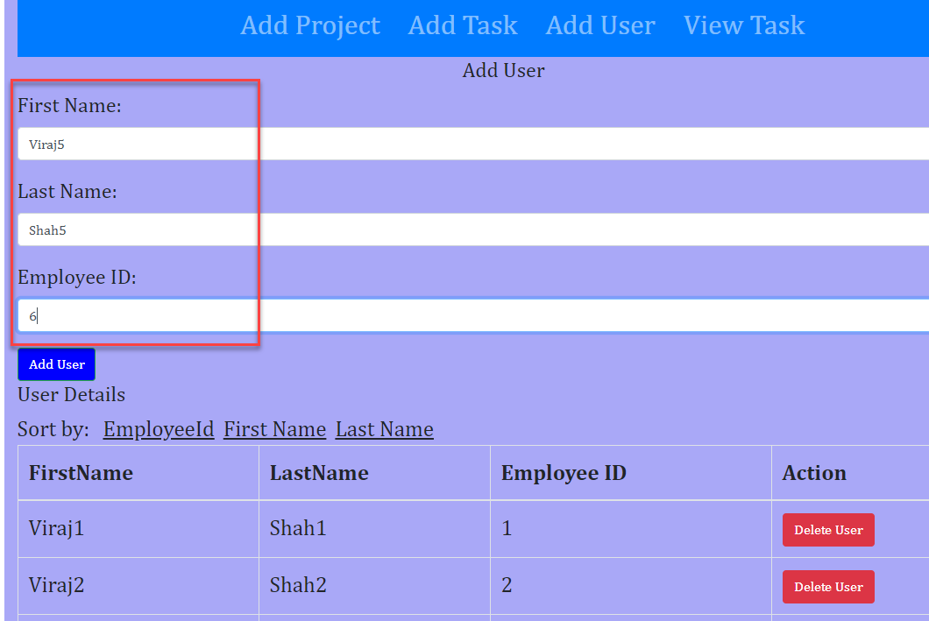

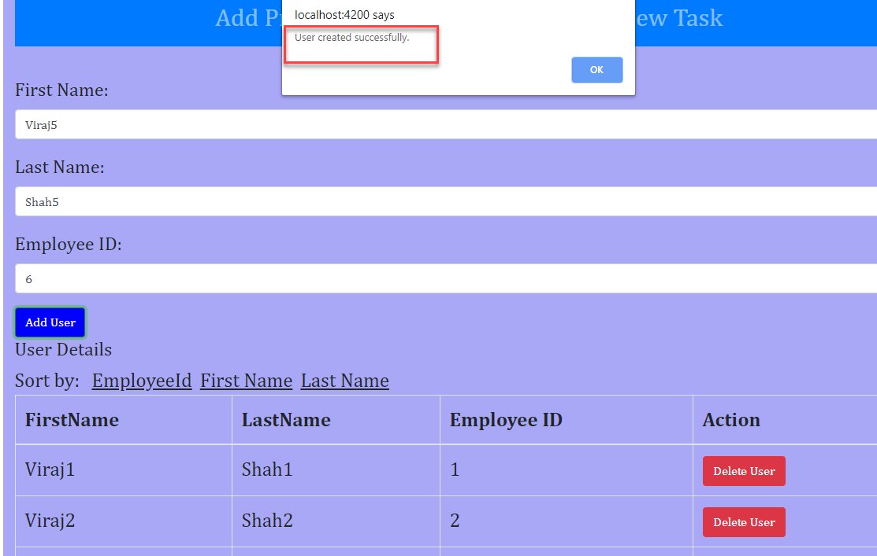

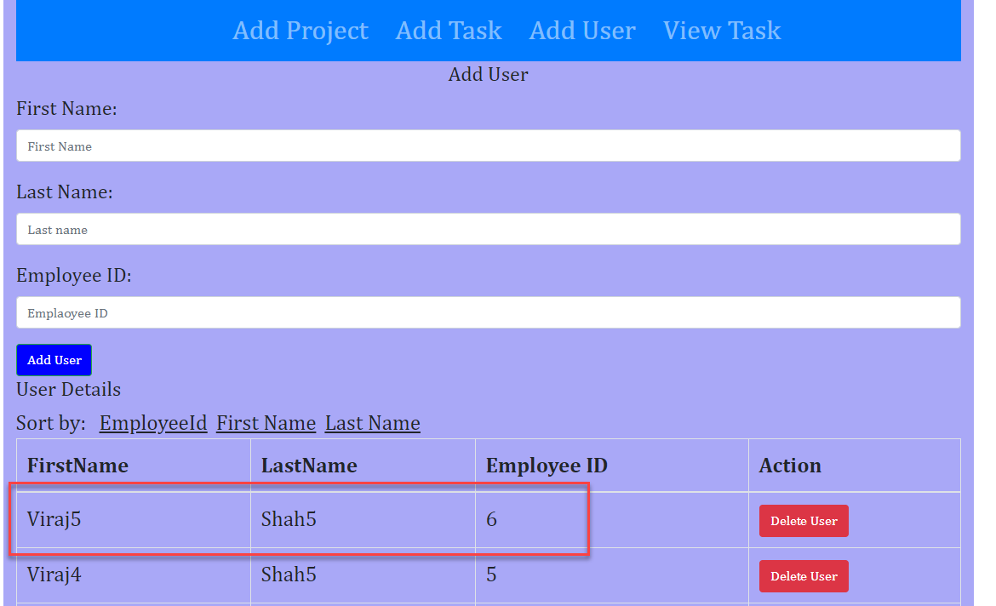

# Sort User

* Sort by Employee id

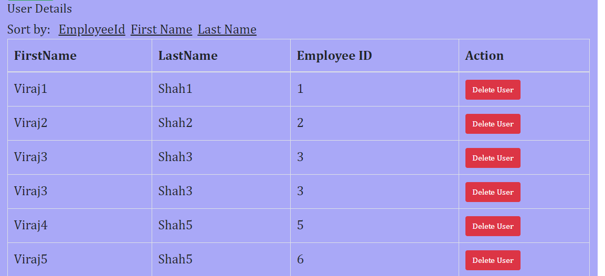

* Sort by First Name

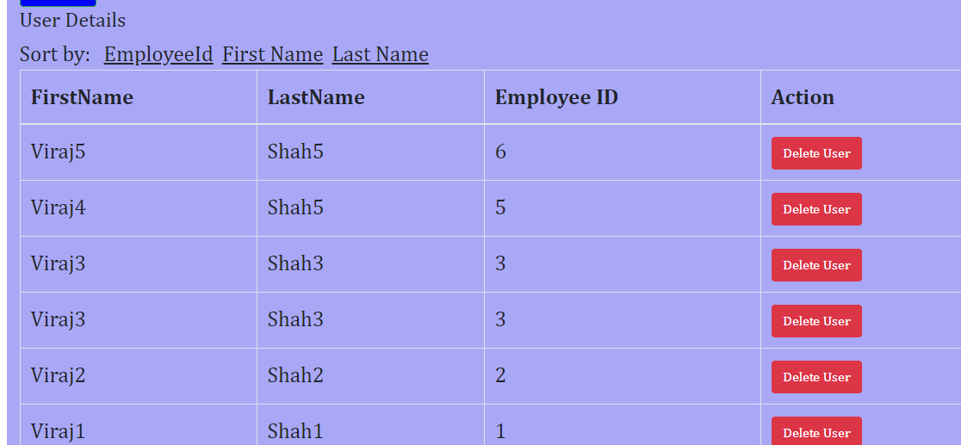

* Sort by Last Name

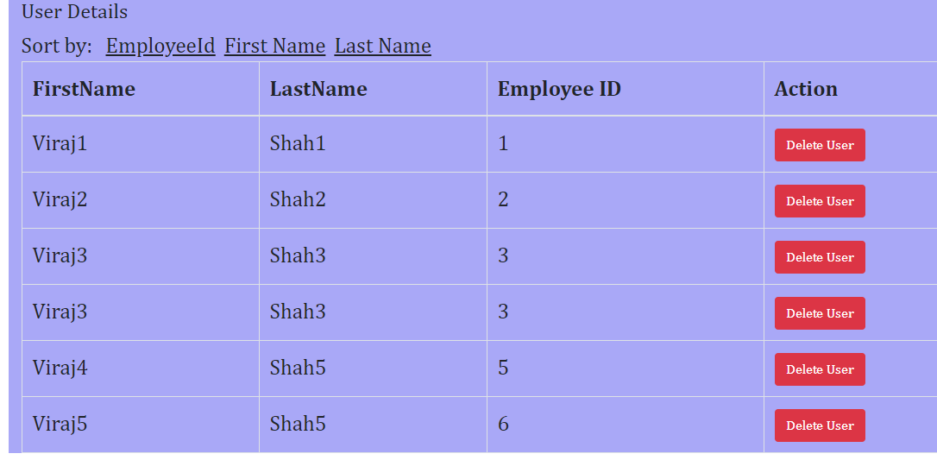

# Code Checked in to Github

<https://github.com/shahvic/ProjectManagement>

