**CSV Data Processor**

**Pre-requisites**

Dot Net framework 3.5

**How to Deploy**

1. Open “Command Prompt” with “Run as Administrator” rights
2. Use below command to install the service

SC Create “CSVDataProcessor” binPath=” Deployables\Bins\ CSVDataProcessor.exe”

1. Close command prompt window.
2. Open CSVDataProcessor.exe.Config and configure below highlighted parameters.

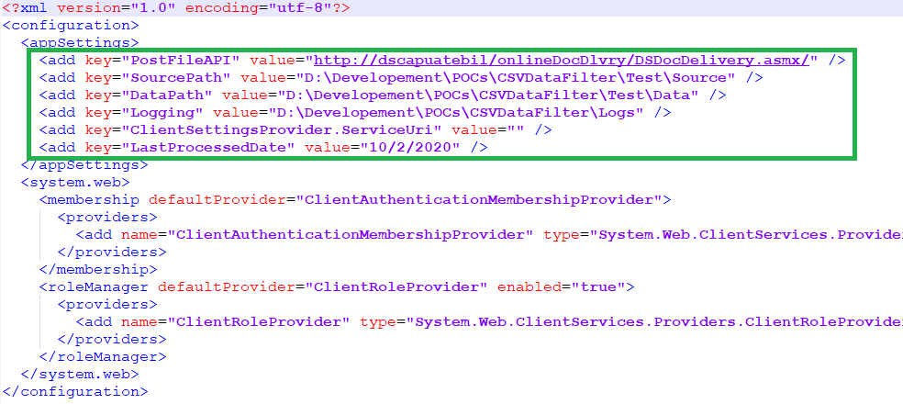

1. Go to Services and open properties of “CSVDataProcessor” service. Set startup type as ‘Automatic’.

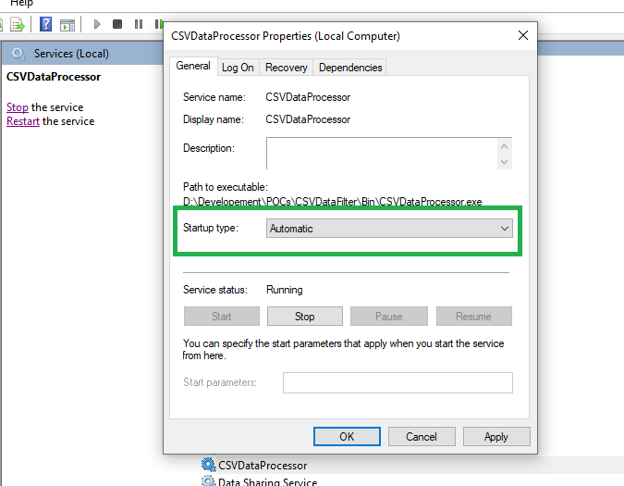

1. Start the service.