Backtesting & smoke testing framework
Architecture and design proposal for a multi-language algo strategy testing platform

Table of contents

1. Overview
This document proposes an architecture for a web application that backtests and smoke-tests trading algorithms, Expert Advisors (EAs), and Pine Script strategies against candle-level historic data, whether sourced offline or fetched online through code.
The core design challenge is not the backtest math itself — it is that Python/generic code, MQL4/5 EAs, and Pine Script have three different execution models. The proposal below standardizes on one internal engine and treats EA/Pine support as a translation problem, rather than attempting to natively execute three languages side by side.
Verdict: this is a sound and well-precedented idea (comparable in spirit to QuantConnect, Backtrader, and freqtrade). The multi-language support is the main source of risk and should be sequenced last, after the core Python-based pipeline is proven.

2. Architecture
The framework is organized as a linear pipeline with two parallel input tracks (strategy code and market data) that converge into a shared processing chain:
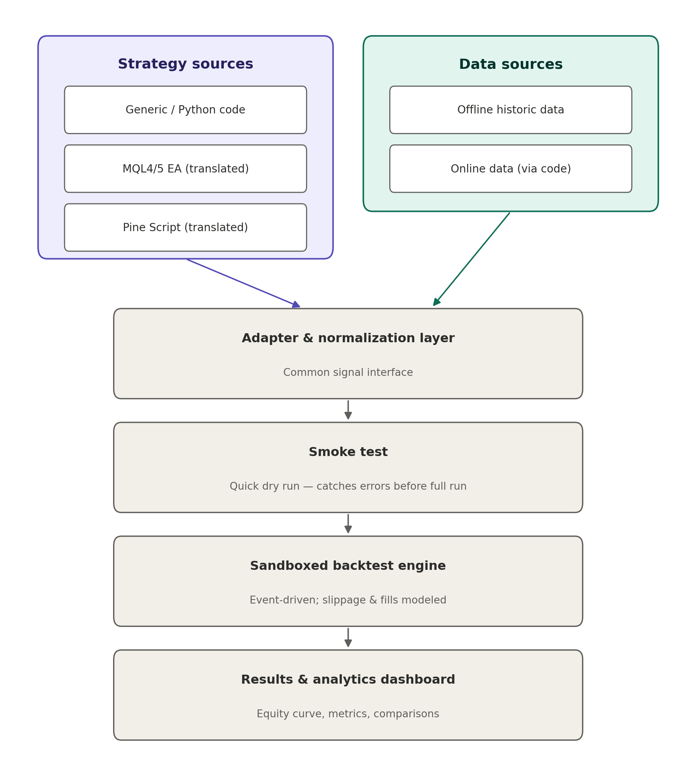
The table below summarizes each layer's purpose and the key design decision behind it.
Layer | Purpose | Key design decision
1. Data layer | Supplies normalized OHLCV candles from offline stores or online fetches. | One schema regardless of source; cache online fetches to avoid re-downloading.
2. Strategy sources | Accepts Python/generic code, MQL4/5 EAs, and Pine Script strategies. | Treat MQL and Pine as translation targets, not natively executed languages.
3. Adapter & normalization | Reduces every strategy to one common signal interface. | A single internal contract (bar + state -> orders/signals) is the linchpin of the whole system.
4. Smoke test | Fast, cheap sanity run before committing to a full backtest. | Small dataset, short timeout; catches crashes and lookahead bias early.
5. Sandboxed backtest engine | Runs the full, realistic simulation. | Event-driven (bar-by-bar), not vectorized; models fills, slippage, commission.
6. Results & analytics | Presents metrics, equity curves, and comparisons. | Standardized metric set so strategies and runs are comparable.

3. What can be tested here
Short answer: yes, in principle any algo trading application can be tested here, provided its decision logic can be expressed as “given this bar and this state, take this action.” That covers the overwhelming majority of retail and semi-professional algo strategies. The practical scope looks like this:

3.1 Directly supported
- Python / generic code strategies: run natively through a thin adapter — no translation risk.
- MQL4/5 Expert Advisors: supported via the EA adapter (headless terminal or validated translation, as described in Section 5).
- Pine Script strategies: supported via the Pine adapter (translated to Python/pandas and validated against TradingView's own output).

3.2 Supported with additional adapter work
Any other language or platform — for example NinjaScript, cAlgo/C#, or a proprietary in-house DSL — can be added later by writing one more adapter that maps its order/indicator calls onto the same common signal interface described in Section 5. The core engine, smoke test, and results layer do not need to change; only a new adapter is required. This is the main reason the common-interface design was chosen: it makes adding a new source language an additive change, not a rearchitecture.

3.3 Not a good fit as-is
- A full application with its own GUI, database, or live order-routing side effects — the framework tests the strategy's decision logic, not an entire piece of software with external integrations.
- Strategies that depend on data this framework doesn't model, such as order-book depth or news/sentiment feeds, unless those data sources are added to the data layer first.
- Strategies with non-deterministic or externally-stateful behavior (e.g. calls to a live external API mid-strategy) — these break the sandboxing and determinism guarantees described in Section 7.
In short: the framework is built to test strategy logic, in whatever language it's written, as long as that logic can be reduced to reading market data and emitting orders. Anything beyond that boundary (UI, live infrastructure, non-market data) would need to be stripped out or mocked before the strategy is handed to the framework.

4. Data layer
Responsible for supplying clean, normalized candle data to every downstream component, regardless of where it came from.

4.1 Offline data
- Storage: pre-downloaded candles held in a columnar store (Parquet/CSV) or a time-series database such as TimescaleDB or InfluxDB.
- Use case: fast, repeatable backtests and walk-forward runs without depending on external services.

4.2 Online data
- Adapters: pluggable connectors per broker/exchange/data-provider API, each mapped to the same internal schema.
- Caching: fetched data should be cached locally so repeated backtests do not re-fetch the same history.

4.3 Normalization
- Common schema: symbol, timeframe, timestamp, open, high, low, close, volume — identical regardless of source.
- Metadata: tick size, lot size, trading sessions, and timezone alignment must be reconciled here; this is a common source of subtle backtest errors.

4.4 MetaTrader 5 (MT5) data integration
Forex and MQL5 strategies are ultimately validated against MT5 itself, so their historical OHLCV data should be sourced directly from a running MT5 terminal rather than a third-party feed — this guarantees the backtest engine sees the same candles the EA would see live. This is scoped narrowly as a read-only historical data connector, not the EA-execution integration described in Section 5.3.
- Fetch: use the official MetaTrader5 Python package against a terminal installed and logged into a broker account on the host machine — pull historical rates (e.g. copy_rates_range) and map them into the same common OHLCV schema as Section 4.3, so the engine's data path doesn't change.
- Display: a lightweight inspection view (table summary or simple candle chart) to sanity-check fetched data before it's used in a backtest — a fetch-and-verify step, not the results dashboard in Section 8.
- Platform constraint: the MetaTrader5 Python package requires Windows and a locally installed terminal instance, unlike the platform-independent CSV/Parquet path — treat it as a Windows-only data source option, not a replacement for the offline loader.
- Scope boundary: this covers data only. Using MT5 to actually execute an EA and intercept its trade calls (Section 5.3, Option A) is separate, higher-risk work and stays on its original timeline — fetching candles and running arbitrary strategy code carry very different risk profiles.

5. Strategy sources and the adapter layer
This is the highest-leverage layer in the system: every downstream component (smoke test, backtest engine, results) only ever interacts with one common signal interface, never with the original Python, MQL, or Pine code directly.

5.1 The common interface
Define a minimal contract that every strategy must reduce to: given a bar (or window of bars) and current state (open positions, account equity, indicator values), return one or more of — open/close/modify order, position size, stop-loss/take-profit levels. This contract is what allows one backtest engine to serve three different source languages.

5.2 Python / generic code
Thinnest adapter: wraps the user's function or class so it exposes the standard bar-in, signal-out interface, and captures any custom indicators it defines.

5.3 MQL4/5 Expert Advisors
- Option A — native terminal: run the EA inside an actual MetaTrader terminal (headless, via Wine) and intercept its trade calls (e.g. OrderSend), translating them into the internal signal format. Highest fidelity, more infrastructure to maintain.
- Option B — static translation: translate MQL logic into Python once and run it natively. Faster to execute, but requires maintaining a translator and validating its output against real terminal behavior.
MT5 is also the data source described in Section 4.4 — that connection covers historical candle fetch only. Executing the EA itself and intercepting its trade calls (Option A/B above) remains separately scoped, later work.

5.4 Pine Script
There is no official standalone Pine runtime, so the adapter's job is translation: convert Pine's indicator and strategy calls into equivalent Python/pandas operations, then validate the translation against TradingView's own backtest output on reference strategies.

5.5 Cross-platform normalization details
- Indicator calculation conventions (e.g. moving-average warm-up behavior, Pine repainting)
- Time and session handling (broker server time vs. exchange time vs. bar-close time)
- Order semantics (e.g. Pine's strategy.entry vs. MQL's OrderSend fill timing)

5.6 Validation approach
Maintain a small “golden set” of reference strategies, one per language, with known-correct backtest results. Re-validate the adapter against this set whenever translation logic changes — fidelity gaps here silently bias every backtest run downstream, even if the engine itself is perfectly built.

5.7 Submission format: multi-file projects and manifests
Real strategies rarely live in a single file — a Python strategy commonly spans a strategy file plus helper modules (indicators, risk rules, config). Rather than forcing everything into one file, the tool should accept a whole project (folder upload, zip, or a git repo URL) alongside a small manifest file at the project root that declares how to run it.
- entry_point: which file and which class/function implements the strategy interface (e.g. strategy.py, class MyStrategy)
- language: python / mql / pine
- dependencies: a requirements.txt-style list of packages the code needs
- parameters: any configurable strategy inputs (lookback period, risk %, etc.), optional
The manifest is metadata, not logic — conceptually the same idea as package.json in a Node project or a Dockerfile's CMD line: it tells the tool where to start and what the code needs, without the tool having to guess which file is “the strategy” among several. The whole project is loaded into the sandbox, but only the declared entry point is executed; it can still import the other files normally, exactly as it would running locally.
Two follow-on considerations this creates: dependency installation is a security surface, so an initial allowlist of vetted packages is safer than open pip access until isolation is well-tested; and each submitted project (code + manifest + resolved dependency versions) should be stored as one immutable version, so any backtest result can be traced back to the exact code that produced it. MQL/Pine submissions are simpler here, since they are typically single-file by convention — the manifest there is just the file and the language, with no entry-point ambiguity to resolve.

6. Smoke testing
A fast, cheap gate that runs before a strategy is queued for a full backtest.
- Syntax / parse validation of the translated strategy
- Short dry run on a small dataset (a day or two of candles) to catch crashes and obvious errors
- Basic lookahead-bias checks (e.g. does the strategy reference future bars)
- Resource and time limits enforced even at this stage
This should complete in seconds, so it can run synchronously in the UI before a longer backtest job is queued.

7. Sandboxed backtest engine

7.1 Sandboxing (isolation)
- Each submission runs in its own container or lightweight VM, never in the same process as the web app
- Hard resource caps: CPU time, memory, wall-clock timeout, no network access unless explicitly whitelisted
- No filesystem access outside a scratch directory; kill-and-discard on timeout or crash
- One job = one container instance, torn down after the run — no shared state between runs

7.2 Simulation mechanics
- Event-driven replay: bar-by-bar, not vectorized — preserves the state carried between bars (open positions, trailing stops, indicator lookbacks) that vectorized math can silently violate via lookahead bias.
- Order model: market/limit/stop orders, partial fills, and a configurable fill-timing rule (e.g. fill at next bar's open, not the signal bar's close). Position sizing (quantity per order) starts fixed during initial development and testing, with dynamic sizing (risk %, account-based) added once the core execution logic is verified — this keeps quantity out of the correctness checks while fill timing and cost modeling are being proven.
- Cost model: spread, commission, and slippage (fixed, percentage, or volatility-scaled) — without these, most strategies look artificially profitable.
- Position and account state: margin, leverage, multiple concurrent positions if allowed, and bar-by-bar equity tracking so intraday drawdown is computed correctly.
- Determinism: identical inputs must always produce identical outputs; log the exact data version and code version used for each run.
This is the most compute-heavy, highest-risk component in the system (arbitrary code plus real resource limits). It is usually worth adopting an existing container-orchestration pattern — a job queue feeding short-lived Docker or Firecracker sandboxes — rather than building sandboxing from scratch.

7.2a Forex-specific account mechanics
The cost/account model in 7.2 covers spread, commission, and slippage; forex specifically needs a few more mechanics modeled explicitly rather than left out silently.
- Swap/rollover: overnight financing charged or credited when a position is held across the broker's daily rollover boundary — model as a pluggable, time-dependent cost function alongside commission/slippage, not a flat per-trade cost.
- Margin and margin calls: track margin usage against account equity explicitly; a margin call (forced position closure when the margin level breaches a threshold) needs to be a modeled account-state rule, not an implicit assumption that positions always stay open until the strategy closes them.
- Weekend/session gaps: forex markets close over the weekend, so the data layer must represent that as no bars (not synthetic flat bars), and the gap between Friday's close and Monday's open can jump past both a stop-loss and a take-profit without either being reachable via the intrabar-path assumption in 7.3 — that assumption only resolves ambiguity within a bar, not a gap between bars, and needs a separate, explicit rule (e.g. fill at the gap-open price, not the stale stop/target level).
- Sequencing: scope this right after the MT5 connector (Section 4.4) rather than the initial engine build — MT5 is what will actually supply realistic forex data with real weekend gaps and swap rates to validate against.

7.3 Intrabar price path and tick-data replay
A single OHLC bar does not record the order prices occurred in. If a bar's range reaches both an open position's stop-loss and its take-profit, an OHLC-only engine cannot know which was hit first without an explicit assumption — this is a real, well-known limitation, and it is why MetaTrader's own tester offers an “every tick” mode as its most trusted setting.
- Intrabar path assumption (default, all languages): the engine walks a configurable assumed path through the bar (e.g. open→high→low→close or open→low→high→close) and closes the position at whichever level it reaches first. A pessimistic default — always resolving in the direction less favorable to the position — is the safer choice, since it never overstates a strategy's performance.
- True tick-data replay (future, MQL/generic-code only): removes the ambiguity entirely by replaying actual price ticks instead of assuming a path. This only ever adds value for MQL and Python/generic strategies — Pine Script executes on bar close only and has no concept of ticks, so tick replay can never apply to it. Scope this as a later enhancement, added only once the OHLC-based engine and its adapters are already trusted, not as part of the initial build.

8. Results and analytics
Where the framework's value becomes visible to the user — this layer should not be an afterthought even if the execution layer starts simple.
- Standard metrics: Sharpe ratio, Sortino ratio, max drawdown, win rate, profit factor, expectancy
- Equity curve and trade-by-trade log
- Side-by-side comparison across strategies and parameter sets
- Support for walk-forward and parameter-sweep runs, not just single backtests — this is where overfitting typically surfaces

8.1 Walk-forward and parameter-sweep methodology
Both build on the same single-run engine from Section 7 — orchestration only, no engine changes.
- Walk-forward: split the data into rolling in-sample/out-of-sample windows (e.g. train on N months, test on the next M months, slide forward); run the engine once per split and report metrics per split, not just pooled — a strategy that only performs on the pooled average is a red flag for overfitting.
- Parameter sweep: run the engine once per parameter combination (grid or random search) over the strategy's declared parameters (Section 5.7's manifest parameters field) and collect one results row per run for side-by-side comparison.
- Both are read-only consumers of the single-run engine and results schema — they don't require changes to the core interface or engine, only a runner that calls it repeatedly and aggregates output.

8.2 Results persistence
Every run's output (metrics, equity curve, trade log) needs to be stored somewhere durable enough to support the comparisons in this section, tagged with the exact code and data version that produced it (Section 7.2's determinism requirement) — without that, “compare this run to last week's” isn't answerable.
- Phase 1: flat JSON files (the Section 11 CLI's output schema) written to a results directory, one file per run, named by timestamp + strategy + data version — no DB needed for a single-user script.
- Phase 2: a results table in the same database as strategy custody (Section 9), keyed by strategy version + data version + parameters, so runs are queryable and comparable without re-running the backtest.

9. Designed for scale
Since the goal is many strategies and eventually a larger audience (potentially license-based access), a few decisions are worth locking in from the start rather than retrofitting later:
- Multi-tenancy from day one: per-job sandboxing (already required for security) also isolates different users' code from each other — build it once, get both benefits.
- Golden-set validation matters more, not less: with outside users, a translator bug erodes trust fast — they can't tell “my strategy is bad” from “your translator misrepresented my strategy.”
- Usage metering from the start: tag every backtest job with user ID, compute time, and job count immediately, even before billing exists — adding metering after the fact usually means an expensive tracking migration.
- Strategy code custody: decide early whether submitted strategies are private-per-user or ever shared/reused; this affects storage design and is hard to change once users have uploaded proprietary logic.
This suggests opening a closed beta to real outside users after the core Python path and multi-tenant isolation are working — before EA/Pine support exists — to get product feedback before investing in the hardest translation work.

10. Development difficulty and effort estimate
Difficulty varies sharply across the layers in this document:

10.1 Easy to moderate (weeks, small team or solo)
- Data layer: schema, offline storage, online fetch adapters
- Python-native strategy adapter (thin wrapper)
- Event-driven backtest engine with cost/slippage models — well-documented territory, with open-source references (Backtrader, backtesting.py) available to study
- Results/analytics dashboard — mostly UI plus standard formulas
- Smoke test gate, once the engine exists
- MT5 historical data connector — thin wrapper around the official MetaTrader5 Python package (Windows-only, requires a local terminal)

10.2 Moderate to hard (months, real engineering time)
- Sandboxing untrusted code safely at scale — not conceptually hard, but easy to get subtly wrong under load or malicious input
- Multi-tenant architecture, metering, per-user isolation — standard SaaS engineering, but genuine work
- MQL4/5 adapter — headless MetaTrader-via-Wine is fiddly infrastructure; translation-to-Python is more upfront work but pays off long-term

10.3 Hardest part of the project
Pine Script translation. There is no official standalone Pine runtime, so this means reverse-engineering TradingView's execution semantics (repainting behavior, strategy.entry fill timing, indicator warm-up quirks) closely enough that a translated strategy's backtest matches TradingView's own numbers — and re-validating as TradingView's Pine behavior evolves over time.
Rough realism check: a working Python-only version (core engine, smoke test, dashboard) is a solid few-months project for one to two experienced engineers. Adding validated MQL and Pine support well enough to trust for outside users realistically adds several more months each, mostly due to validation work rather than the initial translator.

11. Recommended build approach
Build and validate the engine as a plain Python library/script first, proven on known strategies, before wrapping any of it in a web app or sandbox — a full-stack app hides bugs that are obvious in a script.

11.1 Phase 1 — prove the core loop (pure Python, no web app yet)
- Data layer: offline loader (CSV/Parquet to normalized OHLCV) plus a narrow, read-only MT5 historical-fetch connector (Section 4.4) — forex/MQL5 testing depends on it, so it's pulled into this phase; general online fetching from other broker/exchange APIs still comes later
- Strategy interface contract: a fixed on_bar(bar, state) -> orders shape, written as code before anything else, and treated as fixed once written
- Minimal backtest engine: bar-by-bar loop, positions, equity tracking, run against one hardcoded well-known strategy (e.g. moving-average crossover) with hand-calculable expected trades
- Cost/order realism: slippage, commission, fill-timing rules added to the same engine
- Metrics: Sharpe, drawdown, equity curve, trade log, printed/plotted from a script
- Smoke test: a function that runs the strategy on a tiny data slice and flags crashes or obvious lookahead bias

11.2 Phase 2 — wrap it
- Minimal web UI: upload strategy, pick a date range, run, view results — a thin wrapper around the Phase 1 library
- Sandboxing/isolation, added before letting anyone but the builder run code through it
- MQL adapter, then Pine adapter — last, each validated against a golden set before being trusted

11.3 Working module-by-module with Claude Code
- One task/session per module above — don't let it jump ahead to the web app while the engine is still unverified
- Give it the strategy interface contract early and treat it as fixed; later modules should conform to it, not redefine it
- Ask for a couple of known-answer test strategies before building each module, so there is something concrete to check output against
- Ask it to write tests alongside each module, so a later module can't silently break an earlier one without a test catching it

12. Summary and recommendation
The overall idea — a web-based backtesting and smoke-testing platform spanning multiple strategy languages — is sound and has strong precedent. The two decisions that matter most are:
- Standardizing on one internal signal interface and treating EA/Pine as translation targets, rather than trying to natively execute three languages.
- Running all user-submitted code in a strictly resource-limited sandbox, with a cheap smoke test as a gate before any full backtest.
Everything else in this document — data normalization, cost/fill modeling, metrics — is well-understood territory. The adapter/translation layer and the sandboxing model are where the engineering effort should be concentrated.

