SRE Project Phase 2

F2020065197 Muhammad Shahwaiz W5

Requirements Management Program Used: **JIRA Software** by Atlassian

Jira is a software application used for issue tracking and project management. The tool, developed by the Australian software company Atlassian, has become widely used by agile development teams to track bugs, stories, epics, and other tasks.

Project Application: **Discord** (Community-Based Communications App)

Discord is a free voice, video, and text chat app that's used by tens of millions of people ages 13+ to talk and hang out with their communities and friends.

RTS Dashboard

We will primarily be using the Requirement and Test Management Suite, the main page of the suite after making an account on the JIRA website is displayed below:

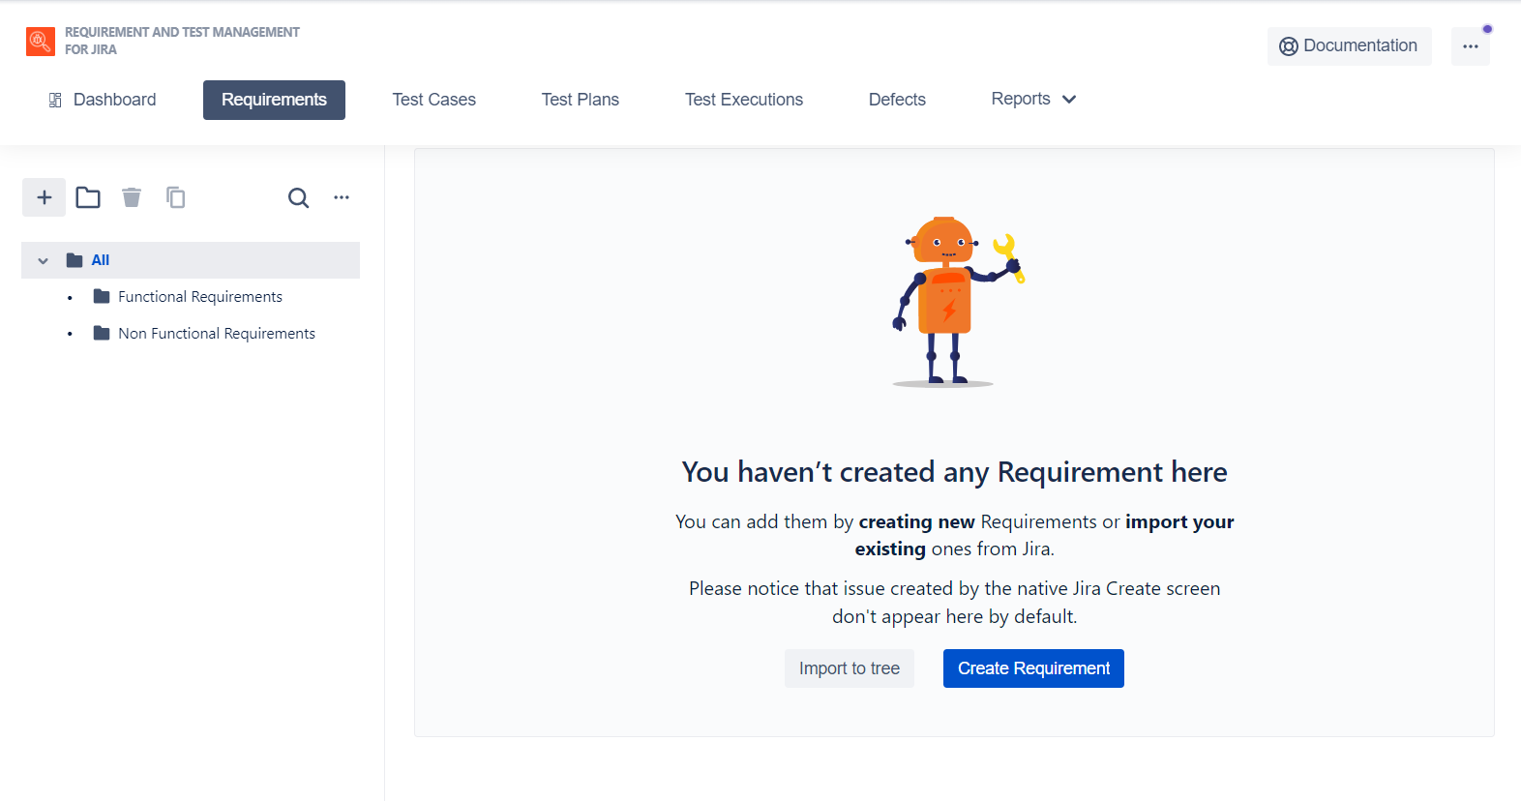

Creating and viewing requirements (Elicitation)

First we click the blue colored ‘Create Requirement’ button found on the homepage, after which we can specify the **requirement type**, write the entire **requirement in summary**, and **select the priority** of the requirement as show below.

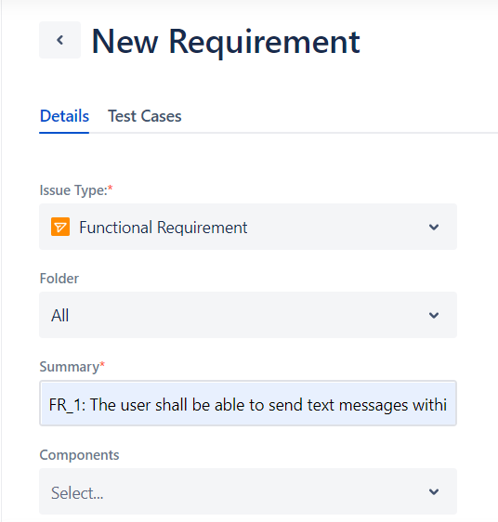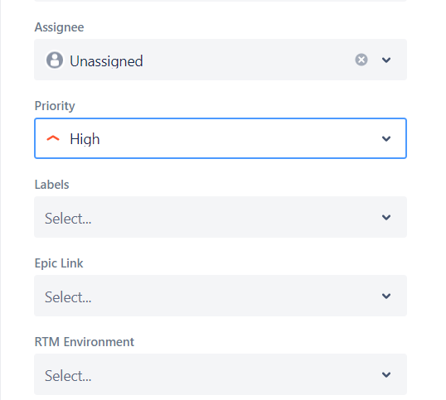

Please note that with this kind of interface we are **working on the validation phase from within the elicitation phase**, since priority of requirements are set when they are created.

After creating all the requirements in this manner, the homepage of the the suite looks like this:

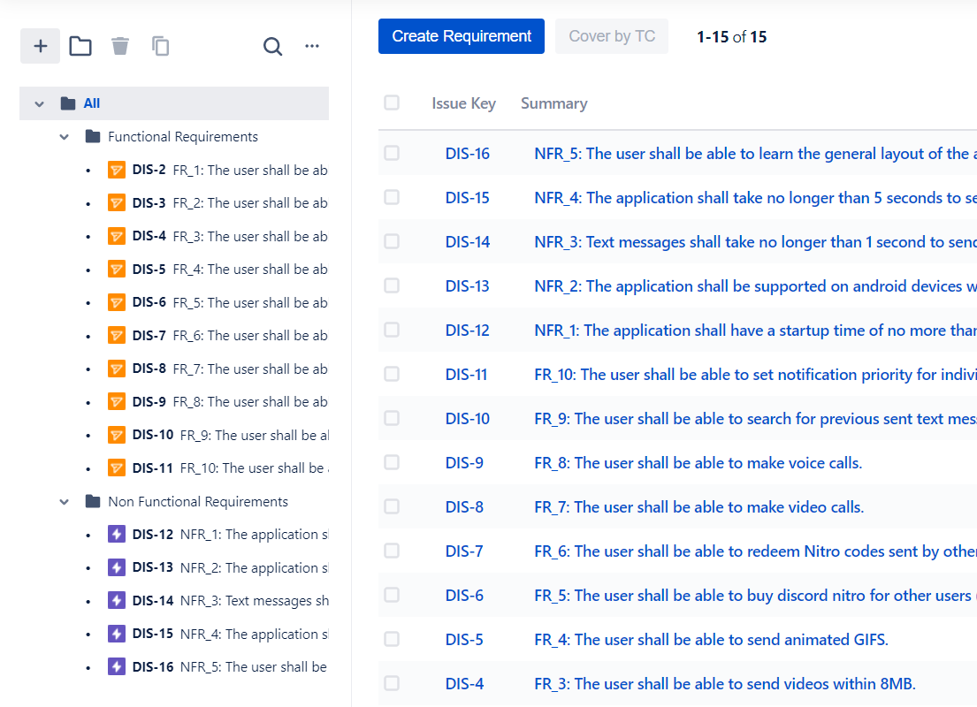

Making UML diagrams (Analysis)

We’ll start off by **creating a generic requirement** and **setting it to the**

**name of the UML** we want to make, after which we will select it from the **Backlog panel** of the JIRA project page.

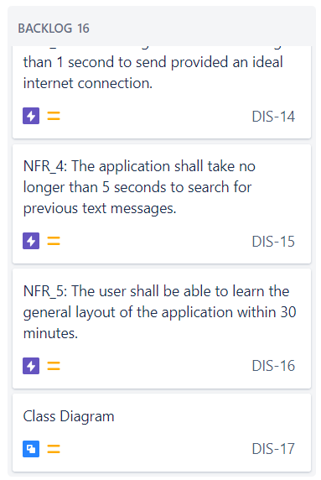

After selecting the **Class Diagram** item from the list above, we get this menu, from which we will select the **Diagrams.net** option:

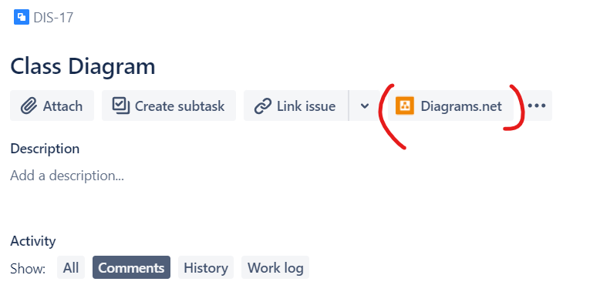

Clicking on the highlighted button brings up the pane below, from which we can create a diagram on the external site <https://www.diagrams.net/> and link the UML diagram to our JIRA project.

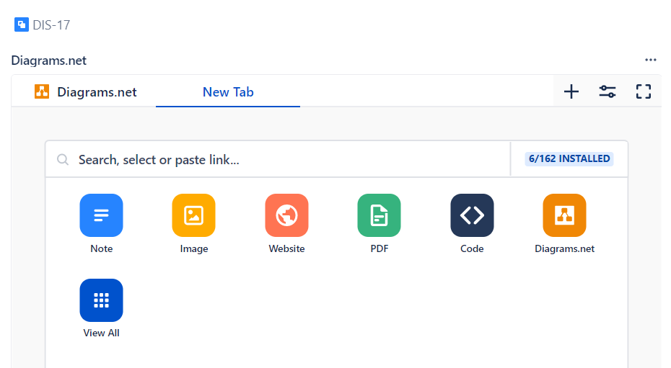

The final view of our created UML diagram is shown below:

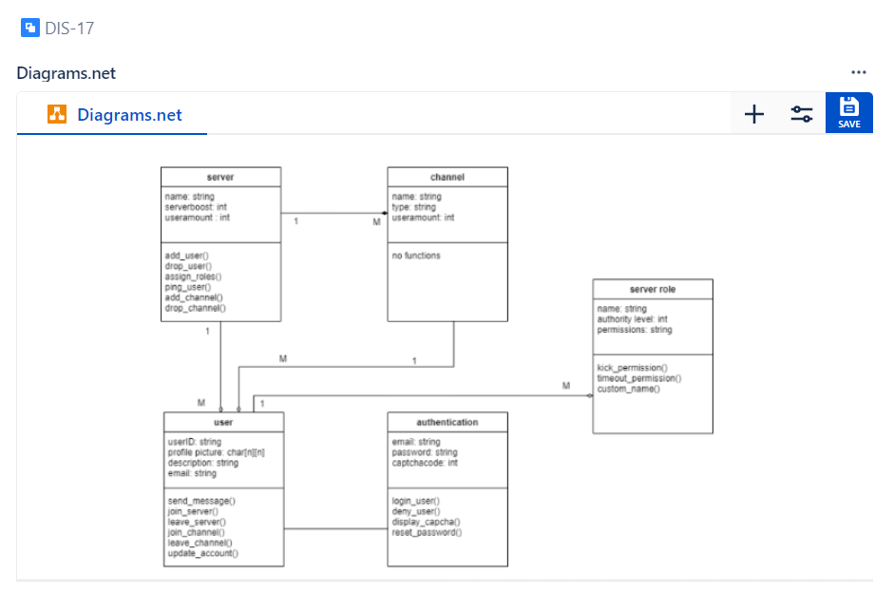

Generating a Requirements Document ( Specification)

To generate a document with our requirements, we will select the **project pages** option from the side panel.

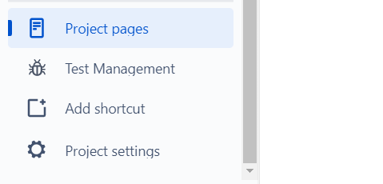

After this we will select the **product requirements** option.

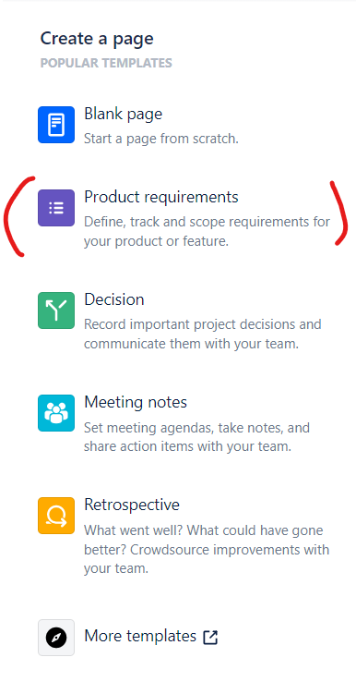

Which will give us an automatically generated template for our SRS document, complete with **requirements, descriptions, and diagrams**.

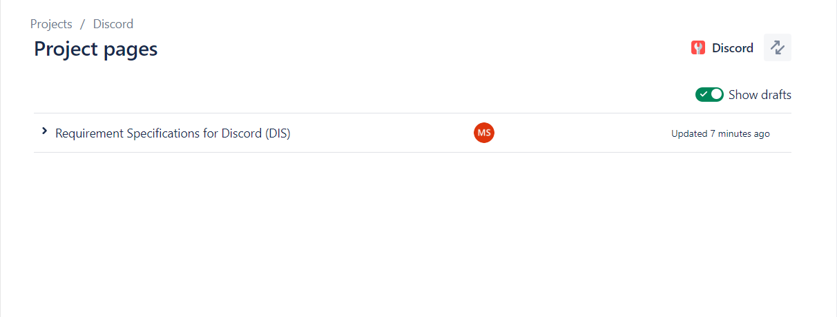

The complete requirements specification page will be at the end of this document.

Modifying Requirements (Management)

Requirements content and priority can be easily modified by clicking on a requirement in the backlog panel.

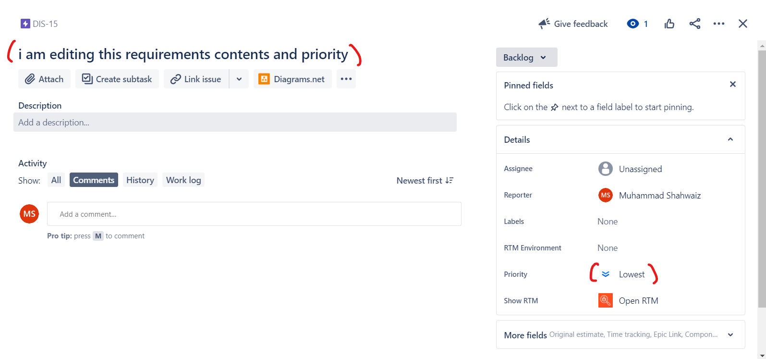

This concludes all steps of the SRE Project Phase II. Requirements document is on the next page.

Additional Notes

The validation section was skipped due to the fact that **prioritizing the requirements was done in elicitation** phase. Changing priority of requirements was also **highlighted in the management phase** and as such, the redundant screenshot and text did not merit an additional section.