**Assignment 2: Draw your Home Network Topology and explain how you are accessing the RPS Lab environment.**

**Home Network Topology**

1. **ISP (Internet Service Provider)**
   * Provides the internet connection to your home.
2. **Modem**
   * Connects to the ISP's infrastructure and provides a bridge between your home network and the internet.
3. **Router**
   * Connected to the modem.
   * Distributes internet connection to various devices in the home network.
   * Manages local IP addresses through DHCP.

4.**Devices**

* Wired Devices (e.g., Desktop PCs)

Connected via Ethernet cables to the router or switch.

* Wireless Devices (e.g., Laptops, Smartphones, Tablets, Smart TVs)

Connected via Wi-Fi to the router.

5.**Firewall**

Can be a part of the router or a separate device.Provides security by filtering incoming and outgoing traffic.

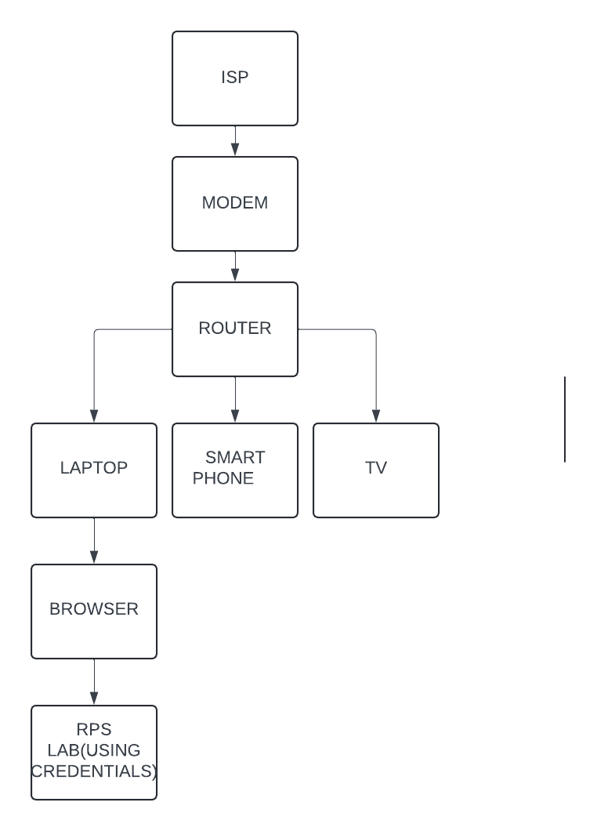

**EXPLANATION**

* **ISP:** Provides the internet connection**.**
* **Modem**: Converts the ISP signal to a format that can be used by the router**.**
* **Router:** Central hub of the home network, distributing internet to all devices and managing local traffic.
* **Devices:** Various home devices connected either via Wi-Fi or Ethernet.
* **RPS Lab Environment:** The remote lab accessible via various protocols for different types of tasks using my own credentials**.**

**Assignment 3: Identify a real-world application for both parallel computing and networked systems. Explain how these technologies are used and why they are important in that context.**

**Parallel Computing**

Real-World Application: Weather Forecasting

**How it works:**

**Data Collection**: Vast amounts of data are collected from satellites, weather stations, radar, and marine stations.

**Data Processing**: Interactive computing systems, such as supercomputers, process this data. For example, systems like NOAA’s Gaea supercomputer.

**Numerical weather forecasting (NWP) models**: These models use complex mathematical algorithms to simulate atmospheric conditions and predict weather conditions. Parallel computing distributes these tasks across multiple processors, allowing for faster computation and more instances.

**Simulation and prediction**: The simulation is interactive, predicting weather conditions, temperature, precipitation, wind speed, and so on.

**Why it matters:**

**Speed ​​and efficiency**: Weather forecasting requires rapid processing of large amounts of data. An integrated statistical approach accelerates this process, enabling timely and accurate prediction.

**Accuracy:** Enhanced statistical power allows for more detailed models, resulting in more accurate results.

**Disaster preparedness**: Accurate and timely weather forecasts are critical to preparing for and responding to natural disasters such as hurricanes, floods and tornadoes, which can save lives and reduce property damage.

**Network Systems**

Real World Application: Online Banking

**How it Works:**

**Customer Information:** Networked systems facilitate real-time transactions, such as deposits, withdrawals, currency placement and payment. Transactions are conducted through secure electronic connections, ensuring data integrity and security.

**ATM Networks**: ATMs are part of the bank’s network system, allowing customers to transact internationally. ATMs communicate with central bank personnel to verify account information and process transactions.

**Mobile and online banking:** Customers can access banking services through web portals and mobile apps. Web-based systems can provide these services, ensuring they are available 24/7.

**Backend Operations:** Networked systems handle internal operations such as account balance updates, fraud detection, and loan processing. Banks use distributed databases and cloud computing to manage large volumes of data and build reliability.

**Why it matters:**

**Convenience**: Web-based systems can provide banking services anytime and anywhere, improving employee productivity.

**Security**: Secure network protocols and encryption protect sensitive financial information from cyber threats.

**Efficiency:** Automates and simplifies banking processes, reducing manual errors and improving speed of processing.