**Blog Post:** Post when not published still remains published in front end

**Editor:** need a good editor which must have upload image, alignment option and mathematical expressions like brainly

**Add Blog:** Content portion has to be large in blog section, please move the “Subject Meta Tags” and “Subject Status” bellow the row. Make the “Subject Details” larger

**Comments:** Reply on comment not available for admin. Admin can reply to a comment from the admin panel.

**Blog Comment :** blog comments should be available for all users with or without login. The comment should be approved from the admin before its published.

**Template File:**  Template file available in upload module should have the latest headers.

**Advertisement section:** we’ve 2 or 4 ads on a single page the first one is a bit short and the second one is a bit larger can you set the height for first one 250px and for second one 400px and make the second one sticky. (I’ll guide you how you’ll do it.)

**Question / Answer:** Can you add a new Filter having feature of (Select2) “Filter by user”. We need this on our “All questions” and “All answers” page.

Sitemap section:

**Media:** I’ve shared with you one example of media. I think it was a simple table not the way you made. Please make this and avail those options too.

**Testimonial:** We’ve a laravel error on this page please check . section and admin-view question mai code aa raahai

In front end answer user link and question user link not working

**Likes:** Created an account and 200 likes already exist. I mentioned this in my previous documentation

Clicked on give answer and account creation was asked before answerbox(Account not getting created so can’t check)

**Redirect:** Redirection to the same page required. I was not able to answer the question after account creation because it redirected me to profile after loggin in(Account not getting created so can’t check)

Linebreak not coming in answer section

Suggest a subject in subjects section in ask question

Put link in popped success notification in ask question text to go to the question directly and be able to edit it

Edit option not available for the user who added question

Schema is not working properly and there is ainvalid ] in line 60 in the schema and accepted answer is not getting changed.

**Question and answer ratings :** Rating increased but count didn’t changed. Changed from 4 stars to five stars but rating decreased (Rating once increased not getting decreased)

Comment for answer not available (I’ll guide you how, don’t concentrate on it)

Question user can’t give answer to his own question

**Question:** Remove question likes and rating, you removed Answer Question too.

**Speed:** Speed not okay , can we increase more speed with any logic. Can you load the ads after 2 to 3 seconds after the page loads. Load only 7 rows not 10 on categories page where questions shows.

**Become an Expert:**  On become an expert page up and lower arrow not needed on phone number. We have small arrows when we create <input type=”number” > disable those up and down arrows.

**Pages under Community:** I have designed 2 pages for this can you check back with the design.

**Footer:** On clicking answerout with copyright in footer section the user should go to homepage

**Profile:** In the profile section when clicking on answered & unanswered it goes to 404 (I mentioned this in my previous document)(Answered and unanswered not there and one more option was present but now not there)

**Home page Search:** On the homepage question box on first banner is not working. Make sure you don’t disturb the design just add the backend logins.

When selecting the whole sentence first character is visible differently selected (I will handle this)

**Loader:** Remove preloader from every page

**Login:** Login with google not working creating authorization error. Last night it was working properly but now it sucks (now this page is coming after clicking on google profile)

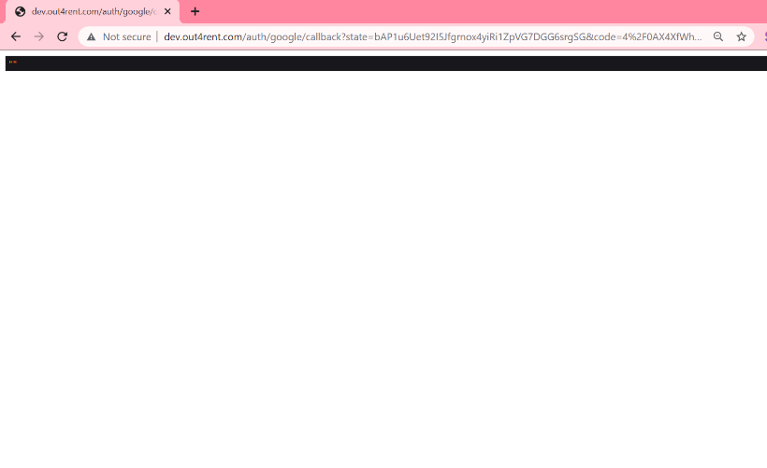

**Editor:** can you give the user a permission to add an image in the editor while answering the question?

**Editor:** How can we add mathematical expression. I mentioned you the editor from brainly.com and also mentioned you in the previous document

**Search on top bar:** Search drop down must disappear when a user clicks somewhere else on the page

In the explore section answer description not showing up

When uploading the same file again it creates new records again and again for question and answers

No option to view the answer in question section by clicking on the question from backend

Added a subject but not coming in the front end

**Profile:** Have to add random icon characters to users adding questions, user simply can update the user profile from the given characters. We’ve different avatars.

On subjects as well as in search boxes the whole box is not clickable only text is clickable

On the question answer page the category on the question box should be clickable

Data is uploaded in [http://dev.out4rent.com/ryan-accidentally-drops-a-very-heavy-object-on-his-foot-in-a-matter-of-just-a-few-seconds-he-feels-a-tremendous-amount-of-pain-he-experienced-the- HYPERLINK "http://dev.out4rent.com/ryan-accidentally-drops-a-very-heavy-object-on-his-foot-in-a-matter-of-just-a-few-seconds-he-feels-a-tremendous-amount-of-pain-he-experienced-the-pain-quickly-because-neurons-rapidly-carried-the-impulse-to-the-brain-which-structure-of-the-neuron-is-responsible-for-the-quick-transmission-of-a-nerve-impulse"pain-quickly-because-neurons-rapidly-carried-the-impulse-to-the-brain-which-structure-of-the-neuron-is-responsible-for-the-quick-transmission-of-a-nerve-impulse](http://dev.out4rent.com/ryan-accidentally-drops-a-very-heavy-object-on-his-foot-in-a-matter-of-just-a-few-seconds-he-feels-a-tremendous-amount-of-pain-he-experienced-the-pain-quickly-because-neurons-rapidly-carried-the-impulse-to-the-brain-which-structure-of-the-neuron-is-responsible-for-the-quick-transmission-of-a-nerve-impulse)url but a 404 page is showing up

Important notes: Some URL shows the 404 error I don’t know how.

Urls are long, have to set limit on them

Applied the ad on right side and the question box went below left ad and right ad went below the question answer box

When clicking on any part of nav bar for eg. Explore the user profile section vanished and then comes back creating a bad view

When I first click on the user profile usama Kashif, there were no questions in the question section but I have had added one there but after that when I checked again everything was good.

Ask question not coming for logged out users & notification icon in nav bar

Clicked on subjects after explore but Laravel error is coming

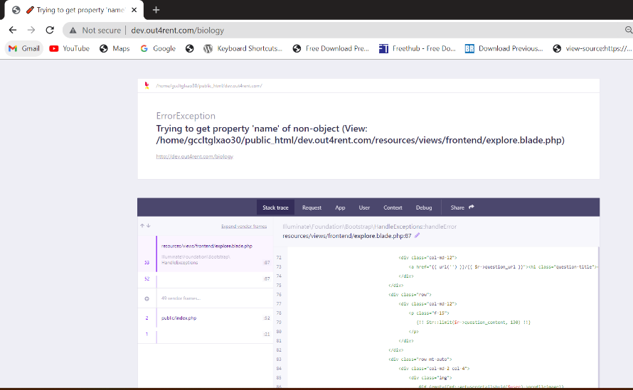

After adding ads on left and right sidebars both upper and lower ads, question and answer section gets shifted below.

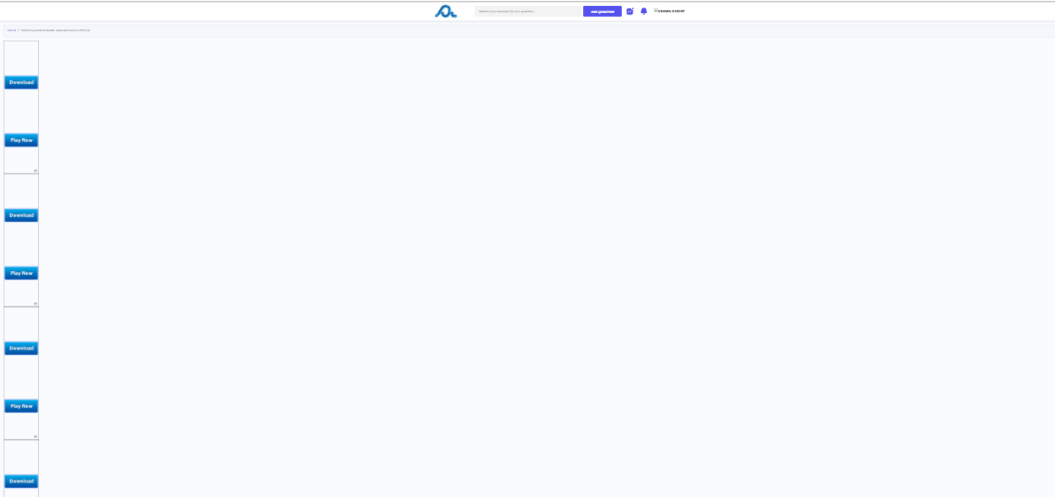

Answerbox editor section is very basic and we want image added to be of 50% size and center aligned bydefault.