Salam please find the points below:

1. Engine should be mapped with engine bearing and engine mounting, and rubber metal and bounded parts categories and products (don’t include the sub category)

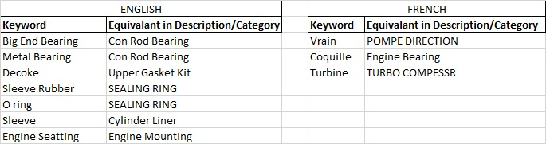

1. Remove sub categories from the search, for example for Piston it should be Piston, Piston Assembly and Piston Ring, for all the searches, we will only display main category

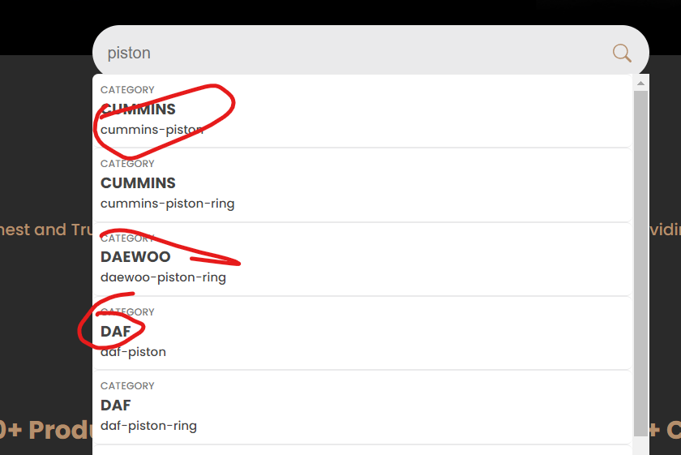

1. Keyword O ring, oring, orin should be mapped to Sealing ring product

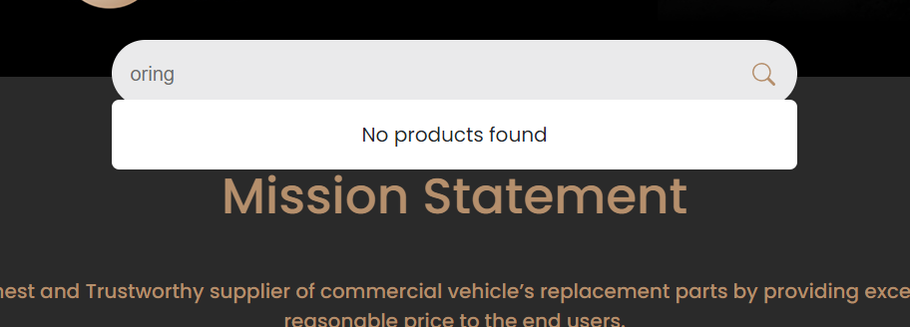

1. In French search categories name must be in French, they are coming in English, in below screenshot I searched Engine but results are coming in English, it should be in French.

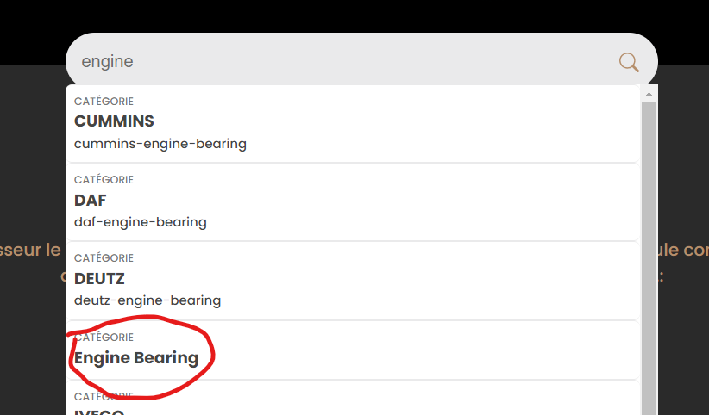

1. key word Engine Seatting is wrongly spelled it should be Engine Seating in the mapping and map it to Engine mounting

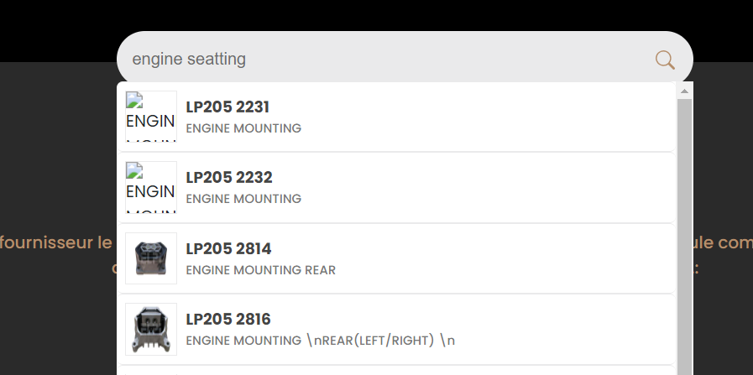

6. Language switcher design (will give you reference)

7. Not able to add the products and categories, getting some kind of error

