Shahzada Fathurrahman
bscs-20f-0002
Lab 11

Bankers implementation task.

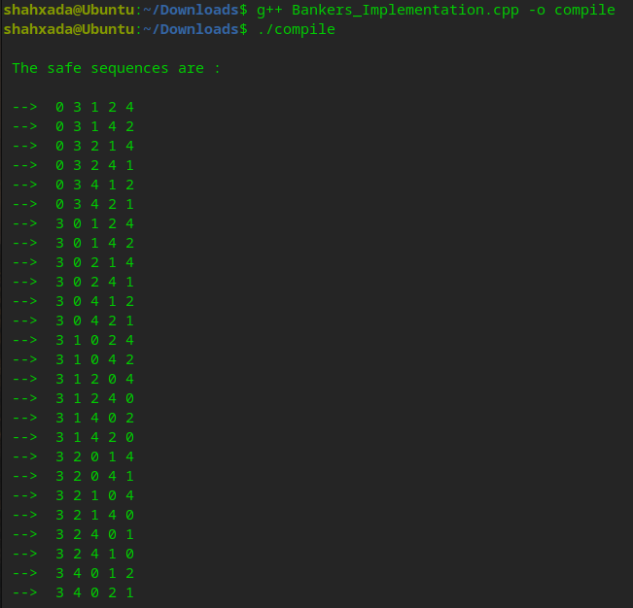

Task 1

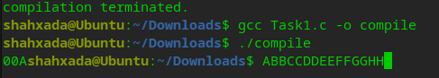

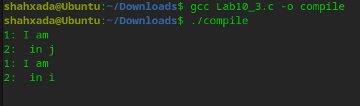
Task2

