To | James Waterson
Company | Becton Dickinson
Cc | Samuel Garcia, Christian Vollmar, Stefan Schraag
Prepared by | Kai Hu | Checked by |  | Gavin Moore
Date | 29 April 2026 | Revision |  | 02
Project No | 12847
Pages | 14
Subject | Nexus Post Market Surveillance Questionnaires for Picot 1 and Picot 2

/For internal reference only

PICOTs for Research

PICOT 1:
BD nexus or BD Bodyguard (including CME pumps, which are the older generation of BD Bodyguard) users who have experience delivering multi step infusion modes requiring 15-minute titrations when administering specialist oncology infusions or intravenous immunoglobulin IVIG.

PICOT 2:
BD neXus or BD Bodyguard (including CME pumps, which are the older generation of BD Bodyguard) users who have experience delivering ramp up or ramp down infusion profiles when administering Total Parenteral Nutrition TPN infusions.

PICOT 3:
BD neXus, BD Alaris neXus, and CareFusion Alaris Guardrails Plus Pumps users who have experience administering sepsis resuscitation fluids using a preset drug library entry with a default rate of 30mL/kg/hr, and administering noradrenaline using standardised doses or custom concentrations with default dosing in mcg/kg/min.

PICOT 4:
BD Alaris neXus (ACE/Wi Fi) and BD neXus (Connected Solution) users who have experience working with infusion pumps connected across the hospital network and creating or using an extensive DERS drug library, with active drug library management and supporting medication safety activities.

Questionnaire for PICOT 1 - “Multistep” or “25 Steps” function.

Q0: This questionnaire asks about your experience and opinion using the “Multistep” or “25 Steps” function on the Becton Dickinson (BD)’s infusion pumps. [Select one answer]

Definition:
A “multistep” / “25 steps” infusion on a smart pump allows the clinician to program stepwise increases in infusion rate after a set time of delivery. For example, an infusion may be programmed to run at 5 ml/hr for 15 minutes, and then automatically increase its rate to 10 ml/hr for the next 15 minutes, to 20 ml/hr for the next 30 minutes, and then to reach its final stable rate of 30 ml/hr for the rest of the infusion.

The operating interface examples:

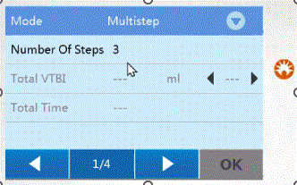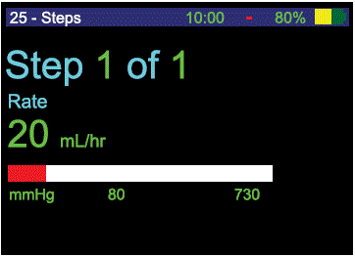

- I understand and continue.
- I have not used this function – Thank and close

Q1. In which clinical area do you use the “Multistep” or “25 Steps” function? [Select all that apply]

- Oncology
- Autoimmune Care Unit
- Intensive Care Unit (ICU/NICU/PICU)
- Haematology
- Gastroenterology
- High Dependence Unit (HDU)
- Emergency Departments
- Admissions Ward
- Intestinal Failure Unit / Intestinal Rehabilitation Unit
- Virtual Wards / Hospital at Home
- Community Infusion Centres
- Other, please specify:

Instructions: From Q2 to Q8 In the following questions, you will be asked to rate each item using a scale from 1 to 5 or rank them from best or worst.

Q2. How often do you administer the following medications or products with the “Multistep” or “25 Steps” function? (1=Never, 7=More than 10 times per shift) [Select one answer for each item]

Randomise the order of options | 1  Never | 2  Very rarely | 3  Every other shift | 4  1-2 times per shift | 5  3-5 times per shift | 6  6-10 times per shift | 7  More than 10 times per shift
Intravenous immunoglobulin (IVIG)
Monoclonal antibodies
Blood products
Beta-interferons
Others, please specify:

Q3. How much have you experienced the following outcomes when using the “Multistep” or “25 Steps” function? (1=Not at all, 5=Substantially) [Select one answer for each item]

Randomise the order of options | 1  Not at all | 2  Slightly | 3  Moderately | 4  Considerably | 5  Substantially
Increased medication safety
Improved workflow efficiency
More time for clinical care
Reduced risk of potential medication errors
Quicker completion of therapy

Q4. How valuable are the following outcomes to you when using the “Multistep” or “25 Steps” function? (1=Not important, 5=Extremely important) [Select one answer for each item]

Randomise the order of options | 1  Not important | 2  Slightly important | 3  Moderately important | 4  Highly important | 5  Extremely important
Increased medication safety
Improved workflow efficiency
More time for clinical care
Reduced risk of potential medication errors
Quicker completion of therapy

Q5. Based on their value to you, rank the following outcomes from the most valuable (1) to the least valuable (5). [Rank] [Randomise the order of options]

- Increased medication safety
- Improved workflow efficiency
- More time for clinical care
- Reduced risk of potential medication errors
- Quicker completion of therapy

Q6. How much do the following “Multistep” or “25 Steps” capabilities help reduce medication errors in your clinical setting? (1=Not at all, 5=Substantially) [Select one answer for each item]

Randomise the order of options | 1  Not at all | 2  Slightly | 3  Moderately | 4  Considerably | 5  Substantially
Minimise manual interventions between rate changes.
Automate movement through the dosing process without the pressure of speedy programming.
Allow for a “one check” process for 2 nurse checks of medication administration.
Be able to map the entire prescription requirements against one screen following set-up on the pump.
Use a set-up that can be matched to the IVIG or other medication’s specific manufacturer’s instructions for administration.

Q7. How valuable are the following “Multistep” or “25 Steps” capabilities in reducing medication errors in your clinical setting? (1=Not important, 5=Extremely important) [Select one answer for each item]

Randomise the order of options | 1  Not important | 2  Slightly important | 3  Moderately important | 4  Highly important | 5  Extremely important
Minimise manual interventions between rate changes.
Automate movement through the dosing process without the pressure of speedy programming.
Allow for a “one check” process for 2 nurse checks of medication administration.
Be able to map the entire prescription requirements against one screen following set-up on the pump.
Use a set-up that can be matched to the IVIG or other medication’s specific manufacturer’s instructions for administration.

Q8. Based on their value to you, rank the following capabilities from the most valuable (1) to the least valuable (5). [Rank] [Randomise the order of options]

- Minimise manual interventions between rate changes.
- Automate movement through the dosing process without the pressure of speedy programming.
- Allow for a “one check” process for 2 nurse checks of medication administration.
- Be able to map the entire prescription requirements against one screen following set-up on the pump.
- Use a set-up that can be matched to the IVIG or other medication’s specific manufacturer’s instructions for administration.

Instructions: From Q9 to Q10 Next, you will be asked to estimate based on your own experience.

Q9. Approximately how much time have you saved by using the “Multistep” or “25 Steps” function comparing with not using this function? [Select one answer]

- More than 50%
- 26 - 50%
- 11 - 25%
- Up to 10%
- No time saved
- It takes more time now
- I don’t know

Q10. Approximately by what percentage does using the “Multistep” or “25 Steps” function improve your productivity comparing with not using this function? (e.g., faster task completion, higher care quality, more patients to attend, etc.) [Select one answer]

- More than 50%
- 26 - 50%
- 11 - 25%
- Up to 10%
- No improvement
- It decreased productivity
- I don’t know

Instructions: In the following series Q11, you will be asked to indicate how much you agree or disagree with the following statements related to the “Multistep” or “25 Steps” function of the BD pumps. [Select one answer for each statement]

Please note that some of the statements in the following section are framed in a positive way and some in a negative way, please read each statement carefully before providing your answers [set up with a 5 second time delay on the “next” button]

Question 11:

Statement A: “It is difficult to understand and rectify alarm messages when using the ‘Multistep’ or ‘25 Steps’ function.”

- Strongly agree
- Agree
- Disagree
- Strongly disagree
- I haven’t used it

Statement B: “It is easy to suspend, pause, stop or change the rate of delivery, and it is clear when this has been completed when using the ‘Multistep’ or ‘25 Steps’ function.”

- Strongly agree
- Agree
- Disagree
- Strongly disagree
- I haven’t used it
Statement C: “Setting the delivery rates for each step when using the ‘Multistep’ or ‘25 Steps’ function is NOT easy, and it is unclear when this has been completed correctly.”

- Strongly agree
- Agree
- Disagree
- Strongly disagree
- I haven’t used it

Statement D: “I have had more time to concentrate on clinical care when using the ‘Multistep’ or ‘25 Steps’ function.”

- Strongly agree
- Agree
- Disagree
- Strongly disagree
- I haven’t used it

Please respond to the following statement if you use the Becton Dickinson (BD)’s neXus pump. If you do not use the BD neXus pump, please select “Not applicable to me”.

BD neXus
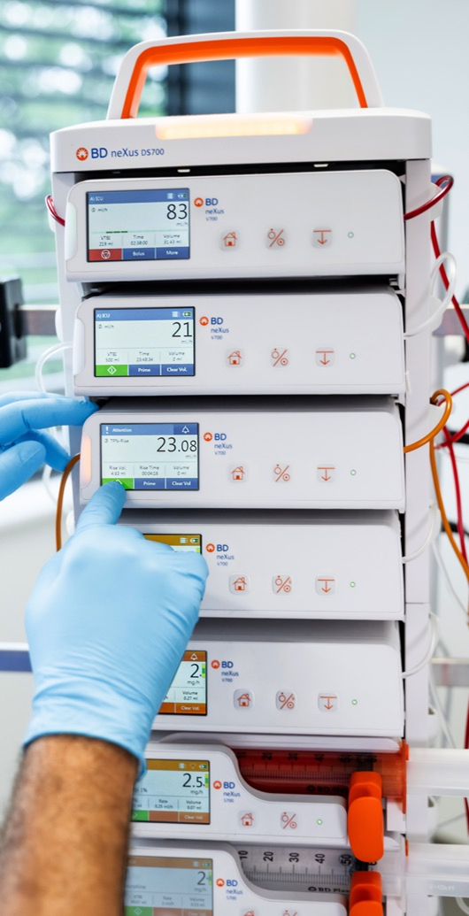

When using the BD neXus ‘Multistep’ mode, you may have received ‘completion alarms’ after each step is finished.
Statement E: “The prompts were useful as they act as a reminder to return to the patient to complete vital signs checks before moving to the next infusion step.”

- Strongly agree
- Agree
- Disagree
- Strongly disagree
- I haven’t used it
- Not applicable to me

Q12. If the “Multistep” or “25 Steps” function could save your time up to 1 hour, what other activities would you like to do instead? [Select all that apply] [Randomise the order of options, except Other]

- Patient care, such as taking vital signs
- Patient counselling
- Non-clinical administrative tasks
- Teaching and training
- Managing additional patients
- Other, please specify:

Questionnaire closed.

