**Project Report: Jobify - Bridging Jobseekers and Companies**

**Executive Summary**

Jobify is a cross-platform mobile application designed to bridge the gap between jobseekers and companies. Developed using Flutter for the front end and Firebase for the backend, Jobify offers a streamlined job search and hiring experience.

**Objectives**:

Efficient job matching for jobseekers. Simplified and cost-effective hiring for companies.Personalized recommendations based on user profiles. Enhanced flexibility in job exploration.

**Key Achievements:**

Smart Matching Algorithm for jobseeker-job post alignment. Effortless connections between users and companies. Time-efficient hiring process. Positive user feedback on usability and personalization.

**Introduction**

**Background and Context:**

The job market is characterized by the need for efficient job matching. Jobify addresses this challenge by connecting jobseekers with companies in a user-friendly and personalized way.

**Purpose and Significance:**

Jobify simplifies the job search and hiring process, making it more effective for both jobseekers and companies. It aims to enhance user satisfaction and streamline recruitment.

**Scope and Target Audience:**

Jobify serves jobseekers and companies of all sizes, from recent graduates to enterprises. Its primary focus is to provide tailored solutions for a seamless job search experience.

**Technology Stack**

Jobify leverages the following technologies:

**Frontend:** Flutter, a cross-platform mobile development framework.

**Backend:** Firebase, offering authentication, real-time database, and cloud functions.

**User Registration and Onboarding**

Jobify features a unified registration process, allowing users to sign up and categorize themselves as either jobseekers or companies. Upon registration, users are prompted to fill out relevant bio data forms.

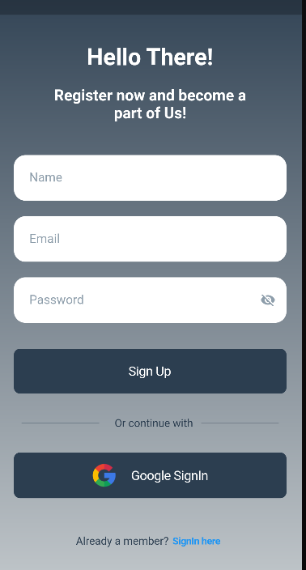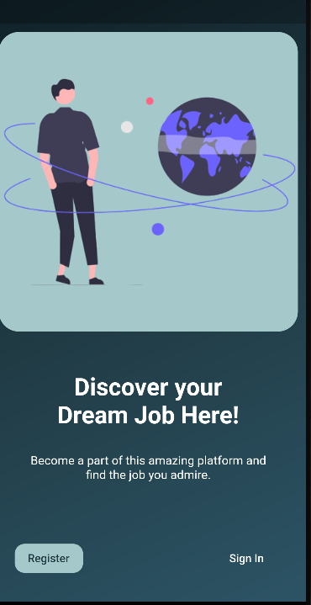

**Homepage and Navigation**

The app's navigation is facilitated by a bottom navigation bar with five primary screens:

Jobseekers: Lists jobseeker profiles.

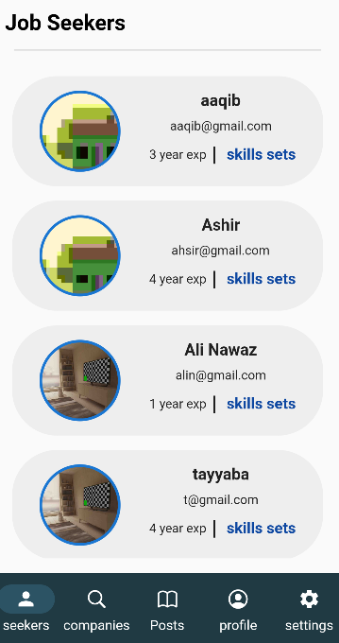

Companies: Displays a directory of companies.

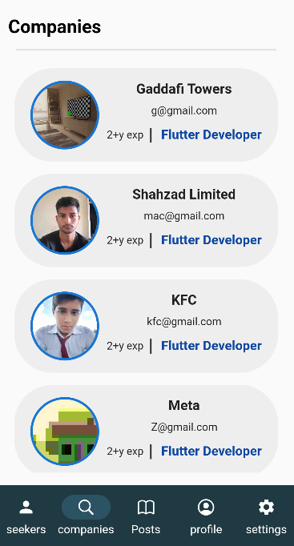

Posts: Shows job posts from companies.

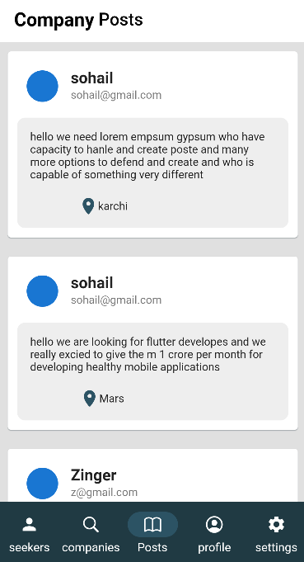

UserProfile: Displays user profiles and settings.

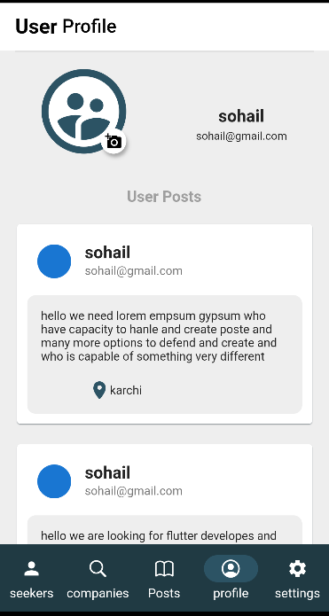

Settings: Provides app settings and sign-out option.

**User Profiles**

Jobify collects comprehensive user data:

**Jobseeker Profiles:** Include skills, experience, and preferences.

**Company Profiles:** Contain company descriptions, job listings, and contact information.

**Data Handling and Backend Integration**

Firebase is used for backend services, including user authentication, data storage, and real-time updates. It ensures the security and integrity of user data.

**Job Listings and Posts**

-Jobseeker Screen: Lists jobseekers based on their profiles.

-Companies Screen: Displays a directory of companies.

- Posts Screen: Shows job posts from companies with relevant details.

**User Experience and Interface**

Jobify boasts a user-friendly and intuitive design. The navigation flow is structured to maximize usability and accessibility.

**Security and Privacy**

The project implements robust security measures to protect user data. It complies with data privacy regulations to ensure user confidentiality.

**Conclusion**

Jobify is set to revolutionize the job search and hiring process. It offers a user-centric approach, delivering efficiency and personalization. User feedback has been overwhelmingly positive, affirming its potential for success.

**Appendices**

- Additional documentation, screenshots, and wireframes.

**References**

- Citations and credits for external sources or libraries used.

**Acknowledgments**

This comprehensive project report outline provides a detailed overview of your Jobify project, its objectives, technologies used, features, and future plans. You can expand each section with specific project details, data, and metrics to create a full-fledged project report tailored to your project's achievements and goals.

**Contributors:**

**Shahzad Haider (20SW067)**

**Aashir Ali (20SW023)**