Development Operations

Assignment No.03

Name: Shahzaib Asghar RegNo: 2020449

Name: Ishaq RegNo: 2020313

Introduction: This is The continuation of my assignment_2 cloned project which was an **Flask Application** for predicting house prices based on user provided area in square feet. the main objectice of this assignment was to implement a robust and automated deployment pipleling using **Docker**, **Github Actions**, **AWS EC2 instances**.

* Github Repository link: <https://github.com/shahzaib-123/DevOpsAssignment3.git>

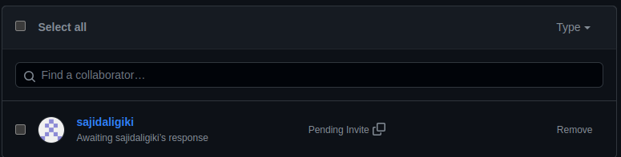

* Since this was a **Flask application** using template, I will be **updating the code** to incorporate **database** in it, such that atleast two containers could be incorporated as requirement of this assignment.

