Artificial Intelligence
Assignment: Designing and Evaluating an AI Agent
Personalized Song Recommendation Agent
(Rule-Based AI Agent)

_______________________________________________________
Submitted By: Shahzaib Imtiaz
Seat No: 23122067
Section: Section B
_______________________________________________________

Personalized Song Recommendation Agent
(Rule-Based AI Agent)
1. Problem Identification in Terms of an Agent
Music streaming platforms hold catalogues of tens of millions of tracks, yet a song that fits one listener's taste can feel completely wrong for another, and even for the same listener a song can feel right on one day and off on another depending on their mood, age group, and what they have been listening to recently. Sorting through this manually for every track is not realistic, and this is exactly the kind of problem an intelligent agent is meant for: something that can sense the listener's details and the candidate song (its environment), reason over this information with a set of preference rules, and act by producing a recommendation that tells the listener whether the song is worth playing. The agent built for this assignment, the Personalized Song Recommendation Agent, is a rule-based agent. It does not train on listening data or learn patterns over time; instead it works off a fixed knowledge base of IF-THEN rules covering genre preference, mood, age suitability, and recent listening history, and checks a listener's profile together with a candidate song against these rules to output a simple, personalized recommendation along with the reasoning behind it.
2. Problem Formulation
Input: Listener's age, favorite genre, current mood, the last song they played, and the candidate song being considered.
Dataset: A set of predefined recommendation rules built from genre match, mood suitability, age group, and recent listening history.
i.e.,
Age | Favorite Genre | Mood | Last Song Played | Candidate Song | Rule / Condition | Recommendation
19 | Pop | Energetic | Blinding Lights  (The Weeknd) | Levitating  (Dua Lipa) | Genre and mood both match | Highly Recommended
27 | R&B | Relaxed | Come Through  (H.E.R.) | Best Part  (Daniel Caesar) | Genre matches, mood fits | Recommended
45 | Rock | Sad | None | Highway to Hell  (AC/DC) | Mood does not match genre's typical energy | Maybe
15 | Pop | Happy | As It Was  (Harry Styles) | Sunroof  (Nicky Youre) | Genre and age group match | Recommended
58 | Classical / Instrumental | Calm | Clair de Lune  (Debussy) | River Flows in You  (Yiruma) | Strong genre and mood match | Highly Recommended

Algorithm: Rule-Based AI using IF-THEN matching, where the listener's input is compared against the rules in the dataset to reach a decision.
Output: Highly Recommended / Recommended / Maybe / Not Recommended, along with a short reason.
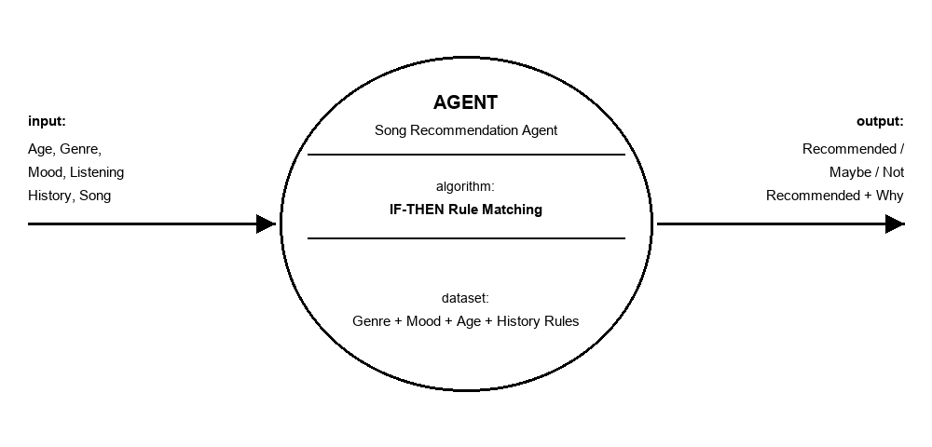
3. Evaluation in the Context of PEAS
PEAS stands for Performance measure, Environment, Actuators, and Sensors. It is a standard way of describing the task environment of an agent.
PEAS Element | Description for the Song Recommendation Agent
Performance  Measure | How well the recommended song matches the listener's current taste and mood, overall listener satisfaction, correctness of the genre/mood/age matching, and how fast the suggestion is produced.
Environment | The listener's personal profile (age, favorite genre, mood, recent listening history), the song catalogue, and the interface through which the listener enters details and views the recommendation.
Actuators | The output/display module that shows the recommendation label (Highly Recommended / Recommended / Maybe / Not Recommended) along with a short reason.
Sensors | The input module that reads the listener's entered or stored details: age, favorite genre, current mood, recently played songs, and the candidate song being queried.

4. Environment Properties
The task environment of the Personalized Song Recommendation Agent can also be looked at through the standard dimensions used to describe intelligent agents. Each of these is explained below.
Observability: Partially observable
The agent can only work with what a listener actually enters, such as favorite genre, current mood, and the last song played. It has no way of sensing things the listener has not typed in, like how they genuinely feel in that exact moment or songs they streamed on a different app that never got logged, so its picture of the listener is incomplete.
Determinism: Deterministic within the rule base
Because the agent is rule-based, feeding it the same listener profile and the same candidate song will always fire the same rules and produce the same recommendation. Nothing about the decision process is left to chance.
Episodic vs. Sequential: Episodic
Each song query is treated as its own episode. What the agent recommended for an earlier song has no bearing on what it recommends for the next one, even though the listener's saved profile carries over between queries.
Static vs. Dynamic: Semi-static (mostly static)
While the agent is working out one recommendation, the listener's profile and the song catalogue are held fixed. Things only change between sessions, for instance when the listener's mood shifts or they play a new song that updates their history, so within a single query the environment is effectively static.
Discrete vs. Continuous: Discrete
Genres, moods, age groups, and recommendation levels are all represented as a fixed, limited set of categories rather than continuous values, and the rules are written to match these discrete categories.
Known vs. Unknown: Known
The rules linking genre, mood, age, and listening history to a recommendation are set in advance by the designer based on general listening habits, so the agent already knows how its environment behaves before it ever processes a query.
Single-agent vs. Multi-agent: Single-agent
The system acts as a single personal recommendation assistant for one listener at a time. It has no need to cooperate or compete with any other independent agent while reaching its decision.

