For dates

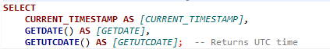

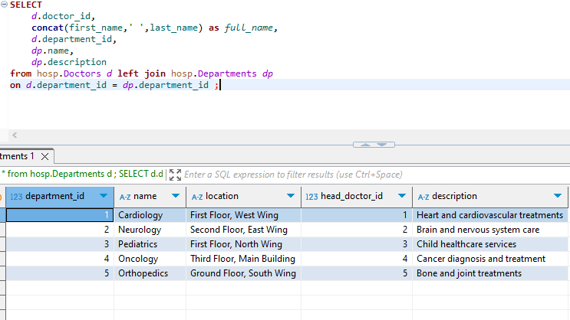Doctors and their dept’s

Completed appointments

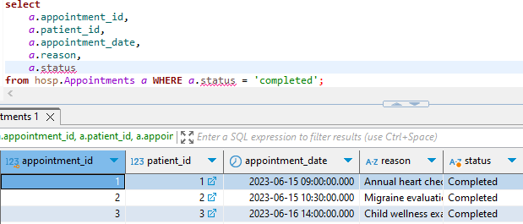

Rename Table:

**EXEC** sp_rename 'Old name', 'New Name';