



**Submitted by : -**

**Mohd FAIZ,**

**MOHD SHAHZAIB**

WELCOME

**Introduction:**

* We have tried our best to make the complicated process of Design and Development of Web Based Hotel Management System as simple as possible using Structured & Modular technique & Menu oriented interface. This project is used by two types of users :
* i. Online User and
* ii. Administrator (management of the Hotel).

# Purpose

The main purpose of my exercise is perform each Employee’s activity in computerized way rather than manually which is time consuming .

The entire activity is to automate the process of day to day activities of Hotel like

* Room activities very safely,
* Assign a room according to customer’s checkout of a computer and
* Releasing the room and finally compute the bill in short time .

# Existing features

“HOTEL Management System” has been designed to computerize the following functions that are performed by the system :

* Room Detail Functions
* Opening a New Room
* Modification to Room assigned
* Check-in and check-out Functions
* Sign-up of New customer
* Room assigning related to customer’s need
* Statement of customer Details
* Room Details
* Individual customer Report.

# System facilities

* Booking a room online add up long before guest’s arrival.
* Guests can read reviews and compare prices for Online Room Booking.
* The most important advantage of online room booking is convenience.
* Internet helps people to browse through the hotels around the world and compare the facilities and rates easily.

Software requirements

* **System development software**
* Operating system: Windows 7
* Development platform: Dreamweaver
* Language: PHP , MySql
* Server: Apache
* HTML: HTML5  Style sheet: CSS JQuery
* Browser: Mozilla Firefox 19.02 Beta



* **User required software:**
* Operating system: Windows7, 8,10
* HTML: HTML 5



**Using Software process Model(waterfall model)**

**Requirements**

**Design**

**Implementation**

**Verification**

**Maintenance**



**Data Flow Diagram(DFD)**

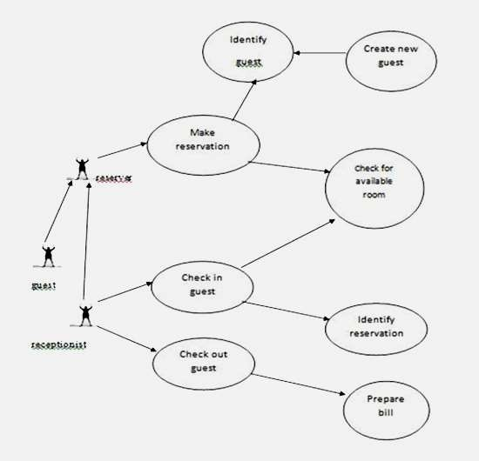

# Database of hotel management

**Admin divide duty time and entry salary of employees**

**Hotel Management System** is a web-based application that allows the **hotel** manager to handle all **hotel** activities online. ... **Hotel management project** provides room booking, staff **management** and other necessary **hotel management** features

**Admin divide duty time and entry salary of employees**

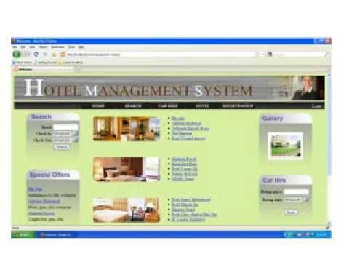

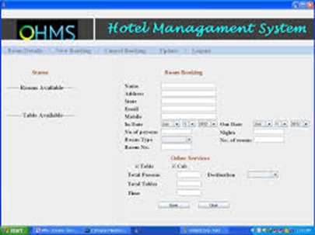

# Future work

* Laundry system,
* Car facilities
* Restaurant system,  Tourist package and guide system,  Meeting and conference facility.

Conclusion:

The proposed Online Hotel Management System in PHP creates an online platform for customer to book, inquire, reserve a hotel. Further, the project makes the hotel management works much easier and comfortable compared to the existing management system in hotels. It reduces the number of [human resource](https://www.codewithc.com/human-resource-management-system-vb-net-project/) in an organization but makes the work faster and more efficient.

# Thank you