**Bitstream Chef**

Shazaib Kashif [](https://orcid.org/0000-0003-4300-125X)1, Talha Ahmed[](https://orcid.org/my-orcid?orcid=0000-0001-9986-3145)1, Farhan Ahmed Karim[](https://orcid.org/0000-0002-9905-2075)2

*1Department of Computer Science, Usman Institute of Technology, Karachi,*

*PK 75300 {shazaib, tahmed}@students.uit.edu*

*2Center for Cyber Security, Faculty of Information Science and Technology, Universiti Kebangsaan Malaysia, Bangi, Selangor 43600 faahmed@uit.edu*

Electronic Design Automation[1] (EDA) technologies have become increasingly important in their fields of application with the open-source revolution in the silicon industry. These tools cover a wide range of automatic operations that save a significant amount of time. Bitstream Chef generates the bitstream of a design as shown in Fig.1 by taking an RTL design, allowing the user to map I/Os onto an FPGA using a GUI, and thus generating the bitstream through automated processes by use of an open-source tool F4PGA[2]. Additionally, it uploads the Bitstream onto the connected FPGA board while also letting the user know whether any boards are currently connected. It will also allow user to either have pre-defined program embedded in the bitstream or upload the program separately through UART. For further moving the design toward GDS generation, it has the Open Lane[3] toolchain integrated as well. Bitstream Chef is designed to be the go-to tool for every developer who frequently must upload or burn designs into FPGA, has a computer with less computing power.

**Fig.1** – Initial Mock-up of Bitstream Chef EDA Tool Graphical User Interface (GUI).

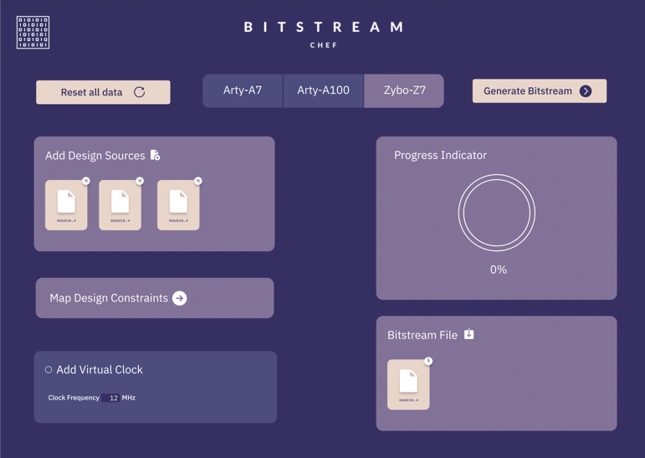

References

[1] Fišer, P., Schmidt, J. and Balcárek, J., 2014, April. Sources of bias in EDA tools and its influence. In 17th International Symposium on Design and Diagnostics of Electronic Circuits & Systems (pp. 258-261). IEEE.

[2] Murray, K.E., Elgammal, M.A., Betz, V., Ansell, T., Rothman, K. and Comodi, A., 2020. SymbiFlow and VPR: An open-source design flow for commercial and novel FPGAs. IEEE Micro, 40(4), pp.49-57.

[3] Ghazy, A. and Shalan, M., 2020. OpenLANE: The open-source digital ASIC implementation flow. In Proc. Workshop on Open-Source EDA Technol.(WOSET).