LAB#6
GITHUB LINK: https://github.com/shahzaibsaeed-12/data_structure_lab
CODE#1
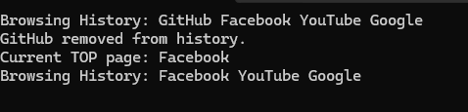
CODE#2

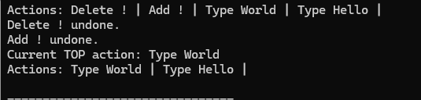

Code#3
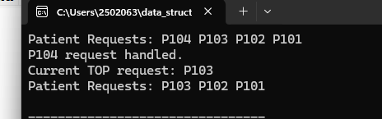

CODE#4
