LAB#4 Home Tasks
Github link : https://github.com/shahzaibsaeed-12/data_structure_lab
TASK#1
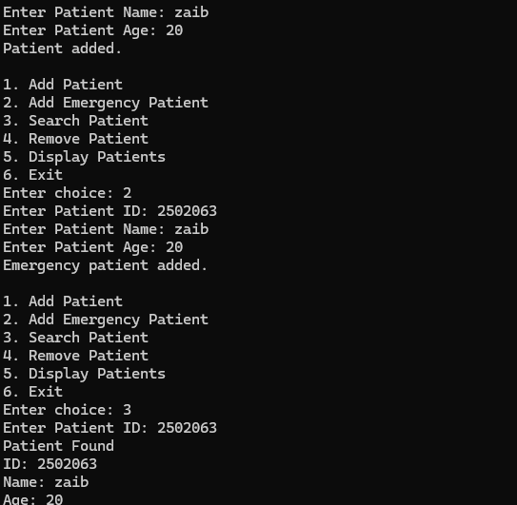
TASK#2
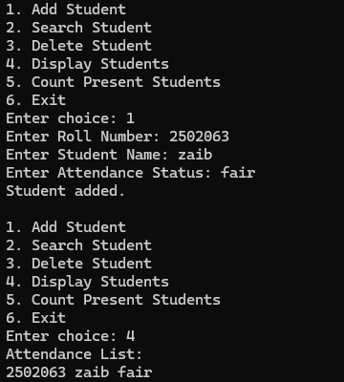

TASK#3
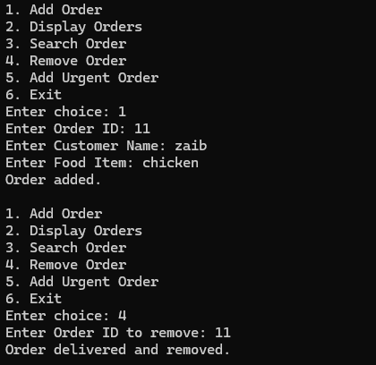
TASK#4
