Git link: https://github.com/shahzaibsaeed-12/data_structure_lab
TASK#1
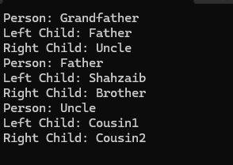
TASK#2
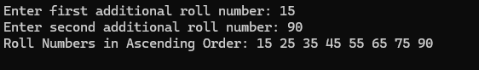
TASK#3
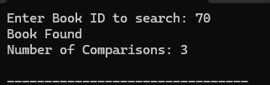
TASK#4
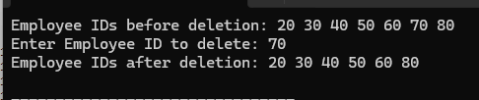
TASK#5
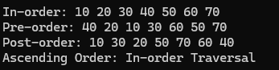
TASK#6
