**ASSIGMENT # 06**

**SQL database VS NoSQL database**

**Different between SQL & NoSQL**

|  |  |
| --- | --- |
| **SQL database** | **NoSQL database** |
| Databases are categorized as Relational Database Management System (RDBMS). | NoSQL databases are categorized as Non-relational or distributed database system. |
| SQL database are Table based | NoSQL database are document, Key-value, graph or wide-column stores. |
| SQL database are vertically scalable | NoSQL database are horizontally scalable |
| SQL databases have fixed or static or predefined schema. | NoSQL databases have dynamic schema. |
| SQL databases are not best suited for hierarchical data storage. | NoSQL databases are best suited for hierarchical data storage. |
| MySQL, Oracle, Sqlite, PostgreSQL and MS-SQL etc. are the example of SQL database. | MongoDB, Bigtable, Redis, RavenDB, Cassandra, Hbase, Neo4j, CouchDB etc. are the example of NoSQL database |
| SQL database performance is not better than NoSQL database | NoSQL database performance is better than SQL database |
| The ***SQL databases have a specific language,*** and it does not vary from databases to databases. This kind of databases uses the SQL (Structured Query Language) for retrieving and manipulating the data. | The***NoSQL databases have no specific language*** used for queries, and it varies from database to database. |

**Code for SQL database: -**

1. Create/Insert.
2. Read/Find.

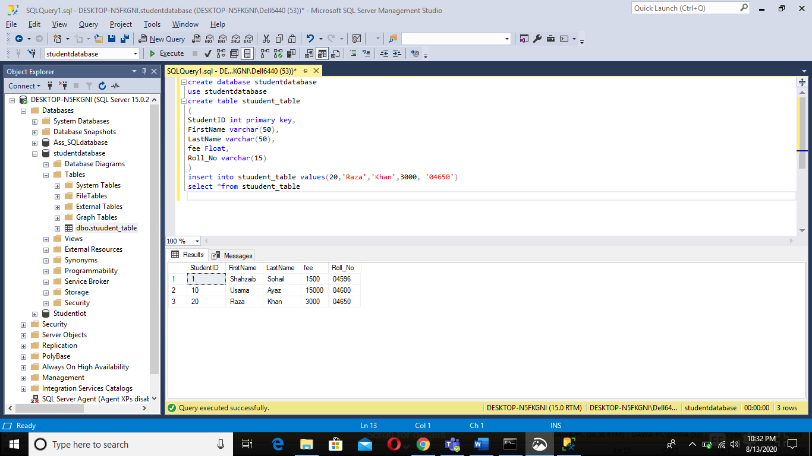

Update Code: -

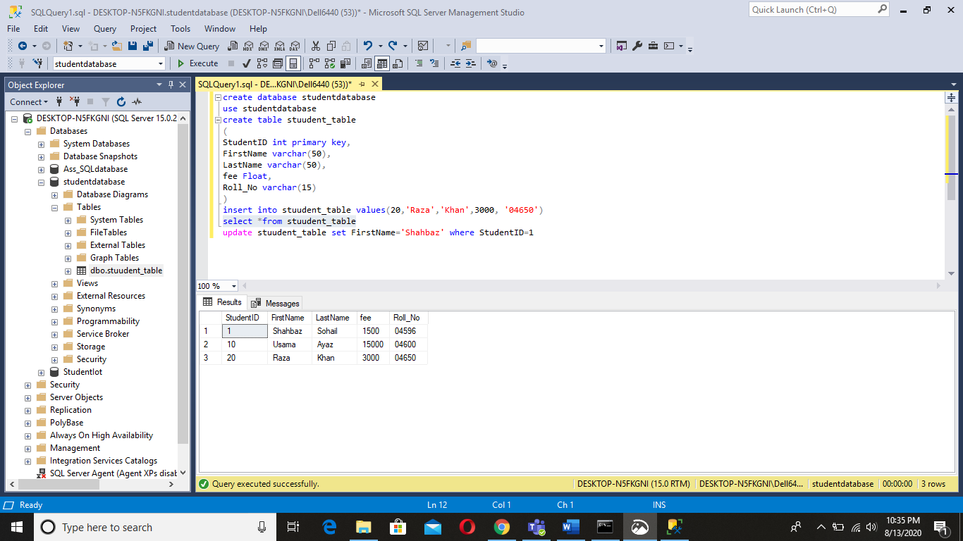

Delete Code: -

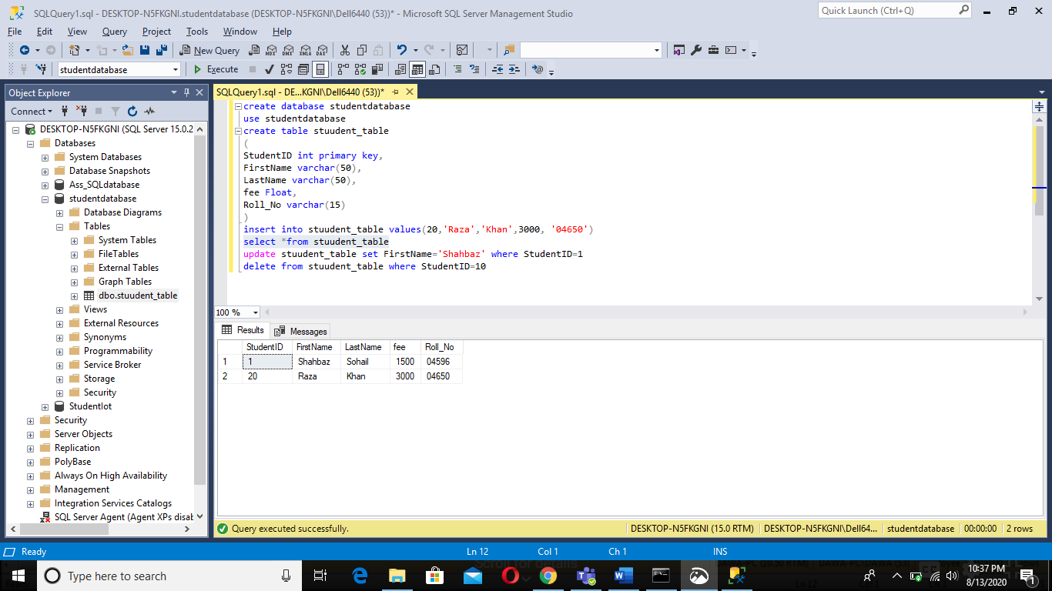

**Code for NoSQL database: -**

1. Create/Insert.
2. Read/Find.

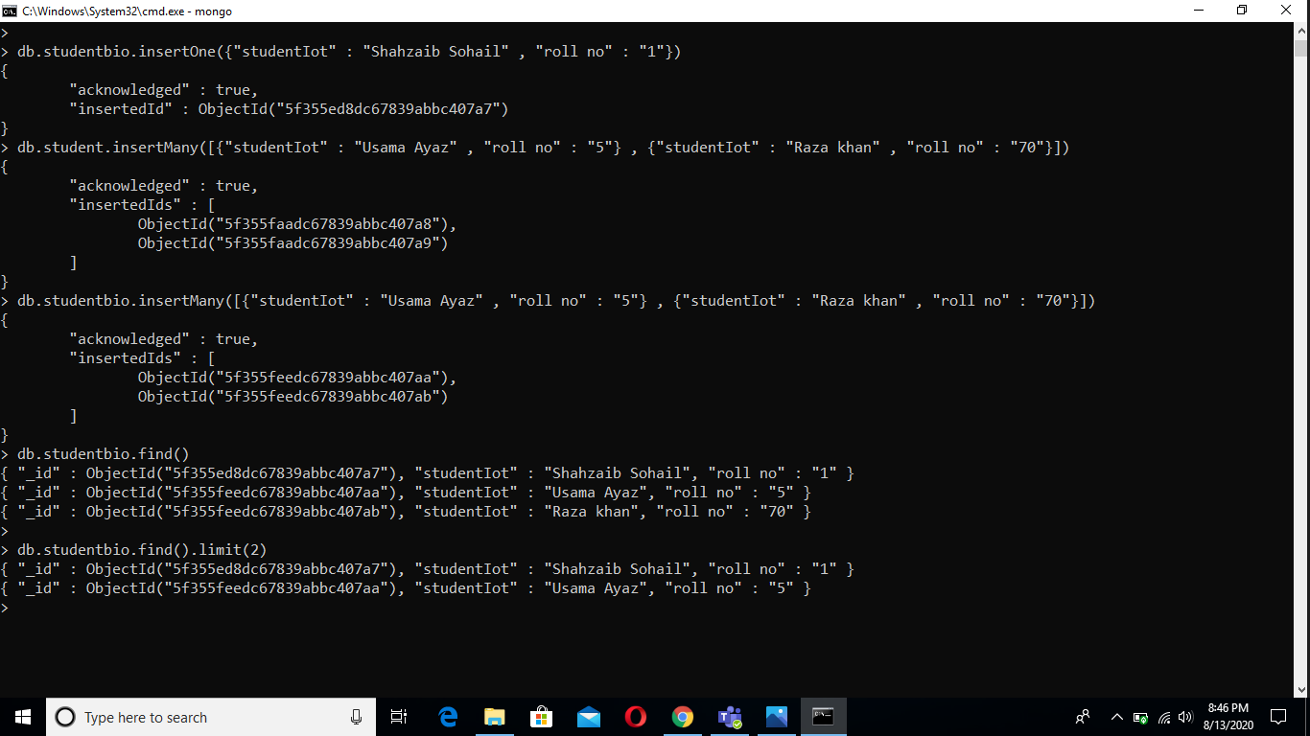

Update Code

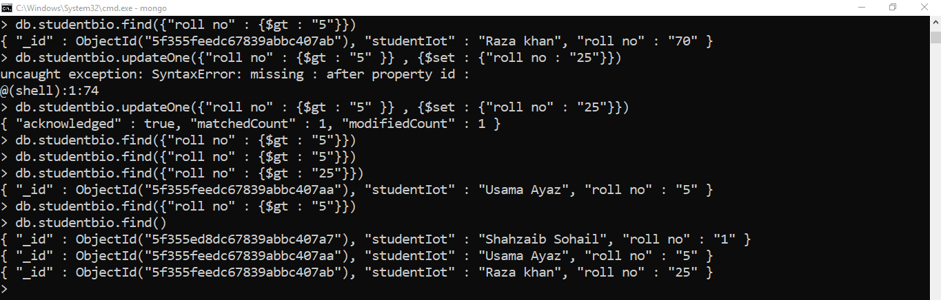

Delete Code

