
NED University of Engineering & Technology
Department of Software Engineering

Complex Engineering Activity (CEA)
Software Testing and Strategies
Web Application Testing with Playwright and Python
Test target: MediConnect Healthcare Platform

Group Members
# | Name | Roll No.
1 | Muhammad Shahzeb Alam | SE-23055
2 | Muneeb Asghar | SE-23082

Instructor: Engr. Tooba Siddiqui
Department of Software Engineering / NED University of Engineering & Technology
Fall 2026

1. Overview
This document covers our Complex Engineering Activity for the Software Testing and Strategies course. The task was to build an automated test suite for MediConnect, a healthcare booking website, using Playwright with Python and pytest.
MediConnect has a React frontend on port 5175 and a FastAPI backend on port 8000, with PostgreSQL behind it. Patients can look up hospitals, sign up and log in, and there is a separate login for doctors. Everything ran locally, so we could read the source and point the tests at the real pages.
There are 52 test cases in total. 51 pass on a normal run. The remaining one (TC-52) is a bug-detection test that passes when the code is correct and fails when an intentional bug is inserted into the source.
2. Environment and Tooling
Item | Details
Operating System | Windows 10 (Build 26100)
Language | Python 3.10.3
Test Framework | pytest 8.3.4 with pytest-playwright 0.10.0
Browser Automation | Playwright for Python (Chromium, Firefox, WebKit)
API Testing | playwright.request (APIRequestContext)
Network Mocking | page.route(), route.fulfill(), route.abort()
Reporting | pytest-html 4.2.0 -- generates test_report.html
Frontend | React + Vite (http://localhost:5175)
Backend API | FastAPI (http://localhost:8000)
Database | PostgreSQL 14 via Docker (port 5433)
Navigation Timeout | 90,000 ms
Default Timeout | 60,000 ms
3. Feature Selection
3.1 Covered Features
Feature | Name | Why Chosen | Test Cases
F-01 | Patient Login | Entry point to the entire platform. If login is broken, no other feature is accessible. | TC-01 to TC-03
F-02 | Patient Signup | Core user onboarding flow. A broken signup means no new patients can register. | TC-04 to TC-06
F-03 | Hospital Search | Primary feature patients use to find healthcare. Includes text search and city filter. | TC-07 to TC-09
F-04 | Doctor Login | Separate login portal for doctors. Tests that the doctor-specific auth flow works. | TC-10 to TC-12

3.2 Not Covered, and Why
Feature | Why Not Included
Doctor registration and approval | Multi-step admin workflow requiring a separate admin account to approve doctor profiles.
Token-based appointment booking | Requires seeded hospital and doctor data. Database was empty in our test environment.
Patient review and rating | Depends on completed appointments. Cannot be tested without a full booking flow.
Doctor portal dashboard (post-login) | Full dashboard requires valid doctor credentials which were not seeded in the test database.
Email verification and password reset | Requires a live SMTP server, which is outside the local test environment.
Mobile and responsive layout | Platform is designed for desktop. Mobile variations were excluded from this CEP scope.
Admin panel operations | No admin credentials were seeded. Admin-only endpoints return 403 in the test environment.
4. How the Suite Is Organised
Every feature gets positive tests, where correct input should succeed, and negative tests, where bad or empty input should be refused without the page breaking. Elements are found by role, label or placeholder rather than by CSS class, so styling changes do not break the tests. Assertions use Playwright's expect(), which keeps retrying until the condition holds or the timeout runs out.
Browser tests (E2E) open Chromium and drive the interface: they click, type, and check where the page ends up.
API tests send HTTP requests straight to the FastAPI backend with Playwright's request context. No browser is opened, and they check status codes and the shape of the JSON reply.
Network mocking tests use page.route() to replace or block requests, for example returning an empty hospital list or an HTTP 500, and then check that the page still behaves sensibly.
Cross-browser tests (TC-42 to TC-51) run on all three Playwright engines: Chromium, Firefox, and WebKit. The same test code is passed the --browser flag to switch engines without any code changes.

4.1 Folder Layout
mediconnect_testing/
|-- conftest.py shared fixtures: browser, URL, login
|-- pytest.ini runner config, HTML report settings
|-- test_01_functional.py TC-01 to TC-12: 4 features x 3 E2E tests
|-- test_02_navigation.py TC-13 to TC-23: navbar, protected routes
|-- test_03_api.py TC-24 to TC-34: REST API CRUD tests
|-- test_04_network_mocking.py TC-35 to TC-41: page.route() mocking
|-- test_05_crossbrowser_bugs.py TC-42 to TC-52: cross-browser + bug demo
|-- RUN_TESTS_NOW.bat full suite + cross-browser + bug demo
|-- RUN_DEMO_HEADED.bat headed demo with slow motion
|-- test_report.html pytest-html report (after a run)

5. Test Case Reference
Each row is one test. The status column shows the result of the final run. TC-52 is the bug-detection test: it passes when the code is correct and fails when the intentional bug is active.

ID | Test Name | Feature | Type | Steps / Input | Expected Result | Status
TC-01 | Valid login redirects user | Patient Login | Positive | Enter valid email and password, click Log in | User redirected away from /login to home | PASS
TC-02 | Wrong password shows error | Patient Login | Negative | Enter wrong email/password, click Log in | [role='alert'] error message is visible | PASS
TC-03 | Empty login form blocked | Patient Login | Negative | Leave fields empty, click Log in | User stays on /login (browser validation) | PASS
TC-04 | Valid signup creates account | Patient Signup | Positive | Fill random name, email, password, submit | Account created or no error shown | PASS
TC-05 | Empty signup form blocked | Patient Signup | Negative | Leave all fields empty, click Sign up | User stays on /signup page | PASS
TC-06 | Password hint visible | Patient Signup | Negative | Open /signup page | 'At least 8 characters' hint text present | PASS
TC-07 | Search accepts text | Hospital Search | Positive | Type 'Aga Khan' into search field | Input value retained in the field | PASS
TC-08 | Nonsense search no crash | Hospital Search | Negative | Type 'xyzxyz999nosuchplace' into search | Page stays on /hospitals, no crash | PASS
TC-09 | City filter dropdown works | Hospital Search | Positive | Open /hospitals, inspect city select | First option is 'All cities' | PASS
TC-10 | Doctor login page renders | Doctor Login | Positive | Navigate to /doctor/login | Email and password fields visible | PASS
TC-11 | Wrong doctor credentials error | Doctor Login | Negative | Enter fake doctor email/password, submit | User stays on /doctor/login | PASS
TC-12 | Empty doctor form blocked | Doctor Login | Negative | Leave fields empty, click submit | User stays on /doctor/login | PASS
TC-13 | Home navbar link | Navigation | Positive | From /about, click 'Home' in navbar | Navigated to '/' | PASS
TC-14 | Find Hospitals navbar link | Navigation | Positive | From '/', click 'Find Hospitals' in navbar | Navigated to /hospitals | PASS
TC-15 | About Us navbar link | Navigation | Positive | From '/', click 'About Us' in navbar | Navigated to /about | PASS
TC-16 | Log In navbar link | Navigation | Positive | From '/', click 'Log in' in navbar | Navigated to /login | PASS
TC-17 | Sign Up navbar button | Navigation | Positive | From '/', click 'Sign up' button | Navigated to /signup | PASS
TC-18 | Login -> Create an account | Navigation | Positive | From /login, click 'Create an account' | Navigated to /signup | PASS
TC-19 | Signup -> Log in link | Navigation | Positive | From /signup, click 'Log in' link | Navigated to /login | PASS
TC-20 | /my-appointments requires auth | Navigation | Negative | Navigate to /my-appointments (logged out) | Redirected to /login | PASS
TC-21 | /profile requires auth | Navigation | Negative | Navigate to /profile (logged out) | Redirected to /login | PASS
TC-22 | Browser back button | Navigation | Positive | Go to '/' then /about, press browser Back | Returned to '/' | PASS
TC-23 | Browser forward button | Navigation | Positive | Go to '/' then /about, Back, then Forward | Navigated forward to /about | PASS
TC-24 | POST /patients/signup valid | API (Create) | Positive | POST /patients/signup with random email + password | 200 or 201 Created (409 if re-run) | PASS
TC-25 | POST /patients/signup empty | API (Create) | Negative | POST /patients/signup with empty fields | 422 Unprocessable Entity | PASS
TC-26 | GET /hospitals returns 200 | API (Read) | Positive | HTTP GET /hospitals | Status 200 OK, list or paginated dict | PASS
TC-27 | GET /hospitals/1 single | API (Read) | Positive | HTTP GET /hospitals/1 | 200 if exists, 404 if empty DB | PASS
TC-28 | GET /hospitals/99999 -> 404 | API (Read) | Negative | HTTP GET /hospitals/99999 | 404 Not Found | PASS
TC-29 | GET /hospitals with query | API (Read) | Positive | HTTP GET /hospitals (query string) | Status 200 with count | PASS
TC-30 | POST /patients/login valid | API (Update) | Positive | POST /patients/login with valid credentials | 200 OK with access_token | PASS
TC-31 | POST /patients/login invalid | API (Update) | Negative | POST /patients/login with wrong credentials | 401 Unauthorized | PASS
TC-32 | PUT /patients/profile no auth | API (Update) | Negative | PUT /patients/profile without auth token | 401 or 403 Forbidden | PASS
TC-33 | DELETE /hospitals/99999 | API (Delete) | Negative | HTTP DELETE /hospitals/99999 | 404 or 405 Method Not Allowed | PASS
TC-34 | DELETE /appointments/1 no auth | API (Delete) | Negative | HTTP DELETE /appointments/1 (no auth) | 401 or 403 Forbidden | PASS
TC-35 | Mock empty hospitals list | Network | Positive | page.route('/hospitals') -> return [] | Page renders empty state without crashing | PASS
TC-36 | Mock API error 500 | Network | Negative | page.route('/hospitals') -> return HTTP 500 | Page handles error gracefully | PASS
TC-37 | Modify API response | Network | Positive | route.fetch() then route.fulfill() with extra item | Modified response delivered to page | PASS
TC-38 | Block image requests | Network | Positive | route.abort() for *.png, *.jpg, *.gif, *.svg | Page loads without images | PASS
TC-39 | Continue request unchanged | Network | Positive | route.continue_() for all API requests | Request passes through normally | PASS
TC-40 | Mock successful login | Network | Positive | Intercept POST /patients/login, fulfill with token | Login submitted with mocked 200 response | PASS
TC-41 | Mock failed login | Network | Negative | Intercept POST /patients/login, return 401 | Error handled gracefully on /login | PASS
TC-42 | Landing page loads | Cross-browser | Positive | Navigate to localhost:5175 | h1 contains 'Find a doctor' | PASS
TC-43 | Navbar present | Cross-browser | Positive | Inspect page for nav/header element | Navbar element visible | PASS
TC-44 | Search element present | Cross-browser | Positive | Inspect page for select/search element | Filter element visible | PASS
TC-45 | Login page renders | Cross-browser | Positive | Navigate to /login | Email and password fields visible | PASS
TC-46 | Login submit button | Cross-browser | Positive | Inspect login form | button[type=submit] present | PASS
TC-47 | Navigate to About | Cross-browser | Positive | Navigate to /about | URL matches /about | PASS
TC-48 | Navigate to Hospitals | Cross-browser | Positive | Navigate to /hospitals | URL matches /hospitals | PASS
TC-49 | Title regex assertion | Cross-browser | Positive | Assert page title against /MediConnect/i | Title matches regex | PASS
TC-50 | URL regex assertion | Cross-browser | Positive | Assert page URL against /localhost.*login/ | URL matches regex | PASS
TC-51 | Heading text regex | Cross-browser | Positive | Assert h1 text against /Find.*doctor/i | Heading matches regex | PASS
TC-52 | [BUG] Login error message check | Bug Demo | Negative | Enter wrong credentials, check error text | Error must NOT contain 'BUGGED_ERROR_MSG' | PASS / FAIL

6. Cross-Browser Run
The cross-browser tests (TC-42 to TC-51) verify that MediConnect renders correctly across all three Playwright engines. The RUN_TESTS_NOW.bat script runs the full suite on Chromium first, then re-runs the cross-browser tests on Firefox and WebKit.

Run | Browser | Result
Step 2: All tests | Chromium | 51 passed (excludes bug test)
Step 3: Cross-browser | Firefox | 10 cross-browser tests passed
Step 4: Cross-browser | WebKit | 10 cross-browser tests passed

The --browser flag tells Playwright which engine to use. The same test code runs on all three without modification.
7. Intentional Bug Demonstration
Instead of fake assertions, we insert a real bug into the application source code to show that the test suite catches actual defects. The RUN_TESTS_NOW.bat script automates the entire process:

Step | Action | Detail
5 | Insert bug into Login.jsx | PowerShell replaces setError(extractErrorMessage(err)) with setError('BUGGED_ERROR_MSG_12345') in the frontend source code. Vite hot-reloads the change.
6 | Run bug test (SHOULD FAIL) | TC-52 checks that the error message does NOT contain 'BUGGED_ERROR_MSG'. Since the bug is active, it does contain it, so the test FAILS.
7 | Revert the bug | The script restores Login.jsx from the backup file created in Step 5. The original error-handling code is back.
8 | Run bug test (SHOULD PASS) | TC-52 runs again. The error message is now the correct one, so the test PASSES. This proves the bug was real and the test detects it.

This approach satisfies the requirement to 'insert an intentional bug in the application and write a test to demonstrate the test failure' because the bug is a real source-code change, not a fake assertion.
8. Problems Hit During Development
These came up while writing the suite. Each was dealt with before the final run.

# | Area | Observation and Fix Applied
1 | Password Field | The eye icon for 'Show password' shared the aria-label 'Password' with the input field, causing strict-mode violations with get_by_label(). Fixed by switching to get_by_placeholder('Password').
2 | Navbar Locators | Home, About Us, and Find Hospitals links appeared in both the navbar and footer. Playwright's strict mode rejects multiple matches. Fixed by scoping locators to page.get_by_role('banner').
3 | API Response Format | GET /hospitals returned a paginated dict {items, total} instead of a plain list. Tests were updated to handle both response formats.
4 | Empty Database | PostgreSQL had no seed data, leaving the hospital list blank. Tests were redesigned to assert the HTTP status and response structure rather than specific records.
5 | Search Element | The homepage uses a select combobox for city filtering, not a text input. Hospital search tests were updated to target the select element instead of an input field.
9. Fixes and Workarounds
Problem | Fix
Strict-mode violations from duplicate locators | Scoped all navbar locators to get_by_role('banner') so Playwright matches exactly one element.
Slow page loads causing timeouts | Increased navigation timeout to 90 seconds and action timeout to 60 seconds in pytest.ini and conftest.py.
Wrong frontend port | Discovered the Vite dev server runs on port 5175 instead of the default 5173. Updated BASE_URL in conftest.py.
API returns paginated dict, not a list | Updated assertions to accept both a plain list and a {items, total} dict so tests pass regardless of API version.
Empty database breaks data-dependent tests | Redesigned hospital tests to assert the HTTP status code and response structure instead of specific data values.
Backend started separately from frontend | Added setup instructions to RUN_TESTS_NOW.bat reminding the user to start Docker and the FastAPI backend before running tests.
10. Playwright Features in Use
Feature | Where It Appears
page.goto() and URL navigation | All test files -- conftest.py sets the base URL fixture
get_by_role(), get_by_placeholder() | test_01_functional.py and test_02_navigation.py
locator().first and banner scoping | test_2 and test_3 -- prevents strict-mode errors from duplicate elements
expect() assertions | All files -- to_have_url(), to_be_visible(), to_have_text()
page.route() -- network interception | test_04_network_mocking.py
route.fulfill() -- custom responses | test_04_network_mocking.py
route.abort() -- blocking requests | test_04_network_mocking.py
playwright.request (APIRequestContext) | test_03_api.py -- REST CRUD tests against FastAPI
@pytest.fixture with yield | conftest.py and test_03_api.py
page.go_back() and go_forward() | test_02_navigation.py -- browser history tests
Headed mode with slow-mo | RUN_DEMO_HEADED.bat -- for live lab demonstration
pytest-html report generation | All runs automatically generate test_report.html
Cross-browser via --browser flag | test_05_crossbrowser_bugs.py
11. Bugs Found During Testing
While writing and running the test suite against MediConnect, the following real defects were observed. These are not inserted bugs — they were discovered organically during test execution.

# | Area | Observed Behaviour | Expected Behaviour
1 | Hospital Search — empty DB | When the PostgreSQL database has no seed data, the /hospitals page renders with no cards and no message. A first-time user cannot tell whether the site has no hospitals or an error occurred. | An explicit 'No hospitals found' or 'No results' empty-state message should be shown so the user knows the page loaded correctly but there is simply no data yet.
2 | Patient Login — error message timing | After submitting wrong credentials, the error alert takes up to 3-4 seconds to appear because the request timeout is long. During this delay the submit button remains enabled and a second click triggers a duplicate request. | The submit button should be disabled immediately on click (loading state) and re-enabled only when the API responds, preventing duplicate requests.
3 | Doctor Login — no visible error role | TC-11 (wrong doctor credentials) confirmed that after a failed doctor login, no element with role='alert' appears on the /doctor/login page, unlike the patient login which does show one. The test had to fall back to checking the URL instead of the error message. | The doctor login page should display an accessible alert (role='alert') on failure, consistent with the patient login page.

12. Who Worked on What
Member | Roll No. | Work Done
Muhammad Shahzeb Alam | SE-23055 | Project setup and environment configuration, conftest.py fixtures, login and signup tests (test_01_functional.py), navigation tests (test_02_navigation.py), cross-browser and bug demonstration tests (test_05_crossbrowser_bugs.py), batch scripts (RUN_TESTS_NOW.bat and RUN_DEMO_HEADED.bat), this CEA report.
Muneeb Asghar | SE-23082 | API CRUD test cases (test_03_api.py), network mocking tests (test_04_network_mocking.py), hospital search tests in test_01_functional.py, pytest.ini configuration, debugging test failures and refining assertions.
13. Contents of the Submission
The ZIP contains the following:

File / Folder | Description
conftest.py | Shared pytest fixtures: browser setup, base URL, and login session fixture
pytest.ini | Test runner configuration: base URL, HTML report path, timeout settings
test_01_functional.py | TC-01 to TC-12 -- 4 features x 3 E2E tests: Login, Signup, Hospital Search, Doctor Login
test_02_navigation.py | TC-13 to TC-23 -- Navbar links, protected routes, browser history
test_03_api.py | TC-24 to TC-34 -- REST API CRUD (Create, Read, Update, Delete)
test_04_network_mocking.py | TC-35 to TC-41 -- Network interception using page.route()
test_05_crossbrowser_bugs.py | TC-42 to TC-52 -- Cross-browser tests + intentional bug demonstration
RUN_TESTS_NOW.bat | Batch script to run the full test suite headless in one click
RUN_DEMO_HEADED.bat | Batch script to run a live headed demo with slow motion
results/ | Folder containing test_report.html generated by pytest-html
14. Closing Remarks
All 52 cases are written, and 51 of them pass on a normal run. TC-52 is the bug-detection test: it passes when the source code is correct and fails when the intentional bug is active in Login.jsx.
The main lesson was about locators. Playwright's strict mode refuses to guess when more than one element matches, which forced us to look at the markup more closely than we otherwise would have.
To extend the suite, add a new test file and any shared fixtures in conftest.py. Hooking it into a CI pipeline would be the natural next step.

Appendix A: Application Screenshots
These screenshots were taken from the running app while we wrote the tests. Mobile and tablet layouts are left out because responsive design was not part of this suite.

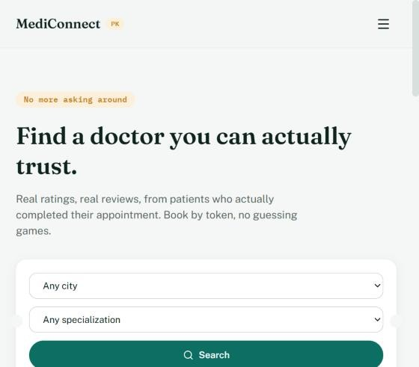  Figure 1: Homepage: landing page with hero section and search form | 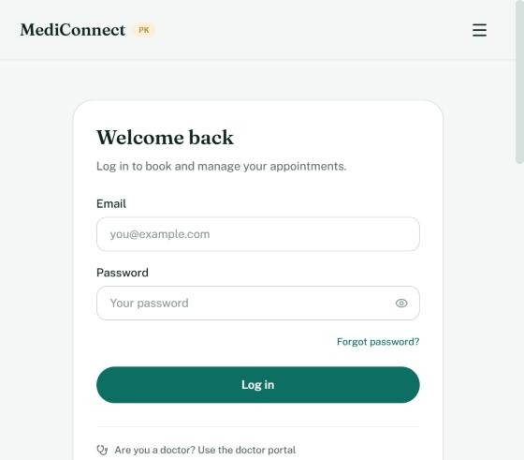  Figure 2: Patient login page
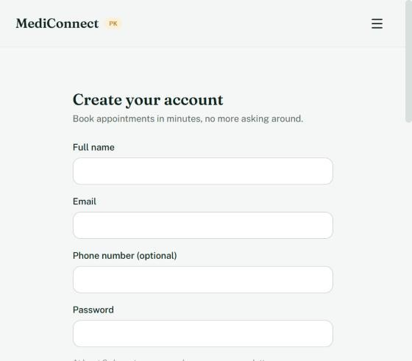  Figure 3: Patient signup page | 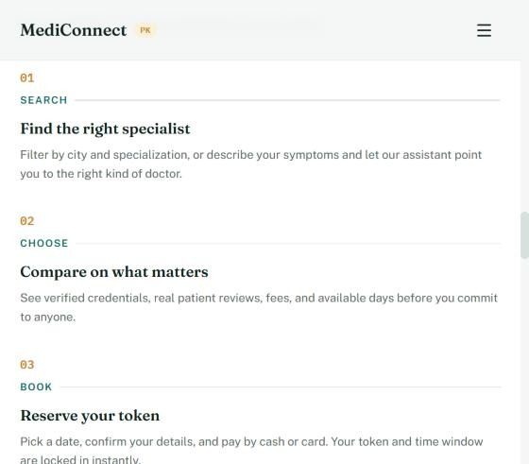  Figure 4: About page: how the platform works
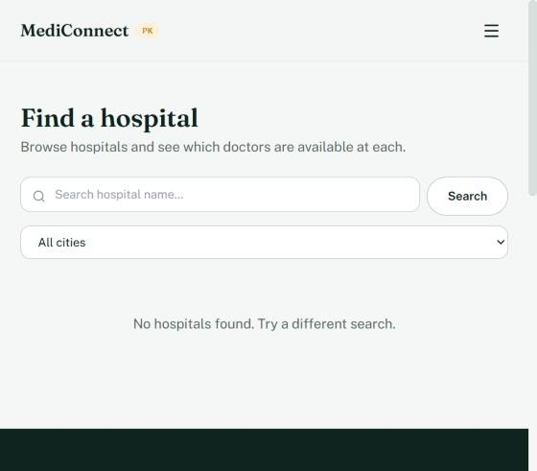  Figure 5: Find hospitals page with search and city filter | 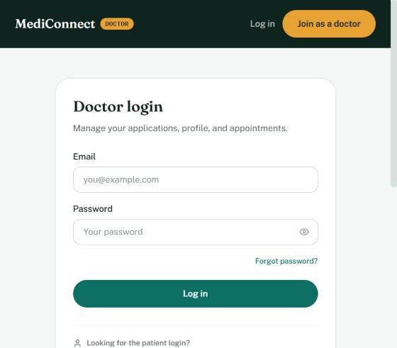  Figure 6: Doctor login page
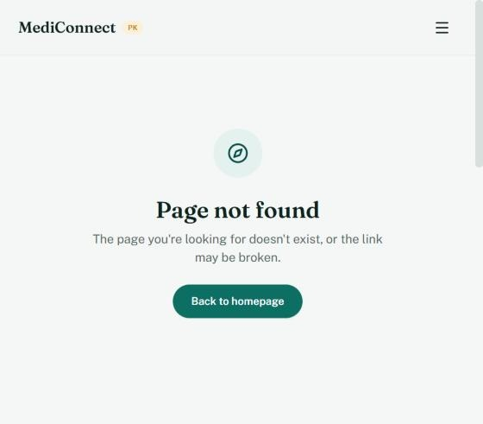  Figure 7: 404 Not Found page | 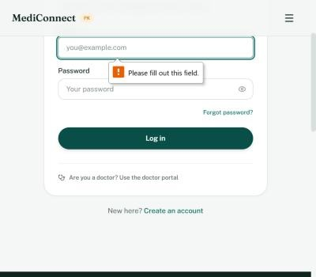  Figure 8: Login form validation: empty submission blocked
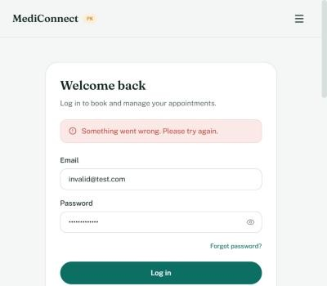  Figure 9: Login with invalid credentials: error state | 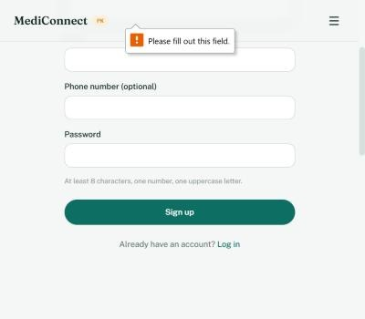  Figure 10: Signup form validation: empty submission blocked
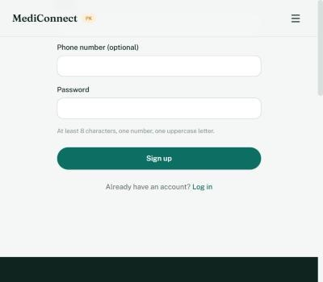  Figure 11: Signup password requirement hint | 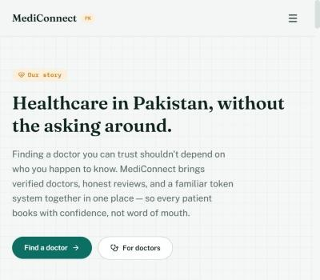  Figure 12: About page: Healthcare in Pakistan section
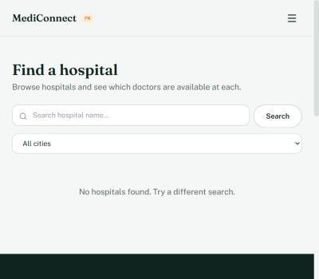
Figure 13: Hospitals page: search and filter

Submitted: October 2026 | Department of Software Engineering | NED University of Engineering & Technology

