1. Print Helloworld in script.

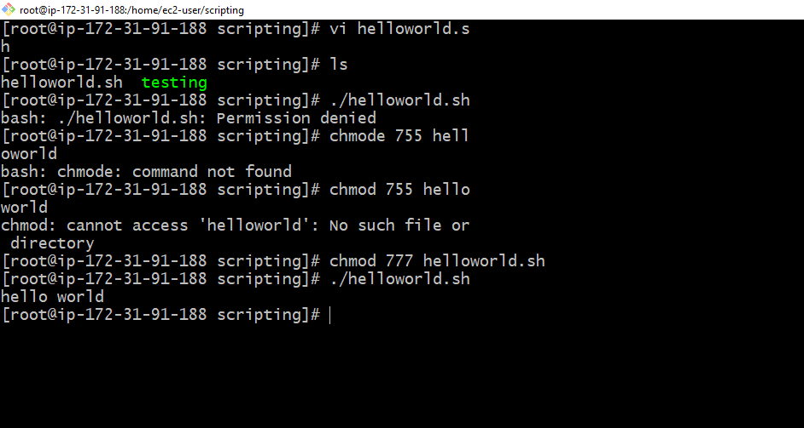

1. Sequence Script  
   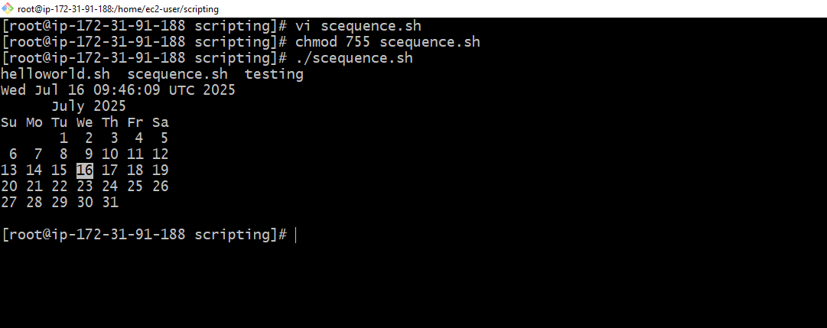
2. Basic second script :

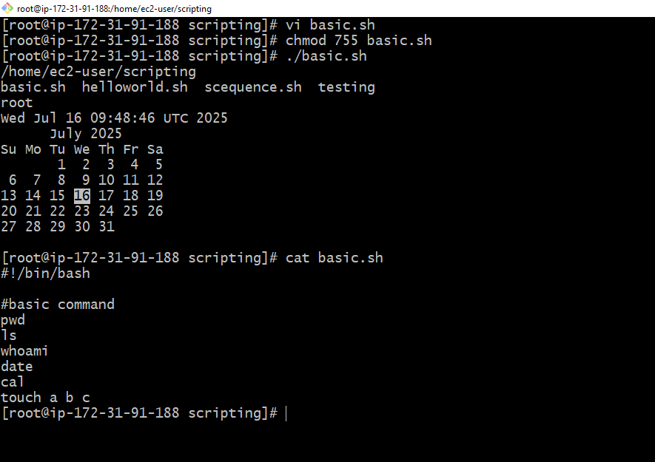

1. Basic administrator task  
   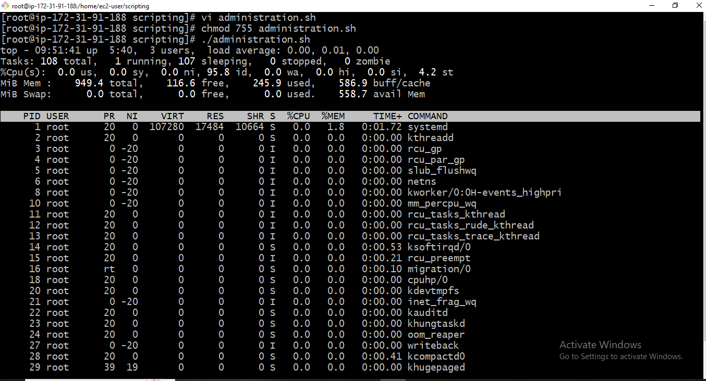
2. Define variable script

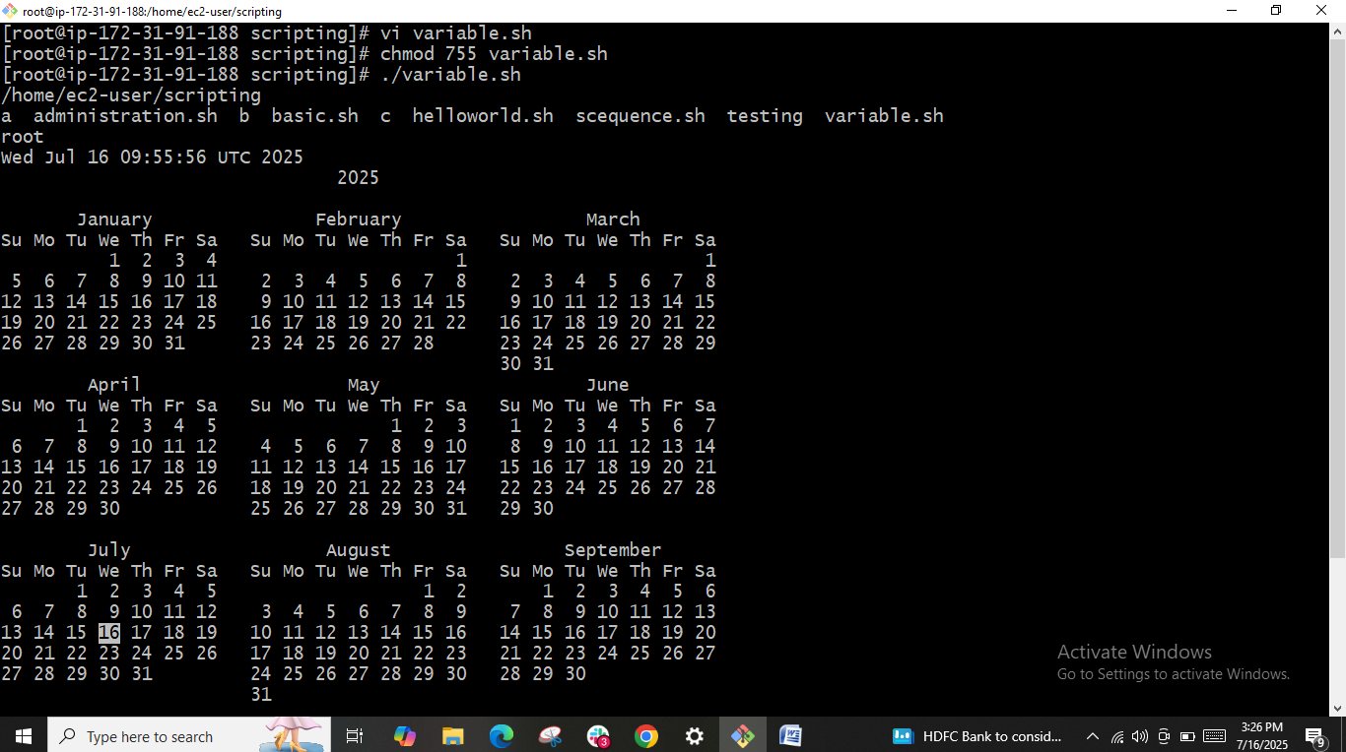

1. Input output script

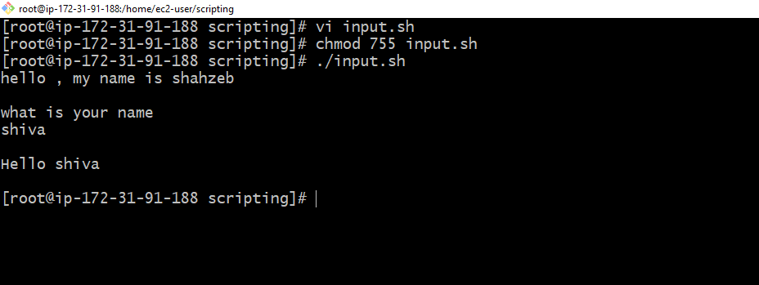

1. Input output script

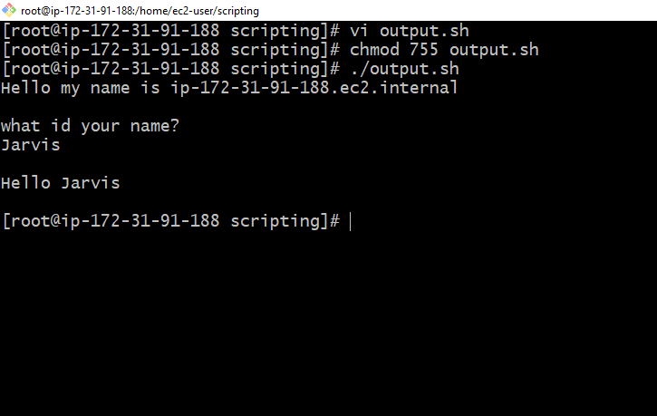

---------------------------------------------------------------------- **Output to screen**

#!/bin/bash

# Simple output script

echo "Hello World"

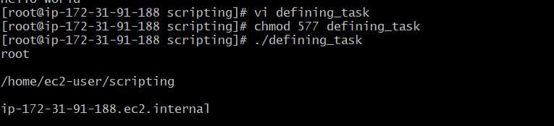

**Defining Tasks**

#!/bin/bash

# Define small tasks

whoami

echo

pwd

echo

hostname

echo

ls -ltr

echo

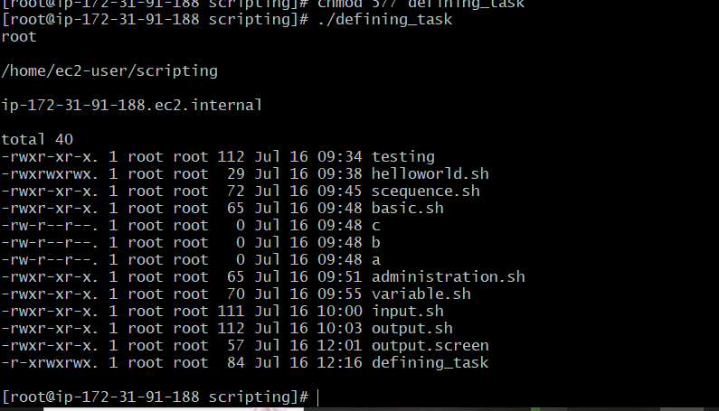

**Defining variables**

#!/bin/bash

# Example of defining variables

a=Imran

b=Afzal

c=’Linux class’

echo "My first name is $a"

echo "My surname is $b"

echo ‘My surname is $c’

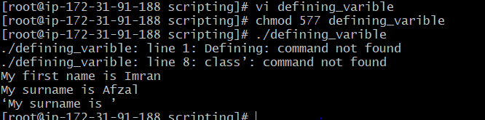

**Read Input**

#!/bin/bash

# Read user input

echo "What is your first name?"

read a

echo

echo "What is your last name?"

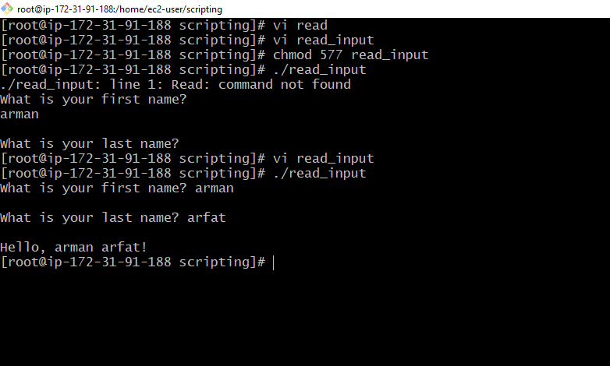

**Scripts to run commands within**

#!/bin/bash

# Script to run commands within

clear

echo "Hello `whoami`"

echo

echo "Today is `date`"

echo

echo "Number of user login: `who | wc -l `"

echo

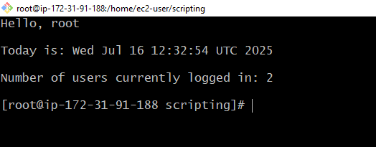

**Read input and perform a task**

#!/bin/bash

# This script will rename a file

echo Enter the file name to be renamed

read oldfilename

echo Enter the new file name

read newfilename

mv $oldfilename $newfilename

echo The file has been renamed as $newfilename

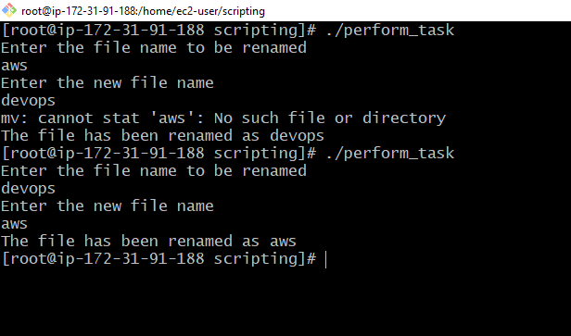

**case Scripts:**

#!/bin/bash

echo

echo Please chose one of the options below

echo

echo 'a = Display Date and Time'

echo 'b = List file and directories'

echo 'c = List users logged in'

echo 'd = Check System uptime'

echo

read choices

case $choices in

a) date;;

b) ls;;

c) who;;

d) uptime;;

*) echo Invalid choice - Bye.

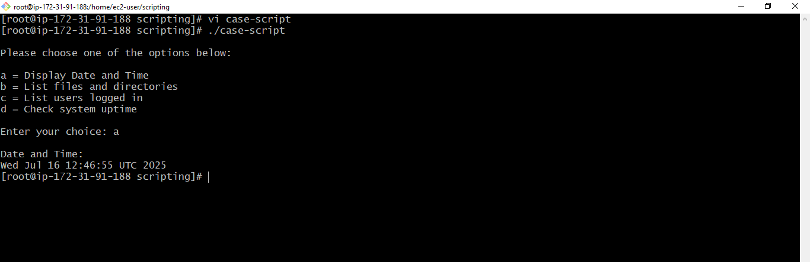

esac

**This script will look at your current day and tell you the state of the backup**

#!/bin/bash

NOW=$(date +"%a")

case $NOW in

Mon)

echo "Full backup";;

Tue|Wed|Thu|Fri)

echo "Partial backup";;

Sat|Sun)

echo "No backup";;

*) ;;

esac

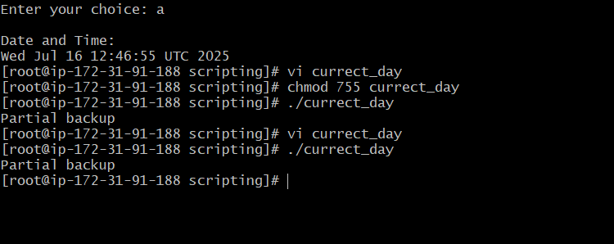

**do-while Script**

**Script to run for a number of times**

#!/bin/bash

c=1

while [ $c -le 5 ]

do

echo "Welcone $c times"

(( c++ ))

done