CENSUS MANAGEMENT SYSTEM
Project Report
1. Introduction
This project is a desktop-based Census Management System built using WPF (Windows Presentation Foundation) in C# with a Microsoft SQL Server database at the back end. The main idea behind this project was to replace the old paper-based census forms that Pakistan has been using for a long time. Those paper forms cause a lot of problems in practice data gets repeated across different forms, finding a specific person or household takes ages, there is no real access control, and putting together any kind of report means someone has to sit down and count things manually. This system solves all of that.
The application lets census officers log in, manage geographic areas, add households, register citizens, and generate population reports all from a clean WPF interface. Every piece of data is stored in a properly structured SQL Server database with foreign key relationships so nothing gets out of sync.
1.1 Why This Project Was Needed
Pakistan's national census process collects information about every household and every person living in the country. This is important data it is used for planning schools, hospitals, roads, and distributing government resources. But when that data is collected on paper, it creates a chain of problems:
• You end up with duplicate entries because the same person might appear on forms from two different officers
• Searching for a specific CNIC or household takes hours when everything is in folders • Anyone can pick up a paper form and read sensitive personal information there is no login or access control
• Generating a simple count of how many people live in a district requires someone to manually go through hundreds of forms
• Forms get lost, get wet, get damaged and that data is gone forever
A digitized system with a proper database, user authentication, and built-in reporting fixes every one of these issues.
1.2 What We Built
We built a full WPF desktop application with the following major pieces: • A Splash Screen that shows when the app first opens
• A Login and Signup system with password hashing no plaintext passwords stored anywhere
• A Dashboard Window showing live statistics pulled directly from the database • Area Management for managing Province, District, and Tehsil records • Household Management for registering family units with their address and area • Citizen Management for registering individual people with CNIC, age, education, occupation etc.
• A Reports section showing population totals, gender split, literacy rates, and employment breakdown
2. Technology Stack
We chose this specific combination of technologies because they are all part of the Microsoft ecosystem, which means they work together smoothly and are well-supported.
Layer | Technology | Why We Used It
UI / Frontend | WPF (.NET Framework 4.8) | XAML-based desktop UI with data binding, styles, and DataGrid support
Business Logic | C# | Handles validation, session state, and all the logic between UI and database
Data Access | ADO.NET (SqlConnection, SqlCommand) | Direct parameterized queries clean, fast, and safe from SQL injection
Database | Microsoft SQL Server | Relational database with proper foreign keys and constraints
Security | SHA-256 Password  Hashing | Passwords are hashed before saving even database admin cannot see them
IDE | Visual Studio 2022 | Full WPF designer, IntelliSense, and debugging tools
DB Management | SQL Server Management Studio | Used to write and test the database script

WPF was the natural choice for the frontend because it gives you proper XAML styling, data binding to C# properties, event handlers (like Button_Click and SelectionChanged), and a built-in DataGrid control that handles sorting and filtering without much extra code. We used .NET Framework 4.8 rather than .NET Core because the project requirements specified WPF and Framework 4.8 has the most stable WPF support.
3. System Architecture
The project follows a three-layer architecture. This means the code is organized into three separate concerns that do not bleed into each other. In practical terms this made it much easier to debug if something went wrong in the UI, we knew the problem was in the XAML or
code-behind. If the data was being saved wrong, we looked at the service class. If there was a database error, we went to the data access layer.
3.1 The Three Layers
Layer 1 UI (The WPF Windows and XAML)
This is everything the user sees and interacts with. Each module has its own Window or Page:
• SplashScreen.xaml the startup window with the logo and loading bar • LoginWindow.xaml and SignupWindow.xaml authentication screens • DashboardWindow.xaml the home screen with stats cards
• AreaManagementWindow.xaml for adding and managing areas
• HouseholdWindow.xaml for registering households
• CitizenWindow.xaml for registering individual citizens
• ReportsWindow.xaml for viewing population reports
The XAML files define the layout using Grid and StackPanel containers. We used Styles and a ResourceDictionary to keep the purple and peach theme consistent across all windows instead of setting the same color on every single Button, we defined a ButtonStyle in App.xaml and applied it everywhere.
Layer 2 Business Logic (Service Classes in C#)
This layer sits in the middle. It takes input from the UI, validates it, and either passes it to the database layer or throws an error back to the UI. The main classes here are:
• UserService.cs handles registration, login, and password hashing/verification • AreaService.cs CRUD operations and validation for Area records
• HouseholdService.cs creates and manages Household records, checks for linked area
• CitizenService.cs the most complex service; validates CNIC format, prevents duplicates, auto-calculates age
• SessionManager.cs a static class that holds the CurrentUser object so we know who is logged in across all windows
Layer 3 Data Access (ADO.NET)
This layer is purely responsible for talking to SQL Server. We have a DatabaseHelper.cs class that holds the connection string and provides a shared SqlConnection. Every query goes through SqlCommand with SqlParameter objects we never concatenate user input directly into SQL strings because that would open the door to SQL injection attacks.
3.2 Folder Structure
Folder | What's Inside
/Views/ | All the .xaml files and their .xaml.cs code-behind files
/Models/ | Plain C# classes: User.cs, Area.cs, Household.cs, Citizen.cs
/Services/ | Business logic: UserService, AreaService, HouseholdService, CitizenService
/Data/ | DatabaseHelper.cs connection string and SqlConnection setup
/Helpers/ | PasswordHelper.cs for hashing, ValidationHelper.cs for CNIC and email checks
/Resources/ | Styles.xaml with all shared WPF styles, brushes, and templates merged in App.xaml
CensusDB.sql | The full database creation script run this first in SSMS before launching the app

4. Database Design
The database is called CensusDB and has four main tables. The relationships between them are enforced using foreign keys so SQL Server itself will reject any data that breaks the links we are not relying only on application-level checks.
4.1 How the Tables Connect
• Areas is the top-level table. Every Household must belong to an Area. • Households links to Areas via AreaID. One area can have many households. • Citizens links to Households via HouseholdID. One household can have many citizens.
• Users is the separate table for people who log into the app census officers, not citizens.
So the chain looks like this: Areas → Households → Citizens. If you try to delete an Area that has Households linked to it, SQL Server will throw a foreign key violation error and our application catches that and shows the user a proper message instead of crashing.
4.2 Table Details
Users Table
This stores the accounts for people who log into the application. The Email column has a UNIQUE constraint so two officers cannot register with the same email address. The
PasswordHash column stores the SHA-256 hash of the password never the actual password.
Column | Type | Constraint | Notes
UserID | INT IDENTITY(1,1) | PRIMARY  KEY | Auto-increments we never set this manually
FullName | NVARCHAR(100) | NOT NULL | Officer's full name
Email | NVARCHAR(150) | UNIQUE, NOT NULL | Used as the login username
PasswordHash | NVARCHAR(256) | NOT NULL | Hashed original password is never stored
CreatedAt | DATETIME | DEFAULT  GETDATE() | Automatically set to current date/time on insert

Areas Table
This table stores the geographic locations. We seed it with Pakistan's five main provinces and a few districts/tehsils to start with. In the WPF app, the Province, District, and Tehsil are actually separate columns here (not separate tables), which keeps the queries simpler while still organizing data properly.
Column | Type | Constraint | Notes
AreaID | INT IDENTITY(1,1) | PRIMARY  KEY | Referenced by  Households.AreaID
Province | NVARCHAR(100) | NOT NULL | e.g. Punjab, Sindh, KPK
District | NVARCHAR(100) | NOT NULL | e.g. Rawalpindi, Lahore
Tehsil | NVARCHAR(100) | NOT NULL | Sub-district level

Households Table
Each row here is one family living in one house. The AreaID column creates the foreign key link to the Areas table. The NumberOfMembers column is a useful quick reference but the actual count of registered Citizens linked to that HouseholdID is what the dashboard uses for accurate totals.
Column | Type | Constraint | Notes
HouseholdID | INT IDENTITY(1,1) | PRIMARY  KEY | Referenced by  Citizens.HouseholdID
HouseNumber | NVARCHAR(50) | NOT NULL | Physical house number

FamilyNumber | NVARCHAR(50) | NOT NULL | Census-assigned family code
HeadOfFamily | NVARCHAR(100) | NOT NULL | Name of the main family  member
Address | NVARCHAR(255) | NOT NULL | Full street or village address
NumberOfMembers | INT | DEFAULT 1 | Entered at registration time
AreaID | INT | FOREIGN  KEY → Areas | Links this household to its area
CreatedAt | DATETIME | DEFAULT  GETDATE() | Auto timestamp

Citizens Table
This is the biggest table. Every individual person gets a row here. The CNICNumber column is UNIQUE which means SQL Server will reject any attempt to insert a second person with the same CNIC this is the core of the duplicate prevention system. The HouseholdID foreign key links each citizen to their household.
Column | Type | Constraint | Notes
CitizenID | INT IDENTITY(1,1) | PRIMARY  KEY | Auto-generated ID
CNICNumber | NVARCHAR(13) | UNIQUE, NOT NULL | 13 digits, no dashes or spaces
FullName | NVARCHAR(100) | NOT NULL | Citizen's full name
Gender | NVARCHAR(10) | NOT NULL | Male / Female / Other
DateOfBirth | DATE | NOT NULL | Selected from DatePicker in the UI
Age | INT | NOT NULL | Auto-calculated when  DateOfBirth is picked
MaritalStatus | NVARCHAR(20) | NOT NULL | Single / Married / Divorced / Widowed
Education | NVARCHAR(50) | NOT NULL | From Illiterate up to  Postgraduate
Occupation | NVARCHAR(100) | NOT NULL | Job or profession
RelationWithHead | NVARCHAR(50) | NOT NULL | Self / Spouse / Son / Daughter / Other
HouseholdID | INT | FOREIGN  KEY →  Households | Links citizen to their household

5. Application Modules How They Work
5.1 Splash Screen
When the application starts, SplashScreen.xaml is the first thing that loads. It uses a DispatcherTimer a WPF timer that runs on the UI thread to animate a ProgressBar from 0 to 100 over about 3 seconds. Once it hits 100, the timer stops, the Dashboard or Login window opens, and the splash screen closes itself. The window has no title bar (WindowStyle="None") and is centered on screen using
WindowStartupLocation="CenterScreen".
5.2 Authentication Login and Signup
The Signup and Login windows are both simple WPF Windows with a Grid layout. The form fields are TextBox and PasswordBox controls bound to variables in the code-behind.
How Signup Works
When the user fills in the form and clicks the Register button, the Button_Click handler in SignupWindow.xaml.cs runs. It first checks that no TextBox is empty, then checks that the two password fields match, then calls UserService.RegisterUser(). That method hashes the password using SHA-256, then runs an INSERT INTO Users query with SqlCommand and SqlParameter. If the email already exists, SQL Server throws a unique constraint violation, we catch it, and show a MessageBox telling the user the email is taken.
How Login Works
The login form takes an email and password. When Login is clicked,
UserService.LoginUser() runs a SELECT query to find a user with that email. If no row comes back, we show an error. If a row comes back, we hash the entered password and compare it to the stored PasswordHash. If they match, we set SessionManager.CurrentUser to the retrieved User object, close the Login window, and open the DashboardWindow. The session stays alive for the entire time the application is running.
5.3 Dashboard
The Dashboard window is the home screen. It has four summary cards at the top Total Households, Total Population, Male Population, Female Population. When the window loads (inside the Window_Loaded event), we run four separate COUNT queries against the database and display the results in TextBlock controls inside styled Border elements. The numbers update every time you navigate back to the dashboard, so they always reflect the current state of the data.
The rest of the dashboard has navigation buttons that open each module window. We used a consistent style for all nav buttons defined once in Styles.xaml and applied via a Style key so every button looks the same without repeating the XAML.
5.4 Area Management
The Area Management window has two main sections. On the left side, there is a form with three TextBox fields: Province, District, and Tehsil. On the right side (or below, depending on the layout), there is a DataGrid bound to a List<Area> that gets populated when the window loads.
Adding an area runs a simple INSERT INTO Areas query. Selecting a row in the DataGrid populates the form fields automatically using the DataGrid SelectionChanged event we read DataGrid.SelectedItem, cast it to an Area object, and fill the TextBoxes. The Update button runs an UPDATE Areas SET query using the AreaID of the selected record. The Delete button first checks if any Household has this AreaID as a foreign key if yes, it shows a warning and does nothing. If no households are linked, it runs DELETE FROM Areas.
The DataGrid itself is set up with AutoGenerateColumns="False" so we define exactly which columns appear and what their headers say. We also set IsReadOnly="True" on the grid so users can only edit data through the form, not by clicking cells directly.
5.5 Household Management
The Household window works similarly to Area Management. The form collects House Number, Family Number, Head of Family, Address, Number of Members, and an Area selection. The Area field is a ComboBox that loads all records from the Areas table when the window opens. The DisplayMemberPath is set to a combined string like "Province - District - Tehsil" so the user sees something readable in the dropdown.
When a household is saved, the selected ComboBox item's AreaID is extracted and included in the INSERT statement. The DataGrid below shows all households with their linked area information using a JOIN query: SELECT h.*, a.Province, a.District, a.Tehsil FROM Households h INNER JOIN Areas a ON h.AreaID = a.AreaID. This way the DataGrid shows the actual province name instead of just a number.
5.6 Citizen Management
This is the most complex window in the application. The form has about twelve fields covering all the personal information required by the census. A few things worth explaining:
CNIC Validation
As soon as the user moves out of the CNIC TextBox (using the LostFocus event), we run a check in code-behind. First we check the length is exactly 13 and that all characters are digits using int.TryParse. Then we run a SELECT COUNT(*) FROM Citizens WHERE CNICNumber = @cnic query to check for duplicates. If either check fails, we highlight the TextBox border in red and show an error label below it. This gives instant feedback without waiting for the Save button.
Auto Age Calculation
The Date of Birth is entered using a DatePicker control. We handle the
SelectedDateChanged event whenever the user picks a date, we calculate the age right there in code: (DateTime.Today - selectedDate.Value).Days / 365. The result gets written into the Age TextBox automatically. The user can still manually edit the Age field if needed.
The DataGrid
The citizen DataGrid supports searching by name or CNIC using a TextBox above the grid. As the user types (TextChanged event), we filter the ObservableCollection<Citizen> or re run the SELECT query with a WHERE FullName LIKE @search OR CNICNumber LIKE @search condition. The results update in real time. The DataGrid also has column header click sorting enabled through the built-in WPF sorting mechanism.
6. Data Validation
We put validation in two places. First in the UI itself (code-behind) so the user gets immediate feedback, and second at the database level through constraints like NOT NULL and UNIQUE so even if something slips through the UI, the database rejects it.
Validation | How We Check It | What the User Sees
Empty fields | string.IsNullOrWhiteSpace() on every required TextBox | Red border on the empty field and an error label below it
CNIC format | Check length == 13 and  long.TryParse succeeds | "CNIC must be exactly 13 digits with no dashes."
Duplicate CNIC | SELECT COUNT(*) query on LostFocus of CNIC TextBox | "A citizen with this CNIC already exists in the system."
Age out of range | Check age > 0 && age <= 150 before saving | "Please enter a valid age between 0 and 150."
Future date of birth | Check selectedDate <=  DateTime.Today | "Date of birth cannot be in the future."
Non-numeric member count | int.TryParse on the members TextBox | "Number of members must be a valid number."

Duplicate email (signup) | Catch SqlException for unique constraint violation | "This email address is already  registered."
Password mismatch | Compare Password.Password == Confirm.Password | "Passwords do not match. Please try again."

7. Reports
The Reports window runs aggregate SQL queries and displays results in DataGrid controls. We did not use any third-party reporting library all reports are built using standard SELECT with GROUP BY and COUNT(*) queries via ADO.NET, and the results are loaded into DataTable objects which are then set as the DataGrid's ItemsSource.
Report | SQL Logic Used
Total Population | SELECT COUNT(*) FROM Citizens also broken down by area using GROUP BY AreaID
Population by Area | JOIN between Citizens, Households, and Areas GROUP BY Province, District, Tehsil with COUNT(*)
Gender Distribution | SELECT Gender, COUNT(*) as Total FROM Citizens GROUP BY Gender
Literacy Statistics | SELECT Education, COUNT(*) as Total FROM Citizens GROUP BY Education ORDER BY Total DESC
Employment Statistics | SELECT Occupation, COUNT(*) as Total FROM Citizens GROUP BY Occupation ORDER BY Total DESC

Each report button triggers a method that runs the relevant query, reads the result into a DataTable using SqlDataAdapter.Fill(), and assigns it to a DataGrid with DataGrid.ItemsSource = dataTable.DefaultView. The DataGrid's AutoGenerateColumns is set to True for reports since the column names come directly from the query aliases.
8. Security
8.1 Password Hashing
When a user registers, we never save their actual password. In PasswordHelper.cs, we use SHA-256 to hash the password string before passing it to the INSERT query. On login, we hash whatever the user types in and compare it to the stored hash. If the hashes match, the password is correct. This means that even if someone gets direct access to the SQL Server database and reads the Users table, they will only see a string like "a665a45920422f9..." not the actual password.
8.2 SQL Injection Prevention
Every single database query in this application uses SqlParameter. We never do something like: cmd.CommandText = "SELECT * FROM Users WHERE Email = '" + email + "'". Instead it looks like this:
Unsafe (what we avoided) | Safe (what we actually do)
cmd.CommandText = "SELECT * FROM Users WHERE Email = '" + email + "'" | cmd.Parameters.AddWithValue("@email", email)

Parameterized queries tell SQL Server to treat the parameter value as data only not as SQL code. So even if a user types something like ' OR 1=1 -- into the email field, SQL Server will treat that as a literal string to search for, not as SQL to execute.
8.3 Session Management
SessionManager is a static C# class with a single property: public static User CurrentUser { get; set; }. When login is successful, we set SessionManager.CurrentUser = the logged-in user object. Every protected window checks this at the top of its Window_Loaded event if CurrentUser is null, the window closes itself and brings the Login window back. When the user logs out, we set SessionManager.CurrentUser = null and navigate back to Login.
9. Problems We Ran Into and How We Solved Them
9.1 Cascading ComboBoxes for Area
The original plan was to have three separate ComboBoxes one for Province, one for District, one for Tehsil where selecting a Province would filter the districts, and selecting a district would filter the tehsils. The problem was that our Areas table stores Province, District, and Tehsil all in one row, not in three separate tables. So instead of three filtered queries, we load all distinct Province values for the first ComboBox, then on SelectionChanged of Province we do SELECT DISTINCT District FROM Areas WHERE Province = @prov, and on SelectionChanged of District we do SELECT AreaID, Tehsil FROM Areas WHERE Province = @prov AND District = @dist. The final selection gives us the AreaID we need.
9.2 The DataGrid Not Refreshing After Adding a Record
After saving a new household or citizen, the DataGrid was not showing the new record. The fix was simple but took a while to figure out after the INSERT, we call the LoadData() method again which re-runs the SELECT query and reassigns the result to the DataGrid's ItemsSource. We also tried using ObservableCollection<T> with data binding, which automatically updates the UI when items are added, but the ADO.NET DataTable approach was simpler given how our queries are structured.
9.3 Foreign Key Delete Errors Looking Like Crashes
When we first tried to delete an Area that had households linked to it, the application was throwing an unhandled SqlException and the window was crashing. The fix was to wrap every DELETE operation in a try-catch block specifically catching SqlException, and checking if the Number property is 547 (which is SQL Server's error code for a foreign key constraint violation). If it is 547, we show a MessageBox like "Cannot delete this area it has households linked to it. Remove the households first." instead of crashing.
9.4 Keeping the Theme Consistent Across All Windows
As more windows were added, copying and pasting the same button color and font settings was getting messy and hard to update. We moved all the shared styles into a ResourceDictionary file called Styles.xaml inside the /Resources folder. This file defines a Style for Button, TextBox, DataGrid, and the purple/peach color brushes. In App.xaml we added a MergedDictionaries entry pointing to Styles.xaml, which makes those styles available in every Window in the project automatically.
9.5 Age Not Matching Date of Birth
When editing a citizen record, the loaded age sometimes did not match the date of birth because the age had been entered manually during the original registration. We added a check in the SelectedDateChanged handler: if the loaded age differs from the calculated age by more than 1 year, we automatically update the Age TextBox and mark the record as modified. This keeps the data consistent without being too strict about manual entries.
10. Testing
We tested each module manually by going through the common user flows and intentionally trying to break things submitting empty forms, entering invalid CNICs, trying to delete linked records, and so on.
What We Tested | Expected Behaviour | Result | Module
Register with a new email and valid password | Account created, redirected to login | PASS | Auth
Register with an email already in the database | Error message email taken | PASS | Auth
Login with wrong password | Error invalid credentials, no crash | PASS | Auth
Dashboard stats after adding test data | Cards show the correct updated counts | PASS | Dashboard

Add a household with all fields filled | Record saved and appears in DataGrid | PASS | Household
Submit household form with empty Address | Red border on Address field, no save | PASS | Household
Add citizen with CNIC that already exists | Error shown on CNIC field, no save | PASS | Citizen
Add citizen with CNIC like "123" (too short) | CNIC format validation error appears | PASS | Citizen
Search citizens by partial name in DataGrid | Grid filters to matching rows only | PASS | Citizen
Try deleting an area with linked households | FK error caught, friendly  message shown | PASS | Area
Open Reports window and  generate gender report | DataGrid fills with correct  Male/Female/Other counts | PASS | Reports

11. Conclusion
This project successfully built a working desktop census management system using WPF and SQL Server that addresses all the problems with the old paper-based process. Officers can log in securely, manage geographic areas, register households and individual citizens, and pull up population reports in seconds things that used to take days of manual work.
From a technical standpoint the project covers a solid range of WPF concepts: XAML layout with Grid and StackPanel, resource dictionaries for shared styles, event handlers for Button_Click and SelectionChanged, DataGrid with search and sort, DatePicker with calculated fields, ComboBox with dynamic loading, and proper window-to-window navigation. On the database side it uses foreign keys, UNIQUE constraints, parameterized queries, aggregate queries with GROUP BY, and JOIN queries for the reports.
If this were to be extended further, the most useful next additions would be:
• Role-based access currently all logged-in users have the same permissions. Adding an Admin role that can manage other users and a Read-Only Viewer role would make the system more realistic for actual government use.
• PDF export for reports right now reports only show in the DataGrid inside the app. Exporting to PDF or Excel would let officers share the data easily.
• Audit trail keeping a log of who added, edited, or deleted each record and when. This is important for any government system.
• Union Council and Census Block fields the current area hierarchy stops at Tehsil. The actual Pakistan census goes down to Union Council and then to individual Census Blocks, which would need to be added for a production system.
Output
Splash screen
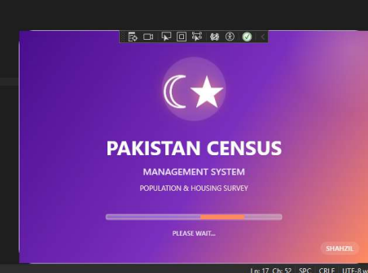Sign up
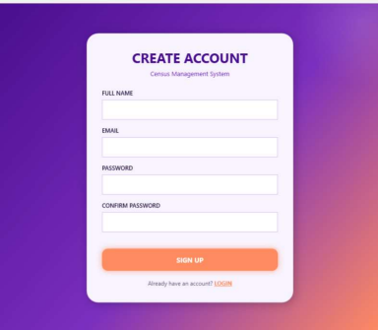
Login in
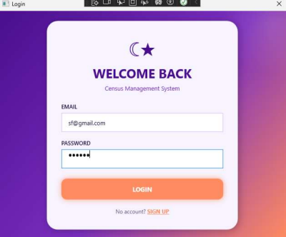Dashboard
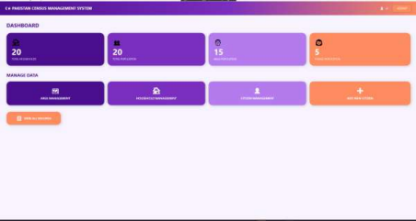
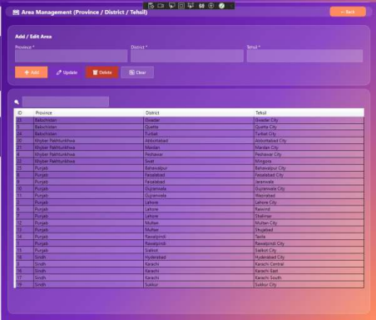CURD
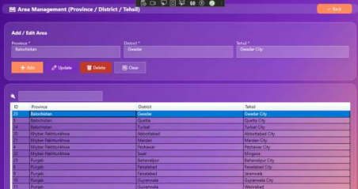Household management
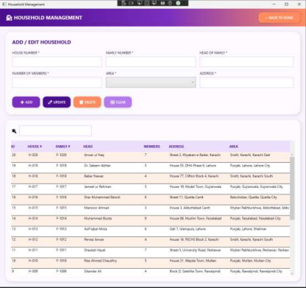CURD
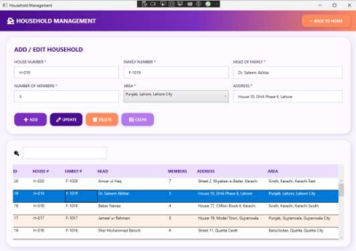
Citizen management
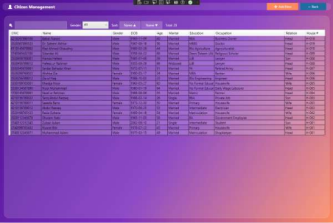CURD
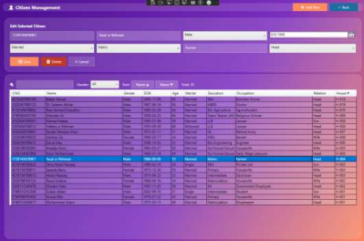Sorting
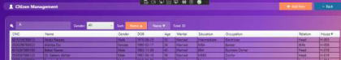
Add new citizen
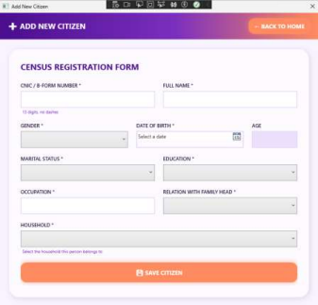
View all records
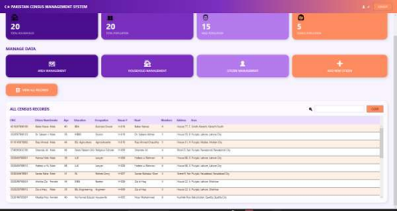Searching
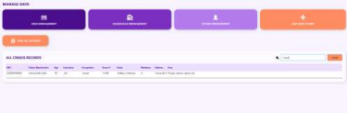Logout

