Begin

1-2-masala

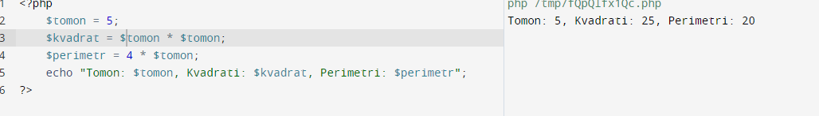

3-masala

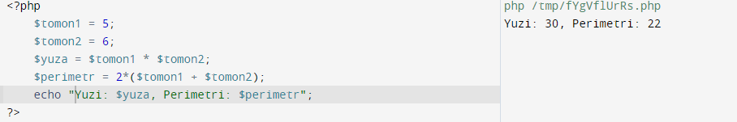

4-masala

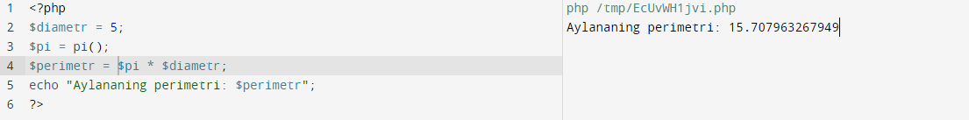

5-masala

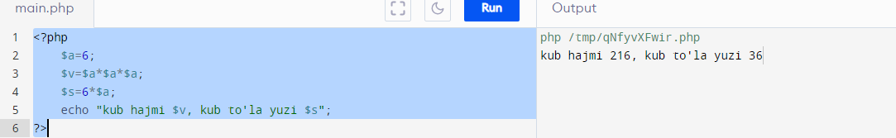

6-masala

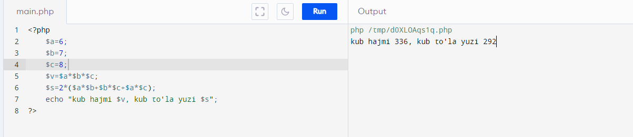

7-masala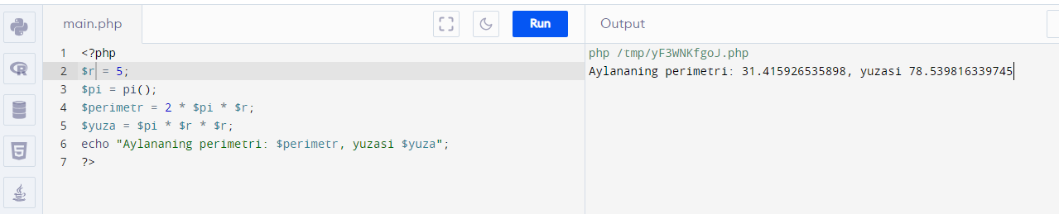

8-9-masala

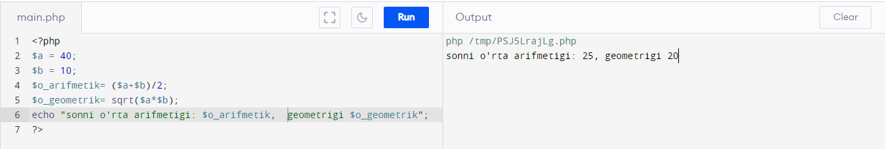

10-masala

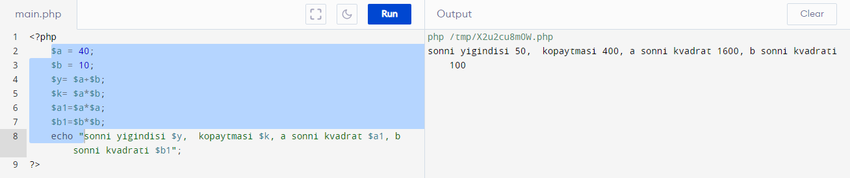

Integer

1-masala

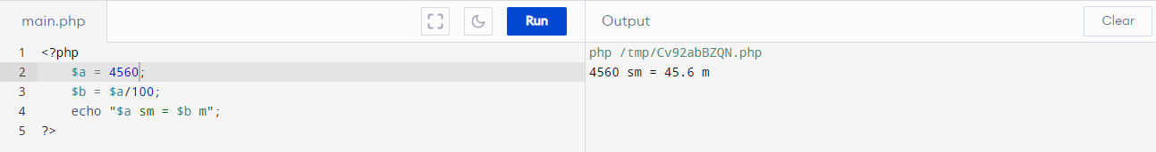

2-masala

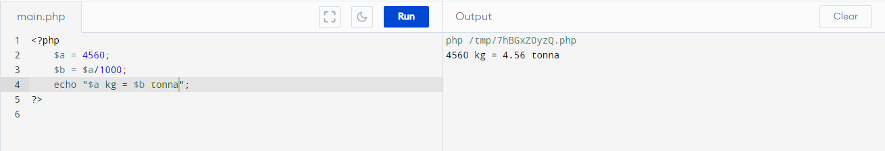3-masala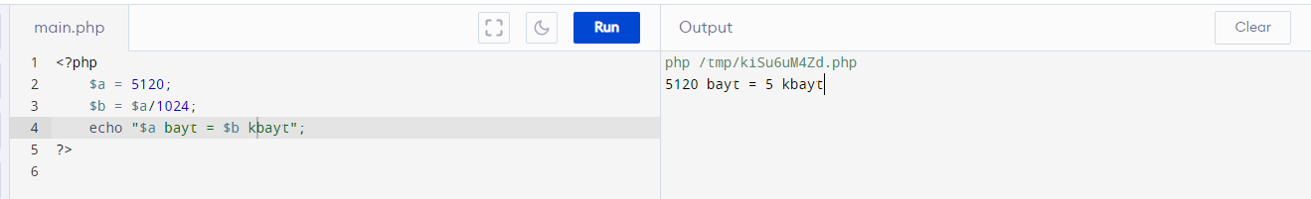

4-masala

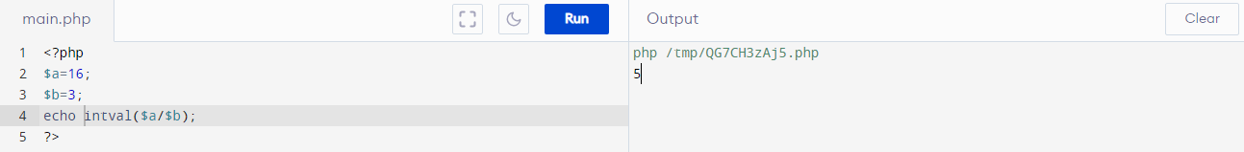

5-masala

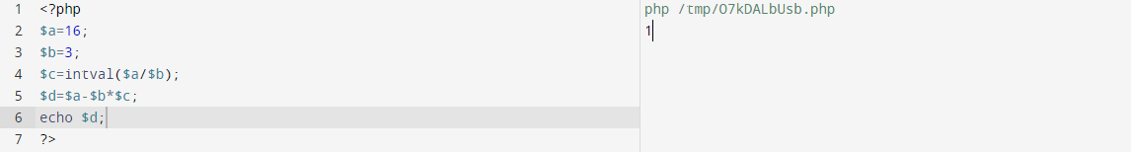

6-masala

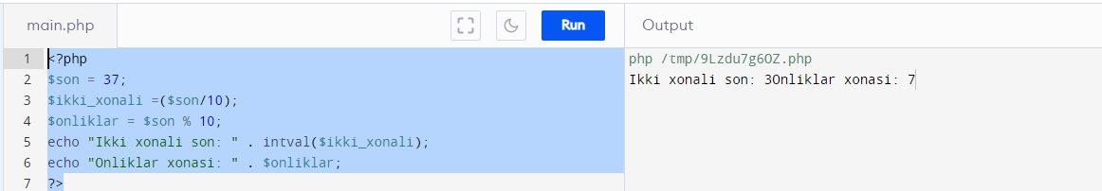

7-masala

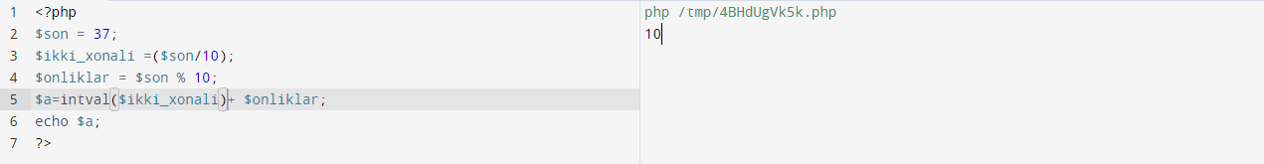

8-masala

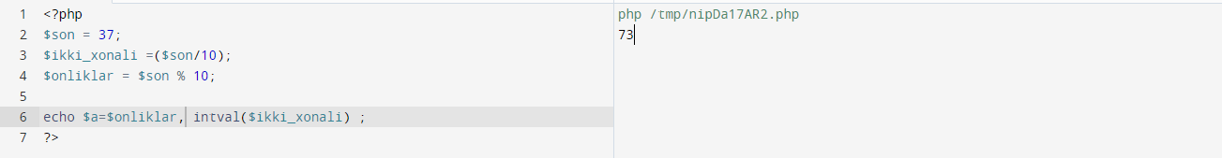

9-masala

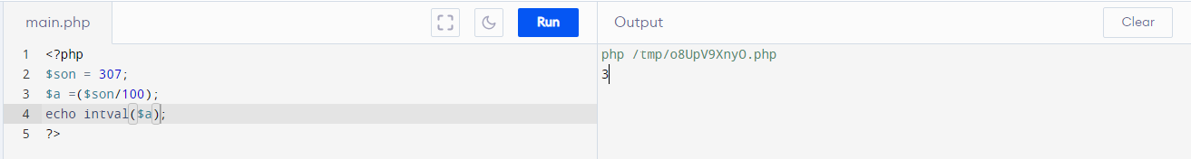

10-masala

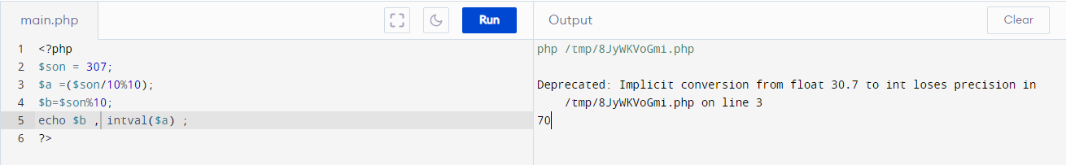

If

1-masala

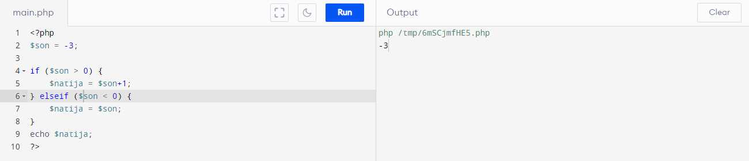

2-masala

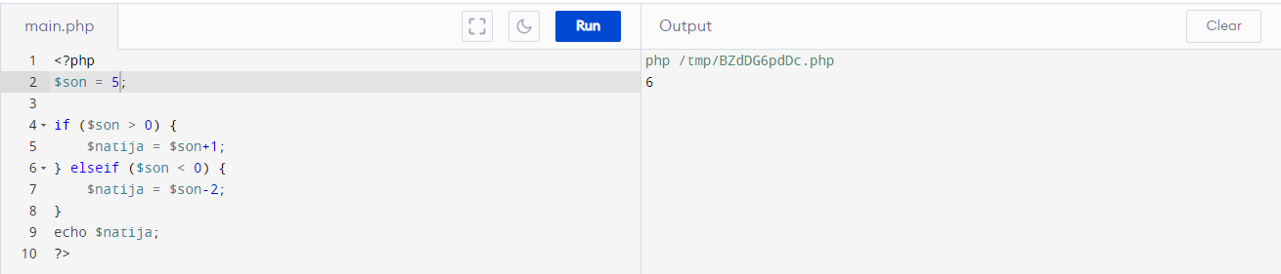

3-masala

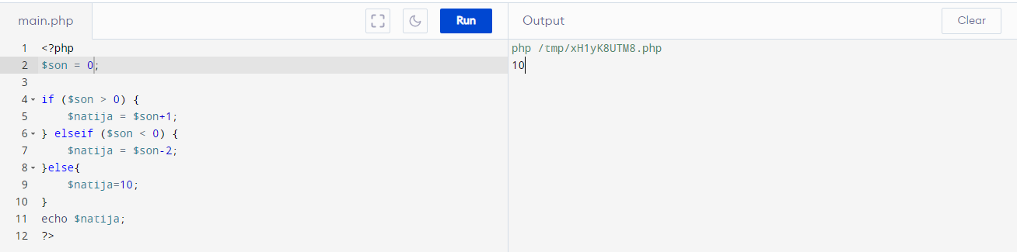

4-masala

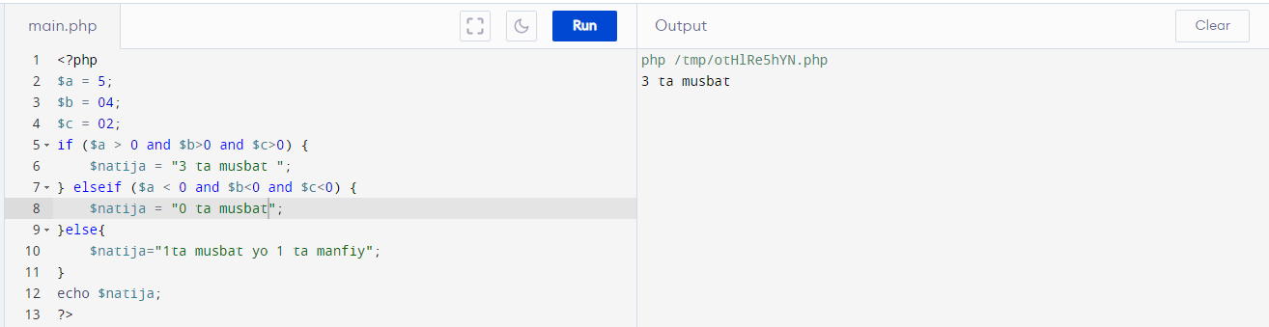

5-6-masala

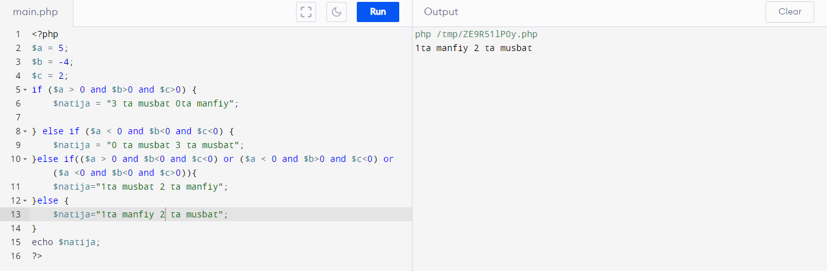

7-masala

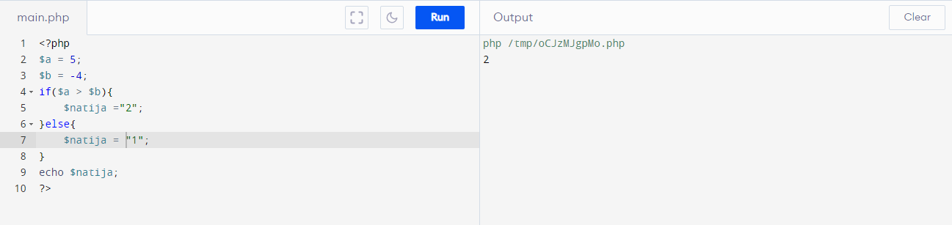

8-masala

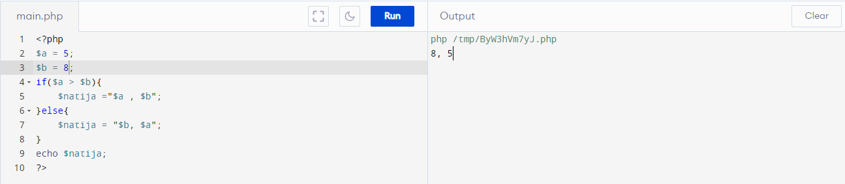

9-masala

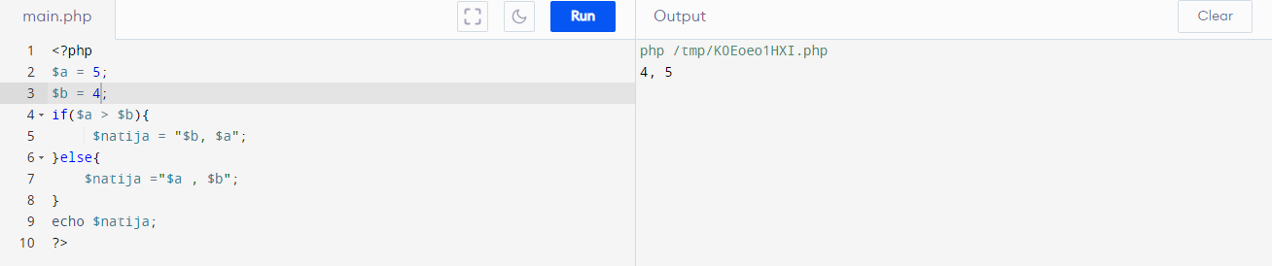

10-masala

