Objective: The purpose of this exercise is to learn how to connect simple input and output devices to an FPGA chip and implement a circuit that uses these devices. The problems in this lab exercise illustrate me to know about DE1-Soc board, Multiplexer, gates, switches, LED, 7 segment display.
- Part1: This is a basic program where we get output for corresponding switch. For example, when We turn on switch (0), it turns on the switch (1). The code screenshot and a sample output what I get are given below:

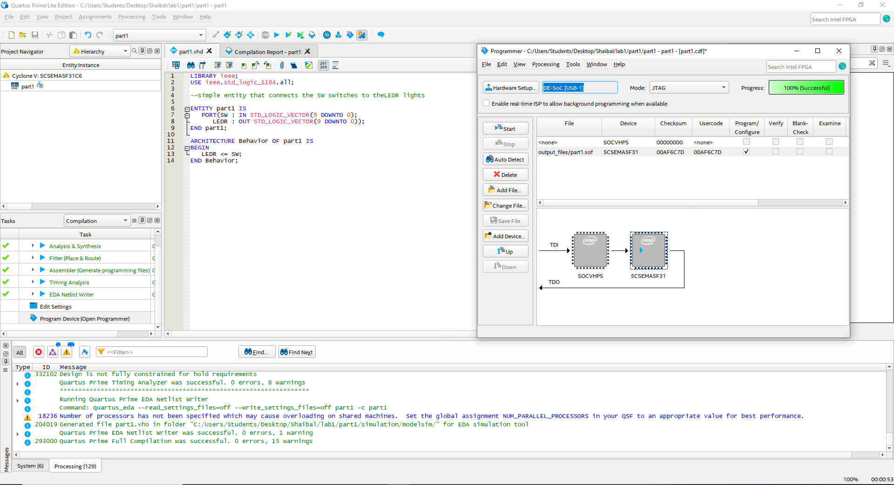
Figure 1.1: Code and analysis successful screenshot for part1

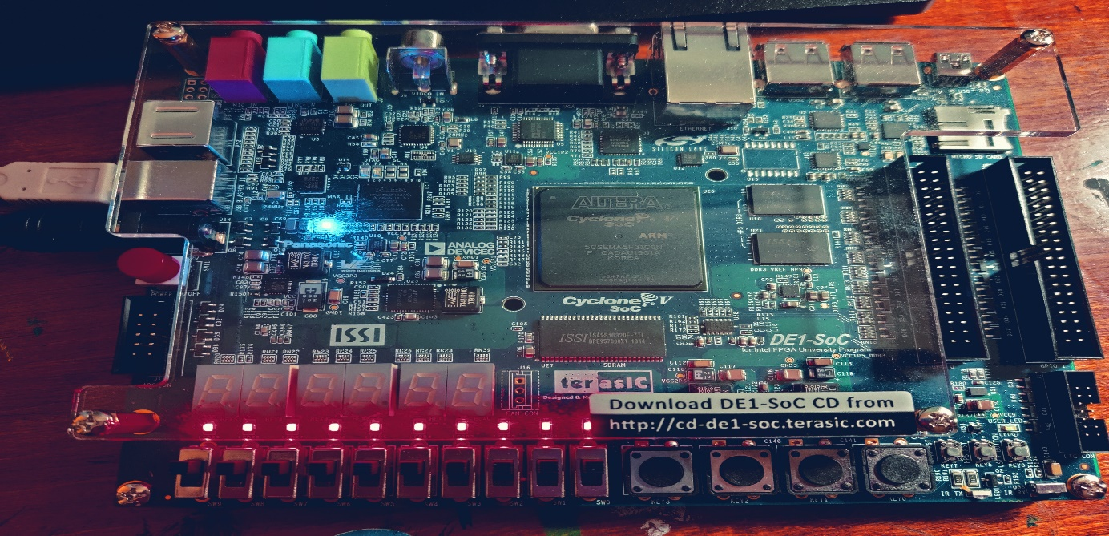

Figure1.2: Sample Output Picture of part1

- Part2: The part2 is to build a 4-bit wide 2 to 1 mux using 1 bit 2 to 1 mux. The truth table for 1 bit 2 to 1 is given below:
Here for four bit we can think x as x0, x1, x2, x3 and Y as y0, y1, y2, y3. All the mux has same selection which makes this truth table as a generic table for models. For example, if you give x=0101 and y=1001 with selection s0=1 we get 1001 as output in this program. A clear picture of input of a sample attached below.
S0 | output
0 | x
1 | y

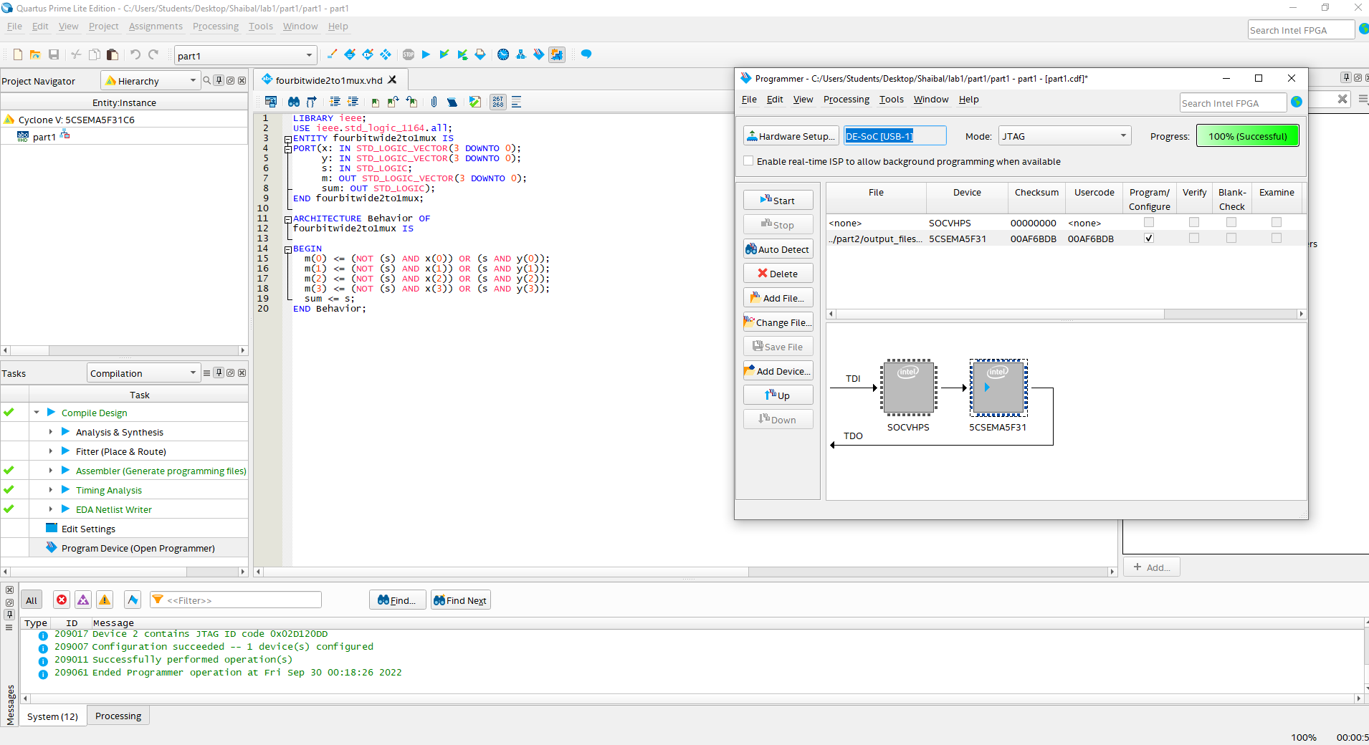
Figure 2.1: Code and analysis successful screenshot for part2
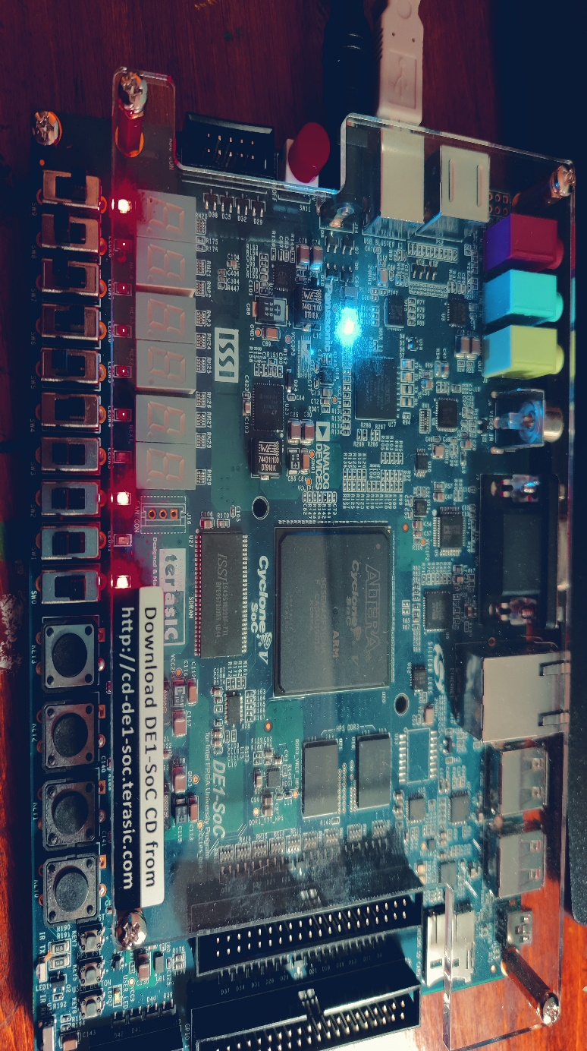Figure 2.2: A sample output for s1=1
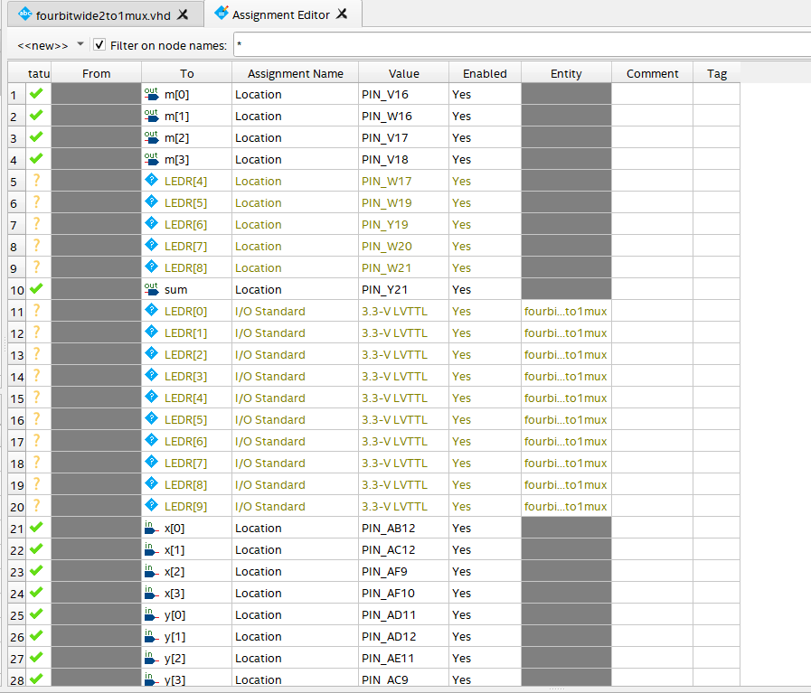
Figure 2.3: A pin configuration for part2 assignment
- Part3: The part3 is a problem to write VHDL program for a two-bit wide 4 to 1 mux. I used same subscript to make a 1 bit 4 to 1 mux to 2 bit 4 to 1 mux and show those output in led . The program. The truth table for 4 to 1 mux is below:

S1 | S0 | out
0 | 0 | u
0 | 1 | v
1 | 0 | w
1 | 1 | x
Here for two bit we can think u as u0, u1 and v as v0, v1 and w as w0,w1 and x as x0, x1. All the mux has same selection which makes this truth table as a generic table for models. For example, if you give u=01 ,v=10,w=00 and x=10 with selection s=00 we get 01 as output in this program. A clear picture of input of a sample attached below.
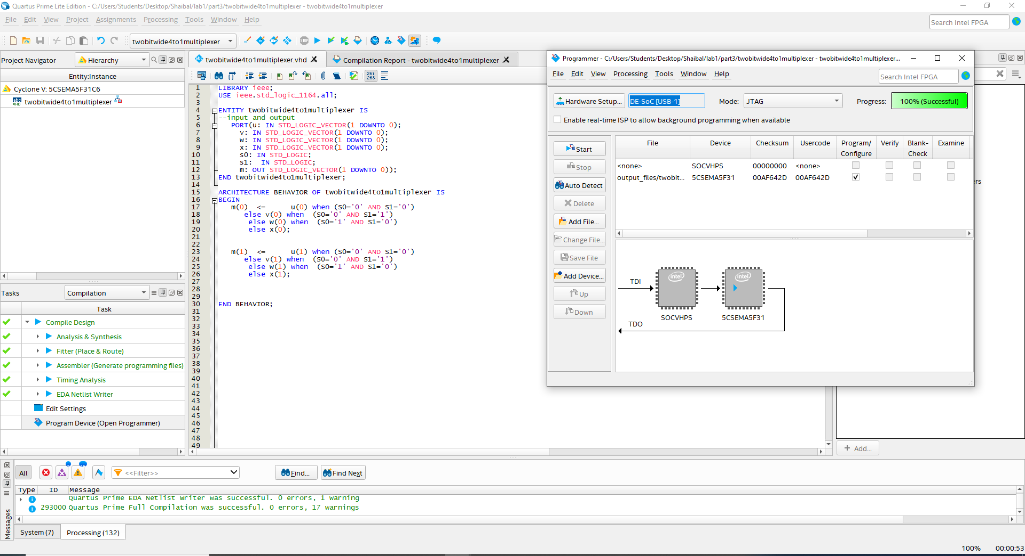
Figure 3.1: Code and analysis screenshot
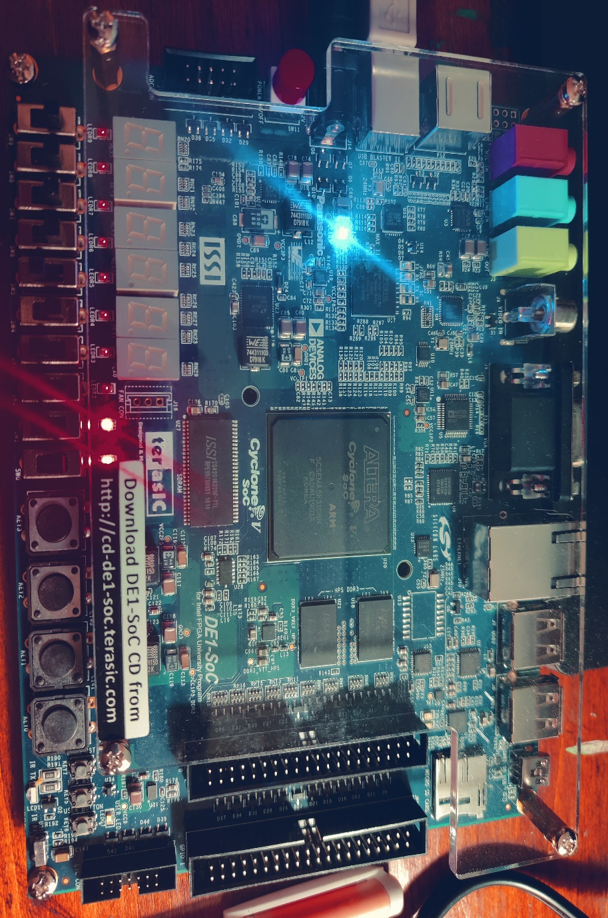
Figure 3.2: A sample picture of output

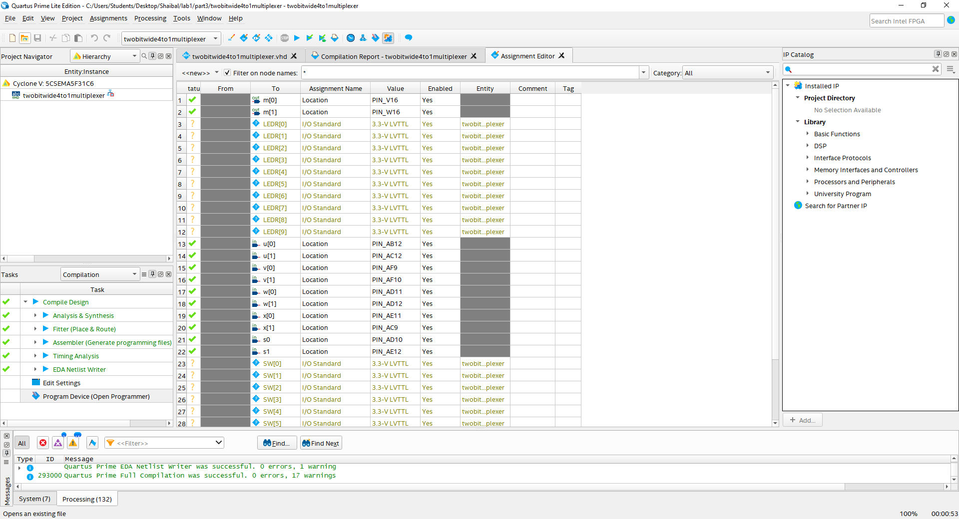
Figure 3.3: Pin configuration for part 3
- Part4: The part4 is a problem to write VHDL program for a 7 segment display which produces a specific letter with input.
c1 | c0 | output
0 | 0 | d
0 | 1 | E
1 | 0 | 1
1 | 1 | blank
I use canonical approach of sop to find the appropriate equations. The assignments are for separate anode in 7 segment display. like I build equation for a,b,c,d,e,f,g nodes. The equations are given below: Here Hex0 is the 7-segment display and 0 to 6 are a to g respectively. The screenshots are given below step by step after equations:
HEX0(0)<= not(((not (c(1))) AND (c(0))));
HEX0(1)<= not(((not(c(1)) ) AND not(c(0))) OR (c(1) AND not(c(0))));
HEX0(2)<= not(((not(c(1)) ) AND not(c(0))) OR (c(1) AND not(c(0))));
HEX0(3)<= not(((not(c(1)) ) AND not(c(0))) OR (c(0) AND not(c(1))));
HEX0(4)<= not(((not(c(1)) ) AND not(c(0))) OR (c(0) AND not(c(1))));
HEX0(5)<= not(((not (c(1))) AND (c(0))));
HEX0(6)<= not(((not(c(1)) ) AND not(c(0))) OR (c(0) AND not(c(1))));
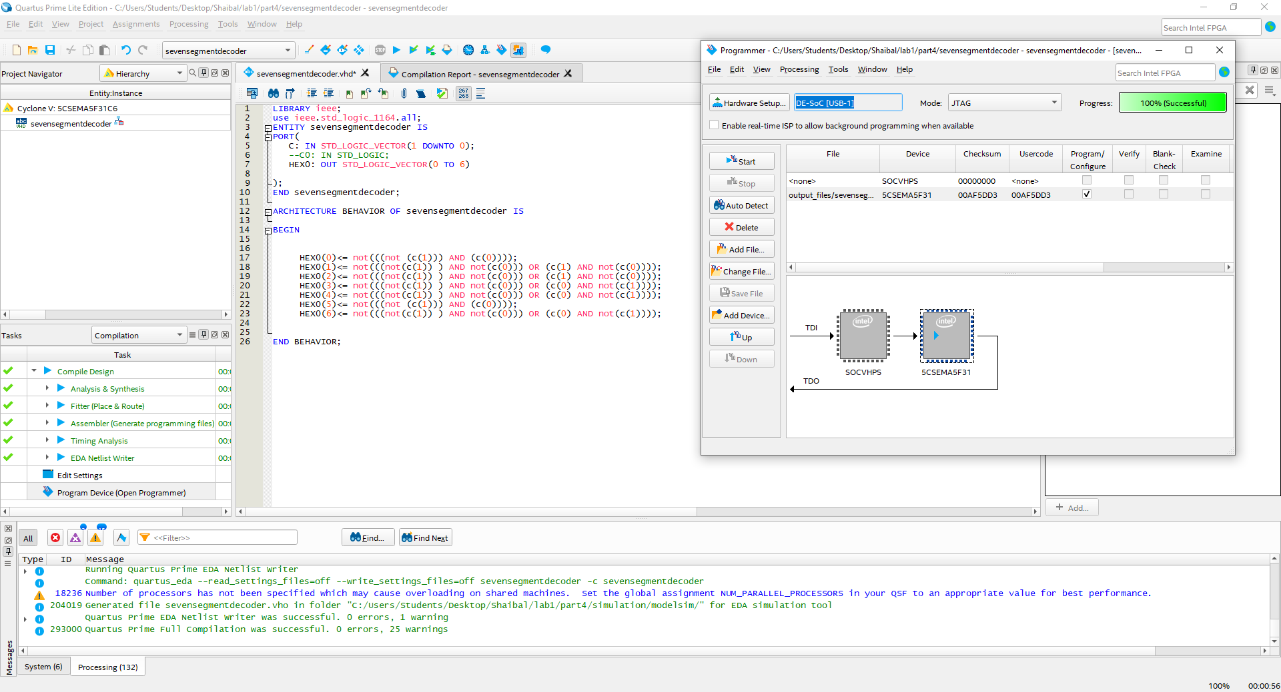
Figure 4.1: Code and analysis screenshot
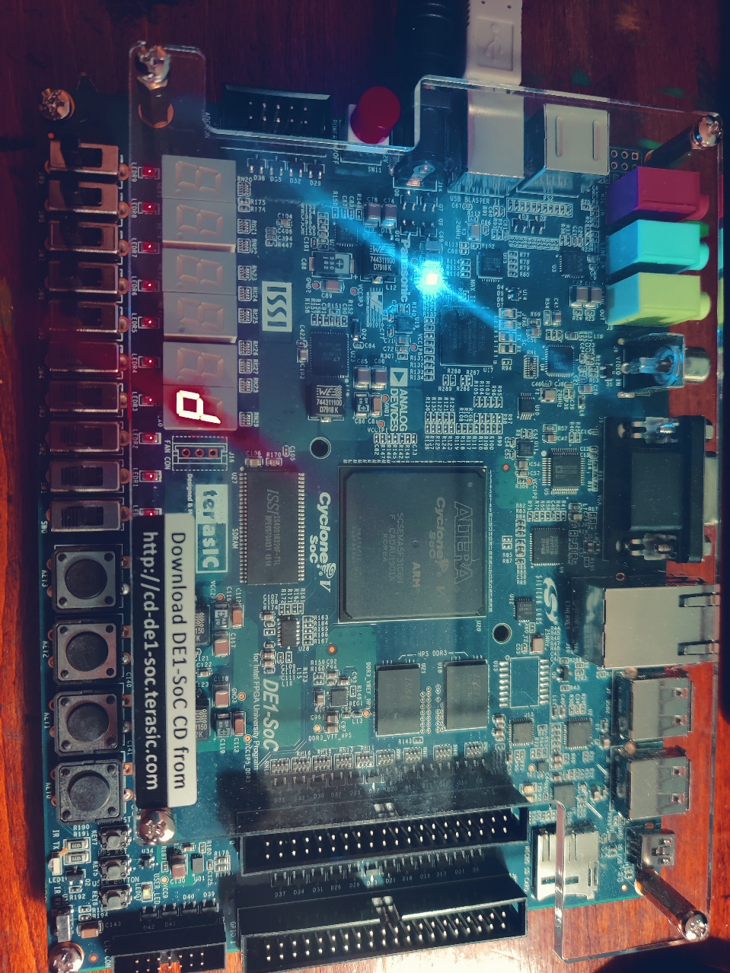
Figure 4.2: Output for 00
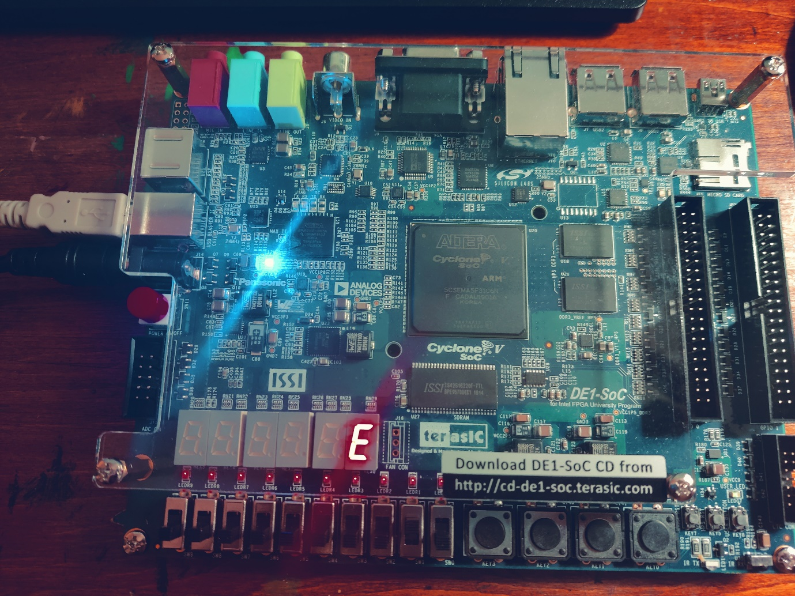Figure 4.3: Output for 01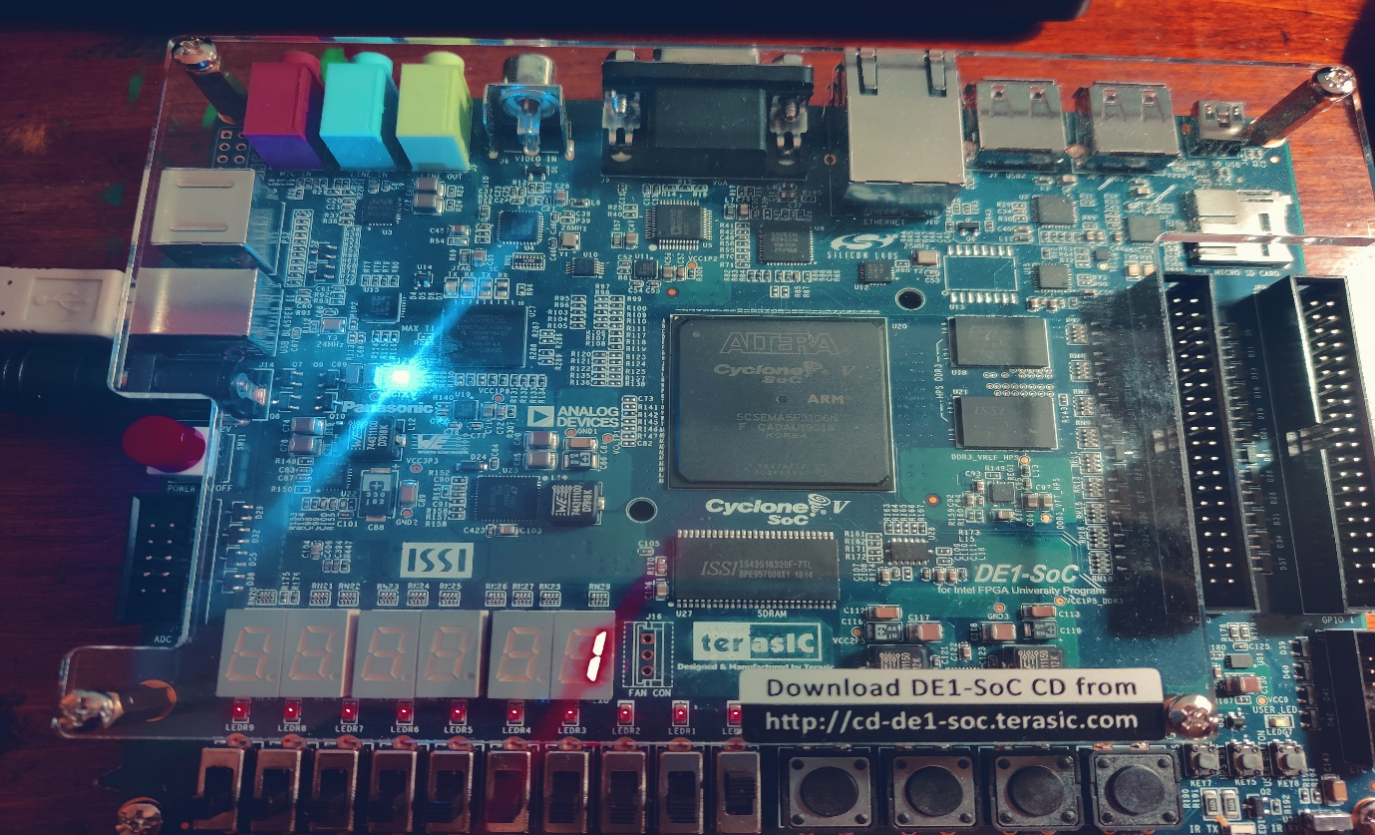
Figure 4.4: output for 10
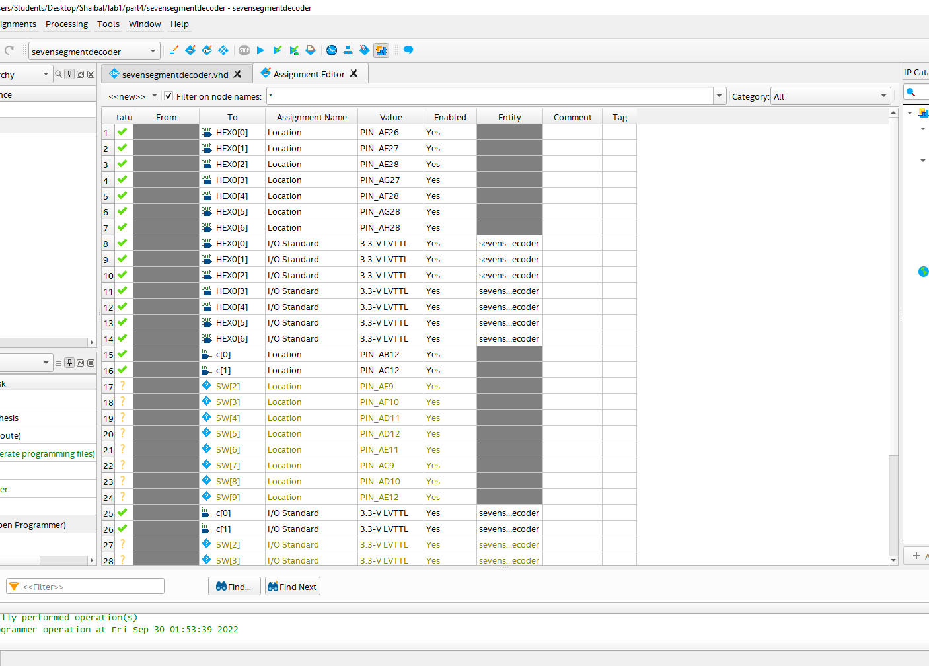
Figure 4.5: Pin assignment for part4
- Part5: The part5 is the combination part for part4 and part5. I have to use 7 segment concepts with mux 4 to1 mux concept where selector is responsible to print de10 word as pattern. In addition, I also did the rotation for the de10 as it is mentioned in the assignment documentation. I use component concept of VHDL programming to use the attribute of another file. I have to use four 7-segment display for this part. The detailed code and sample output along with pin assignment screenshots are attached below.

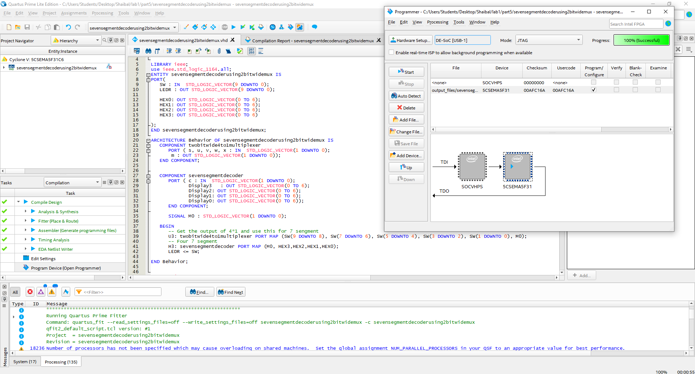
Figure 5.1: Code of part5
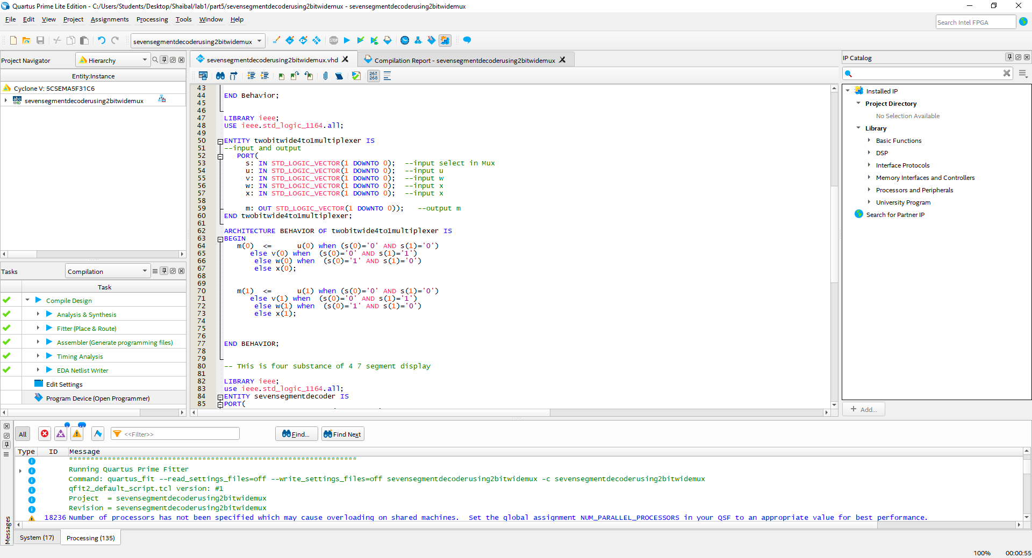
Figure 5.2: Code of part 5 (2bit 4 to1 mux)

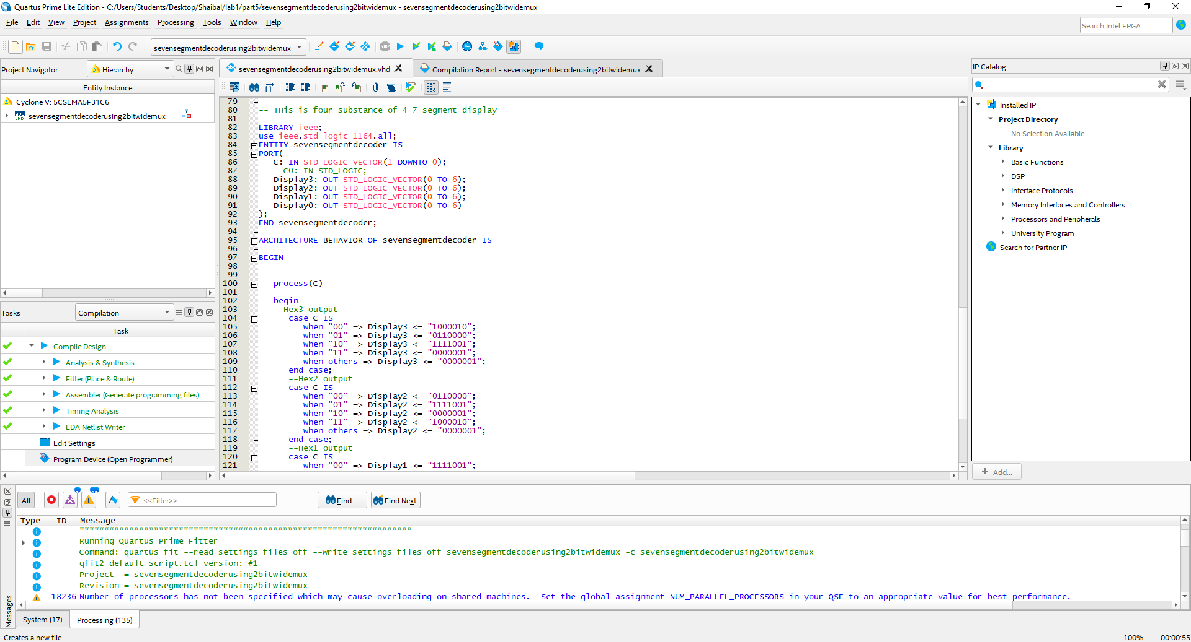
Figure 5.3: Code of part 5 (four 7-segment codes)
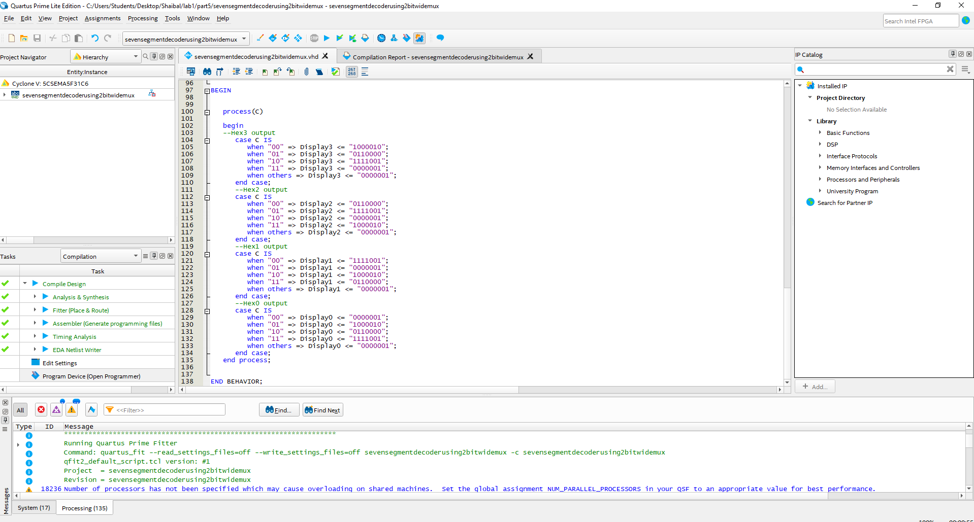
Figure 5.4: Code of part 5 (four 7-segment codes continue)

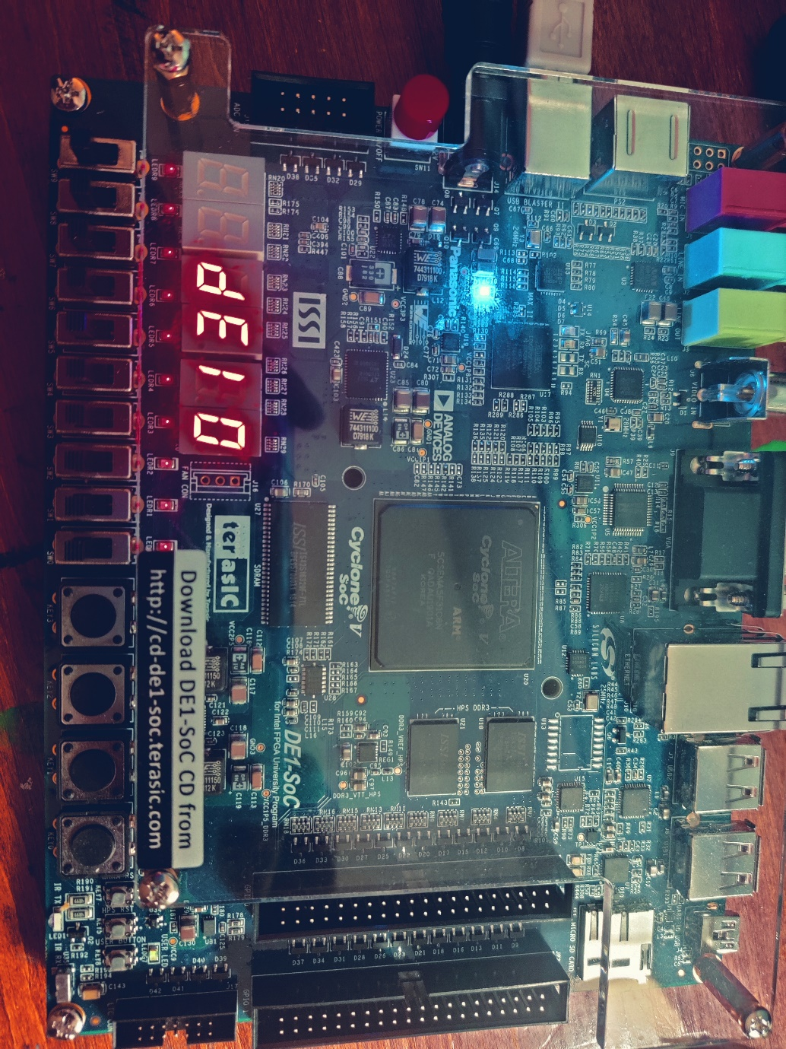
Figure 5.5: Sample Output
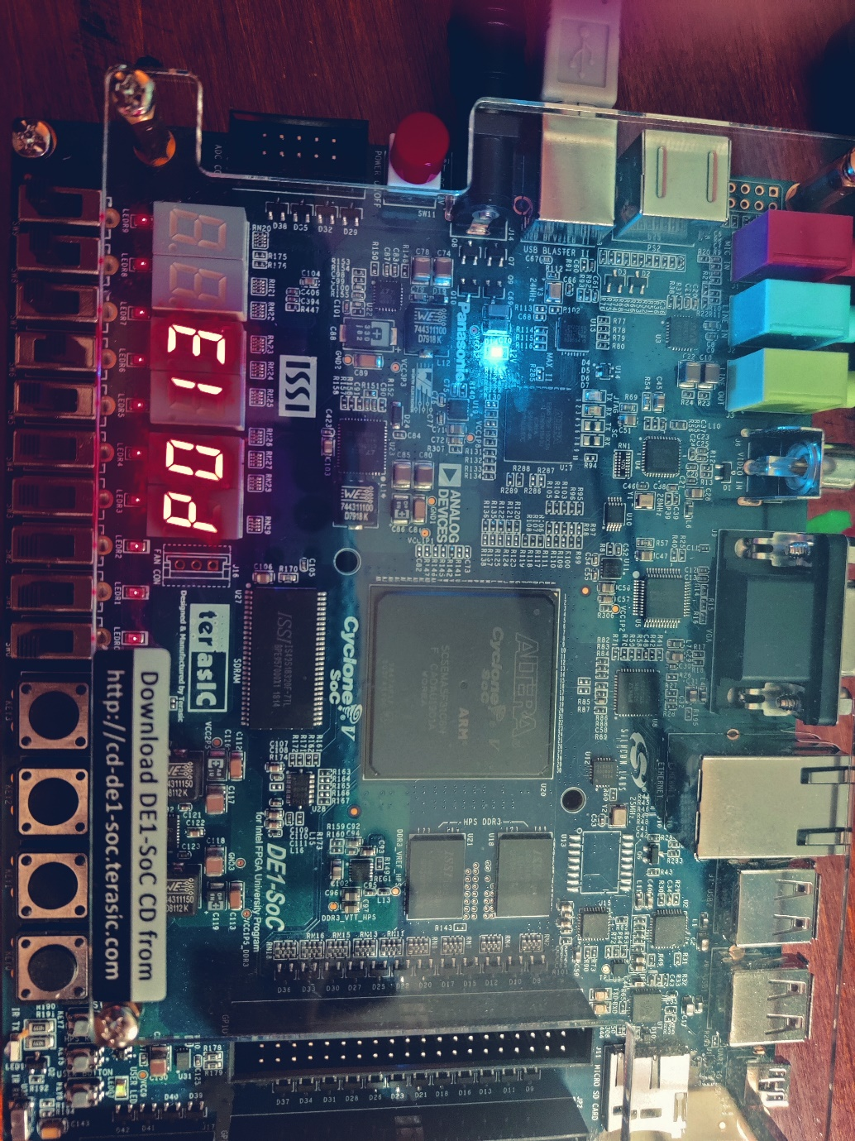
Figure 5.6: Sample Output (2)

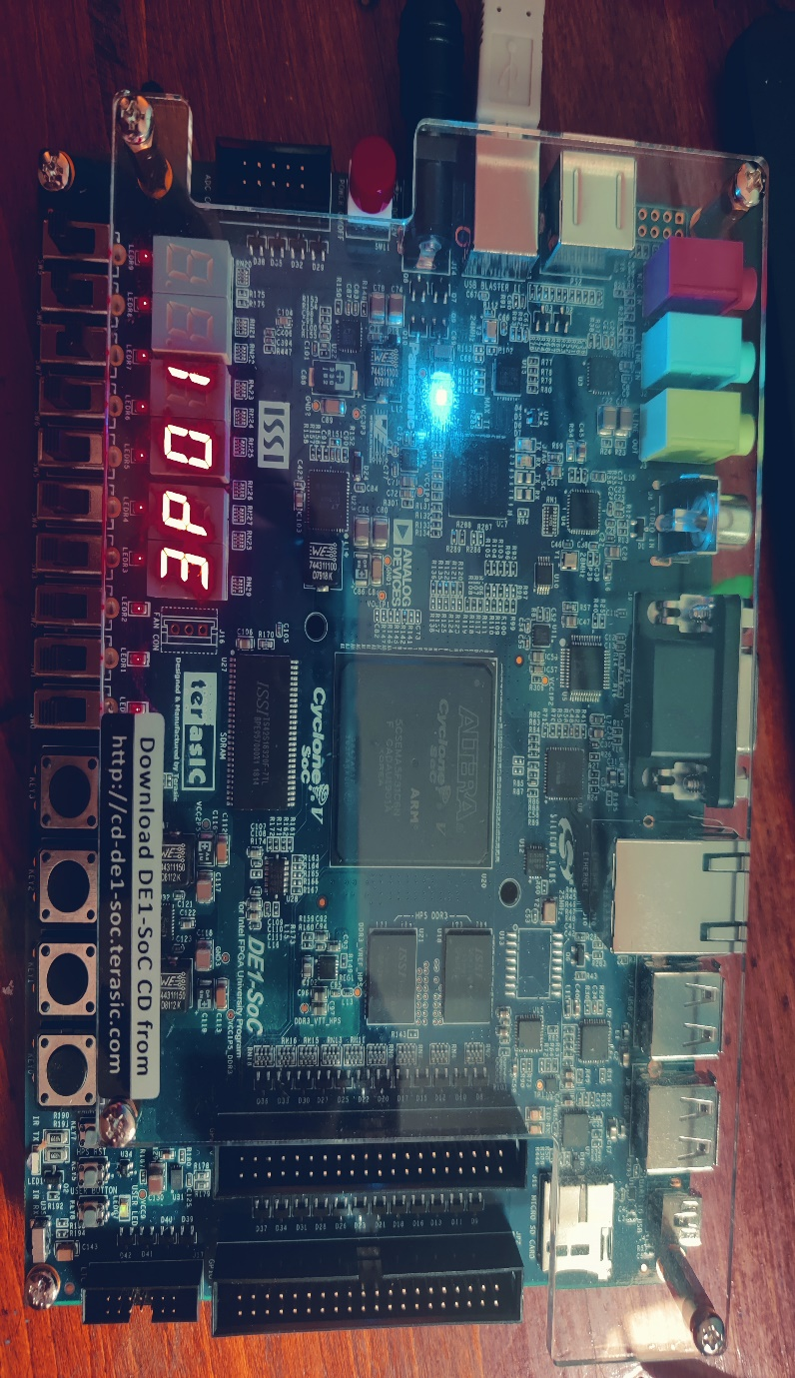
Figure 5.7: Sample Output (3)
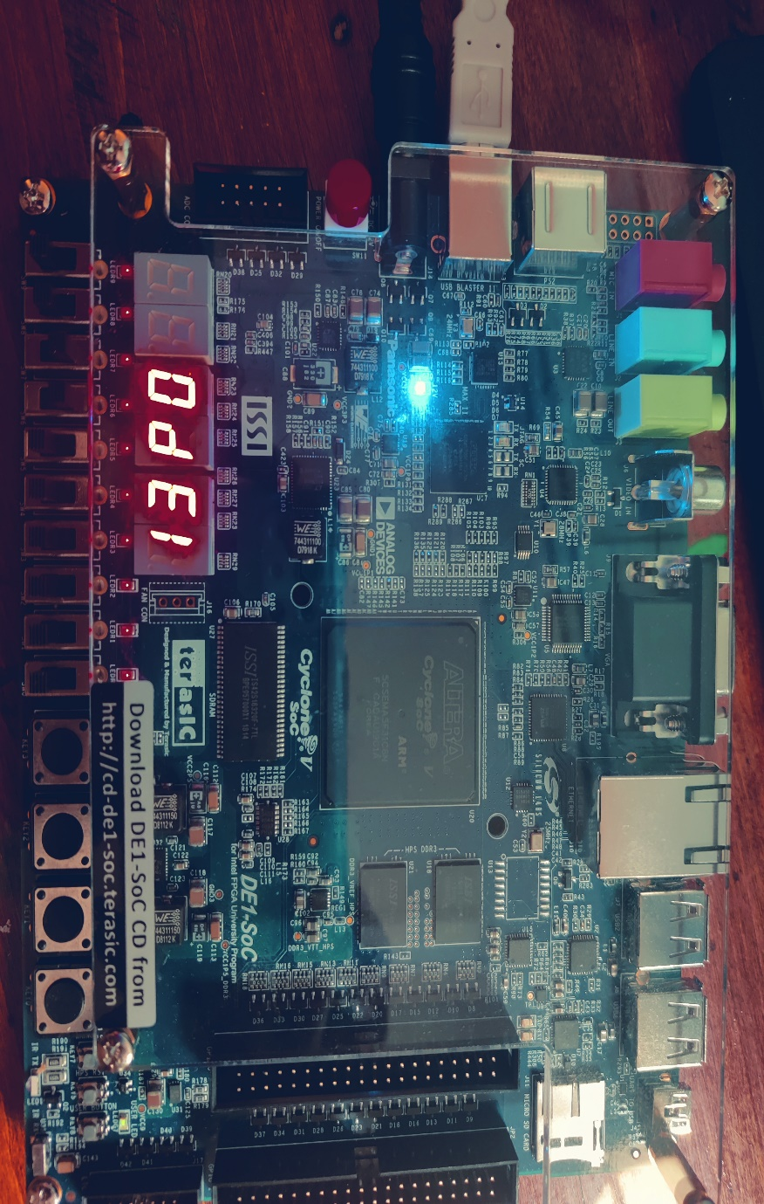
Figure 5.8: Sample Output (4)

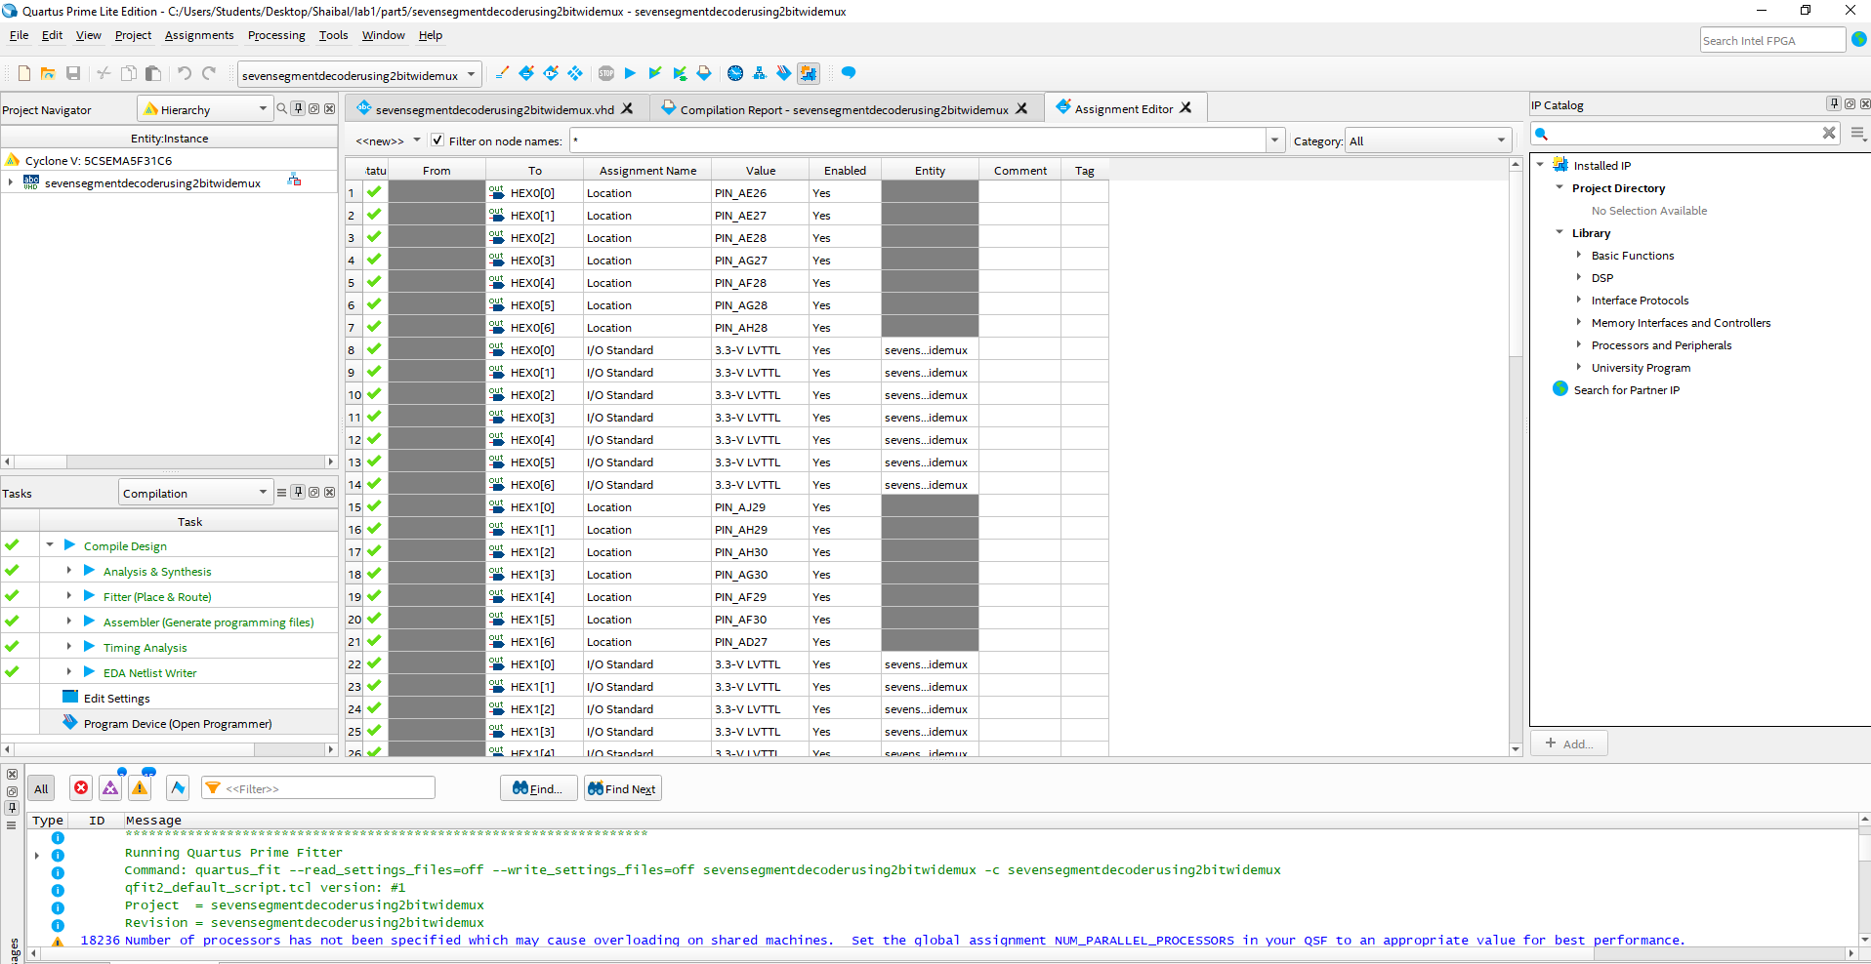
Figure 5.9: Pin assignment (1)
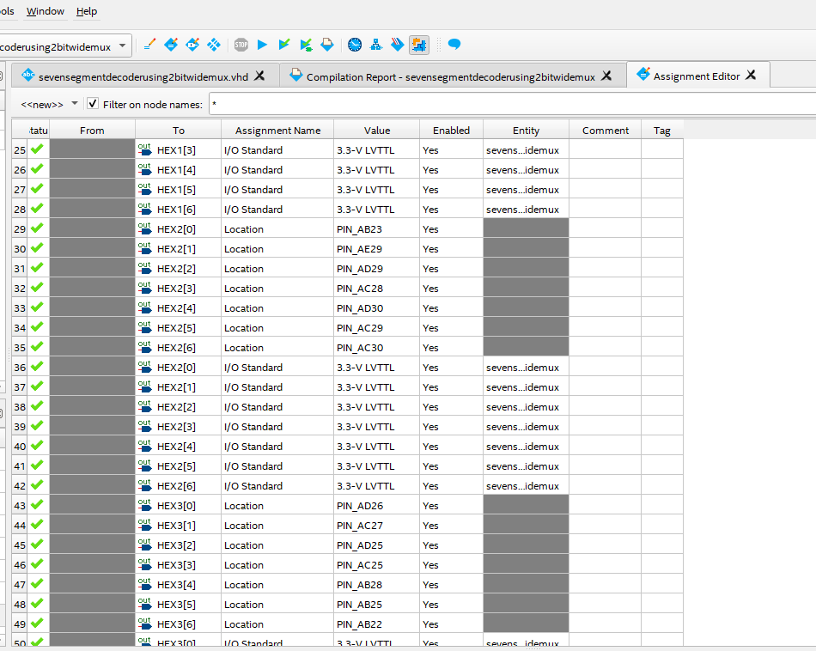
Figure 5.10: Pin assignment (2)

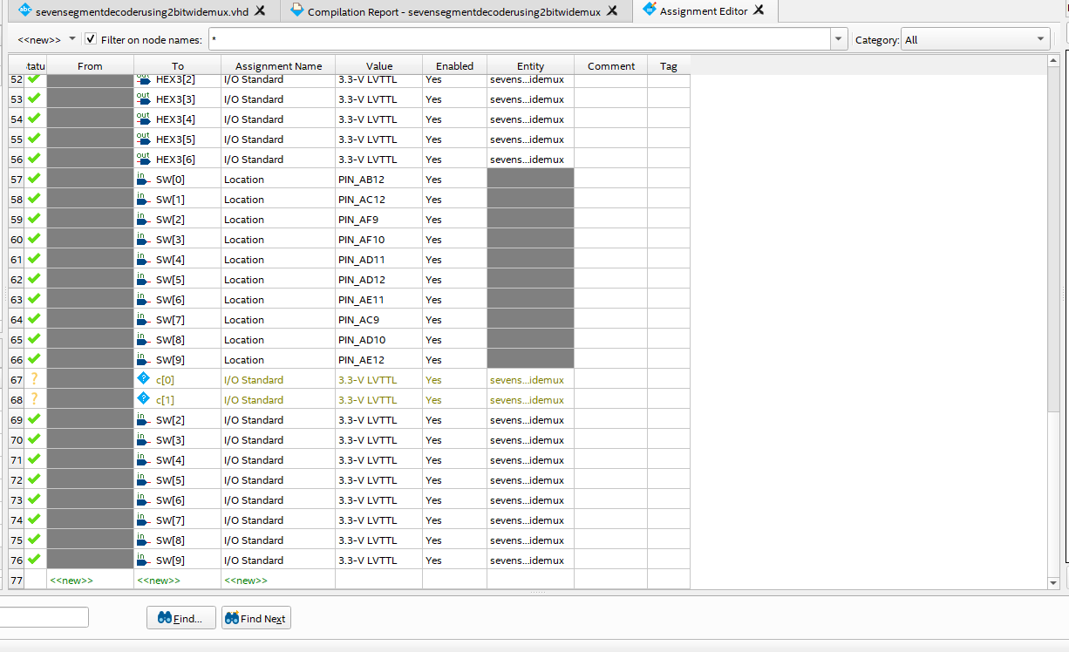
Figure 5.11: Pin assignment (3)

- Part6: The part6 is the extend version of part5. In the part 6, I need to view de10 with two blank 7-segment display. In desoc-1 board, we have 6 7-segment display. We use it all. I design a 6 to 1 mux for limitation of switches. Here I attach all the screenshot as well as sample output and the pin configuration below:
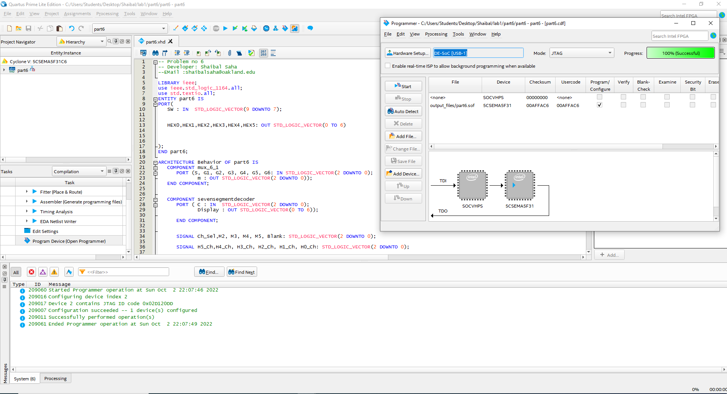
Figure 6.1: Code
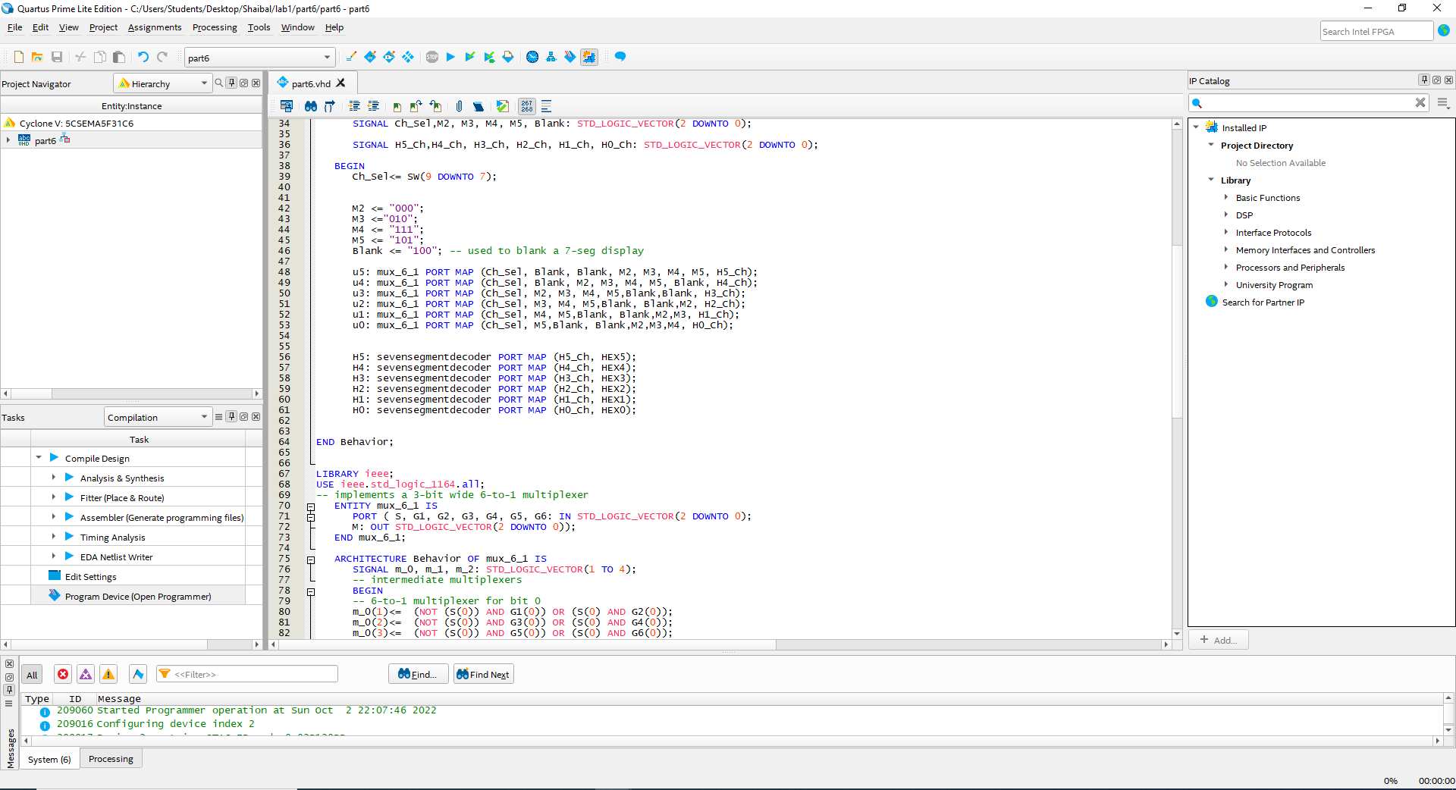
Figure 6.2: Code
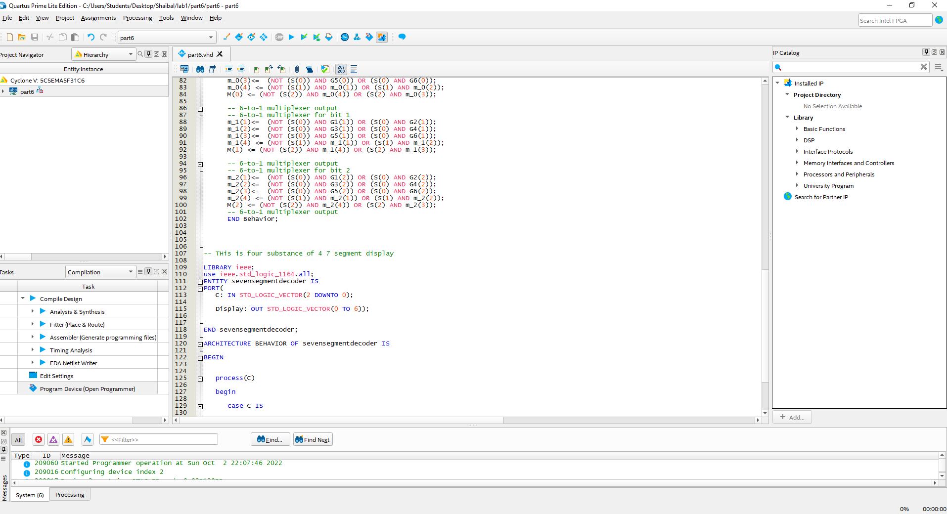
Figure 6.3: Code
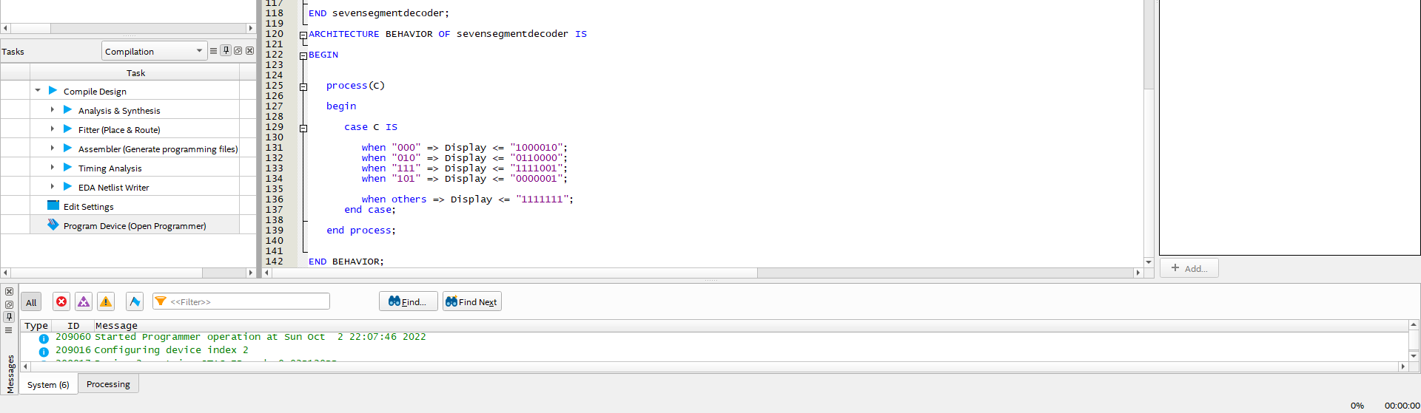
Figure 6.4: Code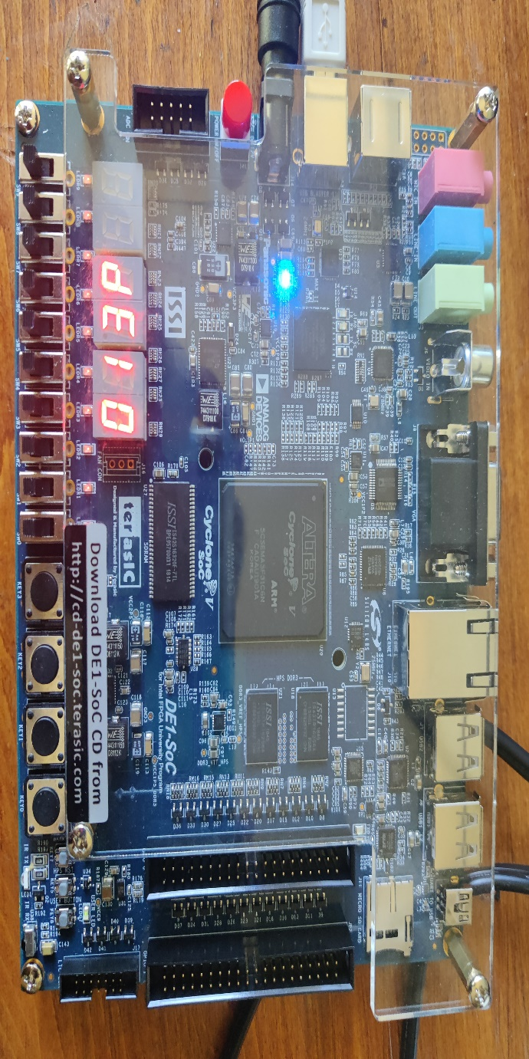

Figure 6.5: Sample Output
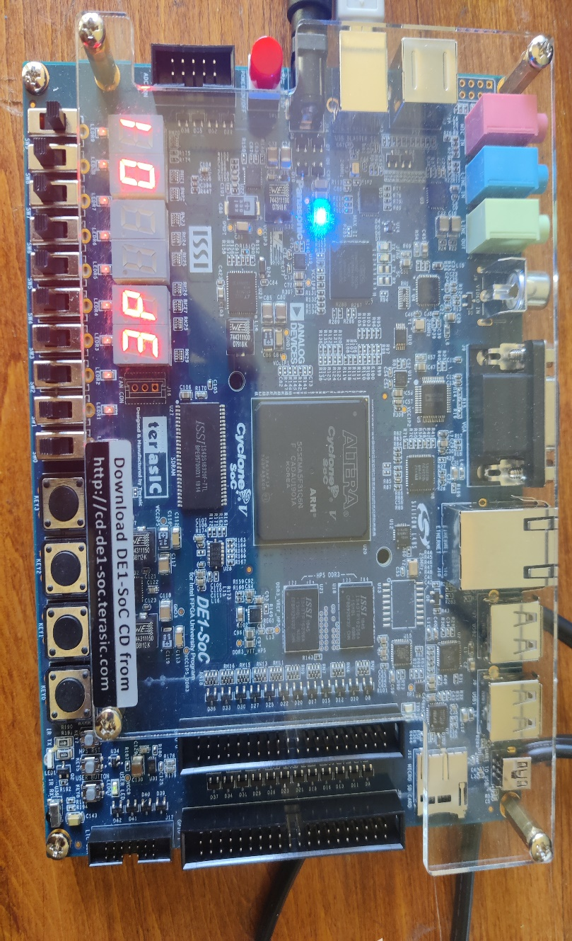
Figure 6.6: Sample Output
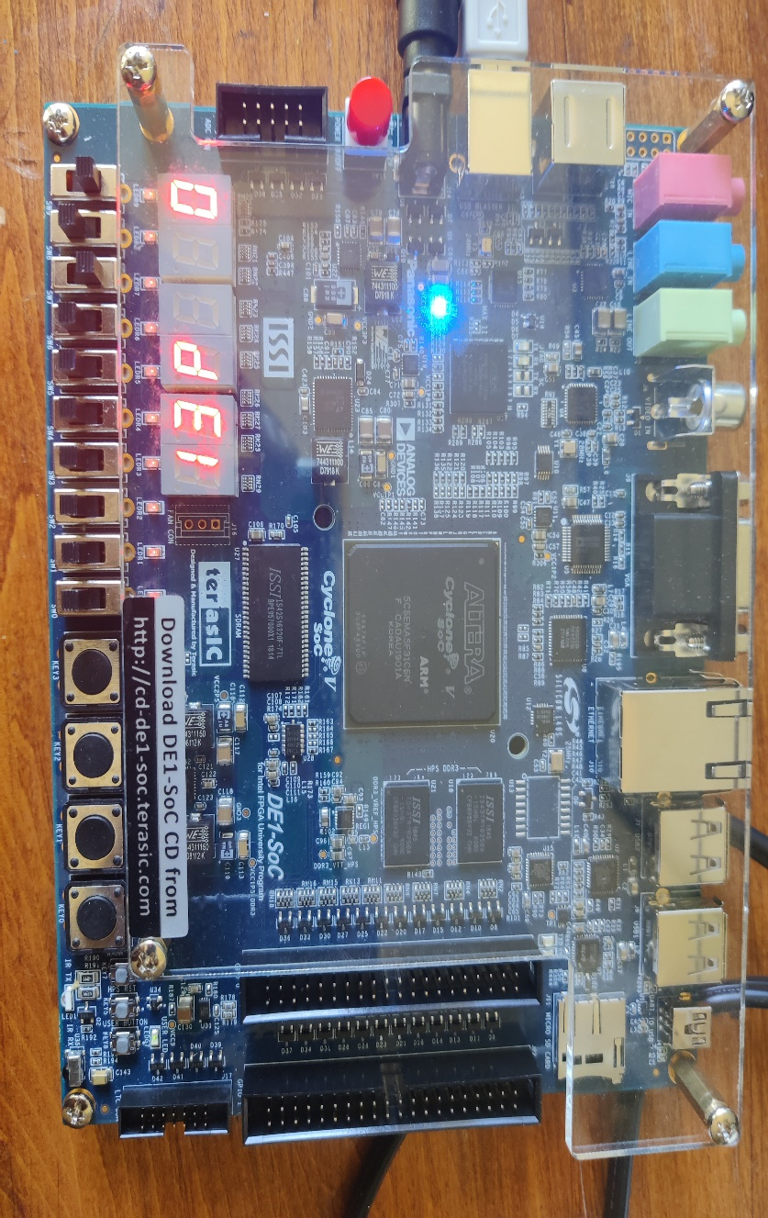
Figure 6.7: Sample Output
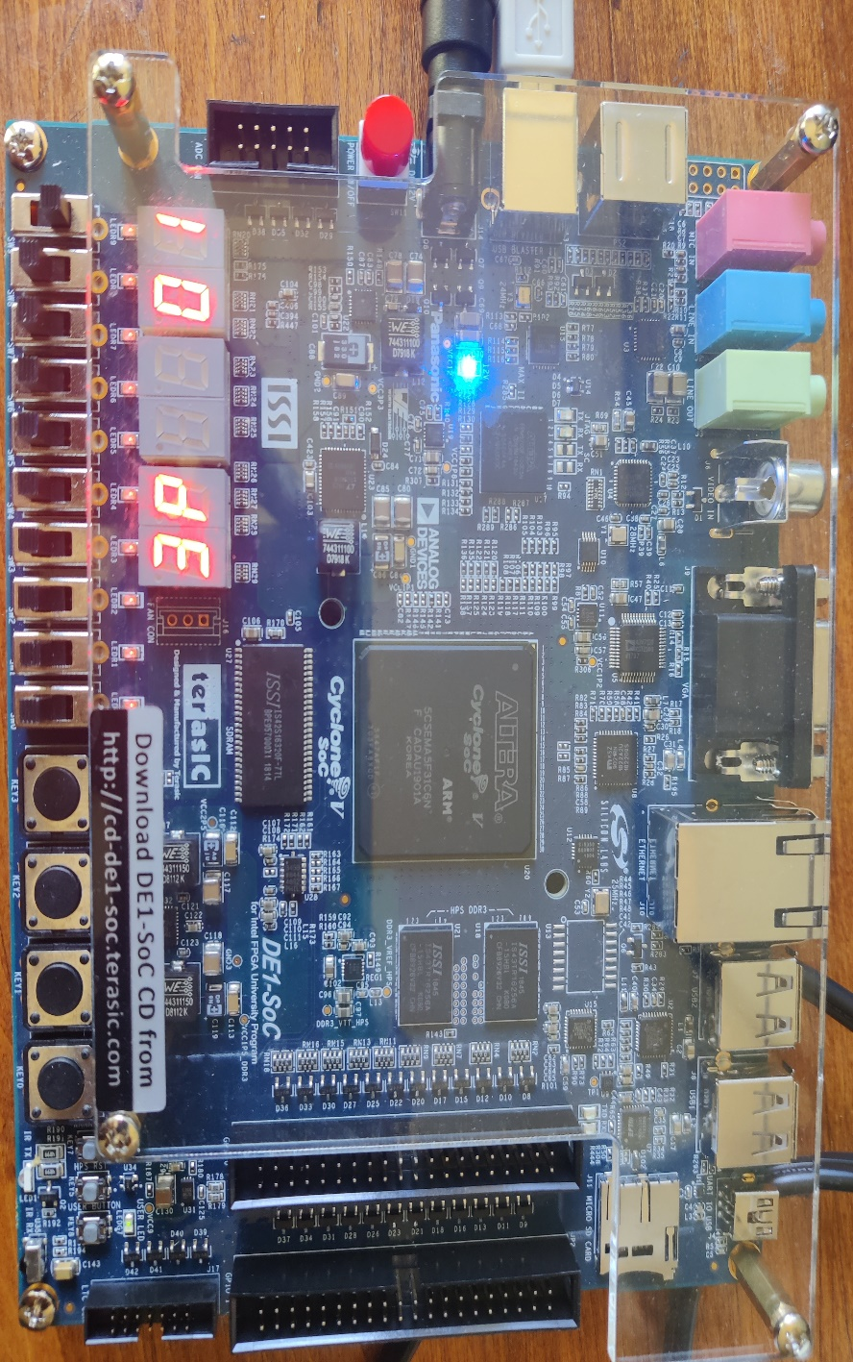
Figure 6.8: Sample Output
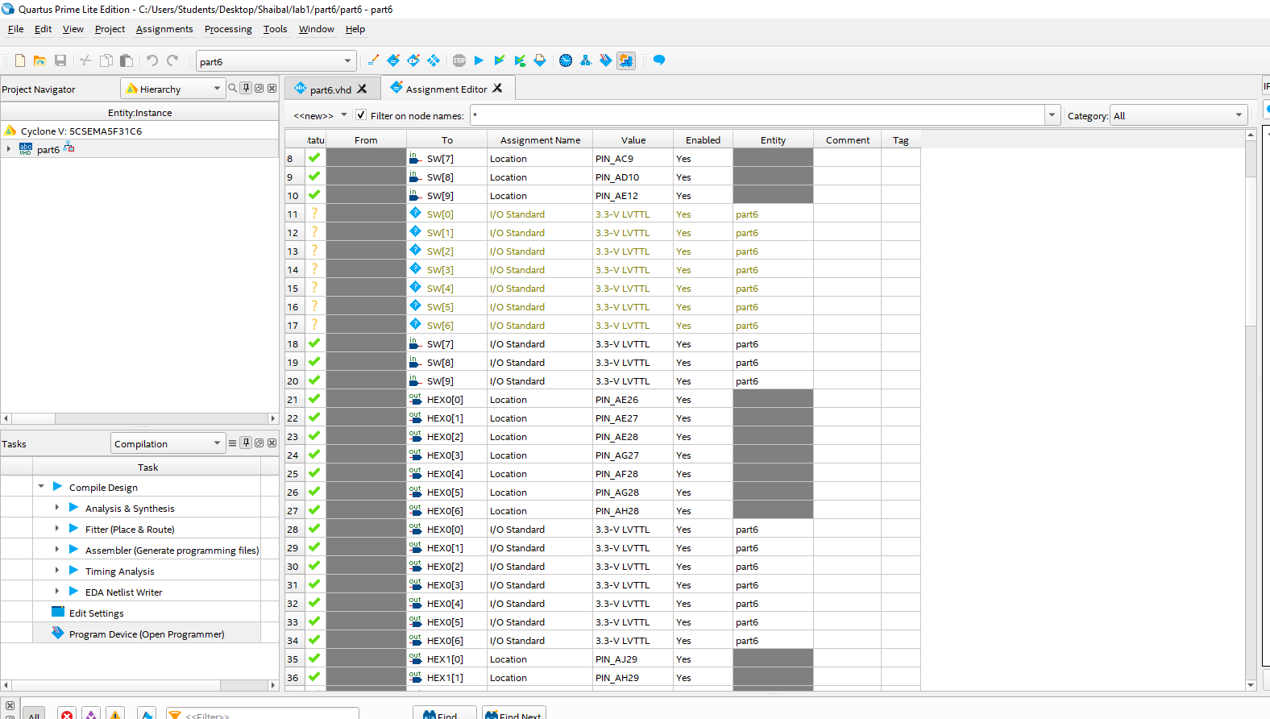
Figure 6.9: Pin assignment
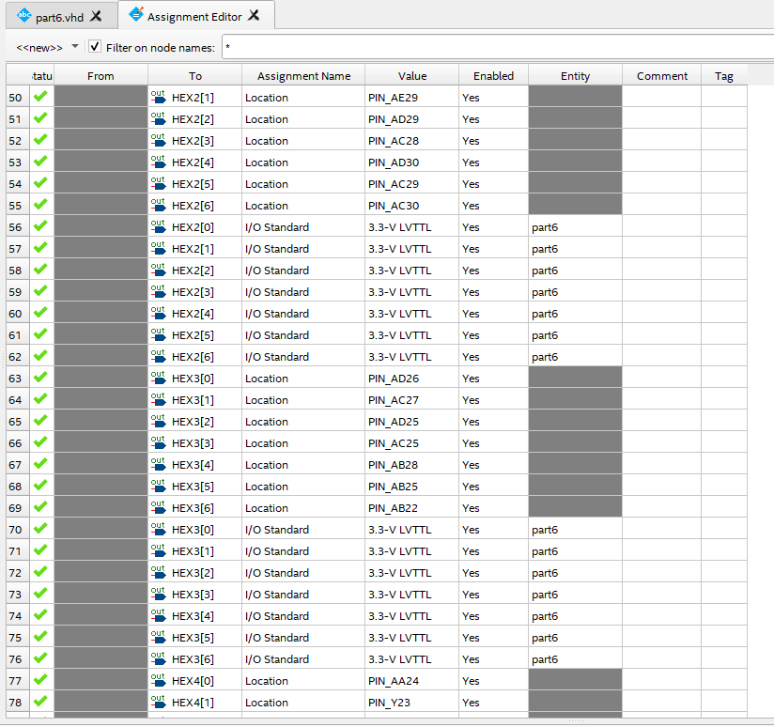
Figure 6.10: Pin Assignment
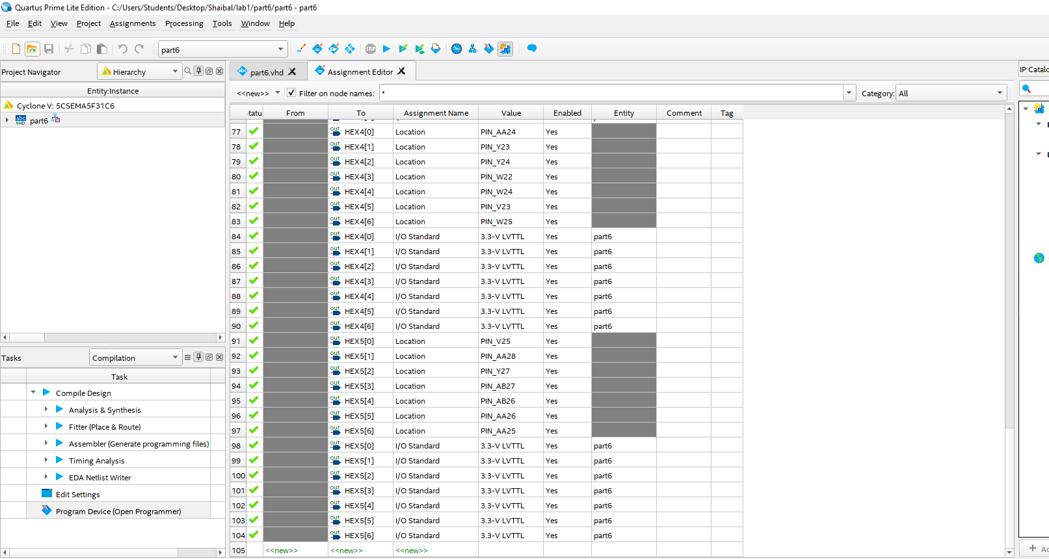
Figure 6.11: Pin Assignment
Note: All the source codes are inside lab folder.

