Objective: The purpose of this exercise is to learn in designing combinational circuits that can perform binary-to-decimal number conversions and binary-coded-decimal (BCD) addition.

- Part1: This is a basic program where we show 7-segment display output in two different 7 segment display in the DE-soc1 board. The code screenshot and a sample output what I get are given below:

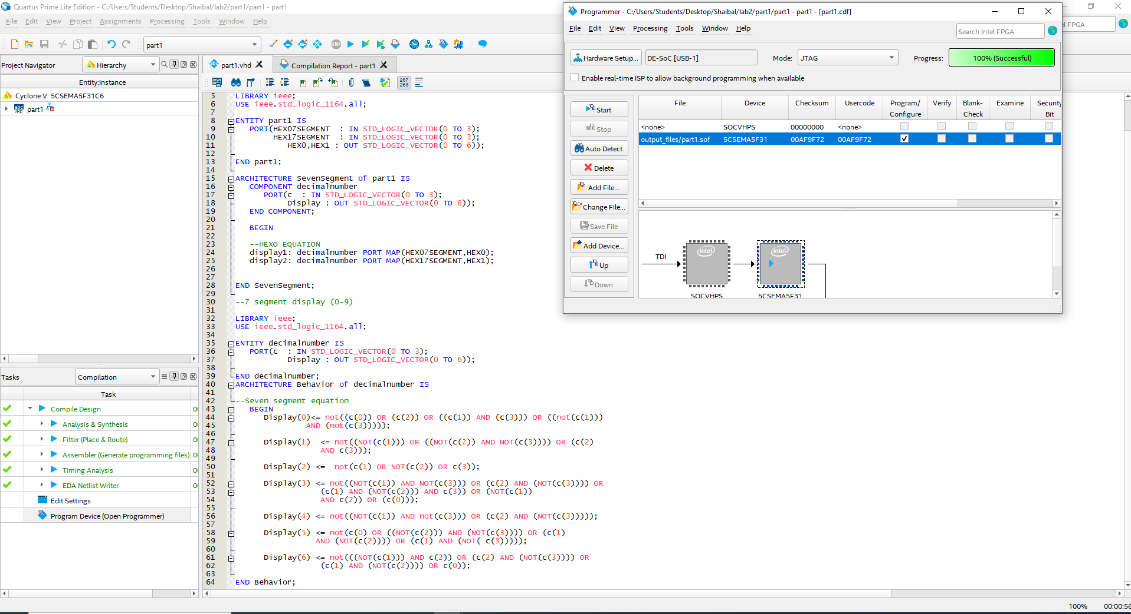
Figure 1.1: Code and analysis successful screenshot for part1
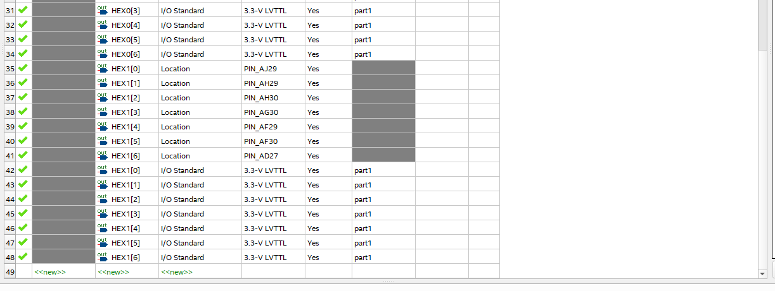
Figure1.2: Pin assignment of part1

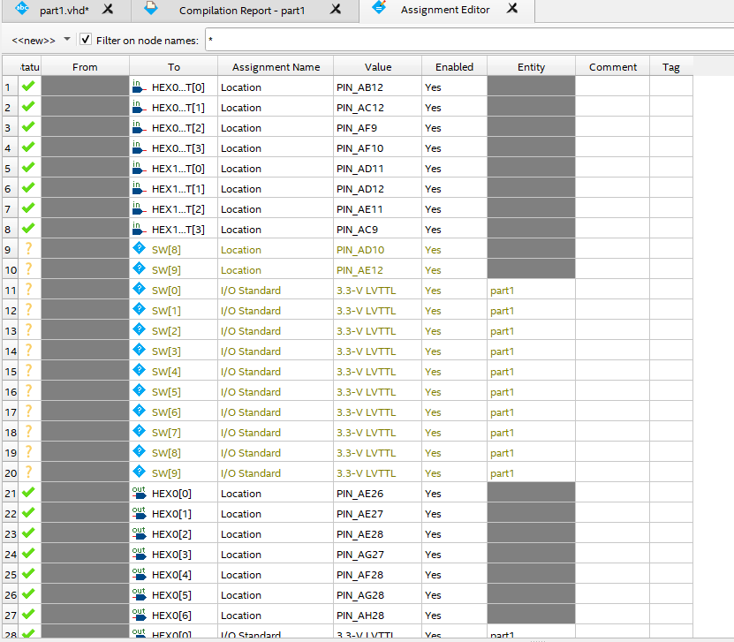
Figure1.3: pin assignment of part1

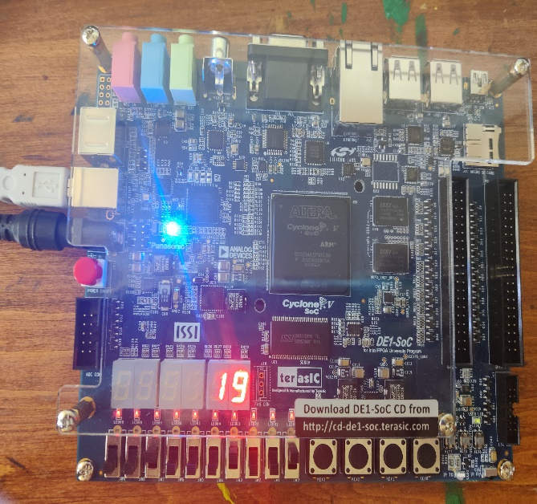
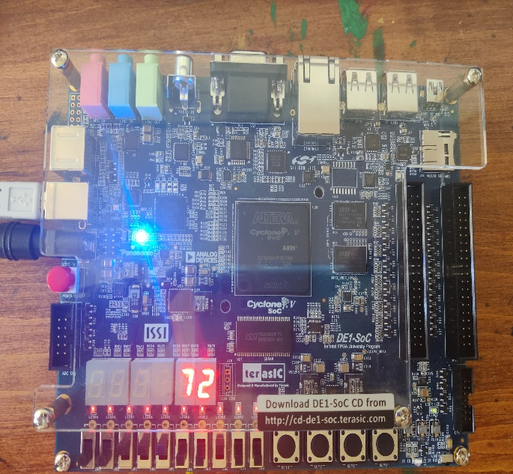

Figure1.4: Sample output of part1

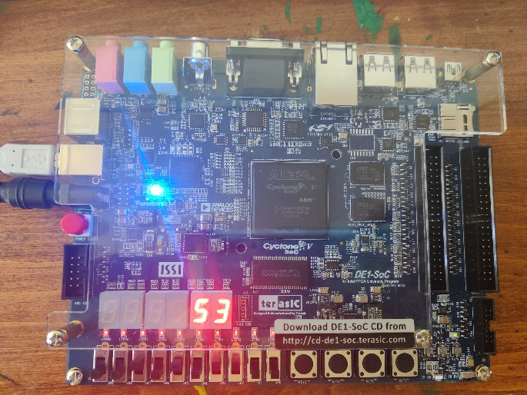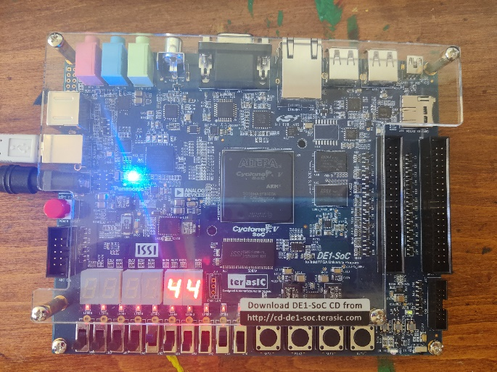
Figure1.5: Sample output of part1 (2)
- Part2: In part 2, I need to design a circuit that converts a four-bit binary number into its two-digit decimal equivalent. Furthermore, I need to show it in 7 segment display. I need to design a comparator (>9) means carry 1 and circuit A for change value like for (“10” in binary we get 1010, but in 7-segment we need 0000 for hex0 and 0001 for hex1). Basically, I did binary to decimal conversion. The code screenshot and a sample output what I get are given below:
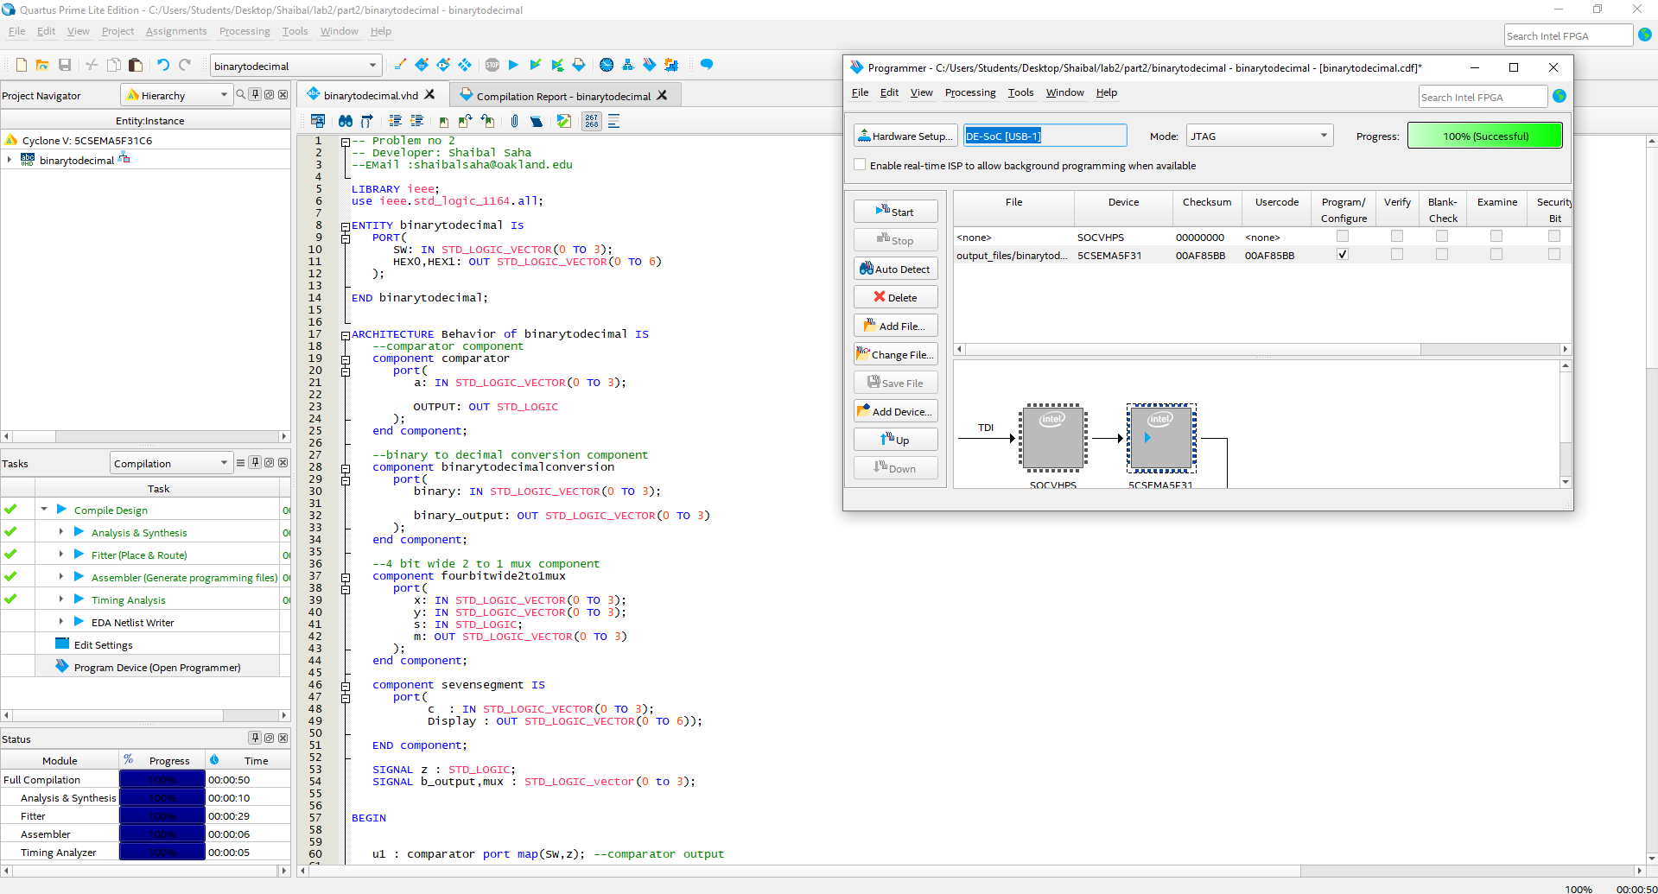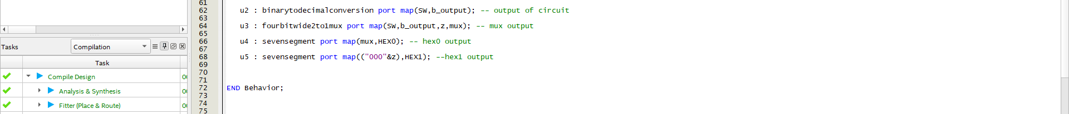
Figure 2.1: Code and analysis successful screenshot for part2

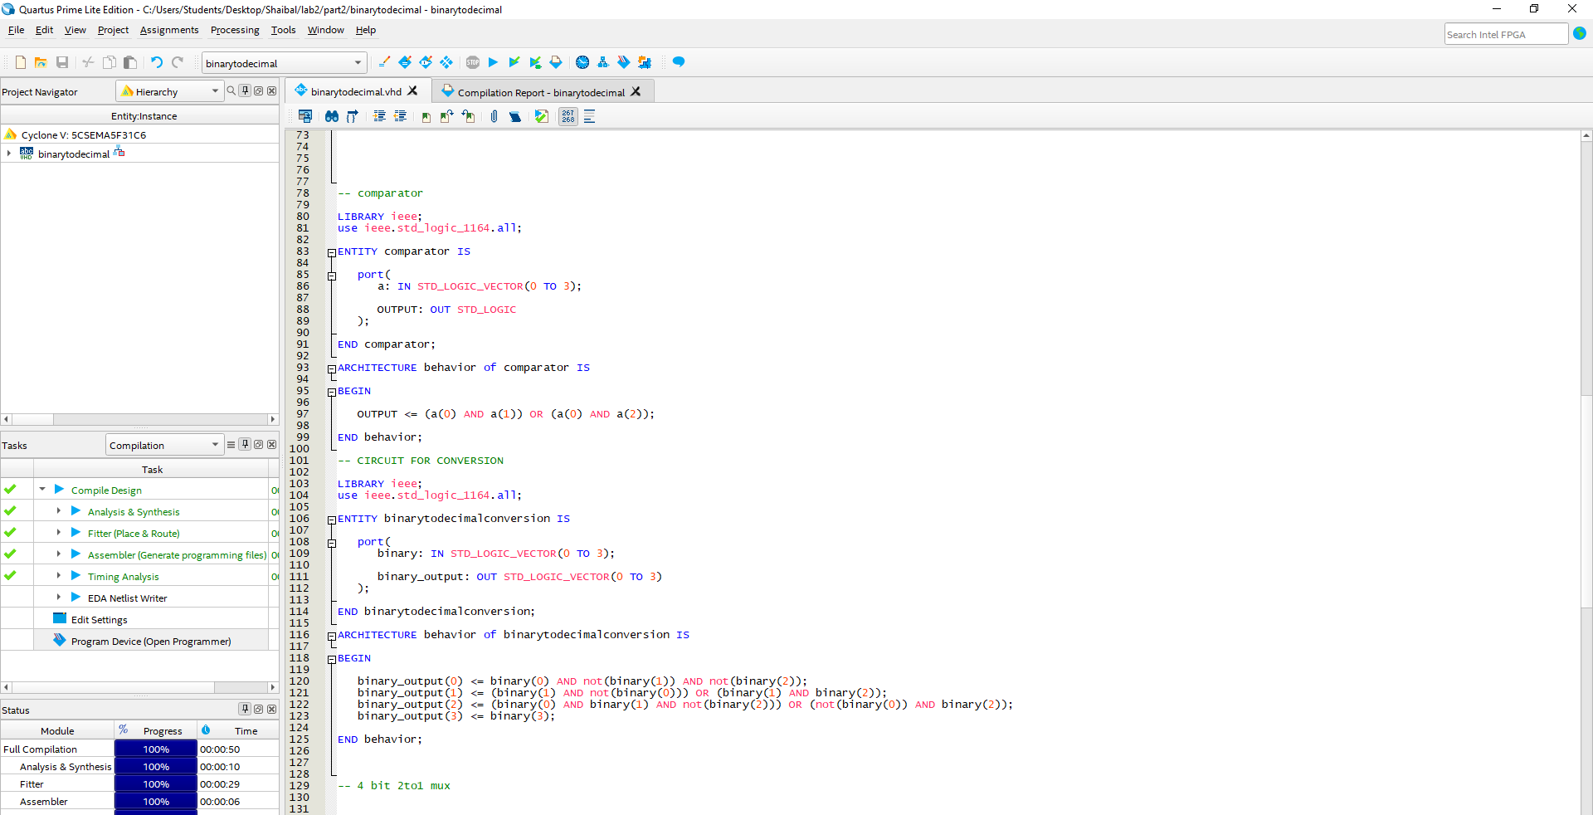
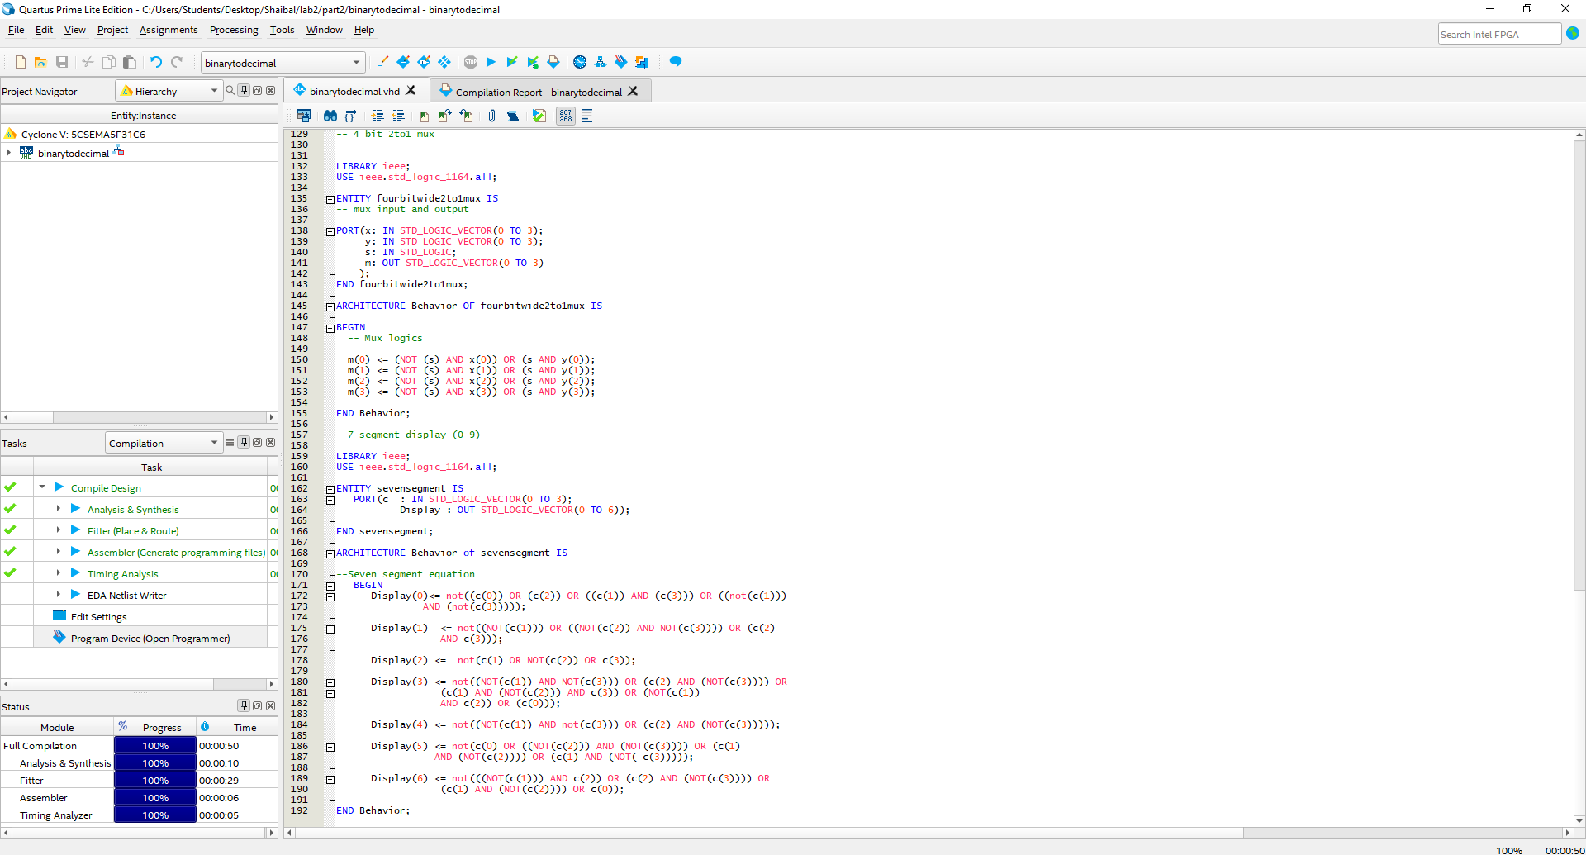
Figure 2.2: Code and analysis successful screenshot for part2
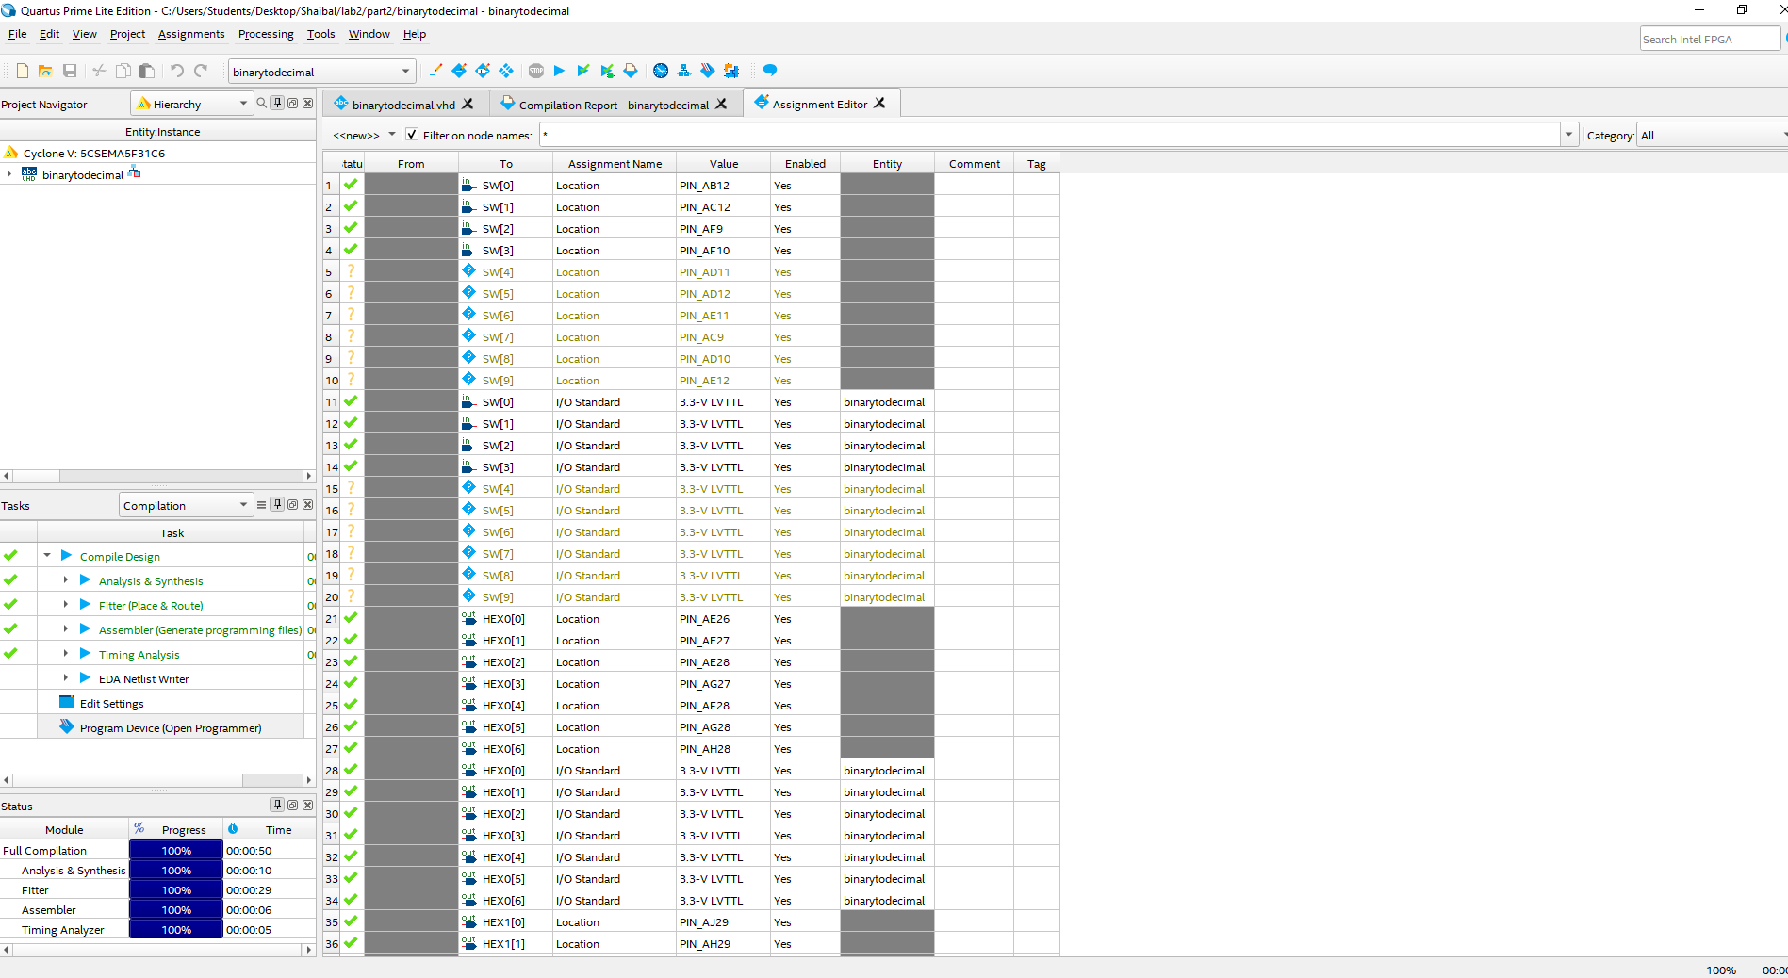
Figure 2.3: Pin assignment screenshot for part2
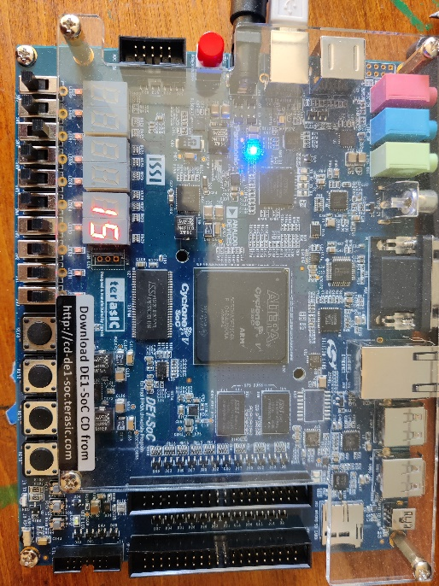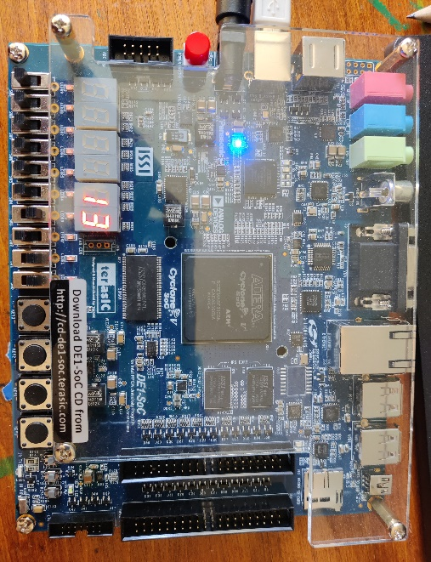
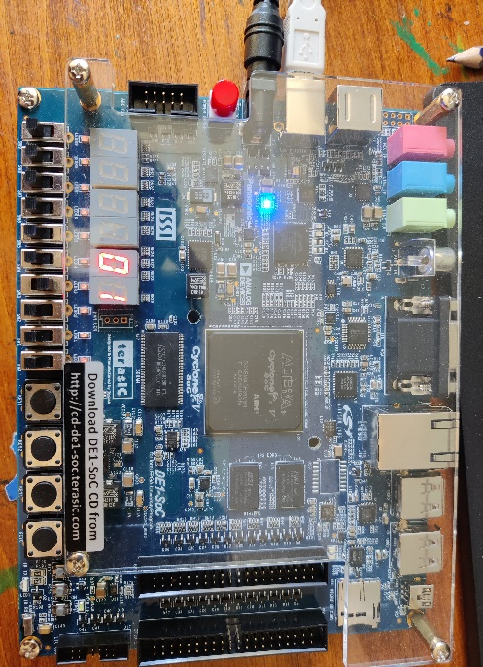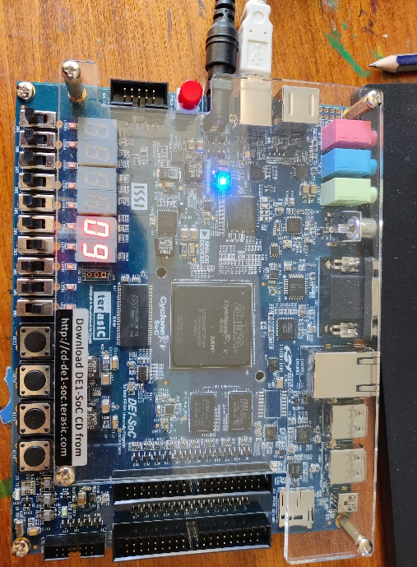
Figure 2.4: Sample output for part2

- Part3: This is the VHDL code for ripple carry adder where the full adder uses the carry output of the previous full adder as a carry input and gives out of sum for individual full adder as well as a final carryout. In this design, I show carry out in LEDR (9). And sum in LEDR (0 to 3). The code design screenshot and a sample output what I get are given below:
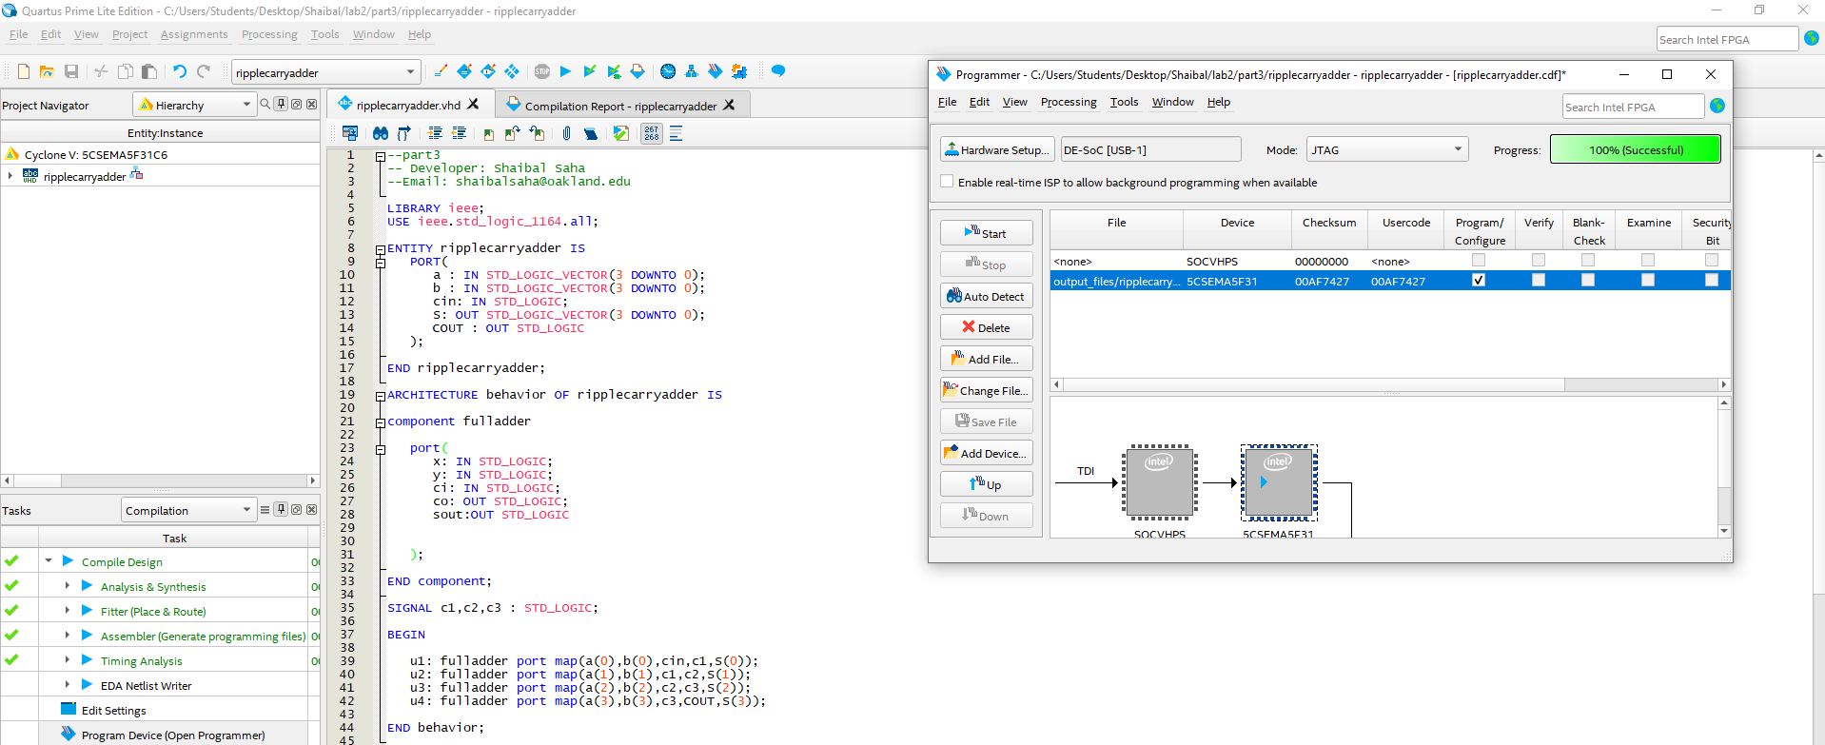
Figure 3.1: code and analysis screenshot for part3
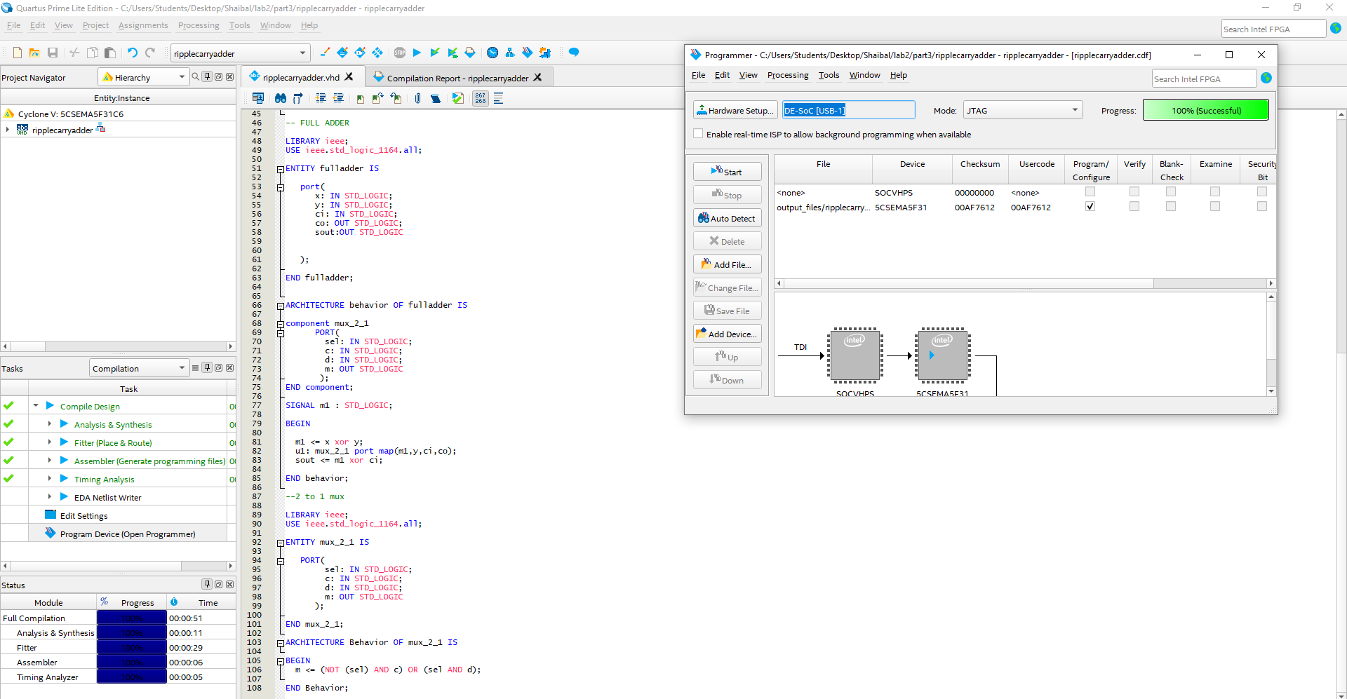
Figure 3.2: code and analysis screenshot for part3
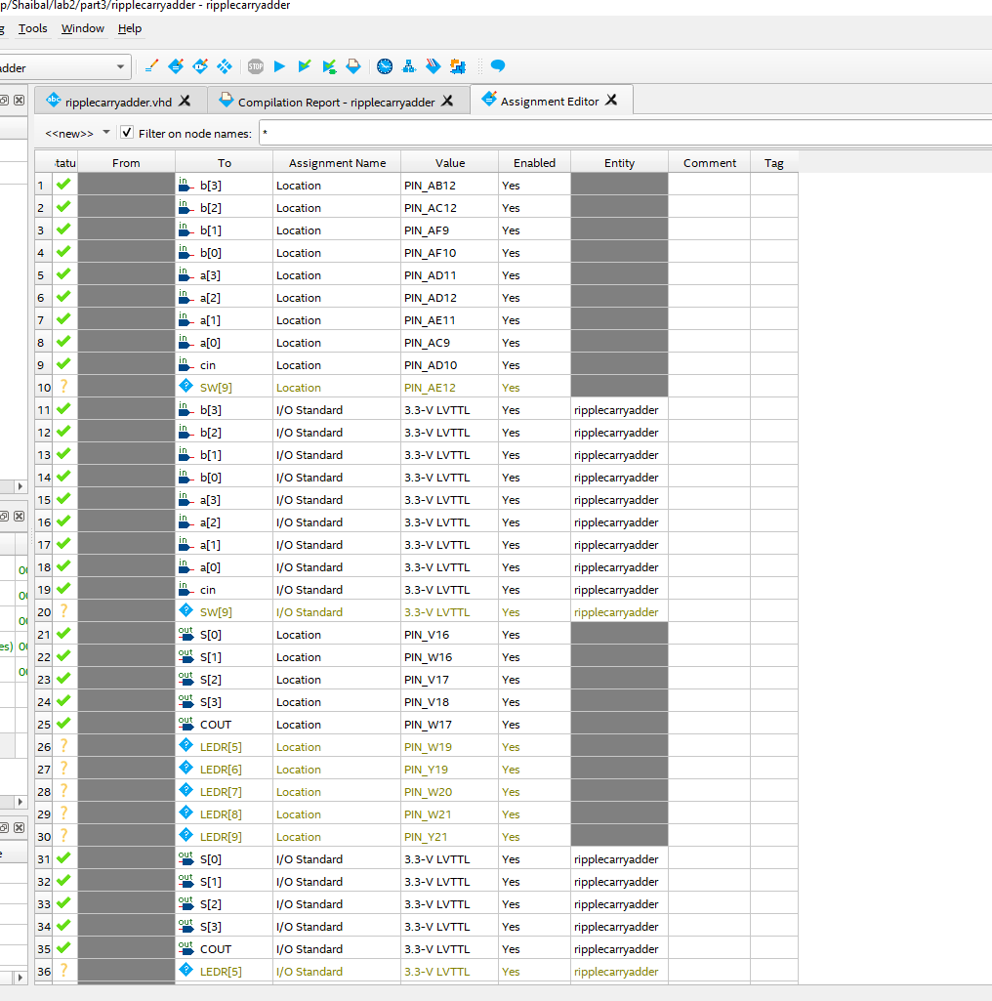
Figure 3.3: Pin assignment for part3

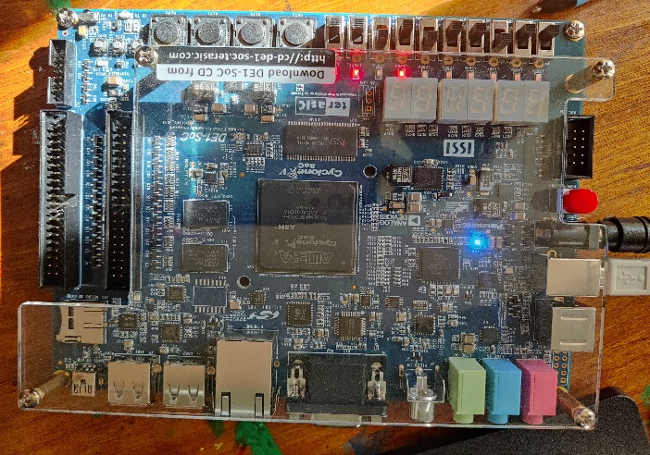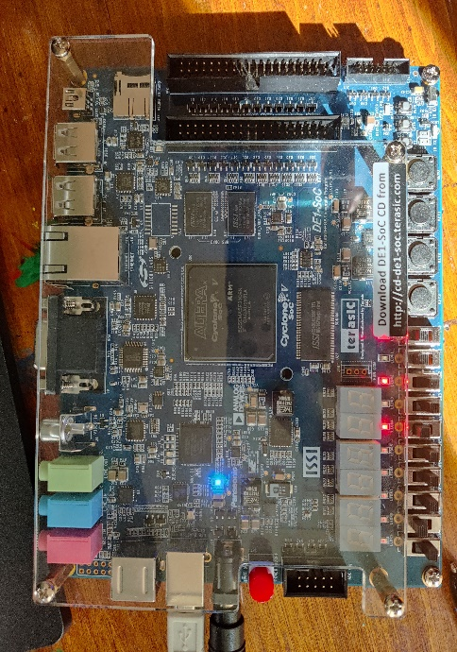
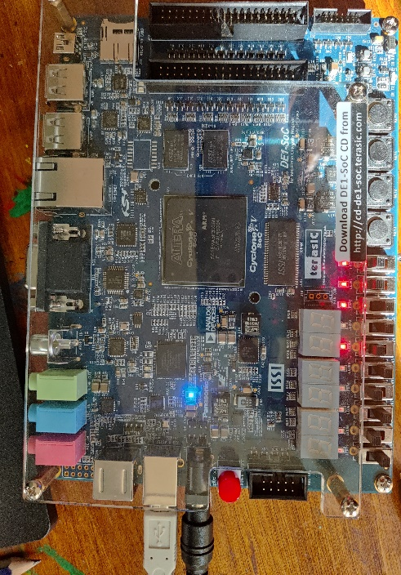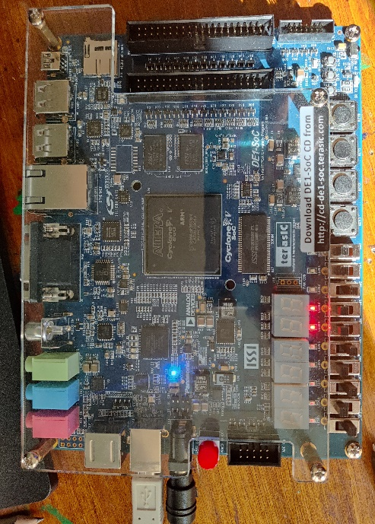
Figure 3.4: Sample output for part3

- Part4: This is the VHDL code for summation of two decimal and show it in 7 segments. In this part, as 7 segments can only show 9 highest. Highest sum we can get (9+9+1=19) where 1 is the carry input. I use the part 2 and part 3 portion and modified the circuit A from the part 2 for getting sum from 16 to 19. I also asked to show a LEDR for error if any user do input of greater than 9(‘1001’). HEX5 and HEX3 to represent 4 bits input each and HEX1 and HEX0 shows the output. LEDR9 shows the error output. The code design screenshot and a sample output what I get are given below:
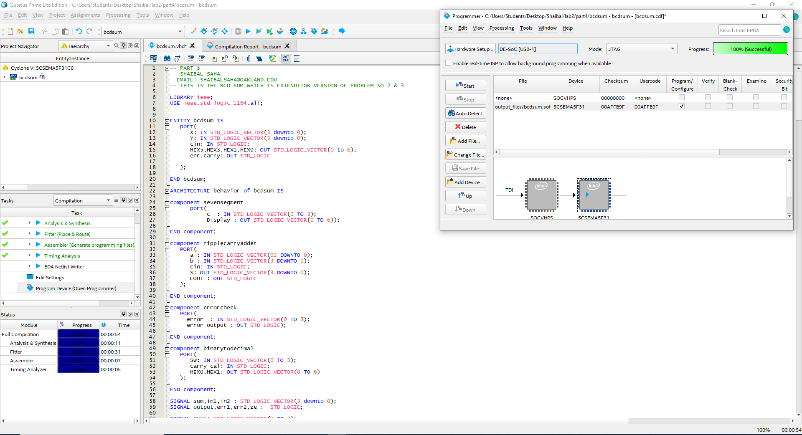
Figure 4.1 code and analysis screenshot for part4(main body function)
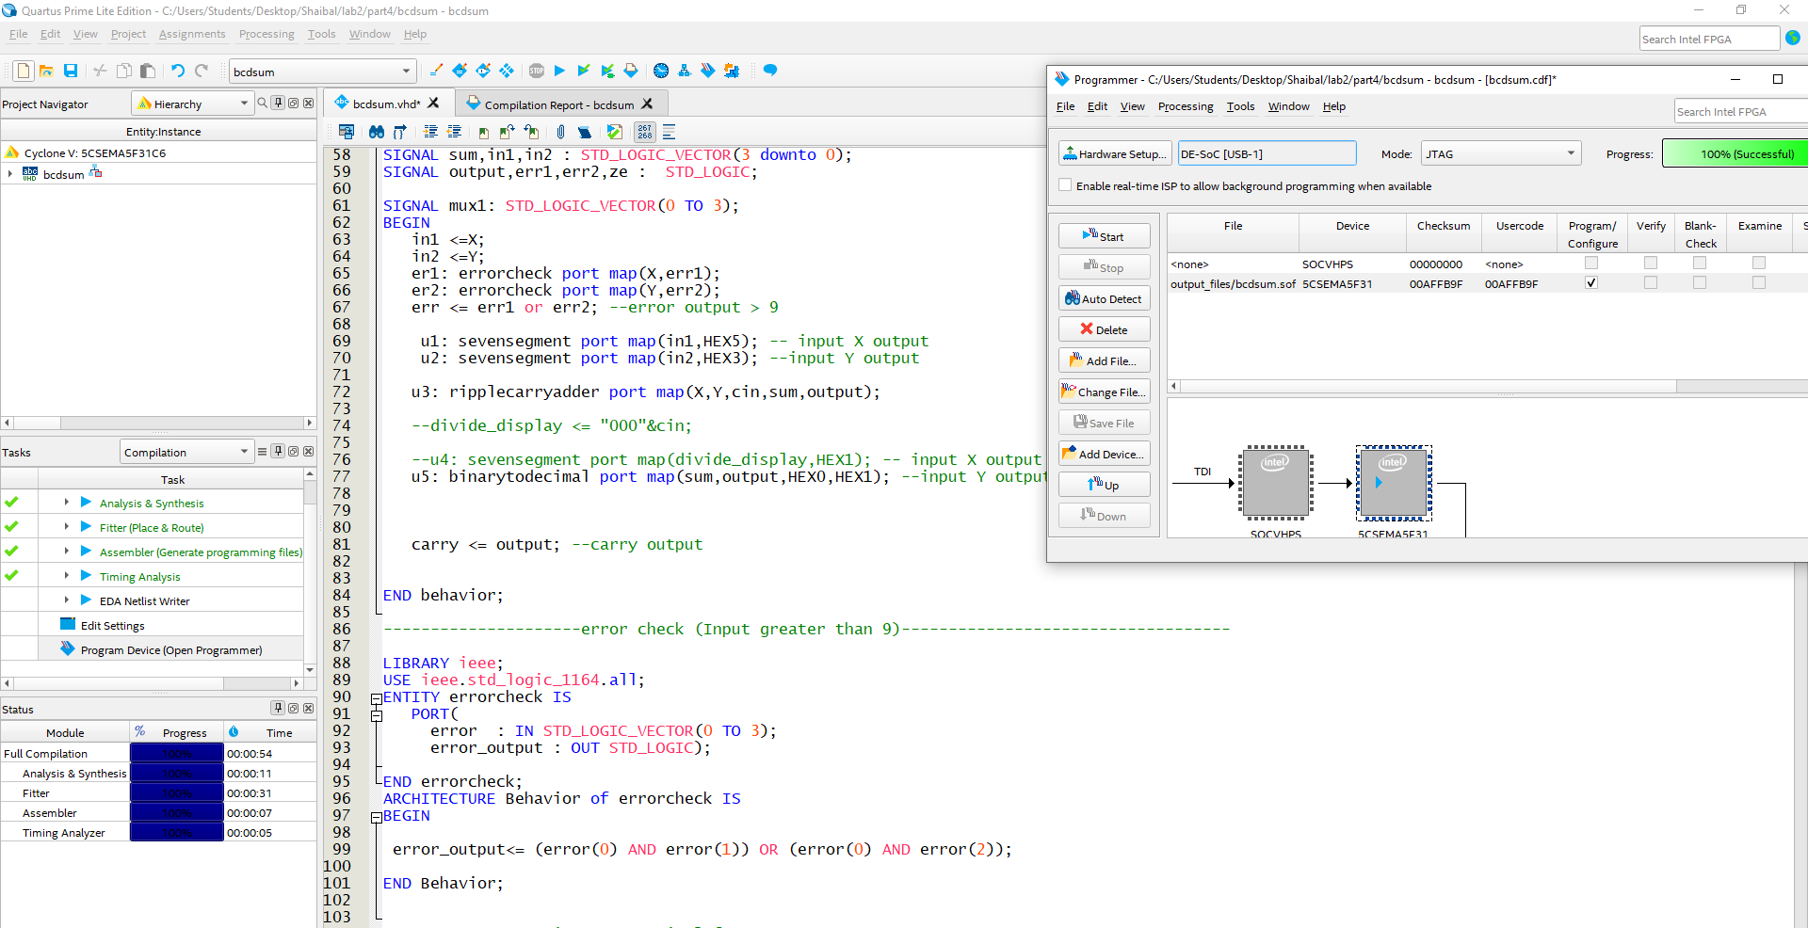
Figure 4.2: code and analysis screenshot for part4 (display output and error check)
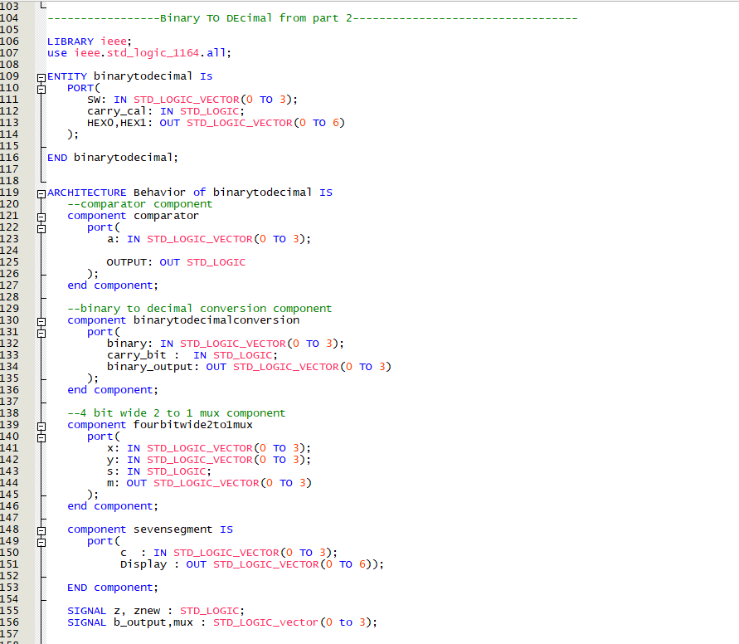Figure 4.3: code and analysis screenshot for part4 (binary to decimal from part 2)

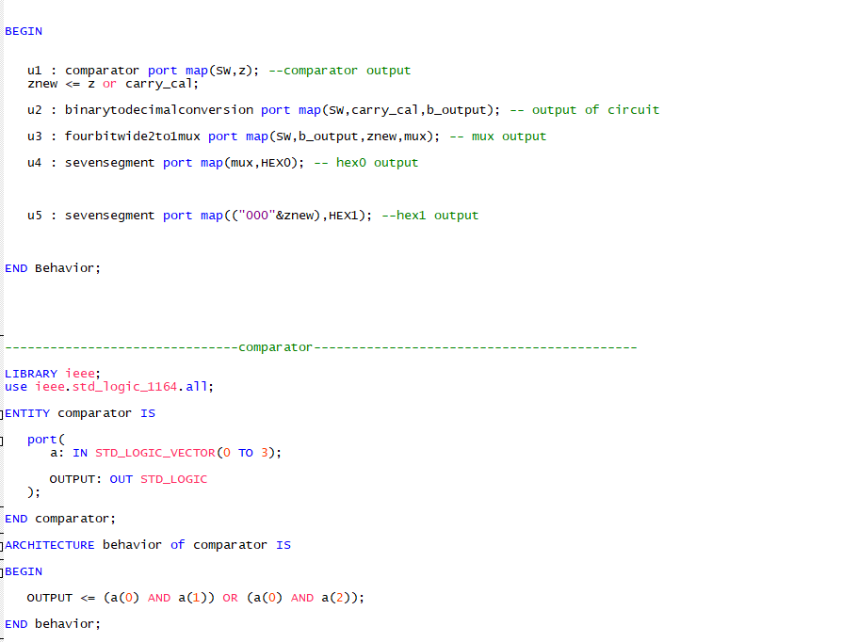
Figure 4.4: code and analysis screenshot for part4 (continue part of figure 4.3 and comparator from part 2)

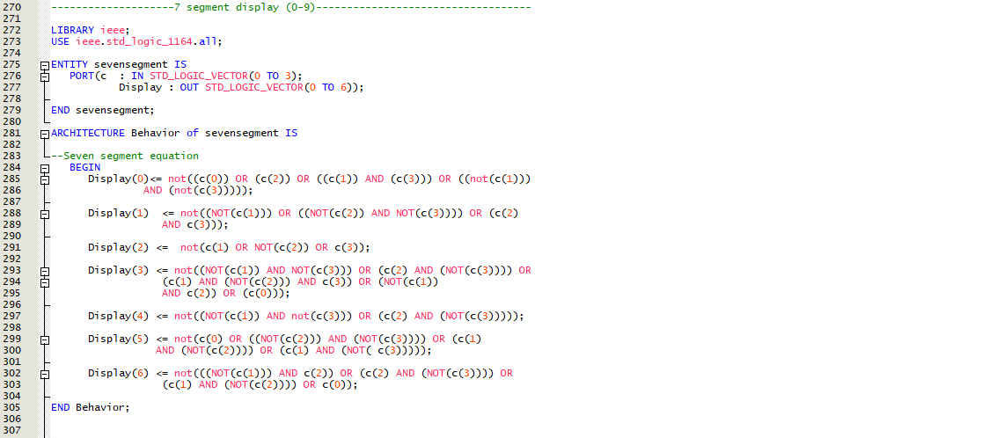
Figure 4.5: code and analysis screenshot for part4 (7-segment display from part 2)

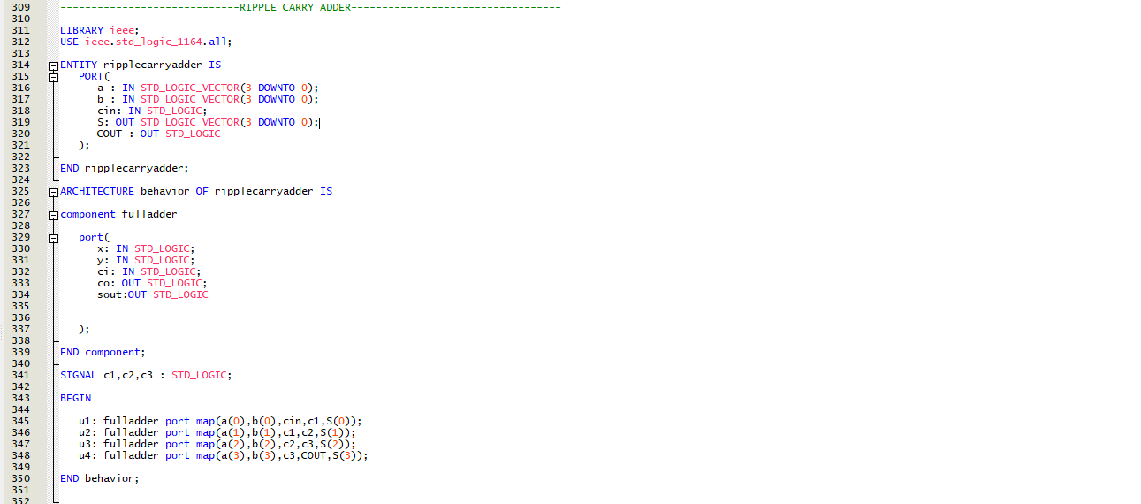
Figure 4.6: code and analysis screenshot for part4 Ripple carry adder from part 3)
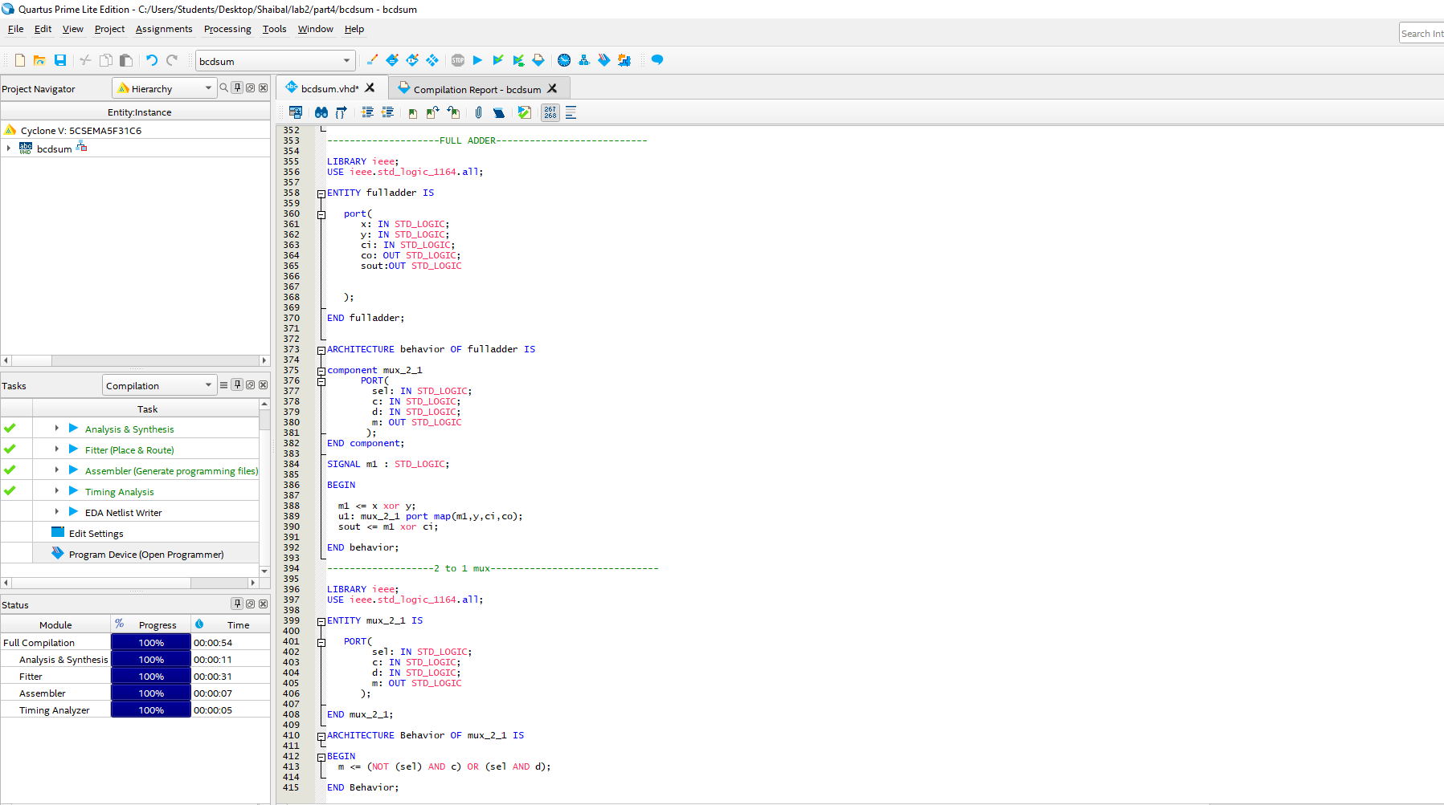
Figure 4.7: code and analysis screenshot for part4 (full adder from part 3)
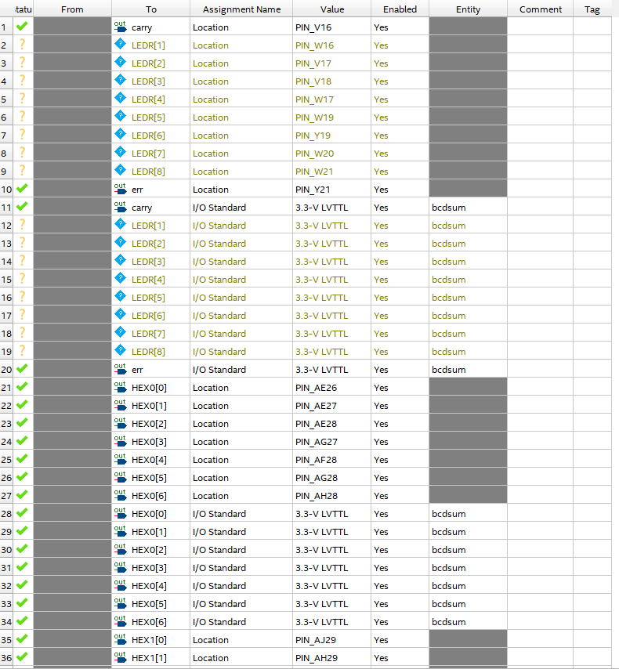
Figure 4.8: Pin assignment of part4

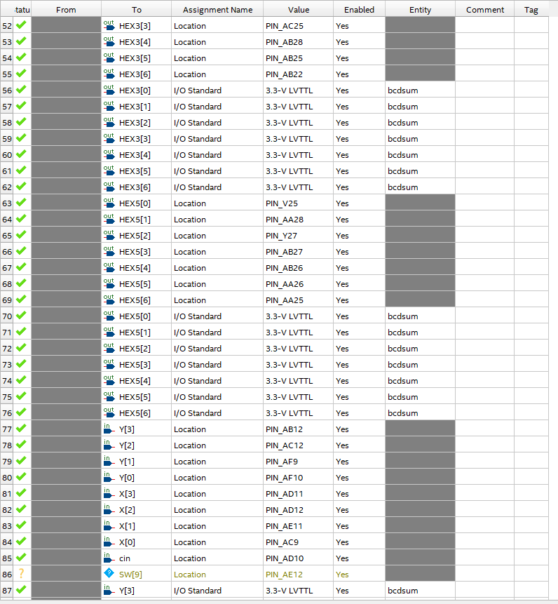
Figure 4.9: Pin assignment of part4
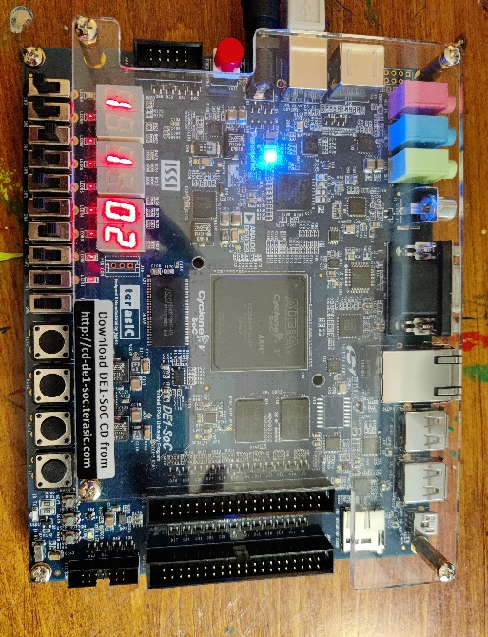
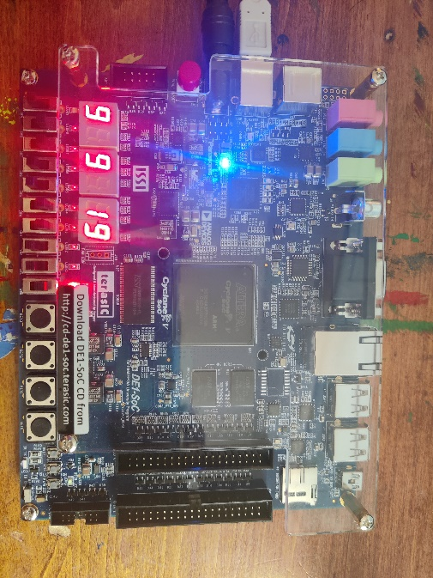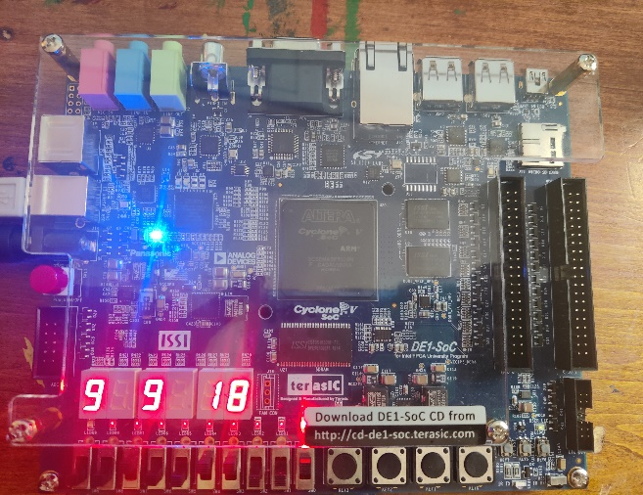
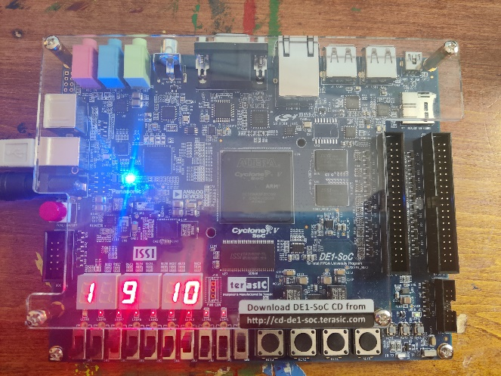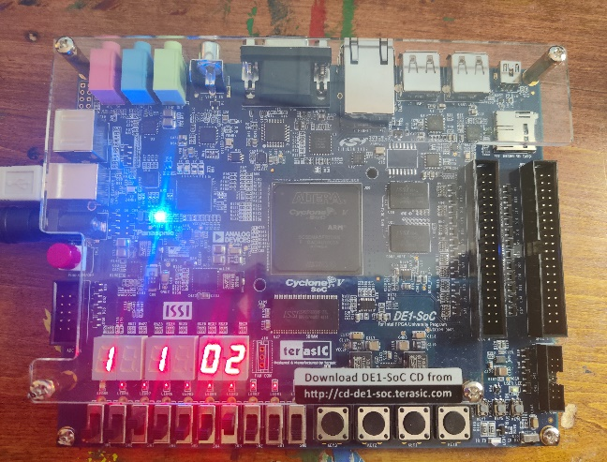
Figure 4.10: Sample output for part4

- Part5: The part5 is another approach to solve circuit of part 4. In part4, we are not allowed to use any if-else statement, but part5 helps to know uses of if-else and stuffs and also same output materials and things in part 4. The code design screenshot and a sample output what I get are given below:
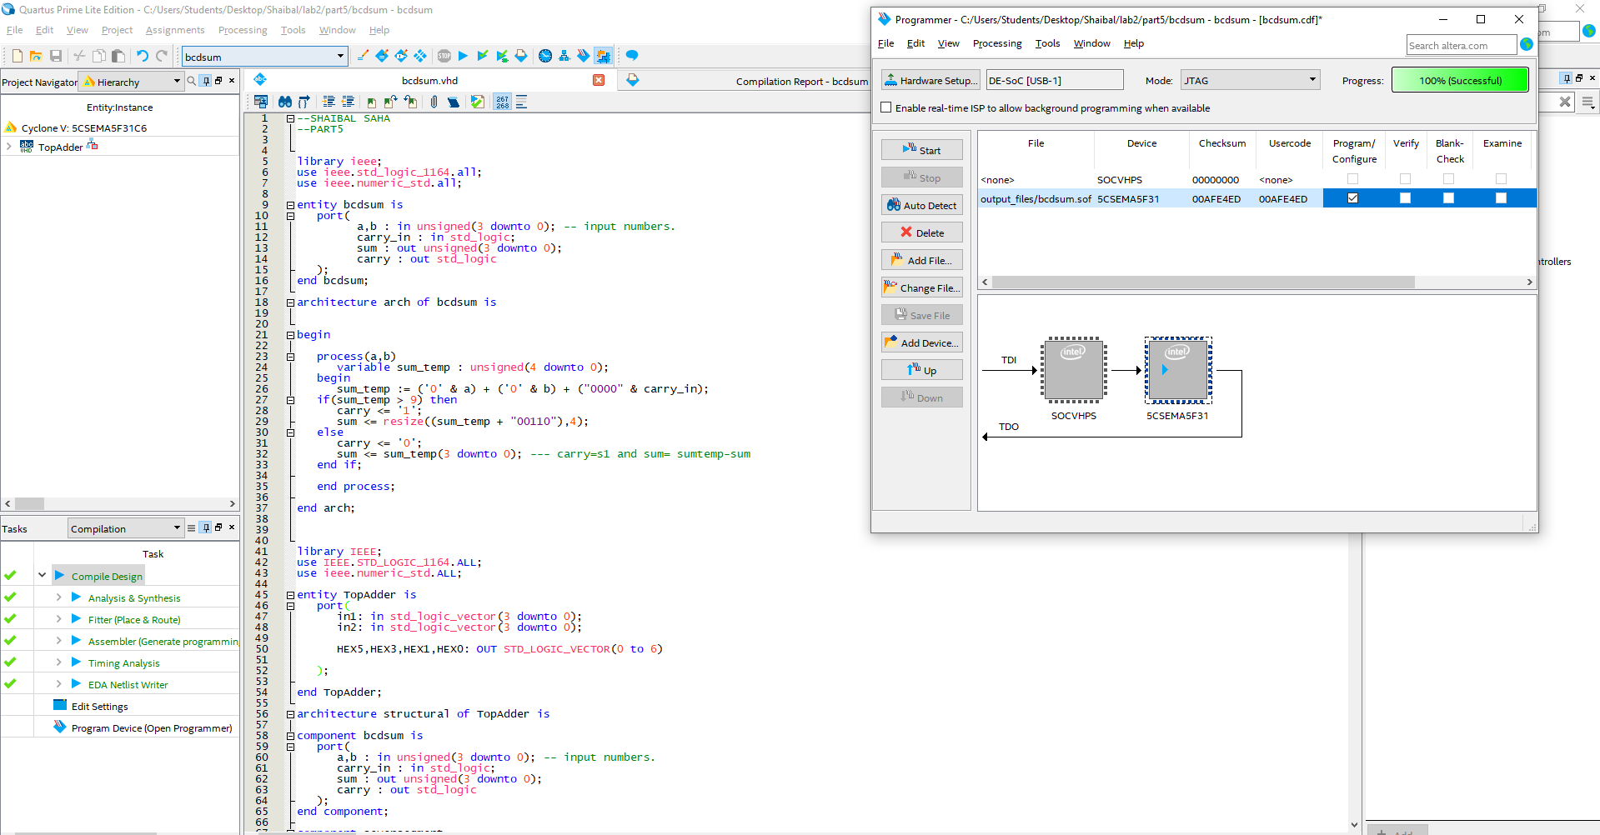
Figure 5.1: code and analysis screenshot for part5
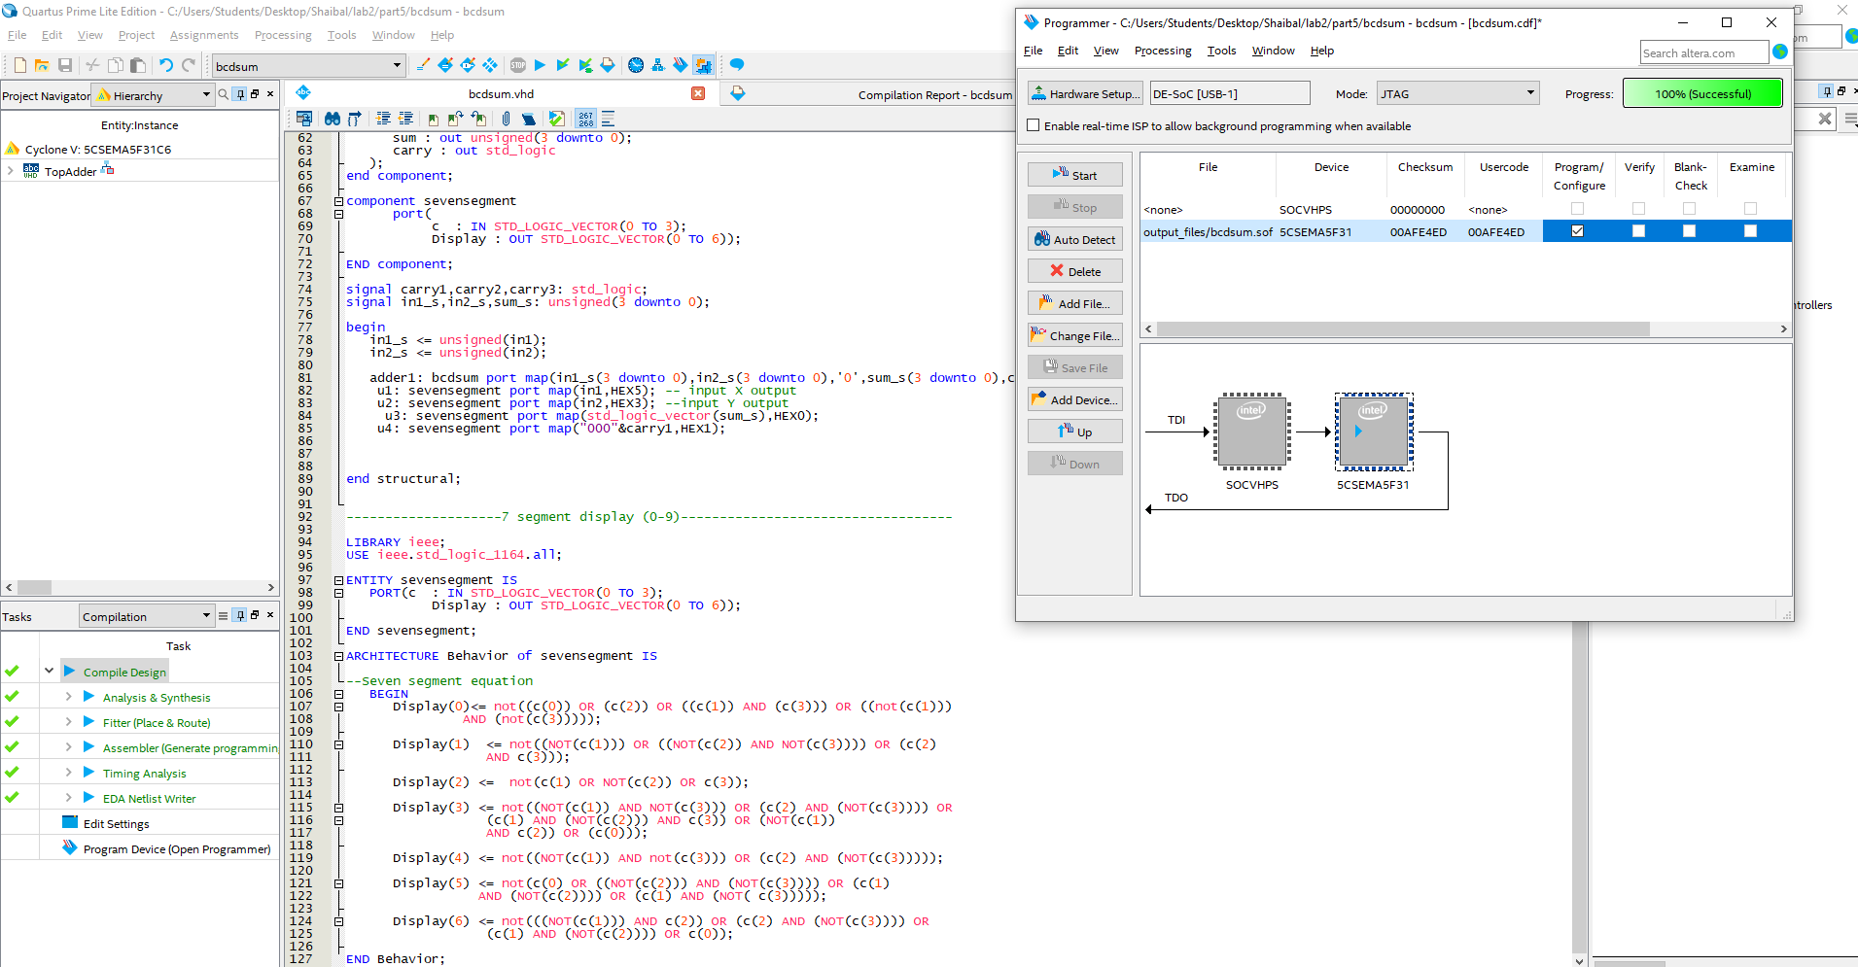
Figure 5.2: code and analysis screenshot for part5
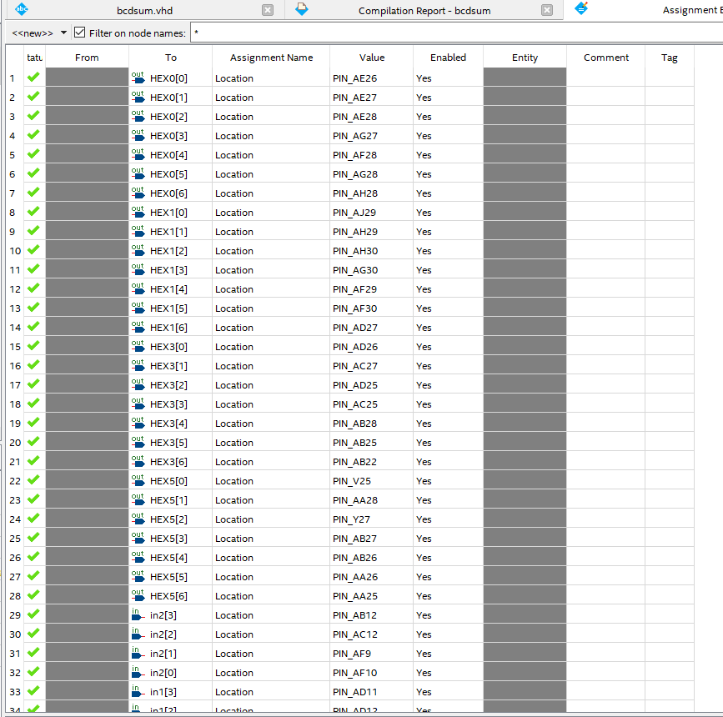
Figure 5.3: Pin assignment for part5

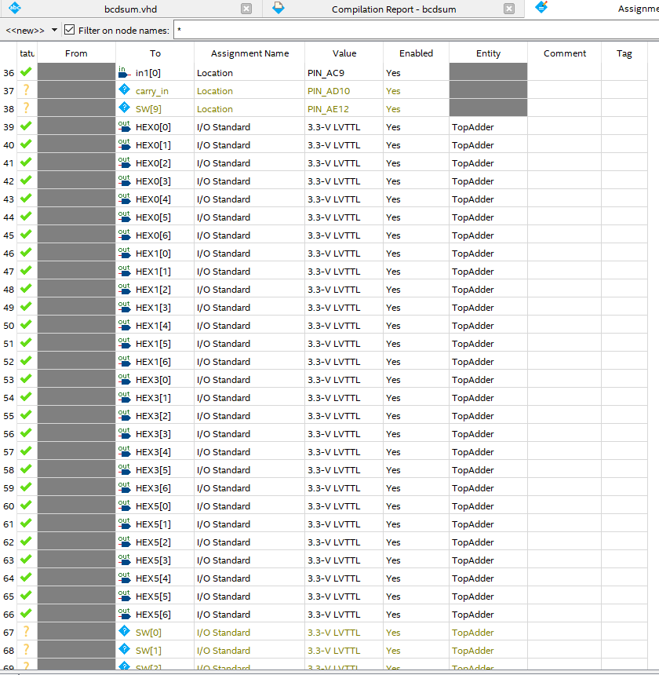
Figure 5.4: Pin assignment for part5
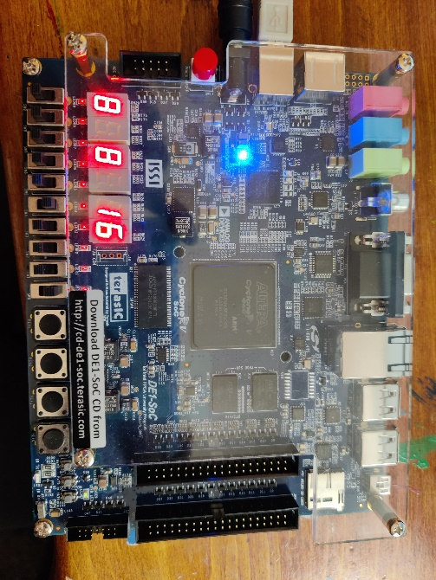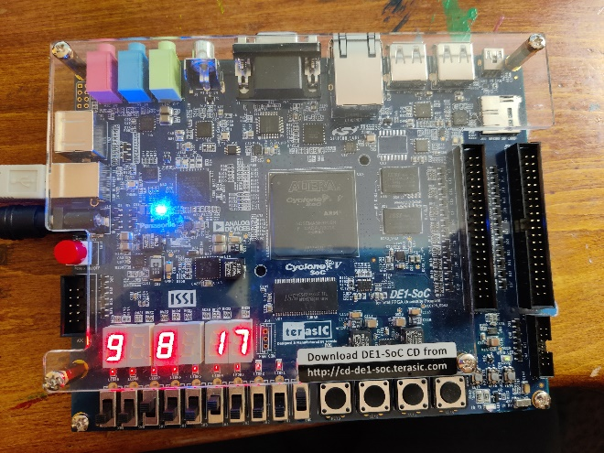
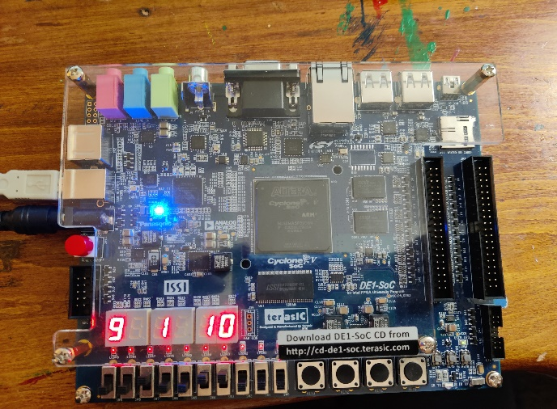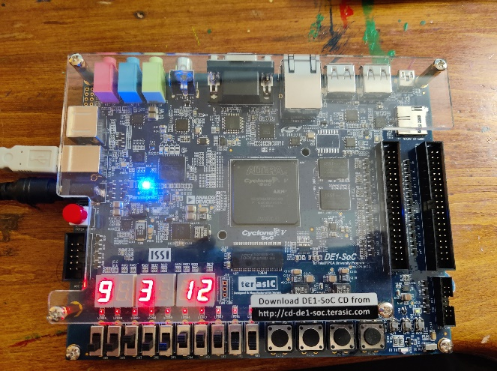
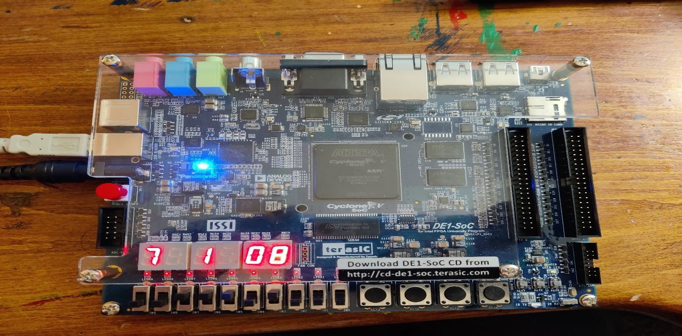
Figure 5.5: Sample output for part5

- Part6: The part6 is the combinational design of 6-bit binary number to 2-bit decimal number. We need to redesign comparator for 6 bit and mux and divide out output like under 10, under 20 means multiples of tens. It can produce up to 63 decimal numbers. The complete code design screenshot and a sample output what I get are given below:
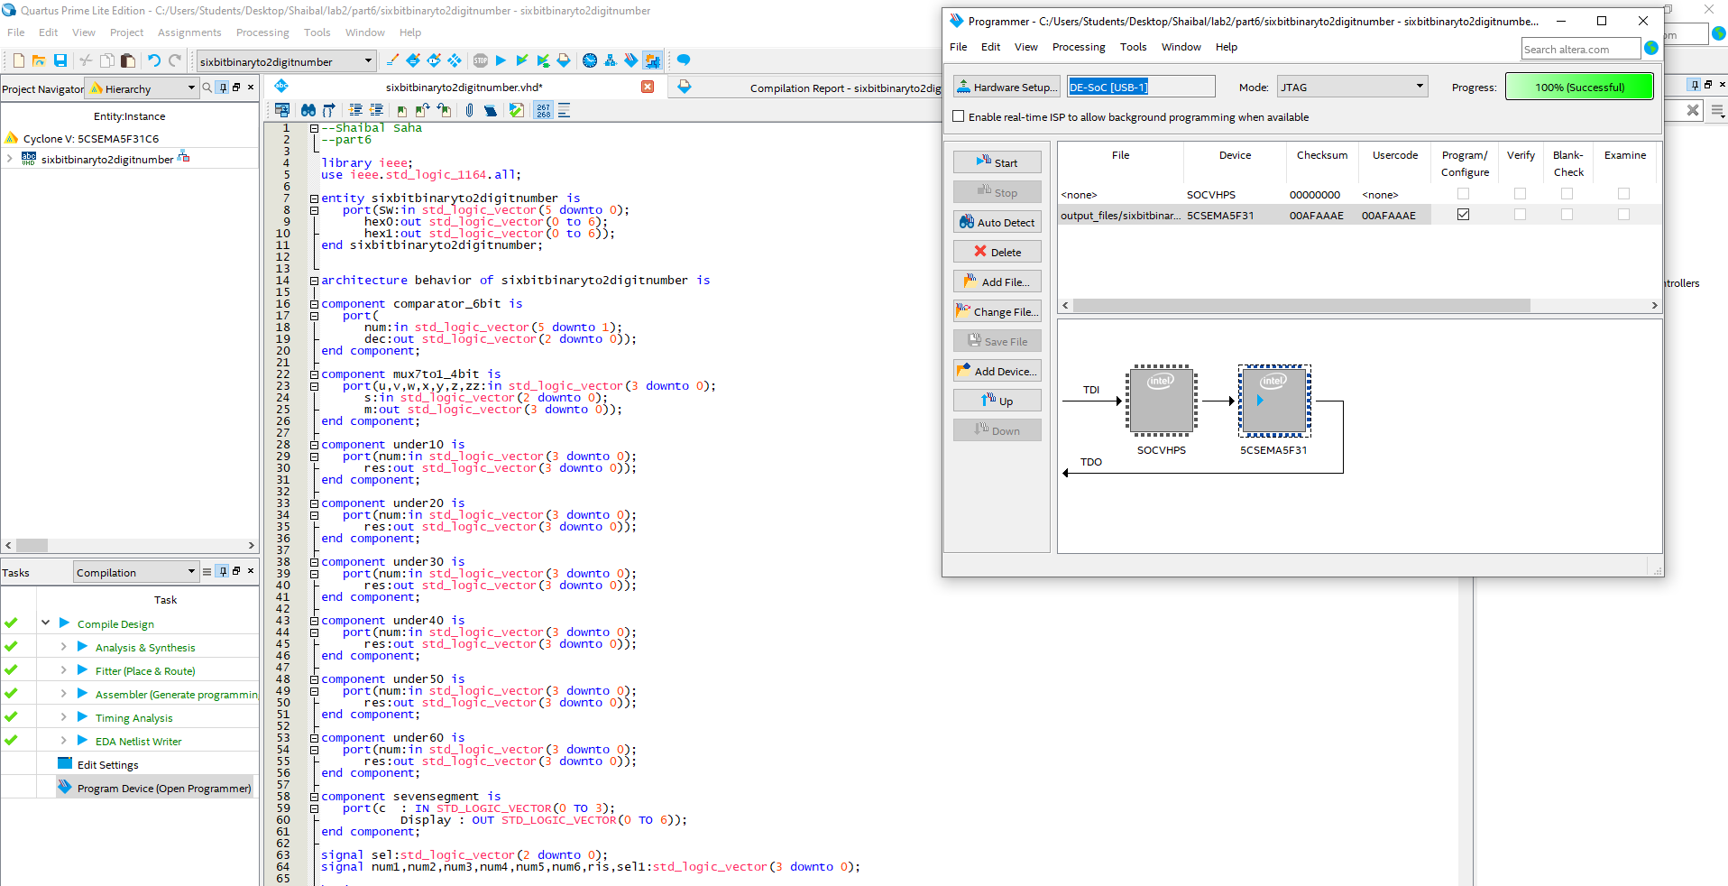
Figure 6.1: code and analysis screenshot for part6
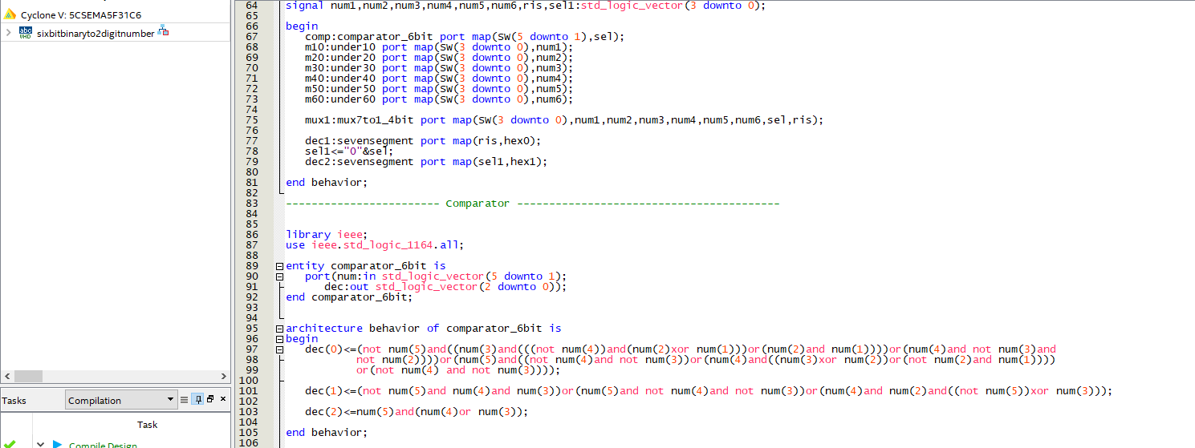
Figure 6.2: code and analysis screenshot for part6(main function output section and comparator)

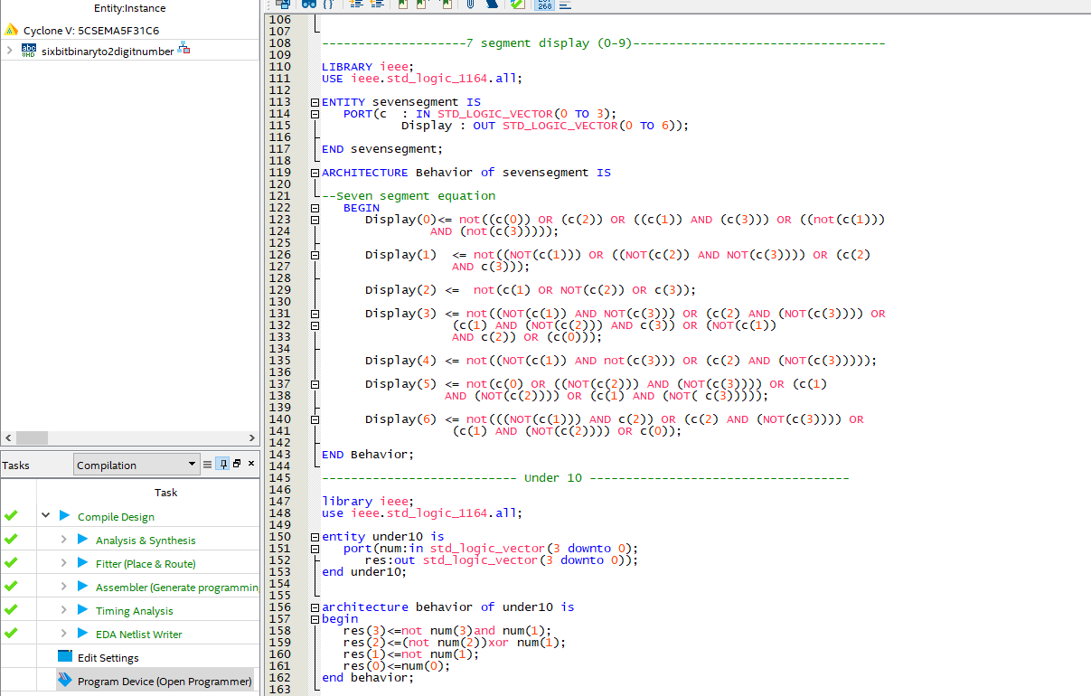
Figure 6.3: code and analysis screenshot for part6(7 segment and equation for under 10 numbers)
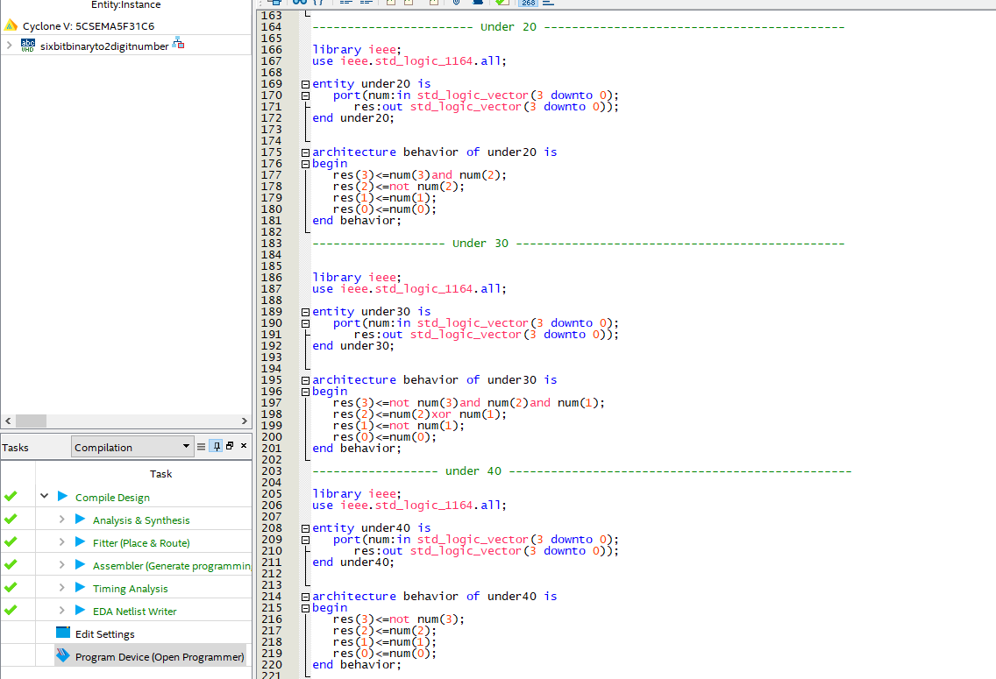
Figure 6.2: code and analysis screenshot for part6(equation for under 20,30,40 numbers)

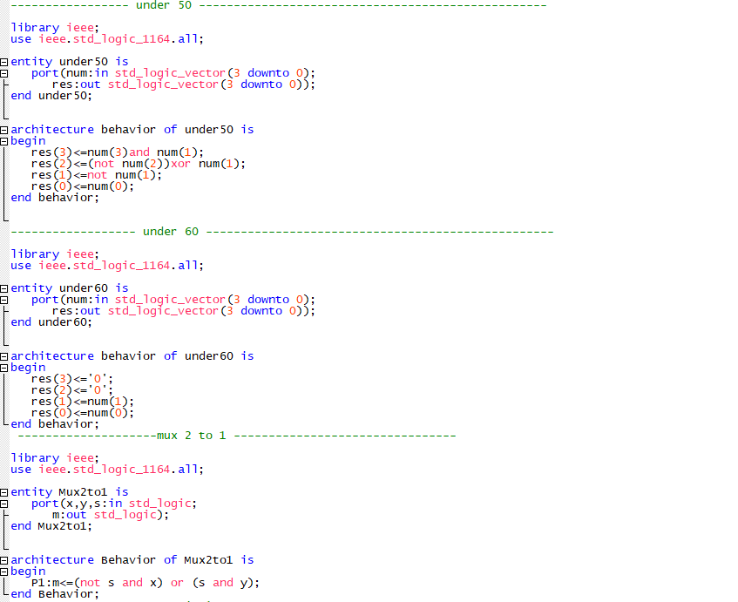
Figure 6.3: code and analysis screenshot for part6(equation for 50,60 numbers and 7-segment display equation)
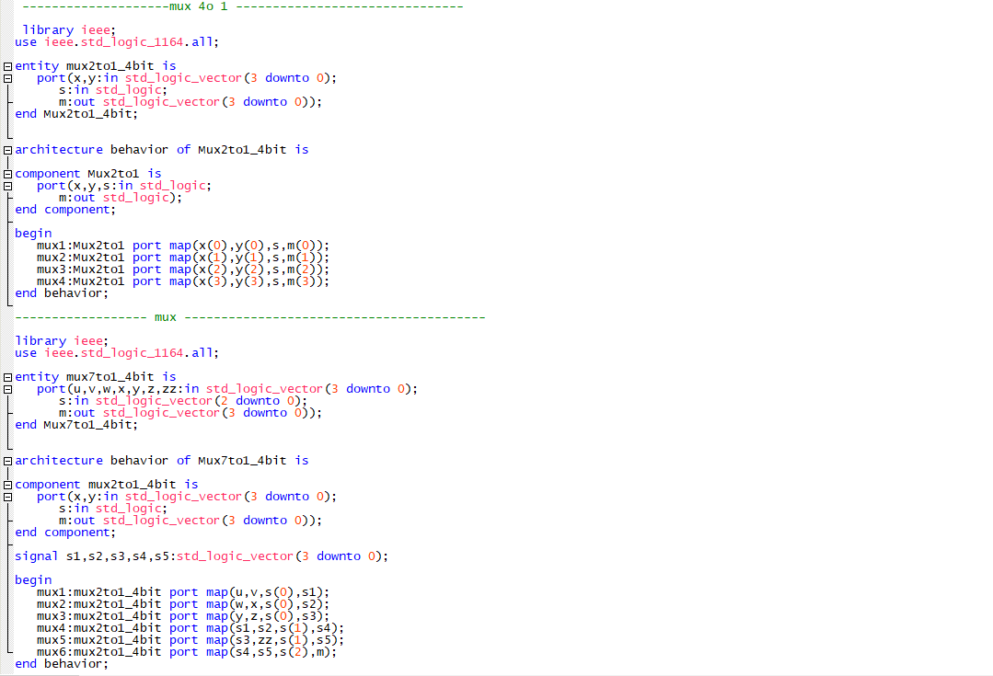
Figure 6.4: code and analysis screenshot for part6(designing mux using 4 to 1 and 2 to 1 mux)
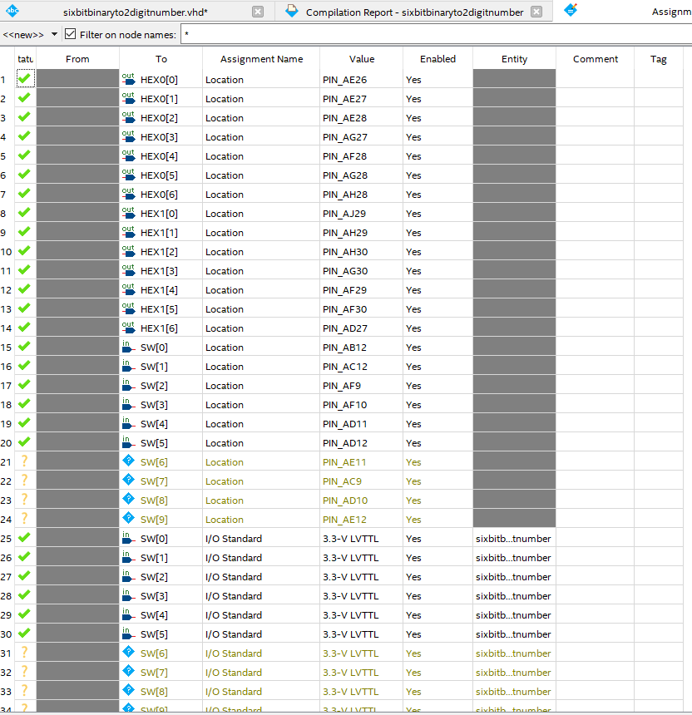
Figure 6.4: Pin assignment for part 6

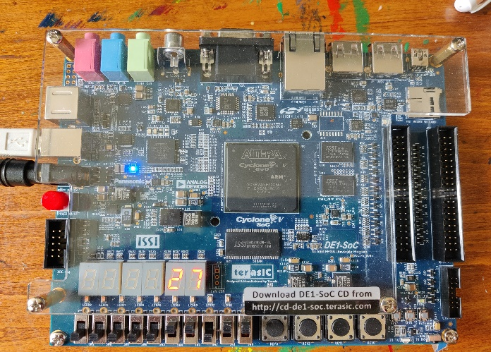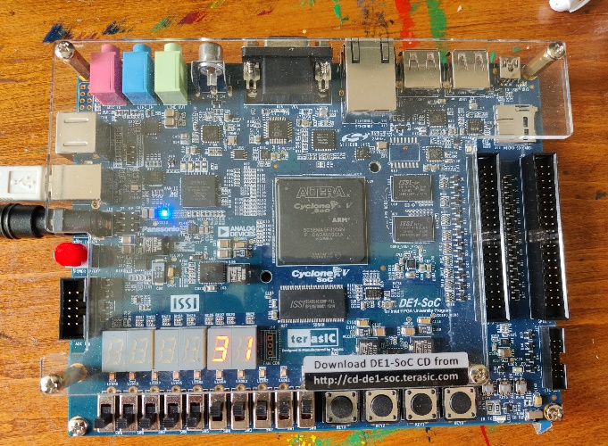
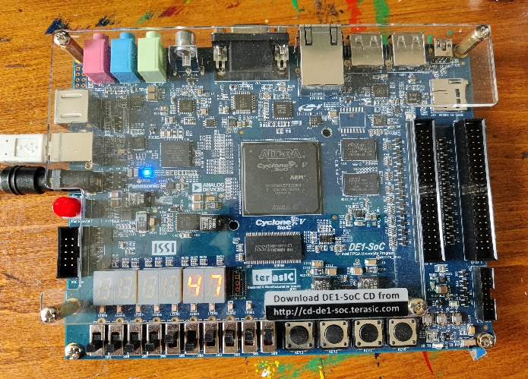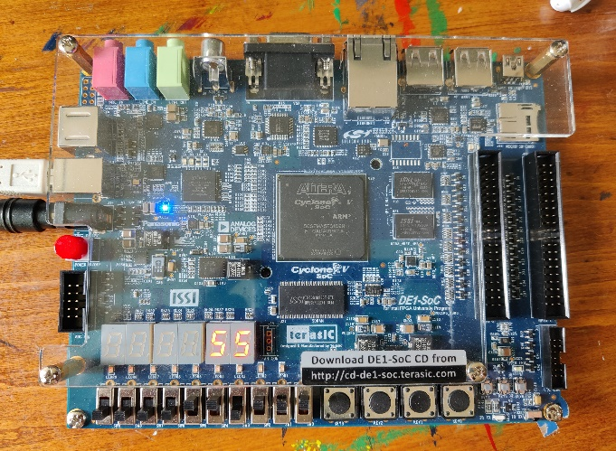
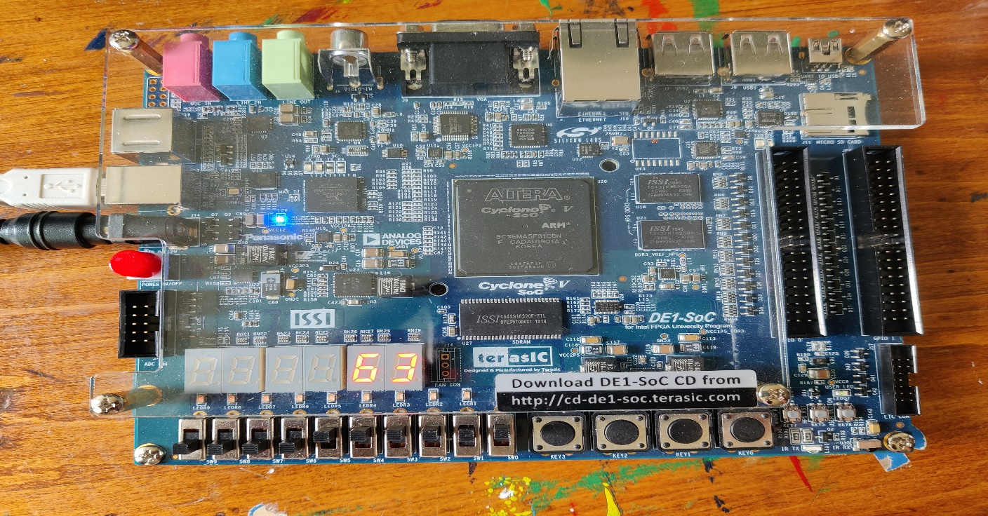
Figure 5.5: Sample output for part6
Note: All the source codes are inside lab folder.

