This problem is the part of midterm 1. Here in this report ,I will show all the screenshot of the code as well as waveform from test branch outputs and screenshot on the output in the DE-soc1 board.
The problem is to design a sum of minterms f(w1,w2,w3) = ∑(1,3,4,5,7) . I need to implement this with 3 to 8 decoder and one OR gate. The below code is for the 3 to 8 decoder and the function that implement the or gate:
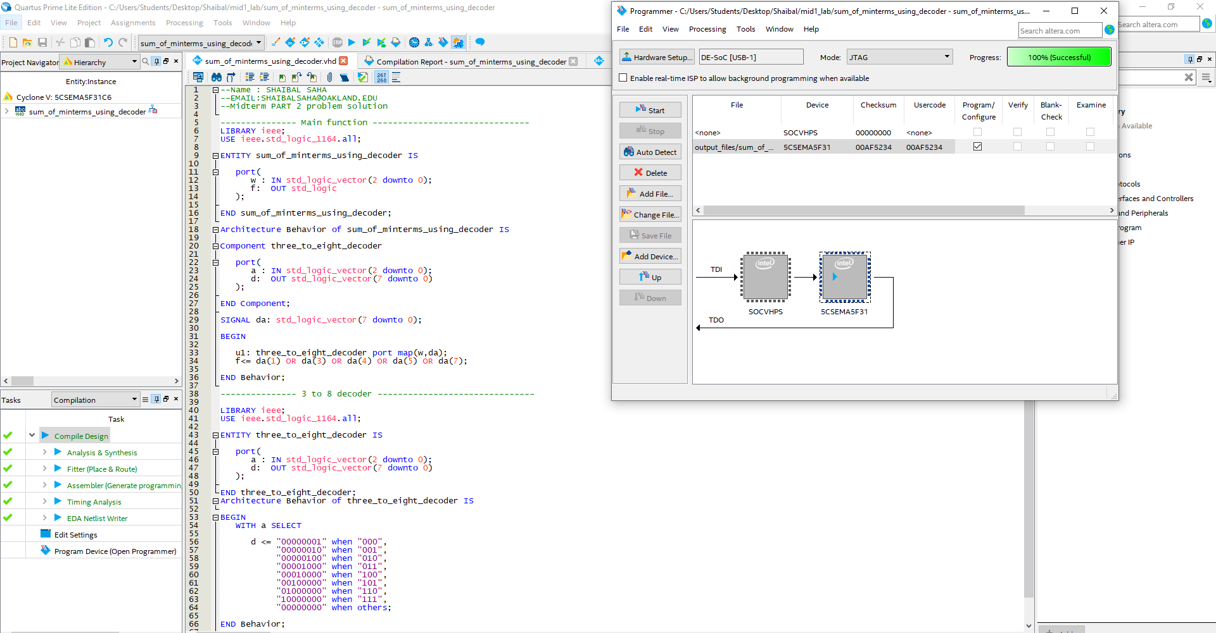
Figure: 3 to 8 decoder and the function that implement or gate
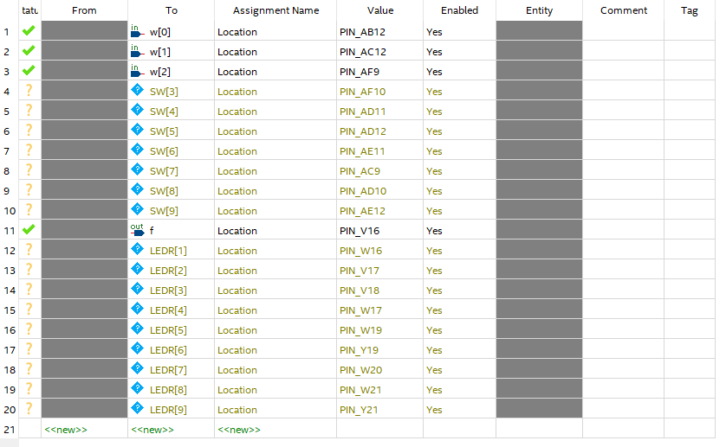
Figure: Pin assignment for desoc1 board output
The next screenshot is the code for the test inputs and outputs .
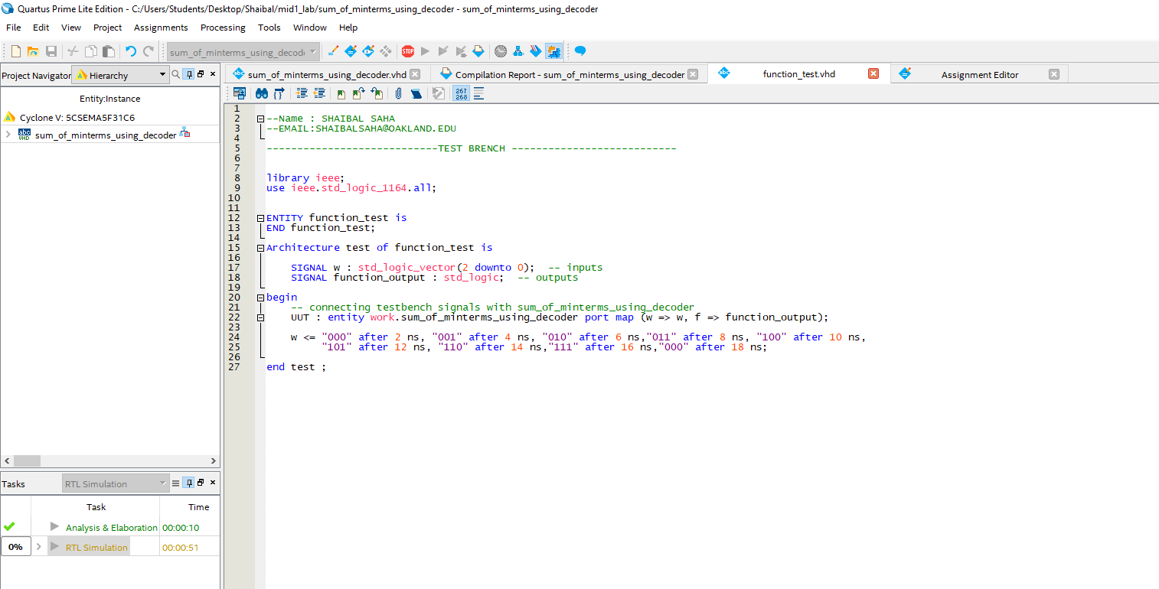
Figure: Test branch code
Output: I simulate in the modelsim altera as well as testing with desoc1 board. Here I attach both the screenshot and picture taken from de-soc1 board some of the inputs.
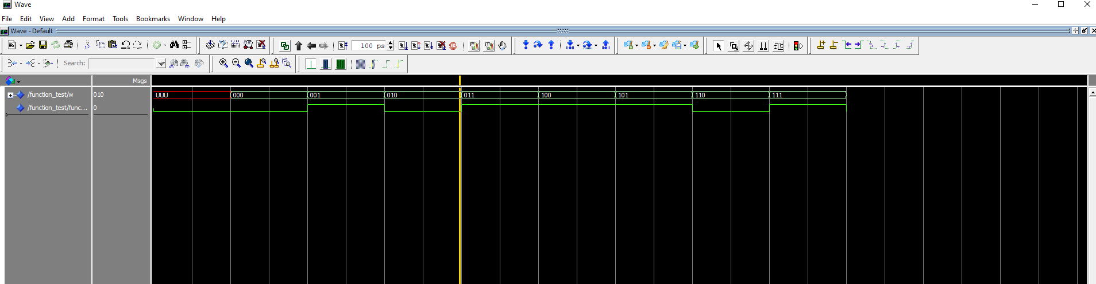
Figure: Waveform of the all possible input
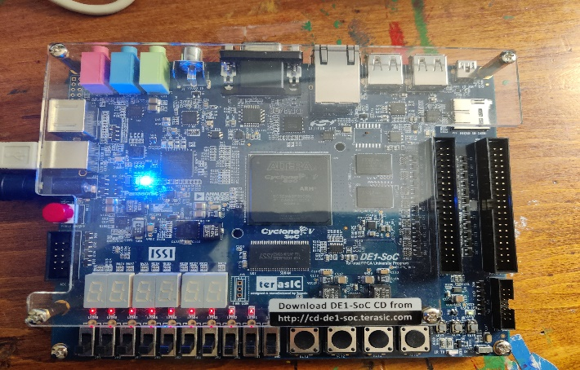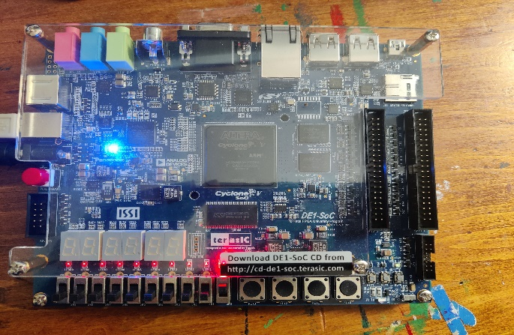
Input (001)-> output(1)
Input (000)-> output(0)
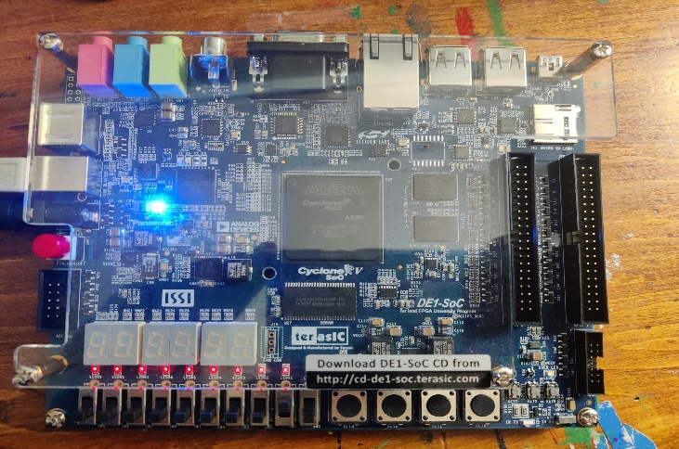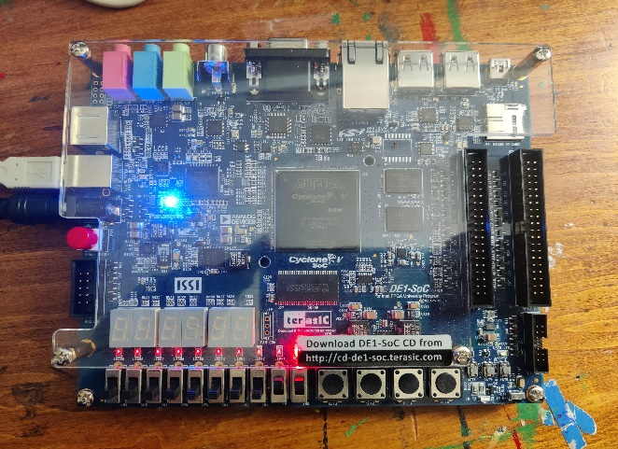
Input (011)-> output(1)
Input (010)-> output(0)
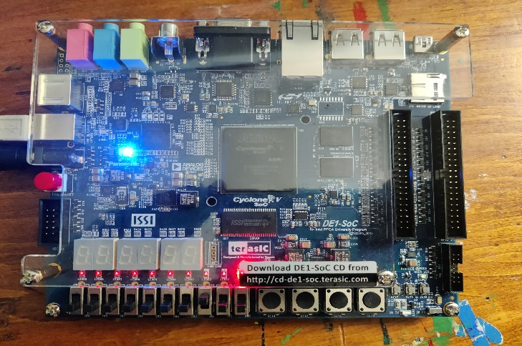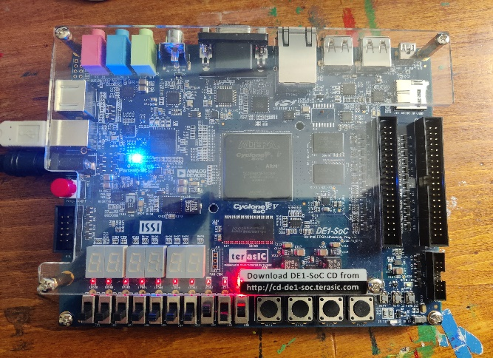
Input (101)-> output(1)
Input (100)-> output(1)

Figure: Output in DE-SOC1 board

Note: SOURCE CODE IS IN THE mid1_lab folder.

