Objective: In this lab We need to design latch and see the waveforms of the output as well as the RTL tool view and technology map view to understand the relationship between input and output.

Part 1: In this part We use the VHDL code of SR latch and see the output of latches in waveform and also the technology view. The screenshots are provided below:
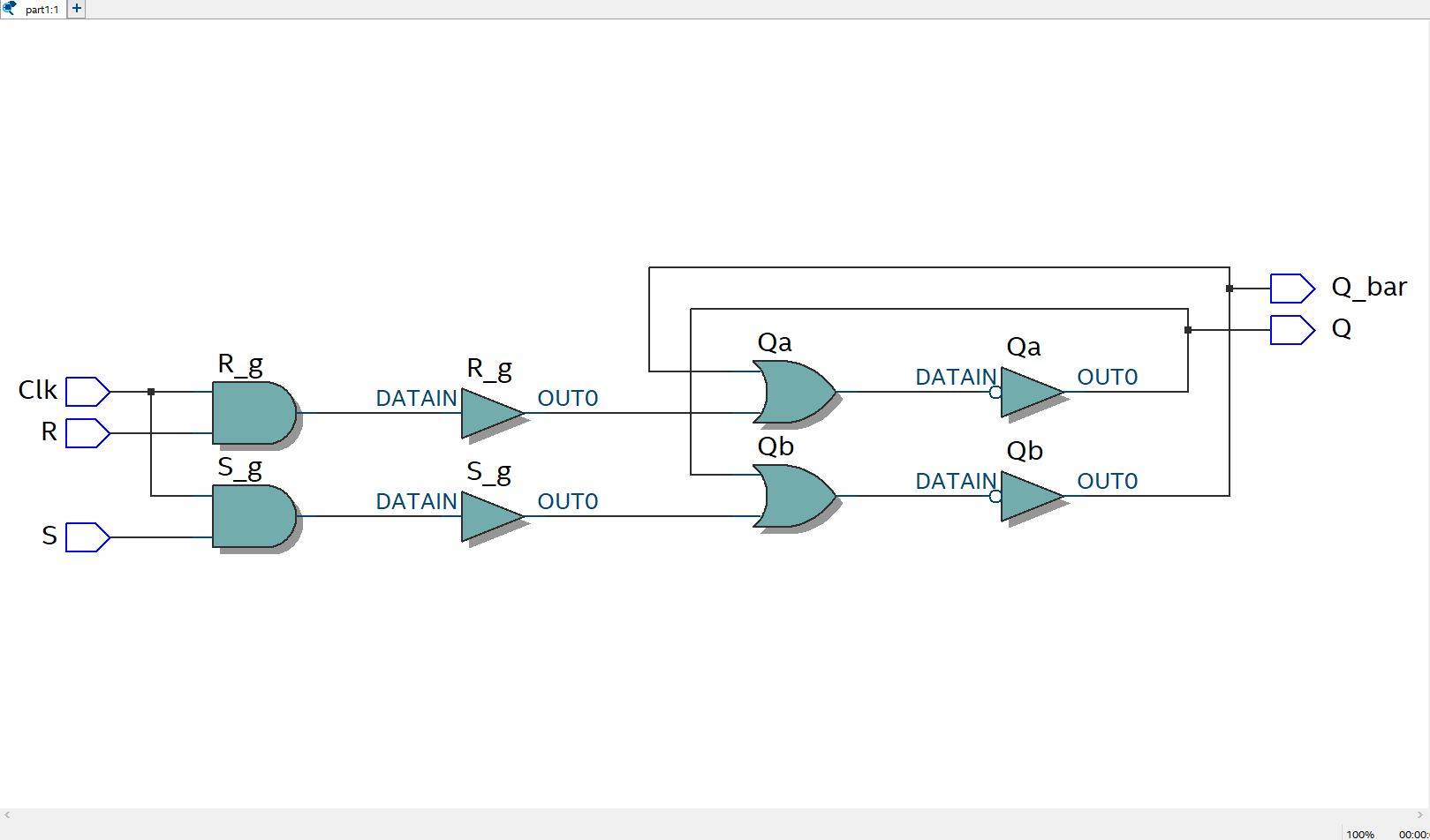
Figure 1.1: RTL viewer tool
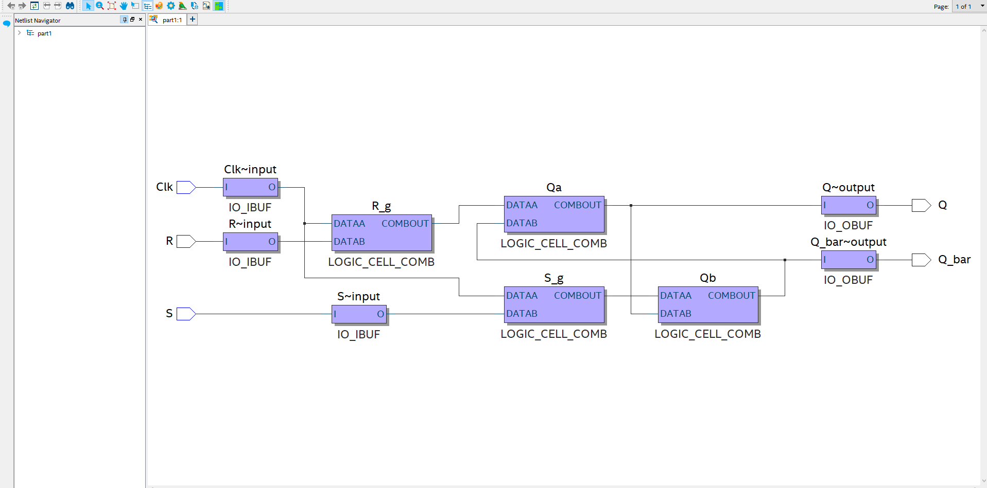
Figure 1.2: Technology map viewer tool
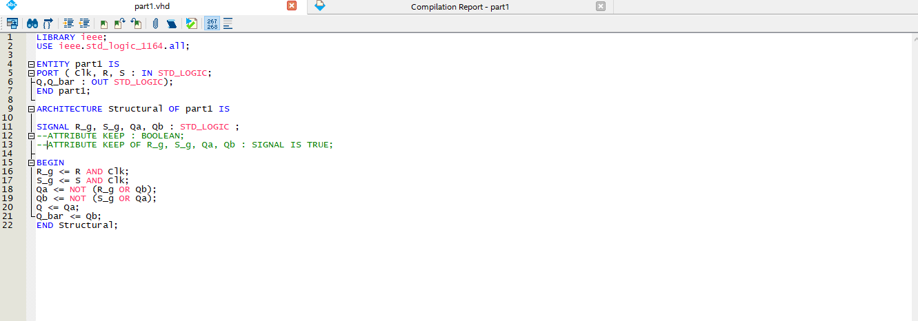
Figure 1.3: RS latch VHDL code
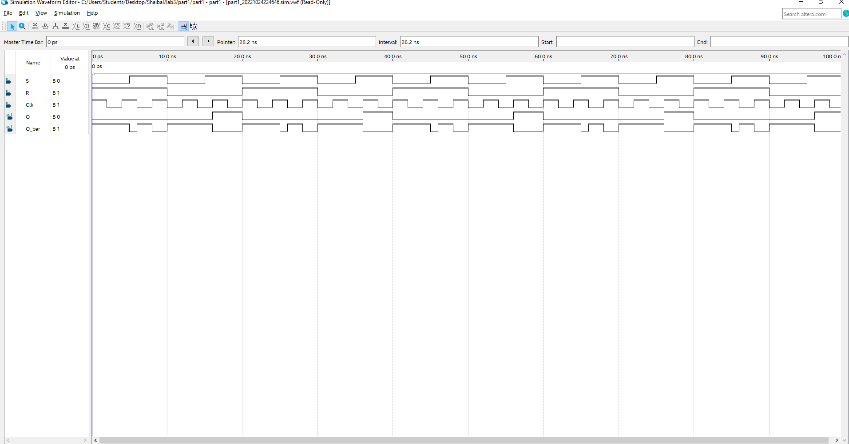
Figure 1.4: Generated waveform
Part 2: In this part 2, I use the VHDL code of D latch and extend the d-flipflop for multiple waveform to see the output of d-latches in waveform and also the technology view. The screenshots are provided below:
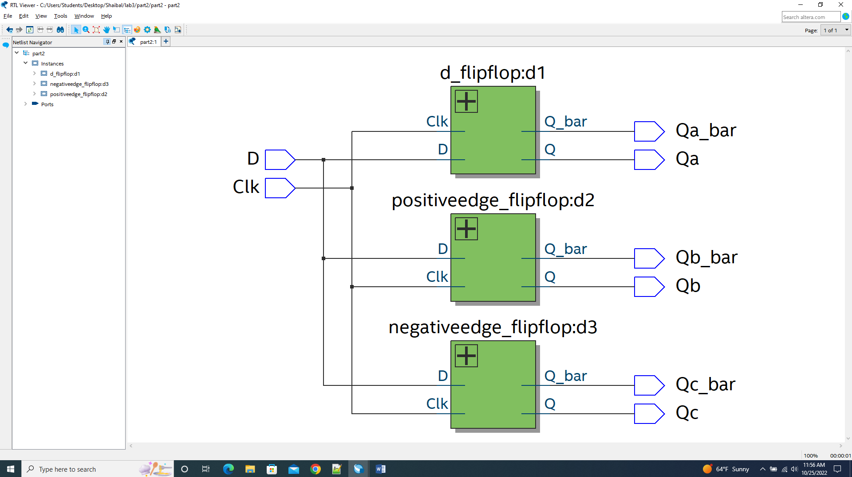
Figure 2.1: RTL viewer tool
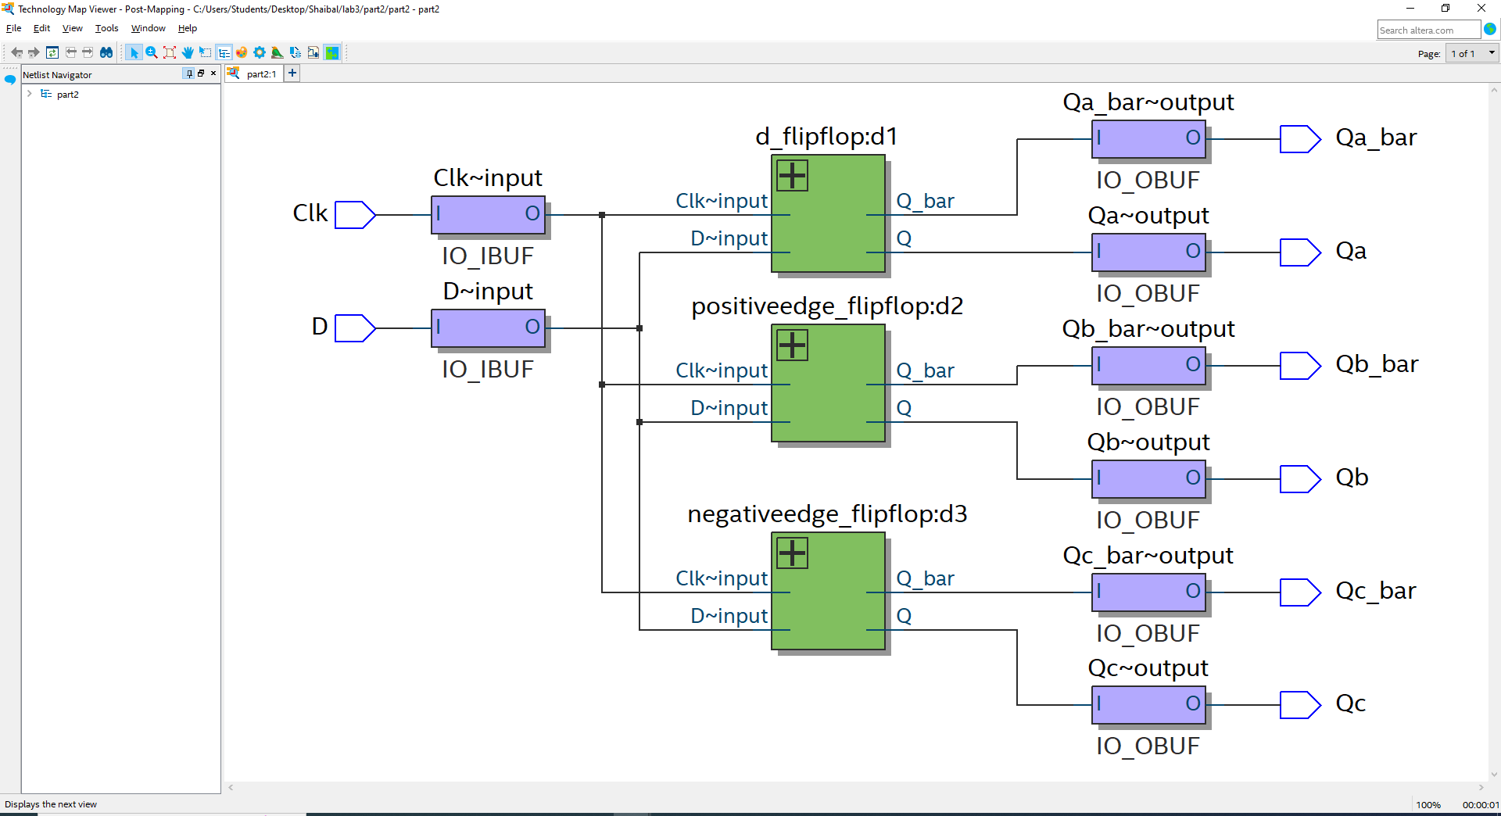
Figure 2.2: Technology map viewer tool

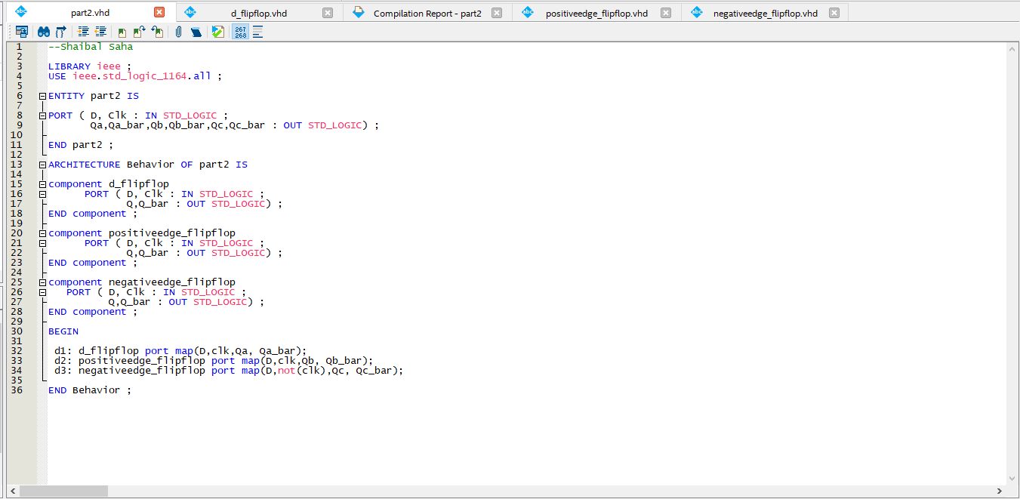
Figure 2.3: Code
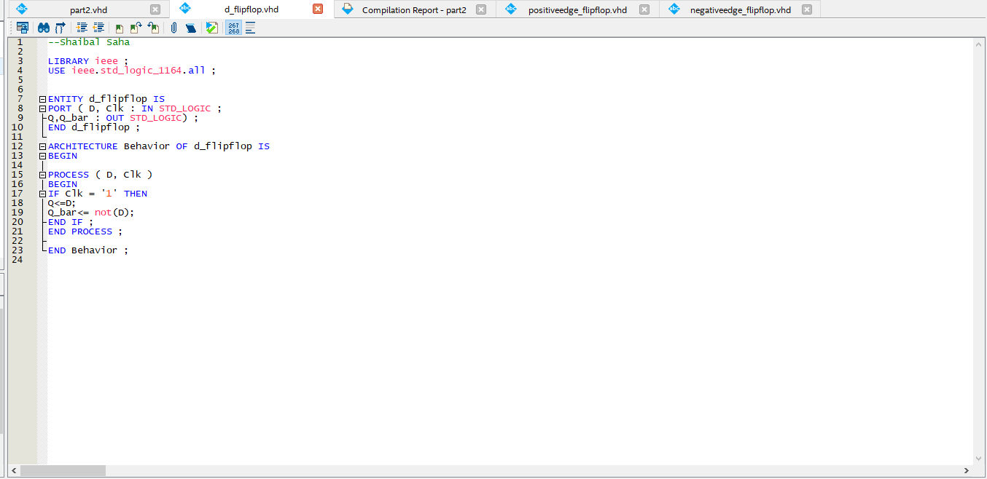
Figure 2.4: Code
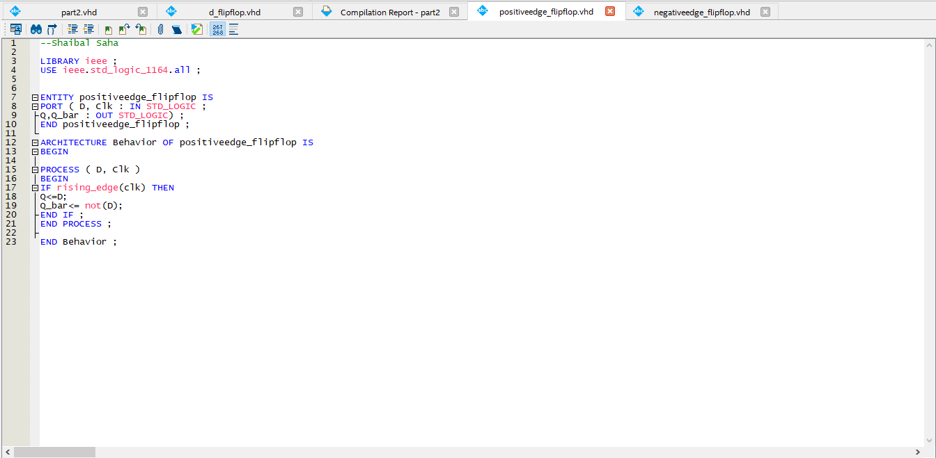
Figure 2.5: Code
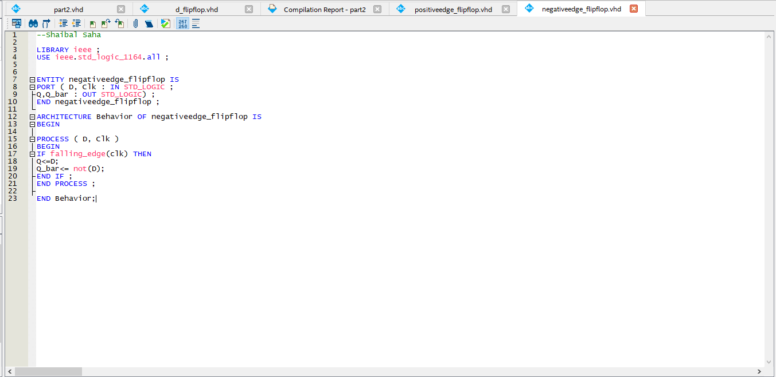
Figure 2.6: Code

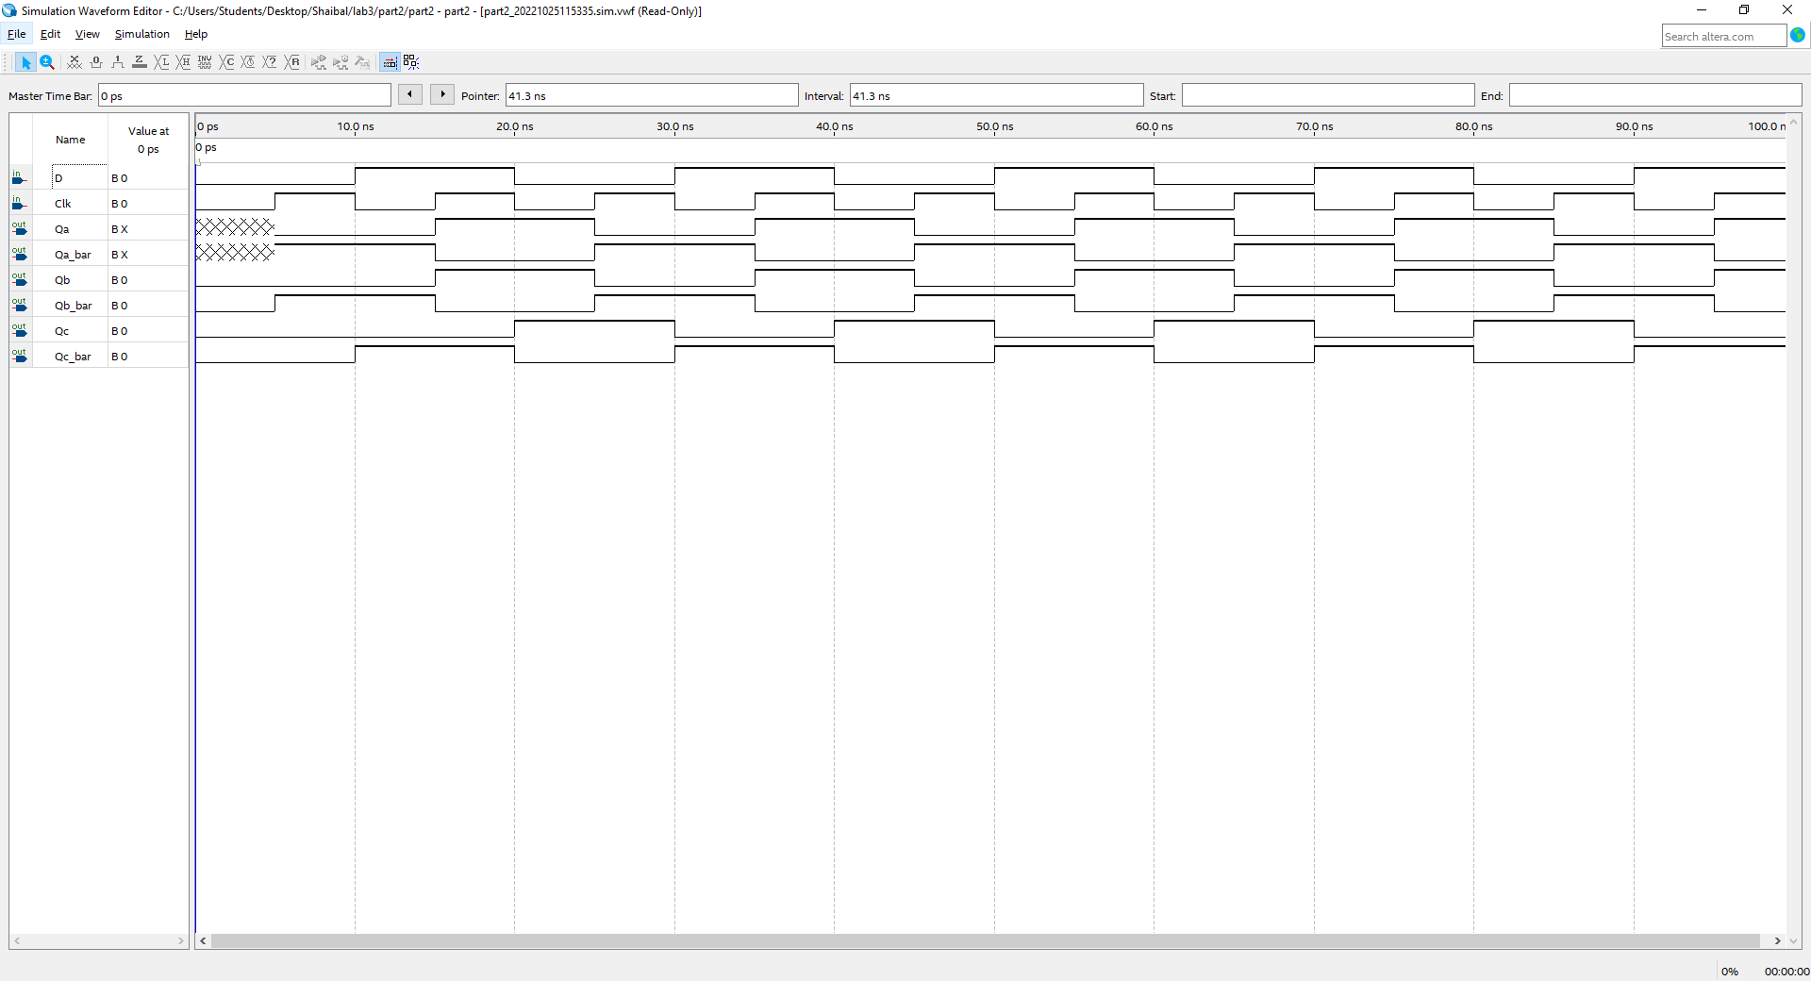
Figure 2.7: Generated waveform

Part 3: In this part 3, I add two 8 bit number using a key to store the variable A . I have to design bcd to binary for 8 bit to get perfectly in 7 segment display. I attached the code as well as the some of the screenshots below:

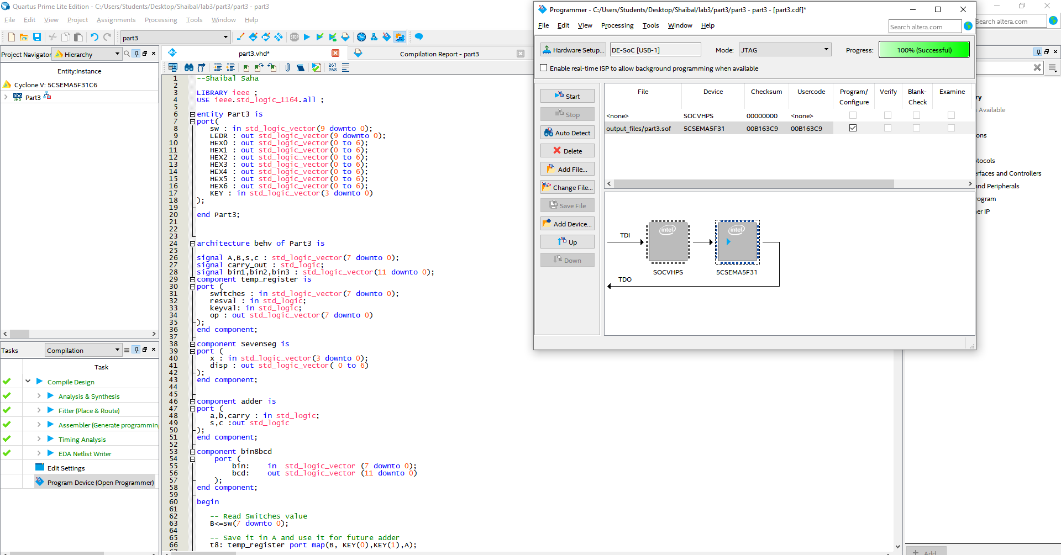
Figure 3.1: Code
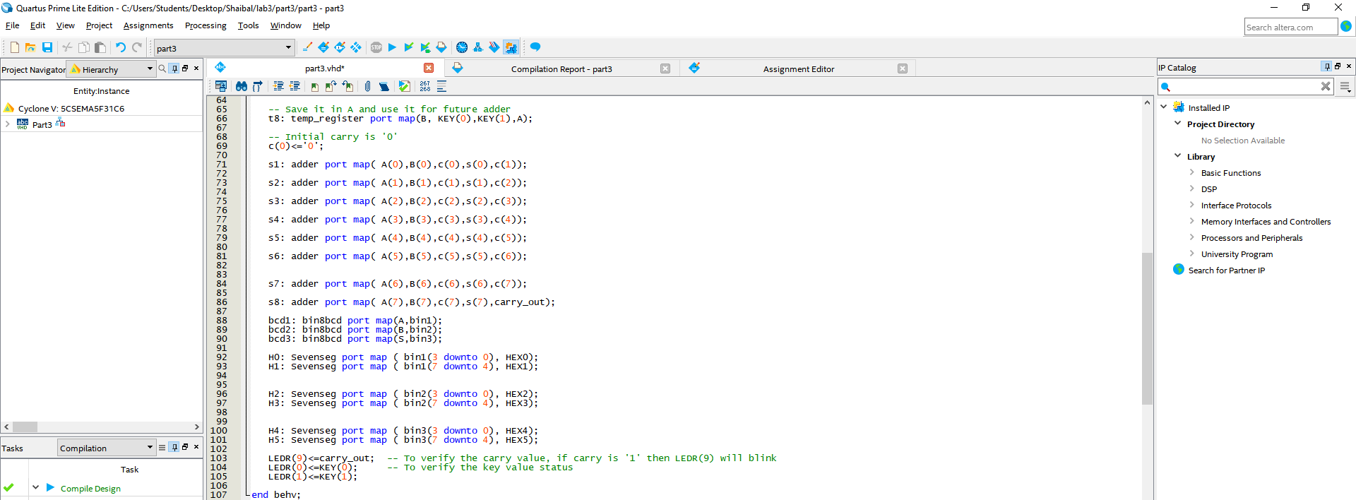
Figure 3.2: Code
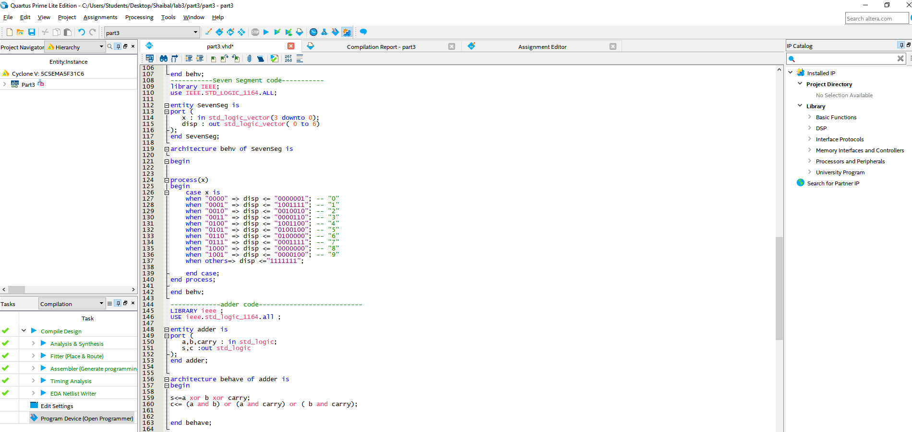
Figure 3.3: Code
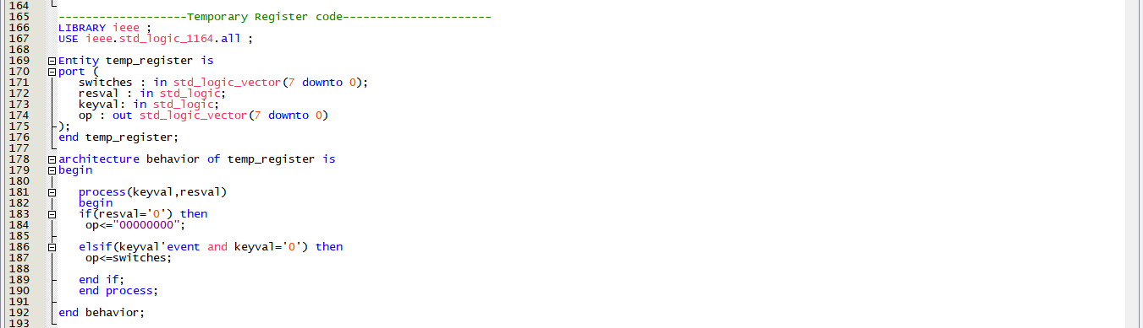
Figure 3.4: Code
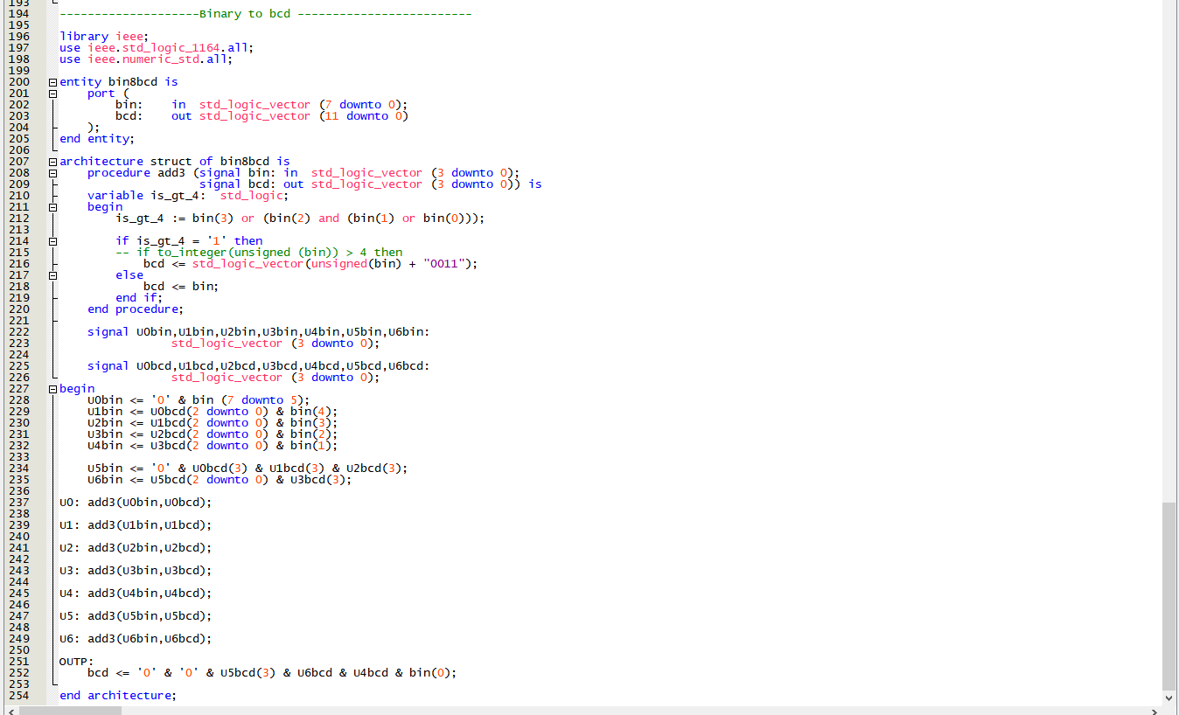
Figure 3.5: Code
Output: Output of the program are given below (some of the photos from the DE-soc1 board)
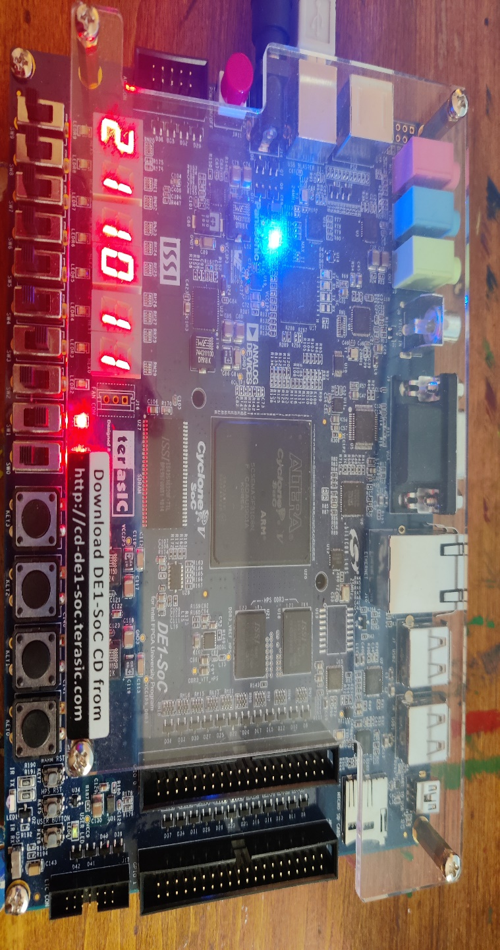
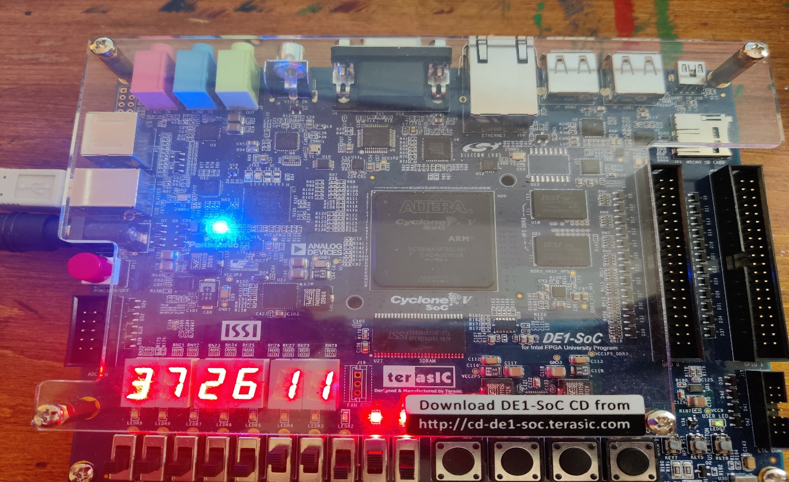
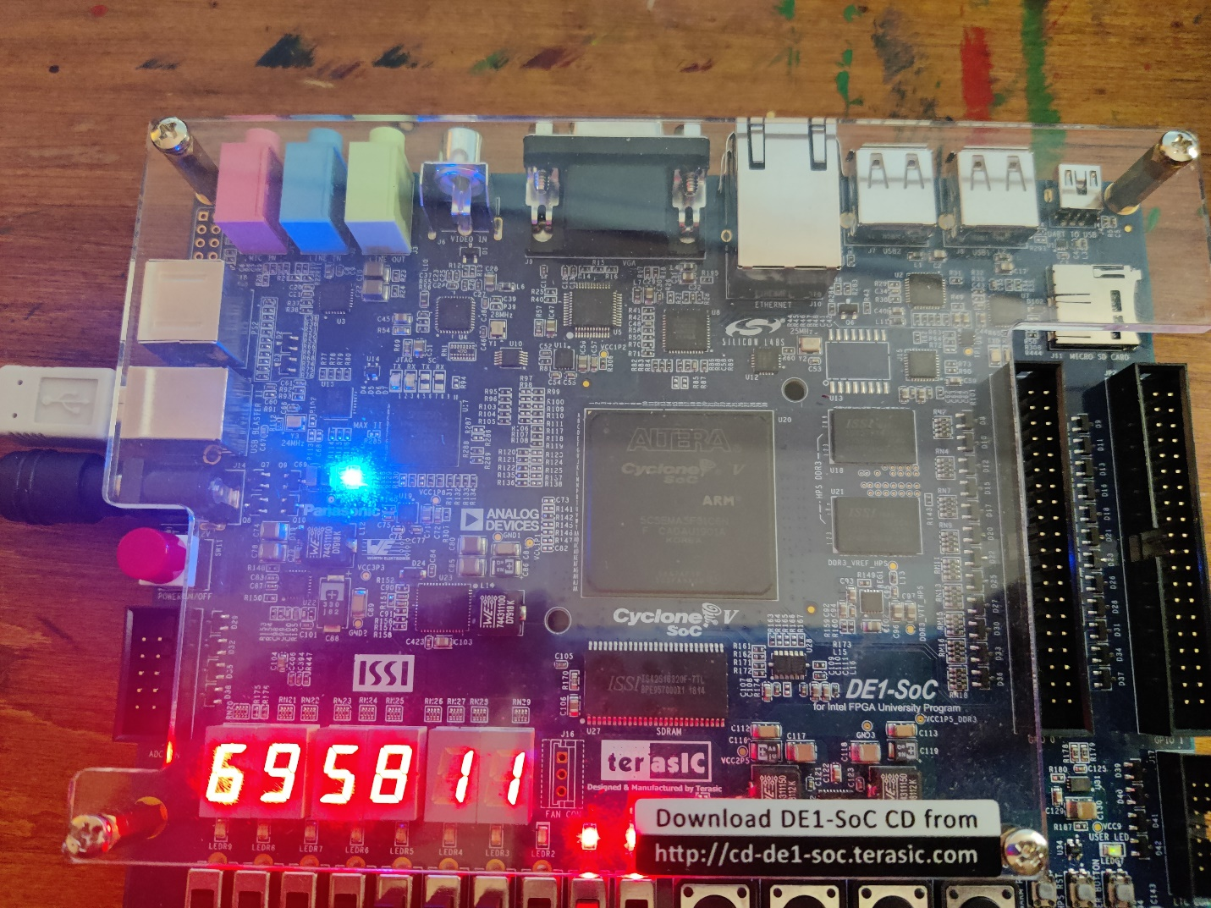
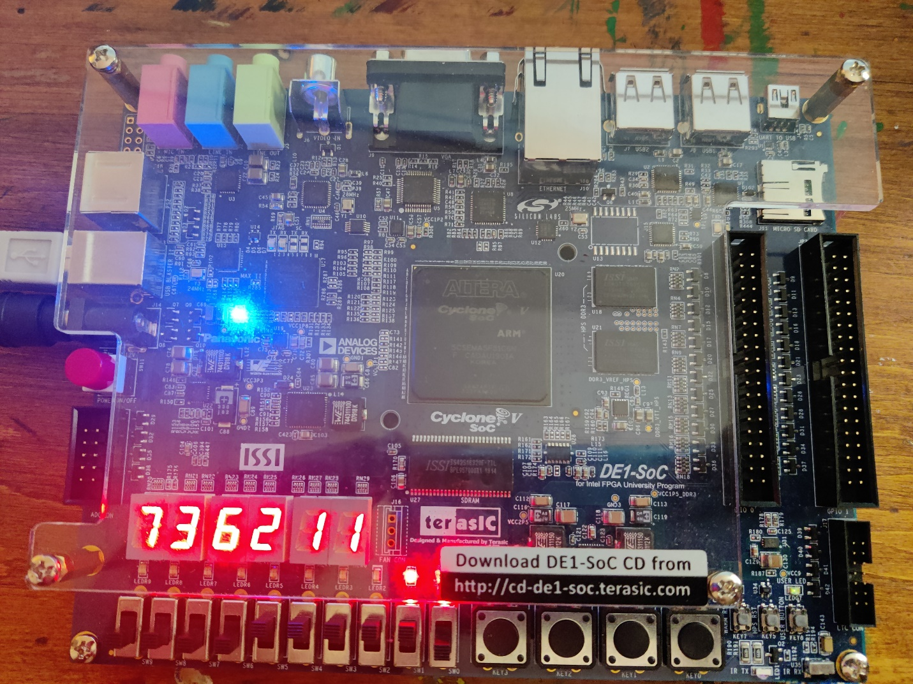
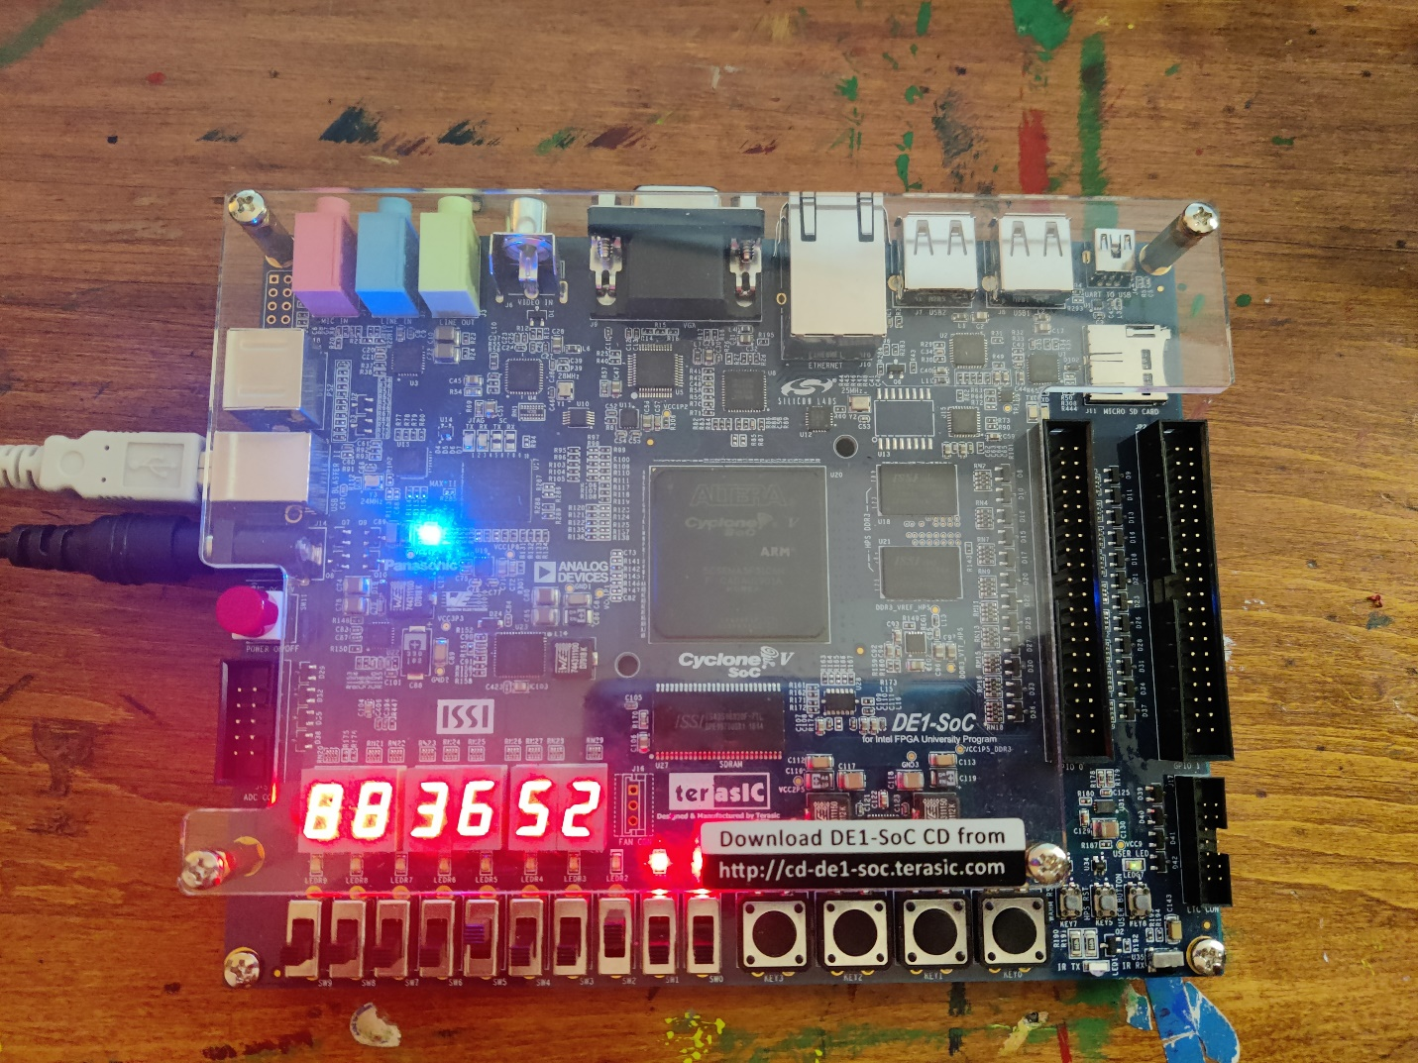
Figure: Output sample of the VHDL code

Note: All the source codes are inside lab3 folder.

