Objective: In this lab, we will work on counter, flipflops and see their characteristics in the De-Soc1 board. Furthermore, we will be able to have a basic understanding of counters and sufficient familiarity with the VHDL hardware description language to implement various types of latches and flip-flops.

Part 1: In this part We use the VHDL code of t-flipflop to design a 8 bit counter and see the results on 7-segment display as well as send the output to LEDR. In addition, I design a 4-bit t-flipflop to understand the basic difference and see the RTL view of this circuit. For implementing, 8-bit counter We need to use 7 logic elements. The screenshot of outputs and codes are given below:
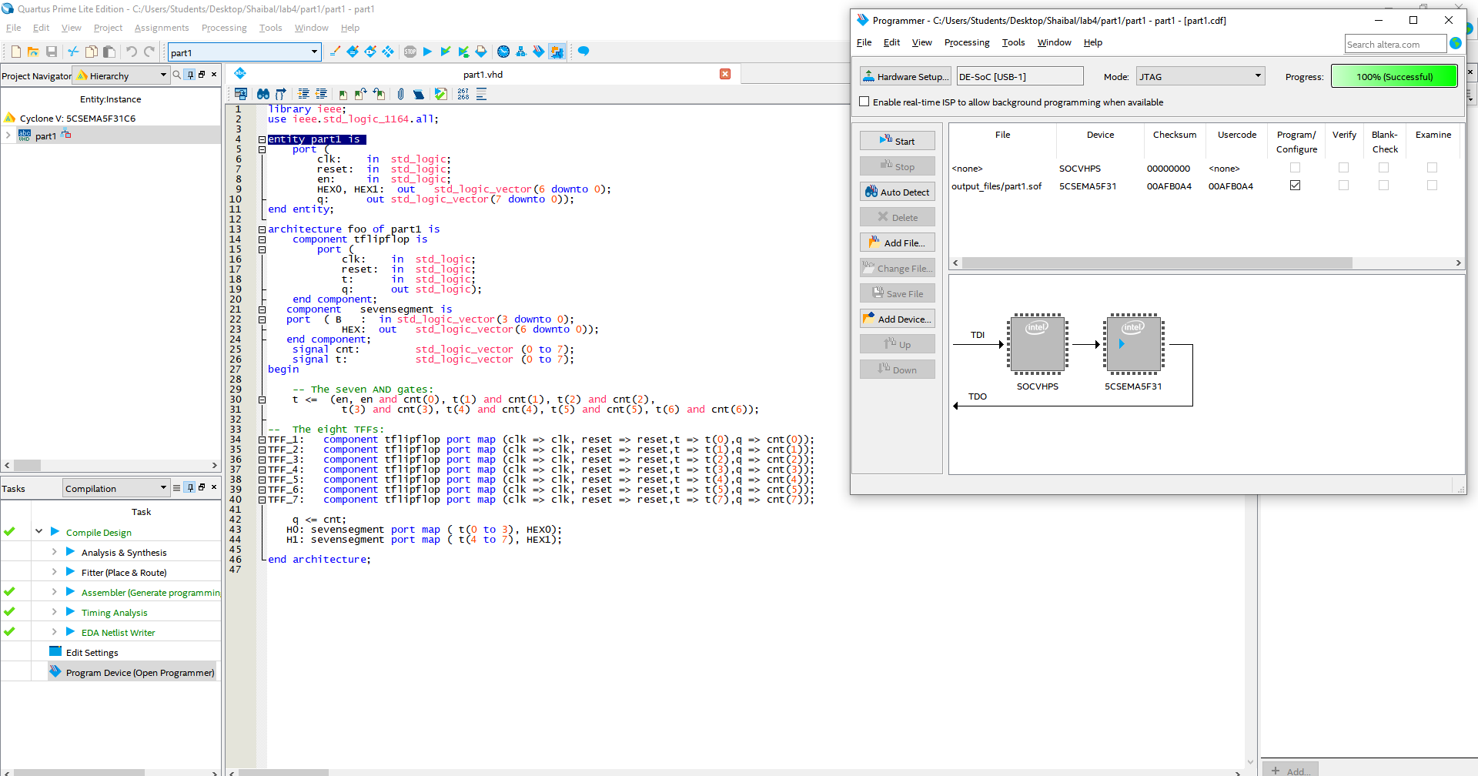
Figure: Code of part1
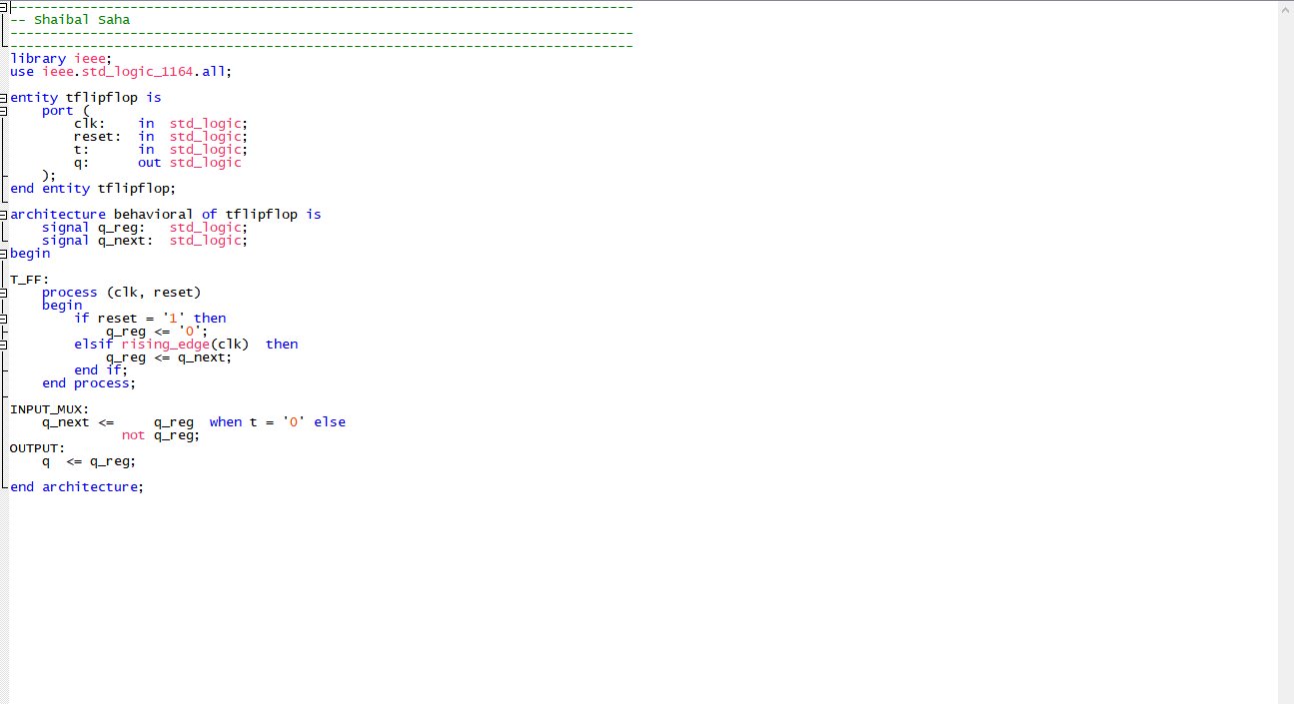
Figure: Code of part1
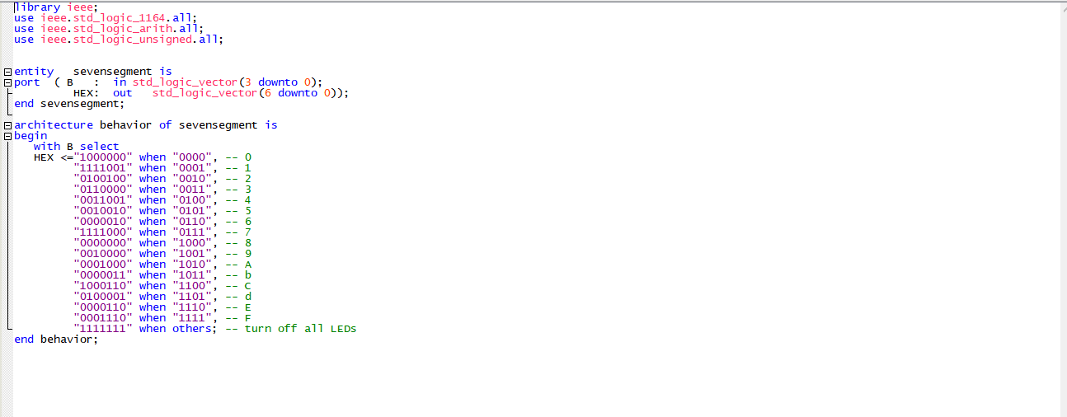
Figure: Code of part1
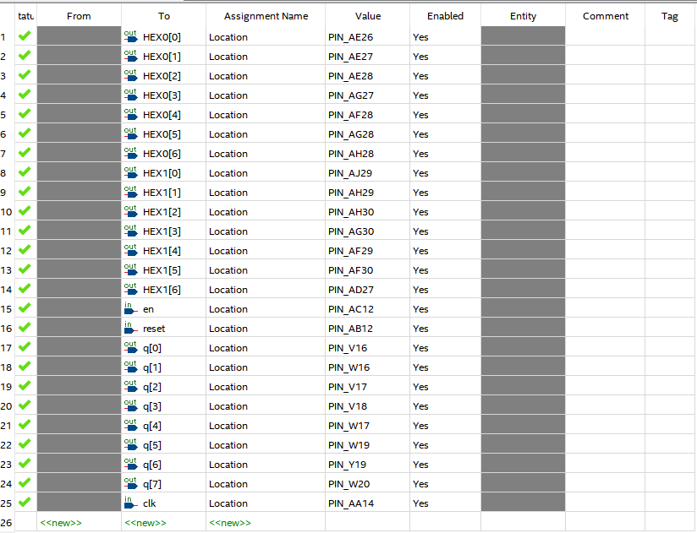
Figure: Pin Assignment
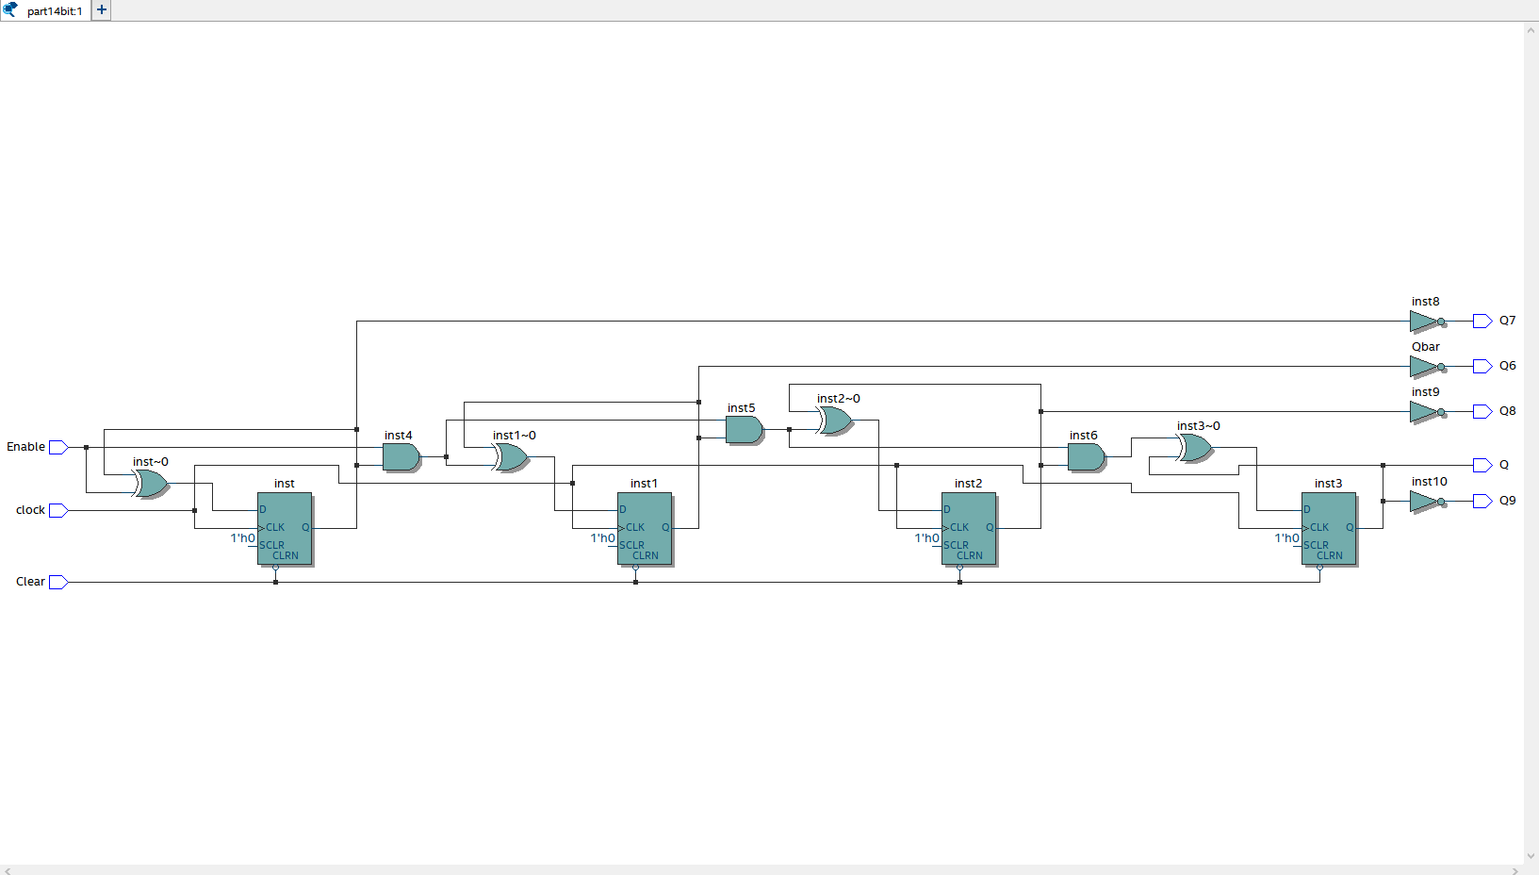
Figure: RTL view of 4 bit counter

Output:

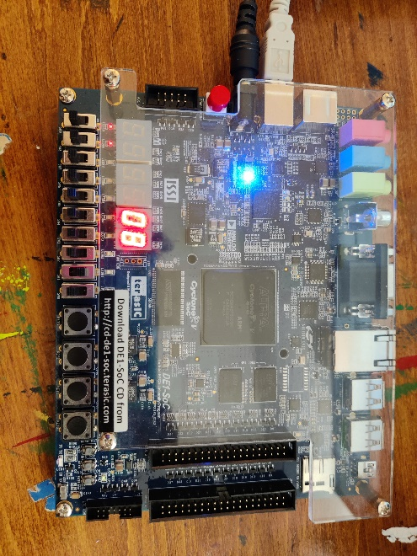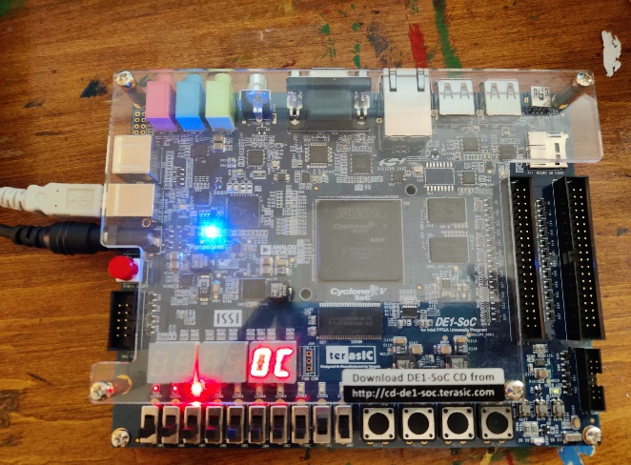

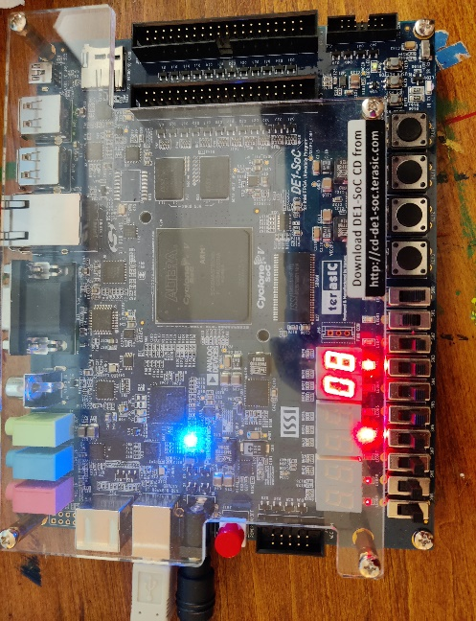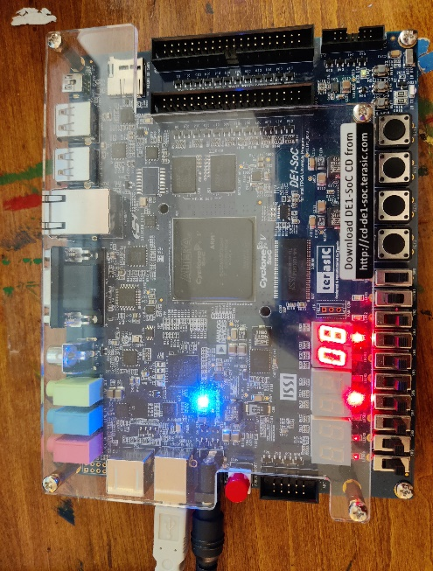
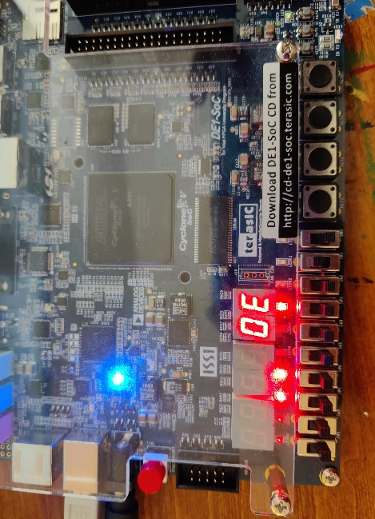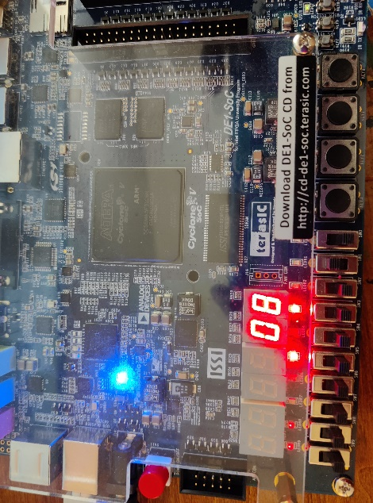
Figure: Output
Part 2: This is the extended version of part1. Here We design a 16-bit counter and display them in 4 7-segment display. The screenshot of outputs and codes are given below:
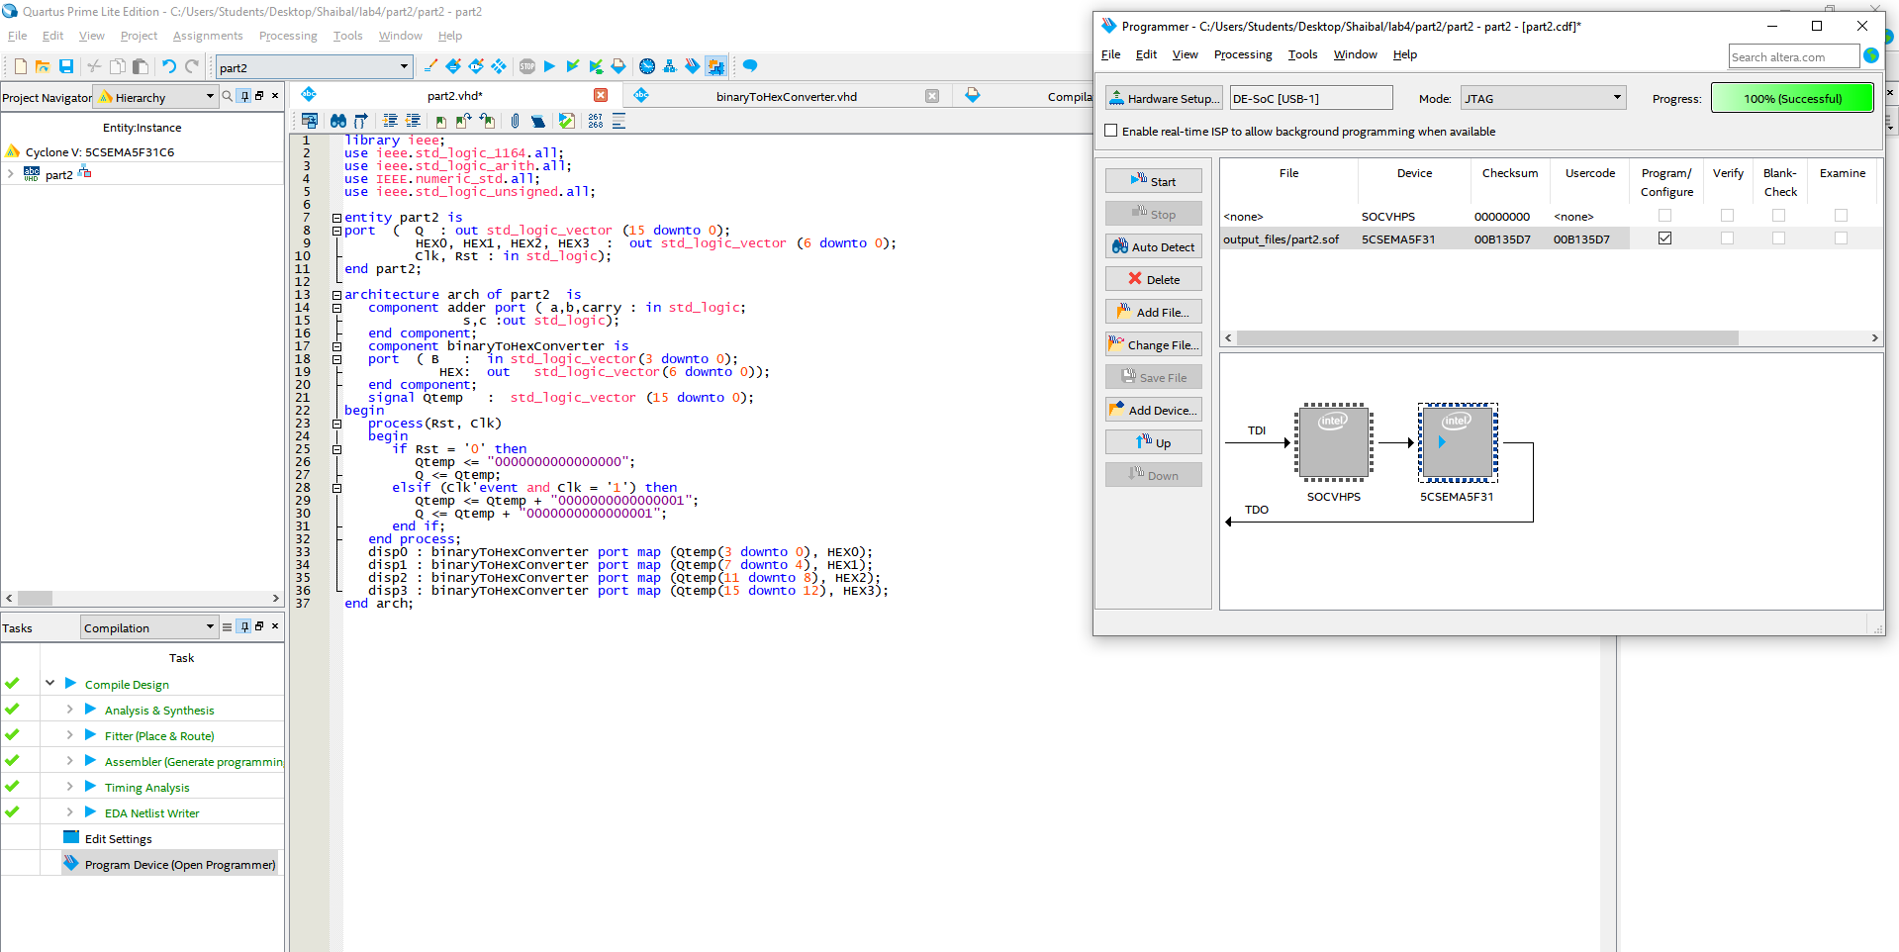
Figure: Code of part2
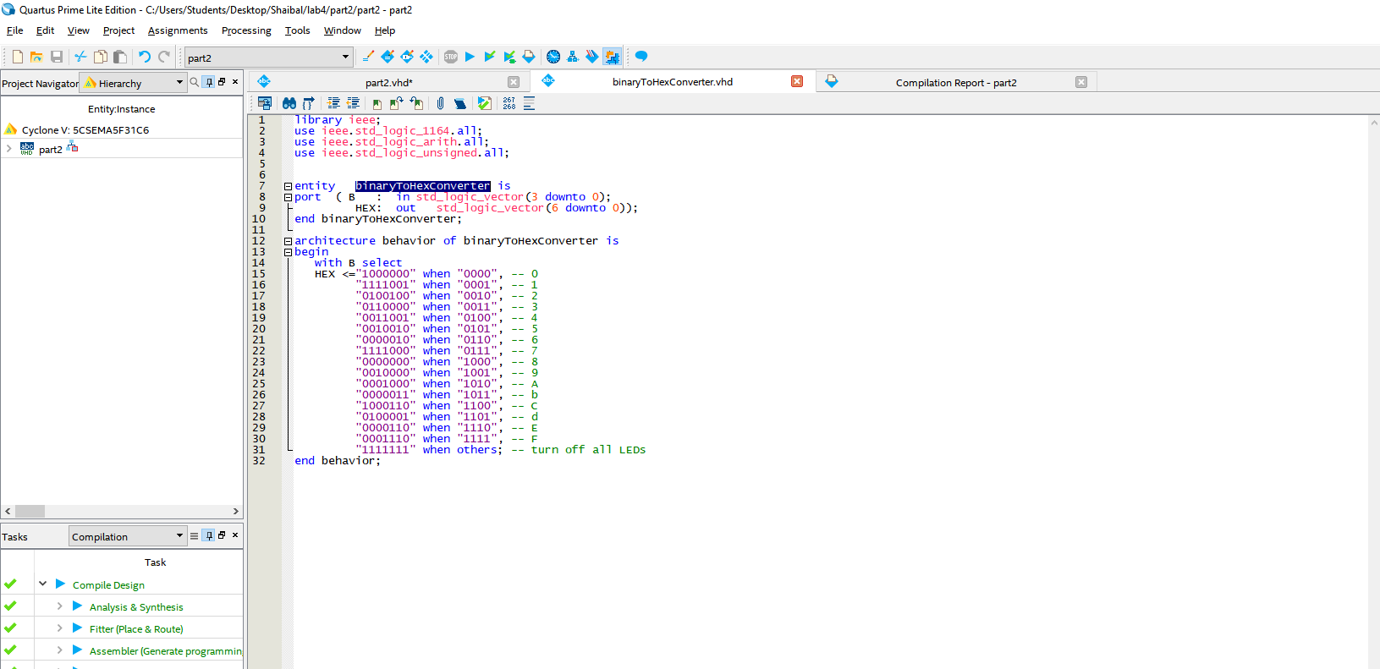
Figure: Code of part2
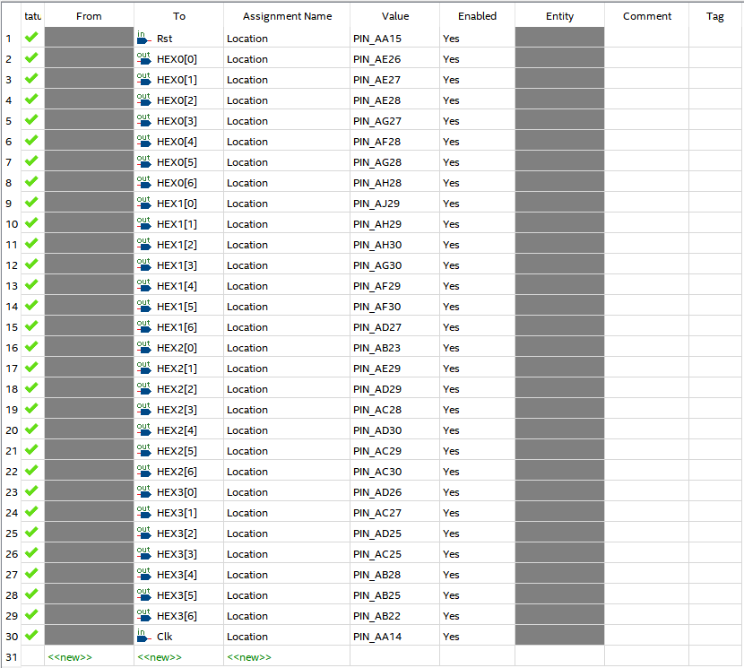
Figure: Pin Assignment

Output:

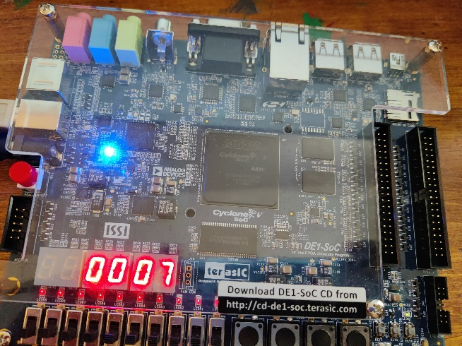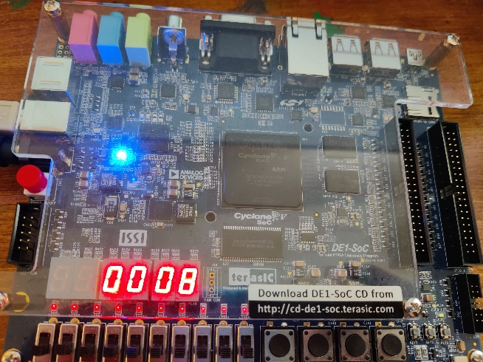
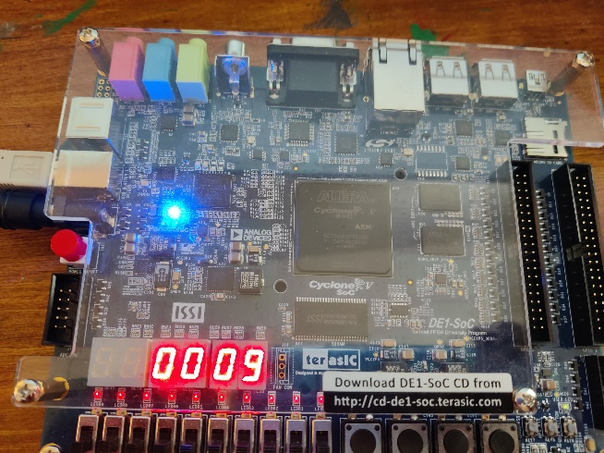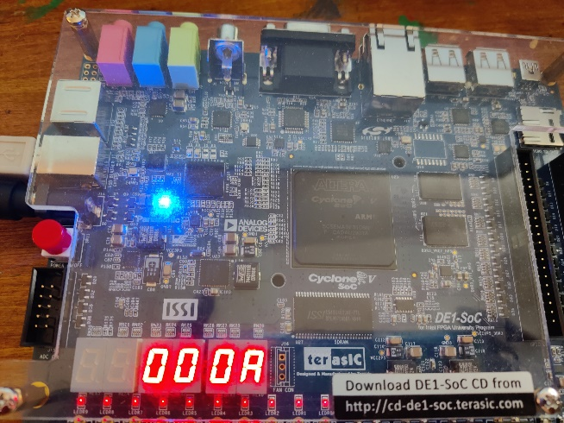
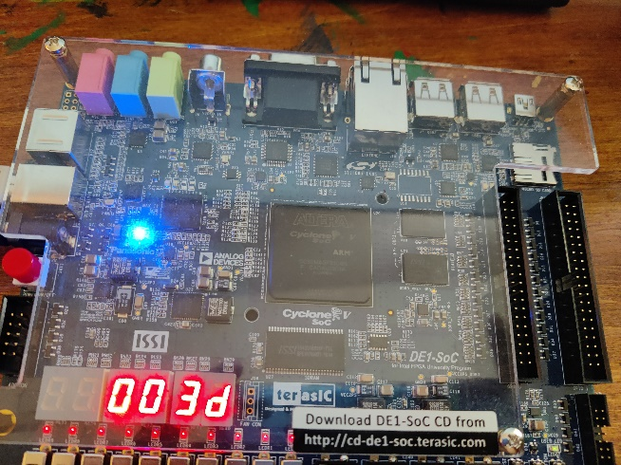
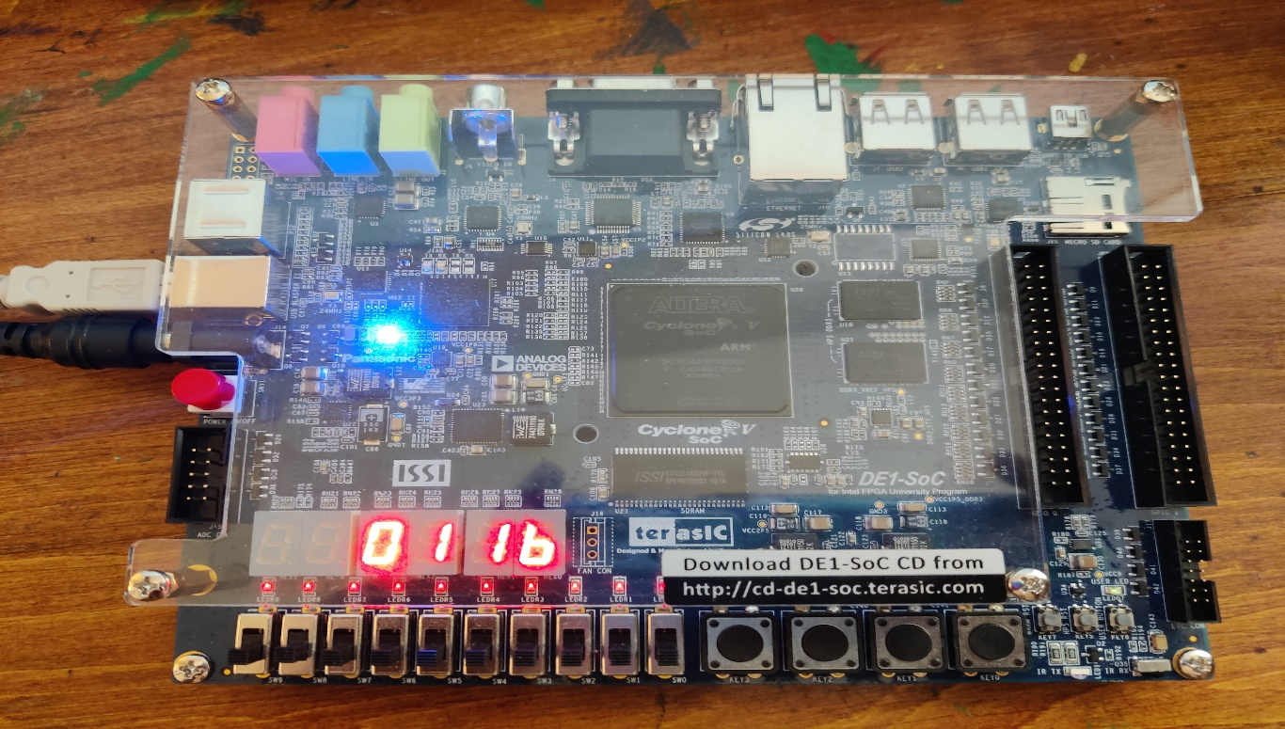
Figure: Output

Part 3: Here, I design a counter o to 9 with a 50 s pause. I got a noise in my DESOC1 board for this problem. The other than Hex0 7 segment display has some noise in this problem, I guess that it is a machine error.The screenshot of outputs and codes are given below:

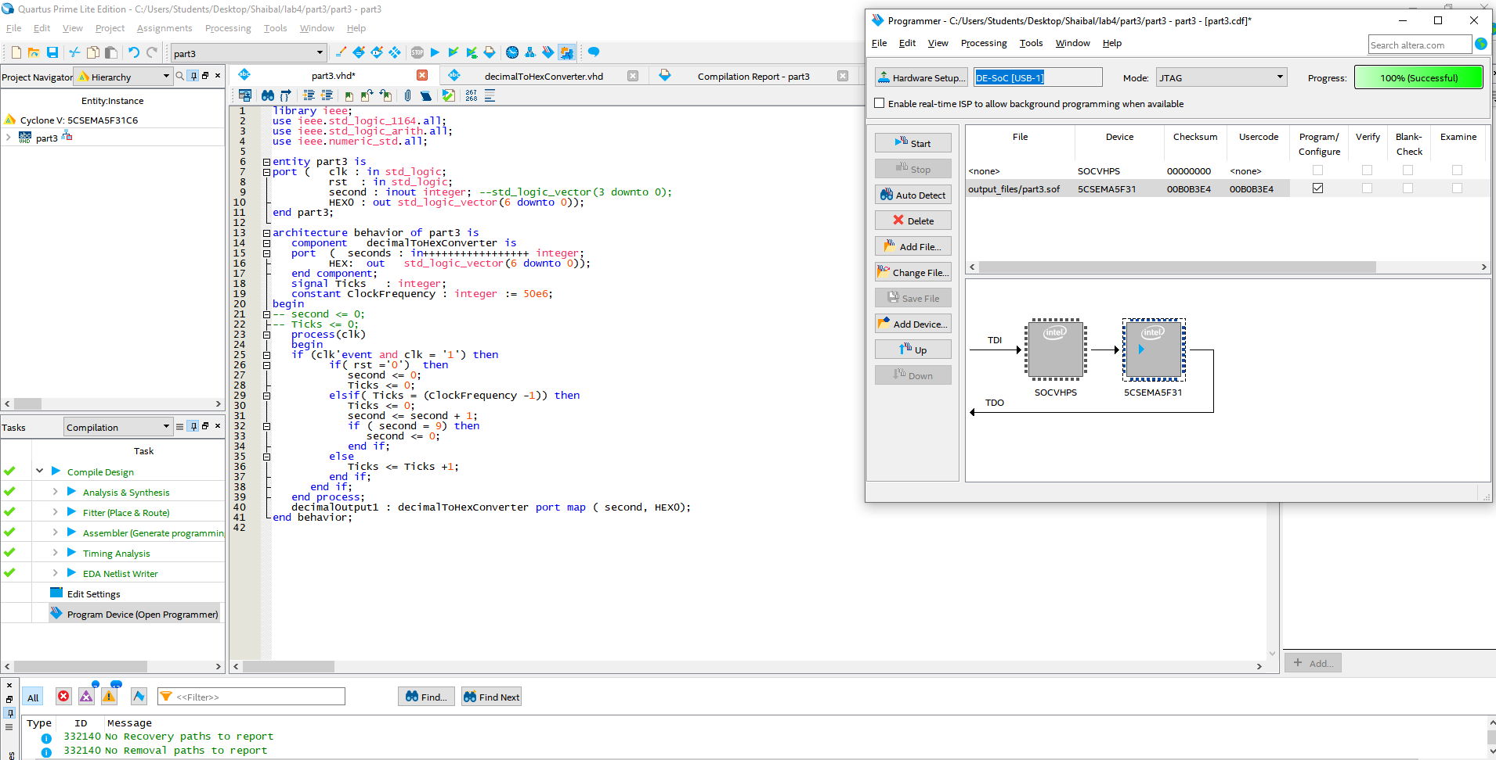
Figure: Code of part3
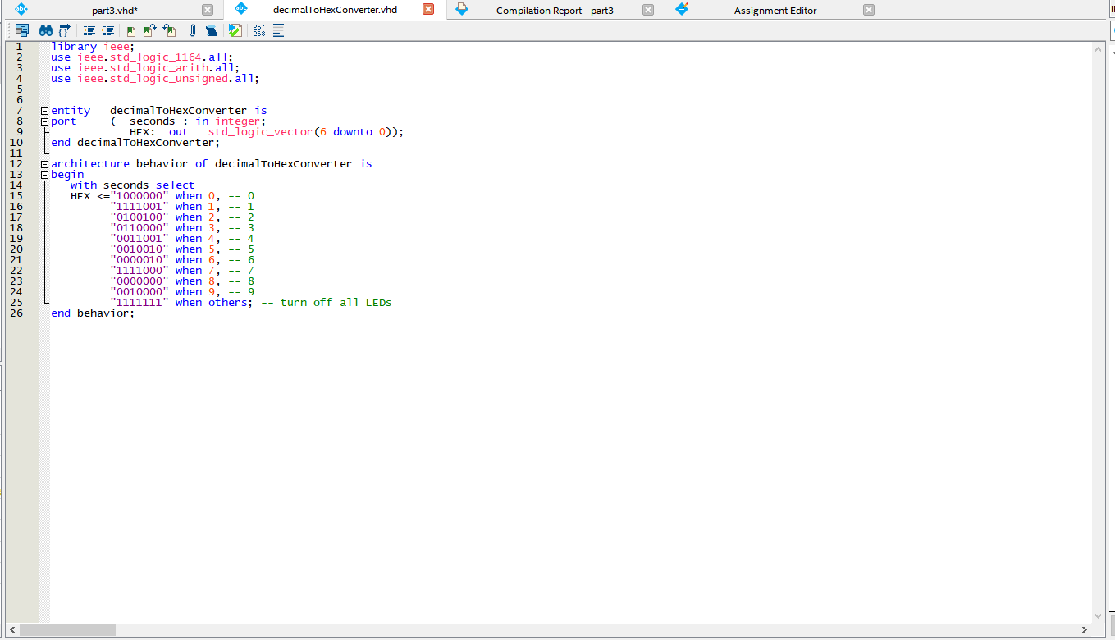
Figure: Code of part3

Output:

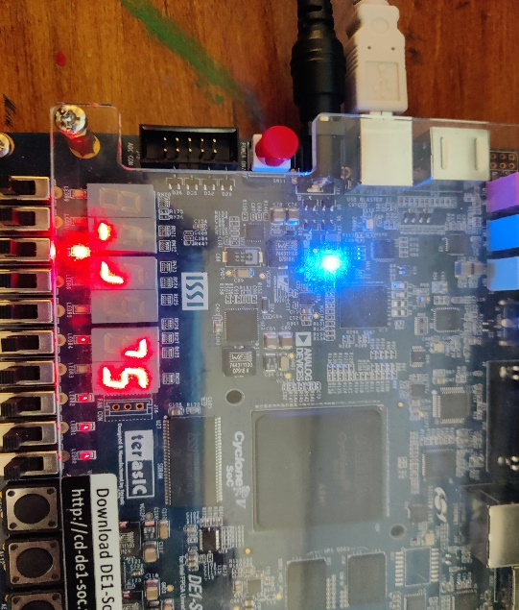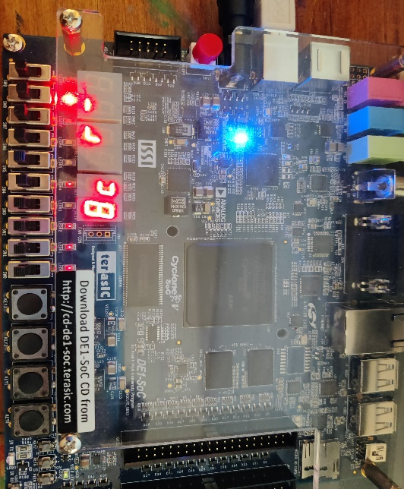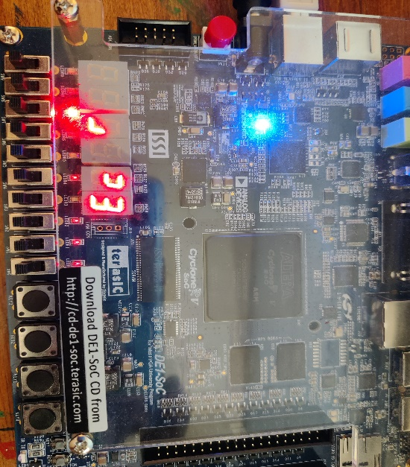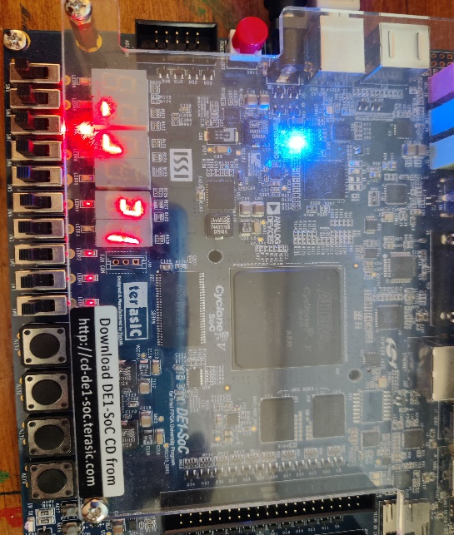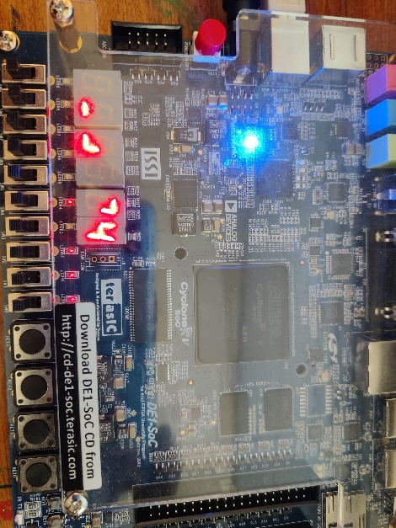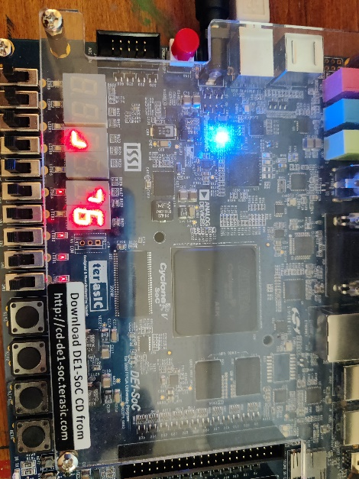
Figure: Output
Part 4: In part4, I need to use the 3 7 segment display and shift right to left the word de1 with a clock 50 seconds delay. The screenshot of outputs and codes are given below:
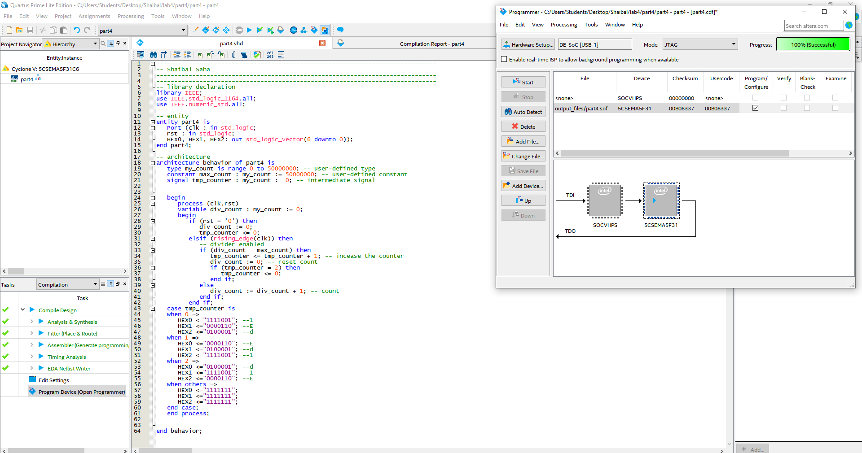
Figure: Code of part4
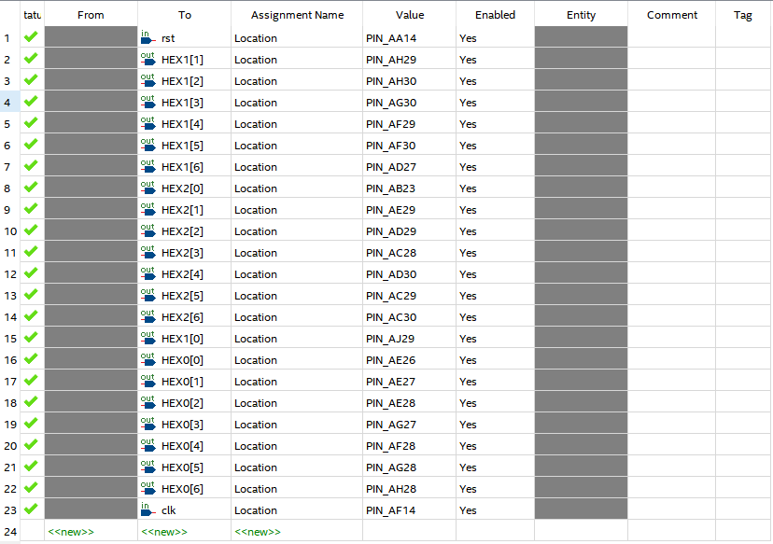
Figure: Pin assignment

Output:

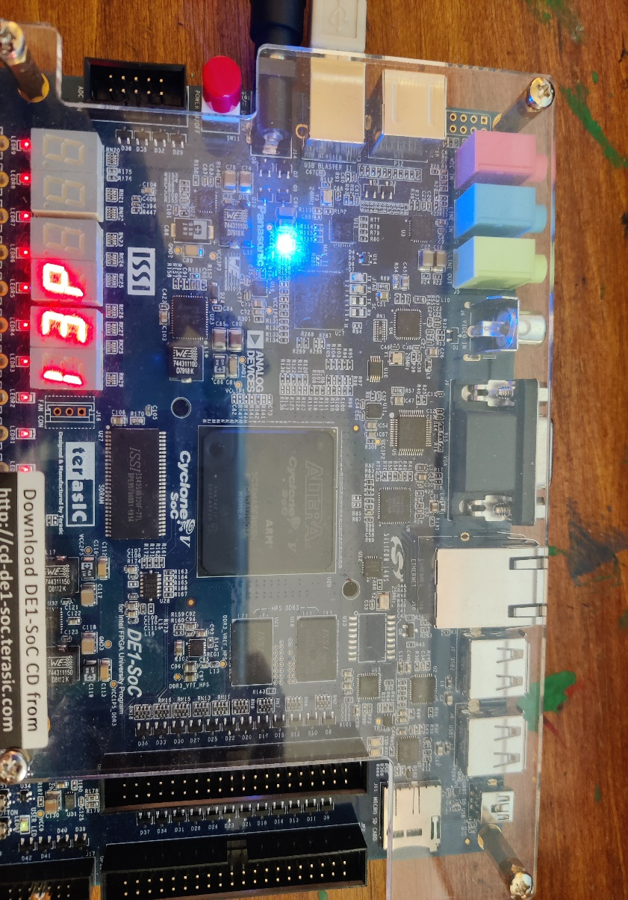
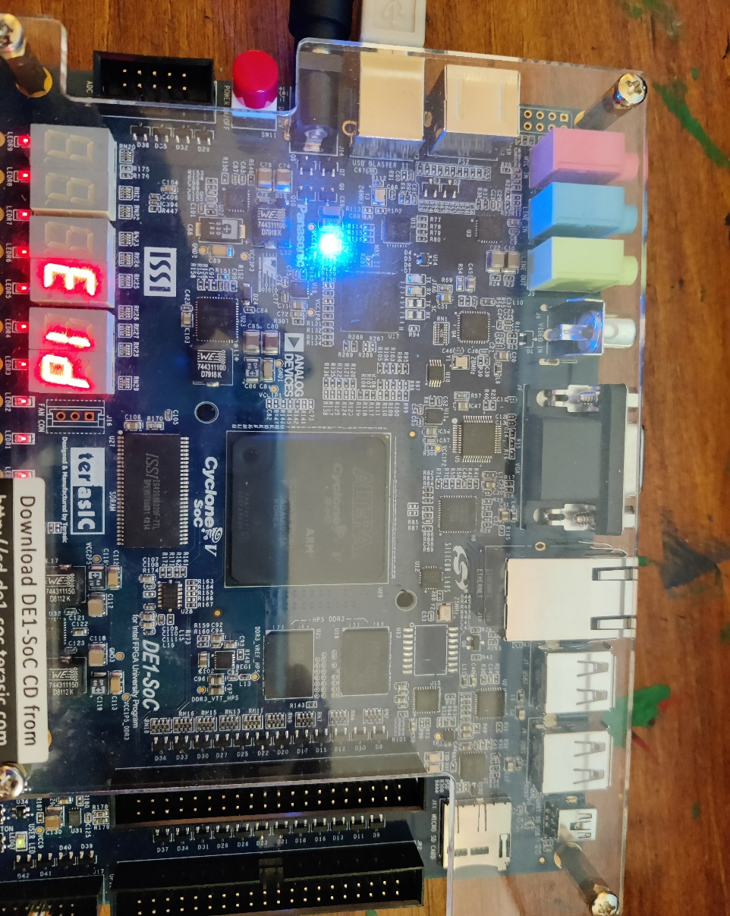
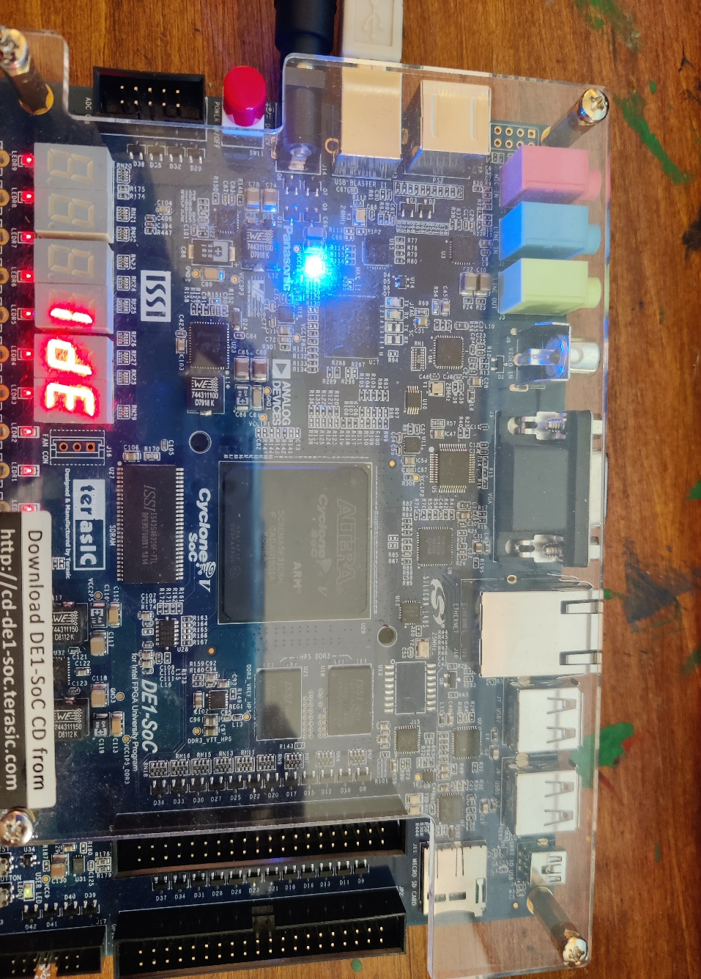
Figure: Output
Part 5: In part 5, We reuse the code from lab 1. We use a counter to shift the letter within those 5 seven segments. The screenshot of outputs and codes are given below:
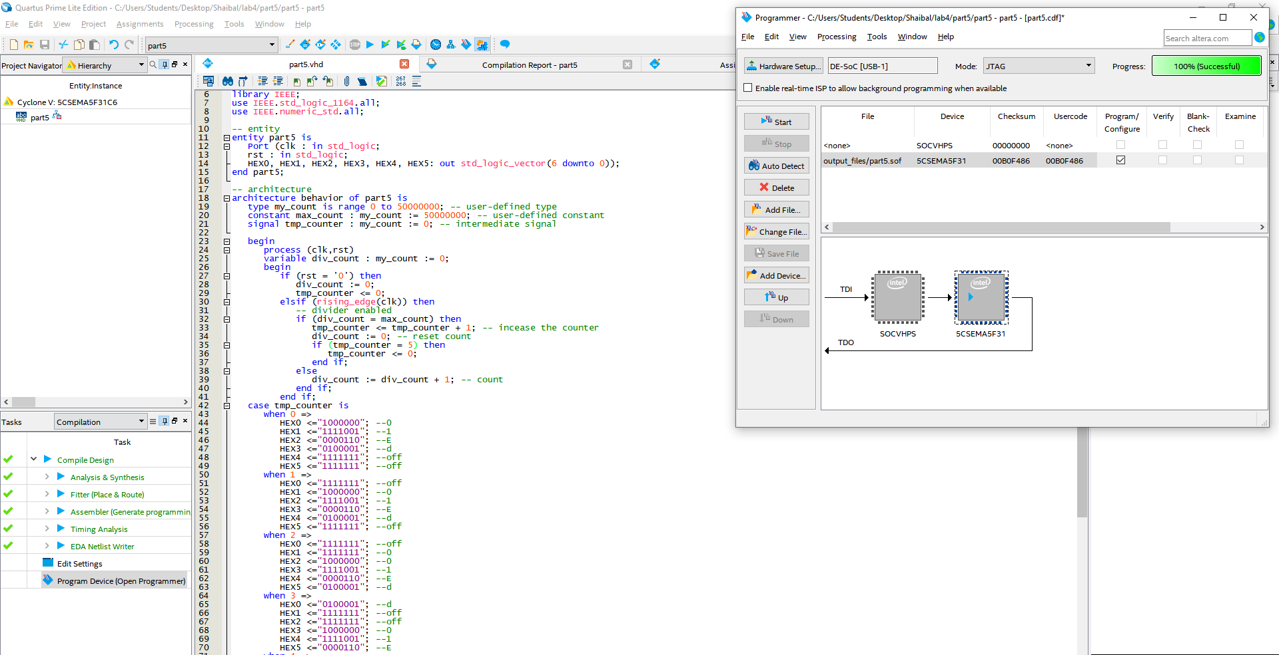

Figure: Code of part5
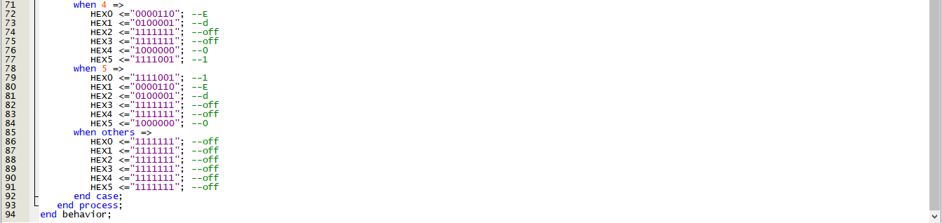
Figure: Code of part5
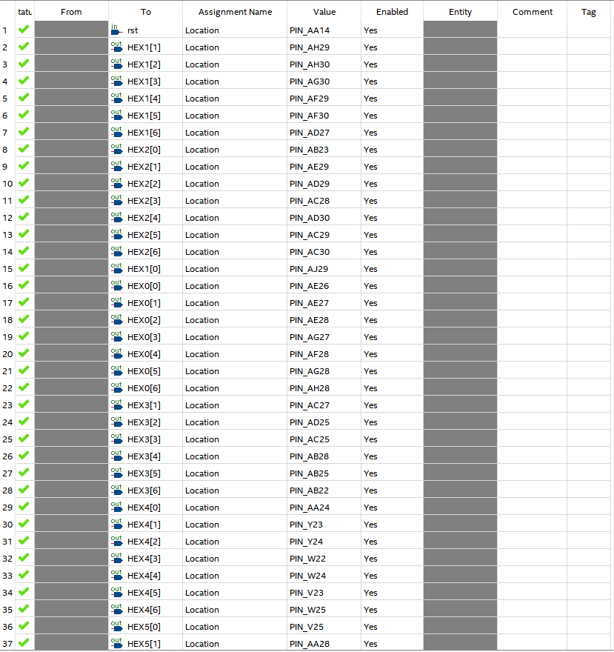
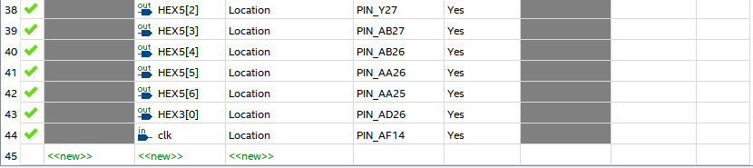
Figure: Pin assignment

Output:

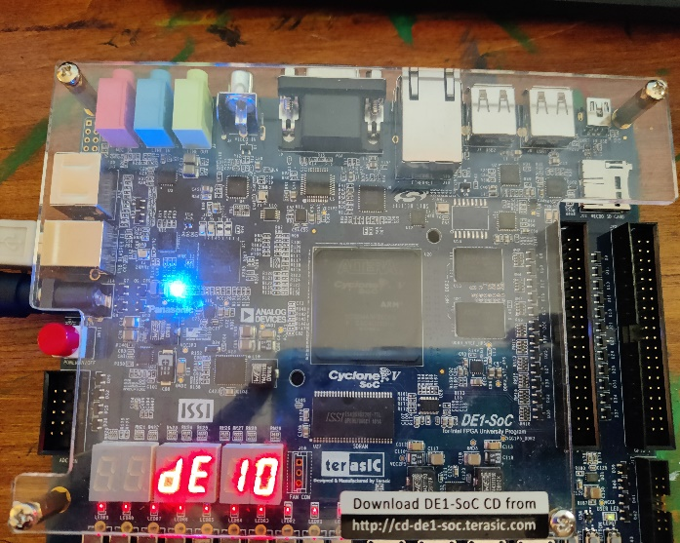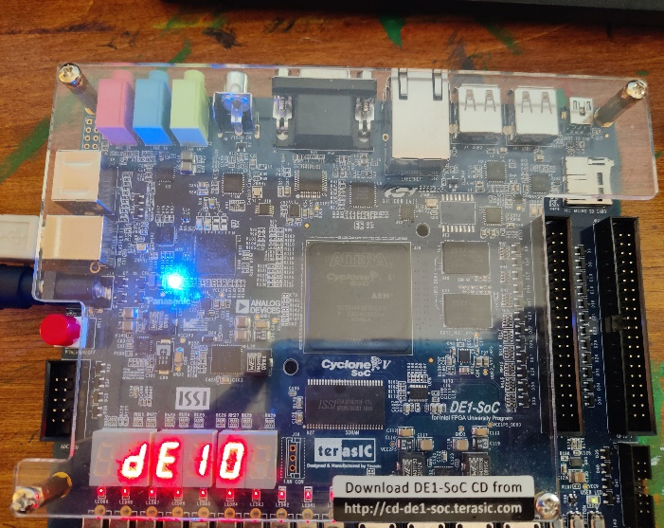
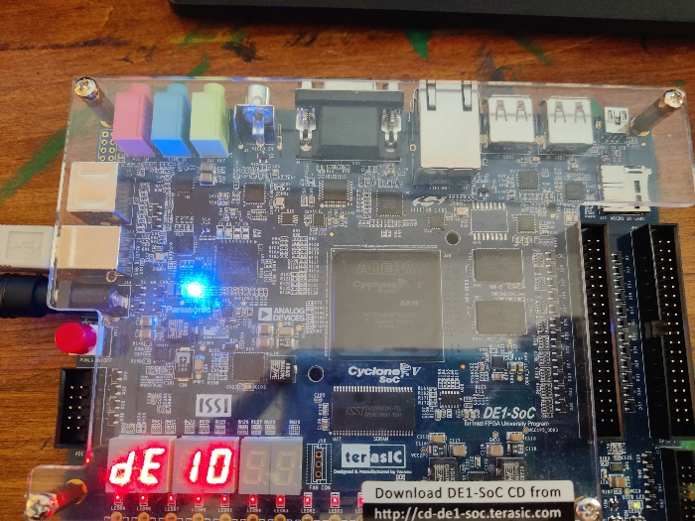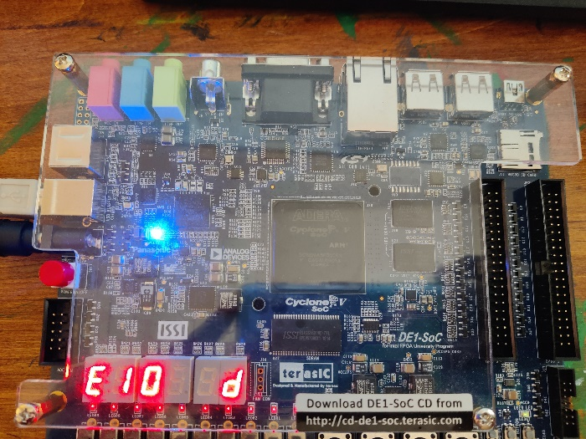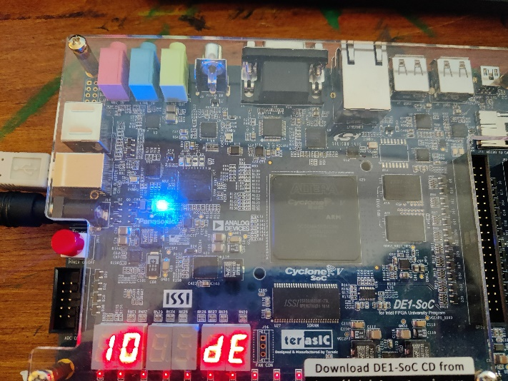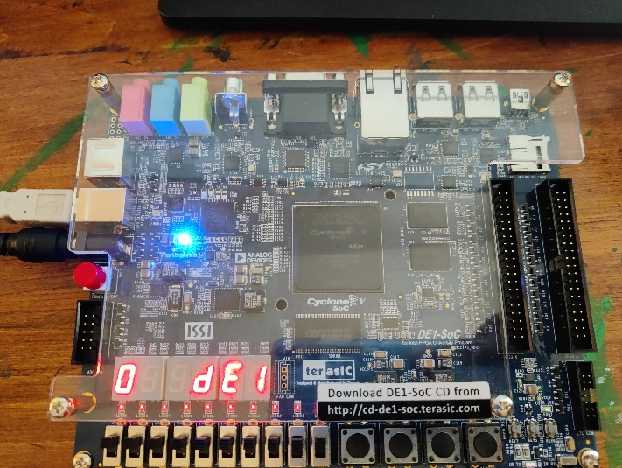
Figure: Output
Note: All the source codes are inside lab4 folder.

