http://www.mathworks.com/products/slhdlcoder/description1.html

Simulink HDL Coder

Product Description
- Introduction and Key Features
- Working with Simulink HDL Coder
- Optimizing Design
- Documenting and Tracing Code
- Cosimulation and Test-Bench Generation
- Automating FPGA Design

Introduction
Simulink HDL Coder™ generates bit-true and cycle-accurate, synthesizable Verilog® and VHDL® code from Simulink® models, MATLAB® code, and Stateflow® charts. The generated HDL code can be simulated and synthesized using industry-standard tools and then implemented on FPGAs and ASICs.
With Simulink HDL Coder you can control HDL architecture and implementation, highlight critical paths in the model, and generate hardware resource utilization estimates. For rapid verification, Simulink HDL Coder generates test benches and EDA Simulator Link™ cosimulation models, and provides code traceability to support the DO-254 workflow.

Key Features
- Generation of target-independent, synthesizable HDL code from Simulink models, MATLAB code, and Stateflow charts
- Support for Mealy and Moore finite-state machines and control logic implementations
- Generation of test benches and EDA Simulator Link cosimulation models
- Resource sharing and subsystem-level retiming options for area-speed tradeoffs
- Simulink model optimization using timing constraint information and HDL synthesis tools
- Code-to-model and model-to-code traceability for DO-254
- Legacy code integration
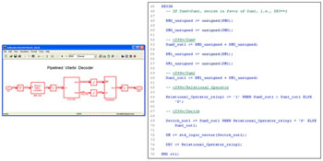
Generating HDL code from a Simulink model. Simulink HDL Coder enables you to model your system and then automatically generate bit-true and cycle-accurate synthesizable Verilog and VHDL code and test benches.
Working with Simulink HDL Coder
Simulink HDL Coder lets you automate your algorithm design process, from modeling to FPGA and ASIC implementation, with these steps:
- Model your system using Simulink, MATLAB code, and Stateflow charts
- Configure parameters to select different HDL block implementations
- Optimize models to meet area-speed design objectives
- Generate HDL code using the HDL Workflow Advisor or the Configuration Parameters GUI
- Verify generated code using test benches and automatically generated cosimulation models
You start the HDL code generation process by first modeling your algorithm in Simulink, MATLAB, or Stateflow. You can select from more than 160 Simulink blocks from add-on products for signal processing and communications to model your algorithm. For example, you can use the Viterbi decoder or Reed-Solomon decoder to model communications receivers and generate HDL code. Similarly, you can use signal processing FFT function and filtering algorithms, including CIC and FIR interpolation and decimation filters.
You can generate HDL code from your MATLAB code by using the Embedded MATLAB® function block in Simulink. Simulink HDL Coder provides a library of common and ready-to-use logic elements, such as counters and timers that are written in MATLAB code. You can also model your finite-state machine (FSM) in Stateflow and integrate your handwritten or legacy HDL code into the Simulink model via black-box interfaces.
Once you have created your model, you can use the HDL Workflow Advisor or the Configuration Parameters GUI to apply code generation constraints and generate HDL code.
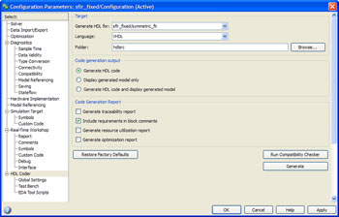
Configuration Parameters GUI for setting code generation options and generating Verilog and VHDL code.
Simulink HDL Coder works with EDA Simulator Link to generate cosimulation test-bench models that are configured for cosimulation with HDL simulators, including Cadence® Incisive®, Mentor Graphics® ModelSim®, and Synopsys® Discovery™. In addition, you can generate HDL test benches and script files for standalone verification in your HDL simulation environment.

Optimizing Design
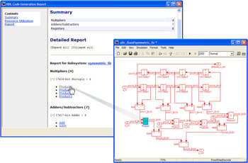
Resource utilization report for performing area-speed tradeoffs.
Simulink HDL Coder lets you control the architecture of the HDL code at a block and subsystem level in your model. For example, you can employ distributed pipelining, streaming, and resource sharing for subsystems, Stateflow charts, and Embedded MATLAB function blocks, to achieve speed-area tradeoffs in your FPGA and ASIC implementations. You can also implement multichannel designs and serialization techniques that are commonly used in signal processing and multimedia applications.
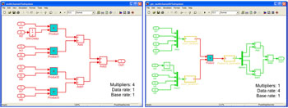
Resource-optimization example. Replacing four multipliers with one multiplier reduces the design area at the cost of increasing the data rate by a factor of four.

Documenting and Tracing Code
Simulink HDL Coder helps you verify your generated code with:
- User-controlled comments and descriptions to improve code readability
- Model-to-code and code-to-model traceability
- Support for including requirements in the generated code, enabling DO-254 compliance
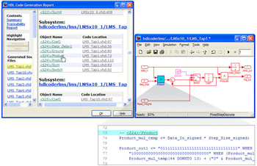
Model-to-code and code-to-model traceability. Simulink HDL Coder facilitates DO-254 compliance and design verification and validation.
Simulink HDL Coder documents the generated code in an HTML report that comprehensively describes the code modules and model optimization settings applied during HDL code generation. The report includes a summary section and a table of generated source files that are linked to your Simulink model. Selecting a source file in the MATLAB Help browser highlights the corresponding block in your model, making the code easy to trace and review. You can also highlight HDL code from Simulink blocks, Stateflow transitions and states, and Embedded MATLAB for bidirectional tracing. When used with Simulink Verification and Validation™, Simulink HDL Coder can embed system requirements within HDL code as comments. As a result, you can achieve complete transparency throughout the entire workflow, from system requirements to implemented HDL code.

Cosimulation and Test-Bench Generation
Simulink HDL Coder generates VHDL and Verilog test benches to enable rapid verification of the generated HDL code. You can customize an HDL test bench using a variety of options that apply stimuli to the HDL code. You can also generate script files to automate the process of compiling and simulating your code in HDL simulators.
Simulink HDL Coder works with EDA Simulator Link to generate a cosimulation model. The automatically generated model is configured for both Simulink simulation and cosimulation with an HDL simulator, such as Cadence Incisive, Mentor Graphics ModelSim, or Synopsys Discovery.
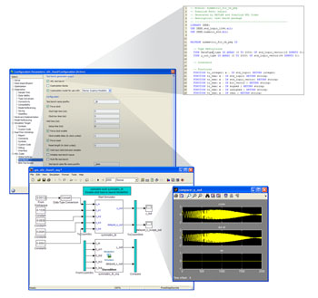
Automatic instantiation of cosimulation model (bottom, left) and generation of HDL test bench (top, right) using Simulink HDL Coder.
Automating FPGA Design  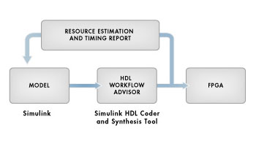  FPGA design workflow with Simulink HDL Coder. The HDL Workflow Advisor works with  third-party synthesis tools, such as Xilinx ISE and Altera Quartus II, for rapid design iterations.  Simulink HDL Coder enables you to quickly implement your Simulink model in Xilinx® and  Altera® FPGAs. The HDL Workflow Advisor supports and integrates all stages of the FPGA  design process, including:  - Checking the Simulink model for HDL code generation compatibility  - Generating RTL code, an RTL test bench, and a cosimulation model  - Performing synthesis and timing analysis through integration with Xilinx ISE® and Altera Quartus® II  - Providing a resource estimation report and guidance on modifying the model to achieve  design constraints  - Back annotating the Simulink model with critical path information  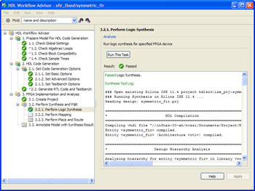  HDL Workflow Advisor, which supports all stages of the FPGA design process from within Simulink.  You can view a postsynthesis timing report and back annotate the Simulink model to identify timing-constraint bottlenecks. Such integration with synthesis tools provides for rapid design iterations and significantly  reduces FPGA design cycle time.  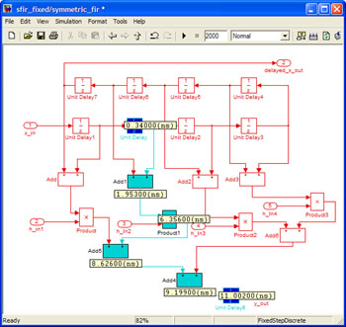  Critical path highlighting of presynthesis and postsynthesis timing information in Simulink.  You can quickly iterate on your design to eliminate timing-constraint bottlenecks.  Simulink HDL Coder generates HDL code that is readable, target-independent, and supports  legacy code integration. As a result, you can quickly transition between FPGA and ASIC  implementations based on your design requirements.
  Contact sales
  Free technical kit
  Trial software
  E-mail this page
  Online Pricing Not Available
  Please contact us for assistance.
  Recorded Webinar
  Advanced HDL Code Generation for FPGAs Using MATLAB and Simulink new
  Register to view now
  Free Seminar
  FPGA Prototyping of Signal Processing and Communications Systems using MATLAB and Simulink new
  Learn more

