Serial Adder using VHDL
library IEEE;
use IEEE.STD_LOGIC_1164.ALL;

entity SA_VHDL is
Port ( I : in std_logic_vector(15 downto 0);
O : out std_logic_vector(7 downto 0);
c_i, a_i, b_i, c_o, s_o : out std_logic;
CLK : in std_logic;
Load : in std_logic);
end SA_VHDL;

architecture Behavioral of SA_VHDL is
signal ina, inb, oreg : std_logic_vector(7 downto 0);
signal so, ci, co: std_logic;
begin

--rec ina
process (CLK)
begin
if CLK'event and CLK='1' then
if (Load='1') then
ina <= I(15 downto 8);
else
ina <= '0' & ina(7 downto 1);
end if;
end if;
end process;

--reg inb
process (CLK)
begin
if CLK'event and CLK='1' then
if (Load='1') then
inb <= I(7 downto 0);
else
inb <= '0' & inb(7 downto 1);
end if;
end if;
end process;

--oreg
process (CLK)
begin
if CLK'event and CLK='1' then
if (Load='1') then
oreg <= "00000000";
ci <= '0';
else
ci <= co;
oreg <= so & oreg(7 downto 1);
end if;
end if;
end process;

-- FA
so <= inb(0) xor ina(0) xor ci;
co <= (inb(0) and ina(0)) or
(inb(0) and ci) or
(ci and ina(0));

O <= oreg;

-- for test
c_i <= ci;
a_i <= ina(0);
b_i <= inb(0);

c_o <= co;
s_o <= so;

end Behavioral;

[edit] Simulation Results
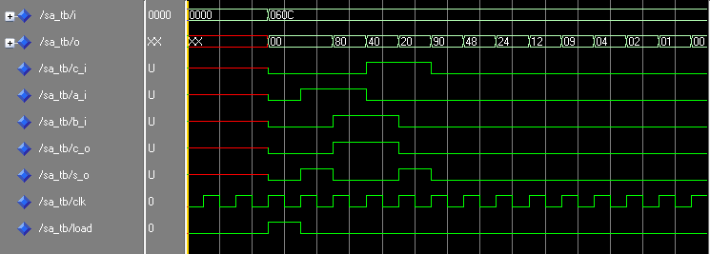

Another Version of Circuit is given below


