- NIOS II is
  - NIOS II is softcore.
  - NIOS II is 32 bits.
  - It has 32 registers.
  - NIOS 2 is implemented FPGA chips. And VHDL is widely used in FPGA.
  - It executes programs in serial.
  - It has 100’s instructions.
  - 5 different types of I/O. They are
    - Instruction master port
    - Instruction cache
    - Data master port
    - Data cache
    - Tightly coupled instruction or data memory port.
  - When the power is off, disconnect the debug cable from the target. Debugger breaks in crt0.s instead of main().
  - Three types of NIOS II are available in Quartus II
    - I-type
    - R-type
    - J-type

  - Avalon switch fabric is used as an interface to its peripherals; it uses a slave-side arbitration scheme that lets multiple masters operate simultaneously. In addition, Avalon switch fabric is the glue that binds together components in a system based on the Avalon interface. Avalon switch fabric is the collection of interconnect and logic resources that connects Avalon master and slave ports on components in a system.

  - Yes, the NIOS II processor can have external memory. It can have up to 4 GB of external address space.

  - The software creation process for NIOS II are
    - Hardware creation
      - Platform Designer
      - Intel® Quartus® Prime software
    - Software project management
      - BSP configuration
      - Application project configuration
      - Editing and building the software project
      - Running, debugging, and communicating with the target
      - Ensuring hardware and software coherency
      - Project management

    - Software project development
      - Developing with the Hardware Abstraction Layer (HAL)
      - Programming the Nios® II processor to access memory
      - Writing exception handlers
      - Optimizing the application for performance and size
      - Real-time operating system (RTOS) support
    - Application development
      - Linking (run-time memory)
      - Boot loading the system application
      - Programming flash memory
  - JTAG (Joint Test Action Group), as defined by the IEEE Std.-1149.1 standard, is an integrated method for testing interconnects on printed circuit boards (PCBs) that are implemented at the integrated circuit (IC) level. It is used for a debugging, programming, and testing interface typically found on microcontrollers, ASICs, and FPGAs. It enables all components with this interface to be tested, programmed, and/or debugged using a single connector on a PC board which can daisy chain them together. It uses the boundary scan technique. So, from simple AVRs to highly specific M4's, all use JTAG these days.

  - The MicroBlaze is a soft microprocessor core designed for Xilinx field-programmable gate arrays (FPGA). It is a 32-bit RISC microprocessor with a rich instruction set optimized for embedded.

  - Vivado Design Suite is a software suite produced by Xilinx. It helps developers to synthesize and analyze their designs.
The Vivado Design Suite provides best-in-class tools for system power analysis and optimization. It accelerates design productivity, maximizes device utilization, and delivers robust performance and lower power with predictable results.
The Vivado Design Suite’s single-data-model architecture enables extensive cross-probing between design sources, schematic views, hierarchy browsers, design reports, messages, floorplan, and the Vivado Device Editor. This unique capability enables faster debugging and timing closure by providing immediate design feedback about any design issues discovered during the entire system development process. Its probing methodologies are intuitive, flexible, and iterative.

  - Vivado ML Editions is the industry’s first FPGA EDA tool suite based on machine-learning optimization algorithms, as well as advanced team-based design flows, for significant design time and cost savings. Vivado ML Editions delivers 5x faster compile time and breakthrough quality of results improvements on average of 10% for complex designs, compared to the current Vivado HLx Editions.

- SoC FPGA devices integrate both processor and FPGA architectures into a single device. They also include a rich set of peripherals, on-chip memory, an FPGA-style logic array, and high-speed transceivers.
SoC FPGAs integrate an ARM*-based hard processor system (HPS) consisting of processor, peripherals, and memory interfaces with the FPGA fabric using a high-bandwidth interconnect backbone. It combines the performance and power savings of hard intellectual property (IP) with the flexibility of programmable logic.
It increases system performance and flexibility as well as helps in improved reliability and lower system cost.

- HDL coder helps to generate VHDL and Verilog code for FPGA and ASIC designs.
It generates code from MATLAB functions, Simulink models and Stateflow charts and the generated code is used for FPGA programming or ASIC prototyping and designs.
HDL Coder provides a workflow advisor that automates the programming of Xilinx, Microsemi, and Intel FPGAs.
It also provides traceability between the Simulink model and the generated Verilog and VHDL code, enabling code verification for high-integrity applications.

- Serial binary adder is a combinational logic circuit that performs the addition of two binary numbers in serial form. Serial binary adder performs bit by bit addition. Two shift registers are used to store the binary numbers that are to be added.

A single full adder is used to add one pair of bits at a time along with the carry. The carry output from the full adder is applied to a D flip-flop. After that output is used as carry for next significant bits. The sum bit from the output of the full adder can be transferred into a third shift register.

The block diagram of the serial adder is

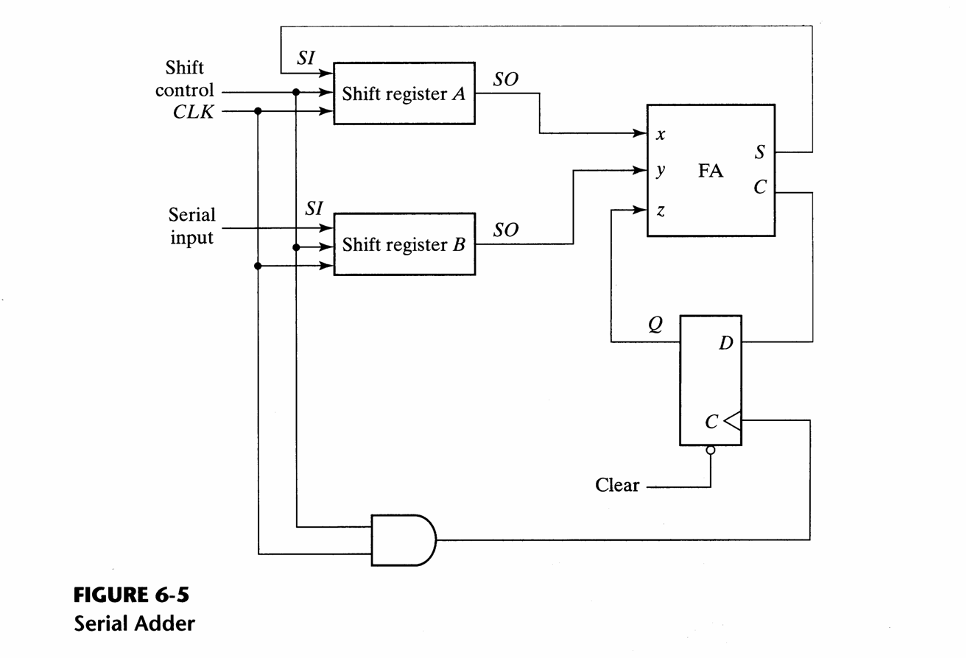
Source of the image: serial adder source

