1. Write a Pl/SQL program to Q \*Hello world

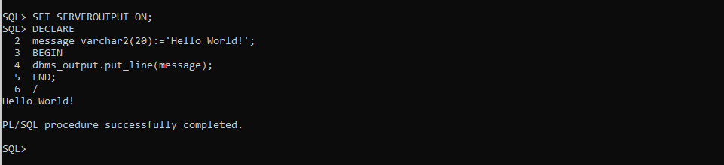

2. Write a PL/SQL block to find the maximum number from the given three

numbers.

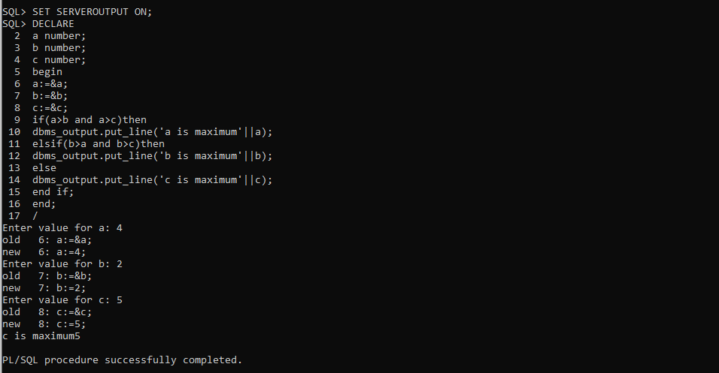

3. Write a Pl/SQL program to print integers from 1 to 10 by using PL/SQL FOR

Loop

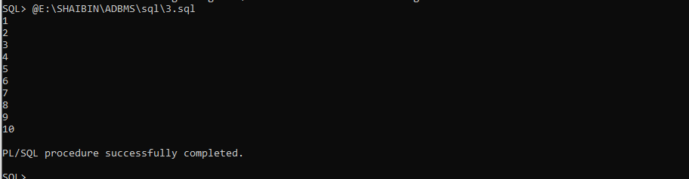

4. Write a program to accept a number and find the sum of the digits .

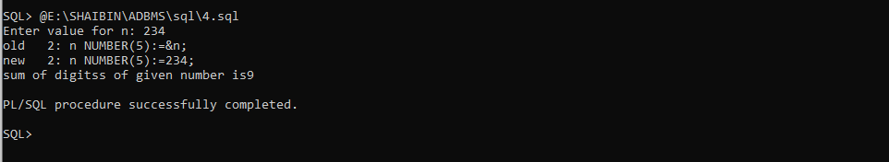

5. Find the greatest number of inputs from the console.

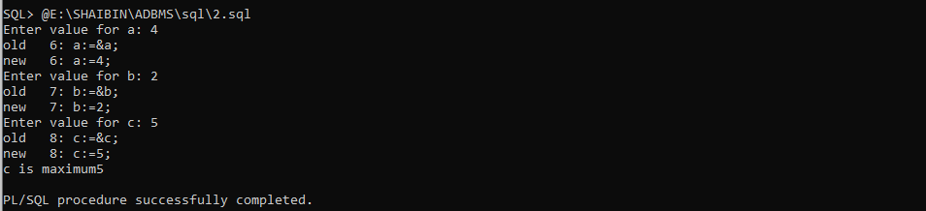

6. Reading the values from EMployee table.

SQL> CREATE TABLE EMPLOYEE( ssn NUMBER(2),fnmae VARCHAR(20),lname VARCHAR(20),salary NUMBER(38));

Table created.

SQL> INSERT INTO EMPLOYEE VALUES(&ssn,'&fname','&lname',&salary);

Enter value for ssn: 01

Enter value for fname: shaibin

Enter value for lname: KB

Enter value for salary: 75000

old 1: INSERT INTO EMPLOYEE VALUES(&ssn,'&fname','&lname',&salary)

new 1: INSERT INTO EMPLOYEE VALUES(01,'shaibin','KB',75000)

1 row created.