**Program 1:**

**Create the following tables and execute the queries given below**

**SAILORS**

|  |  |  |  |
| --- | --- | --- | --- |
| sid | sname | rating | age |
| 22 | Dustin | 7 | 45 |
| 29 | Brutas | 1 | 33 |
| 31 | Lubber | 8 | 55 |
| 32 | Andy | 8 | 25 |
| 58 | Rusty | 10 | 35 |
| 64 | Horatio | 7 | 35 |
| 71 | Zorba | 10 | 16 |
| 74 | Horatio | 9 | 35 |
| 85 | Art | 3 | 26 |
| 95 | Bob | 3 | 64 |

**BOATS**

|  |  |  |
| --- | --- | --- |
| Bid | bname | color |
| 101 | Interlake | Blue |
| 102 | Interlake | Red |
| 103 | Clipper | Green |
| 104 | Marine | Red |

**RESERVES**

|  |  |  |
| --- | --- | --- |
| sid | bid | day |
| 22 | 101 | 10/10/98 |
| 22 | 102 | 10/10/98 |
| 22 | 103 | 10/8/98 |
| 22 | 104 | 10/7/98 |
| 31 | 102 | 11/10/98 |
| 31 | 103 | 11/6/98 |
| 31 | 104 | 11/12/98 |
| 64 | 101 | 9/5/98 |
| 64 | 102 | 9/8/98 |
| 74 | 103 | 9/8/98 |

**1.Find the names and ages of all sailors**

SQL> SELECT SNAME,AGE FROM SAILORS;

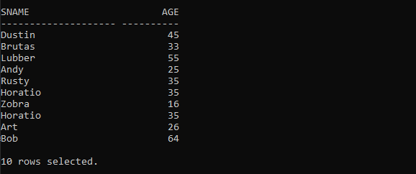

**2.Find all information of sailors who have reserved boat number 101.**

SQL> SELECT * FROM SAILORS JOIN RESERVES ON SAILORS.SID=RESERVES.SID WHERE RESERVES.BID=101;

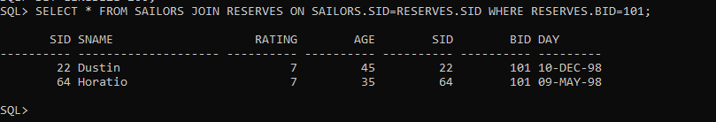

3.**Find all sailors with rating above 7 .**

SQL> SELECT * FROM SAILORS WHERE RATING>7;

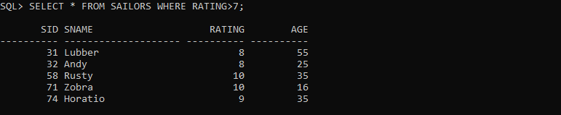

**4.Find the names of sailors who have reserved boat no 103.**

SQL> SELECT SAILORS.SNAME FROM SAILORS JOIN RESERVES ON SAILORS.SID =RESERVES.SID WHERE RESERVES.BID=103;

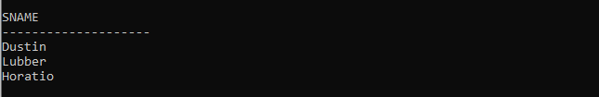

**5.Find the names of sailors who have reserved a red boat, and list in the order of age.**

SQL> SELECT SAILORS.SNAME FROM SAILORS JOIN RESERVES ON SAILORS.SID =RESERVES.SID JOIN BOATS ON RESERVES.BID=BOATS.BID WHERE BOATS.COLOR='Red' ORDER BY SAILORS.AGE;

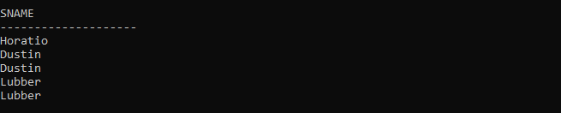

**6. Find the names of sailors who have reserved either a red or green boat .**

SQL> SELECT DISTINCT SAILORS.SNAME FROM SAILORS JOIN RESERVES ON SAILORS.SID=RESERVES.SID JOIN BOATS ON RESERVES.BID =BOATS.BID WHERE BOATS.COLOR IN ('Red','Green');

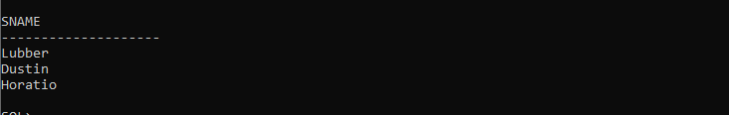

**7.Find the colors of boats reserved by “Lubber”.**

SqL>SELECT DISTINCT BOATS.COLOR FROM SAILORS JOIN RESERVES ON SAILORS.SID =RESERVES.SID JOIN BOATS ON RESERVES.BID=BOATS.BID WHERE SAILORS.SNAME='Lubber';

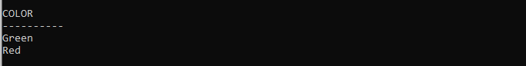

**8.Find the names of sailors who have reserved both red and green boats**

1. Find the names of sailors who have reserved at least one boat
2. Find the ids and names of sailors who have reserved two different boats on the same day.
3. Find the name and the age of the youngest sailor.
4. Find the names and ratings of a sailor whose rating is better than some sailor called Horatio.
5. Find the names of sailors who have reserved all boats.
6. Count the number of different sailor names.
7. Calculate the average age of all sailors.
8. Find the average age of sailors for each rating level.
9. Find the average age of sailors for each rating level that has at least two sailors.

SQL> CREATE TABLE SAILORS(SID NUMBER PRIMARY KEY,SNAME VARCHAR(20),RATING NUMBER,AGE NUMBER);

Table created.

SQL> CREATE TABLE BOATS(BID NUMBER PRIMARY KEY,BNAME VARCHAR(20),COLOR VARCHAR(10));

Table created.

SQL> CREATE TABLE RESERVES(SID INT,BID INT,DAY DATE,FOREIGN KEY(SID) REFERENCES SAILORS(SID),FOREIGN KEY(BID) REFERENCES BOATS(BID));

Table created..

SQL> INSERT INTO SAILORS VALUES(&SID,'&SNAME',&RATING,&AGE);

Enter value for sid: 22

Enter value for sname: Dustin

Enter value for rating: 7

Enter value for age: 45

old 1: INSERT INTO SAILORS VALUES(&SID,'&SNAME',&RATING,&AGE)

new 1: INSERT INTO SAILORS VALUES(22,'Dustin',7,45)

1 row created.

SQL> /

Enter value for sid: 29

Enter value for sname: Brutas

Enter value for rating: 1

Enter value for age: 33

old 1: INSERT INTO SAILORS VALUES(&SID,'&SNAME',&RATING,&AGE)

new 1: INSERT INTO SAILORS VALUES(29,'Brutas',1,33)

1 row created.

SQL> /

Enter value for sid: 31

Enter value for sname: Lubber

Enter value for rating: 8

Enter value for age: 55

old 1: INSERT INTO SAILORS VALUES(&SID,'&SNAME',&RATING,&AGE)

new 1: INSERT INTO SAILORS VALUES(31,'Lubber',8,55)

1 row created.

SQL> /

Enter value for sid: 32

Enter value for sname: Andy

Enter value for rating: 8

Enter value for age: 25

old 1: INSERT INTO SAILORS VALUES(&SID,'&SNAME',&RATING,&AGE)

new 1: INSERT INTO SAILORS VALUES(32,'Andy',8,25)

1 row created.

SQL> /

Enter value for sid: 58

Enter value for sname: Rusty

Enter value for rating: 10

Enter value for age: 35

old 1: INSERT INTO SAILORS VALUES(&SID,'&SNAME',&RATING,&AGE)

new 1: INSERT INTO SAILORS VALUES(58,'Rusty',10,35)

1 row created.

SQL> /

Enter value for sid: 64

Enter value for sname: Horatio

Enter value for rating: 7

Enter value for age: 35

old 1: INSERT INTO SAILORS VALUES(&SID,'&SNAME',&RATING,&AGE)

new 1: INSERT INTO SAILORS VALUES(64,'Horatio',7,35)

1 row created.

SQL> /

Enter value for sid: 74

Enter value for sname: Horatio

Enter value for rating: 9

Enter value for age: 35

old 1: INSERT INTO SAILORS VALUES(&SID,'&SNAME',&RATING,&AGE)

new 1: INSERT INTO SAILORS VALUES(74,'Horatio',9,35)

1 row created.

SQL> /

Enter value for sid: 85

Enter value for sname: Art

Enter value for rating: 3

Enter value for age: 26

old 1: INSERT INTO SAILORS VALUES(&SID,'&SNAME',&RATING,&AGE)

new 1: INSERT INTO SAILORS VALUES(85,'Art',3,26)

1 row created.

SQL> /

Enter value for sid: 95

Enter value for sname: Bob

Enter value for rating: 3

Enter value for age: 64

old 1: INSERT INTO SAILORS VALUES(&SID,'&SNAME',&RATING,&AGE)

new 1: INSERT INTO SAILORS VALUES(95,'Bob',3,64)

1 row created.

SQL> INSERT INTO BOATS VALUES(&BID,'&BNAME','&COLOR');

Enter value for bid: 101

Enter value for bname: Interlake

Enter value for color: Blue

old 1: INSERT INTO BOATS VALUES(&BID,'&BNAME','&COLOR')

new 1: INSERT INTO BOATS VALUES(101,'Interlake','Blue')

1 row created.

SQL> /

Enter value for bid: 102

Enter value for bname: Interlake

Enter value for color: Red

old 1: INSERT INTO BOATS VALUES(&BID,'&BNAME','&COLOR')

new 1: INSERT INTO BOATS VALUES(102,'Interlake','Red')

1 row created.

SQL> /

Enter value for bid: 103

Enter value for bname: Clipper

Enter value for color: Green

old 1: INSERT INTO BOATS VALUES(&BID,'&BNAME','&COLOR')

new 1: INSERT INTO BOATS VALUES(103,'Clipper','Green')

1 row created.

SQL> /

Enter value for bid: 104

Enter value for bname: Marine

Enter value for color: Red

old 1: INSERT INTO BOATS VALUES(&BID,'&BNAME','&COLOR')

new 1: INSERT INTO BOATS VALUES(104,'Marine','Red')

1 row created.