1. Create a three dimensional array specifying float data type and print it.

print("SJC23MCA-2050 : SHAIBIN K B")
print("Batch : MCA 2023-25")
import numpy as np;
array_3d=np.array([ [[1.2,5.7,3.4],[5.6,3.4,2.1],[6.7,2.3,5.7]],[[3.4,6.7,9.0],[3.2,1.2,4.5],[7.8,4.5,3.2]]],dtype=float)
print("3D Array")
print(array_3d)

Ourput :

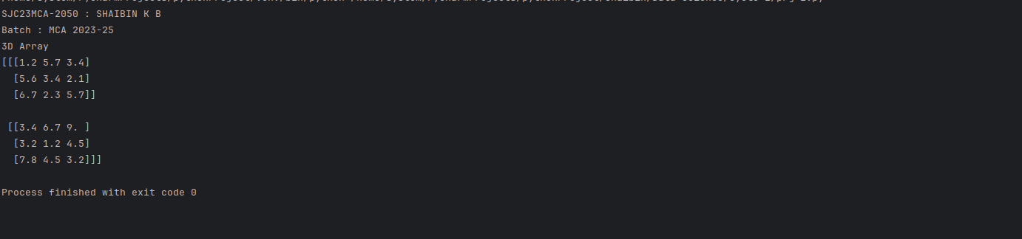

2. Create a 2 dimensional array (2X3) with elements belonging to complex data
type and print it. Also display
a. the no: of rows and columns
b. dimension of an array
c. reshape the same array to 3X2

print("SJC23MCA-2050 : SHAIBIN K B")
print("Batch : MCA 2023-25")

import numpy as np

array_2d=np.array([[1+4j,9+6j,8+6j],[2+8j,5+8j,1+2j]],dtype=complex)
print("2D Array")
print (array_2d)

rows,columns=array_2d.shape
print("The number of rows is : ",rows)
print("The number of colums is : ",columns)

dimentions=array_2d.ndim
print("The dimentons are: ",dimentions)

reshaped=array_2d.reshape(3,2)
print("The new reshaped array is: ")
print(reshaped)

Output:

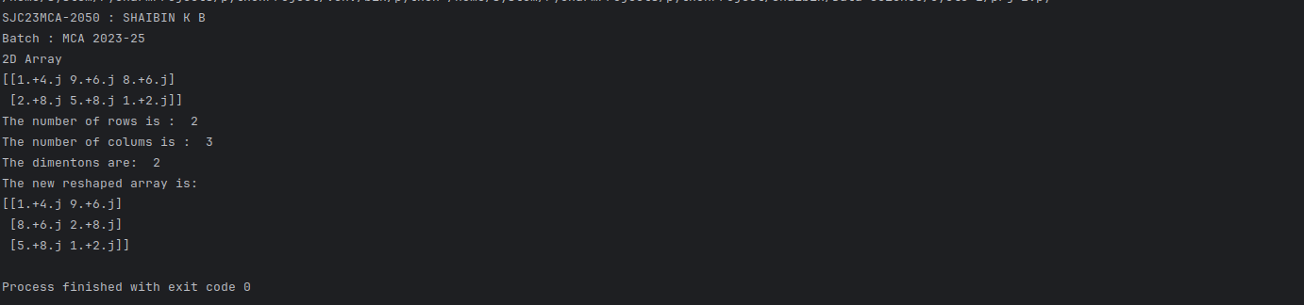

3. Familiarize with the functions to create
a. an uninitialized array
b. array with all elements as 1,
c. all elements as 0

print("SJC23MCA-2050 : SHAIBIN K B")
print("Batch : MCA 2023-25")
import numpy as np
# Create an uninitialized array
uninitilized_array=np.empty(shape=(2,3));
print(uninitilized_array)
ones_array=np.ones(shape=(2,3))
print(ones_array)
zeros_array=np.zeros(shape=(2,3))
print(zeros_array)

Output:

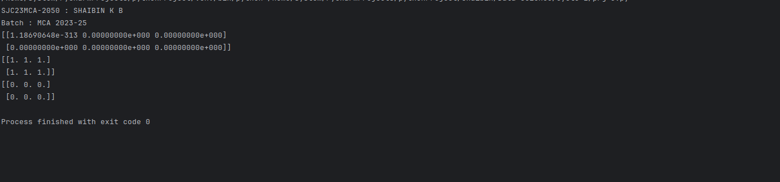

4. Create an one dimensional array using arange function containing 10
elements.Display
a. First 4 elements
b. Last 6 elements
c. Elements from index 2 to 7

print("SJC23MCA-2050 : SHAIBIN K B")
print("Batch : MCA 2023-25")

import numpy as np
array1=np.arange(10)
print(array1)
first4=array1[ :4]
print(first4)
last6=array1[ -6:]
print(last6)
middle=array1[2:7]
print(middle)

Output:
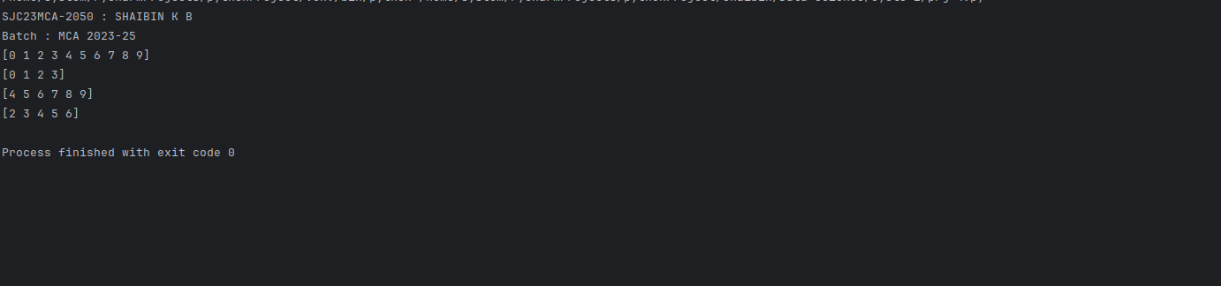
5. Create an 1D array with arrange containing first 15 even numbers as elements
a. Elements from index 2 to 8 with step 2(also demonstrate the same using
slice function)
b. Last 3 elements of the array using negative index
c. Alternate elements of the array
d. Display the last 3 alternate elements

print("SJC23MCA-2050 : SHAIBIN K B")
print("Batch : MCA 2023-25")

import numpy as np
evenumbers=np.arange(2,31,2)
print(evenumbers)
slice_result=evenumbers[2:9:2]
print(slice_result)
last3=evenumbers[-3:]
print(last3)
alternate=evenumbers[::2]
print(alternate)
alternateLast3=alternate[-3:]
print(alternateLast3)

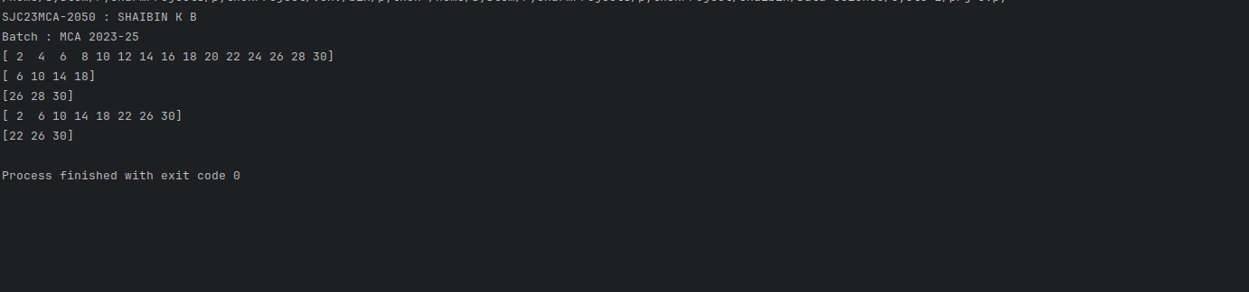
6. Create a 2 Dimensional array with 4 rows and 4 columns.
a. Display all elements excluding the first row
b. Display all elements excluding the last column
c. Display the elements of 1 st and 2 nd column in 2 nd and 3 rd row
d. Display the elements of 2 nd and 3 rd column
e. Display 2 nd and 3 rd element of 1 st row
f. Display the elements from indices 4 to 10 in descending order(use–values)

print("SJC23MCA-2050 : SHAIBIN K B")
print("Batch : MCA 2023-25")

import numpy as np
two_dimensional_array = np.array([[1, 2, 3, 4],
[5, 6, 7, 8],
[9, 10, 11, 12],
[13, 14, 15, 16]])
print("origanl Array\n",two_dimensional_array)

excludingFirst=two_dimensional_array[1:]
print("Excluding First row \n",excludingFirst)
excludingLast=two_dimensional_array[:,:-1]
print("Excluding Last row \n",excludingLast)
rowcolumn=two_dimensional_array[1:3,0:2]
print("Elements of 1st and 2 nd columns in the 2nd and 3 rd row \n",rowcolumn)
column23=two_dimensional_array[:,1:3]
print("Elements of 2nd and 3rd column \n",column23)
element23=two_dimensional_array[:1,1:3]
print("2nd and 3rd element of the 1st row:\n",element23)
selected_elements = two_dimensional_array.ravel()[::-1][4:11]
print("Elements from indices 4 to 10 in descending order:\n",selected_elements)

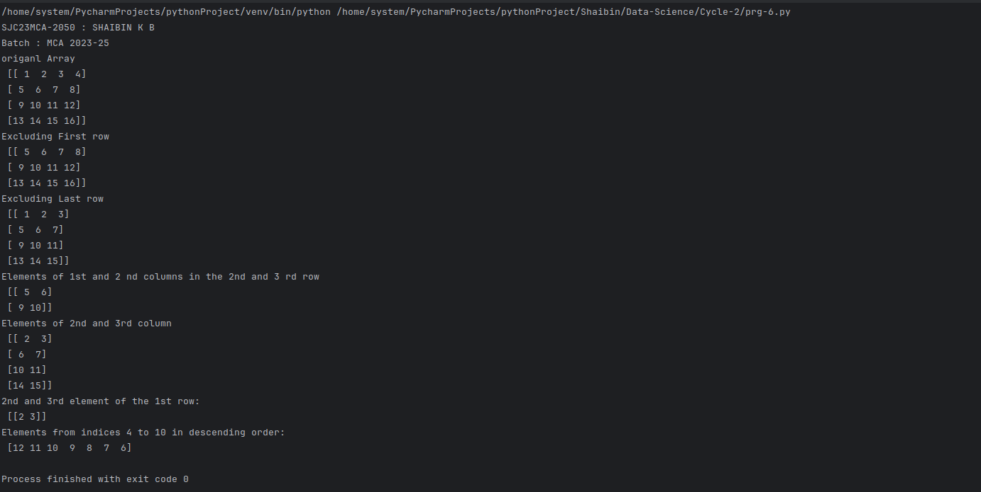

7. Create two 2D arrays using array object and
a. Add the 2 matrices and print it
b. Subtract 2 matrices
c. Multiply the individual elements of matrix
d. Divide the elements of the matrices
e. Perform matrix multiplication
f. Display transpose of the matrix
g. Sum of diagonal elements of a matrix

print("SJC23MCA-2050 : SHAIBIN K B")
print("Batch : MCA 2023-25")

import numpy as np;
matrix1 = np.array([[1, 2, 3], [4, 5, 6], [7, 8, 9]])
matrix2 = np.array([[9, 8, 7], [6, 5, 4], [3, 2, 1]])

matrix_sum=matrix1 + matrix2;
matrix_diff=matrix1 - matrix2;
matrix_product = matrix1 * matrix2
matrix_divide = matrix1 / matrix2
matrix_multiply = np.dot(matrix1, matrix2)
matrix1_transpose = np.transpose(matrix1)
diagonal_sum = np.trace(matrix1)

print("Matrix 1:\n", matrix1)
print("Matrix 2:\n", matrix2)
print("Matrix Sum:\n", matrix_sum)
print("Matrix Difference:\n", matrix_diff);
print("Matrix Element-wise Product:\n", matrix_product)
print("Matrix Element-wise Division:\n", matrix_divide)
print("Matrix Multiplication:\n", matrix_multiply)
print("Transpose of Matrix 1:\n", matrix1_transpose)
print("Sum of Diagonal Elements of Matrix 1:", diagonal_sum)

Output:
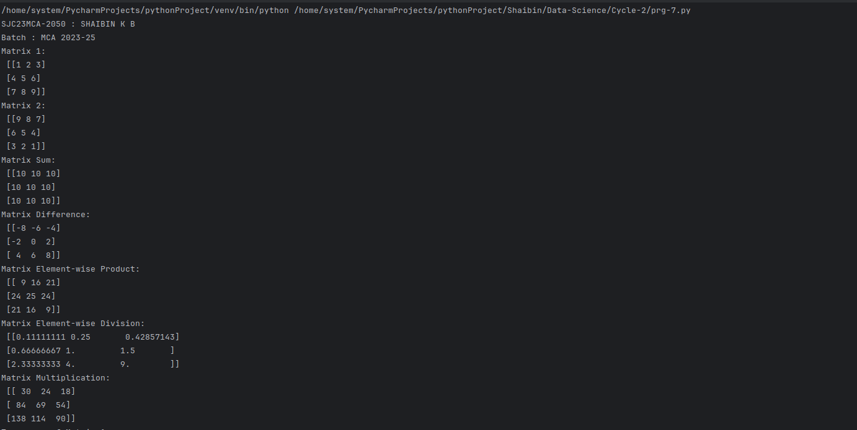
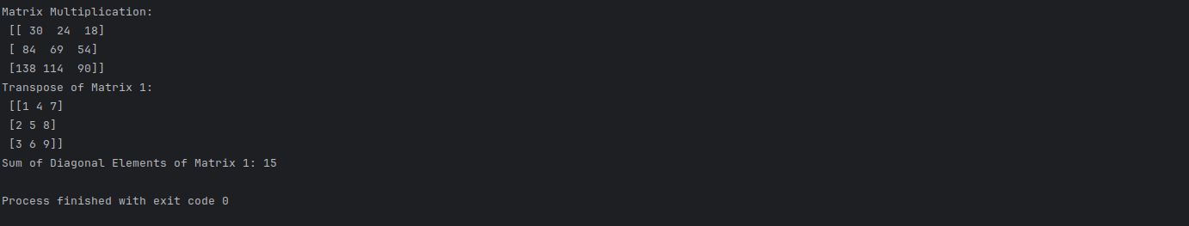

8. Demonstrate the use of insert() function in 1D and 2D array

print("SJC23MCA-2050 : SHAIBIN K B")
print("Batch : MCA 2023-25")

import numpy as np
array1=np.array([2,5,8,4,1])
print("\n\n1D Array before insertion:")
print(array1)
array2=np.insert(array1,2,9);
print("\n1D Array after insertion:")
print(array2)
array3=np.array([[2,4,6,7],
[4,6,8,1]])
print("\nOriginal 2D Array:")
print(array3)
array4=np.insert(array3,1,[6,9,4,2],axis=0)
print("\n2D Array after insertions:")
print(array4)

Output:

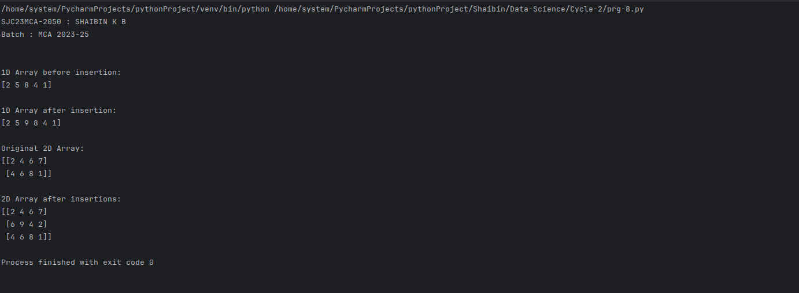

9. Demonstrate the use of diag() function in 1D and 2D array.(use both square matrix and matrix with different dimensions)

print("SJC23MCA-2050 : SHAIBIN K B")
print("Batch : MCA 2023-25")

import numpy as np;
arr_id = np.array([1, 2, 3, 4, 5])
diagonal_matrix = np.diag(arr_id)
print("\n1D Array:")
print(arr_id)
print("\nDiagonal Matrix:")
print(diagonal_matrix)
arr_2d_square = np.array([[1, 2, 3],
[4, 5, 6],
[7, 8, 9]])
diagonal_elements = np.diag(arr_2d_square)
print("\n2D Square Matrix:")
print(arr_2d_square)
print("\nDiagonal Elements:")
print(diagonal_elements)
arr_2d_non_square = np.array([[1, 2, 3],
[4, 5, 6]])

diagonal_elements_non_square = np.diag(arr_2d_non_square)
print("\n2D Non-Square Matrix:")
print(arr_2d_non_square)
print("\nDiagonal Elements (Non-Square):")
print(diagonal_elements_non_square)

Output:

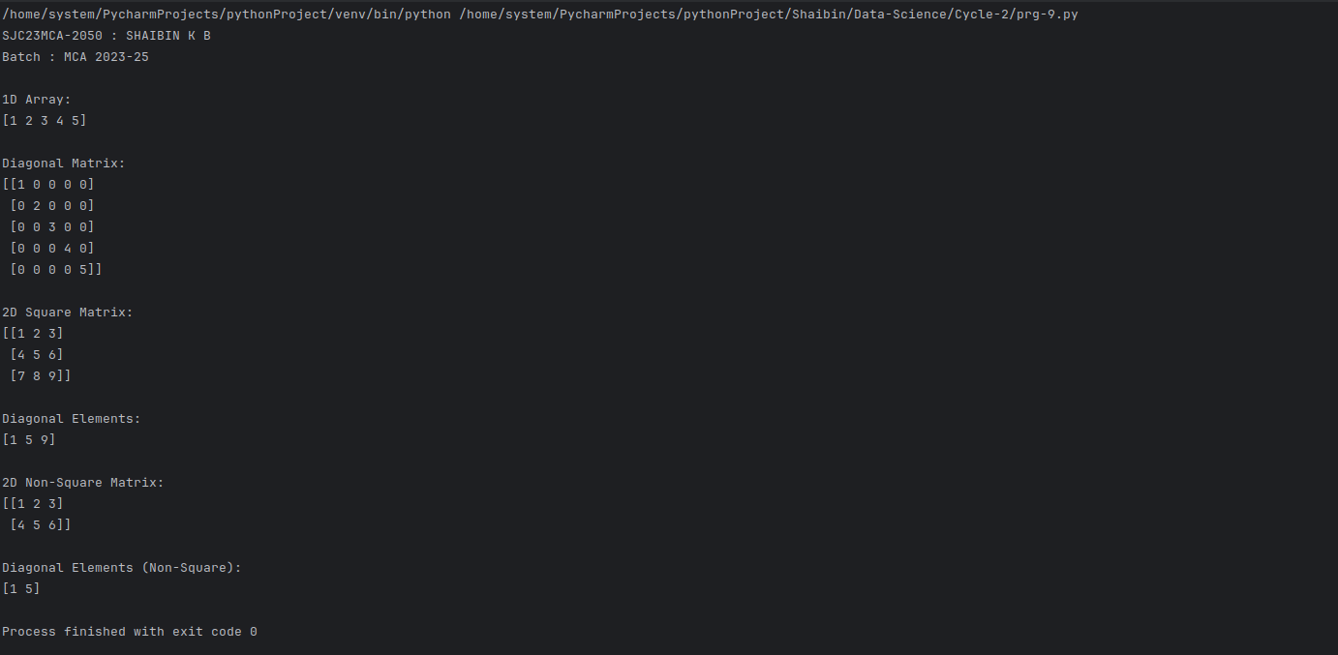

10.Create a square matrix with random integer values(use randint()) and use
appropriate functions to find:
i. Inverse
ii. rank of matrix
iii. Determinant
iv. transform matrix into 1D array
v. eigen values and vectors

print("SJC23MCA-2050 : SHAIBIN K B")
print("Batch : MCA 2023-25")

import numpy as np;
matrix_size = 3
matrix = np.random.randint(10,20, size=(matrix_size, matrix_size))
print("Original Matrix:")
print(matrix)
if np.linalg.matrix_rank(matrix) == matrix_size:
inverse_matrix = np.linalg.inv(matrix)
print("\nInverse Matrix:")
print(inverse_matrix)
else:
print("\nThe matrix is not invertible (its rank is less than the size).")
rank = np.linalg.matrix_rank(matrix)
print("\nRank of the Matrix:", rank)
determinant = np.linalg.det(matrix)
print("\nDeterminant of the Matrix:", determinant)
matrix_1d = matrix.flatten()
print("\nMatrix as 1D Array:")
print(matrix_1d)
eigenvalues, eigenvectors = np.linalg.eig(matrix)
print("\nEigenvalues:")
print(eigenvalues)
print("\nEigenvectors:")
print(eigenvectors)

Output:

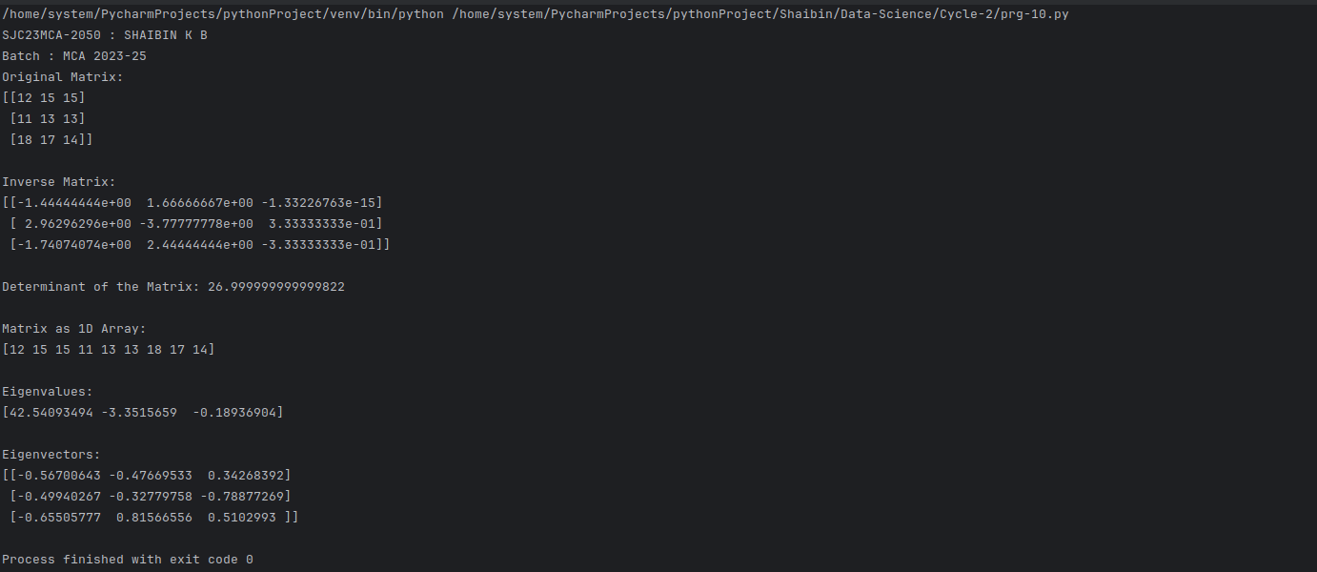

11. Create a matrix X with suitable rows and columns

i. Display the cube of each element of the matrix using different methods(use multiply(), *, power(),**)
ii. Display identity matrix of the given square matrix.
iii. Display each element of the matrix to different powers.
print("SJC23MCA-2050 : SHAIBIN K B")
print("Batch : MCA 2023-25")

import numpy as np
X = np.array([[1, 2,3 ],
[4, 5, 6],
[7, 8, 9]])

X_cube_multiply = np.multiply(X, np.multiply(X, X))
X_cube_operator = X * X * X
X_cube_power = np.power(X, 3)
X_cube_double_star = X ** 3
identity_matrix = np.identity(X.shape[0])
X_power_2 = np.power(X, 2)
X_power_3 = np.power(X, 3)
X_power_4 = np.power(X, 4)
print("Original Matrix X:")
print(X)
print("\nCubed Matrix (Method 1 - multiply()):")
print(X_cube_multiply)
print("\nCubed Matrix (Method 2 - * operator):")
print(X_cube_operator)
print("\nCubed Matrix (Method 3 - power()):")
print(X_cube_power)
print("\nCubed Matrix (Method 4 - ** operator):")
print(X_cube_double_star)
print("\nIdentity Matrix:")
print(identity_matrix)
print("\nMatrix to Different Powers:")
print("X^2:")
print(X_power_2)
print("\nX^3:")
print(X_power_3)
print("\nX^4:")
print(X_power_4)

Output :

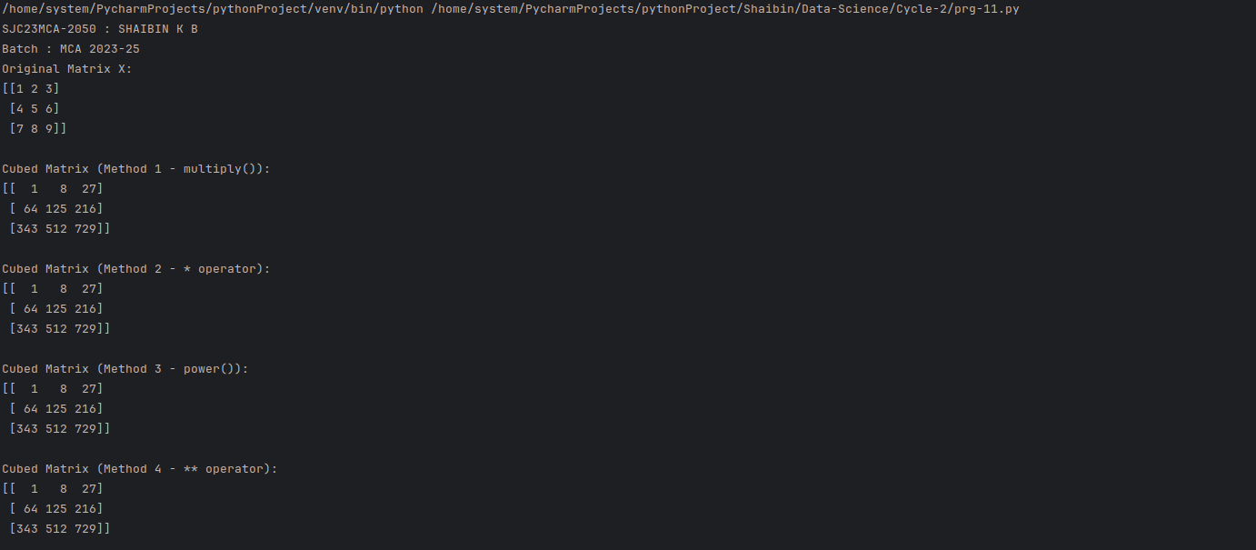
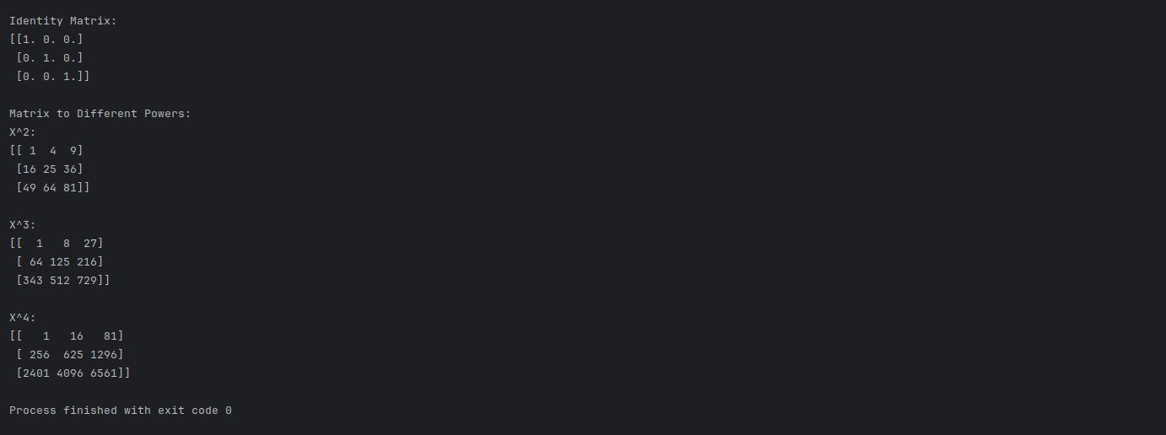

12.Create a matrix Y with same dimension as X and perform the operation X 2 +2Y

print("SJC23MCA-2050 : SHAIBIN K B")
print("Batch : MCA 2023-25")

import numpy as np;
X = np.array([[1, 2],
[3, 4]])
Y = np.random.rand(*X.shape)
result = X * 2 + 2 * Y
print("\n\nNew array : \n")
print(result)

Output:
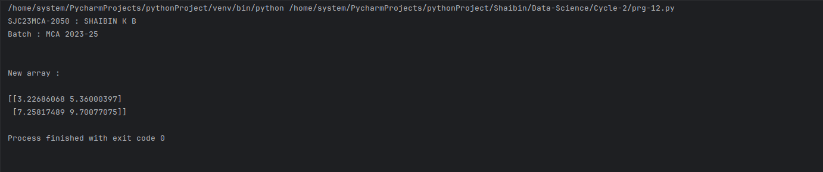
13.Define matrices A with dimension 5x6 and B with dimension 3x3. Extract a sub
matrix of dimension 3x3 from A and multiply it with B. Replace the extracted sub
matrix in A with the matrix obtained after multiplication

print("SJC23MCA-2050 : SHAIBIN K B")
print("Batch : MCA 2023-25")

import numpy as np
# Define matrix A with dimensions 5x6
A = np.array([[1,2,3,4,5,6],
[7,8,9,10,11,12],
[13,14,15,16,17,18],
[19,20,21,22,23,24],
[25,26,27,28,29,30]])

print("Matrix A is : ")
print(A)
B = np.array([[1,2,3,],[4,5,6],[7,8,9]])
print("Matrix B is : ")
print(B)
sub_matrix = A[:3, :3]
print("The sub matrix is ")
print(sub_matrix)
result = np.dot(sub_matrix,B)
print("Matrix after multiplication with the sub matrix of A an d matrix B")
print(result)
A[:3, :3] = result
print("Matrix A after the operation:")
print(A)

Output:

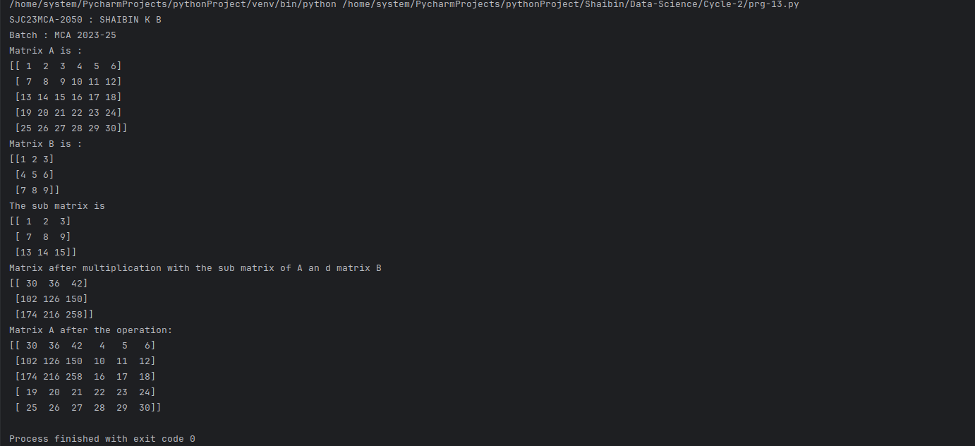

14.Given 3 Matrices A, B and C. Write a program to perform matrix multiplication of
the 3 matrices.

print("SJC23MCA-2050 : SHAIBIN K B")
print("Batch : MCA 2023-25")

import numpy as np
A = np.array([[1, 2, 3],
[4, 5, 6],
[7, 8, 9]])
B = np.array([[9, 8, 7],
[6, 5, 4],
[3, 2, 1]])
C = np.array([[10, 5, 9],
[20, 15, 19],
[30, 2, 29]])
result = np.dot(np.dot(A, B), C)
print("Matrix A:")
print(A)
print("Matrix B:")
print(B)
print("Matrix C:")
print(C)
print("Result of (A * B) * C:")
print(result)

Output:
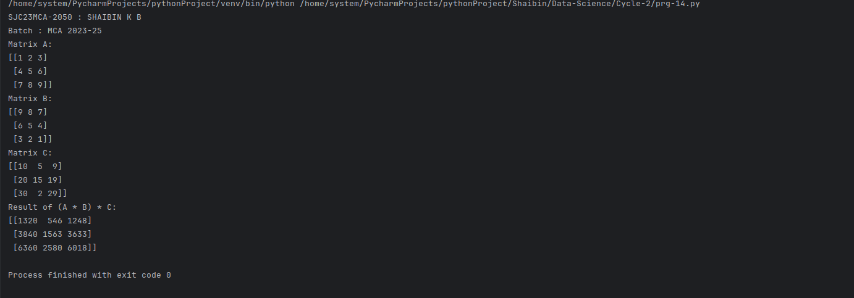

15.Write a program to check whether a given matrix is symmetric or Skew Symmetric.

print("SJC23MCA-2050 : SHAIBIN K B")
print("Batch : MCA 2023-25")

import numpy as np
def is_symmetric(matrix):
return (matrix == matrix.T).all()
def is_skew_symmetric(matrix):
return (matrix == -matrix.T).all()
matrix = np.array([[0, 1, -2],
[-1, 0, 3],
[2, -3, 0]])
print(matrix)
if is_symmetric(matrix):
print("The matrix is symmetric.")
elif is_skew_symmetric(matrix):
print("The matrix is skew-symmetric.")

Output:

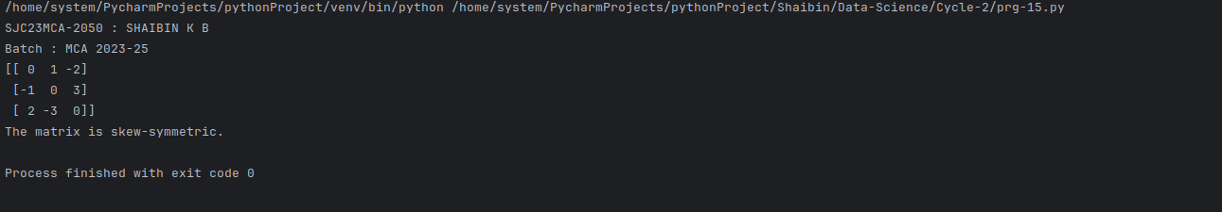

16.Given a matrix-vector equation AX=b. Write a program to find out the value of X
using solve(), given A and b as below

X=A-1 b.

Note: Numpy provides a function called solve for solving such equations.

print("SJC23MCA-2050 : SHAIBIN K B")
print("Batch : MCA 2023-25")

import numpy as np
A = np.array([[2, 1,-2],[3,0,1],[1,1,-1]])
b = np.array([-3,5,-2])
X = np.linalg.solve(A, b)
print("Matrix A:")
print(A)
print("Vector b:")
print(b)
print("Solution for X:")
print(X)

Output:

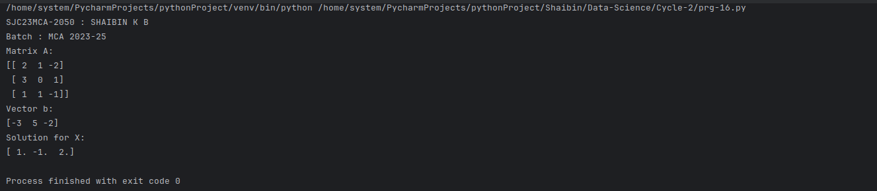

17.Write a program to perform the SVD of a given matrix A. Also reconstruct the
given matrix from the 3 matrices obtained after performing SVD.
Use the function: numpy.linalg.svd()
Singular value Decomposition
Matrix decomposition, also known as matrix factorization, involves describing a
given matrix using its constituent elements.
The Singular-Value Decomposition, or SVD for short, is a matrix decomposition
method for reducing a matrix to its constituent parts in order to make certain
subsequent matrix calculations simpler. This approach is commonly used in
reducing the no: of attributes in the given data set.

print("SJC23MCA-2050 : SHAIBIN K B")
print("Batch : MCA 2023-25")

import numpy as np
A = np.array([[5, 27, 32], [14, 53, 62], [67, 88, 19]])
U, S, Vt = np.linalg.svd(A)
A_hat = U @ np.diag(S) @ Vt
print('Original Matrix A :' )
print(A)
print('\nSingular Values : ')
print(S)
print('\nReconstructed')

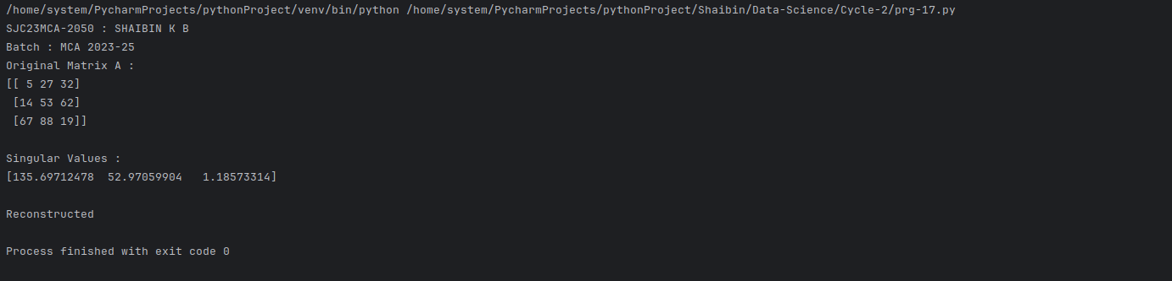

18.Sarah bought a new car in 2001 for $24,000. The dollar value of her car changed each
year as shown in the table below.
Value of Sarah's Car
Year Value
2001 $24,000
2002 $22,500
2003 $19,700
2004 $17,500
2005 $14,500
2006 $10,000
2007 $ 5,800
Represent the following information using a line graph with following style properties
● X- axis - Year
Y –axis - Car Value
● title –Value Depreciation (left Aligned)
● Line Style dash dot and Line-color should be red
● point using * symbol with green color and size 20

Subplot() provides multiple plots in one figure.

