### **Basic Linux Commands:**

**1.man**

The man command in Linux is used to display the manual pages of other commands, utilities, and functions available in the system. It stands for "manual" and provides detailed documentation, including descriptions, options, syntax, and examples, for various commands and functions.

Here's how you typically use the man command:

**man [command/function]**

For example, to view the manual page for the ls command (which lists directory contents), you would use:

**man man**

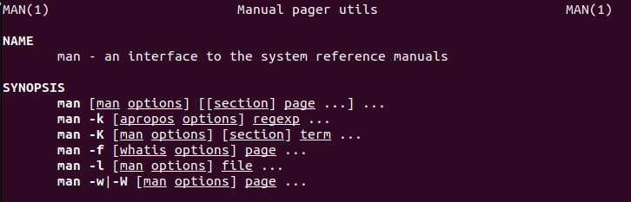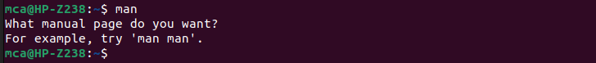

**2. ls, echo, read**

**ls:**

The ls command is used to list directory contents in Linux and Unix-like operating systems.

Syntax: ls [options] [file/directory]

Common options:

-l: Long listing format, showing detailed information about files and directories.

-a: Include hidden files (files starting with .).

-h: Human-readable sizes (e.g., 1K, 2M).

Example: ls -l

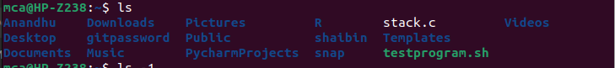

**echo:**

The echo command is used to display text or variables on the terminal.

Syntax: echo [options] [text]

Common options:

-e: Interpret backslash escapes.

-n: Do not output the trailing newline.

Example:

echo "Hello, World!"



**read:**

The read command is used to read input from the standard input (usually the keyboard) and store it in a variable.

Syntax: read [options] [variable]

Common options:

-p: Prompt before reading input.

Example:

read -p "Enter your name: " name



**3. more, less, cat**

The commands more, less, and cat are used to display the contents of files in Linux and Unix-like operating systems, but they offer different functionalities and options.

**more:**

The more command is a basic pager that displays text files page by page. It allows you to navigate through the file using the spacebar to advance one page at a time, the Enter key to advance one line at a time, and the 'q' key to quit.

Example:

more new.txt

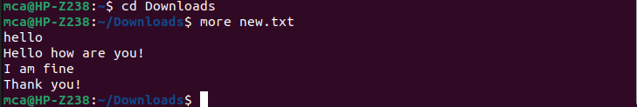

**less:**

The less command is an improved version of more. It also displays text files page by page but offers more features, such as backward navigation, searching, and jumping to specific line numbers. It is more user-friendly for viewing large files.

Example:

less new.txt

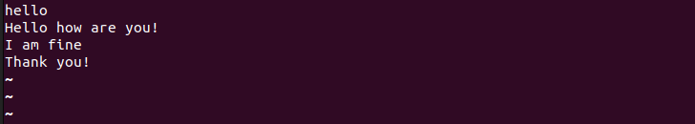

**cat:**

The cat command is used to concatenate and display the contents of files. It outputs the entire file without pausing, so it is not suitable for large files.

Example:

cat new.txt

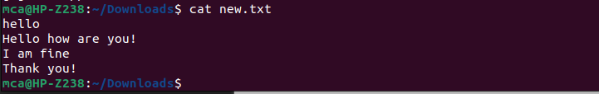

**4. cd, mkdir, pwd, find**

**cd:**

The cd command is used to change the current working directory in the shell.

Syntax: cd [directory]

Example:

cd /path/to/directory

Without any arguments, cd changes to the user's home directory.

**mkdir:**

The mkdir command is used to create directories (folders) in the file system.

Syntax: mkdir [options] directory_name

Common options:

**-p:** Create parent directories if they do not exist.

Example:

mkdir new_directory



**pwd:**

The pwd command stands for "print working directory". It prints the current working directory to the terminal.

Syntax: pwd

Example:

pwd



**find:**

The find command is used to search for files and directories within a directory hierarchy Syntax: find [directory] [options] [expression]

Common options:

-name: Search for files matching a specific name.

-type: Specify the type of file (e.g., file, directory).

Example:

find /path/to/search -name "*.txt"

These commands are essential for navigating the file system, creating directories, finding files, and managing paths in the Linux command line environment. They are frequently used in shell scripts and for everyday file management tasks.

**5. mv, cp, rm ,tar**

**mv:**

The mk command is not a standard Unix or Linux command. It's possible that you're referring to the mkdir command, which is used to create directories (folders) in a filesystem. Here's how you typically use it:

mkdir directory_name

For example, to create a directory called "example", you would use:

mkdir example

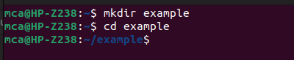

**cp:**

The cp command in Unix-like operating systems is used to copy files and directories from one location to another. Here's the basic syntax:

cp [options] source destination

source: This is the file or directory you want to copy.

destination: This is where you want to copy the source file or directory.

**Rm:**

The rm command in Unix-like operating systems is used to remove (delete) files or directories from the filesystem. Here's the basic syntax:

bash

rm [options] file1 file2 ...



**tar:**

The tar command in Unix-like operating systems is used to create, maintain, modify, and extract files that are archived in a tarball archive. The name "tar" stands for "tape archive," as it was originally used to write data to tape drives.

Here's the basic syntax of the tar command:

css

tar [options] [archive-file] [files/directories...]

**6. wc, cut, paste**

**wc:**

The wc command in Unix-like operating systems is used to display the number of lines, words, and bytes contained in a file or standard input. It stands for "word count."

Here's the basic syntax of the wc command:

wc [options] [file1 file2 ...]

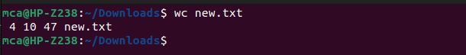

**cut:**

The cut command in Unix-like operating systems is used to extract sections from each line of input (usually text files) or from the standard input. It's particularly useful for manipulating text data by selecting specific fields or columns.

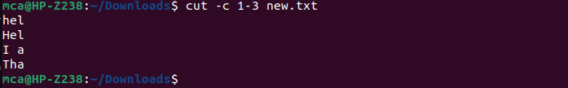

**Paste:**

The paste command in Unix-like operating systems is used to merge lines of files horizontally (side by side) by concatenating corresponding lines from each file. It's particularly useful for merging data from different sources into a single output.

**7. head, tail, grep, expr**

**head :**

The head command in Unix-like operating systems is used to output the first part of files. By default, it displays the first 10 lines of each specified file to the standard output.

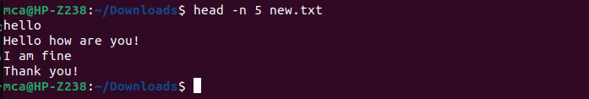

**tail :**

The tail command in Unix-like operating systems is used to output the last part of files. By default, it displays the last 10 lines of each specified file to the standard output.

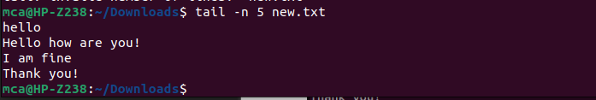

**Grep :**

The grep command in Unix-like operating systems is used to search for a specified pattern within one or more files or streams of text input. It is a powerful tool for pattern matching and text manipulation.

**Expr :**

The expr command in Unix-like operating systems evaluates expressions and prints the result to standard output. It's often used in shell scripting or in command-line operations to perform arithmetic operations or string comparisons.



**8. chmod, chown**

**chmod:**

The chmod command in Unix-like operating systems is used to change the permissions of files and directories. The name "chmod" stands for "change mode".