Does urbanization filter vegetation through the soil? A spatially validated test with global soil maps in a West African floodplain city
Ochoche Shaibu^{1,*} and Anatoly A. Kirichuk¹
¹Department of Human Ecology and Bioelementology, Institute of Environmental Engineering, Peoples’ Friendship University of Russia (RUDN University), 6 Miklukho-Maklaya Street, Moscow, 117198, Russia
*Corresponding author: Ochoche Shaibu, shaibuochoche2014@gmail.com (ORCID 0000-0003-2034-1980)
Anatoly A. Kirichuk: kirichuk_aa@rudn.ru

Abstract
Global soil maps such as SoilGrids 2.0 are increasingly combined with nighttime lights and vegetation indices to infer how urbanization alters soils, and through them vegetation, in data-poor cities, yet this inference is rarely tested. Along the urban gradient of Makurdi, a Guinea-savanna floodplain city in Nigeria, we tested three competing hypotheses — a soil-degradation filter, a geomorphic template and urban amplification of soil sensitivity. We used 3,507 cells of 500 m with VIIRS nighttime lights (NTL), Sentinel-2 EVI and eight SoilGrids properties, and re-examined every inference under geographic validation and spatially robust uncertainty. The SoilGrids built-up mask removed 59% of the most luminous cells, truncating the gradient before the urban core. NTL explained at most 11.5% of the variance of any soil property and about 1% of unique cross-validated EVI variance. The soil-mediated effect of NTL on EVI was −0.010 (block-bootstrap 95% CI −0.057 to 0.035), against a direct effect of −0.088, which rejects the soil-degradation filter. Soil organic carbon, the leading predictor, was negatively related to EVI, indexing hydromorphic floodplain soils. An apparent 2.2-fold steepening of the EVI–pH slope in luminous cells (p < 0.001 in conventional tests) vanished within latitude bands (p = 0.528), whereas a pH breakpoint at 5.83 (block CI 5.78 to 5.91) was stable. Effective sample size was about 601, and skill fell from R² = 0.914 in-sample to 0.355 (random) and about 0.2 (geographic cross-validation). We distil these results into a five-step screening protocol for urban uses of global soil maps.
Keywords: SoilGrids, Nighttime lights, Spatial cross-validation, Mediation analysis, Floodplain geomorphology, Guinea savanna

1 Introduction
Urbanization alters vegetation in two ways: directly, by replacing vegetated land with impervious surfaces, and indirectly, by changing the environment in which the remaining vegetation grows (Zhao et al. 2016; Zhang et al. 2022). Global syntheses built on this direct–indirect framework show that the indirect component is often positive, through warming, CO₂ enrichment and management. However, they resolve climatic and management pathways much better than edaphic ones (Zhang et al. 2022; Kang et al. 2025). In the rapidly expanding cities of sub-Saharan Africa, field studies report compaction, nutrient loss and altered soil reaction under urban land use (Asongwe et al. 2022; Zandybay et al. 2024; Fang et al. 2025; Rezapour et al. 2025). Whether such soil change is the route by which urbanization reduces vegetation vigour at landscape scale — an “urbanization filter” acting through the soil (Borowy and Swan 2022; Kisvarga et al. 2025) — has rarely been tested rather than assumed.
Field soil data are scarce in most African cities, so this question is increasingly addressed with globally or continentally modelled soil products, principally SoilGrids 2.0 (Poggio et al. 2021) and, for Africa, AfSoilGrids250m and iSDAsoil (Hengl et al. 2015, 2021). These are combined with nighttime lights (NTL), vegetation indices and machine learning (Wadoux et al. 2020; Dash et al. 2025; Huang et al. 2025). Urban-gradient studies of this kind usually rank the soil properties that “drive” vegetation along the gradient (Adelana et al. 2023; Mollashahi et al. 2023; Doğan et al. 2025). Yet evaluations of global soil maps in Africa have concentrated on farmland and on-farm decisions (Maynard et al. 2023). Global machine-learning maps are also known to extrapolate silently where training data are sparse (Meyer and Pebesma 2021, 2022). Whether these products can support inference about urban soil–vegetation coupling has not been examined systematically.
At least five properties of the data and of the analysis can make such inference unreliable:
- Coverage bias. SoilGrids restricts its predictions to land outside built-up, water and glacier classes (Poggio et al. 2021), so the most urbanized cells can drop out of an analysis without notice.
- Circularity. The candidate covariates of SoilGrids include MODIS EVI, NDVI, net primary production and land-cover layers, so an association between modelled soil and observed vegetation is not fully independent evidence.
- Confounding. Cities do not expand at random with respect to landform and drainage, so urban and geomorphic gradients are confounded.
- Validation-dependent skill. The apparent skill of machine-learning models on spatially structured data depends strongly on the validation design (Roberts et al. 2017; Meyer et al. 2019; Ploton et al. 2020).
- Spatial dependence in inference. Thousands of autocorrelated grid cells contain far less independent information than their number suggests, which inflates the apparent significance of interactions and thresholds (Dormann et al. 2007).
This study builds on, and is distinct from, our two earlier papers on the Nigerian Middle Belt. Shaibu and Kirichuk (2026a) evaluated SoilGrids at ward level, in 24 wards of Makurdi and Otukpo, against field vegetation plots. They found weak zonal differences in modelled soil properties except pH, and missing values in the most urbanized wards. Shaibu and Kirichuk (2026b) described multi-scale vegetation responses to urban growth in Makurdi. Neither paper tested whether urban effects on vegetation pass through the soil, quantified masking continuously along the urban gradient, or asked how validation design and spatial dependence change the conclusions. Here we move from wards to 3,507 cells of 500 m. We test the soil-mediated pathway formally against competing hypotheses, and we re-examine every inferential result under geographic validation and spatially robust uncertainty.
We treat the urbanization filter as three competing, testable hypotheses:
- H1 (soil-degradation filter): urban intensity shifts soil properties, and these shifts mediate the decline of canopy vigour, so the indirect effect of NTL on EVI through soil is substantial.
- H2 (geomorphic template): soil–vegetation relationships are set mainly by pre-urban landform and drainage, so NTL explains little soil variance and the soil-mediated effect is negligible.
- H3 (sensitivity amplification): urbanization changes the strength of the vegetation response to soil rather than the mean soil state, producing steeper soil–EVI slopes in more urbanized cells.
The study makes four contributions:
- a continuous quantification of the coverage bias introduced by the SoilGrids built-up mask along an urban gradient;
- a variance-partitioning and multiple-mediator test that rejects the soil-mediated pathway, with uncertainty that accounts for spatial dependence;
- a demonstration that an apparently strong urban amplification of vegetation sensitivity to soil pH — highly significant under conventional tests — does not survive geographic controls, whereas a pH breakpoint does;
- a hierarchy of apparent, random, feature-space and geographic validation, together with an estimate of the effective sample size, distilled into a five-step screening protocol for using global soil maps in urban environmental monitoring.

2 Materials and methods

2.1 Study area
Makurdi, the capital of Benue State, Nigeria, lies in the Benue River trough between about 7°34' and 7°53' N and 8°22' and 8°43' E (Fig. 1). It is a primary commercial centre of Nigeria’s Middle Belt, and its built-up area is expanding into the surrounding Southern Guinea savanna (Modu and Yager 2024). The climate is tropical wet and dry (Köppen Aw), with a wet season from April to October, mean annual rainfall of 1,200–1,500 mm and mean maximum temperatures near 35 ° C in March (Balogun et al. 2019).
The vegetation is a mosaic of gallery forest along the Benue and open parkland savanna dominated by Parkia biglobosa, Vitellaria paradoxa and Daniellia oliveri (Buba 2015). Ruderal and exotic species such as Azadirachta indica and Eucalyptus spp. are common in the urban fabric (Ranelović and Jovanović 2023). Soils are ferruginous tropical Luvisols and Ferralsols on Cretaceous sandstones, with hydromorphic alluvial soils on the Benue floodplain (Agada et al. 2024; Malum et al. 2025). The river divides the city, and the floodplain extends into the urban core. Urban and geomorphic gradients are therefore spatially entangled by construction, which is the condition under which H1 and H2 are hardest to separate.
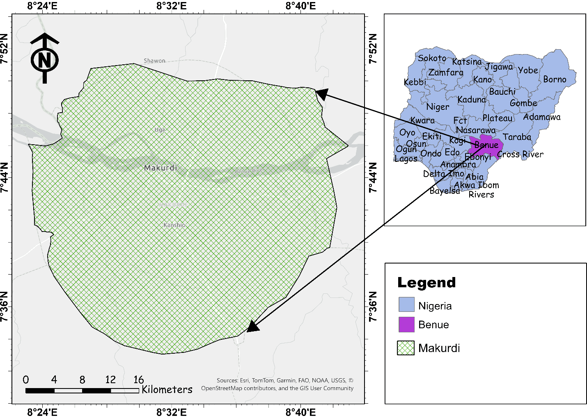
Fig. 1 Location of the study area: Makurdi within Benue State and Nigeria, with the delineated study boundary.

2.2 Conceptual framework
Figure 2 contrasts the three hypotheses. Under H1, urban intensification (the anthropogenic driver) alters the soil (the abiotic filter), which in turn reduces canopy vigour (the biological response). Under H2, soil state is set chiefly by landform and drainage, and urban intensity affects vegetation mainly through direct land-cover change. Under H3, urban intensity acts on the link between soil and vegetation. The workflow had six stages (Fig. 3):
- fusion of NTL, EVI and eight SoilGrids layers in Google Earth Engine (GEE);
- construction of a 500 m grid and an audit of cells lacking soil values;
- Random Forest (RF) modelling under a hierarchy of validation designs;
- tests of H1–H3;
- breakpoint estimation;
- re-estimation of every inferential result under spatially robust uncertainty and geographic controls.
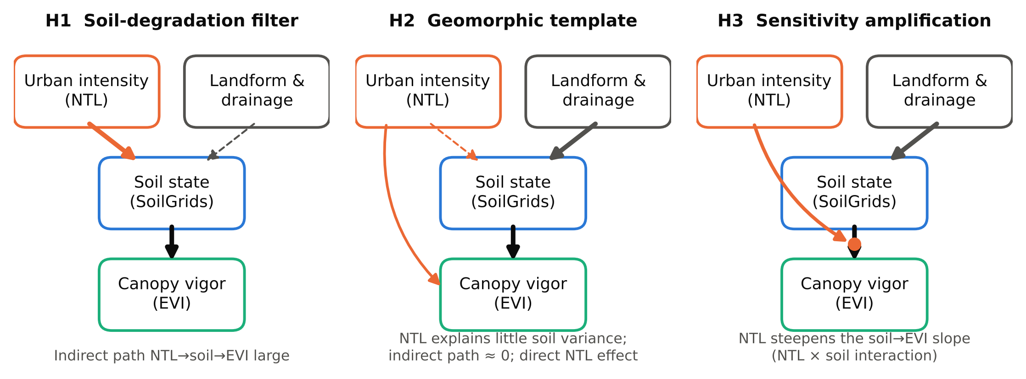
Fig. 2 Competing hypotheses. H1: urban intensity degrades the soil, which mediates the decline in canopy vigour. H2: soil state is set by landform and drainage, and urban intensity acts on vegetation directly. H3: urban intensity steepens the soil–vegetation relationship (an interaction). Arrow width indicates the strength of the pathway expected under each hypothesis; dashed arrows indicate weak pathways.
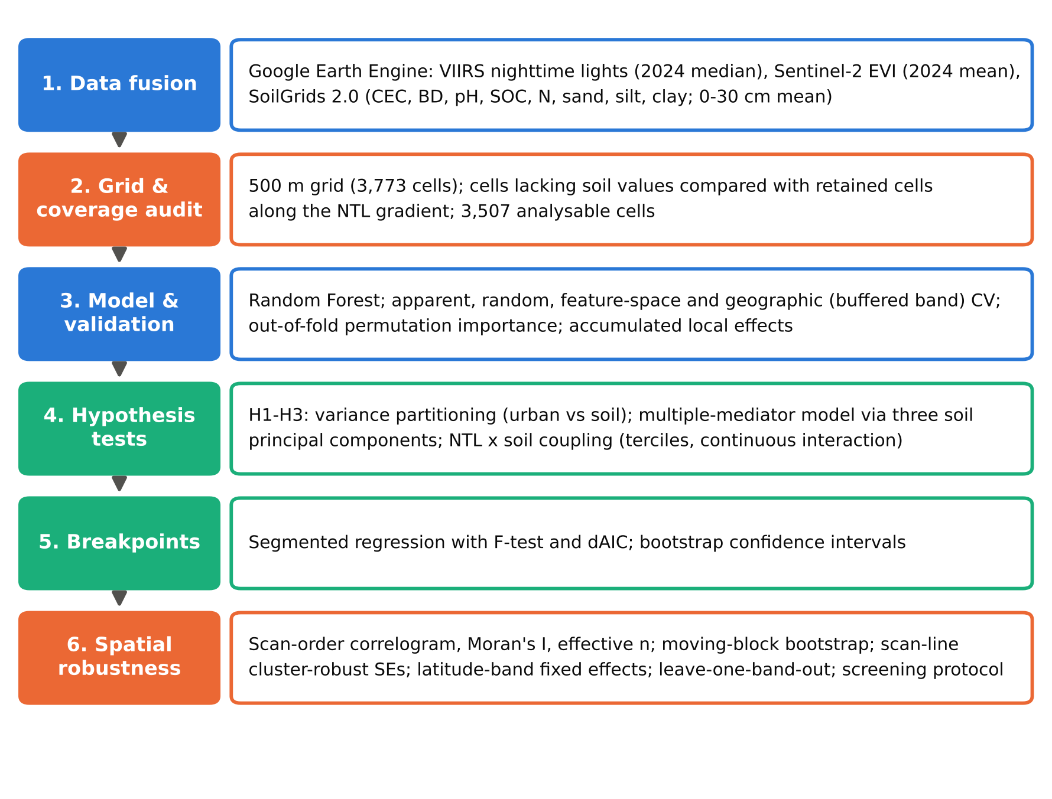
Fig. 3 Analytical workflow. Stages 2, 4 and 6 (coverage audit, hypothesis tests and spatial robustness) distinguish this assessment from a conventional driver-ranking analysis.

2.3 Data acquisition and pre-processing
All layers were processed in GEE (Ghosh et al. 2022).

Urban intensity.
We used the VIIRS Day/Night Band monthly cloud-free composites (NOAA/VIIRS/DNB/MONTHLY_V1/VCMCFG, band avg_rad), taking the per-pixel median of the twelve 2024 composites. Radiance (nW cm⁻² sr⁻¹) is a continuous proxy for anthropogenic pressure. It is affected by blooming around bright sources and by viewing geometry (Levin et al. 2020; Uyar 2024).

Soil.
Eight SoilGrids 2.0 properties at 250 m were used (Poggio et al. 2021): cation exchange capacity (CEC), soil organic carbon (SOC), total nitrogen (N), pH (H₂O), bulk density (BD), and sand, silt and clay. The 0–5, 5–15 and 15–30 cm layers were averaged (unweighted) and converted to conventional units with the ISRIC factors. Two properties of the product are central here. First, predictions are restricted to land outside the built-up, water and glacier classes of the 2015 ESA land-cover layer. Second, the candidate covariates include land-cover classes, MODIS and Landsat reflectance, and MODIS EVI, NDVI and net primary production (Poggio et al. 2021). SoilGrids layers are therefore spatial predictions with regionally variable uncertainty (Park 2026), and they are not statistically independent of vegetation indices. Our ward-level evaluation found that they reproduce relative patterns better than absolute values (Shaibu and Kirichuk 2026a), so all analyses are framed in terms of relative gradients.

Vegetation.
The Enhanced Vegetation Index was computed from Sentinel-2 Level-2A surface reflectance as EVI = 2.5(ρ_{NIR}−ρ_{R})/(ρ_{NIR}+6ρ_{R}−7.5ρ_{B}+1), using bands 8, 4 and 2. All 2024 scenes with less than 15% cloudy pixels were averaged. Because such scenes cluster in the dry season, the composite mainly represents dry-season canopy greenness, when edaphic moisture constraints should be most limiting.

Gridding.
All layers were summarized on a 500 m covering grid by zonal means. This support reconciles the native resolutions of SoilGrids (250 m) and VIIRS (about 450 m), and no inference is drawn below it.

2.4 Grid, gradient and coverage audit
Discretization produced 3,773 cells. Of these, 266 lacked a value in at least one layer (250 lacked all eight soil layers) and were removed, leaving n = 3,507. Because the SoilGrids mask excludes built-up and water areas, this deletion is not expected to be random with respect to urbanization. We therefore audited it: we compared the NTL distributions of excluded and retained cells (two-sided Mann–Whitney test) and tabulated the proportion of excluded cells in five NTL classes (≤0.5, 0.5–1, 1–2, 2–4 and > 4 nW cm⁻² sr⁻¹).

2.5 Predictive modelling, validation and predictor effects
Pearson correlations described bivariate coupling. Because sand, silt and clay are compositional and the other properties are inter-correlated, the eight standardized soil properties were also summarized by principal component analysis (PCA). The first three components were used in the hypothesis tests.
A Random Forest regressor (scikit-learn; 1,000 trees, unrestricted depth, seed 42) predicted EVI from NTL and the eight soil properties (Simon et al. 2023). Skill was summarized by R2=1−i​yi−yi2/i​yi−y2 and RMSE=n−1i​yi−yi2, under five designs:
- Apparent fit: training observations are predicted, to show how far this overstates skill.
- Random ten-fold cross-validation (CV): estimates interpolation within sampled conditions.
- Feature-space blocked CV: withholds ten clusters obtained by k-means on the standardized soil covariates.
- Geographic band CV: withholds ten contiguous latitude bands (Sect. 2.7).
- Buffered band CV: as design 4, but cells within one or two scan lines (about 0.5 or 1 km) of the withheld band are also removed from training (Roberts et al. 2017; Linnenbrink et al. 2024).
All designs were repeated with a regularized forest (minimum leaf size 20).
Predictor importance was estimated by permutation on held-out folds, for single predictors and for groups: NTL; SOC, N and CEC; sand, silt and clay; BD; and pH. Held-out permutation is less biased than impurity importance for correlated predictors (Strobl et al. 2007). Marginal responses were described with accumulated local effects (ALE) (Apley and Zhu 2020) rather than partial dependence. Partial dependence averages predictions over combinations of correlated soil properties that do not occur in the landscape, and its curves can be unstable (Liang et al. 2023). ALE avoids this by accumulating local prediction differences within quantile bins. Partial dependence is shown only for comparison.

2.6 Hypothesis tests and breakpoints

Variance partitioning (H1 vs H2).
EVI variance was partitioned into unique urban, unique soil and shared fractions by comparing models with NTL only, soil only and both (Borcard et al. 1992). Partitioning used cross-validated RF R² (minimum leaf size 20; random, feature-space and buffered geographic folds) and adjusted R² from ordinary least squares (OLS). We also quantified how much of the variance of each soil property NTL explains.

Multiple-mediator model (H1).
Standardized log NTL affected the first three soil principal components (the a paths). These, together with a direct NTL path (c'), affected EVI (the b paths). Specific indirect effects (a×b), their sum and the direct effect received 95% bootstrap intervals (Preacher and Hayes 2008). Under H1 the total indirect effect should be substantial and have the same sign as the total effect; under H2 it should be near zero.

Gradient-dependent coupling (H3).
Cells were divided into NTL terciles: low (0.28–0.39), middle (0.39–0.52) and high (0.52–6.40 nW cm⁻² sr⁻¹), with n = 1,171, 1,168 and 1,168. Within each tercile we computed:
- the correlations of EVI with each soil property and principal component;
- the OLS slope of EVI on pH;
- the cross-validated skill of a soil-only RF.
Correlations were compared between the low and high terciles with Fisher’s z. The modification of the pH–EVI slope by urban intensity was also tested as a continuous pH × log NTL interaction, with and without the other soil properties as covariates. Within-tercile standard deviations were compared to exclude range artefacts.

Breakpoints.
Single breakpoints in the bivariate EVI response to SOC, pH, BD and log NTL were estimated by segmented regression (Muggeo 2003). Each breakpoint was located by least-squares grid search over the 5th–95th percentiles of the predictor. Support for a break was assessed with an F-test and with ΔAIC relative to a linear model.

2.7 Spatial dependence and spatially robust inference
The archived analytical table has no coordinates, but its rows are stored in the order in which GEE generates the covering grid, that is, as a raster scan of 500 m cells. We verified this empirically. Consecutive rows were strongly autocorrelated, and the autocorrelation of NTL peaked again at a lag of 70 rows, the length of one east–west scan line. Cells with EVI < 0.05, which mark the Benue channel, all fell within about 11 consecutive scan lines (half of them within four), consistent with a west–east river crossing a north–south sequence of lines. Contiguous runs of rows therefore form latitude bands of about 54 lines in total. We used them in three ways:
- as geographic CV folds (ten bands of about 2.7 km, with optional buffers);
- as clusters for cluster-robust standard errors (Cameron and Miller 2015), using pairs of scan lines (about 1 km);
- as fixed effects that remove all between-band (north–south) variation, so that the H3 interaction is estimated only from contrasts within bands.
Residual spatial dependence was summarized with the scan-order correlogram of OLS residuals, along-row Moran’s I, and an AR(1) effective sample size, n_{eff} = n(1−ρ₁)/(1+ρ₁). Bootstrap intervals for the mediation effects, the tercile slope difference and the pH breakpoint were recomputed with a moving-block bootstrap (Künsch 1989), with blocks of two scan lines, and compared with the independent (i.i.d.) bootstrap. Breakpoint stability was also assessed by re-estimating the breakpoint with each band left out in turn.
Analyses used Python 3 (scikit-learn, statsmodels, SciPy). The scripts that reproduce every number, table and figure are archived as described in the Data and Code Availability statements. Reporting follows the REFORMS recommendations for machine-learning-based science (Kapoor et al. 2024).

3 Results

3.1 Spatial patterns of urban intensity, soil and vegetation
Nighttime radiance formed a concentrated core of high values ( > 4 nW cm⁻² sr⁻¹) around the central business district on both banks of the Benue and decayed to below 0.3 at the rural periphery (Fig. 4). EVI broadly mirrored this decline, with the highest values ( > 0.45) in the peri-urban fringe and riparian gallery forest, but green patches persisted inside the urban core. Modelled soils were organized by the river. Cells near the channel had higher SOC and N, sand dominated the eastern uplands, and clay and silt were concentrated in low-lying depressions. Bulk density showed localized highs ( > 1.40 g cm⁻³), and pH was slightly less acidic in and around the luminous core. The maps alone cannot show whether these patterns reflect urban modification of the soil or the position of the city relative to the floodplain; this is tested below. They also show that parts of the brightest core have no soil values.
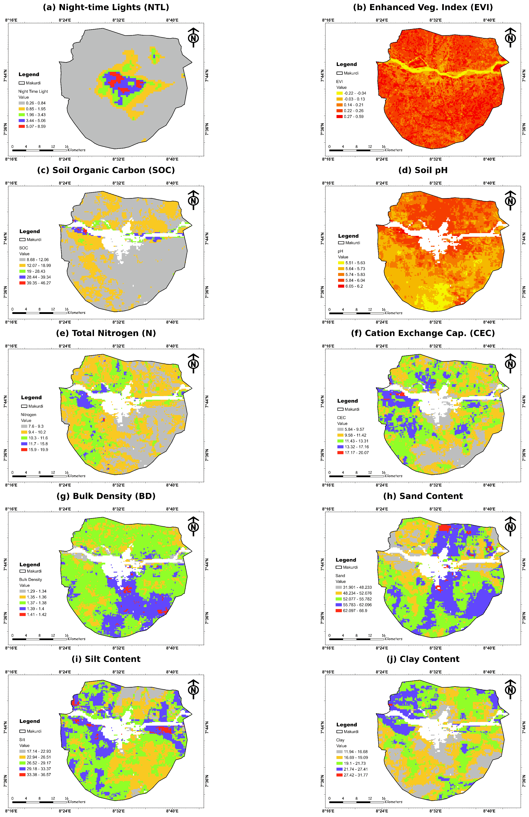
Fig. 4 Spatial configuration of urban intensity (NTL), vegetation vigour (EVI) and the eight SoilGrids properties across Makurdi (500 m grid). White areas within the boundary are cells without SoilGrids values (Sect. 3.2).

3.2 Coverage bias of the soil layers
Soil values were missing for 266 of the 3,773 cells (7.1%), and these cells were concentrated in the urban core (Fig. 5). Their median NTL was 2.36 nW cm⁻² sr⁻¹, against 0.44 in retained cells (Mann–Whitney p < 0.001). The proportion of cells without soil values rose monotonically along the gradient:
NTL class (nW cm⁻² sr⁻¹) | Cells without soil values (%)
≤0.5 | 3
0.5–1 | 4
1–2 | 9
2–4 | 23
> 4 | 59
Across the brightest decile (NTL > 2.05), 37% of cells were lost. About 104 excluded cells had EVI < 0.05 and correspond mainly to the river channel and bare surfaces; most of the rest lay in the luminous built-up core. The maximum NTL in the analysable sample was 6.40, against 7.64 in the full grid. The analysable gradient is therefore truncated precisely where urban effects on soils would be expected to be largest. All further results describe the peri-urban to moderately urbanized part of the gradient, not the dense core.
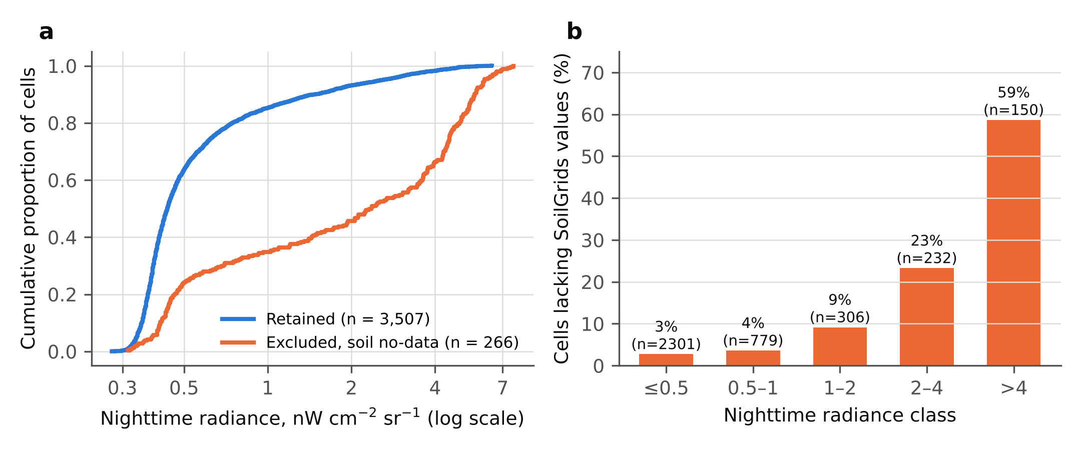
Fig. 5 Coverage audit of the SoilGrids layers along the urban gradient. (a) Cumulative distribution of nighttime radiance for retained cells and for cells excluded because SoilGrids values were missing. (b) Proportion of cells lacking SoilGrids values in five radiance classes; n is the total number of cells in each class.

3.3 Bivariate coupling
More luminous cells had slightly less acidic (pH: r = 0.249), denser (BD: r = 0.234) and less clay-rich (r = −0.339) modelled soils with lower CEC (r = −0.253; all p < 0.001; Table 1, Fig. 6). In terms of shared variance these associations are small. NTL explained at most 11.5% of the variance of any soil property (clay), 6.2% of pH and 0.6% of SOC, and an RF using NTL alone explained at most 6.5% of the cross-validated variance of any soil property.
The first three soil principal components explained 45.6%, 17.6% and 11.0% of soil variance:
- PC1 contrasts coarse, dense, carbon- and nutrient-poor soils with fine, carbon-rich soils, and shared only 6.2% of its variance with NTL.
- PC2 contrasts silty soils with sandy, less acidic soils.
- PC3 is dominated by clay.
SOC and pH had the strongest associations with EVI, both negative (r = −0.443 and −0.349), whereas BD was positively associated with EVI (r = 0.314; Online Resource 1, Fig. S1). Both the SOC–EVI and the BD–EVI signs are opposite to those expected if nutrition and compaction limited vegetation. NTL had only a weak linear association with EVI (r = −0.088). With n = 3,507 even small coefficients are nominally significant; because neighbouring cells are not independent (Sect. 3.8), interpretation rests on effect sizes.
Table 1 Principal bivariate associations among urban intensity, modelled soil properties and vegetation vigour (n = 3,507 cells; Pearson r; all nominal p < 0.001). Coefficients describe association only.
Pair | r | Interpretation
NTL – pH | 0.249 | More luminous cells have slightly less acidic modelled soils
NTL – CEC | −0.253 | More luminous cells have lower modelled CEC
pH – EVI | −0.349 | Less acidic cells have lower vigour (Sect. 3.7)
SOC – EVI | −0.443 | Carbon-rich floodplain cells have lower vigour (Sect. 4.2)
NTL – EVI | −0.088 | Weak association; soil-mediated path tested in Sect. 3.5
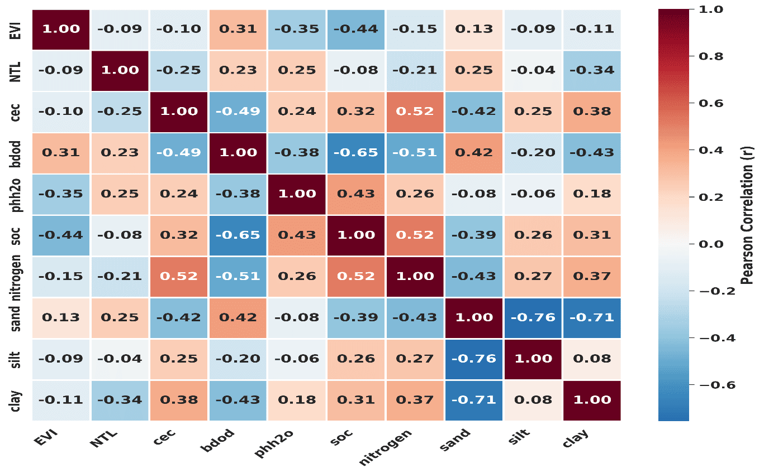
Fig. 6 Pearson correlation matrix of urban intensity (NTL), the eight SoilGrids properties and vegetation vigour (EVI) (n = 3,507).

3.4 Predictive skill under a hierarchy of validation designs
Model skill depended strongly on the evaluation design (Table 2; Figs. 7 and 8). The fully grown forest reproduced 91.4% of EVI variance in-sample, a statistic that reflects memorization rather than predictive skill. Random ten-fold CV gave R² = 0.355. Holding out geographically contiguous latitude bands gave R² = 0.221, and feature-space blocking gave 0.144. With a buffer of two scan lines around each withheld band, skill was 0.167 for the fully grown forest and 0.194 for the regularized forest.
Geographic skill of the fully grown forest varied with buffer width (0.221, 0.092 and 0.167 for 0, 0.5 and 1 km). The regularized forest was more stable (0.230, 0.227 and 0.194). This indicates that fully grown trees overfit local structure that does not transfer. In short, about one third of the spatial variance in dry-season EVI can be interpolated from the nine predictors, and about one fifth transfers to geographically separate parts of the landscape.
Table 2 Random Forest performance under different evaluation designs (n = 3,507). Each design answers a different question; the apparent statistic is not a measure of predictive skill. Geographic designs use 500 trees.
Evaluation design | What it estimates | R² (full depth) | R² (leaf ≥20)
Apparent (in-sample) | Fit to training data, not skill | 0.914 | –
Random ten-fold CV | Interpolation within sampled conditions | 0.355 | 0.296
Feature-space blocked CV (k-means, k = 10) | Transfer to unrepresented soil conditions | 0.144 | 0.203
Latitude-band CV (10 bands) | Transfer to unsampled areas | 0.221 | 0.230
Latitude-band CV, 0.5 km buffer | As above, adjacency removed | 0.092 | 0.227
Latitude-band CV, 1 km buffer | As above, wider buffer | 0.167 | 0.194
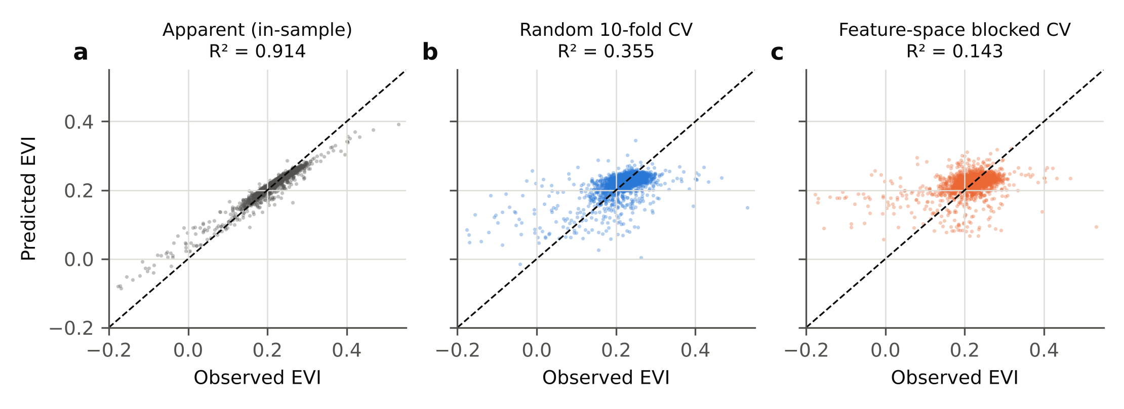
Fig. 7 Observed versus predicted EVI under (a) apparent fit, (b) random ten-fold CV and (c) feature-space blocked CV (held-out predictions only in b and c). The dashed line is the 1:1 line.
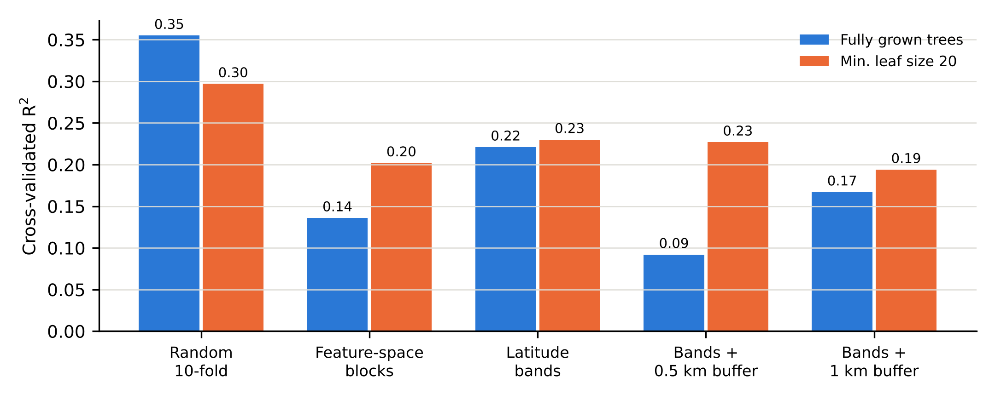
Fig. 8 Cross-validated R² of the Random Forest (NTL + eight soil properties) under random, feature-space and geographic designs, for fully grown trees and for a regularized forest (minimum leaf size 20). Latitude bands are contiguous runs of the 500 m grid’s scan lines; buffers remove the adjacent 0.5 or 1 km from training.
Out-of-fold permutation identified SOC as the most informative single predictor: the mean drop in held-out R² was 0.503 (±0.147 SD across folds). It was followed by pH (0.156), silt (0.109), total N (0.083), sand (0.073) and NTL (0.054), with CEC, BD and clay contributing least (Fig. 9). Grouped permutation gave the same order: organic matter and nutrients (0.564), texture (0.229), pH (0.156), NTL (0.054) and BD (0.028). Importance measures predictive contribution, not mechanism or direction. SOC is the soil variable that best separates vegetation conditions in this landscape, but its negative sign and its near-zero relationship with NTL (r = −0.076) indicate that this separation is not urban in origin.
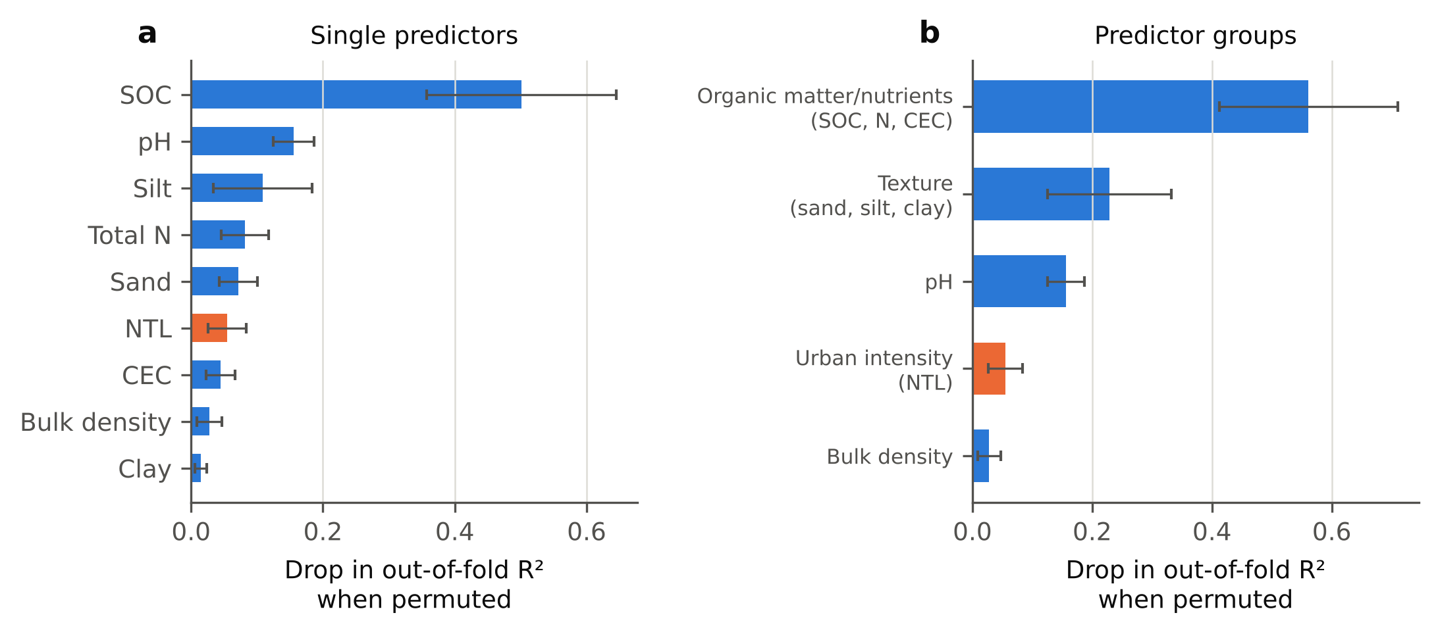
Fig. 9 Out-of-fold permutation importance of (a) single predictors and (b) predictor groups: the mean drop in held-out R² when the predictor or group is permuted. Error bars are standard deviations across ten folds. NTL is shown in orange.

3.5 Urban versus edaphic control: variance partitioning and mediation
Nearly all explainable variance in EVI was edaphic (Table 3; Fig. 10a). With a regularized RF and random folds, soil alone explained R² = 0.287 and NTL plus soil 0.297, so the unique urban contribution was 0.010. Under feature-space blocking the values were 0.192, 0.202 and 0.009. Under buffered geographic bands they were 0.221, 0.227 and 0.006. NTL alone had no cross-validated skill under any design. The OLS partition agreed: soil alone explained 24.0% (adjusted R²), NTL alone 0.7% and the full model 24.2%, leaving a shared fraction of 0.5%. Because the shared fraction is the only route by which an urban effect could pass through the soil, H1 predicts it to be large; it was negligible.
In the multiple-mediator model, the standardized total effect of log NTL on EVI was −0.097. Urban intensity was associated with each soil component, with a paths of 0.238 (PC1), −0.183 (PC2) and −0.301 (PC3). Each component was associated with EVI, with b paths of 0.327, 0.222 and 0.156. The resulting indirect effects had opposite signs:
- +0.078 through PC1;
- −0.041 through PC2;
- −0.047 through PC3.
They summed to a total soil-mediated effect of −0.010. Its interval included zero under the i.i.d. bootstrap (−0.029 to 0.008) and, more widely, under the moving-block bootstrap (−0.057 to 0.035). The direct effect, −0.088 (block-bootstrap 95% CI −0.141 to −0.025), accounted for about 90% of the total. The data are therefore inconsistent with H1. To the extent that SoilGrids represents soil variation in Makurdi, urban intensity lowers canopy vigour mainly through pathways that do not run through the modelled soil, such as vegetation removal and surface sealing.
Table 3 Variance partitioning of EVI between urban intensity and soil, and decomposition of the effect of log NTL on EVI into soil-mediated and direct components. RF: Random Forest, minimum leaf size 20. Band CV: latitude bands with a 0.5 km buffer. OLS: ordinary least squares (adjusted R²). Mediation effects are standardized; “i.i.d.” and “block” are 95% intervals from the independent and the moving-block bootstrap.
Variance partitioning (R²) | RF random | RF feature-blocked | RF band | OLS
NTL + soil | 0.297 | 0.202 | 0.227 | 0.242
Soil only | 0.287 | 0.192 | 0.221 | 0.240
NTL only | −0.019 | −0.057 | −0.073 | 0.007
Unique NTL (full − soil) | 0.010 | 0.009 | 0.006 | 0.002
Mediation (log NTL → EVI) | Estimate | i.i.d. 95% CI | block 95% CI | Share
Indirect via PC1 | +0.078 | 0.063 to 0.094 | 0.040 to 0.128 | –
Indirect via PC2 | −0.041 | −0.051 to −0.031 | −0.073 to −0.017 | –
Indirect via PC3 | −0.047 | −0.060 to −0.034 | −0.081 to −0.014 | –
Total indirect | −0.010 | −0.029 to 0.008 | −0.057 to 0.035 | 10% (n.s.)
Direct | −0.088 | −0.115 to −0.060 | −0.141 to −0.025 | 90%
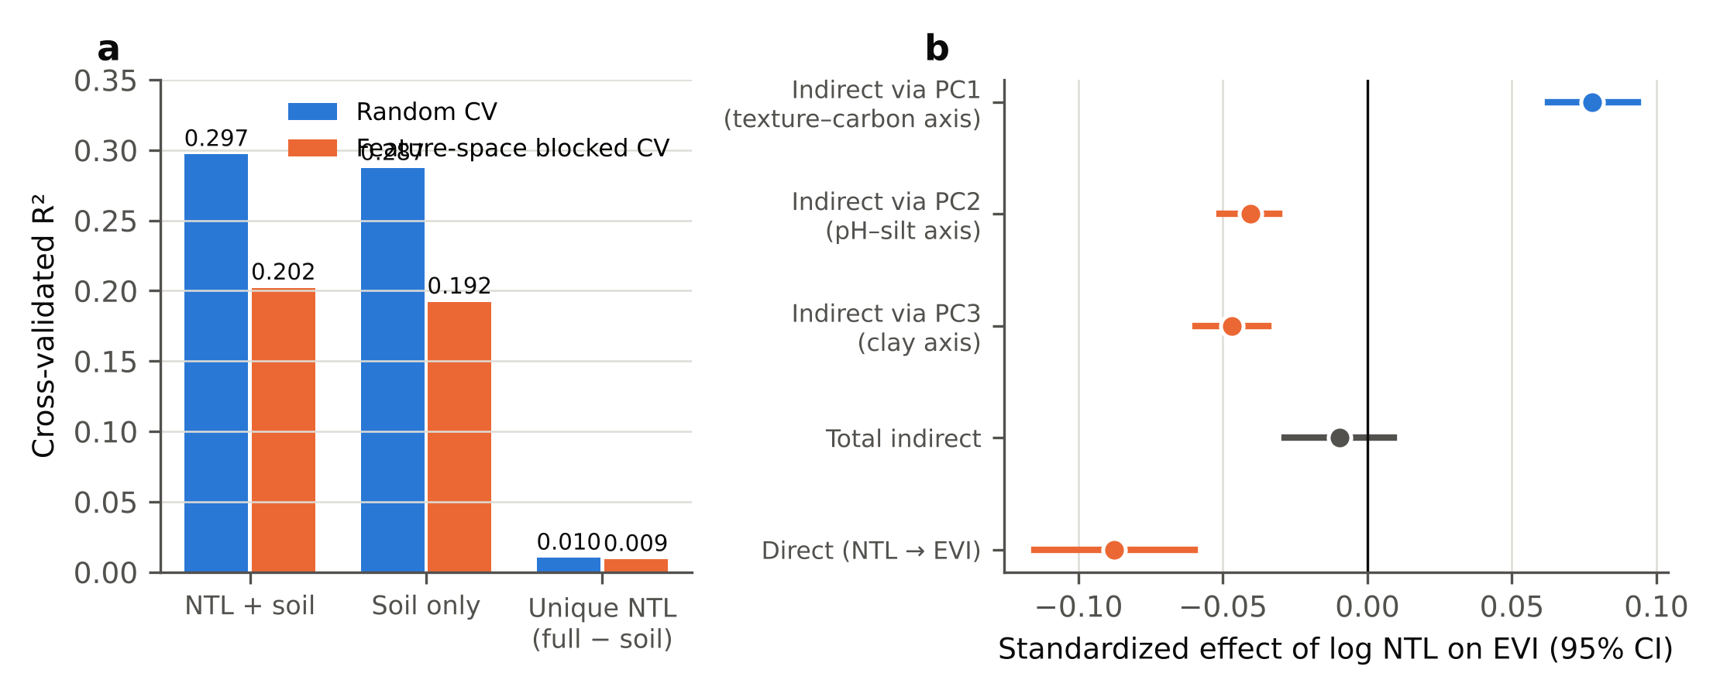
Fig. 10 Tests of the soil-mediated pathway (H1). (a) Cross-validated R² of regularized RF models with NTL and soil, soil only, and the unique contribution of NTL, under random and feature-space blocked CV. (b) Standardized direct and indirect effects of log NTL on EVI from the multiple-mediator model, with i.i.d. bootstrap 95% intervals (2,000 resamples); grey marks an interval that includes zero. Block-bootstrap intervals are given in Table 3.

3.6 Non-linear responses and breakpoints
Accumulated local effects showed how the fitted RF response changes across each predictor while respecting the correlation among soil properties (Fig. 11). For SOC the response was flat up to about 17 g kg⁻¹ and declined above about 20 g kg⁻¹; mean observed EVI was 0.231 in each of the lowest three SOC quintiles and 0.197 in the highest. For pH the response was flat to about 5.8 and declined above it. For BD it rose to about 1.36 g cm⁻³ and then levelled off. For NTL it declined gradually without an abrupt change. Partial dependence curves had similar shapes, but their amplitude differed from ALE (for SOC, 0.109 vs 0.096 EVI units). They are therefore not used for thresholds.
Segmented regression supported breakpoints for pH and BD, supported a SOC break only weakly, and found none for NTL (Table 4).
- pH. EVI was nearly constant below 5.83 (slope −0.03 per unit) and declined steeply above it (−0.51 per unit; ΔAIC = 292). Mean EVI was 0.231 below and 0.198 above the break.
- Bulk density. EVI rose steeply up to 1.360 g cm⁻³ and was nearly flat above (ΔAIC = 287). Cells below this break (13.2% of the landscape) had higher SOC (18.4 vs 11.5 g kg⁻¹) and lower EVI (0.190 vs 0.228).
- SOC. The break (13.3 g kg⁻¹) had a wide interval and modest support (ΔAIC = 21).
- NTL. A segmented model was no better than a linear one (p = 0.41).
The pH breakpoint was insensitive to spatial resampling, with a moving-block bootstrap 95% CI of 5.78 to 5.91. Leaving out each latitude band in turn moved it only within 5.81 to 5.88.
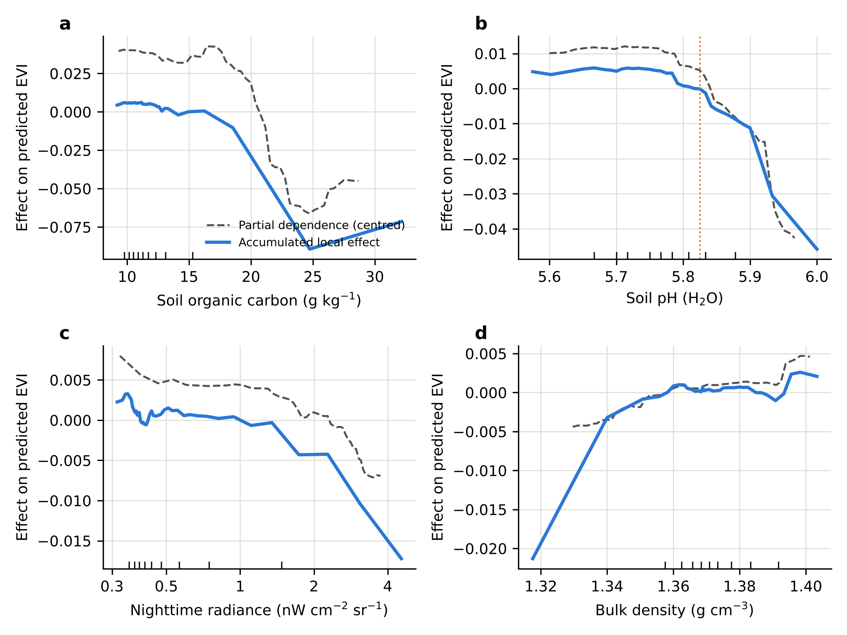
Fig. 11 Accumulated local effects (solid) and centred partial dependence (dashed) of predicted EVI on (a) soil organic carbon, (b) soil pH, (c) nighttime radiance (log axis) and (d) bulk density, from a Random Forest with minimum leaf size 5. The dotted line in (b) marks the segmented-regression breakpoint. Ticks on the x-axis mark deciles of the observed distribution.
Table 4 Breakpoints in the bivariate EVI response estimated by segmented regression, compared with the landscape medians reported as “tipping points” in earlier work. ΔAIC = AIC(linear) − AIC(segmented). The breakpoint CIs are from the i.i.d. bootstrap (500 resamples); the moving-block CI for pH is 5.78 to 5.91. Slopes are in EVI units per unit of the predictor (per log unit for NTL).
Predictor | Median | Breakpoint (95% CI) | Slope below → above | ΔAIC | F-test p
SOC (g kg⁻¹) | 11.27 | 13.3 (9.6–17.1) | −0.0020→−0.0056 | 21.0 | < 0.001
pH (H₂O) | 5.77 | 5.83 (5.78–5.88) | −0.034→−0.508 | 291.6 | < 0.001
BD (g cm⁻³) | 1.37 | 1.360 (1.357–1.362) | +2.54→+0.17 | 287.1 | < 0.001
NTL | 0.44 | not supported | −0.014→−0.005 | −2.2 | 0.41

3.7 Gradient-dependent coupling (H3)
Under conventional tests, urban intensity appeared to modify soil–vegetation coupling, most clearly for pH (Table 5; Fig. 12a). The OLS slope of EVI on pH was:
- −0.124 (95% CI −0.149 to −0.099) in the low-NTL tercile;
- −0.171 in the middle tercile;
- −0.277 (−0.306 to −0.248) in the high tercile.
This 2.2-fold steepening was nominally highly significant (tercile interaction and continuous pH × log NTL interaction, both p < 0.001). The pH–EVI correlation strengthened from −0.271 to −0.481 (Fisher’s z = −5.94), and the steepening was not a range artefact: the pH standard deviation was smallest in the high tercile. Urban cells were also more often beyond the pH breakpoint (32.8% of high-tercile cells vs 18.4% of low-tercile cells).
Table 5 Soil–vegetation coupling in the low, middle and high terciles of urban intensity. Fisher’s z compares the high and low terciles; tests treat cells as independent (see Table 6).
Metric | Low NTL | Mid NTL | High NTL | High vs low
 | (0.28–0.39) | (0.39–0.52) | (0.52–6.40)
Cells (n) | 1,171 | 1,168 | 1,168 | –
Mean EVI | 0.228 | 0.224 | 0.218 | –
Mean pH (SD) | 5.745 (0.089) | 5.760 (0.087) | 5.802 (0.078) | –
Cells above pH breakpoint (%) | 18.4 | 20.9 | 32.8 | –
EVI–pH slope | −0.124 | −0.171 | −0.277 | nominal p < 0.001
r(pH, EVI) | −0.271 | −0.292 | −0.481 | z = −5.94
r(BD, EVI) | 0.281 | 0.340 | 0.384 | z = 2.80
r(SOC, EVI) | −0.508 | −0.407 | −0.449 | z = 1.85
r(PC3, EVI) | 0.052 | 0.137 | 0.307 | z = 6.39
Soil-only RF R² (CV) | 0.258 | 0.284 | 0.408 | –
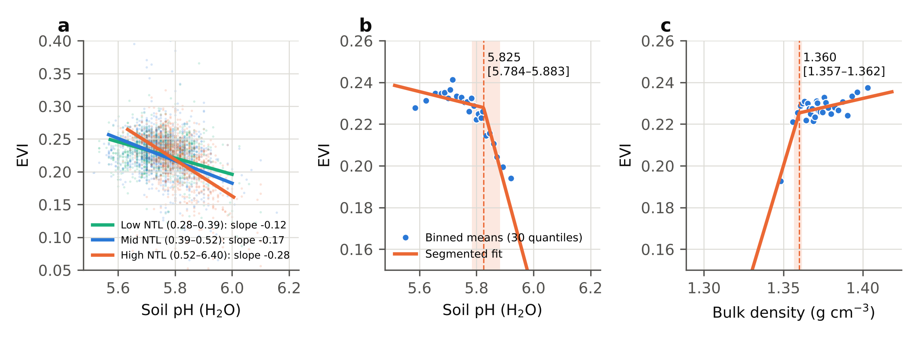
Fig. 12 (a) EVI against soil pH in the low, middle and high NTL terciles with OLS fits (slopes in EVI units per pH unit). (b, c) Segmented regression of EVI on (b) soil pH and (c) bulk density; points are means of 30 quantile bins, and the dashed line and shading show the breakpoint and its bootstrap 95% interval. The tercile contrast in (a) does not survive spatial controls (Table 6).

3.8 Robustness to spatial dependence
Residuals were strongly spatially dependent:
- the lag-1 autocorrelation of OLS residuals along the scan was 0.707;
- along-row Moran’s I was 0.472;
- the correlogram fell below 0.1 only at about 7.0 km.
Under an AR(1) approximation the 3,507 cells carry the information of about 601 independent observations. Re-estimating the inferential results with this dependence taken into account separated robust from fragile findings (Table 6).
Robust findings. The rejection of H1 held: the total indirect effect remained indistinguishable from zero and the direct effect remained negative under the block bootstrap. The pH breakpoint held (Sect. 3.6).
Fragile finding. The apparent amplification of pH sensitivity (H3) did not survive. Clustering standard errors on pairs of scan lines inflated the standard error of the pH × log NTL interaction and raised its p value from < 0.001 to = 0.031. Adding latitude-band fixed effects, which removes north–south contrasts between the urban core, the floodplain and the periphery, reduced the interaction to −0.025 (p = 0.528). The block-bootstrap 95% interval for the high-minus-low difference in tercile slopes (−0.153) was −0.264 to 0.032 and included zero. The interaction persisted when the other soil properties were added as covariates (−0.125, p < 0.001), so it is not explained by other soil properties; it is largely accounted for by where the luminous cells are.
Table 6 Robustness of the inferential results to spatial dependence. Clusters are pairs of scan lines (about 1 km; 27 clusters); band fixed effects (FE) remove variation between ten latitude bands; the block bootstrap resamples blocks of two scan lines. All variables in the interaction models are standardized.
Result | Conventional | Spatially robust | Verdict
Total soil-mediated effect (H1) | −0.010 (−0.029 to 0.008) | −0.010 (−0.057 to 0.035) | H1 rejected
Direct effect of NTL | −0.088 | −0.088 (−0.141 to −0.025) | Robust
pH × log NTL (H3) | p < 0.001 | clustered: p = 0.031; band FE: −0.025, p = 0.528 | Not robust
High−low tercile pH slope | −0.153, p < 0.001 | block CI −0.264 to 0.032 | Not robust
pH breakpoint | 5.83 (5.78–5.88) | block CI 5.78 to 5.91; LOBO 5.81 to 5.88 | Robust
Unique urban share of EVI variance | 0.010 (random CV) | 0.006 (band CV) | Robust (small)

4 Discussion

4.1 What open soil maps can and cannot see in an African city
SoilGrids does not see the urban core. Its predictions are restricted to land outside the built-up class of a 2015 land-cover map (Poggio et al. 2021), so listwise deletion removed 59% of the brightest cells in Makurdi, and the retained gradient ends before the densest development. Our ward-level study had already noted that the most urbanized wards lacked soil values (Shaibu and Kirichuk 2026a). The continuous audit shows how steeply the loss rises with radiance and how it truncates the analysable gradient. Any “urban soil signature” recovered from such data describes the peri-urban fringe and scattered built-up land, not sealed or heavily disturbed urban soils. The problem will grow as cities expand beyond the 2015 mask: recently urbanized land keeps its pre-urban soil prediction, so the soil layer lags the city by design.
The second limitation is circularity. SoilGrids models draw on candidate covariates that include MODIS EVI, NDVI and net primary production and several land-cover products (Poggio et al. 2021). The final covariate set differs among properties and is not reported per pixel. An association between modelled soil and observed vegetation is therefore partly an association between vegetation and a function of vegetation, and should not be treated as independent evidence of edaphic control (Wadoux et al. 2020). Global soil layers are better treated as descriptors of landscape position and broad soil pattern than as measurements of soil condition in individual urban cells.

4.2 A geomorphic template rather than a soil-degradation filter
Within the analysable gradient the evidence favours H2 over H1, and this conclusion was the most robust result of the study:
- urban intensity explained little modelled soil variance;
- it added about 1% of unique explained variance in EVI under every validation design;
- its soil-mediated effect on EVI was indistinguishable from zero under both i.i.d. and spatial-block resampling, because pathways of opposite sign cancelled.
The negative direct effect of NTL is what would be expected if urbanization reduces vegetation mainly through clearance and sealing. This is the direct component of the framework of Zhao et al. (2016) and Zhang et al. (2022), and it is consistent with direct, non-linear greenness losses reported along other urban gradients (Anwar et al. 2026; Ergen and Gökçe 2026; Gan et al. 2026). The cascade from urbanization through soil degradation to vegetation decline (e.g. Mollashahi et al. 2023) is therefore not supported by open soil data here. It may still operate at finer scales or in sealed soils that SoilGrids cannot represent.
The negative SOC–EVI and positive BD–EVI associations, both contrary to first principles, are explained by the same geomorphic template. High-SOC cells were clay-rich and sand-poor (r = 0.309 and −0.388), of lower bulk density (r = −0.650) and higher pH (r = 0.428). Cells below the BD breakpoint combined high SOC with low EVI. This is the signature of the poorly drained, fine-textured soils of the Benue floodplain, where seasonal waterlogging, burning and cultivation are likely to suppress dry-season greenness. In this landscape SOC therefore indexes drainage class and topographic position at least as much as nutritional status, consistent with its near-zero coupling with NTL.
Elsewhere SOC responds systematically to land-use intensity (Edmondson et al. 2014; Zhao et al. 2023; Muzaffar and Saha 2026) and co-varies with canopy condition in Nigerian forests (Mesele and Huising 2024). In a floodplain city this signal can be overwhelmed by hydromorphy, so the direction of the SOC–vegetation relationship must be established locally rather than assumed. Likewise, within the narrow modelled range (1.30–1.42 g cm⁻³) the positive BD–EVI association reflects the contrast between loose, wet floodplain soils and better-drained uplands. It gives no basis for the compaction limits recommended for temperate cities (Czaja et al. 2020).

4.3 An apparent amplification that did not survive spatial controls
Under conventional tests, vegetation in the most luminous tercile was more than twice as sensitive to modelled soil pH as vegetation in the least luminous tercile (p < 0.001). The steepening was not a range artefact and persisted after adjustment for the other soil properties. A plausible mechanism exists: urban soils tend towards higher pH through calcium-rich construction debris (Olchowik et al. 2023), and pH is tightly linked to SOC and nutrient status (Kandadai and Dadhwal 2026). In an earlier draft of this study we reported this result as the main finding.
It did not survive spatial controls. The interaction weakened when standard errors accounted for spatial clustering. It disappeared when it was estimated only from contrasts within latitude bands, and the block-bootstrap interval for the tercile slope difference included zero. Two features of the landscape explain why. First, the 3,507 cells carry the information of only about 601 independent observations, so nominal p values from cell-level tests are far too small (Dormann et al. 2007). Second, the luminous cells are concentrated in a few bands where the urban core abuts the floodplain. A between-area contrast in the pH–EVI slope, plausibly geomorphic, therefore appears as an urban interaction in a pooled model.
The H3 pattern is thus another expression of the confounding of urban and geomorphic gradients (failure mode 3), revealed only once spatial dependence (failure mode 5) was handled. We report it because the sequence — a highly significant, mechanistically plausible “urban amplification” that disappears under geographic controls — is likely to recur in other urban-gradient studies that treat grid cells as independent.
The pH breakpoint, by contrast, was stable under block resampling and when any single band was left out. It lies close to the landscape median (5.77), which studies of this kind often report as a “tipping point”, but the two quantities have different meanings: the median describes where the landscape sits, the breakpoint where the response changes. Because SoilGrids pH varies over only 0.7 units in Makurdi and is itself a prediction, the absolute value needs field confirmation. Its relative position — just above the typical modelled pH — is the more robust finding. No breakpoint was supported for NTL, so NTL-based “urban thresholds” should be treated with caution.

4.4 A screening protocol for global soil maps in urban monitoring
The results suggest five checks that can be applied, at little cost, to any urban-gradient analysis built on SoilGrids or similar products (Table 7). Applied in Makurdi, these checks turned an apparently strong urbanization filter — an in-sample R² of 0.914, SOC as the dominant “driver” and a highly significant urban amplification of pH sensitivity — into a smaller set of defensible conclusions:
- a geomorphic soil template;
- a direct urban effect on vegetation;
- a stable pH breakpoint;
- honest limits on transferability (about one fifth of EVI variance under geographic validation).
Table 7 Five-step screening protocol for using global soil maps in urban-gradient analyses.
Check | What to report | Makurdi outcome
1. Coverage audit | Number and urban-intensity distribution of cells lost to product masks; the part of the gradient to which results apply | 59% of cells with NTL > 4 lost
2. Circularity | Whether the response (or close correlates) is among the product’s covariates; treat soil–response associations as descriptive if so | EVI/NDVI/NPP among SoilGrids covariates
3. Partition and mediation | Unique urban, unique soil and shared fractions; direct test of the soil-mediated path | Indirect effect ≈ 0
4. Validation hierarchy | Apparent, random, feature-space and geographic (buffered) skill side by side | 0.914 → 0.355 → ≈0.2
5. Spatial dependence | Residual autocorrelation, effective n, block-resampled or cluster-robust uncertainty, and within-area (fixed-effects) estimates for interactions and thresholds | n_{eff}≈ 601; H3 not robust
For management in Makurdi, the results support a soil-informed rather than a threshold-driven approach. The floodplain soils identified by the SOC–BD–clay signature are distinctive units whose protection from construction is justified by their hydrological role and carbon storage, not by their canopy greenness (Turrini and Knop 2015). Planting programmes on less acidic urban soils should include pH testing and avoid incorporating construction debris into planting sites (Malone et al. 2023). Threshold-based planning limits (Liu et al. 2024) should be set only after SoilGrids-based estimates have been calibrated against field survey.

4.5 Limitations and further work
The soil predictors are model outputs, so the analysis characterizes the modelled soil template rather than measured urban soils. Paired field sampling of pH, SOC, bulk density and drainage in urban and rural cells matched for landscape position remains the priority (Maynard et al. 2023).
Geographic blocking here was one-dimensional (latitude bands reconstructed from the grid’s scan order). Full two-dimensional blocking, area-of-applicability analysis (Meyer and Pebesma 2021) and nearest-neighbour distance matching (Linnenbrink et al. 2024) require cell coordinates. So does explicit control for terrain and hydrology — height above nearest drainage, topographic wetness and distance to the Benue — which would test the geomorphic interpretation of SOC directly rather than through soil signatures. A second soil product that does not use vegetation covariates in the same way, such as iSDAsoil (Hengl et al. 2021), would allow a negative-control test of circularity. The archived Earth Engine workflow has been extended to export these layers with coordinates for this purpose.
The mediation model is linear and uses principal components as mediators. The near-zero shared variance in the RF partition suggests that the conclusion does not depend on linearity.
The EVI composite averaged 2024 scenes filtered only by scene-level cloud cover, from a Sentinel-2 collection whose processing baseline changed in 2022. Residual cloud and the reflectance offset bias absolute EVI slightly but are unlikely to alter relative gradients. A pixel-masked, harmonized and seasonally resolved time series would sharpen the dry-season interpretation and allow resilience to be measured directly (Kabano et al. 2021).
Finally, the study covers one city and one year. Applying the protocol across Nigerian savanna cities would show whether the absence of a soil-mediated pathway is general.

5 Conclusions
We tested whether open global soil maps can reveal an urbanization filter on vegetation in Makurdi, a Guinea-savanna floodplain city in Nigeria, and re-examined every inference under geographic validation and spatially robust uncertainty. Five conclusions follow.
- The SoilGrids built-up mask removed most of the brightest urban cells, so the analysable gradient stops short of the dense core. Coverage audits should be standard in studies of this kind.
- Urban intensity explained little of the modelled soil variance, and its effect on canopy vigour was direct rather than soil-mediated: the indirect effect was −0.010 (block-bootstrap 95% CI −0.057 to 0.035), against a direct effect of −0.088. The leading soil predictor, SOC, was negatively related to EVI because it indexes hydromorphic floodplain soils, not nutrient supply. The landscape is better described by a geomorphic template than by a soil-degradation filter.
- An apparently strong urban amplification of vegetation sensitivity to soil pH was an artefact of between-area structure: it disappeared within latitude bands. A pH breakpoint at 5.83 was stable.
- The 3,507 cells carried the information of about 601 independent observations. Predictive skill fell from R² = 0.914 in-sample to 0.355 under random and about 0.2 under geographic cross-validation, and no breakpoint in the response to nighttime lights was supported.
- The combination of global soil maps, nighttime lights and machine learning, now widely used to diagnose urban soil–vegetation relationships in data-poor cities, can produce strong but misleading conclusions unless coverage, circularity, confounding, validation and spatial dependence are examined explicitly. The five-step protocol proposed here is a transferable way to do so.
For Makurdi, the results point to a soil-informed greening strategy that protects floodplain soils, tests pH before planting in the urban fabric, and calibrates all soil-based targets against field survey.

Declarations

Funding
The authors declare that no funds, grants or other financial support were received during the preparation of this manuscript.

Competing interests
The authors have no relevant financial or non-financial interests to disclose.

Ethics approval
Not applicable. The study used only publicly available satellite and modelled geospatial data and involved no human participants or animals.

Consent to participate and for publication
Not applicable.

Data availability
The processed grid-cell dataset, including cells with missing soil values (data/Makurdi_Full_Suite_EVI_Data.csv), and a data dictionary are openly available at https://github.com/shaibu1986/Makurdi_Urban_Ecology. The release used in this article is archived at Zenodo (DOI: to be inserted). Source data are openly licensed products: VIIRS DNB monthly composites (NOAA/EOG), Sentinel-2 Level-2A (Copernicus) and SoilGrids 2.0 (ISRIC, CC-BY 4.0).

Code availability
The Google Earth Engine extraction script and the Python scripts that reproduce every statistic, table and figure are in the same repository and archive:
- scripts/urban_filter_tests.py: coverage audit, validation designs, importance, partitioning, mediation, coupling and breakpoints;
- scripts/robustness_scan.py: geographic validation, spatially robust inference and accumulated local effects;
- scripts/gee/makurdi_export_v2.js and scripts/robustness_geo.py: the coordinate-based extension described in Sect. 4.5.
Numerical results are written to results/ and inserted into the manuscript source automatically. Software versions are pinned in requirements.txt, and random seeds are fixed.

Author contributions
Conceptualization: Ochoche Shaibu, Anatoly A. Kirichuk. Methodology, data acquisition, geospatial processing, formal analysis, software and visualization: Ochoche Shaibu. Validation and resources: Anatoly A. Kirichuk. Writing — original draft: Ochoche Shaibu. Writing — review and editing: Anatoly A. Kirichuk, Ochoche Shaibu. Supervision and project administration: Anatoly A. Kirichuk. Both authors read and approved the final manuscript.

Use of generative AI
During the preparation of this work the authors used an AI assistant (Claude, Anthropic) for code review, reproducibility checks, implementation of the spatial-robustness analyses and language editing. The authors reviewed and verified all analyses and text and take full responsibility for the content of the publication.

References
Adelana AO, Aiyelari EA, Are KS, Oluwatosin GA (2023) Influence of urban land use types on ecosystem services in two rapidly urbanizing cities of Southwestern Nigeria. Environmental Monitoring and Assessment 195:1279. https://doi.org/10.1007/s10661-023-11910-6
Agada B, Tasie L, Snapp S, Agber P (2024) Soil nutrient status of smallholder farmers in Makurdi, Benue State, Nigeria. Journal of Global Agriculture and Ecology 16:50–59. https://doi.org/10.56557/jogae/2024/v16i28710
Anwar F, Billa L, Wee KS (2026) Long-term relationships between vegetation, urban expansion, and Local climate: a Landsat-based time-series analysis of Jeddah, Saudi Arabia (1992–2022). Environmental Monitoring and Assessment 198:889. https://doi.org/10.1007/s10661-026-15736-w
Apley DW, Zhu J (2020) Visualizing the effects of predictor variables in black box supervised learning models. Journal of the Royal Statistical Society Series B: Statistical Methodology 82:1059–1086. https://doi.org/10.1111/rssb.12377
Asongwe GA, Bame IB, Ndam LM, et al (2022) Influence of urbanisation on phytodiversity and some soil properties in riverine wetlands of Bamenda Municipality, Cameroon. Scientific Reports 12:19766. https://doi.org/10.1038/s41598-022-23278-7
Balogun IA, Ntekop AA, Daramola MT (2019) Assessment of the bioclimatic conditions over some selected stations in Nigeria. SN Applied Sciences 1:610. https://doi.org/10.1007/s42452-019-0589-y
Borcard D, Legendre P, Drapeau P (1992) Partialling out the spatial component of ecological variation. Ecology 73:1045–1055. https://doi.org/10.2307/1940179
Borowy D, Swan CM (2022) The effects of Local filtering processes on the structure and functioning of native plant communities in experimental urban habitats. Ecology and Evolution 12:e9397. https://doi.org/10.1002/ece3.9397
Buba T (2015) Spatial variation of soil physicochemical properties with respect to some selected tree species in the Nigerian Northern Guinea Savanna. International Journal of Plant & Soil Science 7:273–283. https://doi.org/10.9734/ijpss/2015/17770
Cameron AC, Miller DL (2015) A practitioner’s guide to cluster-robust inference. Journal of Human Resources 50:317–372. https://doi.org/10.3368/jhr.50.2.317
Czaja M, Kołton A, Muras P (2020) The complex issue of urban Trees—Stress factor accumulation and ecological service possibilities. Forests 11:932. https://doi.org/10.3390/f11090932
Dash PK, Ferhatoglu C, Miller BA, et al (2025) Influence of sample size and machine learning algorithms on digital soil nutrient mapping accuracy. Environmental Monitoring and Assessment 197:996. https://doi.org/10.1007/s10661-025-14322-w
Doğan TG, Eroğlu E, Küçüksille EU, et al (2025) Modelling urban plant diversity along environmental, edaphic, and climatic gradients. Diversity 17:706. https://doi.org/10.3390/d17100706
Dormann CF, McPherson JM, Araújo MB, et al (2007) Methods to account for spatial autocorrelation in the analysis of species distributional data: a review. Ecography 30:609–628. https://doi.org/10.1111/j.2007.0906-7590.05171.x
Edmondson JL, O’Sullivan OS, Inger R, et al (2014) Urban tree effects on soil organic carbon. PLoS ONE 9:e101872. https://doi.org/10.1371/journal.pone.0101872
Ergen M, Gökçe GC (2026) Decoupling vegetation greenness, surface moisture, and thermal stress under rapid urbanization: a resilience-based remote sensing analysis from Sakarya, Türkiye. Environmental Monitoring and Assessment 198:660. https://doi.org/10.1007/s10661-026-15499-4
Fang M, Lu G, Zhang S, Liang W (2025) Urbanized lands degrade surrounding grasslands by deteriorating the interactions between plants and soil microbiome. Frontiers in Microbiology 15:1505916. https://doi.org/10.3389/fmicb.2024.1505916
Gan J, Sun H, Dewan A, et al (2026) Net effect of urbanization on vegetation dynamics in city surrounding zones in China’s arid regions: spatiotemporal patterns and driving mechanisms. Environmental Monitoring and Assessment 198:475. https://doi.org/10.1007/s10661-026-15318-w
Ghosh S, Kumar D, Kumari R (2022) Cloud-based large-scale data retrieval, mapping, and analysis for land monitoring applications with Google Earth Engine (GEE). Environmental Challenges 9:100605. https://doi.org/10.1016/j.envc.2022.100605
Hengl T, Heuvelink GBM, Kempen B, et al (2015) Mapping soil properties of Africa at 250 m resolution: random forests significantly improve current predictions. PLoS ONE 10:e0125814. https://doi.org/10.1371/journal.pone.0125814
Hengl T, Miller MAE, Križan J, et al (2021) African soil properties and nutrients mapped at 30 m spatial resolution using two-scale ensemble machine learning. Scientific Reports 11:6130. https://doi.org/10.1038/s41598-021-85639-y
Huang P, Huang Q, Wang J, Shi Y (2025) Predicting surface soil pH spatial distribution based on three machine learning methods: a case study of Heilongjiang Province. Environmental Monitoring and Assessment 197:367. https://doi.org/10.1007/s10661-025-13814-z
Kabano P, Lindley S, Harris A (2021) Evidence of urban heat island impacts on the vegetation growing season length in a tropical city. Landscape and Urban Planning 206:103989. https://doi.org/10.1016/j.landurbplan.2020.103989
Kandadai S, Dadhwal VK (2026) Large-scale spatial assessment of soil organic carbon, pH and their interrelation in Indian agricultural soils using soil health card big data. Environmental Monitoring and Assessment 198:336. https://doi.org/10.1007/s10661-026-15184-6
Kang J, Zhang B, Zhang Q, et al (2025) Global urbanization indirectly “enhances” the carbon sequestration capacity of urban vegetation. Geography and Sustainability 6:100268. https://doi.org/10.1016/j.geosus.2025.100268
Kapoor S, Cantrell EM, Peng K, et al (2024) REFORMS: Consensus-based recommendations for machine-learning-based science. Science Advances 10:eadk3452. https://doi.org/10.1126/sciadv.adk3452
Kisvarga S, Horotán K, Neményi A, et al (2025) The ecology of urban vegetation: Trade-Offs, stressors, and adaptive strategies. Environmental and Sustainability Indicators 28:100887. https://doi.org/10.1016/j.indic.2025.100887
Künsch HR (1989) The jackknife and the bootstrap for general stationary observations. The Annals of Statistics 17:1217–1241. https://doi.org/10.1214/aos/1176347265
Levin N, Kyba CCM, Zhang Q, et al (2020) Remote sensing of night lights: A review and an outlook for the future. Remote Sensing of Environment 237:111443. https://doi.org/10.1016/j.rse.2019.111443
Liang B, Liu H, Cressey EL, et al (2023) Uncertainty of partial dependence relationship between climate and vegetation growth calculated by machine learning models. Remote Sensing 15:2920. https://doi.org/10.3390/rs15112920
Linnenbrink J, Milà C, Ludwig M, Meyer H (2024) kNNDM CV: k-fold nearest-neighbour distance matching cross-validation for map accuracy estimation. Geoscientific Model Development 17:5897–5912. https://doi.org/10.5194/gmd-17-5897-2024
Liu C, Hao M, Tang N, et al (2024) Threshold effects of vegetation cover on production-living-ecological functions coordination in Xiangyang city, China. Environmental Monitoring and Assessment 196:1202. https://doi.org/10.1007/s10661-024-13352-0
Malone Z, Berhe AA, Ryals R (2023) Impacts of organic matter amendments on urban soil carbon and soil quality: A meta-analysis. Journal of Cleaner Production 419:138148. https://doi.org/10.1016/j.jclepro.2023.138148
Malum JF, Eze EC, Okafor IJ (2025) Soil erodibility indices along River Benue banks at Makurdi, Nigeria. FUDMA Journal of Sciences 9:240–247. https://doi.org/10.33003/fjs-2025-0912-4394
Maynard JJ, Yeboah E, et al (2023) Accuracy of regional-to-global soil maps for on-farm decision-making: are soil maps “good enough”? SOIL 9:277–300. https://doi.org/10.5194/soil-9-277-2023
Mesele SA, Huising EJ (2024) Soil organic carbon and nutrient characteristics of Anogeissus groves in old Opara forest Reserve, Nigeria. Environmental Monitoring and Assessment 196:490. https://doi.org/10.1007/s10661-024-12636-9
Meyer H, Pebesma E (2021) Predicting into unknown space? Estimating the area of applicability of spatial prediction models. Methods in Ecology and Evolution 12:1620–1633. https://doi.org/10.1111/2041-210X.13650
Meyer H, Pebesma E (2022) Machine learning-based global maps of ecological variables and the challenge of assessing them. Nature Communications 13:2208. https://doi.org/10.1038/s41467-022-29838-9
Meyer H, Reudenbach C, Wöllauer S, Nauss T (2019) Importance of spatial predictor variable selection in machine learning applications – moving from data reproduction to spatial prediction. Ecological Modelling 411:108815. https://doi.org/10.1016/j.ecolmodel.2019.108815
Modu M, Yager G (2024) The effects of urbanization on wetland ecosystem and aquatic biodiversity in Makurdi Metropolis, Nigeria. Sustainability and Environmental Management. https://doi.org/10.5281/zenodo.13996596
Mollashahi H, Szymura M, Perera PCD, Szymura TH (2023) The effect of grassland type and proximity to the city center on urban soil and vegetation coverage. Environmental Monitoring and Assessment 195:599. https://doi.org/10.1007/s10661-023-11210-z
Muggeo VMR (2003) Estimating regression models with unknown break-points. Statistics in Medicine 22:3055–3071. https://doi.org/10.1002/sim.1545
Muzaffar T, Saha B (2026) Land-use gradients alter active and bulk soil carbon indicators in a coarse-textured sandstone landscape of the Pachmarhi Biosphere Reserve, India. Environmental Monitoring and Assessment 198:754. https://doi.org/10.1007/s10661-026-15606-5
Olchowik J, Jankowski P, Suchocka M, et al (2023) The impact of anthropogenic transformation of urban soils on ectomycorrhizal fungal communities associated with silver birch (Betula pendula roth.) growth in natural versus urban soils. Scientific Reports 13:21268. https://doi.org/10.1038/s41598-023-48592-6
Park CH (2026) Assessing depth-resolved tropical soil organic carbon with ERA5-land and SoilGrids-conditioned dielectric inversion. Environmental Monitoring and Assessment 198:969. https://doi.org/10.1007/s10661-026-15790-4
Ploton P, Mortier F, Réjou-Méchain M, et al (2020) Spatial validation reveals poor predictive performance of large-scale ecological mapping models. Nature Communications 11:4540. https://doi.org/10.1038/s41467-020-18321-y
Poggio L, Sousa LM de, Batjes NH, et al (2021) SoilGrids 2.0: Producing soil information for the globe with quantified spatial uncertainty. SOIL 7:217–240. https://doi.org/10.5194/soil-7-217-2021
Preacher KJ, Hayes AF (2008) Asymptotic and resampling strategies for assessing and comparing indirect effects in multiple mediator models. Behavior Research Methods 40:879–891. https://doi.org/10.3758/BRM.40.3.879
Ranelović D, Jovanović S (2023) Understanding the role of ruderal plant species in restoration of degraded lands. In: Environmental contamination remediation and management. Springer, pp 31–67
Rezapour S, Nouri A, Shokohi M, Alamdari P (2025) Urbanization accelerates soil degradation in peri-urban compared to rural farms. Scientific Reports 16:3878. https://doi.org/10.1038/s41598-025-33995-4
Roberts DR, Bahn V, Ciuti S, et al (2017) Cross-validation strategies for data with temporal, spatial, hierarchical, or phylogenetic structure. Ecography 40:913–929. https://doi.org/10.1111/ecog.02881
Shaibu O, Kirichuk AA (2026a) Evaluating soilGrids predictions along urban gradients in tropical Africa using a convergence-of-evidence approach with field vegetation and remote sensing data from two Nigerian cities. Urban Ecosystems 29:219. https://doi.org/10.1007/s11252-026-02080-7
Shaibu O, Kirichuk AA (2026b) Multi-Scale landscape responses of vegetation to urban growth in Makurdi, Nigeria. RUDN Journal of Ecology and Life Safety 34:205–222. https://doi.org/10.22363/2313-2310-2026-34-2-205-222
Simon SM, Glaum P, Valdovinos FS (2023) Interpreting random forest analysis of ecological models to move from prediction to explanation. Scientific Reports 13:3881. https://doi.org/10.1038/s41598-023-30313-8
Strobl C, Boulesteix A-L, Zeileis A, Hothorn T (2007) Bias in random forest variable importance measures: Illustrations, sources and a solution. BMC Bioinformatics 8:25. https://doi.org/10.1186/1471-2105-8-25
Turrini T, Knop E (2015) A landscape ecology approach identifies important drivers of urban biodiversity. Global Change Biology 21:1652–1667. https://doi.org/10.1111/gcb.12825
Uyar N (2024) Monitoring Turkey’s nighttime light and environmental change. Environmental Monitoring and Assessment 196:851. https://doi.org/10.1007/s10661-024-13032-z
Wadoux AMJ-C, Minasny B, McBratney AB (2020) Machine learning for digital soil mapping: Applications, challenges and suggested solutions. Earth-Science Reviews 210:103359. https://doi.org/10.1016/j.earscirev.2020.103359
Zandybay A, Adylbek Z, Saspugayeva G, et al (2024) Assessing the impact of urban development on soil health. Journal of Ecological Engineering. https://doi.org/10.14411/22998993/193832
Zhang L, Yang L, Zohner CM, et al (2022) Direct and indirect impacts of urbanization on vegetation growth across the world’s cities. Science Advances 8:eabo0095. https://doi.org/10.1126/sciadv.abo0095
Zhao S, Liu S, Zhou D (2016) Prevalent vegetation growth enhancement in urban environment. Proceedings of the National Academy of Sciences 113:6313–6318. https://doi.org/10.1073/pnas.1602312113
Zhao Z, Dong P, Fu B, et al (2023) Soil organic carbon distribution and factors affecting carbon accumulation in natural and plantation forests in tropical China. Ecological Indicators 148:110127. https://doi.org/10.1016/j.ecolind.2023.110127

