Online Resource 1
Does urbanization filter vegetation through the soil? A spatially validated test with global soil maps in a West African floodplain city
Ochoche Shaibu, Anatoly A. Kirichuk. Environmental Earth Sciences. Corresponding author: shaibuochoche2014@gmail.com

Fig. S1
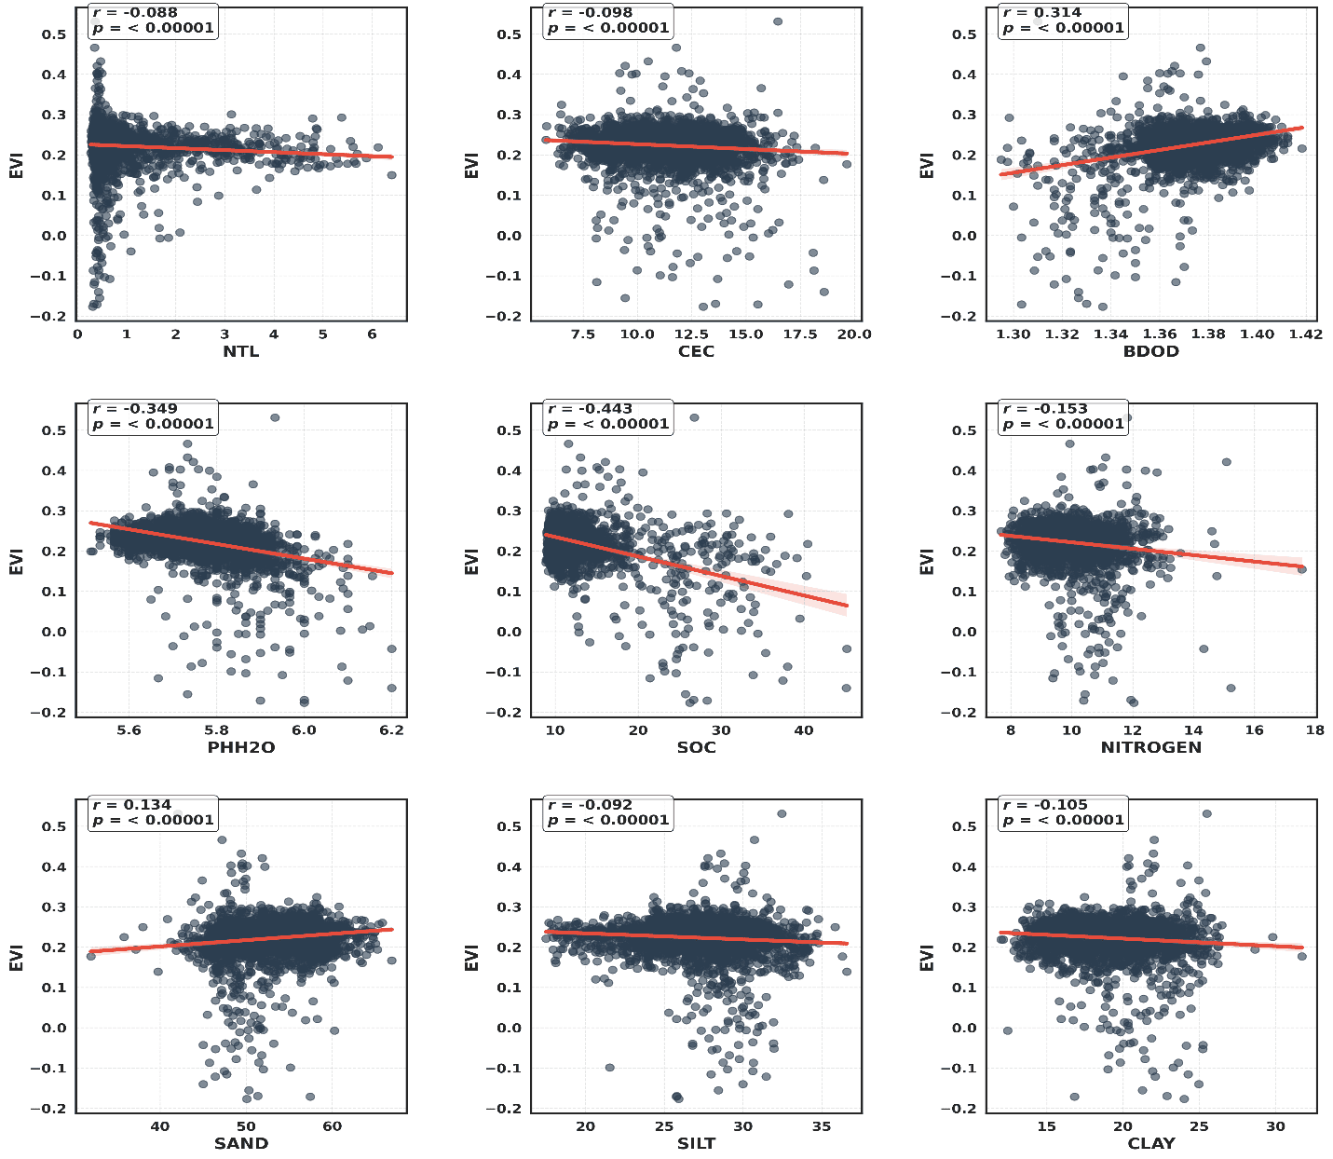
Fig. S1 Bivariate response of EVI to urban intensity (NTL) and each SoilGrids property, with linear trends (n = 3,507 grid cells of 500 m). The p values treat cells as independent and are therefore nominal (see main text, Sect. 3.8, for the effective sample size).

S2. Scan-order structure of the archived grid table
The archived table stores cells in Google Earth Engine coveringGrid order. The autocorrelation of nighttime radiance between consecutive rows was 0.971 and peaked again at a lag of 70 rows (0.919), the mean length of one east–west scan line; the analogous values for EVI were 0.808 and 0.504. Cells with EVI < 0.05 (the Benue channel) all fell between rows 2,176 and 2,924 (about 11 scan lines). These properties justify the latitude-band validation and clustering used in the main text. The coordinate-based extension (scripts/gee/makurdi_export_v2.js) re-exports the same grid with centroid coordinates and verifies row-for-row identity with the archived table.

