**Software Engineering**

**Deliverable-3**

**Team Members**  
Adeel Mahmood Ansari 22i-0979

Abdul Wasay 22i-1198

Muhammad Shaif Imran 22i-1024

**Software Project Plan**

**Smart Complaint Management System**

**1. Work Breakdown Structure (WBS)**

The Work Breakdown Structure (WBS) visually represents the division of the project into manageable sections. Each task is divided into subtasks to simplify project planning and resource allocation.

**Figure 1**: *Work Breakdown Structure of Smart Complaint Management System*

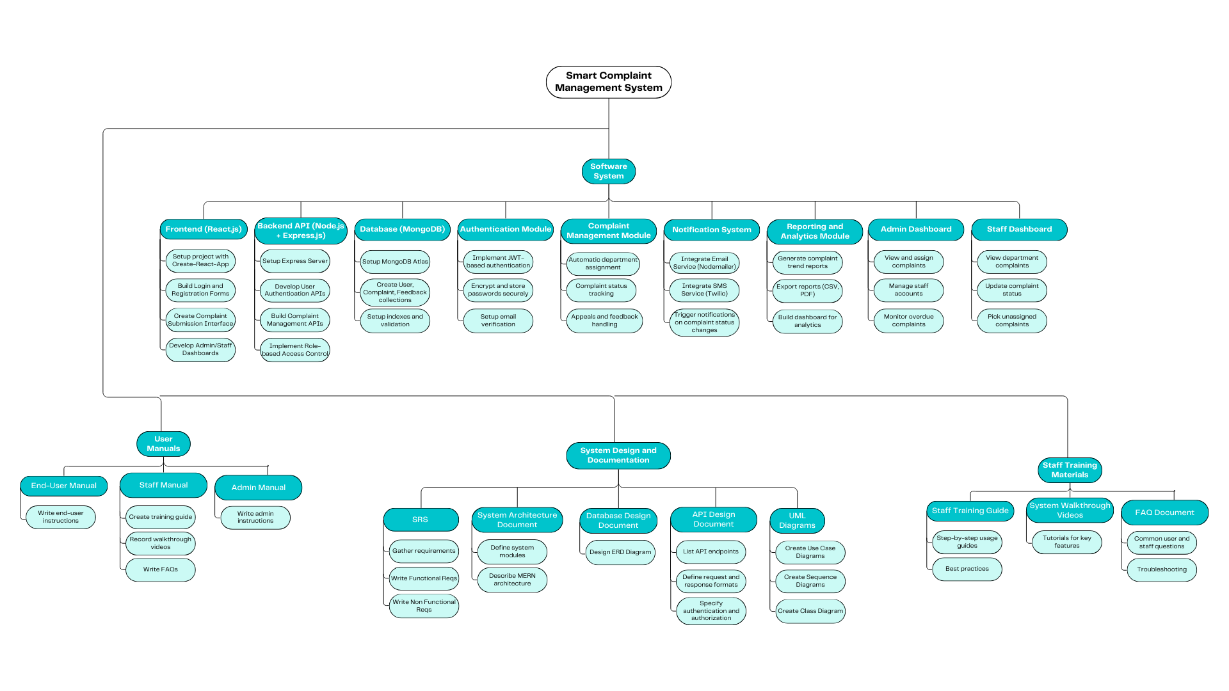

Link of Design: <https://www.canva.com/design/DAGlvkxSSJ4/50rFbD9wWHoTwsmHOWPhgw/edit?utm_content=DAGlvkxSSJ4&utm_campaign=designshare&utm_medium=link2&utm_source=sharebutton>

**2. Project Gantt Chart**

The Gantt Chart outlines the timeline of the project, indicating the start and end dates of all major activities and milestones. It is essential for tracking progress and ensuring timely delivery.

**Figure 2**: *Gantt Chart of Smart Complaint Management System Project*

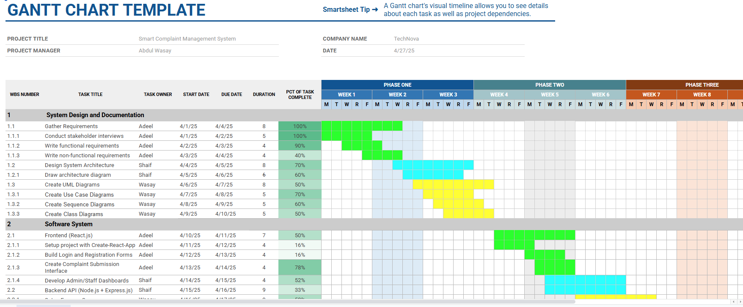

Link of Design:

https://docs.google.com/spreadsheets/d/1Y0W04dFA-dAtgDcWWRwiklOOPw_arHTKI1su3HWEz6E/edit?usp=sharing