 

**Department of Computer Science**

# National University of Computer & Emerging Sciences



Name: **Muhammad Ali Shaikh**

Roll No: **21F-9631**

Section: **BCS-6E**

Subject: **Web Programming**

Assignment: **2**

**Task1**

Code:

<!DOCTYPE html>

<html lang="en">

<head>

    <meta charset="UTF-8">

    <meta name="viewport" content="width=device-width, initial-scale=1.0">

    <style>

        body {

            background-color: #092A49;

            color: white;

            font-family: Arial, sans-serif;

            text-align: left;

            margin: 0;

            padding: 0;

            padding-top: 20px;

            padding-left: 20px;

        }

        h1 {

            font-size: 2em;

            margin-top: 10px;

        }

        p {

            font-size: 0.8em;

        }

        .start-button {

            background-color: #29800B;

            color: white;

            padding: 10px 20px;

            font-size: 1em;

            border: none;

            border-radius: 5px;

            cursor: pointer;

            position: relative;

            text-decoration: none;

            display: inline-block;

        }

        .start-button::after {

            content: '>';

            margin-left: 10px;

        }

    </style>

    <title>Task 1</title>

</head>

<body>

    <h1>Start CSS Exercises</h1>

    <p style="font-size: 0.8em;">Good Luck!</p>

    <a href="#" class="start-button">Start CSS Exercises</a>

</body>

</html>

Output:

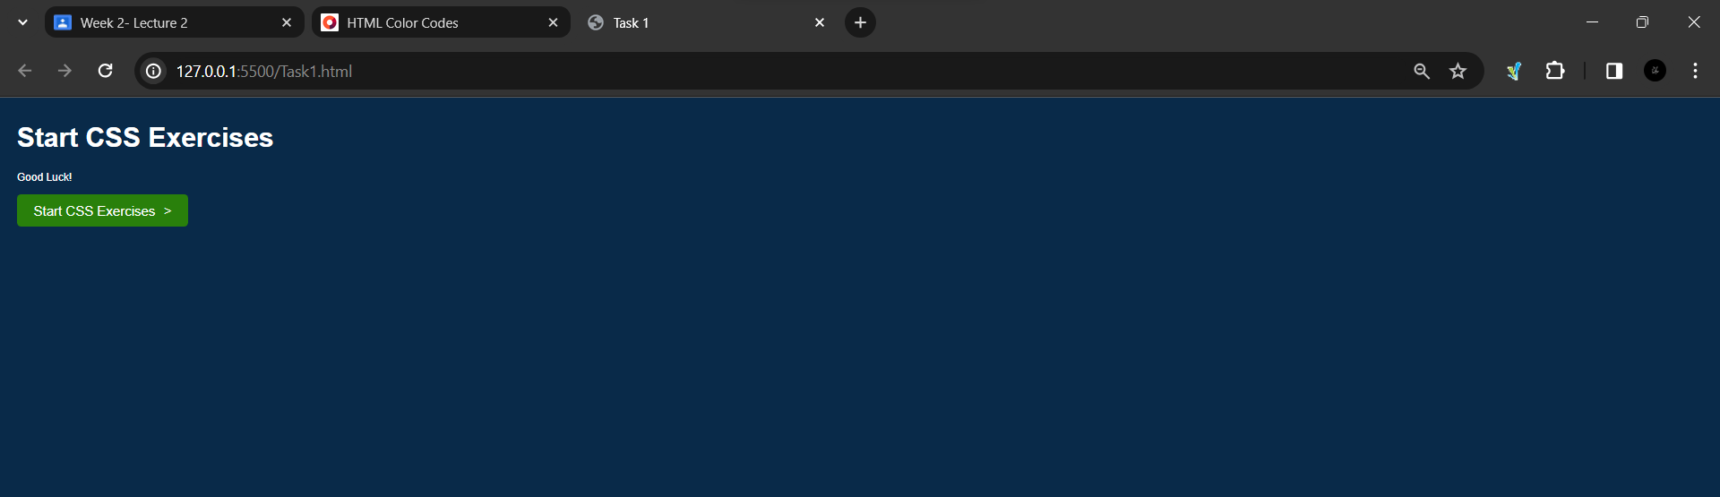

**Task2**

Code:

.html:

<!DOCTYPE html>

<html>

<head>

  <link rel="stylesheet" type="text/css" href="Task2.css">

</head>

<body>

    <title>Task 2</title>

  <div class="form-container">

    <form>

      <input type="text" id="name" name="name" placeholder="Name*" required><br>

      <input type="text" id="username" name="username" placeholder="Username*"><br>

      <input type="password" id="password" name="password" placeholder="Password*" required><br>

      <input type="tel" id="number" name="number" placeholder="Number*"><br>

      <input type="email" id="email" name="email" placeholder="Email id*" required><br>

      <input type="submit" value= "Register">

    </form>

  </div>

</body>

</html>

.css:

body {

    background-color: white;

  }

  .form-container {

    width: 500px;

    margin: 0 auto;

    padding: 55px;

    border: 1px solid #0D6DA1 ;

    background-color: #0D6DA1 ;

  }

  form {

    display: flex;

    flex-direction: column;

  }

  label {

    margin-bottom: 5px;

    color: white;

  }

  input[type="text"], input[type="password"], input[type="tel"], input[type="email"] {

    height: 30px;

    margin-bottom: 10px;

    padding: 5px;

    background-color: white;

    color: black;

  }

  input[type="submit"] {

    height: 40px;

    margin-top: 10px;

    cursor: pointer;

    background-color: #C10A10;

    color: white;

    border: none;

  }

Output:

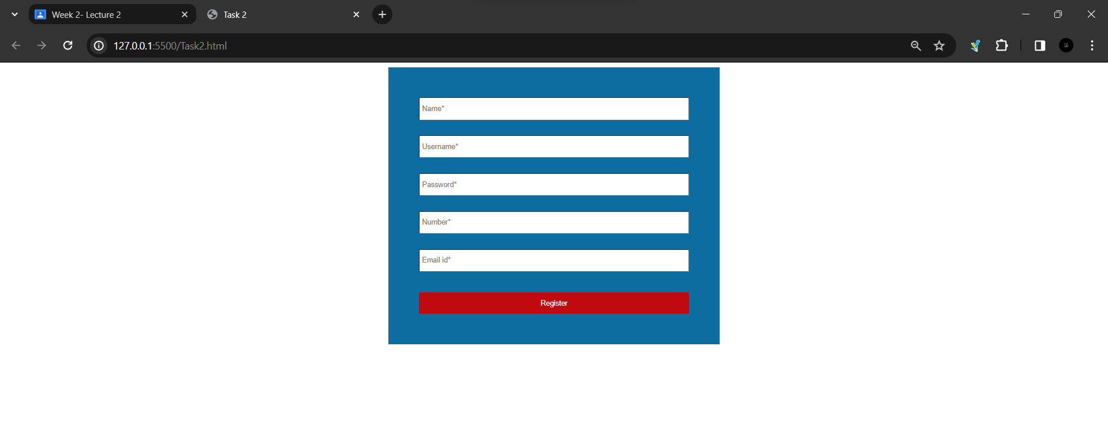

**Task3**

Code:

.html:

<!DOCTYPE html>

<html lang="en">

  <head>

    <meta charset="UTF-8" />

    <meta name="viewport" content="width=device-width, initial-scale=1.0" />

    <link rel="stylesheet" href="Task3.css" />

    <title>Task 3</title>

  </head>

  <body>

    <div class="flex">

      <div class="card">

        <img src="T3.jpg" width="100%" height="100%" />

        <p>Istanbul</p>

      </div>

    </div>

  </body>

</html>

.css:

.flex {

    display: flex;

    flex-direction: column;

    align-items: center;

  }

  .card {

    width: 40%;

    box-shadow: 2px 2px 10px #000;

  }

  .card p {

    text-align: center;

    padding-bottom: 20px;

    font-family: sans-serif;

  }

Output:

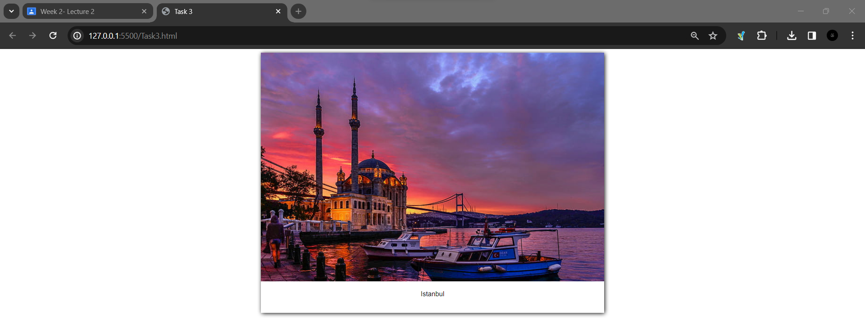

**Task4**

Code:

.html:

<!DOCTYPE html>

<html lang="en">

  <head>

    <meta charset="UTF-8" />

    <meta name="viewport" content="width=device-width, initial-scale=1.0" />

    <link rel="stylesheet" href="Task4.css" />

    <title>Task 4</title>

  </head>

  <body>

    <div class="flex">

      <div class="card">

        <img src="T3.jpg" width="100%" height="100%" />

        <p>Istanbul</p>

      </div>

    </div>

  </body>

</html>

.css:

@keyframes slideIn {

    0% {

      transform: translateX(-100%);

    }

    100% {

      transform: translateX(0);

    }

  }

  .flex {

    display: flex;

    flex-direction: column;

    align-items: center;

  }

  .card {

    width: 40%;

    box-shadow: 2px 2px 10px #000;

    animation: slideIn 5s ease-out;

  }

  .card p {

    text-align: center;

    padding-bottom: 20px;

    font-family: sans-serif;

  }