 

**Department of Computer Science**

# National University of Computer & Emerging Sciences



Name: **Muhammad Ali Shaikh**

Roll No: **21F-9631**

Section: **BCS-6E**

Subject: **Web Programming**

Assignment: **3**

**Q1**

Code:

.html:

<!DOCTYPE html>

<html>

<head>

    <title>Q1</title>

    <link rel="stylesheet" href="Q1.css">

</head>

<body>

    <div class="box" id="box1"> <a href="https://www.w3schools.com/bootstrap/bootstrap_ver.asp"

            style="color: black;">Feel good about Bootstrap</a> </div>

    <div class="box" id="box2"> <a href="https://www.w3schools.com/bootstrap/bootstrap_ver.asp"

            style="color: black;">Feel interested about Bootstrap</a> </div>

    <div class="box" id="box3"> <a href="https://www.w3schools.com/bootstrap/bootstrap_ver.asp"

            style="color: black;">Feel worried about Bootstrap</a> </div>

    <div class="box" id="box4"> <a href="https://www.w3schools.com/bootstrap/bootstrap_ver.asp"

            style="color: black;">Maybe I should read this docs...</a> </div>

    <div class="box" id="box5"> <a href="https://www.w3schools.com/bootstrap/bootstrap_ver.asp"

            style="color: black;">Danger Zone</a> </div>

    <div class="box" id="box5"> <a href="https://www.w3schools.com/bootstrap/bootstrap_ver.asp"

            style="color: black;">I really should read the docs</a> </div>

    </body>

</html>

.css:

.box a {

    text-decoration: none;

    color: black;

    font-size: large;

}

#box1 {

    background-color: #86cb6b;

}

#box2 {

    background-color: #8fd0e0;

}

#box3 {

    background-color: #b5b735;

}

#box4 {

    background-color: #b5b735;

}

#box5 {

    background-color: #d8b0c7;

}

#box6 {

    background-color: #d8b0c7;

}

Output:

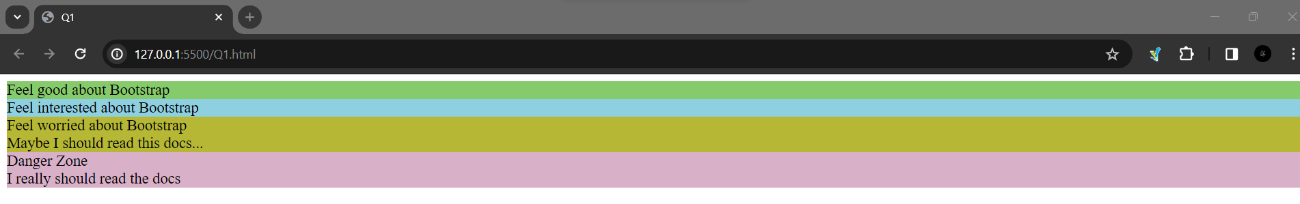

**Q2**

Code:

.html:

<!DOCTYPE html>

<html>

<head>

    <link rel="stylesheet" href="https://maxcdn.bootstrapcdn.com/bootstrap/4.5.2/css/bootstrap.min.css">

    <link rel="stylesheet" href="Q2.css">

    <title>Q2</title>

</head>

<body> <button class="btn btn-basic" id="basic-button" onclick="showMessage('Basic Button')">Basic</button>

    <button class="btn btn-secondary" onclick="showMessage('Default Button')">Default</button> <button

        class="btn btn-primary" onclick="showMessage('Primary Button')">Primary</button> <button

        class="btn btn-success" onclick="showMessage('Success Button')">Success</button> <button

        class="btn btn-info" onclick="showMessage('Info Button')">Info</button> <button class="btn btn-warning"

        style="color: white;" onclick="showMessage('Warning Button')">Warning</button> <button

        class="btn btn-danger" onclick="showMessage('Danger Button')">Danger</button> <button

        class="btn btn-link" onclick="showMessage('Link Button')">Link</button>

    <script src="https://maxcdn.bootstrapcdn.com/bootstrap/4.5.2/js/bootstrap.min.js"></script>

    <script> function showMessage(message) { alert(message); } </script>

</body>

</html>

.css:

.btn-basic {

    border: none;

    background-color: #e8e7e89b;

    box-shadow: none;

}

.btn-secondary {

    border: 1px solid #C7C7C7;

    background-color: rgba(191, 191, 191, 0.395);

}

.btn-warning {

    color: white;

}

.btn-secondary{

    color: black;

}

Output:

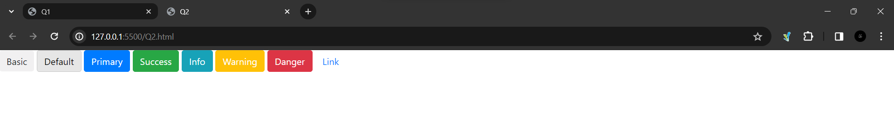

**Q3**

Code:

.html:

<!DOCTYPE html>

<head>

<title>Q3</title>

  <style>

    body {

      font-family: 'Arial', sans-serif;

      background-color: #f7f7f7;

      text-align: center;

      margin: 50px;

    }

    h2 {

      color: #333;

    }

    input {

      margin-bottom: 10px;

      padding: 8px;

      border: 1px solid #ccc;

      border-radius: 5px;

    }

    button {

      padding: 10px 20px;

      margin: 5px;

      font-size: 16px;

      cursor: pointer;

      background-color: #4CAF50;

      color: #fff;

      border: none;

      border-radius: 5px;

    }

    button:hover {

      background-color: #45a049;

    }

    #result {

      font-size: 18px;

      color: #333;

      margin-top: 15px;

    }

  </style>

</head>

<body>

  <h2>Calculator</h2>

  <input type="number" id="num1" placeholder="Enter first number">

  <input type="number" id="num2" placeholder="Enter second number">

  <button onclick="calculate('add')">Add</button>

  <button onclick="calculate('subtract')">Subtract</button>

  <button onclick="calculate('multiply')">Multiply</button>

  <button onclick="calculate('divide')">Divide</button>

  <p id="result"></p>

  <script src="Q3.js"></script>

</body>

</html>

.js:

function calculate(operation) {

    var num1 = parseFloat(document.getElementById("num1").value);

    var num2 = parseFloat(document.getElementById("num2").value);

    var resultElement = document.getElementById("result");

    switch (operation) {

      case 'add':

        resultElement.innerText = "Result: " + (num1 + num2);

        break;

      case 'subtract':

        resultElement.innerText = "Result: " + (num1 - num2);

        break;

      case 'multiply':

        resultElement.innerText = "Result: " + (num1 * num2);

        break;

      case 'divide':

        if (num2 === 0) {

          resultElement.innerText = "Cannot divide by zero";

        } else {

          resultElement.innerText = "Result: " + (num1 / num2);

        }

        break;

      default:

        resultElement.innerText = "Invalid operation";

    }

}

Output:

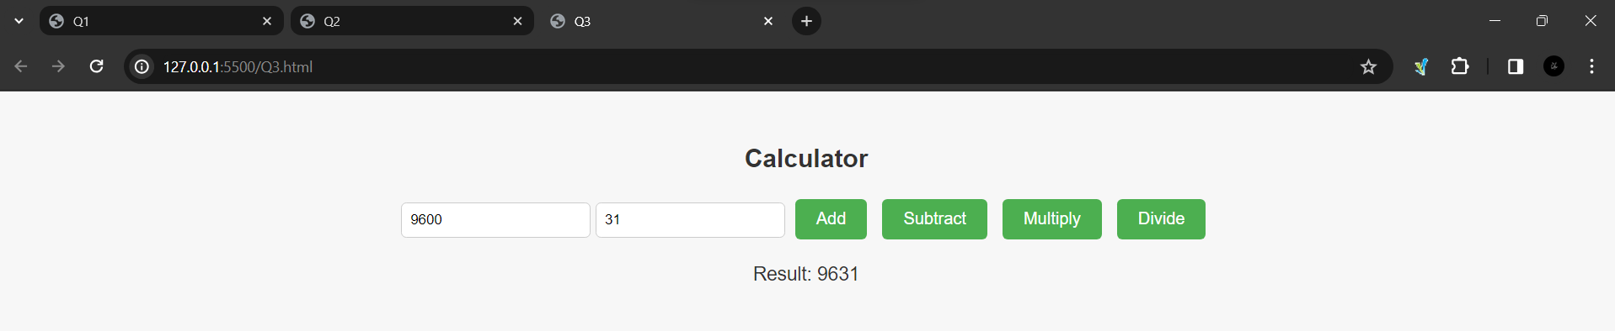

**Q4**

Code:

.html:

<!DOCTYPE html>

<head>

  <title>Q4</title>

  <link rel="stylesheet" href="Q4.css">

</head>

<body>

  <div class="container">

    <h1>Discover Month Days</h1>

    <label for="monthInput">Enter the month (three characters):</label>

    <input type="text" id="monthInput">

    <button onclick="getDays()">Check Days</button>

    <p id="result"></p>

    <script src="Q4.js"></script>

  </div>

</body>

</html>

.css:

body {

    font-family: 'Arial', sans-serif;

    background-color: #f8f8f8;

    text-align: center;

    margin: 50px;

  }

  .container {

    max-width: 400px;

    margin: auto;

    padding: 20px;

    border: 1px solid #ddd;

    border-radius: 5px;

    background-color: #fff;

    box-shadow: 0 4px 8px rgba(0, 0, 0, 0.1);

  }

  h1 {

    color: #333;

  }

  label {

    display: block;

    margin: 20px 0 10px;

    font-size: 18px;

  }

  input {

    padding: 8px;

    font-size: 16px;

  }

  button {

    background-color: #4CAF50;

    color: white;

    padding: 10px 20px;

    font-size: 16px;

    cursor: pointer;

    border: none;

    border-radius: 5px;

  }

  button:hover {

    background-color: #45a049;

  }

  #result {

    margin-top: 20px;

    font-size: 20px;

  }

  .highlight {

    color: red;

    font-weight: bold;

  }

.js:

function getDays() {

    var monthInput = document.getElementById("monthInput").value.toLowerCase();

    let days;

    switch (monthInput) {

      case "jan":

      case "mar":

      case "may":

      case "jul":

      case "aug":

      case "oct":

      case "dec":

        days = 31;

        break;

      case "apr":

      case "jun":

      case "sep":

      case "nov":

        days = 30;

        break;

      case "feb":

        days = "28 or 29";

        break;

      default:

        days = "Invalid month";

        break;

    }

    document.getElementById("result").innerHTML = `Total days in ${monthInput.toUpperCase()}: <span class="highlight">${days}</span>`;

}

Output:

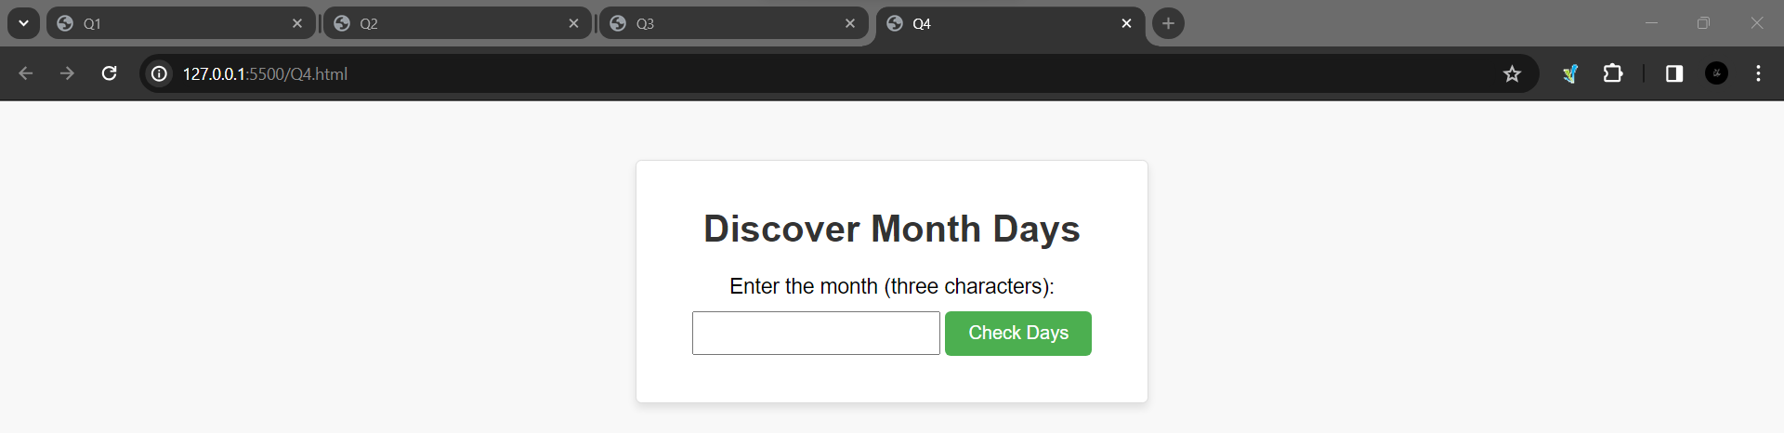

**Q5**

Code:

.html:

<!DOCTYPE html>

<html lang="en">

<head>

  <meta charset="UTF-8">

  <meta name="viewport" content="width=device-width, initial-scale=1.0">

  <title>Q5</title>

  <link rel="stylesheet" href="Q5.css">

</head>

<body>

  <div class="container">

    <h2>Multiplication Table</h2>

    <label for="numberInput">Enter a number: </label>

    <input type="number" id="numberInput">

    <button onclick="printTable()">Print Table</button>

    <div id="tableContainer"></div>

    <script src="Q5.js"></script>

  </div>

</body>

</html>

.css:

body {

    font-family: 'Arial', sans-serif;

    background-color: #f5f5f5;

    margin: 0;

    display: flex;

    align-items: center;

    justify-content: center;

    height: 100vh;

  }

  .container {

    background-color: #fff;

    padding: 20px;

    border-radius: 8px;

    box-shadow: 0 4px 8px rgba(0, 0, 0, 0.1);

    text-align: center;

  }

  h2 {

    color: #333;

  }

  label {

    margin-right: 10px;

  }

  input {

    padding: 5px;

    margin-right: 10px;

  }

  button {

    padding: 7px 15px;

    background-color: #4caf50;

    color: #fff;

    border: none;

    border-radius: 4px;

    cursor: pointer;

  }

  button:hover {

    background-color: #45a049;

  }

  ul {

    list-style-type: none;

    padding: 0;

  }

  li {

    margin: 5px 0;

  }

.js:

function printTable() {

    var number = parseInt(document.getElementById("numberInput").value);

    var table = "<h3>Table of " + number + "</h3><ul>";

    for (var i = 1; i <= 10; i++) {

      table += "<li>" + number + " x " + i + " = " + (number * i) + "</li>";

    }

    table += "</ul>";

    document.getElementById("tableContainer").innerHTML = table;

  }

Output:

