**Task 1**

Code:

<!DOCTYPE html>

<html lang="en">

<head>

    <title>Simple Calculator</title>

    <style>

        body {

            display: flex;

            justify-content: center;

            align-items: center;

            height: 100vh;

            margin: 0;

            background-color: #f4f4f4;

        }

        .calculator {

            width: 400px;

            box-shadow: 0px 0px 10px 0px #000;

            position: relative;

        }

        .calculator-screen {

            width: 100%;

            height: 80px;

            border: 2px solid #0f8;

            background-color: #fff;

            display: block;

            font-size: 2em;

            padding: 20px;

            box-sizing: border-box;

            margin-bottom: 1px;

            color: #0f8;

        }

        .key-clear {

            width: 100px;

            border: none;

            height: 85px;

            position: absolute;

            right: 0;

            top: 0;

            background-color: #0f8;

            color: white;

            outline: none;

            cursor: pointer;

            font-size: 2.5em;

        }

        .separator-line {

            width: 100px;

            height: 1px;

            background-color: white;

            position: absolute;

            top: 80px;

            right: 0;

        }

        .calculator-keys {

            display: grid;

            grid-template-columns: repeat(4, 1fr);

            gap: 1px;

        }

        .calculator-keys button {

            height: 80px;

            border: none;

            background-color: #0f8;

            font-size: 2.5em;

            color: white;

            outline: none;

            cursor: pointer;

        }

    </style>

</head>

<body>

<div class="calculator">

    <output id="result" class="calculator-screen"></output>

    <button type="button" class="key-clear">C</button>

    <div class="separator-line"></div>

    <div class="calculator-keys">

        <button type="button">1</button>

        <button type="button">2</button>

        <button type="button">3</button>

        <button type="button" class="key-divide">/</button>

        <button type="button">4</button>

        <button type="button">5</button>

        <button type="button">6</button>

        <button type="button" class="key-multiply">*</button>

        <button type="button">7</button>

        <button type="button">8</button>

        <button type="button">9</button>

        <button type="button" class="key-subtract">-</button>

        <button type="button" class="key-zero">0</button>

        <button type="button" class="key-decimal">.</button>

        <button type="button" class="key-equals">=</button>

        <button type="button" class="key-add">+</button>

    </div>

</div>

</body>

</html>

Output:

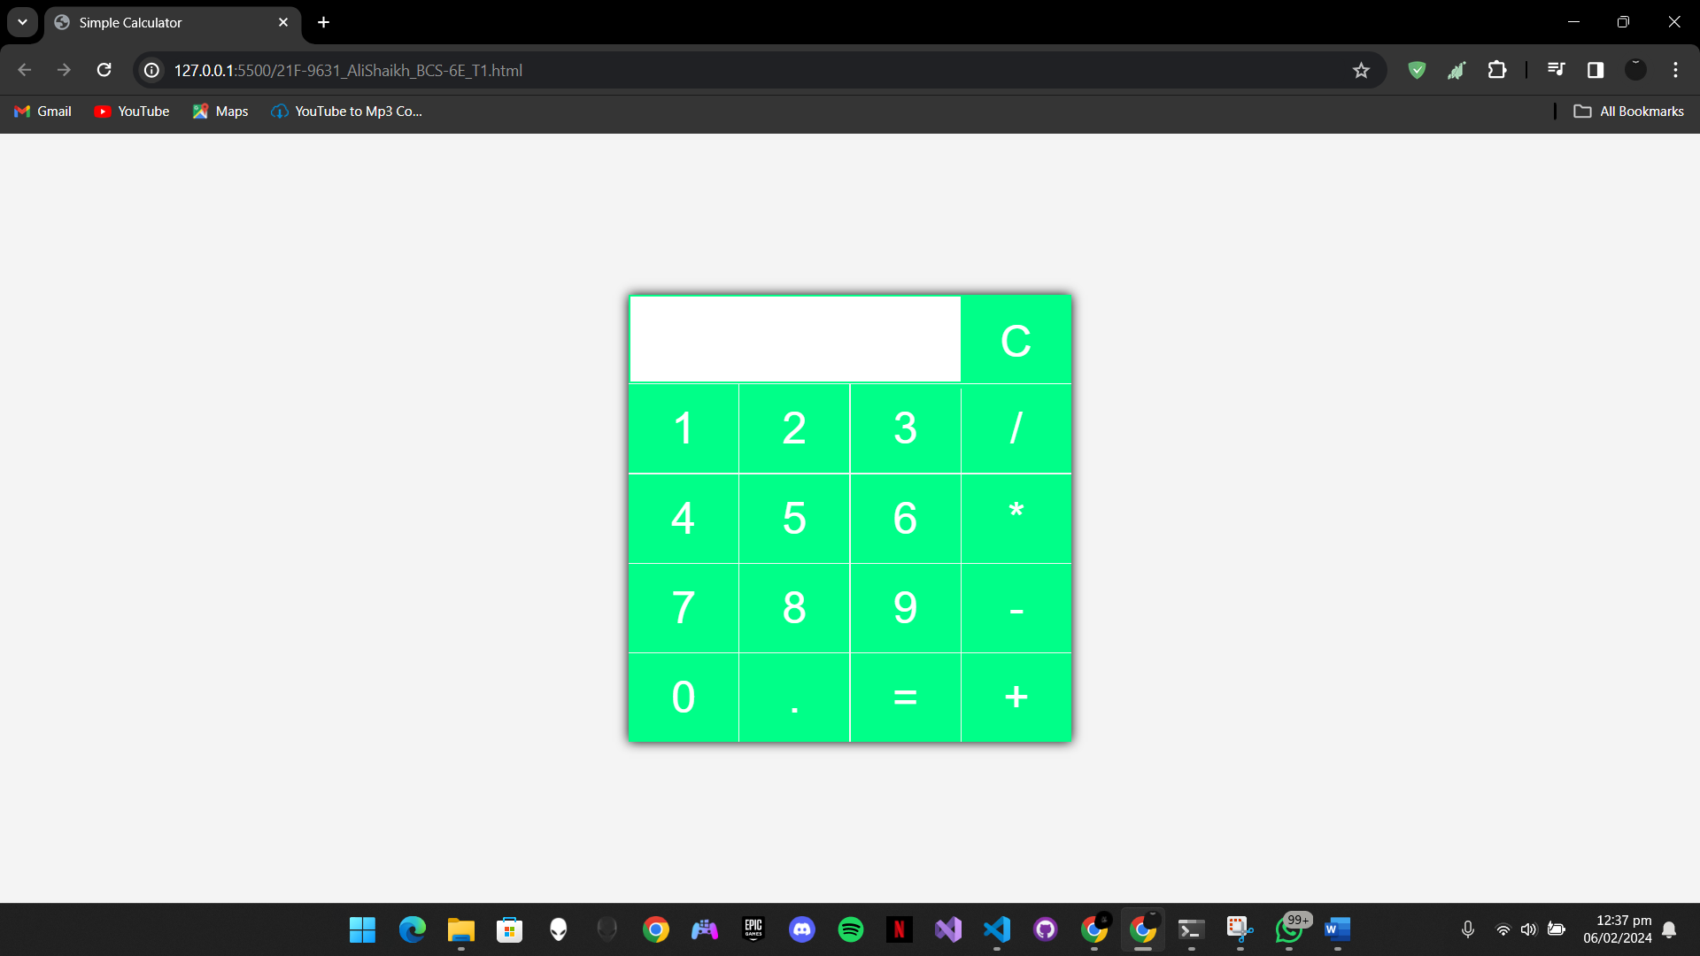

**Task 2**

Code:

<!DOCTYPE html>

<html lang="en">

<head>

    <title>Timetable</title>

    <style>

        body, table { background-color: rgb(255, 255, 255); color: black; font-size: large; width: 100%; }

        table { border-collapse: separate; }

        th, td, .time-slot, .day { border: 1px solid black; padding: 5px; text-align: center; vertical-align: middle; }

        .time-slot, .day, h2, .footer, h3 { background-color: #f2f2f2; color: #000000; font-weight: bold; text-align: center; }

        .day { font-size: xx-large; }

        .time-slot { font-size: 14px; position: relative; }

        .time-number { position: absolute; top: 0; left: 0; }

        .subject, .R, .teacher { text-align: center; }

        .room, .teacher { font-size: smaller; }

        .teacher { text-align: right; }

        .header, .footer { margin-top: -55px; }

    </style>

</head>

<body>

  <h2 style="text-align: center; margin-bottom: 0;">Department of Computer Science</h2>

  <h3 style="text-align: center; margin-top: 0; font-weight: bold; font-size: 30px;"><big>BCS-6E</big></h3>

  <div class="header">

    <br>

    <p>FAST-NU CFD CAMPUS</p>

  </div>

  <table>

    <tr>

      <td class="time-slot"></td>

      <td class="time-slot"><span class="time-number">1</span>8:45<br>9:15</td>

      <td class="time-slot"><span class="time-number">2</span>9:15<br>9:45</td>

      <td class="time-slot"><span class="time-number">3</span>9:45<br>10:10</td>

      <td class="time-slot"><span class="time-number">4</span>10:15<br>10:45</td>

      <td class="time-slot"><span class="time-number">5</span>10:45<br>11:15</td>

      <td class="time-slot"><span class="time-number">6</span>11:15<br>11:40</td>

      <td class="time-slot"><span class="time-number">7</span>11:45<br>12:15</td>

      <td class="time-slot"><span class="time-number">8</span>12:15<br>12:45</td>

      <td class="time-slot"><span class="time-number">9</span>12:45<br>1:10</td>

      <td class="time-slot"><span class="time-number">10</span>1:10<br>1:45</td>

      <td class="time-slot"><span class="time-number">11</span>1:45<br>2:15</td>

      <td class="time-slot"><span class="time-number">12</span>2:15<br>2:45</td>

      <td class="time-slot"><span class="time-number">13</span>2:45<br>3:10</td>

      <td class="time-slot"><span class="time-number">14</span>3:15<br>3:45</td>

      <td class="time-slot"><span class="time-number">15</span>3:45<br>4:15</td>

      <td class="time-slot"><span class="time-number">16</span>4:15<br>4:40</td>

    </tr>

    <tr>

      <td class="day">Mon</td>

      <td></td>

      <td></td>

      <td></td>

      <td colspan="3" class="subject"><b>Web Programming</b>

        <br>

        <br>

        <br>

        <br>

        <br>

        <span style="float: left; font-size: smaller;">R-8</span>

        <div class="teacher">Mr. Mustafa</div>

      </td>

      <td colspan="3" class="subject"><b>Parallel and Distributed Computing</b>

        <br>

        <br>

        <br>

        <br>

        <span style="float: left; font-size: smaller;">R-9</span>

        <div class="teacher">Mr. Arshad</div>

      </td>

      <td></td>

      <td colspan="3" class="subject"><b>Artificial Intelligence</b>

        <br>

        <br>

        <br>

        <br>

        <br>

        <span style="float: left; font-size: smaller;">R-13</span>

        <div class="teacher">Mr. Raza</div>

      </td>

      <td></td>

      <td></td>

      <td></td>

      </td>

    </tr>

    <tr>

      <td class="day">Tue</td>

      <td colspan="3" class="subject"><b>Computer Networks</b>

        <br>

        <br>

        <br>

        <span style="float: left; font-size: smaller;">R-19</span>

        <div class="teacher">Dr. Umar</div>

      </td>

      <td colspan="3" class="subject"><b>Artificial Intelligence</b>

        <br>

        <br>

        <br>

        <span style="float: left; font-size: smaller;">R-10</span>

        <div class="teacher">Mr. Raza</div>

      </td>

      <td></td>

      <td></td>

      <td></td>

      <td></td>

      <td colspan="6" class="subject"><b>Artificial Intelligence Lab</b>

        <br>

        <br>

        <br>

        <span style="float: left; font-size: smaller;">Lab#1</span>

        <div class="teacher">Mr. Tabassam</div>

      </td>

    </tr>

    <tr>

      <td class="day">Wed</td>

      <td></td>

      <td></td>

      <td></td>

      <td></td>

      <td></td>

      <td></td>

      <td></td>

      <td></td>

      <td></td>

      <td></td>

      <td colspan="6" class="subject"><b>Computer Networks-Lab</b>

        <br>

        <br>

        <br>

        <span style="float: left; font-size: smaller;">Lab#1</span>

        <div class="teacher">Mr. Hamza</div>

      </td>

    </tr>

    <tr>

      <td class="day">Thu</td>

      <td></td>

      <td></td>

      <td></td>

      <td colspan="3" class="subject"><b>Computer Networks</b>

        <br>

        <br>

        <br>

        <br>

        <br>

        <span style="float: left; font-size: smaller;">R-15</span>

        <div class="teacher">Dr. Umar</div>

      </td>

      <td colspan="3" class="subject"><b>Software Design and Analysis</b>

        <br>

        <br>

        <br>

        <br>

        <span style="float: left; font-size: smaller;">R-19</span>

        <div class="teacher">Mr. Azam</div>

      </td>

      <td colspan="1"></td>

      <td colspan="3" class="subject"><b>Web Programming</b>

        <br>

        <br>

        <br>

        <br>

        <br>

        <span style="float: left; font-size: smaller;">Lab#1</span>

        <div class="teacher">Mr. Mustafa</div>

      </td>

      <td colspan="3" class="subject"><b>Parallel and Distributed Computing</b>

        <br>

        <br>

        <br>

        <br>

        <span style="float: left; font-size: smaller;">R-19</span>

        <div class="teacher">Mr. Arshad</div>

      </td>

    </tr>

    <tr>

      <td class="day">Fri</td>

      <td></td>

      <td></td>

      <td></td>

      <td colspan="3" class="subject"><b>Software Design and Analysis</b>

        <br>

        <br>

        <br>

        <span style="float: left; font-size: smaller;">R-8</span>

        <div class="teacher">Mr. Azam</div>

      </td>

      <td></td>

      <td></td>

      <td></td>

      <td></td>

      <td></td>

      <td></td>

      <td></td>

      <td></td>

      <td></td>

      <td></td>

    </tr>

  </table>

  <div class1="footer">

    <p>w.e.f January 29, 2024</p>

  </div>

  <div class="footer" style="text-align: right;">

    <p>aSc Timetable</p>

  </div>

</body>

</html>

Output:

**Task 3**

Code:

<!DOCTYPE html>

<html>

<head>

    <title>CV</title>

    <style>

        body {

            font-family: Arial, sans-serif;

            margin: 0;

            padding: 0;

        }

        .container {

            padding: 20px;

            display: flex;

            justify-content: center;

            background-color: white;

            max-width: 900px;

            margin: auto;

        }

        .left-column {

            flex: 1;

            padding-right: 10px;

            background-color: lightgrey;

            text-align: left;

        }

        .right-column {

            flex: 2;

            padding-left: 10px;

            text-align: left;

            background-color: skyblue;

        }

        .profile-image {

            text-align: center;

        }

        .profile-image img {

            width: 200px;

            height: 200px;

            border-radius: 50%;

            margin-bottom: 20px;

        }

        h1, h2, h3 {

            margin: 0;

        }

        ul {

            margin: 5px 0;

            padding-left: 20px;

        }

        a {

            text-decoration: none;

            color: inherit;

        }

    </style>

</head>

<body>

<div class="container">

    <div class="left-column">

        <div class="profile-image">

            <img src="T3.jpg" alt="profile-image">

        </div>

        <h2>Contact</h2>

        <p><b>Email:</b> shaiiikhllc@gmail.com</p>

        <p><b>GitHub:</b> <a href="https://github.com/shaiiikh">https://github.com/shaiiikh</a></p>

        <h2>Skills</h2>

        <ul>

            <li>Java</li>

            <li>JavaScript</li>

            <li>HTML/CSS</li>

            <li>Go (Golang)</li>

            <li>Ruby</li>

            <li>C# / .NET</li>

            <li>Swift</li>

            <li>Shell Scripting (e.g., Bash)</li>

            <li>MongoDB</li>

            <li>Cassandra</li>

            <li>Redis</li>

            <li>AWS</li>

            <li>Azure</li>

            <li>Google Cloud</li>

            <li>Docker</li>

            <li>Kubernetes</li>

            <li>Git</li>

            <li>Cybersecurity</li>

            <li>Functional Programming Languages (e.g., Haskell, Scala)</li>

            <li>IoT Programming (e.g., Arduino, Raspberry Pi)</li>

        </ul>

        <h2>Languages</h2>

        <ul>

            <li>English</li>

            <li>Urdu</li>

            <li>Sindhi</li>

            <li>Punjabi</li>

        </ul>

        <h2>Hobbies</h2>

        <ul>

            <li>Playing Football</li>

            <li>Coding</li>

            <li>Overthinking</li>

        </ul>

    </div>

    <div class="right-column">

        <div class="profile">

            <h1>MUHAMMAD ALI SHAIKH</h1>

            <b><p>Computer Scientist</p></b>

        </div>

        <h2>Summary</h2>

        <p>Skilled Computer Scientist excelling in advanced software engineering, algorithmic intricacies, and intricate system architecture. Demonstrates a commitment to unraveling complex challenges through cutting-edge technologies, contributing to groundbreaking advancements in software-driven solutions.</p>

        <p><h2>Experience</h2></p>

        <h3>Software Enginner - NETSOL</h3>

        <p>September 2021 - Present</p>

        <ul>

            <li>Led the creation of feature-rich mobile apps on Android and iOS platforms.</li>

            <li>Managed the entire software development life cycle for applications, ensuring seamless integration.</li>

            <li>Implemented robust, scalable code, adhering to industry best practices, and delivering high-quality mobile solutions.</li>

        </ul>

        <h3>Data Entry Engineer - Devsinc</h3>

        <p>October 2020 - August 2021</p>

        <ul>

            <li>Conducted precise and efficient data entry, maintaining accuracy in updating databases and spreadsheets.</li>

            <li>Diligently verified and validated data to ensure completeness and correctness.</li>

            <li>Demonstrated strong attention to detail, delivering timely and efficient data entry contributions.</li>

        </ul>

        <p><h2>Education</h2></p>

        <h3>Master of Business Administration</h3>

        <p>IBA, Karachi, Pakistan</p>

        <p>Graduated: October 2023</p>

        <h3>Bachelor of Science in Computer Science</h3>

        <p>FAST Nuces, Karachi, Pakistan</p>

        <p>Graduated: October 2021</p>

    </div>

</div>

</body>

</html>

Output:

