 

**Department of Computer Science**

# National University of Computer & Emerging Sciences



Name: **Muhammad Ali Shaikh**

Roll No: **21F-9631**

Section: **BCS-6E**

Subject: **Web Programming**

Lab: **6**

**Github Link :**

[**https://github.com/shaiiikh/F219631Web_Programming/tree/main/CPs**](https://github.com/shaiiikh/F219631Web_Programming/tree/main/CPs)

**Task1**

**HTML:** In HTML, you can use <!-- --> to create comments. Anything within these tags won't be displayed in the browser.

Example:

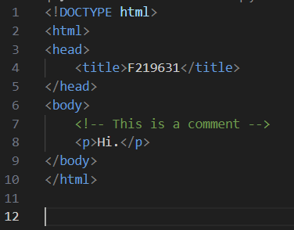

**CSS:** In CSS, you can use **/* */** to create comments. Anything within these tags won't affect the styling.

Example:

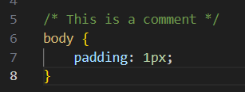

**JavaScript:** In JavaScript, you can use **//** for single-line comments or **/* */** for multi-line comments. These comments won't be executed by the JavaScript engine.

Example:

**Task2**

**Code:**

<!DOCTYPE html>

<html>

<head>

    <title>Task2</title>

    <script src="https://code.jquery.com/jquery-3.7.1.min.js" integrity="sha256-/JqT3SQfawRcv/BIHPThkBvs0OEvtFFmqPF/lYI/Cxo=" crossorigin="anonymous"></script>

</head>

<body>

    <script>

        $(document).ready(function(){

            alert("Welcome to jQuery");

        });

    </script>

</body>

</html>

**Output:**

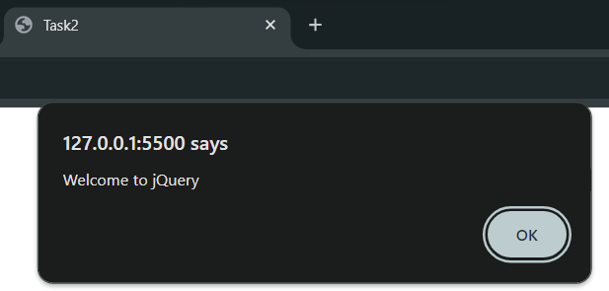

**Task3**

**Code:**

**.html :**

<!DOCTYPE html>

<html>

<head>

    <title>Task3</title>

    <link rel="stylesheet" type="text/css" href="Task3.css">

    <script src="https://ajax.googleapis.com/ajax/libs/jquery/3.6.0/jquery.min.js"></script>

</head>

<body>

    <h1>Image Toggle</h1>

    <input type="file" id="image-input" accept="image/*">

    <button id="toggle-button">Show Image</button>

    <div id="image-container">

        <img id="uploaded-image" alt="Uploaded Image">

    </div>

    <script src="Task3.js"></script>

</body>

</html>

**.css :**

body {

    font-family: Arial, sans-serif;

    margin: 0;

    padding: 20px;

    background-color: #f7f7f7;

}

h1 {

    text-align: center;

    color: #333;

}

#image-container {

    margin-top: 20px;

    text-align: center;

    display: none;

    animation: fadeIn 1s ease-in-out;

}

@keyframes fadeIn {

    from { opacity: 0; }

    to { opacity: 1; }

}

#toggle-button {

    display: block;

    margin: 20px auto;

    padding: 10px 20px;

    background-color: #FFA500;

    color: white;

    border: none;

    border-radius: 5px;

    cursor: pointer;

    transition: background-color 0.3s ease;

}

#toggle-button:hover {

    background-color: #FF8C00;

}

**.js :**

$(document).ready(function(){

    $('#toggle-button').text('Show Image');

    $('#image-container').hide();

    $('#image-input').on('change', function(e){

        var file = e.target.files[0];

        if(file){

            var reader = new FileReader();

            reader.onload = function(e){

                $('#uploaded-image').attr('src', e.target.result);

            };

            reader.readAsDataURL(file);

        }

    });

    $('#toggle-button').on('click', function(){

        if ($('#toggle-button').text() === 'Show Image') {

            if ($('#uploaded-image').attr('src')) {

                $('#image-container').show();

                $('#toggle-button').text('Hide Image');

            } else {

                alert('Please upload an image first.');

            }

        } else {

            $('#image-container').hide();

            $('#toggle-button').text('Show Image');

        }

    });

});

**Output:**

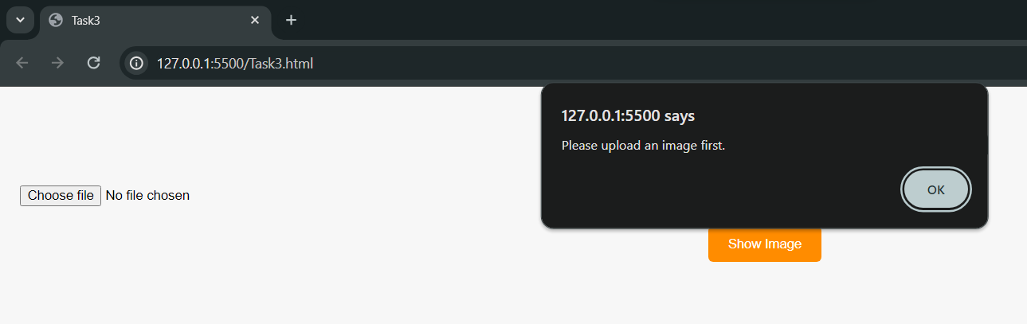

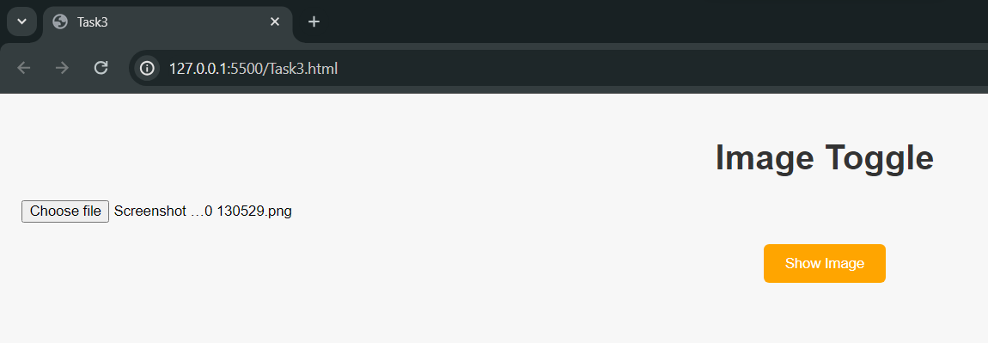

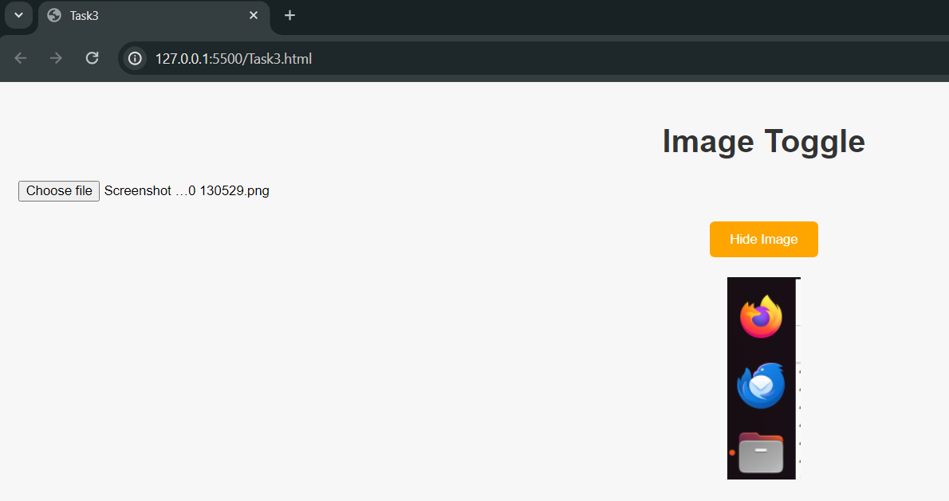

**Task4**

**Code:**

**.html :**

<!DOCTYPE html>

<html>

<head>

    <title>Task4</title>

    <link rel="stylesheet" type="text/css" href="Task4.css">

    <script src="https://ajax.googleapis.com/ajax/libs/jquery/3.6.0/jquery.min.js"></script>

    <script>

        $(document).ready(function(){

            $('.remove-row').on('click', function(){

                $(this).closest('tr').remove();

            });

        });

    </script>

</head>

<body>

    <h1>Remove Table Row</h1>

    <table id="my-table">

        <tr>

            <th>Name</th>

            <th>CGPA</th>

            <th>Action</th>

        </tr>

        <tr>

            <td>Muhammad</td>

            <td>2.5</td>

            <td><button class="remove-row">Remove</button></td>

        </tr>

        <tr>

            <td>Ali</td>

            <td>2.8</td>

            <td><button class="remove-row">Remove</button></td>

        </tr>

        <tr>

            <td>Shaikh</td>

            <td>2.2</td>

            <td><button class="remove-row">Remove</button></td>

        </tr>

    </table>

</body>

</html>

**.css :**

body, html {

    height: 100%;

    margin: 0;

    display: flex;

    justify-content: center;

    align-items: center;

    background-color: #f7f7f7;

}

h2 {

    margin-top: 0;

}

#my-table {

    border-collapse: collapse;

}

#my-table th, #my-table td {

    border: 1px solid black;

    padding: 8px;

    text-align: center;

}

#my-table th {

    background-color: orange;

    color: white;

}

.remove-row {

    cursor: pointer;

    background-color: orange;

    color: white;

    border: none;

    border-radius: 5px;

    padding: 5px 10px;

}

.remove-row:hover {

    background-color: #FF8C00;

}

**Output:**

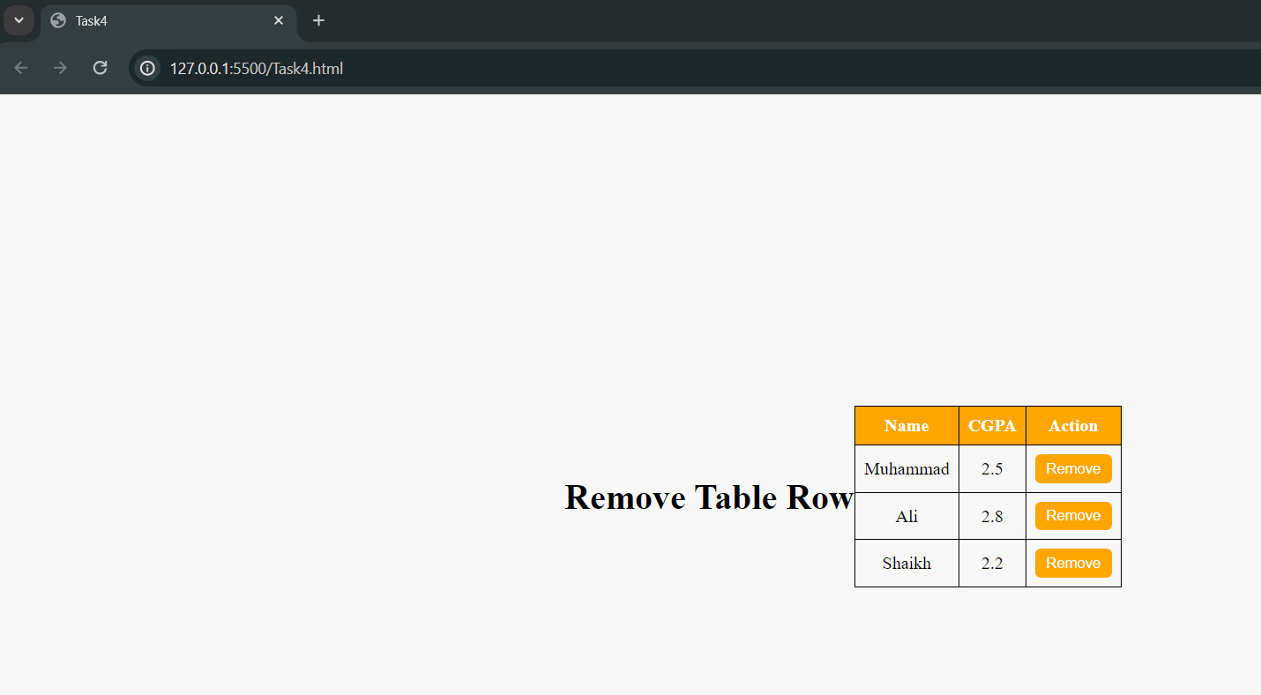 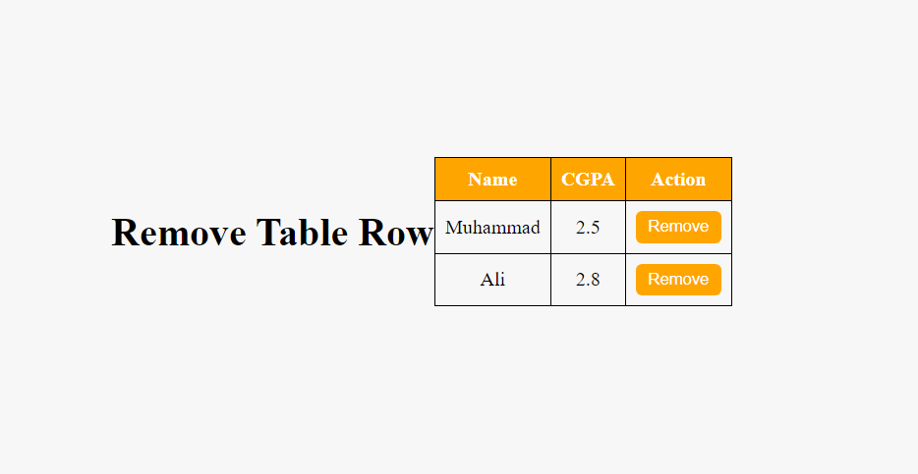 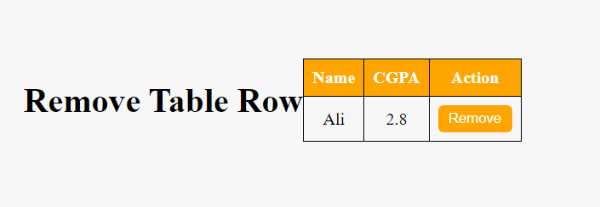

**Task5**

**Code:**

**.html :**

<!DOCTYPE html>

<html lang="en">

<head>

    <meta charset="UTF-8">

    <meta name="viewport" content="width=device-width, initial-scale=1.0">

    <title>Task5</title>

    <link rel="stylesheet" type="text/css" href="Task5.css">

    <script src="https://ajax.googleapis.com/ajax/libs/jquery/3.6.0/jquery.min.js"></script>

</head>

<body>

    <div class="container">

        <button class="box red" id="box1">Box 1</button>

        <button class="box green" id="box2">Box 2</button>

        <button class="box blue" id="box3">Box 3</button>

    </div>

    <script>

        $('.box').click(function() {

            var className = $(this).attr('class').split(' ')[1];

            var elementId = $(this).attr('id');

            alert('Class: ' + className + '\nID: ' + elementId);

        });

    </script>

</body>

</html>

**.css :**

body, html {

    height: 100%;

    margin: 0;

    display: flex;

    justify-content: center;

    align-items: center;

    background-color: #f7f7f7;

}

.container {

    display: flex;

    flex-direction: column;

    align-items: center;

}

.box {

    padding: 10px 20px;

    margin: 10px;

    border: none;

    border-radius: 5px;

    cursor: pointer;

}

.red {

    background-color: red;

    color: white;

}

.green {

    background-color: green;

    color: white;

}

.blue {

    background-color: blue;

    color: white;

}

**Output:**

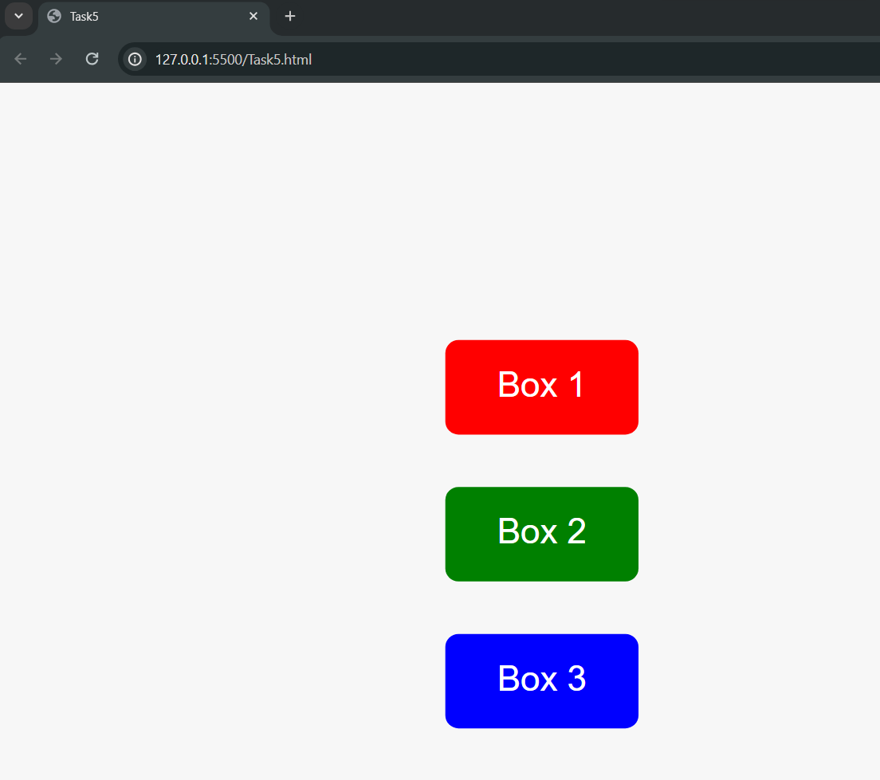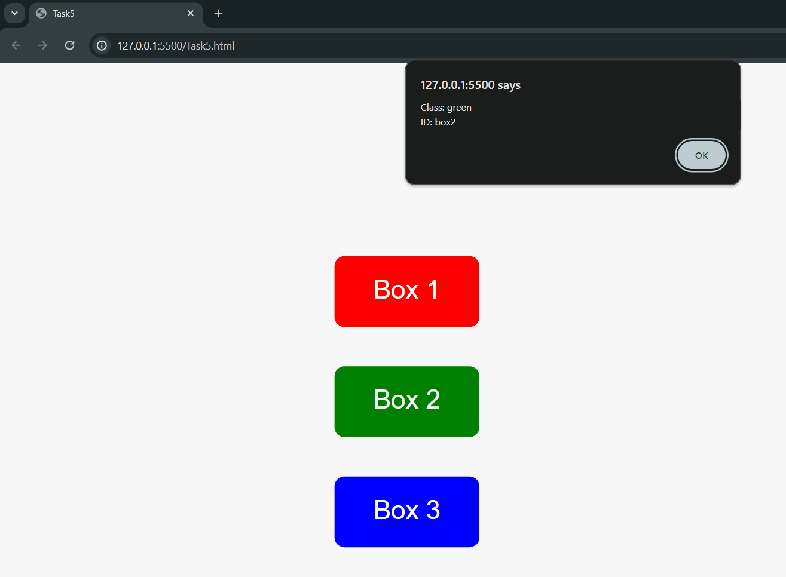

**Task6**

**Code:**

**.html :**

<!DOCTYPE html>

<html>

<head>

    <script src="https://code.jquery.com/jquery-git.js"></script>

    <script src="Task6.js"></script>

    <link rel="stylesheet" type="text/css" href="Task6.css">

    <meta charset="utf-8">

    <meta name="viewport" content="width=device-width">

    <title>Find total width of an element (including width, padding and border) in jQuery.</title>

</head>

<body>

    <p id="myText">jQuery Exercises, Practice, Solution</p>

</body>

</html>

**.css :**

p {

    padding-top: 50px;

    padding-right: 30px;

    padding-bottom: 50px;

    padding-left: 80px;

}

**.js :**

$(document).ready(function(){

    var totalWidth = $('#myText').outerWidth(true);

    alert('Total width of the element: ' + totalWidth + 'px');

});

**Output:**

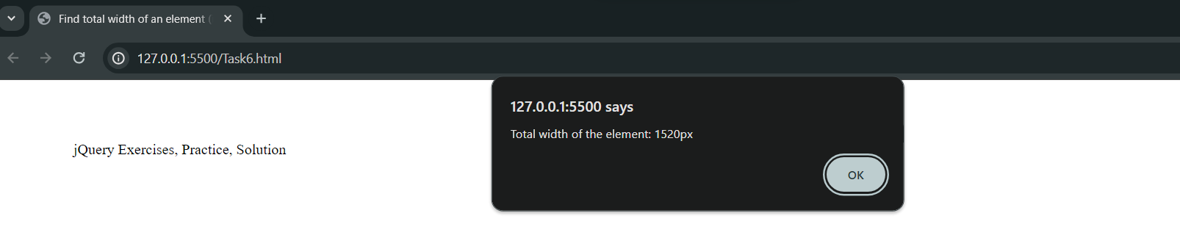

**Task7**

**Code:**

<!DOCTYPE html>

<html>

<head>

    <script src="https://code.jquery.com/jquery-git.js"></script>

    <meta charset="utf-8">

    <meta name="viewport" content="width=device-width">

    <title>Count child elements using jQuery.</title>

</head>

<body>

    <div id="selected">

        <p>Red</p>

        <p>White</p>

        <p>Green</p>

        <p>Black</p>

        <p>Blue</p>

        <p>Orange</p>

    </div>

    <script>

        $(document).ready(function(){

            var pCount = $('#selected p').length;

            alert('Number of <p> elements: ' + pCount);

        });

    </script>

</body>

</html>

**Output:**

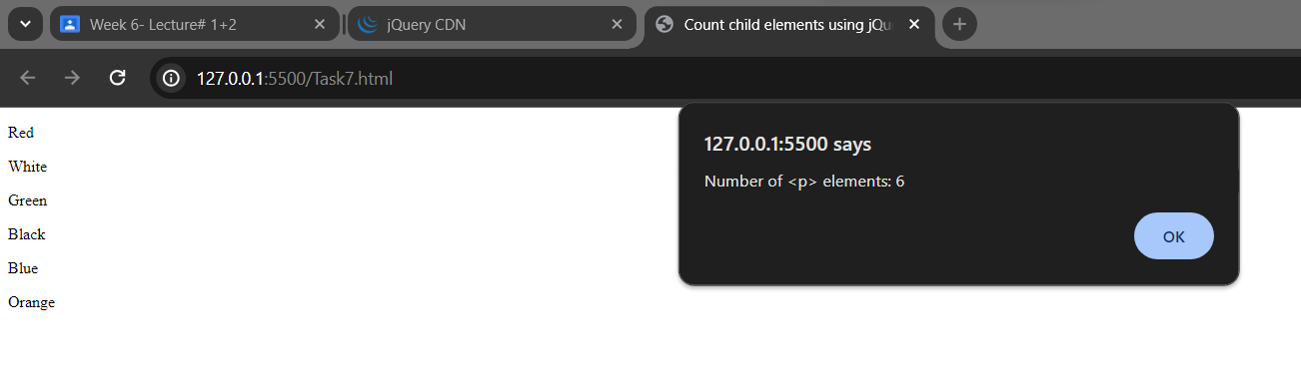

**Task8**

**Code:**

<!DOCTYPE html>

<html>

<head>

    <script src="https://code.jquery.com/jquery-git.js"></script>

    <meta charset="utf-8">

    <meta name="viewport" content="width=device-width">

    <title>Task8</title>

    <style>

        #animated-div {

            width: 100px;

            height: 100px;

            background-color: green;

            border-radius: 50%;

            position: relative;

        }

    </style>

</head>

<body>

    <div id="animated-div"></div>

    <script>

        $(document).ready(function(){

            $('#animated-div').animate({ left: '500px' }, 8000);

        });

    </script>

</body>

</html>

**Output:**

