**STEP 1:** Right click on the master zip folder and click extract all, now in the extracted folder you will have zip folder for separate accounts unzip that folder by right clicking on the folder and select extract all.

**STEP 2:** Go to the folder in which you want to take report (For EG : etg_report)

1. In this just click the etgbackup application.

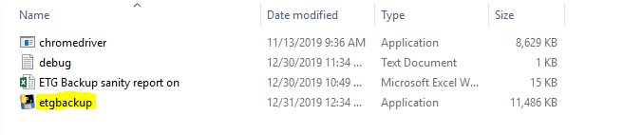

1. After the above step, a chrome window opens, and it will be automatically redirected to signin page, if this does not happened close the window and run the application again.
2. Then a new popup will be displayed on screen, or you can find it in task bar, in that enter the username and click ok.

(**NOTE : do not directly enter username and password in the signin page, if popup is not displayed you can check in the application window in taskbar and you can find the popup**)

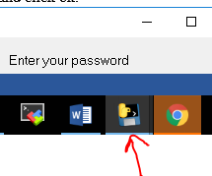

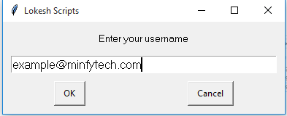

1. Now enter your password and click ok.

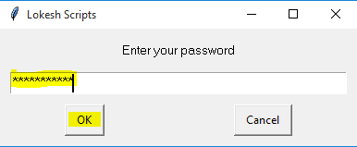

1. Now enter the MFA and click ok.

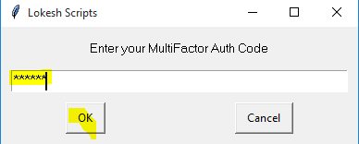

**STEP 3:** You can see the progress of the script in new window in the taskbar.

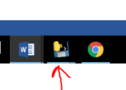

When everything is done a new updated excel file with the current date will be displayed in the folder from where you execute the python file.

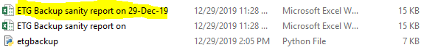

**STEP 4:** Now close the py.exe window in taskbar.

**NOTE: ANY UPDATES IN THE NWELY CREATED INSTANCE, THE NEWLY CREATED INSTANCE ID HAS TO BE INCLUDED IN EXCEL SHEET. (In the below image the newly created instance id, host name and retention days)**

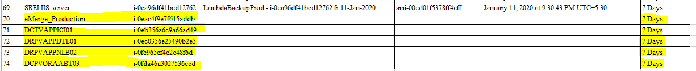

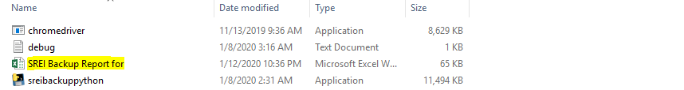

(**UPDATE HAS TO BE DONE IN THE SAMPLE EXCEL SHEET WHICH IS HIGHLITED ABOVE**).

**The script will only take the instance id from the excel sheet and find the ami name, and ami id, and creation date for that instance id and updates it in the excel sheet..**

**NOTE:** For iquippo backup and srei backup do S3 related sheets manually.