1)Created a WorkSpace WS_WSTEST as a folder.

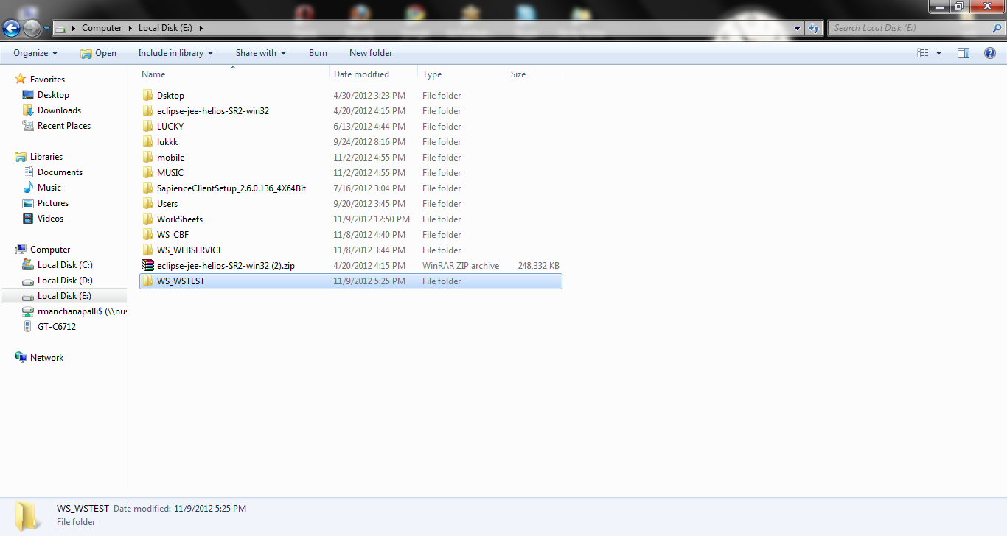

2) Opened the Eclipse and Switched the Workspace to the newly created folder.

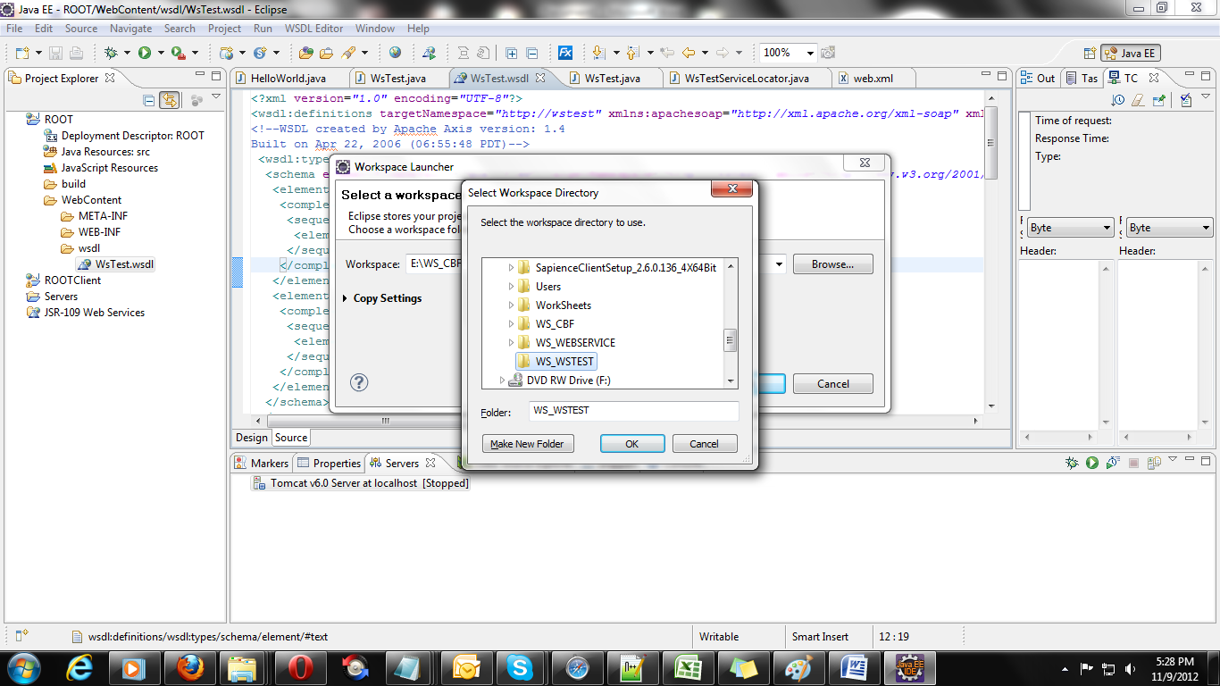

3) Created a new Dynamic Web project as following.

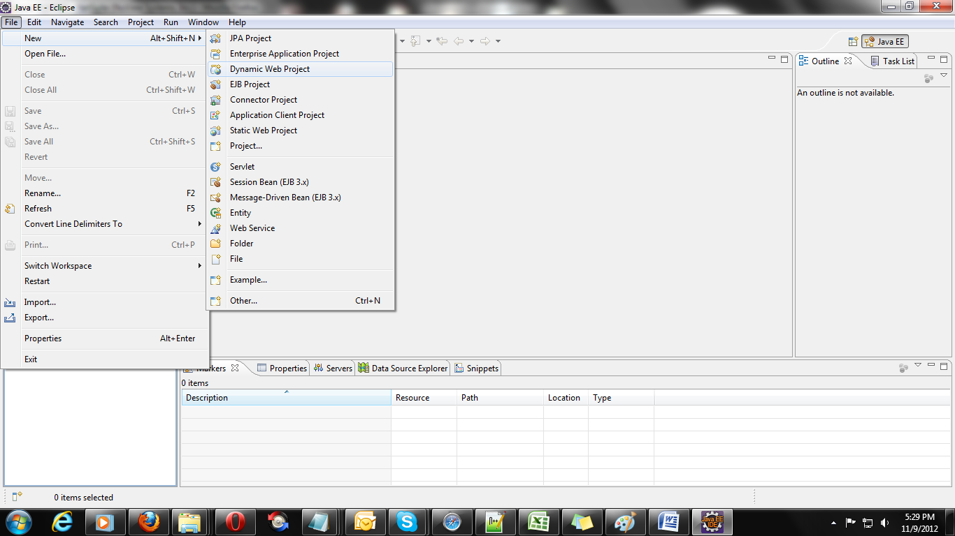

4) Named the Dynamic Web project as ROOT and set the target runtime environment to Tomcat6, click on the next button.,

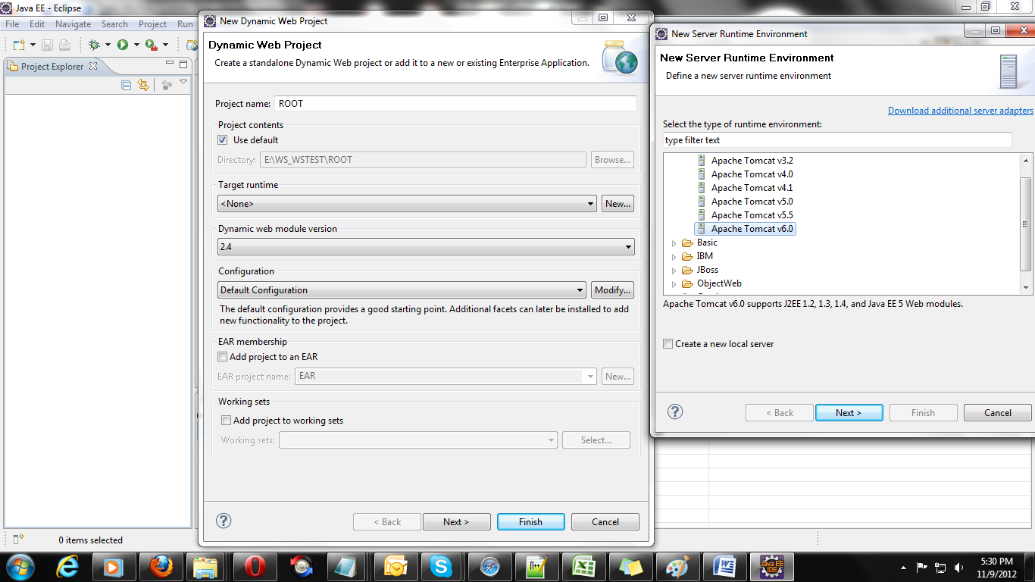

4.1) configured the Tomcat6 as follows.

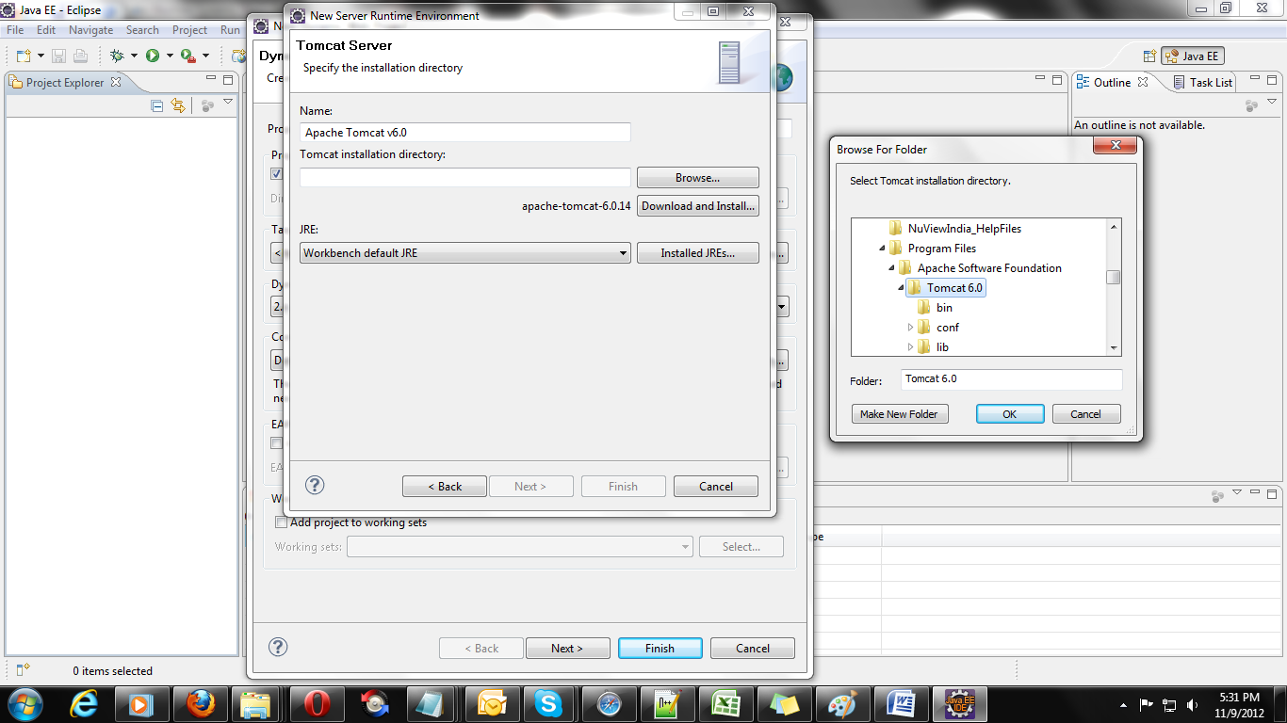

5) Click next and finish to complete the Project and Tomcat installation,

6) Create a Package WsTest by clicking as below.

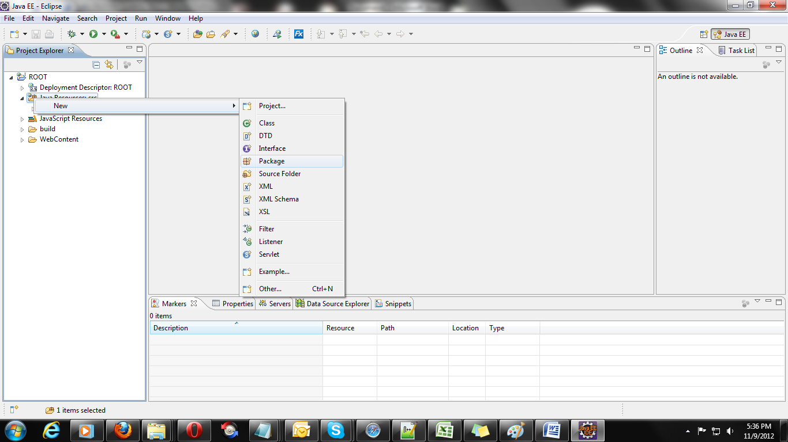

7)Create a class TestWS as follows,

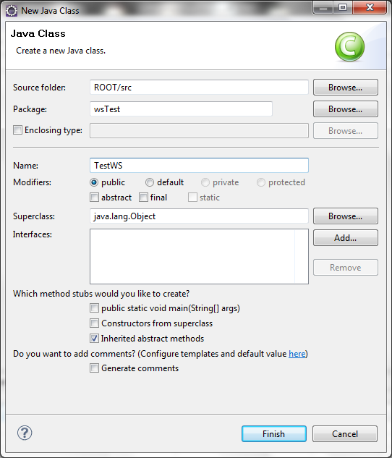

8) Now Generate a method named getName in the class, which also returns String appended with Hello CBF+the name passed as a parameter to strName.

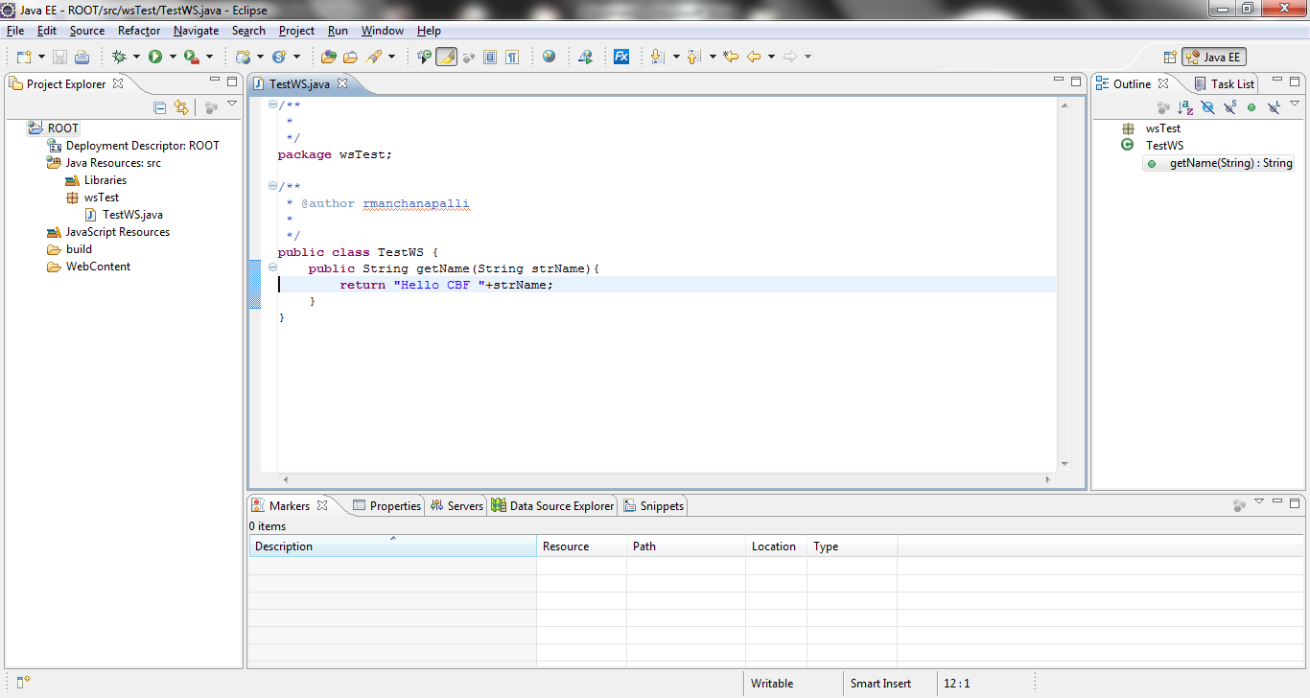

9 )Now right click on the src again and create a new web Service as follows,

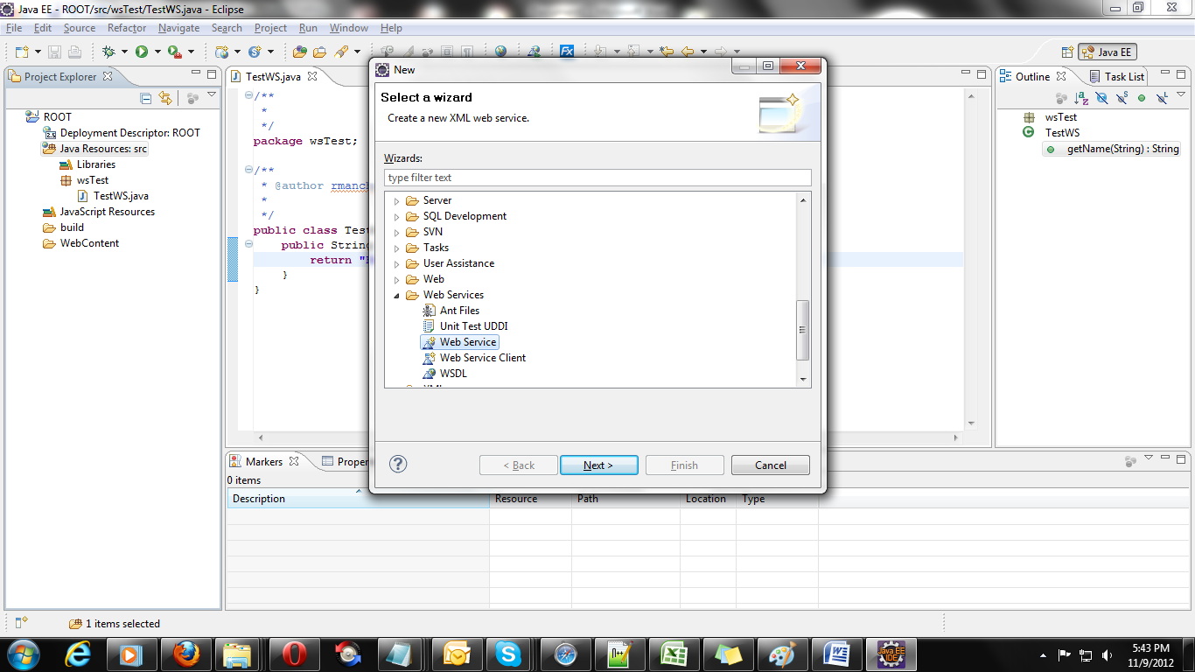

10) Click next; Select the service implementation with the recently created Java class WsTest.TestWs. Keep the webservice type as Bottom up Java bean Web Service. And drag the client till Test client.

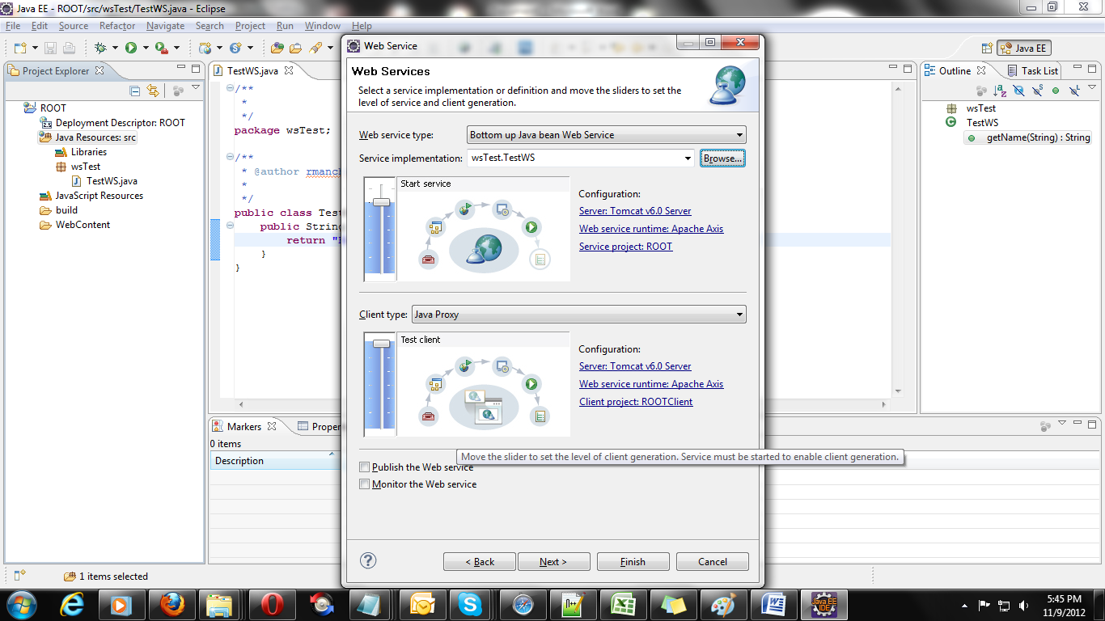

11) select the newly created method Name in the class by clicking the Next button,

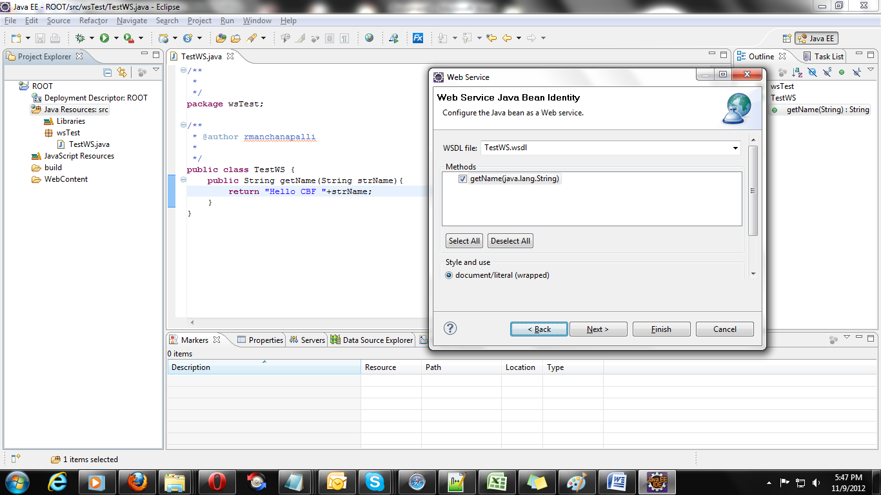

12) The following window pops up if the server is not started, Click Start server and keep clicking Next;

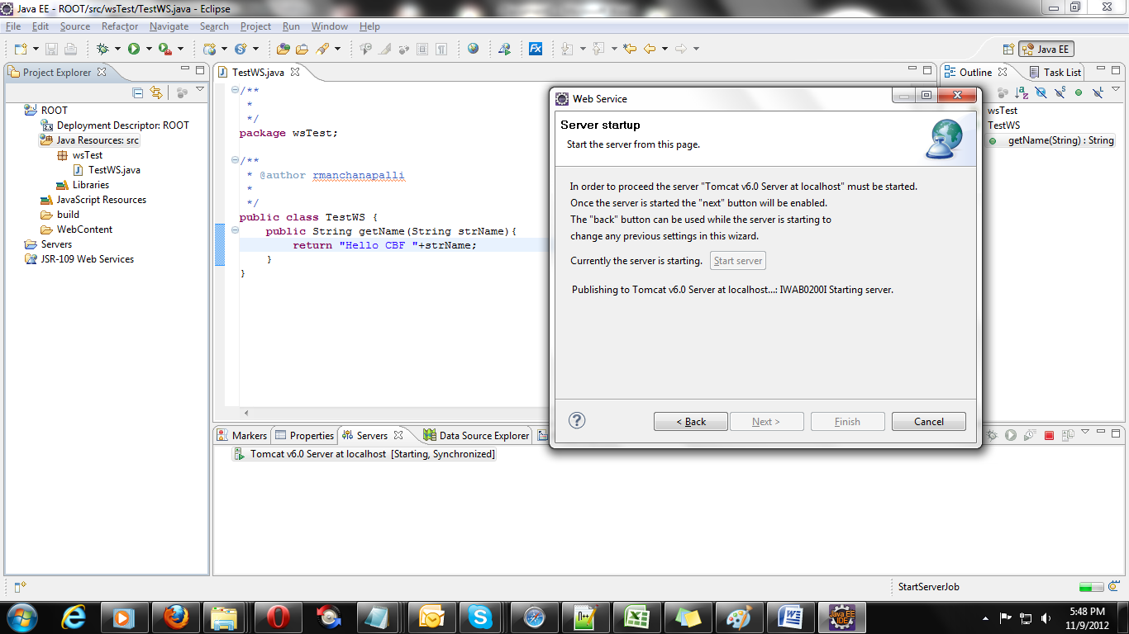

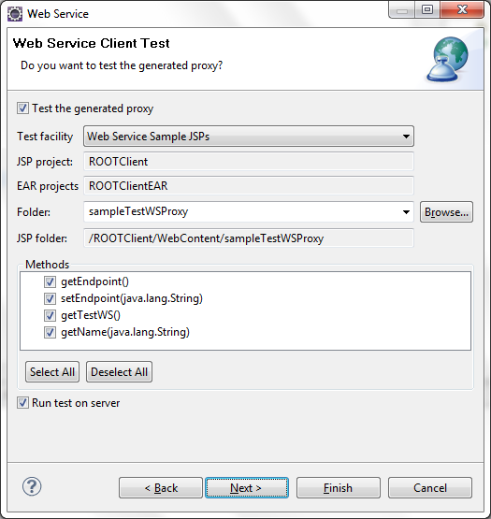

13) Keep clicking Next until the Next> is greyed out., and the following screen pops up,

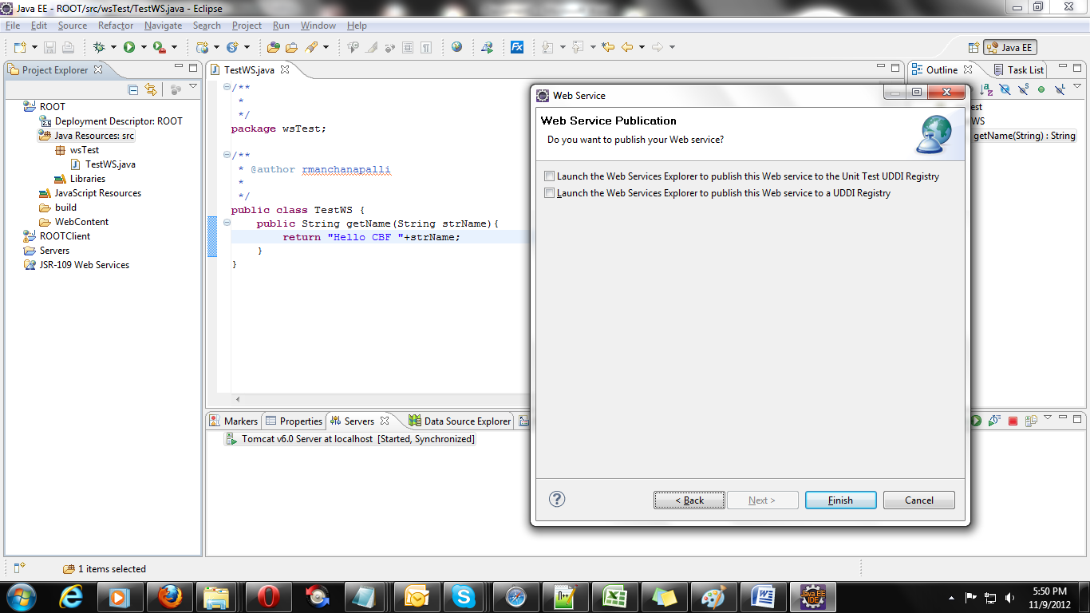

14) The following screen pops up, showing the Methods created by Web Service and the method created by us which is highlighted,

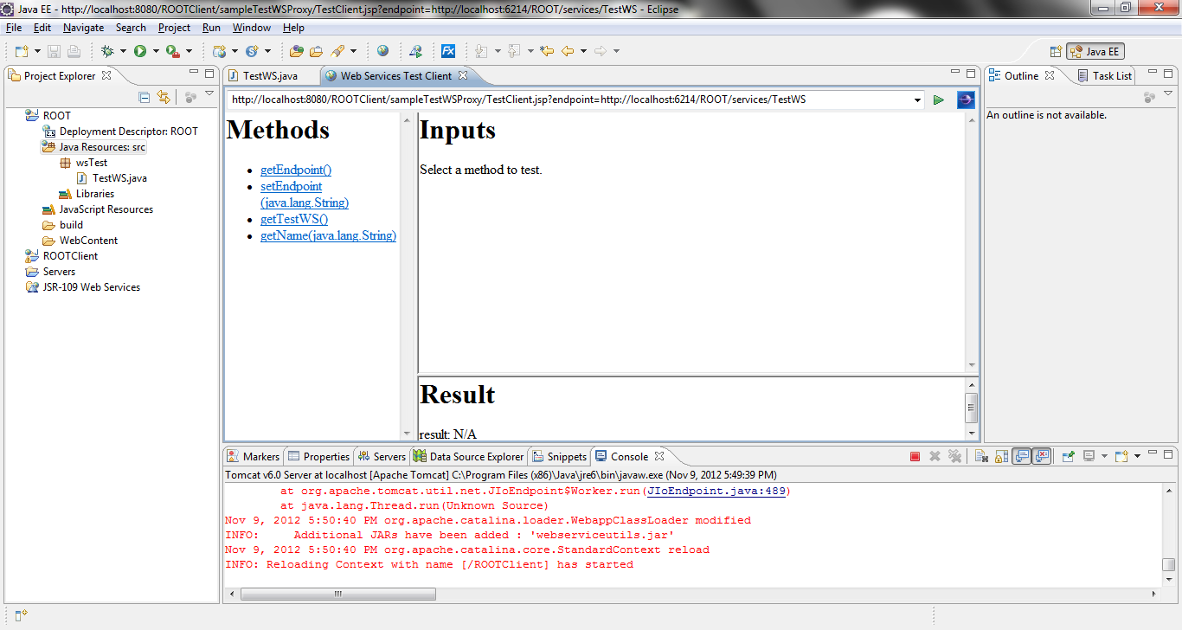

15)Now click on the getName which is created in the Java class earlier, provide the input in the text box,

The desired output is returned.

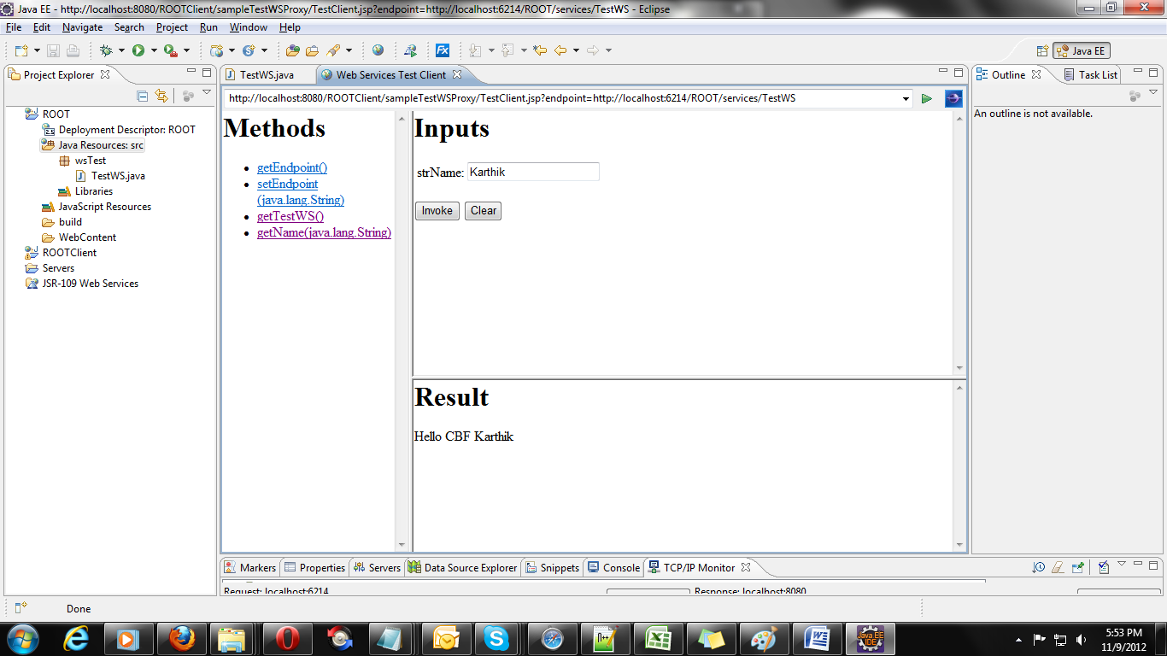

16) WSDL file is created at the following location,

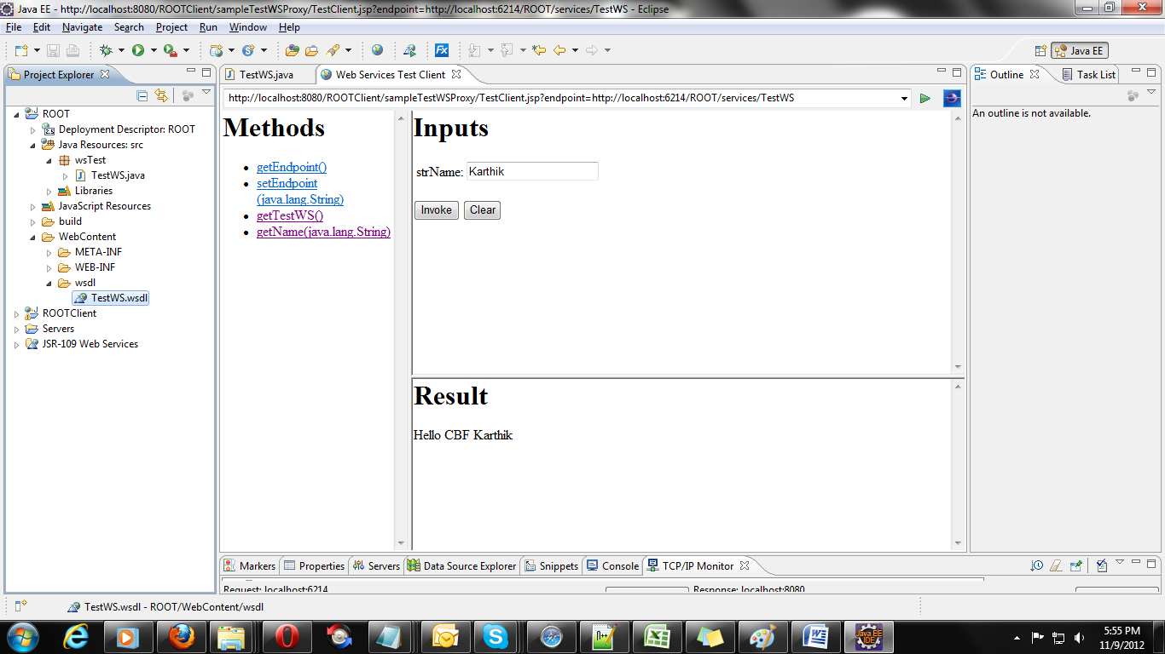

17) The following is the WSDL file generated,

<?xml version=*"1.0"* encoding=*"UTF-8"*?>

<wsdl:definitions targetNamespace=*"http://wsTest"* xmlns:apachesoap=*"http://xml.apache.org/xml-soap"* xmlns:impl=*"http://wsTest"* xmlns:intf=*"http://wsTest"* xmlns:wsdl=*"http://schemas.xmlsoap.org/wsdl/"* xmlns:wsdlsoap=*"http://schemas.xmlsoap.org/wsdl/soap/"* xmlns:xsd=*"http://www.w3.org/2001/XMLSchema"*>

<!--WSDL created by Apache Axis version: 1.4

Built on Apr 22, 2006 (06:55:48 PDT)-->

<wsdl:types>

<schema elementFormDefault=*"qualified"* targetNamespace=*"http://wsTest"* xmlns=*"http://www.w3.org/2001/XMLSchema"*>

<element name=*"getName"*>

<complexType>

<sequence>

<element name=*"strName"* type=*"xsd:string"*/>

</sequence>

</complexType>

</element>

<element name=*"getNameResponse"*>

<complexType>

<sequence>

<element name=*"getNameReturn"* type=*"xsd:string"*/>

</sequence>

</complexType>

</element>

</schema>

</wsdl:types>

<wsdl:message name=*"getNameRequest"*>

<wsdl:part element=*"impl:getName"* name=*"parameters"*/>

</wsdl:message>

<wsdl:message name=*"getNameResponse"*>

<wsdl:part element=*"impl:getNameResponse"* name=*"parameters"*/>

</wsdl:message>

<wsdl:portType name=*"TestWS"*>

<wsdl:operation name=*"getName"*>

<wsdl:input message=*"impl:getNameRequest"* name=*"getNameRequest"*/>

<wsdl:output message=*"impl:getNameResponse"* name=*"getNameResponse"*/>

</wsdl:operation>

</wsdl:portType>

<wsdl:binding name=*"TestWSSoapBinding"* type=*"impl:TestWS"*>

<wsdlsoap:binding style=*"document"* transport=*"http://schemas.xmlsoap.org/soap/http"*/>

<wsdl:operation name=*"getName"*>

<wsdlsoap:operation soapAction=*""*/>

<wsdl:input name=*"getNameRequest"*>

<wsdlsoap:body use=*"literal"*/>

</wsdl:input>

<wsdl:output name=*"getNameResponse"*>

<wsdlsoap:body use=*"literal"*/>

</wsdl:output>

</wsdl:operation>

</wsdl:binding>

<wsdl:service name=*"TestWSService"*>

<wsdl:port binding=*"impl:TestWSSoapBinding"* name=*"TestWS"*>

<wsdlsoap:address location=*"http://localhost:8080/ROOT/services/TestWS"*/>

</wsdl:port>

</wsdl:service>

</wsdl:definitions>

18) Size has been reduced for better alignment.

**Conclusion:**

1. **The following phenomenon of creating the Web Service is a BOTTOM UP approach as we are deriving the WSDL file from the Business, i.e., from the Java class**
2. **This is only the fundamental of learning the webservice as such how they are developed using the eclipse api.**

**Feel free to approach me in case of any further clarification is required.**

**Thanks,**

**Rajaram Manchanapalli.**