MySQL Queries and Results

1. Simple SELECT + WHERE
-- Get all customers from the USA
SELECT * FROM Customers
WHERE country = 'USA';

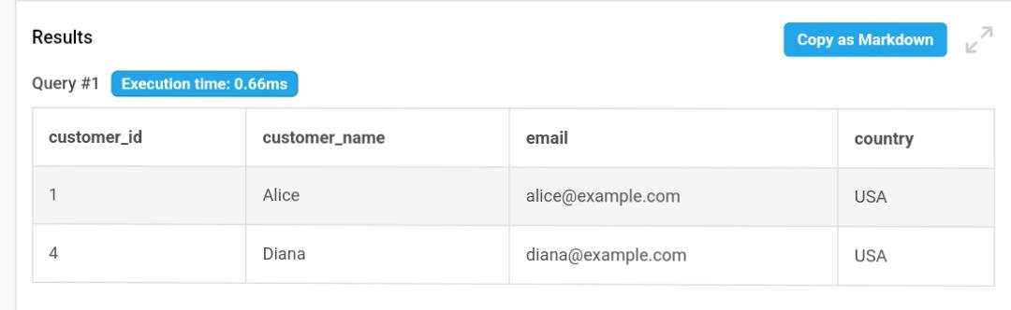

2. JOIN + SELECT + ORDER BY
-- Get orders with customer names and product names
SELECT o.order_id, c.customer_name, p.product_name, o.quantity, o.order_date
FROM Orders o
JOIN Customers c ON o.customer_id = c.customer_id
JOIN Products p ON o.product_id = p.product_id
ORDER BY o.order_date;
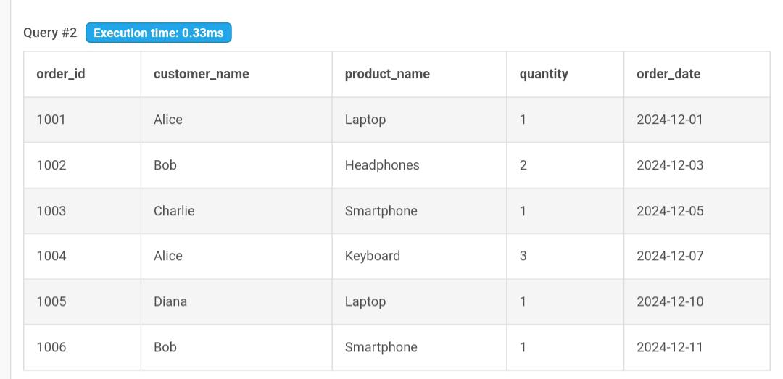

3. GROUP BY + Aggregate Functions
-- Total quantity ordered per product
SELECT p.product_name, SUM(o.quantity) AS total_quantity
FROM Orders o
JOIN Products p ON o.product_id = p.product_id
GROUP BY p.product_name;
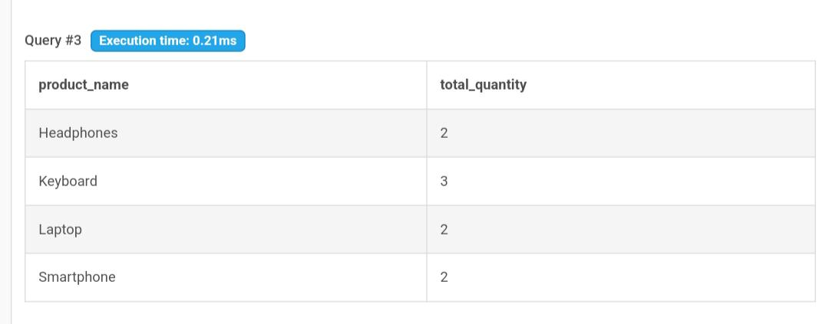

4. Subquery
-- Get customers who ordered more than 1 product in total
SELECT customer_id
FROM Orders
GROUP BY customer_id
HAVING SUM(quantity) > 1;
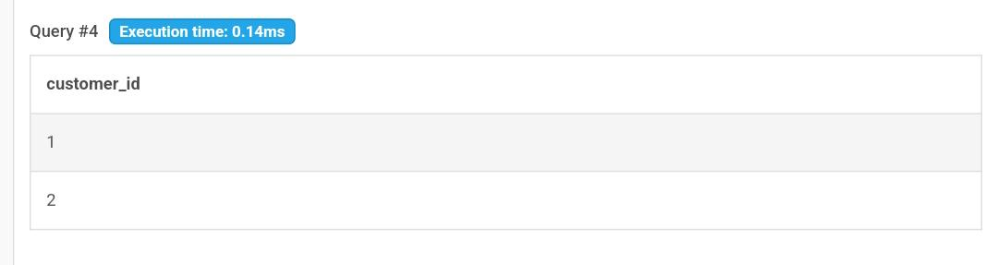

5. Create a VIEW
-- Create a view for order summary
CREATE VIEW OrderSummary AS
SELECT o.order_id, c.customer_name, p.product_name, o.quantity, p.price,
(o.quantity * p.price) AS total_price
FROM Orders o
JOIN Customers c ON o.customer_id = c.customer_id
JOIN Products p ON o.product_id = p.product_id;

6. Query the View
-- View total price per order
SELECT * FROM OrderSummary;
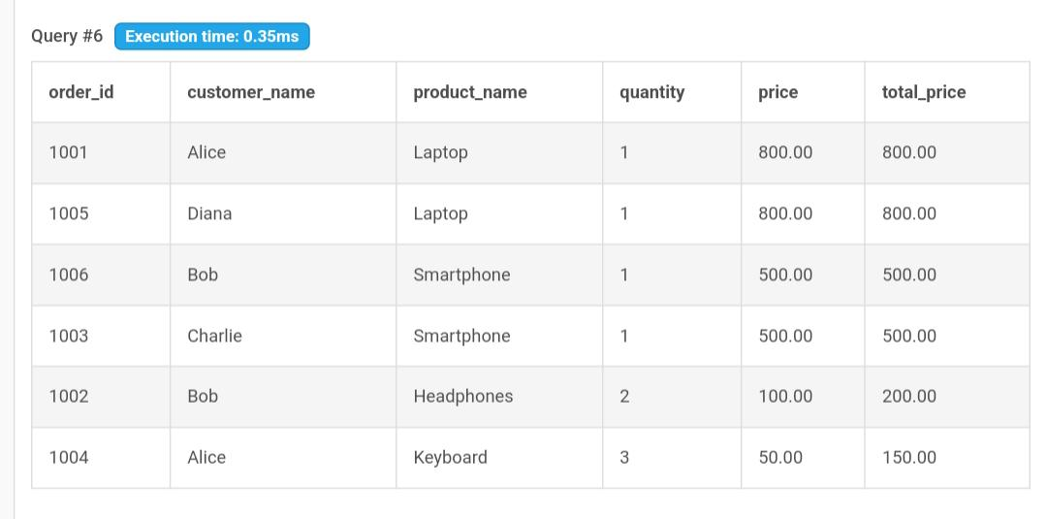

7. Average Revenue per User
-- Calculate average revenue per user
SELECT c.customer_name, AVG(o.quantity * p.price) AS avg_revenue
FROM Orders o
JOIN Customers c ON o.customer_id = c.customer_id
JOIN Products p ON o.product_id = p.product_id
GROUP BY c.customer_name;
