**DA Assignment –1 Submission**

**Title:**  
**Supermarket Sales Dashboard**

**Submitted by:**  
**Name :** Shaik Tanzil Basha

**Roll Number :** 22AT1A3241

**Institute Name :** G.Pullaiah College Of Engineering and Technology

**📊 Introduction**

**Objective:**  
To analyze the sales performance of a supermarket chain operating in three branches over three months using Tableau visualizations. The data contains customer demographics, purchase behavior, and sales figures.

**Tools Used:**

* Tableau Public/Desktop
* Supermarket Sales Dataset (Jan–Mar 2019)

**Dataset Source:**  
*Supermarket Sales (Kaggle / Classroom link)*

**🧹Data Cleaning in Tableau**

**Steps Performed:**

* Imported CSV dataset into Tableau
* Removed unnecessary columns:
  + *Invoice ID* (unique identifier not required for analysis)
  + *COGS* (already factored into other calculations)
  + *Date/Time columns* – not used in some dashboards
* Renamed field names for better clarity (optional)

**📉 Visualizations + Insights**

**🔷 1. Donut Chart – by Customer Type**

**Screenshot:**

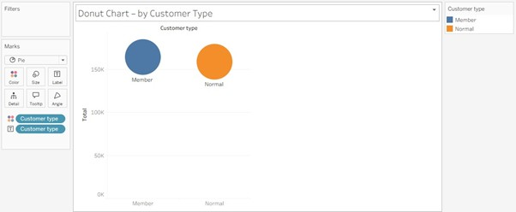

**Purpose:** Compare values across categories  
**Best Attribute Combination:**

* **Dimension:** Branch or Product Line
* **Measure:** Total or Gross Income

📌 **Example:**  
"Total Sales by Branch"

* *X-axis:* Branch (A, B, C)
* *Y-axis:* Total Sales

💡 **Insight**: Branch **C** has the highest total sales, followed by Branch A and B. This can be due to higher footfall or higher average transaction value.

**✅ 2. Pie Chart**

**Screenshot:**

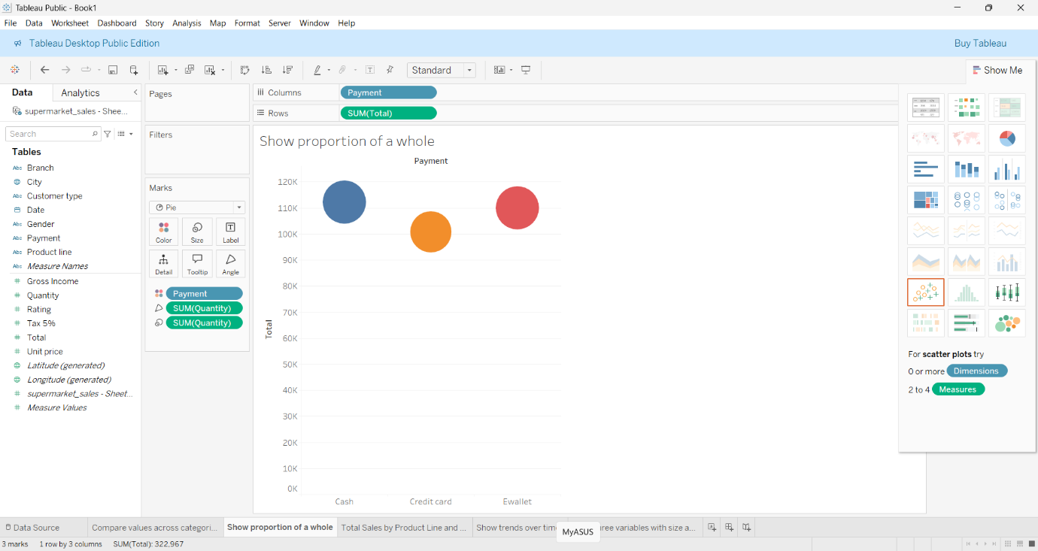

**Purpose:** Show proportion of a whole  
**Best Attribute Combination:**

* **Dimension:** Payment or Customer Type
* **Measure:** Number of Records or Total

📌 **Example:**  
"Sales Distribution by Payment Method"

* Slice by: Payment Type (Cash, Credit Card, Ewallet)
* Size: Count of Transactions or Total Amount

💡 **Insight:** Understand preferred customer payment methods.

**✅ 3. Stacked Bar Chart**

**Screenshot:**

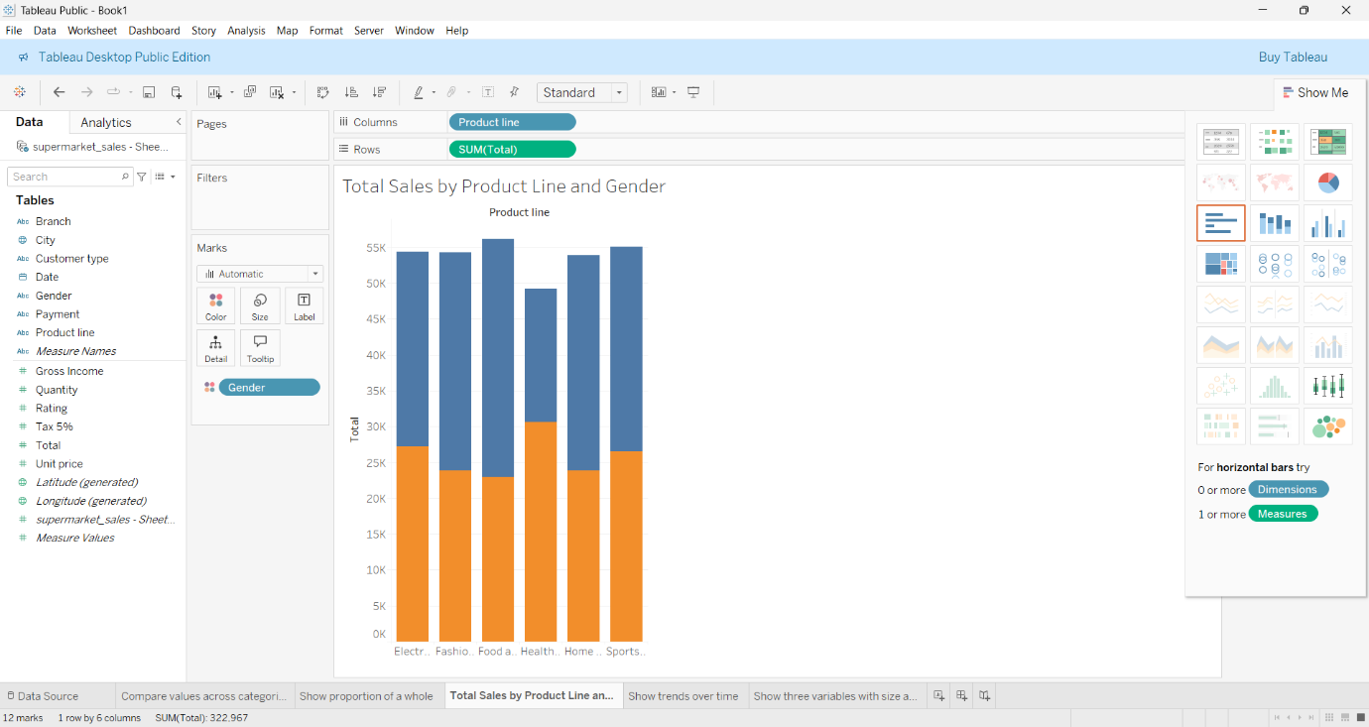

**Purpose:** Compare sub-category values across a main category  
**Best Attribute Combination:**

* **Main Dimension (X):** Product Line
* **Subcategory (Color):** Gender or Customer Type
* **Measure (Y):** Total or Quantity

📌 **Example:**  
“Total Sales by Product Line and Gender”

💡 **Insight:** Reveal customer preferences by gender for each product type.

**✅ 4. Line Chart**

**Screenshot:**

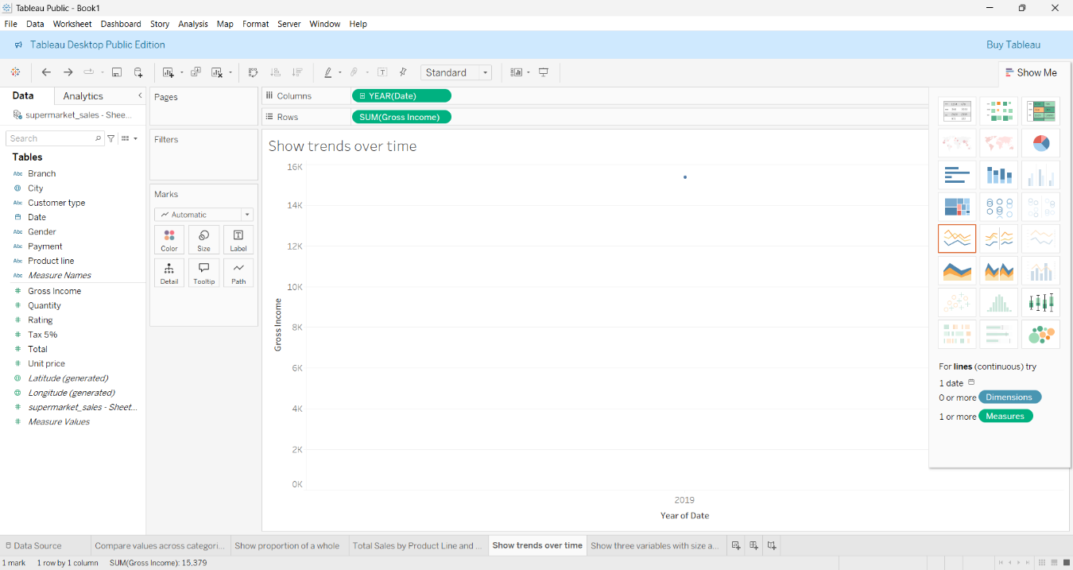

**Purpose:** Show trends over time  
**Best Attribute Combination:**

* **Dimension (X-axis):** Date (converted to Day or Month)
* **Measure (Y-axis):** Total or Gross Income

📌 **Example:**  
"Daily Sales Trend Over 3 Months"

💡 **Insight:** Detect sales patterns, promotions impact, or end-of-month spikes.

**✅ 5. Bubble Chart**

**Screenshot:**

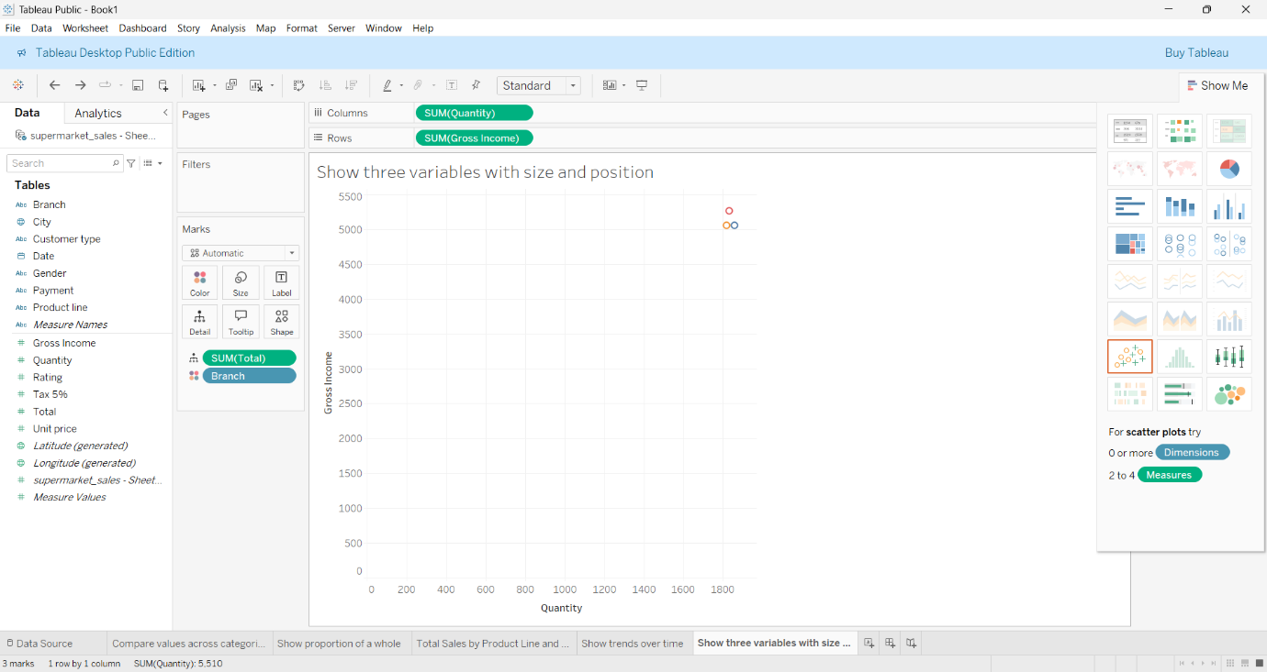

**Purpose:** Show three variables with size and position  
**Best Attribute Combination:**

* **X-axis:** Quantity
* **Y-axis:** Gross Income
* **Size:** Total
* **Color:** Branch or Product Line

📌 **Example:**  
"Gross Income vs Quantity by Product Line"

💡 **Insight:** Identify high-margin product lines or efficient selling items.

**Supermarket Sales Dashboard**

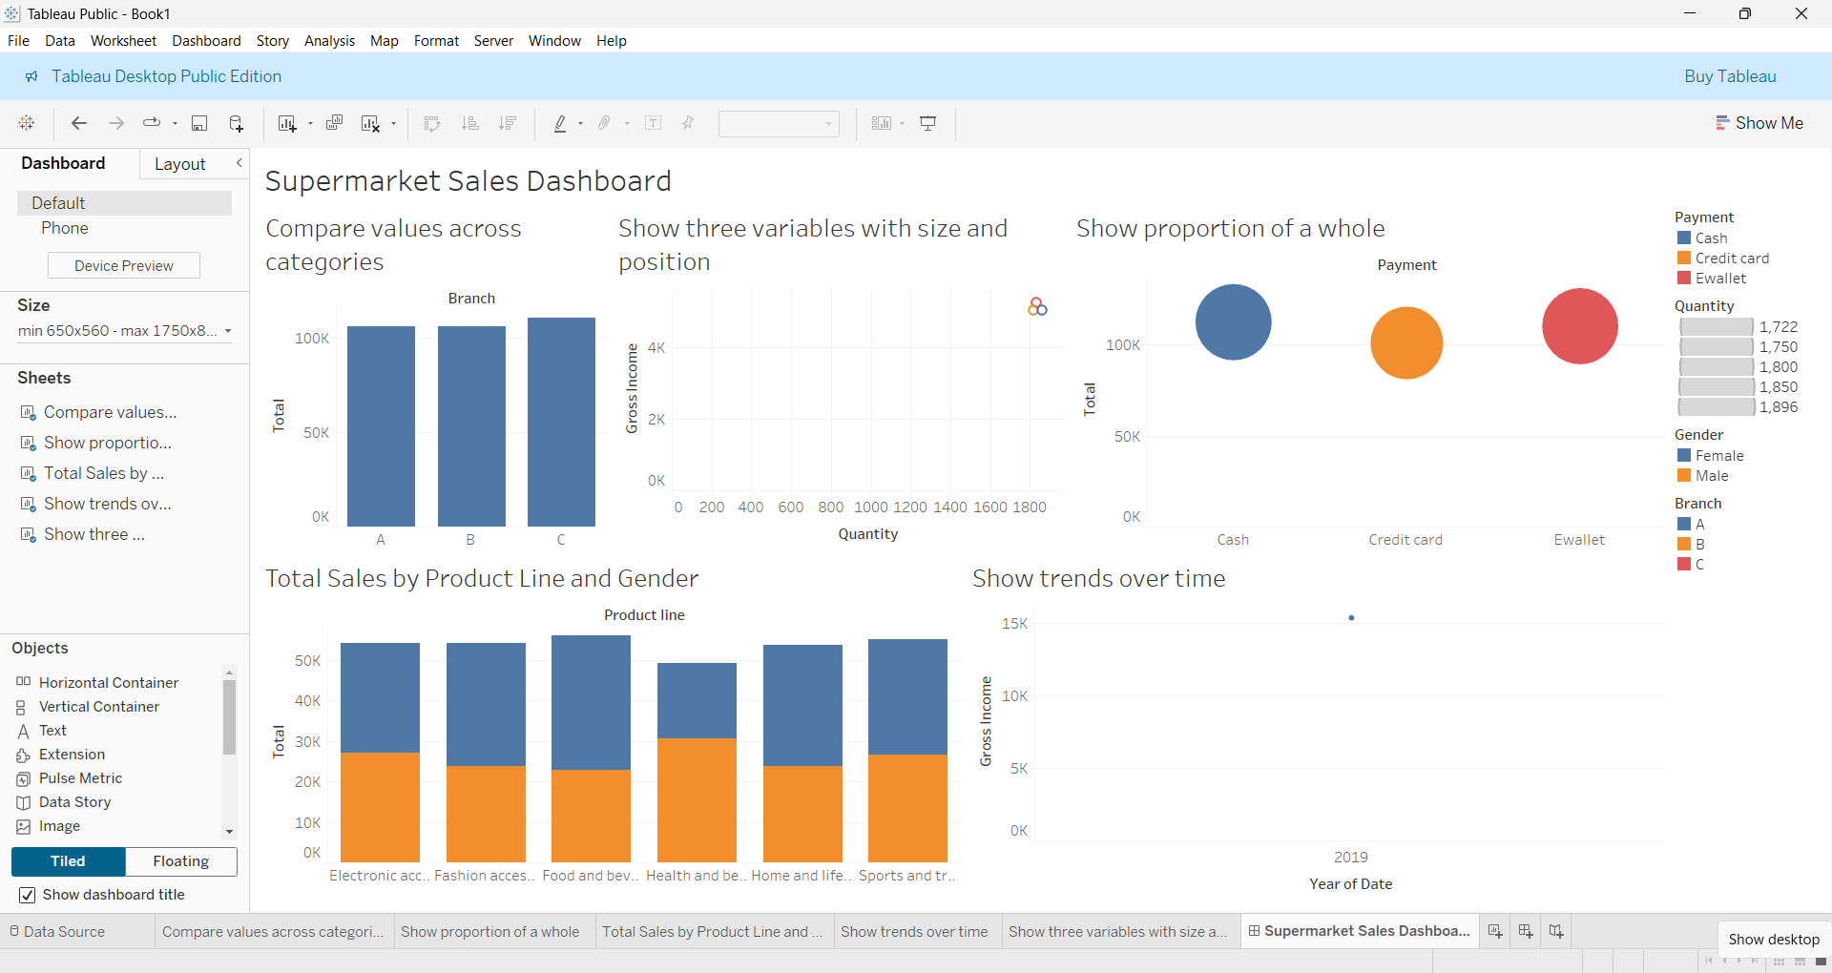

**🧾Conclusion**

* Visualizations reveal valuable insights about branch performance, customer preferences, and sales behavior.
* Tableau helped quickly identify patterns such as peak sales periods, product popularity, and preferred payment methods.